
mbX Pro -- internal technical reference
Step 4
mbx_dada2_run.sh
Run DADA2 denoising and produce all summary visualizations
Pipeline step 4 -- the slowest and most CPU-bound stage.

1. Purpose and scope
Read the four DADA2 parameters chosen by step 3, validate the user's metadata file (mirroring mbX R-package validation), and run `qiime dada2 denoise-paired` plus three QZV-summary commands. The result is the canonical feature table + representative-sequences + denoising-stats triple that drives every downstream step.

2. Inputs and outputs

2.1 Inputs (data structures)
Name | Source | Format | Required
<dada2_parameters.txt> | From step 3 | Plain-text k=v + ranked-candidate table | yes
<metadata.txt> | User-provided | QIIME2 metadata file (.txt/.tsv/.csv) | yes
--threads N | User flag | Integer (default = sysctl/nproc) | no
--dry-run | User flag | Boolean | no

2.2 Outputs (data structures)
Path (relative to output dir) | What it contains | Read by
4_dada2_outputs/feature_table.qza | FeatureTable[Frequency] (samples x ASVs) | every later step
4_dada2_outputs/feature_table.qzv | Per-sample/per-feature visualization | report
4_dada2_outputs/representative_sequences.qza | FeatureData[Sequence] (one DNA seq per ASV) | step 5/6 (classifier), step 11 (tree)
4_dada2_outputs/representative_sequences.qzv | Tabulated seqs (BLAST-able) | report
4_dada2_outputs/dada2_stats.qza | Per-sample reads-in / reads-out / merged / non-chim counts | report
4_dada2_outputs/dada2_stats.qzv | Visualization of the above | report

2.3 Downstream consumers
These steps depend on this script's outputs:
- Step 5/6 read representative_sequences.qza for classifier extract-reads + classify-sklearn.
- Step 7 reads feature_table.qza to build feature_table_filtered.qza (mito/chloro removed).
- Step 11 reads representative_sequences.qza to build the phylogenetic tree.
- Step 18 embeds dada2_stats.qzv-derived numbers into the report's QC table.

3. Complete parameter reference
The script is parameter-light: trunc-len/trim-left are inherited from step 3.
Parameter | Default | Decision rule / where it comes from
--threads N | auto | Passed verbatim to --p-n-threads. auto resolves via `nproc` (Linux) or `sysctl -n hw.logicalcpu` (macOS). DADA2 scales sub-linearly past 8 threads -- typical sweet spot is 4-8.

4. Algorithm walkthrough

4.1 Metadata validation (mirrors mbX R-package logic)
The script applies six validation rules, designed to catch every failure mode we have seen in real datasets BEFORE running the 30-90 minute DADA2 step:
- Extension must be .txt/.tsv/.csv. .xls/.xlsx is explicitly refused with an Excel-export tip.
- First column header (after BOM stripping + lowercasing + trim) must match one of: id, sampleid, sample id, sample-id, featureid, feature id, feature-id.
- If second line starts with #q2:types it is recognised as a QIIME2 directive and DATA_START moves to row 3.
- Sample IDs must be non-empty, unique, and have no leading/trailing whitespace.
- Sample IDs containing characters outside [A-Za-z0-9._-] trigger a warning (QIIME2 may reject them later).
Empty/duplicate detection uses bash sort + sort -u and comm -23 to enumerate the duplicates for the error message.

4.2 Parameter parsing
The four DADA2 parameters and the input artifact path are extracted from dada2_parameters.txt via grep + cut. Each parameter is then sanity-checked: integer type and trunc > trim_left (DADA2 enforces this internally but a clearer error message here saves debugging time).

4.3 DADA2 denoising
Six QIIME2 calls are run sequentially:
Step 3: qiime dada2 denoise-paired with the four parameters + --p-n-threads. This is the long-running step (CPU-bound, scales with sample count and read length).
Step 4: qiime metadata tabulate on dada2_stats.qza -> dada2_stats.qzv.
Step 5: qiime feature-table summarize on feature_table.qza + metadata -> feature_table.qzv (the per-sample frequency table the user looks at to choose rarefaction depth).
Step 6: qiime feature-table tabulate-seqs on representative_sequences.qza -> representative_sequences.qzv (BLAST-clickable).

5. Flow diagram
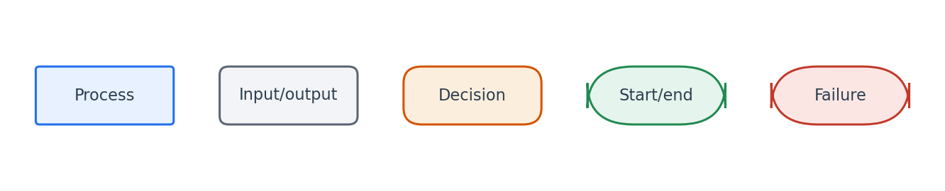
Flowchart symbol legend (used in every chapter).
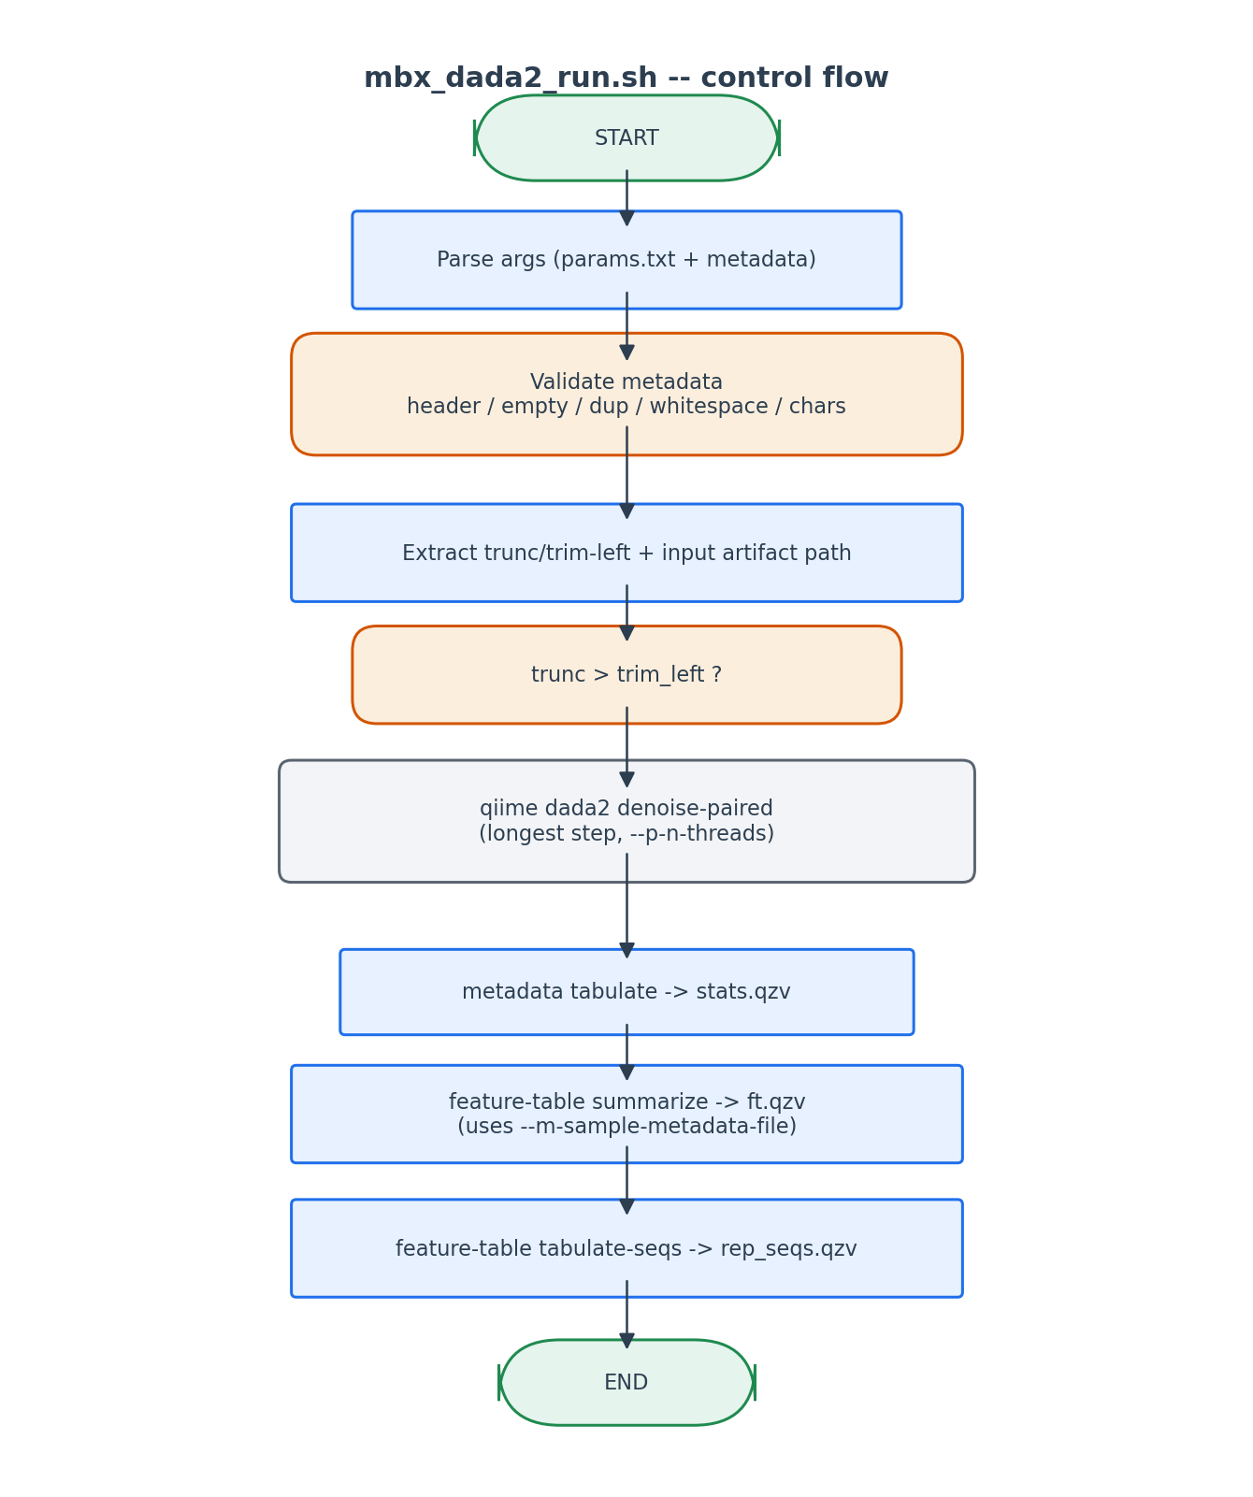
Validation gates run BEFORE the slow DADA2 step.

6. Edge cases and caveats

UTF-8 BOM in metadata
Excel-exported files start with U+FEFF. The header validator strips it via `sed 's/^\xef\xbb\xbf//'`. Without this stripping, the BOM is part of the first column header, which fails to match any allowed alias.

Sample IDs in metadata that are not in the artifact
DADA2 itself does not check this -- step 5 (feature-table summarize) will silently drop those samples. We pass --m-sample-metadata-file so the QZV exposes the mismatch visually.

Threads = 0
Treated identically to 'auto'. Resolves via nproc/sysctl.

7. Implementation notes

Why pre-validate metadata?
DADA2 is the slowest step (30+ min). A metadata typo discovered AFTER DADA2 finishes is hours of wasted time. Pre-validation catches every metadata-format error in seconds.

BOM stripping
We use the literal byte sequence `\xef\xbb\xbf` (UTF-8 BOM) rather than relying on iconv. This works on every macOS/Linux without extra dependencies.

Reading parameters with grep + cut
Faster and more portable than parsing via awk/python. Each parameter line in dada2_parameters.txt has a fixed `--p-key value` format -- grep -m1 'key ' + awk '{print $2}' is sufficient.

8. Testing checklist
Things to verify before considering this script production-ready:
- Run with valid metadata + valid params -> verify all 6 outputs exist.
- Run with metadata containing duplicate sample IDs -> verify error names the duplicates.
- Run with metadata first-column header 'SampleName' (invalid) -> verify clear actionable error.
- Run with --threads 4 -> verify --p-n-threads 4 appears in the dada2 command.
- Run with a manually edited dada2_parameters.txt where trunc < trim -> verify pre-flight catches it.

