
mbX Pro -- internal technical reference
Step 5
mbx_classifier_arranger.sh
Auto-detect QIIME2/GG2 versions, download references, prepare classifier inputs
Pipeline step 5 -- the orchestration prep for taxonomic classification.

1. Purpose and scope
Solve the practical questions of taxonomic classification BEFORE the expensive train+classify step: which Greengenes2 version to use, where to download it from, what the per-ASV length distribution is, and how to construct the three QIIME2 commands that step 6 will run.

2. Inputs and outputs

2.1 Inputs (data structures)
Name | Source | Format | Required
<mbX_pro_outputs_dir> | User CLI arg | Directory containing 0_primer_handling/, 4_dada2_outputs/, etc. | yes
--gg2-version V | User flag | Override GG2 version (e.g. 2024.09) | no
--skip-download | User flag | Boolean | no
--dry-run | User flag | Boolean | no
0_primer_handling/mbx_primer_info.txt | Auto-discover | Read FORWARD_PRIMER_*, REVERSE_PRIMER_* | no (graceful degradation)
4_dada2_outputs/representative_sequences.qza | Auto-discover | QIIME2 artifact | yes

2.2 Outputs (data structures)
Path (relative to output dir) | What it contains | Read by
5_classifier_working_dir/exported_rep_seqs/dna-sequences.fasta | FASTA export of rep_seqs | step 6 (length stats)
5_classifier_working_dir/<ver>.backbone.full-length.fna.qza | Downloaded GG2 reference sequences (1.5-2.5 GB) | step 6
5_classifier_working_dir/<ver>.backbone.tax.qza | Downloaded GG2 reference taxonomy (0.5-1 GB) | step 6
5_classifier_working_dir/length_summary.txt | Min / max / total ASV lengths | step 6
5_classifier_working_dir/mbx_classifier_run_info.txt | Machine-readable: every path + ready-to-run commands | step 6

2.3 Downstream consumers
These steps depend on this script's outputs:
- Step 6 (mbx_classifier_run.sh) reads mbx_classifier_run_info.txt for everything it needs.
- Step 7 (mbx_taxonomy_run.sh) reads FEATURE_TABLE_QZA path from the same info file.

3. Complete parameter reference
Parameter | Default | Decision rule / where it comes from
--gg2-version V | (auto) | Override the auto-detected GG2 version. Auto rule: QIIME2 >= 2024.5 -> GG2 2024.09 (sklearn 1.4.2 compatible). QIIME2 < 2024.5 -> GG2 2022.10 (sklearn 0.24.1).
--skip-download | off | Assume the .qza files are already on disk in the expected paths (e.g. shared install).

4. Algorithm walkthrough

4.1 QIIME2 version detection
Run `qiime info | grep 'QIIME 2 release' | grep -oE '[0-9]{4}\.[0-9]+'`. Fallback to grep 'version' if the format changes. Default to '2025.4' if all parsing fails (a defensive guess that picks the modern GG2).

4.2 GG2 version selection
Compare the major.minor of the detected QIIME2 version. The threshold (2024.5) is significant because that release shipped the sklearn 1.4.2 stack -- mismatched sklearn versions between training and classification trigger 'incompatible classifier' errors.

4.3 Disk-space guard
Run `df -k <target>` and parse `awk 'NR==2 {print $4}'` (kilobytes). Convert to GB. Warn (but do not fail) if < 4 GB available -- the user might know they have an external drive elsewhere.

4.4 Download with resume support
Prefer wget -c (continues partial downloads). Fall back to `curl -L --retry 3 --continue-at -`. Both support HTTP range requests, which matters for ~2 GB downloads on flaky networks.

4.5 Length statistics
Single-pipeline awk extracts per-ASV sequence lengths from dna-sequences.fasta:
awk '/^>/ {if (seq) print length(seq); seq=""; next} {seq=seq$0} END {print length(seq)}' \
"$FASTA_PATH" | sort -n | \
awk 'NR==1 {min=$1} {max=$1; count++} END {
printf "Min Length: %d\nMax Length: %d\nTotal ASVs: %d\n", min, max, count
}' > length_summary.txt
min/max are passed to `qiime feature-classifier extract-reads --p-min-length / --p-max-length`. This narrows the GG2 reference to roughly the same length distribution as the user's ASVs, which improves classification accuracy at genus/species level.

4.6 CLASSIFIER_MODE auto-fallback (the new bit)
The arranger now decides one of two modes BEFORE writing the run-info file, and embeds that decision as CLASSIFIER_MODE=region-specific or CLASSIFIER_MODE=full-length:
PRIMERS_AVAILABLE=false
[[ "$FWD_PRIMER" != "None" && "$REV_PRIMER" != "None" \
&& -n "$FWD_PRIMER" && -n "$REV_PRIMER" ]] && PRIMERS_AVAILABLE=true
if $PRIMERS_AVAILABLE; then
CLASSIFIER_MODE="region-specific"
TRAINED_CLASSIFIER_QZA="${CLASSIFIER_DIR}/gg2_trained_classifier.qza"
else
CLASSIFIER_MODE="full-length"
TRAINED_CLASSIFIER_QZA="${CLASSIFIER_DIR}/gg2_full_length_trained_classifier.qza"
fi
Different filenames so both classifiers can co-exist on disk and be reused independently across projects (region-specific is keyed to a primer set, full-length is reusable for ANY primer set / V-region).

4.7 Run-info file emission
The output run-info file has TWO sections: a machine-readable key=value block (read by step 6/7), and a human-readable 'ready-to-run commands' block at the bottom (Step A: extract-reads, Step B: fit-classifier, Step C: classify-sklearn, Step D: tabulate, Step E: barplot).
When CLASSIFIER_MODE=full-length, Step A is replaced with an explanatory 'AUTO-SKIPPED' note and Step B's --i-reference-reads is repointed to the full GG2 backbone .fna.qza (instead of the missing extracted .qza). Step 6 then executes that exact plan.

5. Flow diagram
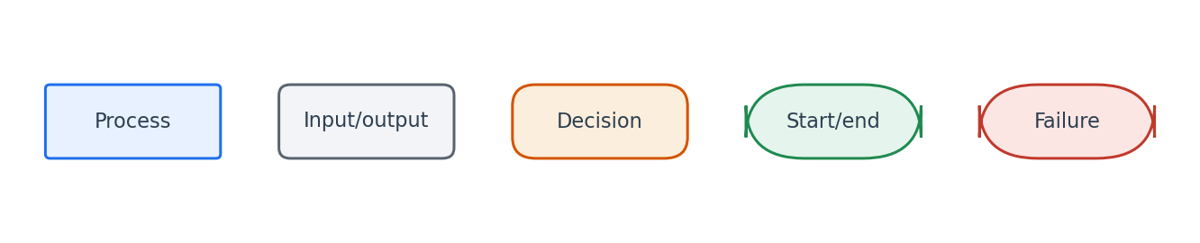
Flowchart symbol legend (used in every chapter).
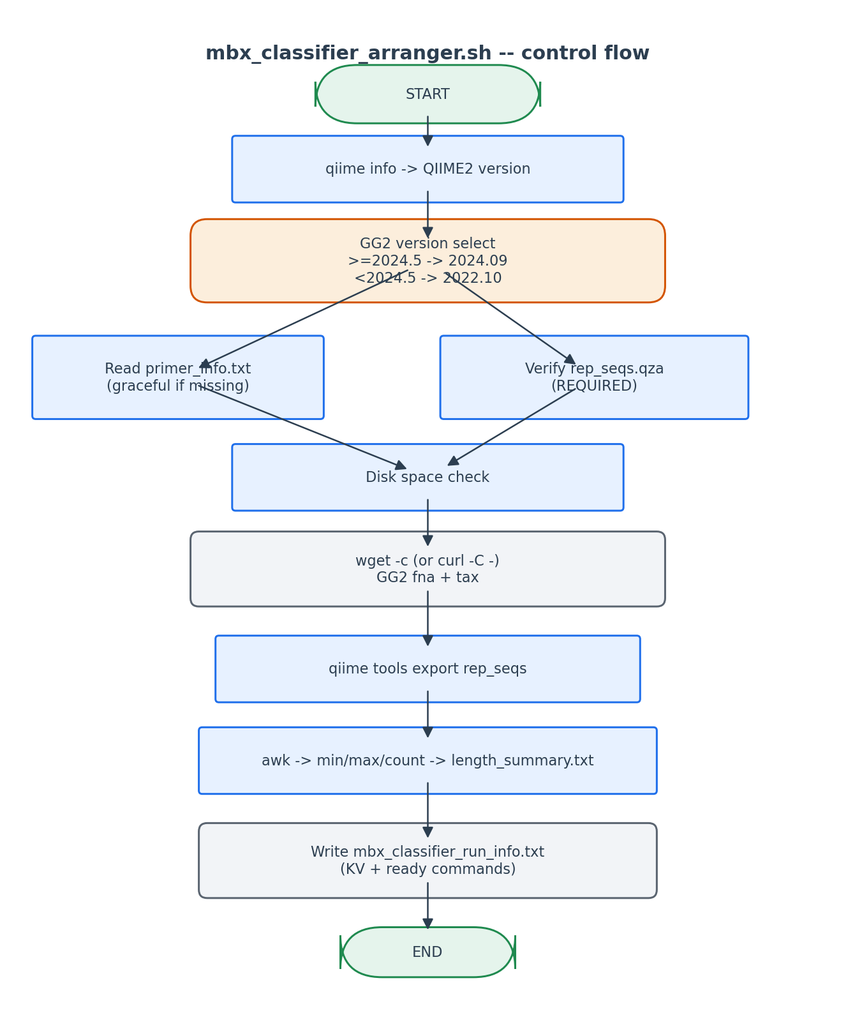
Decisions are made up-front (versions, paths) so step 6 has a deterministic plan.

6. Edge cases and caveats

QIIME2 version cannot be parsed
Defaults to 2025.4 -> picks GG2 2024.09. The user can always override with --gg2-version.

Primer info file missing or DETECTION_STATUS=TRIMMED/UNKNOWN
FWD_PRIMER/REV_PRIMER are set to 'None' and CLASSIFIER_MODE is set to 'full-length'. The Step A extract-reads block in run_info.txt becomes an 'AUTO-SKIPPED' note. Step 6 reads CLASSIFIER_MODE and trains Naive-Bayes directly on the full GG2 backbone -- no user intervention. The pipeline runs end-to-end without error.

Existing GG2 download in target dir
The download function checks `[[ -f "$dest" ]]` first. Idempotent re-run: re-uses the previous download.

`df` output format differs across BSD/GNU
We use -k for portability (kilobytes) and parse `awk 'NR==2 {print $4}'`. Tested on macOS BSD df and Linux GNU df.

7. Implementation notes

Why this script and not just bake commands into step 6?
Separating 'plan' from 'execute' makes the pipeline auditable: a researcher can read mbx_classifier_run_info.txt and verify every parameter without running the slow training step. It also makes the trained classifier reusable across projects with the same primers + GG2 version.

Resumable downloads
wget -c re-uses partial downloads byte-for-byte via HTTP Range requests. Curl --continue-at - has the same effect. Both honour the GG2 server's Last-Modified+If-Range semantics.

8. Testing checklist
Things to verify before considering this script production-ready:
- Run with QIIME2 2025.4 active -> verify GG2 2024.09 is selected.
- Pre-create empty GG2 .qza files -> verify --skip-download mode picks them up.
- Hand-delete primer_info.txt -> verify run_info.txt has CLASSIFIER_MODE=full-length and an 'AUTO-SKIPPED' Step A note pointing at the full backbone for Step B.
- Run with --dry-run -> verify no downloads, no FASTA export.
- Verify length_summary.txt min/max match the actual rep_seqs.fasta lengths.

