
mbX Pro -- internal technical reference
Step 6
mbx_classifier_run.sh
Train a Naive Bayes classifier on a primer-extracted GG2 region, then classify ASVs
Pipeline step 6 -- one of the longest (20-90 min) but fully cacheable.

1. Purpose and scope
Execute the taxonomy classification plan that step 5 wrote into mbx_classifier_run_info.txt. Two operating modes are supported, auto-selected from the CLASSIFIER_MODE field of the run-info file:
* CLASSIFIER_MODE=region-specific (the default when both primers are known): extract amplicon-region GG2 reads, train a Naive Bayes classifier on those reads, then classify the user's ASVs. This is slightly more precise at species level.
* CLASSIFIER_MODE=full-length (auto-selected when primers are absent -- typically because the sequencing facility trimmed them before delivery, or because primer detection failed): extract-reads is SKIPPED entirely; Naive-Bayes is trained directly on the full Greengenes2 backbone; the user's ASVs are then classified as usual.
The script is fully idempotent in BOTH modes -- any of the existing artifacts is reused. The dual-mode design is what makes the pipeline robust to the very common case of pre-trimmed primers.

2. Inputs and outputs

2.1 Inputs (data structures)
Name | Source | Format | Required
<mbX_pro_outputs_dir> | User CLI | Directory containing 5_classifier_working_dir/ | yes
--classifier <path> | User flag | Pre-built .qza classifier (skip extract+train) | no
--confidence F | User flag | Naive Bayes posterior probability cutoff (default 0.7) | no
--force-extract / --force-train / --force-classify | User flags | Boolean toggles to overwrite existing outputs | no
--skip-extract | User flag | Boolean | no

2.2 Outputs (data structures)
Path (relative to output dir) | What it contains | Read by
5_classifier_working_dir/gg2_extracted_reads.qza | Region-trimmed GG2 reference (region-specific mode only; REUSABLE) | step 6 fit-classifier
5_classifier_working_dir/gg2_trained_classifier.qza | V-region NB classifier (region-specific mode; REUSABLE) | step 6 classify-sklearn
5_classifier_working_dir/gg2_full_length_trained_classifier.qza | Full-length NB classifier (full-length mode; REUSABLE across ANY primer set) | step 6 classify-sklearn
6_classifier_taxonomy/taxonomy.qza | FeatureData[Taxonomy] -- per-ASV taxonomy + confidence | step 7 (tax csv export)
6_classifier_taxonomy/taxonomy.qzv | Tabulated taxonomy | report

2.3 Downstream consumers
These steps depend on this script's outputs:
- Step 7 reads taxonomy.qza for `qiime taxa filter-table` (mito/chloro removal) and `qiime taxa barplot`.
- Step 14 (ANCOMBC2), 15 (PICRUSt2), 17 (networks) read the level-*.csv files derived from this taxonomy.

3. Complete parameter reference
Idempotency flags are the heart of this script -- each major step has a per-step on-disk sentinel.
Parameter | Default | Decision rule / where it comes from
--classifier PATH | (unset) | Use a pre-built classifier .qza directly. Skips both extract-reads and fit-classifier-naive-bayes. Useful when reusing a classifier from a previous project (same primers + GG2 version).
--confidence F | 0.7 | qiime feature-classifier classify-sklearn --p-confidence. Posterior probability threshold above which a taxonomic label is assigned. 0.7 = QIIME2 default. Lower (0.5-0.6) yields more assignments at the cost of more false positives. Higher (0.8-0.9) yields fewer but more reliable assignments.
--force-extract | off | Re-run extract-reads even if gg2_extracted_reads.qza exists (e.g. primer changed).
--force-train | off | Re-run fit-classifier-naive-bayes even if gg2_trained_classifier.qza exists.
--force-classify | off | Re-run classify-sklearn even if taxonomy.qza exists.
--skip-extract | off | Skip extract-reads (use existing gg2_extracted_reads.qza or pre-built --classifier).

4. Algorithm walkthrough

4.1 Read run-info file
Every parameter (GG2 paths, primer sequences, ASV length range, output paths) is read from `5_classifier_working_dir/mbx_classifier_run_info.txt` via the _read_key() helper. This is the contract that lets step 5 plan and step 6 execute.

4.2 Idempotency engine
For each of the three major steps, the rule is the same:
if [[ -f "$OUTPUT_QZA" ]] && ! $FORCE_FLAG; then
skipped "step name"
else
qiime ... --o-... "$OUTPUT_QZA"
fi
Each skip prints a [SKIP] line with the existing file path. Power users can `rm` a single artifact to re-run only that step.

4.3 Extract-reads (region-specific mode only)
When CLASSIFIER_MODE=region-specific, qiime feature-classifier extract-reads trims the full-length GG2 backbone to amplicons matching --p-f-primer + --p-r-primer, with min/max length filters.
When CLASSIFIER_MODE=full-length the script branches early: SKIP_EXTRACT is forced to true, this entire step is bypassed, and Step 4.4 below points at the full backbone instead.

4.4 Fit Naive Bayes (mode-aware)
qiime feature-classifier fit-classifier-naive-bayes trains a multinomial NB on k-mer features.
Region-specific mode: --i-reference-reads is gg2_extracted_reads.qza (the V-region trim from step 4.3). Runtime 20-60 min, classifier .qza ~500 MB - 1 GB.
Full-length mode: --i-reference-reads is the full GG2 backbone .fna.qza directly. Runtime 30-90 min, classifier .qza ~1.5-3 GB. Both modes use 8-16 GB RAM. Both classifiers are reusable across projects -- the full-length one is reusable across ANY primer set; the region-specific one is reusable only for matching primers + GG2 version.
if [[ "$CLASSIFIER_MODE" == "full-length" ]]; then
REF_QZA="$GG2_FNA_QZA" # full backbone, no extract step
else
REF_QZA="$EXTRACTED_QZA" # V-region trimmed
fi
qiime feature-classifier fit-classifier-naive-bayes \
--i-reference-reads "$REF_QZA" \
--i-reference-taxonomy "$GG2_TAX_QZA" \
--o-classifier "$TRAINED_QZA"

4.5 Classify-sklearn
qiime feature-classifier classify-sklearn applies the trained model to the user's representative_sequences.qza. --p-n-jobs is set to the auto-detected core count. --p-confidence defaults to 0.7.

4.6 Tabulate taxonomy
qiime metadata tabulate produces a clickable QZV. This is the only one of the four artifacts that ALWAYS gets re-tabulated when --force-classify fires (cheap to regenerate).

5. Flow diagram
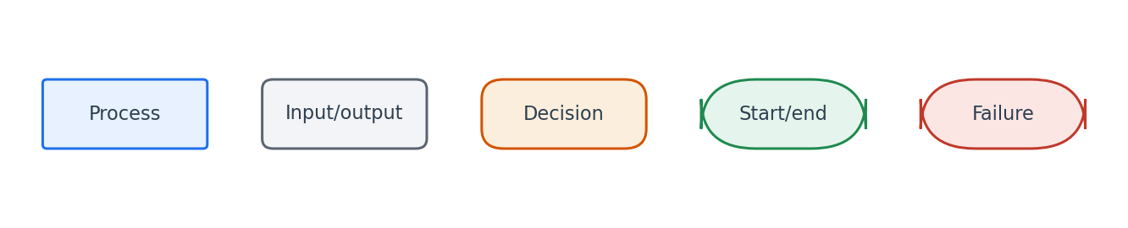
Flowchart symbol legend (used in every chapter).
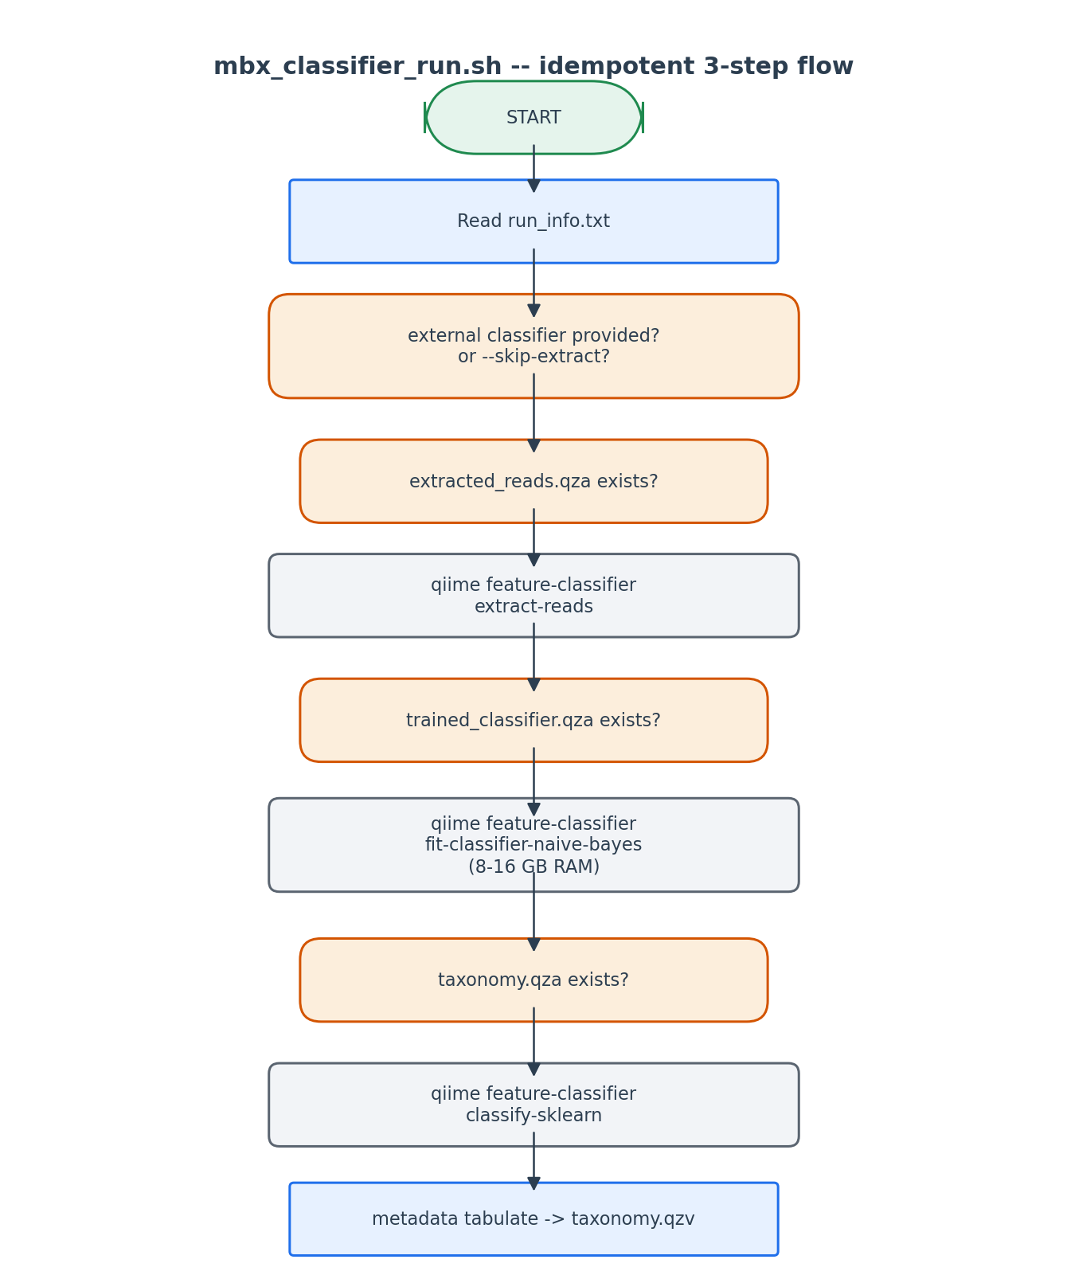
Each artifact is checked on disk before being recomputed. Force flags override.

6. Edge cases and caveats

Primers are 'None' but no --classifier provided
The script aborts with a list of three options for the user, including a clickable URL for the pre-built GG2 V4 classifier.

Memory error during fit-classifier
Naive Bayes feature counting needs >> the size of the reference alone. We document the 8-16 GB requirement up-front. If the user's machine cannot accommodate, the only workaround is a pre-built classifier.

Stale extracted_reads.qza vs new primers
If the user re-runs step 5 with different primers but doesn't pass --force-extract here, the old extracted reads are reused. Mitigation: --force-extract is documented prominently.

7. Implementation notes

Reusability of intermediates
extracted_reads.qza and trained_classifier.qza live in 5_classifier_working_dir/, NOT in the per-run output. This intentionally invites cross-project reuse: copy that directory to a new project's mbX_pro_outputs and step 6 will skip extract+train automatically.

Confidence threshold rationale
0.7 is QIIME2's default and matches Bokulich et al. 2018 Mol Ecol Resour benchmarks. We expose --confidence so users running comparison studies can match their lab's previous setting.

8. Testing checklist
Things to verify before considering this script production-ready:
- Run with all artifacts absent -> verify all 3 commands run.
- Re-run -> verify all 3 are skipped.
- Re-run with --force-classify -> verify only classify-sklearn runs.
- Run with --classifier <prebuilt.qza> -> verify extract+train both skipped.
- Run with primers='None' and no --classifier -> verify the 3-option error fires.

