
mbX Pro -- internal technical reference
Step 7
mbx_taxonomy_run.sh
Filter mitochondria/chloroplasts, build bar plot, export 7 level CSVs
Pipeline step 7 -- the taxonomy table-formatting bridge.

1. Purpose and scope
Convert the QIIME2 .qza taxonomy + feature table into the seven level-*.csv files that the mbX R package consumes. Filter mitochondria + chloroplasts before bar-plotting (critical for plant/soil samples) and emit the canonical filtered feature table that every downstream step uses.

2. Inputs and outputs

2.1 Inputs (data structures)
Name | Source | Format | Required
<mbX_pro_outputs_dir> | User CLI | Directory containing 6_classifier_taxonomy/ | yes
<metadata.txt> | User CLI | QIIME2 metadata | yes
--exclude TERMS | User flag | Comma-separated taxa names (default: mitochondria,chloroplast) | no
--skip-filter | User flag | Boolean (do NOT filter) | no

2.2 Outputs (data structures)
Path (relative to output dir) | What it contains | Read by
7_taxonomy_csv/feature_table_filtered.qza | Mito/chloro-removed FeatureTable[Frequency] | every later step (alpha/beta/ANCOMBC/PICRUSt/...)
7_taxonomy_csv/taxa_bar_plots.qzv | Multi-level bar plot QZV | report + 8/9/10 R steps
7_taxonomy_csv/level-1.csv ... level-7.csv | Wide-format absolute counts (sample-id rows, taxon columns) | step 8 (ezclean), 9 (ezviz), 10 (ezstat), 16 (ML), 17 (networks)
7_taxonomy_csv/mbx_taxonomy_info.txt | K=V file with all paths + R usage examples | step 8 onwards

2.3 Downstream consumers
These steps depend on this script's outputs:
- Steps 8/9/10 use the level CSVs as direct input to mbX::ezclean/ezviz/ezstat.
- Step 11 reads feature_table_filtered.qza for tree+depth selection.
- Step 14 collapses the filtered table at multiple levels for ANCOMBC2.

3. Complete parameter reference
Parameter | Default | Decision rule / where it comes from
--exclude TERMS | mitochondria,chloroplast | Pass-through to qiime taxa filter-table --p-exclude. Comma-separated, partial-match (any taxon string containing this substring at any level is dropped).
--skip-filter | off | Bypass filtering -- only useful when the user has confirmed there is no host or plastid contamination.

4. Algorithm walkthrough

4.1 Auto-discover inputs
FEATURE_TABLE_QZA is read from 5_classifier_working_dir/mbx_classifier_run_info.txt. taxonomy.qza is taken from 6_classifier_taxonomy/. The user only supplies the metadata.txt path explicitly because it was never stored in the run_info file (intentional -- metadata path is project-specific).

4.2 Metadata header validation
Same logic as step 4: first column header must match the QIIME2-valid set. We pre-check before invoking qiime to surface the error in seconds.

4.3 Filter mitochondria + chloroplasts
qiime taxa filter-table is called with --p-exclude. This drops any feature whose taxonomy string contains 'mitochondria' or 'chloroplast' at ANY level. The result is feature_table_filtered.qza. Idempotent: if the file exists we skip.
WHY this matters: in plant/soil samples, mitochondrial and plastid 16S can constitute 30-70% of reads. Without filtering, relative abundance plots are dominated by these eukaryotic sequences, and downstream stats become uninterpretable.

4.4 Bar plot generation
qiime taxa barplot consumes the filtered table + taxonomy + metadata. Output is a single QZV that contains relative-abundance bar charts at every taxonomic level. The same QZV exports cleanly to 7 level-*.csv files.

4.5 Level-CSV export
qiime tools export on the bar-plot QZV produces level-1.csv ... level-7.csv (named by the QIIME2 taxa-barplot internals). Each CSV is a wide table: rows = samples, columns = taxa at that level + a column per metadata variable. The `cp` step moves them out of the staging subdir into the canonical `7_taxonomy_csv/` directory.
If a level cannot be exported (e.g. taxonomy did not reach species level for any feature), a warning fires but the pipeline proceeds. LEVELS_PRESENT is reported.

4.6 Info-file emission
mbx_taxonomy_info.txt records the rank of each level (1=Domain, 2=Phylum, ..., 7=Species), every CSV path, and inline R usage examples. Steps 8+ rely on this file to find inputs.

5. Flow diagram
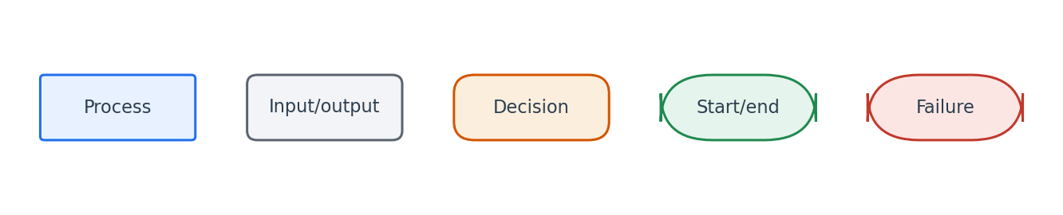
Flowchart symbol legend (used in every chapter).
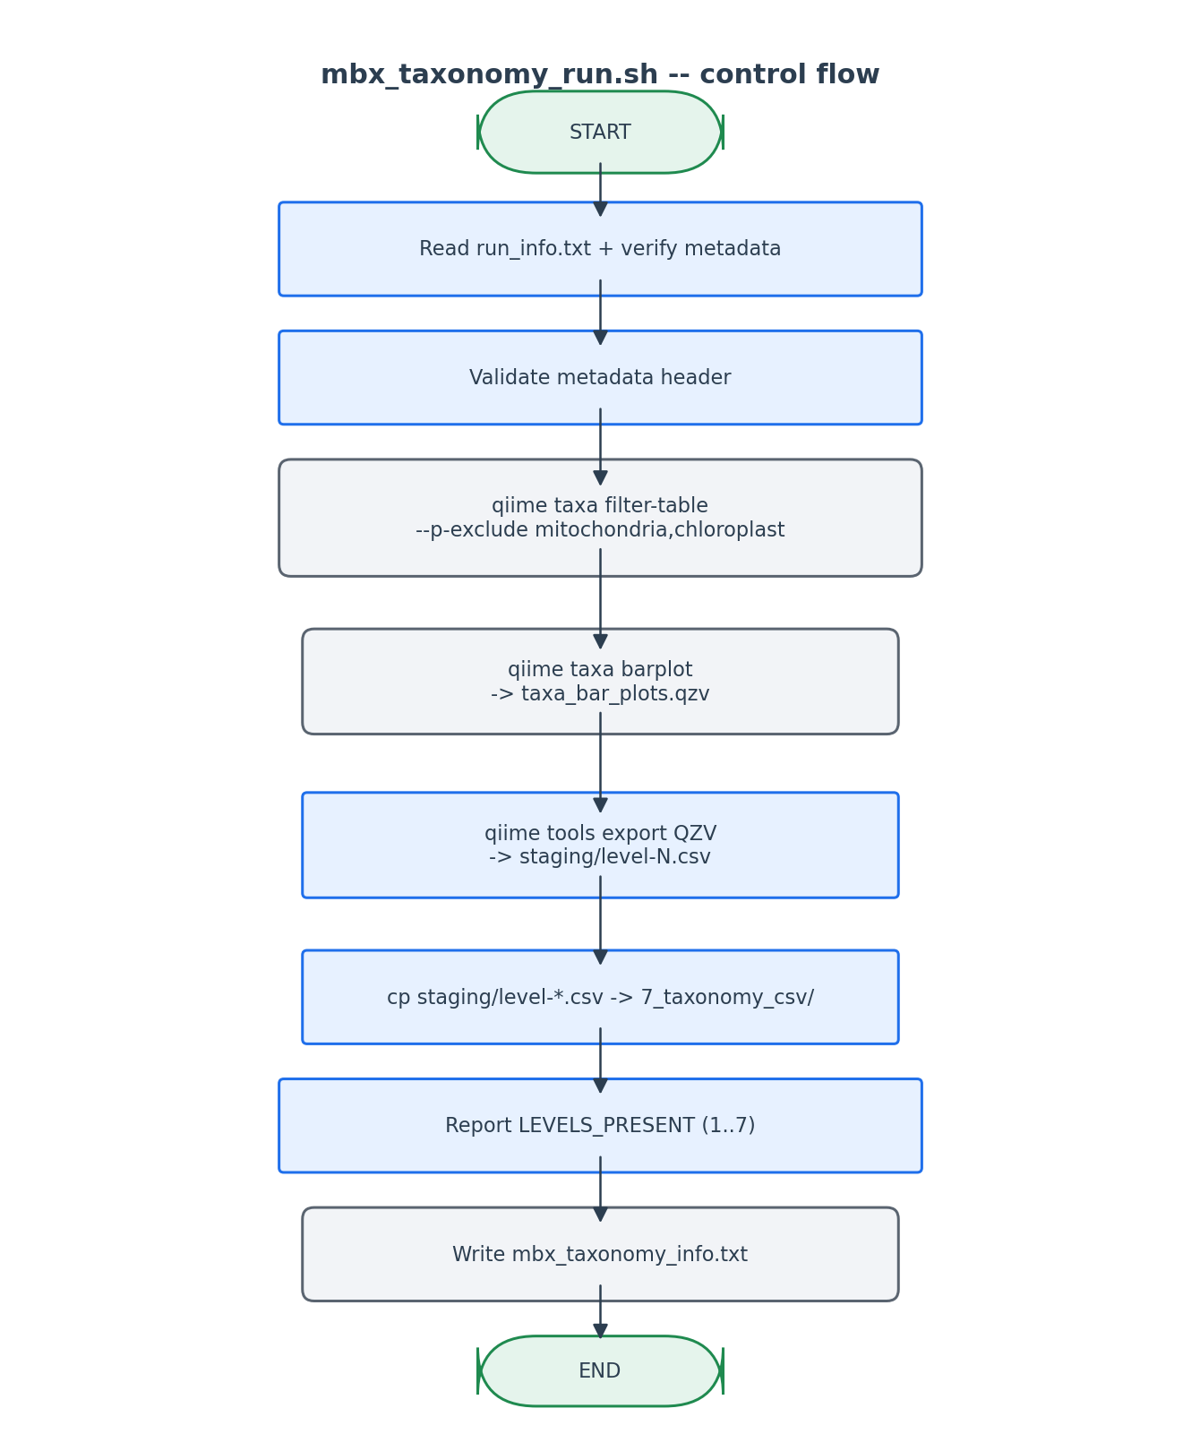
The barplot QZV is the universal source from which all 7 level CSVs derive.

6. Edge cases and caveats

Sample IDs in feature table absent from metadata
qiime taxa barplot will fail with 'No sample data shared'. We pre-validate metadata header but do NOT do a full sample-ID intersection -- that would be redundant since QIIME2's error is clear.

Custom taxa exclusion list
--exclude lets users add 'unassigned' or 'eukaryota' in addition to the default. Each term is partial-matched against the full taxonomy string.

Less than 7 levels exported
Some classifiers (e.g. SILVA) commonly stop at level 6. The script tolerates missing higher levels with a per-level warning. Subsequent scripts (8/9/10) loop over [1..7] but skip missing files.

7. Implementation notes

Why the bar plot is the source of truth for level CSVs
QIIME2 stores per-level CSVs as files INSIDE the .qzv. There is no `qiime taxa collapse` -> `feature-table summarize` -> CSV path that produces the exact same format. Going via the barplot QZV is the supported, idiomatic route.

filtered table as the canonical input downstream
Every later step preferentially reads `7_taxonomy_csv/feature_table_filtered.qza` if it exists. This is captured explicitly in step 11's auto-discovery logic.

8. Testing checklist
Things to verify before considering this script production-ready:
- Run with default exclusion -> verify mitochondria/chloroplast features dropped (compare counts in feature_table.qza vs feature_table_filtered.qza).
- Run with --skip-filter -> verify the unfiltered table is used for the bar plot.
- Run with metadata containing fewer samples than the feature table -> verify QIIME2's actual error message is surfaced.
- Verify level-6.csv (genus) opens cleanly in mbX::ezclean("...", "metadata.txt", "g").

