
mbX Pro -- internal technical reference
Step 8
mbx_ezclean_all_levels.sh
Install mbX R package, run ezclean() for all 7 taxonomic levels
Pipeline step 8 -- the first R-based step. Establishes the system-R environment.

1. Purpose and scope
Run mbX::ezclean() once per taxonomic level (1-7). ezclean() takes the QIIME2-exported level-7.csv (which contains the full taxonomy string) and produces one cleaned, taxonomically-deduplicated XLSX per level. This script also bootstraps the entire R environment for subsequent R-based steps (9, 10, 12, 13, 14, 15, 16, 17, 18).

2. Inputs and outputs

2.1 Inputs (data structures)
Name | Source | Format | Required
<mbX_pro_outputs_dir> | User CLI | Directory containing 7_taxonomy_csv/ | yes
7_taxonomy_csv/level-7.csv | Auto-discover | Wide-format CSV with full taxonomy strings | yes
metadata.txt | Auto-discover (path stored in mbx_taxonomy_info.txt) | QIIME2 metadata | yes
--levels LIST | User flag | Subset to clean (default: d,p,c,o,f,g,s -- all) | no
--skip-install | User flag | Boolean (assume mbX already installed) | no

2.2 Outputs (data structures)
Path (relative to output dir) | What it contains | Read by
8_cleaned_files/mbX_cleaned_<plural>_level-7/<plural>_level-7.xlsx | ezclean output for each level (one per level) | step 9, 10, 16, 17
8_cleaned_files/mbx_ezclean_info.txt | K=V mapping level letter -> XLSX path | step 9, 10, 16, 17, 18

2.3 Downstream consumers
These steps depend on this script's outputs:
- Steps 9 (ezviz) and 10 (ezstat) call mbX::ezviz() / mbX::ezstat() which internally re-run ezclean() on the same input.
- Steps 16 (ML) and 17 (networks) read these XLSX files directly via openxlsx.

3. Complete parameter reference
Parameter | Default | Decision rule / where it comes from
--levels LIST | d,p,c,o,f,g,s | Comma-separated single-letter codes. Each letter maps to one level (d=Domain, p=Phylum, c=Class, o=Order, f=Family, g=Genus, s=Species).
--skip-install | off | Skip the R-package install step. Useful for HPC where root cannot write to /usr/local/R.

4. Algorithm walkthrough

4.1 The system-R discovery + env-stripping pattern
mbX is installed via Homebrew R (system-wide), NOT inside the QIIME2 conda env. Installing R inside conda corrupts QIIME2's Python ABI. But running this script INSIDE the conda env (typical user pattern) means conda's R_LIBS_USER and R_HOME poison the system R.
The mitigation, used by every R-based step in the pipeline, is the `_R` wrapper:
_R() {
env -u R_LIBS_USER -u R_LIBS -u R_HOME -u R_INCLUDE_DIR \
-u R_DOC_DIR -u R_SHARE_DIR -u R_PROFILE -u R_PROFILE_USER \
"$RSCRIPT_CMD" "$@"
}
This strips every R_* variable. The system R then searches its own .libPaths() correctly. Errors like "shared object 'methods.dylib' not found" or "Rcpp.so not found" disappear.

4.2 Rscript discovery preference order
1) /opt/homebrew/bin/Rscript (Apple Silicon Homebrew). 2) /usr/local/bin/Rscript (Intel macOS Homebrew). 3) /usr/bin/Rscript (system R on Linux). 4) `command -v Rscript` as a last-resort fallback. Absolute paths come first specifically to avoid `command -v` returning conda's R inside an active env.

4.3 R package installation
Required packages: mbX (CRAN), openxlsx, ggplot2, dplyr, tidyr, stringr, dunn.test. The script writes a temp R script (PID-based filename to avoid macOS mktemp .R-suffix bug), runs `_R "$TMP_R"`. Inside the R script, install.packages() is called for any missing package via setdiff(required, installed.packages()[,'Package']).

4.4 ezclean() invocation
For each level letter L:
- Compute the matching plural name (d->domains_or_kingdom, p->phylum, c->classes, o->orders, f->families, g->genera, s->species).
- Compute the output sub-dir: `8_cleaned_files/mbX_cleaned_<plural>_level-7/`.
- Write a temp R script that setwd()s to `8_cleaned_files/` (CRITICAL -- ezclean writes intermediate files to cwd) and calls `mbX::ezclean(level_7_csv, metadata_txt, L)`.
- Invoke `_R` with the temp script.
- Verify the expected XLSX appeared.
Each level runs in an INDEPENDENT R session. This means a failure at level 's' (species) does not abort levels 'd' through 'g'.

4.5 Info file emission
After all 7 levels (or the user-selected subset), the script writes `mbx_ezclean_info.txt` with one CLEANED_<LETTER>=<absolute_path> line per level. Steps 9, 10, 16, 17 read these to locate XLSX inputs without globbing the directory.

5. Flow diagram
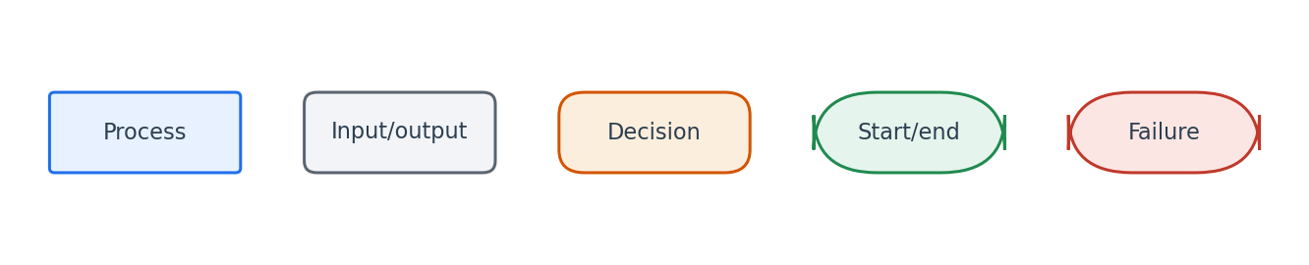
Flowchart symbol legend (used in every chapter).
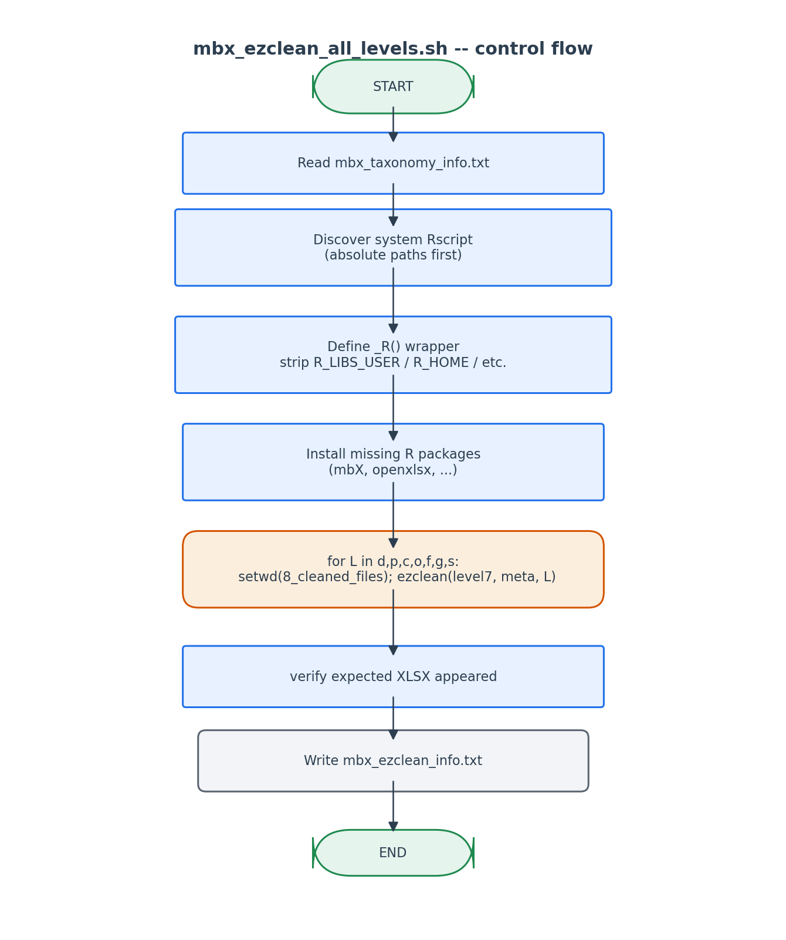
Each level runs in its own R session so failures isolate.

6. Edge cases and caveats

level-7.csv has fewer than 7 levels populated
ezclean()'s level argument controls how the taxonomy string is parsed; even if level-1.csv is the only file present, we ALWAYS pass level-7.csv because it carries the full string. ezclean parses based on the requested rank, not the file.

R installation needed but no admin access
The script tries `Rscript -e 'install.packages(...)'` first. install.packages defaults to a user-writable lib path on macOS Homebrew. If that fails (HPC), the user must `--skip-install` and pre-install packages via the system administrator.

conda's Rscript shadows system Rscript
Mitigated by the absolute-path preference order. Even if conda's Rscript appears first in PATH, our discovery picks the system one.

7. Implementation notes

Why level-7.csv is the input for every level
level-7.csv is the only CSV that preserves the FULL taxonomy string (Domain;Phylum;...;Species) per ASV. ezclean parses this string to whatever depth the user requested. level-2.csv (Phylum-only) does NOT have enough information to produce a Genus-level cleaned output.

setwd() before ezclean()
ezclean writes ~12 intermediate XLSX files relative to the current working directory, then deletes them. Running it from the wrong cwd litters the user's home directory. We always setwd() to 8_cleaned_files/ first.

8. Testing checklist
Things to verify before considering this script production-ready:
- Run with all 7 levels -> verify 7 XLSX files in 7 sub-directories.
- Run with --levels g -> verify only the genus XLSX is produced.
- Hand-corrupt one level (rename the file) -> verify only that level's R session fails, others succeed.
- Inspect mbx_ezclean_info.txt and verify all reported paths exist.
- Run inside an active conda env -> verify _R wrapper successfully avoids 'methods.dylib not found'.

