604:-COMPUTER GRAPHICS
- discuss application of computer graphics?
- Computer graphics is the part of computer science that studies methods for manipulating visual content although computer graphics deals with 3D graphics, 2D graphics, and image processing. It also deals with the creation, manipulation, and storage of different types of images and objects.
- Computer graphics play a crucial role across various fields, offering innovative ways to create, visualize, and interact with data.
- There are some of the applications of computer graphics are described below.:-
- Education: Computer-generated models are extremely useful for teaching huge number of concepts and fundamentals in an easy-to-understand and learn manner. Using computer graphics many educational models can be created through which more interest can be generated among the students regarding the subject.
- Training: Specialised systems for training like simulators can be used for training the candidates in a way that can be grasped in a short span of time with better understanding. The creation of training modules using computer graphics is simple and very useful.
- Image Processing: Various kinds of photographs or images require editing in order to be used in different places. Processing of existing images into refined ones for better interpretation is one of the many applications of computer graphics.
- Graphical User Interface: The use of pictures, images, icons, pop-up menus, and graphical objects helps in creating a user-friendly environment where working is easy and pleasant, using computer graphics we can create such an atmosphere where everything can be automated and anyone can get the desired action performed in an easy fashion.
- Entertainment: Computer graphics find a major part of its utility in the movie industry and game industry. Used for creating motion pictures, music videos, television shows, and cartoon animation films. In the game industry where focus and interactivity are the key players, computer graphics help in efficiently providing such features.
- Designing: Designing buildings, automobiles, and aircraft is done with the help of computer-aided drawing, this helps in providing minute details to the drawing and producing more accurate and sharp drawings with better specifications.
- Computer Art: Using computer graphics we can create fine and commercial art which includes animation packages, and paint packages. These packages provide facilities for designing object shapes and specifying object motion. Cartoon drawings, paintings, and logo designs can also be done.

- Explain Flat Panel Display in Detail?
- A Flat Panel Display (FPD) is a lightweight, thin-screen technology used in devices like televisions, computers, smartphones, and other electronic gadgets. It has largely replaced traditional bulky cathode ray tube (CRT) displays due to its compact size, energy efficiency, and improved performance.
- Flat panel displays can be categorized into two main types.
- Emissive Displays
- Non-Emissive Displays
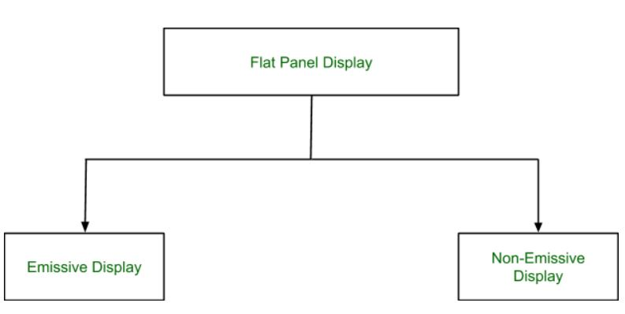
- Emissive Displays:- Emissive displays generate light directly from the pixels. They do not require a backlight as the image is produced by the pixel elements themselves.
- Plasma Displays − These use small cells containing electrically charged ionized gases (plasma) to produce images. Plasma displays are known for producing contrasting colors and deep blacks. This makes them suitable for high-quality television displays.
- Organic Light Emitting Diode (OLED) − OLED screens are composed of organic compounds that emit light when an electric current is applied. They offer vibrant color reproduction and high contrast. OLED displays are thinner, more flexible, and provide better picture quality than other display types.
- Non-Emissive Displays:- Non-emissive displays rely on external light sources, usually a backlight, to illuminate the screen.
- Liquid Crystal Display (LCD) − LCD is perhaps the most commonly used flat panel technology. It consists of liquid crystals in between two layers of glass. These crystals do not emit light but rather manipulate light from a backlight to create images. LCD displays are energy-efficient and widely used in smartphones, computer monitors, and TVs.

- What is 2D viewing pipeline ? Derive its transformation matrix.
- ✅ 2D Viewing Pipeline in Computer Graphics
- The 2D viewing pipeline is the process used in computer graphics to convert 2D world coordinate descriptions of objects into screen coordinates for visualization on a display device. This process determines what to display (viewing region) and where to display it (on the screen).

- 📌 Stages of the 2D Viewing Pipeline
- Modeling Coordinates (World Coordinates)
→ Coordinates in which objects are originally defined.
- World-to-Window Transformation
→ Define a window: a rectangular portion of the scene (in world coordinates) that you want to display.
- Window-to-Viewport Mapping
→ Define a viewport: a rectangular region on the display device where the contents of the window will be shown.
- Coordinate Mapping (Transformation)
→ Transform the window (in world coordinates) into the viewport (in device/screen coordinates).

- Explain 3D display methods in detail in CG
- In computer graphics (CG), 3D viewing methods are techniques used to render and visualize three-dimensional objects and scenes. Here are some common methods:
- Perspective Projection: Mimics human vision by projecting 3D objects onto a 2D plane using lines that converge at a vanishing point, creating a sense of depth.
- Orthographic Projection: Projects 3D objects onto a 2D plane without perspective distortion, maintaining parallel projection lines for accurate scaling and proportions.
- Stereoscopic Viewing: Uses two slightly different images (one for each eye) to simulate binocular vision, creating a 3D effect when viewed with specialized glasses or displays.
- Anaglyphic 3D: Combines two images in different color channels (typically red and cyan) to create a stereoscopic effect, viewed with color-filtering glasses.
- Parallax Barrier and Lenticular Displays: Provides a glasses-free 3D viewing experience by using barriers or lenses to send slightly different images to each eye.
- Head-Mounted Displays (HMDs): Common in VR environments, these devices immerse users in a 3D world by displaying stereo images directly to their eyes.
- Volumetric Displays: Projects light into a medium (e.g., mist, glass) to create holographic 3D images that can be viewed from multiple angles.
- Do any of these intrigue you? Or perhaps you want to explore one in more depth?
- Explain Exterior clipping and its applications in CG
- Exterior clipping is a technique used in 2D computer graphics to remove or exclude the parts of objects that fall outside a specified region. Unlike interior clipping, which keeps what's inside a region, exterior clipping removes the interior and keeps only what's outside.

- Exterior clipping is a technique in computer graphics where the parts of objects inside a defined clipping window are removed, while the parts outside the window are retained. This is the opposite of traditional clipping, which keeps the visible portions inside the window and discards the rest.
- Applications of Exterior Clipping
- Highlighting Specific Areas: It is used to emphasize or isolate parts of a scene by removing the interior details and focusing on the exterior.
- Creating Visual Effects: Exterior clipping can be applied to generate unique visual effects, such as silhouettes or outlines of objects.
- Data Visualization: In scenarios like geographical mapping or scientific visualization, exterior clipping helps in excluding unnecessary details within a region of interest.
- Architectural Design: It is useful in rendering external views of structures by clipping out the interiors.
- Game Development: Exterior clipping is employed to manage rendering performance by excluding interior details that are not visible to the player.
- Heads-Up Displays (HUDs)
  - Ensuring that certain screen overlays (like health bars) don’t interfere with interactive regions.
- Privacy Masking
  - Hiding sensitive parts of a scene (e.g., blurring faces in surveillance).
- Graphics Masking / Cutout Effects
  - Creating artistic effects like “cutout” text or holes in images.
- Focus View in Editors
  - Fading or removing background content while focusing on one region.
- Map and UI Design
  - Preventing annotations or icons from appearing over specific areas.
- Simulation and Virtual Environments
  - Hiding the simulation core or a restricted zone in visualization.
- Explain Cohen-suthrelandline clipping algorithm
 