**Project 3: Color Segmentation**.

ENPM 673, Robotics Perception

Utsav V Patel

UID – 115816756

Following are the steps that I took to complete this project

1. **Part 0 :- Data Preparation and Vanilla Approach-**

Here, in this step, the video ‘detectbuoy.avi’ which was taken by an underwater camera is broken into frames. The frames are then divided into training and test frames. I have chosen 40 frames as a training frames and 180 frames as test frames. The colored buoys from the training frames are extracted and saved into cropped images folder. The training frames are used to get the parameters of the gaussian model and the test frames are used to test the performance of the model. Training frame and cropped buoy are shown in figure(1) and figure (2) respectively.

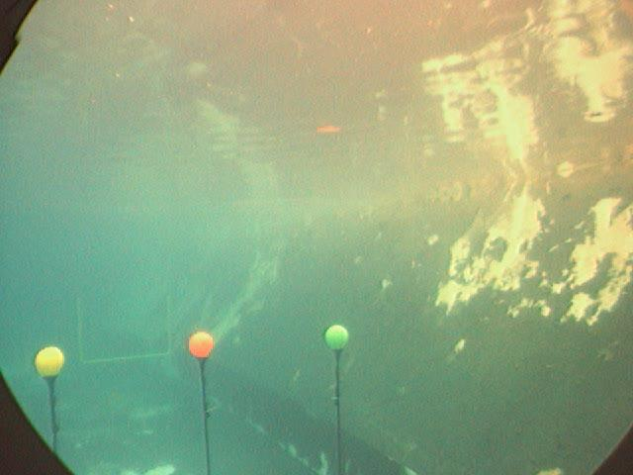

Figure(1) – Extracted frame



Figure(2) Cropped color sample of a green buoy

After extracting cropped buoys, average histograms for each color channel is found and plotted. The script which is used to plot the extract the histogram is named ‘averagehistogram.m’. The average histograms for each colored object are shown in figure (3), figure(4) and figure(5).

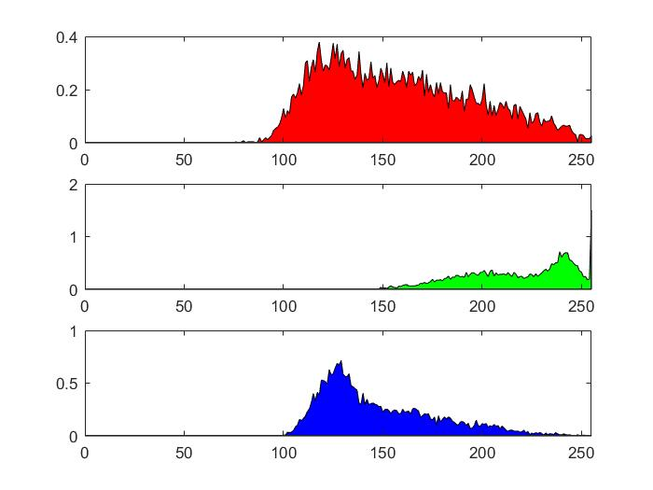

Figure(3) Histogram for green colored buoy

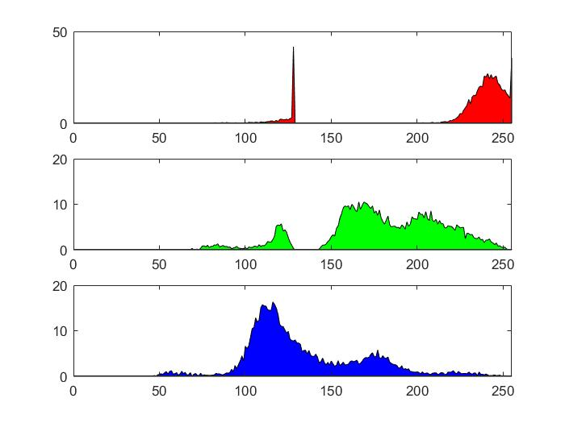

Figure(4) Histogram for Red buoy

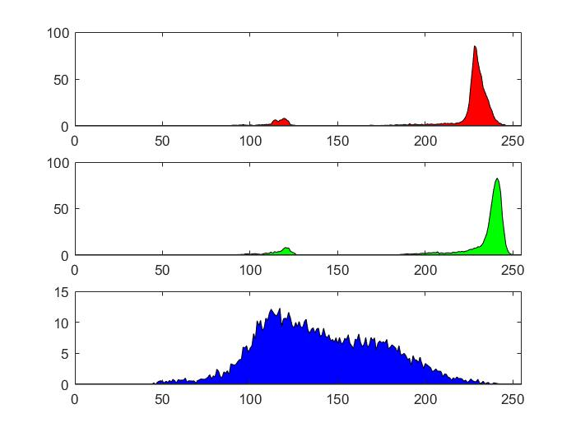

Figure(5) Histogram for Yellow Buoy

By observing the histograms we can observe that in the Green colored buoy, the pixels with green intensity more than 240 are in large number, in the same manner the red buoy has more number of pixels with higher red intensity pixels and yellow buoy has more pixels with high red intensities and green intensities.

After getting this histogram, I tried to fit a 1D Gaussian for each colored buoy. The script which performs this task is named as ‘estimateparam.m’. The figure(6) shows the histograms.

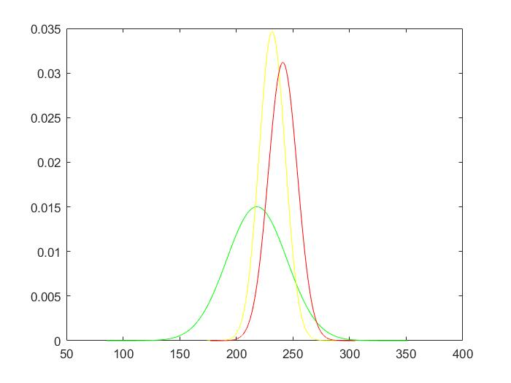

Figure (6) histograms for each colored buoy

The histogram and the intensity values are used to detect the buoys. The script is run on the test frames and the probability for each pixel is calculated. According to the histograms the threshold value for green color is kept at 250, for red color it is kept at 240 and for yellow buoy it kept at the average of the red and green threshold values. (Note – In scripts, I have directly extracted the frames from the video).

The frame showing detected buoys is shown in figure (7).

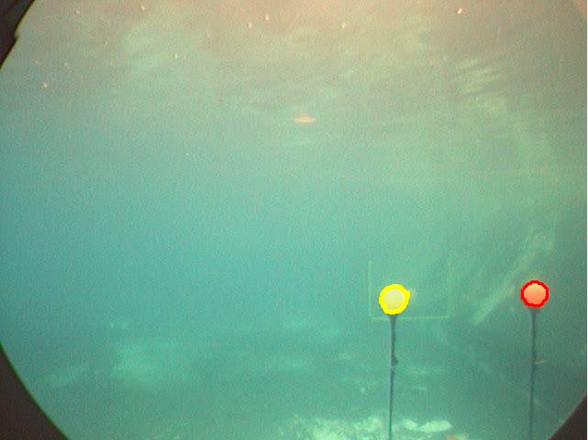

Figure (7) Frame with detected buoys

1. **Part 1:- Gaussian Mixture Models and Maximum Likelihood Algorithm –**

In this part 3 1D Gaussians are plotted for different mean and standard deviations. The EM method is implemented to recover the model parameters. The figure (8) shows the 3 1D gaussians.

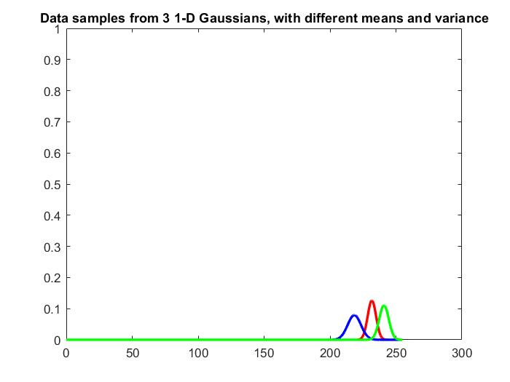

Figure (8) 3 1D gaussians

The same method was applied to plot the 4 1D gaussians, the plot for 4 gaussians is shown in figure (9).

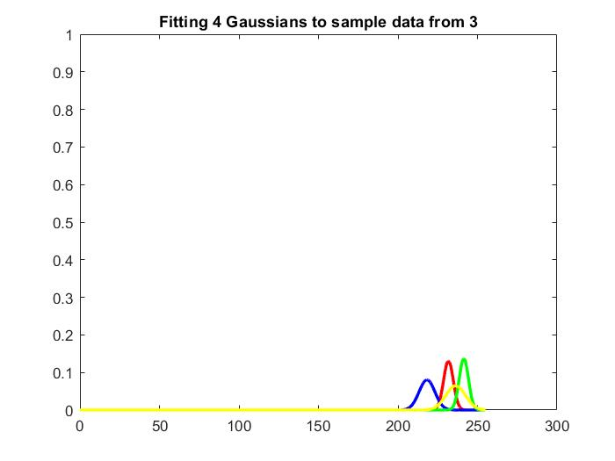

Figure (9) 4 1D gaussians

1. **Part 2:- Color Model L earning-**

In this step, 3 1D gaussian model is used to represent the histograms we obtained in part 0. For each colored buoy three histogram model is used. Each histogram of the model describes a single-color channel. The EM algorithm is used to recover the model parameters. The figure (10) shows the 3 gaussian model for red colored buoy.

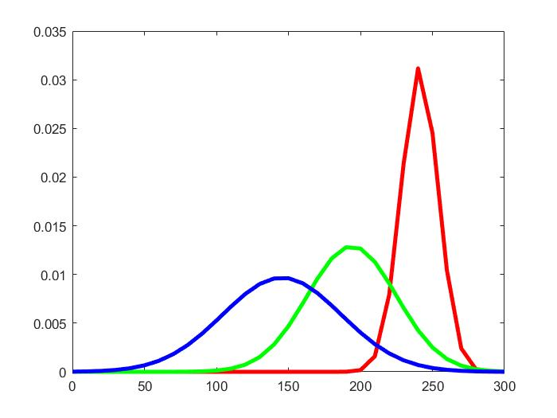

Figure(10) 3 1D Gaussian model for red colored buoy

1. **Part 3:- Buoy Detection -**

In this part the colored buoys are segmented. I have binarized the buoy and detected the blob and then applied mask to segment it and then applied contour of the respective color to detect it. The output is as shown below: Where all yellow, Red and green buoy are detected, and the contours are drawn around them. The frame with segmented buoy is shown in figure (11) and the binary frame is shown in figure (12).

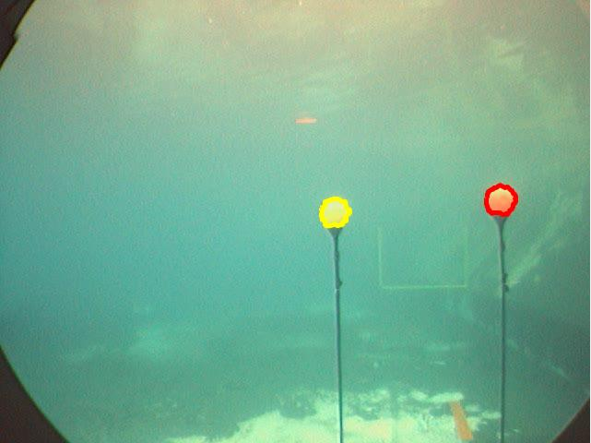

Fig(11) – Image with corresponding points

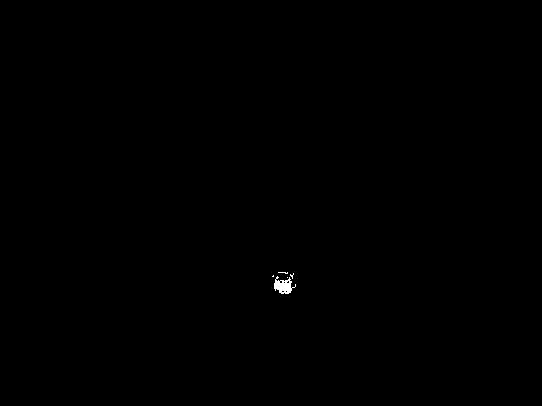

Figure(12) Binary image

**Extra-Credit –**

For the last part I tried to implement HSV color space instead of RGB color space. In the given video, due to varying illumination, the colors of buoys become bright and dark and the RGB values for these colors would be very different. So, it is very difficult to segment the varying intensity colors from the image if we use RGB color space. In the case of HSV color space, the hue would stay relatively constant for the buoys, the differences in lighting would be represented through the value component and the “colorfulness” of the each color through the saturation component. So, by using the HSV color space the problem can be solved.

**References-**

1. Lecture slides (ENPM 673)
2. “Segmentation of Color Image Using EM algorithm in HSV Color Space” – by Zhi-Kai Huang, De-Hui Liu. Published in: Information Acquisition, 2007. ICIA '07.
3. <http://www.cs.ubbcluj.ro/~csatol/gep_tan/Bishop-CUED-2006.pdf>