BookMyDoc
Software Design Specification

V0.2



Spartan Health Team
Amit Gupta
Mridul Bansal
Roopesh Vaddepally
Utkarsh Sengar

November 07, 2009

CMPE 131, Fall 2009

PREFACE
Purpose of the Document
This document outlines the design specification of the online doctor booking system, BookMyDoc.

Intended Audience
The document holds relevance for the System Administrator, the Doctor and the Patient, who are the main Actors of the system according to the use case diagram.

This document is intended for use by the designers of the system, and for those who may be required to maintain it. The document shall enable them to understand all aspects of the system in detail. The document shall also be used to carry out the acceptance testing.
Change Log

Version | Date | Author | Change
0.1 | 10/7/2009 | Utkarsh | New Document
0.2 | 11/3/2009 | Mridul | Modified class diagram

Table of Contents
PREFACE 2
1. Introduction 5
1.1 Purpose 5
1.2 Scope 5
1.3 Design Goals 6
2. References 6
3. System Architecture Description 7
3.1. Class Diagram 7
3.2. Behavior Design 9
4. Detailed Design 14
4.1. Technical dependencies 14
4.2. Classes in the system 15
4.3. Description 16
5. Design Rationale 18
5.1. Design Issues 18
5.2. Data Dictionary 19
6. User Interface Design 21
7. Validation and Verification 24
7.1. Traceability Matrix 24

Figure 1: Class Diagram 7
Figure 2: Modules in the system 8
Figure 3: SD - Create Doctor 10
Figure 4: SD - Give Prescription 11
Figure 5: SD - Request Appointment 12
Figure 6: SD - Login Patient 14
Figure 7: AD - Doctor Registration 16
Figure 8: AD - Appointment Booking 17

Introduction

Purpose
BookMyDoc intends to develop a web based application that provides a platform for doctors and patients to conveniently interact by maintaining appointments, medical history and feedbacks to medication provided. A patient can look for relevant doctors as per their medical problems, view respective doctor’s appointment timings and fix an appointment; the target audience would be hospitals, doctors and patients. BookMyDoc would display the doctors as per the patient’s requirement of timing and doctor.

Scope
BookMyDoc is a web based application developed with the concept to facilitate the user for 24 hr access to the application. The business scope of the application revolves around three users Admin, Doctor and Patient. All type of users has different rights and scope in the application. The detailed scope of the project can be analyzed by major business requirements of the application:
- Admin Module :
  - Login
  - Managing doctor details include adding, updating and deleting doctor related information,
  - Deleting Patient.
- Patient Module:
  - Registration
  - Login
  - Viewing list of doctors according to the problem type.
  - Checking doctor availability
  - Booking doctor
- Doctor Module:
  - Registration
  - Login
  - Update Appointments
  - View present and past appointments
  - Give prescription to patient

Design Goals
The goal of this design document is the following:
  - Understand and breakup the system into various sub-modules.
  - Develop the class diagram to understand the relationship and working of the code.
  - Develop a behavior design for the major actions in the system.

References
The following documents have been referred to for the preparation of this SDS document:
- Complete Reference – Java By Herbert Schildt
- The J2EETM Tutorial By Stephanie Bodoff , Dale Green, Kim Haase, Eric Jendrock, Monica Pawlan, Beth Stearns
- The Java Servlet API White Paper - Sun Developer Network
- Software Engineering, 8th Edition – Ian Sommerville

System Architecture Description

Class Diagram
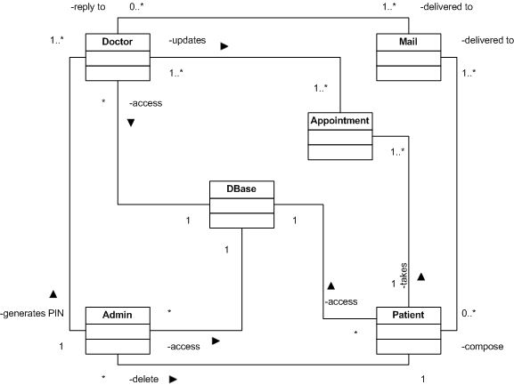
Figure 1: Class Diagram

The system has been sub divided into 4 subsystems- User, Appointment, Mail and Database. The interaction between subsystems is shown in the figure below and then each subsystem is explained in detail later.

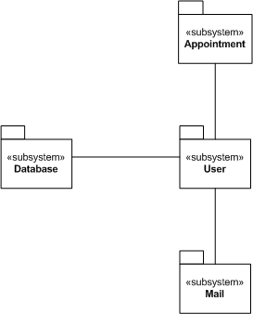

Figure 2: Modules in the system

- User –This subsystem comprises of 3 classes- Admin, Doctor and Patient classes.
  - Admin- The following details explain about the ‘admin’ class-
- The class is implemented for following Use Cases: Login, Change Password, Create Doctor, Delete Doctor, Delete Patient, and Logout.
- The class provides following Services: generatePIN(), executeQuery() which encompasses all the creation and deletion of doctors and patients.
- The Non-Functional requirements are: admin is logged in.
  - Doctor- The following details explain about the ‘admin’ class-
- The class is implemented for following Use Cases: Login, Change Password, Compose Mail, Check Mail Notification, Check Appointment History, Apply for Leave, Register Doctor, and Logout’s
- The class provides following Services: givePrescription(), replyToMail()
- The Non-Functional requirements are: doctor is logged in, Doctor has a valid ID.
  - Patient- The subsystem is itself a class named Patient.
- Patient class is being used in the following use cases as mentioned in the SRS document- Login, Change Password, Request Appointment, Cancel Appointment, Send Mail, Check Mail Notification, Check Appointment History, Register Patient, Logout.
- The class provides following services: viewAppointmentHistory(), searchDoctor()
- Appointment- This subsystem is itself a class named appointment.
- The appointment class is being implemented for following Use cases- Request Appointment, Cancel Appointment, Check appointment History.
- The class provides following Services: listAppointment(), listHistory() specific for Admin, Doctor, and Patient, and bookSlot(), cancelSlot()
- The Non-Functional requirements are: connection to Database is established. ID of the user is provided.
- Mail- The subsystem is itself a class named mail.
- The appointment class is being implemented for following Use cases- Send Mail, Check Mail notification, Compose Mail, Check Mail notification.
- The class provides following Services: sendMail(), retrieveMail(), archiveMail(), deleteMail(), listAllMail(), sendNotification().
- The Non-Functional requirements are: User is Logged In.
- Database- This subsystem comprises of a dBase class that is used to establish and terminate connections. It is an important class and has been implemented for all the use cases.
- The class provides following services: connectToDatabase(), disconnect(), executeQuery().
- Non-Functional Requirements: All database attributes are provided correctly.

Behavior Design

3.2.1. Create Doctor
Name | Create Doctor
Description | - Data is posted by the UI to the servlet  - Servlet instantiates an object for the Admin class.  - Admin class generates a 4 digit random PIN.  - The admin class connects to the database using dbase class, which establishes a connection with the database.  - The Admin class queries the database to verify the uniqueness of the generated PIN.  - If the PIN already exists in the database, the Admin class generates a new PIN and again verifies with the database.  - Once the PIN is verified as unique in the database, then the Admin creates the Doctor in the database.
Modules | Admin | dBase
Modules | - Generate PIN.  - Verify uniqueness of the PIN.  - Execute query | - Establish connection with the database.  - Close connection with the database.

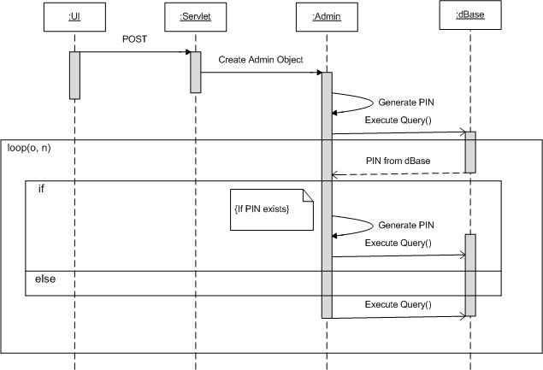

Figure 3: SD - Create Doctor

3.2.2. Give Prescription
Name | Give Prescription
Description | - User requests a prescription through UI.  - The request is sent by Servlet to appropriate Doctor Class to get appointment list.  - The Doctor connects to dBase to validate Appointment Details.  - The dBase in turn connects to the database and returns list of appointments.  - Doctor validates the appointment id.  - If the appointment exists, the Doctor asks the dbase to execute the query to update resultset.  - Upon successful update, the Doctor gives the prescription to the User.
Modules | Admin | dBase
Modules | 1. Get Appointment List.  2. Validate appointment id.  3. Execute query. | 1.Establish Connection with DB  2.Disconnect from DB

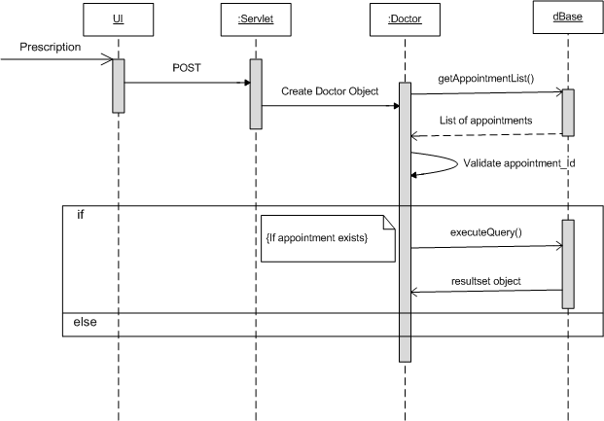

Figure 4: SD - Give Prescription

3.2.3. Request Appointment
Name | Request Appointment
Description | - User requests an appointment through UI.  - The request is sent by Servlet to appropriate Appointment class to create an appointment.  - The Appointment connects to dBase to get Appointment Details.  - The dBase, in turn connects to the database and returns set of free appointments.  - Appointment validates the requested slot, again against the free time slots.  - If the time slot is free, the Appointment asks the dbase to execute the query to update his appointments.  - Upon successful update, the Appointment informs the User of the confirmation.
Modules | Appointment | dBase
Modules | - GetAppointmentDetails  - validateRequestedSlot  - executeQueryToBookAppointment | - Establish Connection With DB  - Disconnect from DB

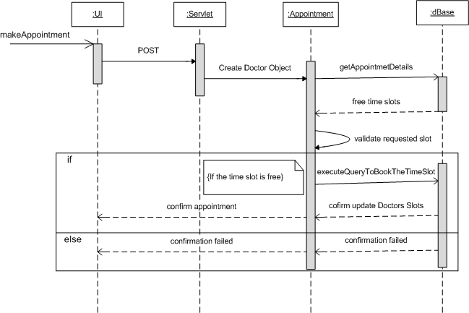

Figure 5: SD - Request Appointment

3.2.4. Login Patient
Name | Login Patient
Description | - Patient logins through UI using the id and password.  - Servlet instantiates an object for the Patient class  - The Patient connects to dBase to get getRowCount Details.  - The dBase, in turn connects to the database and returns set of Rows selected.  - Patient validates id. If incorrect, an invalid user message is prompted.  - If correct, the patient validates the password and login successful message is prompted.  - Upon incorrect password, the invalid user message is displayed to the patient.
Modules | Patient | dBase
Modules | - getRowcount details.  - Validate Id.  - Validate Password.  - Appropriate message is displayed. | 1.Establish Connection with DB  2.Disconnect from DB

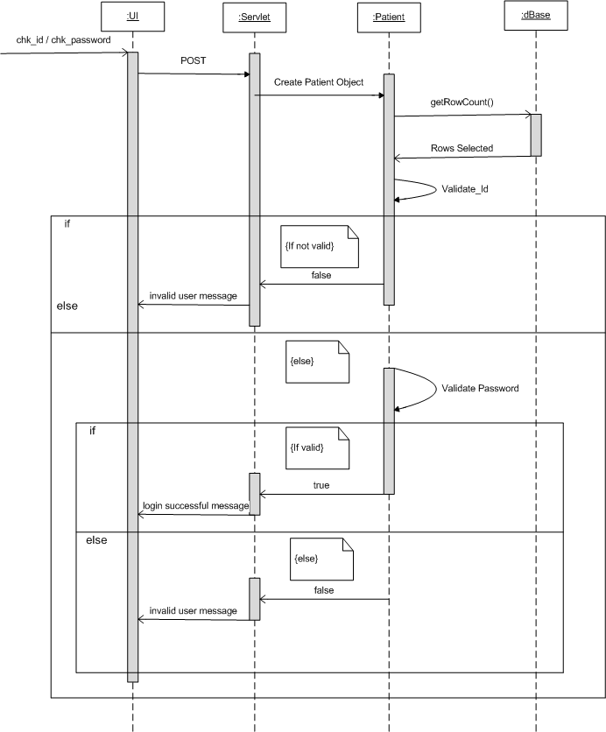

Figure 6: SD - Login Patient

Detailed Design

Technical dependencies
The BookMyDoc system requires the following services running on the server:
  - Java 1.5
  - Apache Tomcat server
  - SMTP mailing server
  - MySQL database

Classes in the system
The basic functionality of BookMyDoc lies in the 6 classes and their major methods:

    - Admin class
      - login()
      - setpassword()
      - createdoctor()
      - showDoctor()
      - createPatient()
      - showPatient()
      - deleteDoctor()
      - deletePatient()

    - Patient class
      - login()
      - setPassword()
      - register()
      - viewAppointmentHistory()
      - searchDoctors()

    - Doctor class
      - getPassword()
      - setPassword()
      - login()
      - register()
      - applyforLeave()
      - givePrescription()

    - Appointment class
      - setFeedback()
      - setPrescription()
      - bookAppointment()
      - checkAvailabity()
      - updateAppointment()

    - Mail class
      - sendMail()
      - checkInbox()
      - checkSentMail()

    - dbase class
      - createConn()
      - executeQuery()
      - getRowCount()
      - closeConnection()

Description
      - Doctor Registration

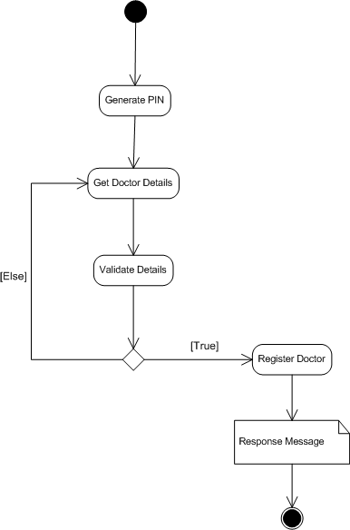

Figure 7: AD - Doctor Registration

        - The doctor manually requests the admin to create an account for the doctor on BookMyDoc.
        - The admin creates an account for the doctor, where an object of the Doctor class is instantiated which then calls the function “register()” in the doctor class. The register method generates a 4 digit PIN for the doctor, creates a connection with the database using the class “dbase” and creates an entry in the database for the doctor, with an unregistered flag set.
        - The admin gives the PIN to the doctor, personally.
        - The doctor goes to the doctor register page and enters his details, including the 4 digit PIN he received from the admin.
        - When the doctor submits the form, an object of the Doctor class is instantiated and the register function is again called. The class connects with the database using the dBase class and then the register method unsets the “doctor unregistered flag” and the doctor is officially registered.

      - Patient Registration
        - The patient registration process is rather straight forward.
        - The patient visits the Register page and submits the requested information.
        - An object of the Patient class is instantiated and the register method in the patient class is called.
        - The method connects with the database using the dBase class and creates a new entry for the patient.

      - Appointment Booking

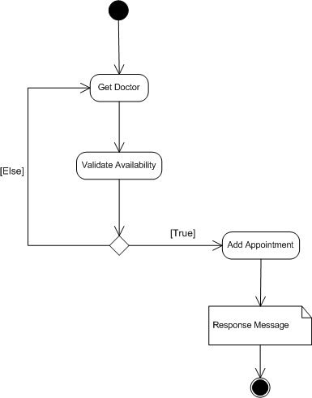

Figure 8: AD - Appointment Booking

        - The patient logs in the system with this user name and password.
        - He clicks on Check Appointment Availability and searches for a given date.
        - An object of the Appointment class is instantiated which calls a function, checkAvailabity(). This connects to the database using the dBase class and queries the database for the list of available doctors on the data specified by the patient.
        - The result set is returned by the dBase class which contains the list of doctors.
        - On the UI, the patient can see a list of all the doctors available and beside that; there is a link to Book this doctor.
        - When Book Doctor Appointment is clicked by the patient, an object is instantiated for the appointment class and the method bookAppointment() is called to block that specific time slot for the patient.
        - After a confirmation dialogue, the appointment is b for the patient.

Design Rationale

Design Issues
- Issue 1 – The doctor registration requires manual intervention
- Description – The registration process of doctor requires a manual creation of the doctor entry in the database due to authenticity issues. In the present system, the admin has to create a doctor manually and give the PIN to the doctor to complete the registration process.
- Factors Affecting issue – Doctor Authenticity check.
- Alternatives and their pros and cons – Another way of checking if the doctor registering is genuine or not is by requesting the doctor for some kind of genuine authentication number like SSN during the registration process. But this will create even more over head of verifying the doctor with the SSN dept.
- Resolution of Issue – The current system is the best resolution. The admin creates the doctor and gives a PIN to him to complete the registration.

- Issue 2 – Connection with Google Health
- Description – The requirement states that the prescription given by the doctor show also be uploaded to Google Health. But, Google Health is still in infancy and the lack of knowledge of Google Health might be a concern.
- Factors Affecting issue – Lack of Google health knowledge.
- Alternatives and their pros and cons – The data can simply be stored in database. But this will not enable the patient to connect with Google Health, which is considered to the next revolution in the Healthcare industry.
- Resolution of Issue – Get more in-depth knowledge of Google Health.

Data Dictionary

4.3.1. Patient
Column Name | Data Type | Nullable | Data Default | COLUMN ID | Primary Key | Unique Key
PATIENT_ID | NUMBER(5) | No |  | 1 | YES | YES
P_NAME | VARCHAR2 | No |  | 2
P_AGE | NUMBER(3) | No |  | 3
P_PASSWORD | VARCHAR2 | No |  | 4

4.3.2 Appointment
Column Name | Data Type | Nullable | Data Default | Primary Key
APPOINTMENT_ID | VARCHAR2 | No |  | YES
PATIENT_ID | VARCHAR2 | No
DOCTOR_ID | VARCHAR2 | No
A_DATE | DATE (DD/MM/YYYY) | No
A_SLOT | VARCHAR2 | No
A_FEEDBACK | VARCHAR2 | Yes
A_PRESCRIPTION | VARCHAR2 | Yes

4.3.3 Doctor
Column Name | Data Type | Nullable | Data Default | Primary Key | Secondary Key
DOCTOR_ID | VARCHAR2 | No |  | 1 | 1
D_PASSWORD | VARCHAR2 | No
D_NAME | VARCHAR2 | No
D_SPECIALITY | VARCHAR2 | No
DAYS | VARCHAR2 | Yes
SLOT1 | VARCHAR2 | Yes
SLOT2 | VARCHAR2 | Yes
SLOT3 | VARCHAR2 | Yes
SLOT4 | VARCHAR2 | Yes

4.3.4 Admin
Column Name | Data Type | Nullable | Data Default | Primary Key | Secondary Key
ADMIN_ID | VARCHAR2 | No |  | 1 | 1
A_PASSWORD | VARCHAR2 | No
A_NAME | VARCHAR2 | No

User Interface Design

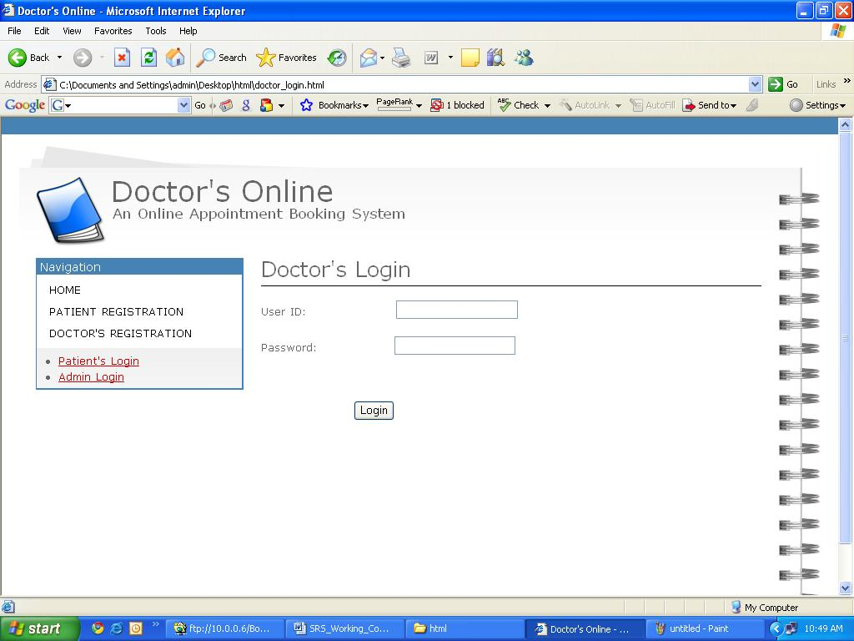

Figure 9: UI- Doctor Login Page

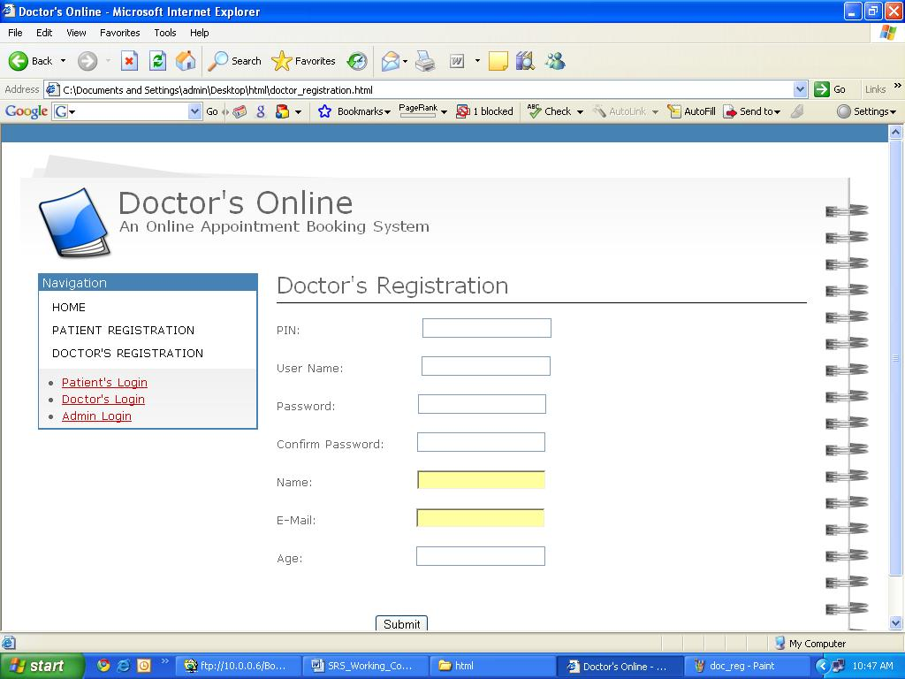

Figure 10: UI- Doctor Registration Page

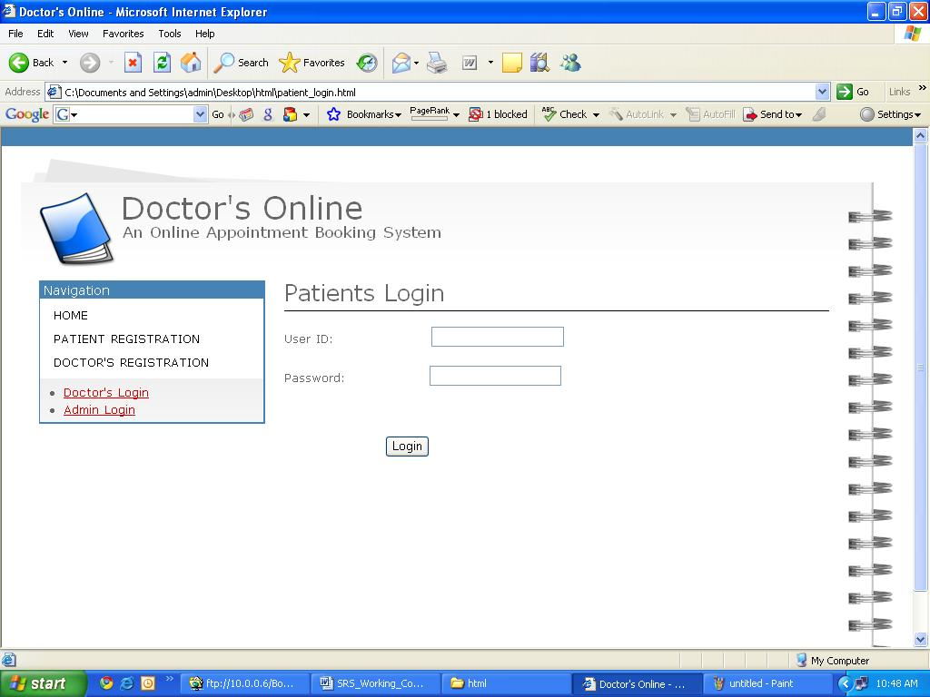

Figure 11: UI- Patient Login Page

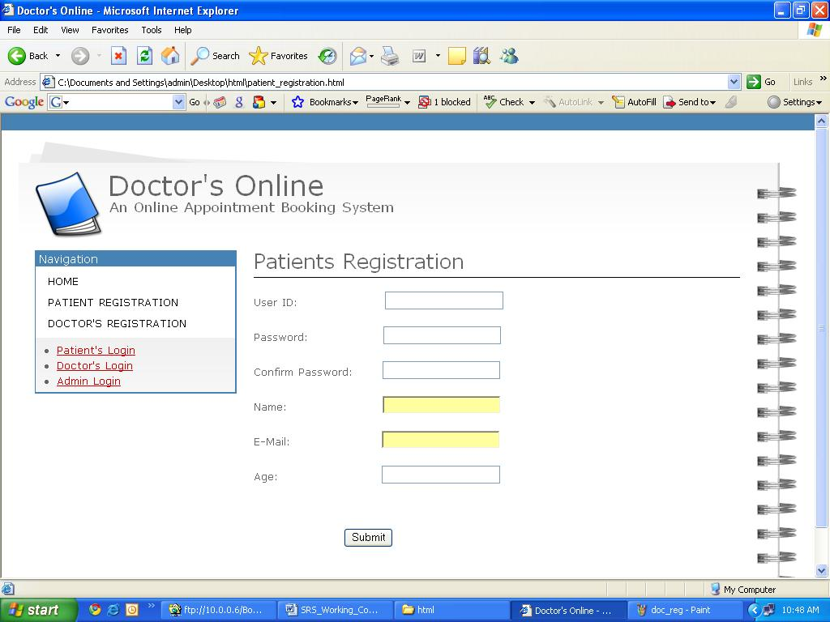

Figure 12: UI- Patient Registration Page

Validation and Verification

Traceability Matrix


