BookMyDoc
Software Requirements Specification



Spartan Health Team
Amit Gupta
Mridul Bansal
Roopesh Vaddepally
Utkarsh Sengar

September 20, 2009

CMPE 131, Fall 2009

PREFACE
Purpose of the Document
This document outlines the functional and non functional requirements of the online doctor booking system, BookMyDoc.

Intended Audience
The document holds relevance for the System Administrator, the Doctor and the Patient, who are the main Actors of the system according to the use case diagram.

This document is intended for use by the designers of the system, and for those who may be required to maintain it. The document shall enable them to understand all aspects of the system in detail. The document shall also be used to carry out the acceptance testing.

Table of Contents
PREFACE 2
1. Introduction 4
1.1 Problem Statement 4
1.2 Objective 4
1.3 Scope 4
1.4 Assumptions and Dependencies 5
1.5 Feasibility Study 5
2. System Model 6
2.1 Use Case Specification 6
2.2 Use Case Diagrams 11
3. Requirement Analysis 13
3.1 Development Platform Requirement 13
3.2 Functional Requirements 13
3.3 Non – Functional Requirements 15
4. Validation Criteria 16
4.1 Requirement Validation 16
4.2 Test Plan Overview 17
4.3 System Test 18
5. Appendix 19
5.2. Methodology Analysts 19
5.3. Elicitation Techniques 19
6. References 20
7. UI Prototype 21

Use Cases
Table 1: UC - Login 6
Table 2: UC - Change Password 6
Table 3: UC - Request Appointment 7
Table 4: UC - Cancel Appointment 7
Table 5: UC – Send mail 7
Table 6: UC - Check mail notification 7
Table 7: UC - Check Appointment History 8
Table 8: UC – Compose Mail 8
Table 9; UC - Check Mail Notification 8
Table 10: UC - Check Appointment History 8
Table 11: UC - Apply for leave 9
Table 12: UC – Register Doctor 9
Table 13: UC – Register Patient 9

Introduction

Problem Statement
BookMyDoc intends to develop a web based application that provides a platform for doctors and patients to conveniently interact by maintaining appointments, medical history and feedbacks to medication provided. A patient can look for relevant doctors as per their medical problems, view respective doctor’s appointment timings and fix an appointment; the target audience would be hospitals, doctors and patients. BookMyDoc would display the doctors as per the patient’s requirement of timing and doctor’s fees.

Objective
- To develop a feasible solution meeting all the client requirements as stated in the document.
- To develop the system within the commited time deadline. To develop an economically viable system by using open source development technology.
- To meet the software and hardware requirement specifications described for the project in the document.
- Proper documentation shall be provided with the project.
- For BookMyDoc users proper online user help manual shall be provided.
- To follow standardized software architecture for development of BookMyDoc system to take care of application’s performance. .

Scope
BookMyDoc is a web based application accessible all round the clock to facilitate the user. The business scope of the application revolves around three users- Admin, Doctor and Patient. The mentioned users have different privileges and scope in the application. The detailed scope of the project can be analyzed by major business requirements of the application:

- Admin Module:
- Login
- Managing doctor details include adding, updating and deleting doctor related information,
- Adding, Updating and Deleting Patient details.
- Patient Module:
- Registration
- Login
- Viewing list of doctors according to the problem type.
- Checking doctor availability
- Booking doctor

- Doctor Module:
- Registration
- Login
- Update Appointments
- View present and past appointments
- Update medical history of patient

Assumptions and Dependencies

- Assumptions:
- Prompt responses from the client on queries from the project.
- The PIN for doctor registration is manually provided by the admin to the doctor.
- The doctor attends 4 appointments every day in predefined slots.
- The doctor can apply for leave any day and his appointments for that day are cancelled.

- Dependencies
- Involvement of the end users in signing off this SRS document.
- Availability of System Software from the client for development.
- Availability of installed hardware/System software for implementation.

Feasibility Study
An important outcome of the preliminary investigation is the determination that the system requested is feasible. Depending on the results of the preliminary investigation the survey is expanded to a more detailed feasibility study. Feasibility study is a test of a system proposal according to its workability, impact on the organization, ability to meet user needs, and effective use of resources. The objective of feasibility study is not to solve the problem but to acquire a sense of its scope. During the study, the problem definition is crystallized and aspects of the problem to be included in the system are determined. Consequently, costs and benefits are estimated with greater accuracy at this stage.

Technical Feasibility:
In this part the aspects that are considered are:

- Can the work for the project be done with the current equipment, existing software technology and available personnel?
- If new technology is required, what is the likelihood that it can be developed?

It was found that the main need was the development of a dynamic system, which would help the Patients and the Doctors in easy and quick interaction. It should be easy to use and it should offer the different features like easy search and quick web page loading.

Keeping in view with above problems the group has selected the MySQL RDBMS with compactable open source technology Java/J2EE which could meet the needs of the end users.

Moreover, the technical skills required to implement the project are also present in the form of competent software professionals. Thus, the project is considered technically feasible.

System Model

Use Case Specification

Table 1: UC - Login
Actors | Doctor, Patient & System Administrator
Use Case | Login
Pre Condition | They must remember user id and password
Post Condition | They should login successfully to the Appointment Booking interface
Basic Flow | 1.Enter the user id and password  2.Press the submit button
Alternate Flow | 1. If user id or password does not match then an appropriate error message shall be displayed.

Table 2: UC - Change Password
Actors | Doctor, Patient & System Administrator
Use Case | Change Password
Pre Condition | Doctor, Patient & System Administrator must be logged in the system.
Post Condition | Doctor, Patient & System Administrator must enter their existing password once and the new password twice and click Submit.
Basic Flow | - Enter the information.  - Press the submit button
Alternate Flow | - If the current password is not correct then the user gets an appropriate error message.  - If the new password entered twice does not match, then an appropriate error message shall be displayed...

Table 3: UC - Request Appointment
Actors | Patient
Use Case | Request Appointment
Pre Condition | The Patient must select a doctor for appointment.
Post Condition | Patient gets an appointment.
Basic Flow | 1. Select appointment time.  2. Press the Submit button
Alternate Flow | 1. The user must select another appointment time if required slot is not available.

Table 4: UC - Cancel Appointment
Actors | Patient
Use Case | Cancel Appointment
Pre Condition | The Patient must be logged in the System.
Post Condition | The appointment is cancelled and the doctor is shown as available for that time.
Basic Flow | 1. Select the appointment  2. Press the Submit button
Alternate Flow | - If the appointment is not selected and Submit is clicked then an appropriate Error Message is displayed.

Table 5: UC – Send mail
Actors | Patient
Use Case Name | Send mail
Pre Condition | The Patient should be logged in the System.
Post Condition | Patient should type the mail and click Submit.
Basic Flow | - The patient types the mail.  - Press the Submit button.
Alternate Flow | - If no mail is entered and the Submit button is pressed then the user get an appropriate Error Method.

Table 6: UC - Check mail notification
Actors | Patient
Use Case Name | Check Mail Notification
Pre Condition | The Patient should be logged in the System.
Post Condition | The Patient checks the mail sent by the Doctor and also can request an emergency appointment by composing a mail.
Basic Flow | - Patient checks the mail on update of his appointment details.
Alternate Flow | - Patient checks his sent mail.  - Patient requests an emergency by composing a mail.

Table 7: UC - Check Appointment History
Actors | Patient
Use Case Name | Check Appointment History
Pre Condition | The Patient must be logged in the System.
Post Condition | Patient checks his old appointments.
Basic Flow | - Patient clicks on Appointments History link and views the Appointments.
Alternate Flow | 1. Patient opts for sending mail for a particular appointment.

Table 8: UC – Compose Mail
Actors | Doctor
Use Case Name | Compose Mail
Pre Condition | The Doctor should be logged in the System.
Post Condition | Doctor should type the prescription and click Submit.
Basic Flow | - Doctor types the prescription.  - Doctor clicks the Submit button.
Alternate Flow

Table 9; UC - Check Mail Notification
Actors | Doctor
Use Case Name | Check Mail Notification
Pre Condition | The Doctor should be logged in the System.
Post Condition | The Doctor checks the mail sent by the patient and also can send a mail to patient regarding appointment update.
Basic Flow | - Doctor checks his mail on pending appointment requests.
Alternate Flow | - Doctor checks his sent mail.  - Doctor sends a mail regarding appointment update.

Table 10: UC - Check Appointment History
Actors | Doctor
Use Case Name | Check Appointment History
Pre Condition | The Doctor must be logged in the System.
Post Condition | Doctor checks the feedback given by the patient and also checks his old appointments.
Basic Flow | - Doctor clicks on Feedback link and views the prescription.  - Doctor clicks on Appointments History link and views the Appointments.
Alternate Flow | 1. Doctor opts for giving prescription for a particular appointment.

Table 11: UC - Apply for leave
Actors | Doctor
Use Case Name | Apply For Leave
Pre Condition | The Doctor should be logged in the System.
Post Condition | The appointments are cancelled for the respective day.
Basic Flow | - Doctor clicks on apply for leave and enters a date.  - All appointments for that day are cancelled and mails are sent to the corresponding patients.
Alternate Flow

Table 12: UC – Register Doctor
Actors | Doctor
Use Case Name | Register Doctor
Pre Condition | The doctor must possess an authentication PIN manually provided by admin.
Post Condition | The Doctor is registered as an authorized user in the system.
Basic Flow | - Doctor enters the fields in the registration form.  - Doctor clicks the submit button.
Alternate Flow | If the entered PIN is incorrect, the doctor is not authorized to access the system.

Table 13: UC – Register Patient
Actors | Patient
Use Case Name | Register Patient
Pre Condition | The patient must be connected to the application.
Post Condition | Patient is provided with login details by the Admin...
Basic Flow | - Patient enters the relevant fields in the registration form.  - Patient clicks the submit button.
Alternate Flow | If a field is left blank, the patient is prompted to enter the blank field(s).

Table 12: UC - Create Doctor
Actors | Admin
Use Case Name | Create Doctor
Pre Condition | The admin must be logged in to the system.
Post Condition | The PIN is manually provided by the admin to the doctor.
Basic Flow | - Admin clicks on the create doctor link.  - System generates a unique PIN for the new doctor.
Alternate Flow | The admin has authority to decline a register doctor request.

Table 13: UC - Delete Doctor
Actors | Admin
Use Case Name | Delete Doctor
Pre Condition | The admin must be logged in to the system.
Post Condition | The doctor loses authority to log into the system.
Basic Flow | - Admin clicks on the delete doctor link.  - System displays a list of doctors.  - The admin then selects a doctor by deleting him.
Alternate Flow

Table 14: UC - Delete Patient
Actors | Admin
Use Case Name | Delete Patient
Pre Condition | The admin must be logged in to the system.
Post Condition | The patient loses his authority to access the system and medical records.
Basic Flow | - Admin clicks on the delete patient link.  - System displays a list of patient.  - The admin then selects a patient to delete.
Alternate Flow

Table 15: UC - Logout
Actors | Admin, doctor and patient.
Use Case Name | Logout
Pre Condition | They must be logged in to the system.
Post Condition | The system logs out the users by ending their session.
Basic Flow | - They click on the logout link.  - System displays the home page by ending the session.
Alternate Flow

Use Case Diagrams
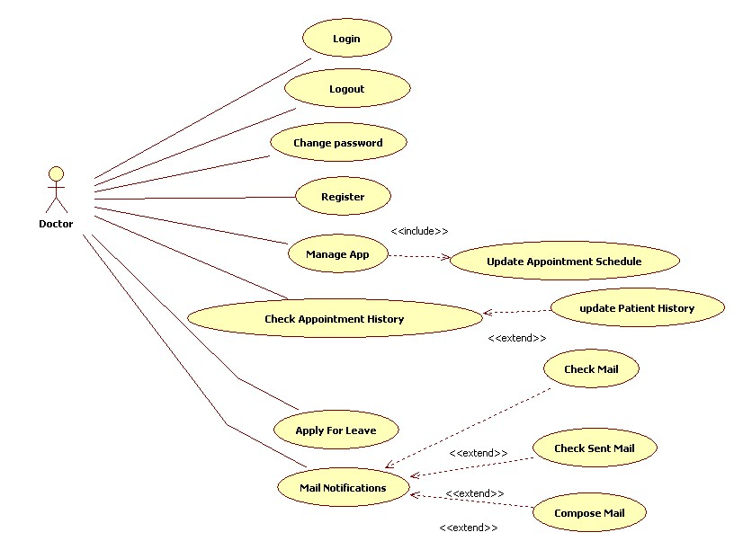
Figure 1: Use Case: Doctor
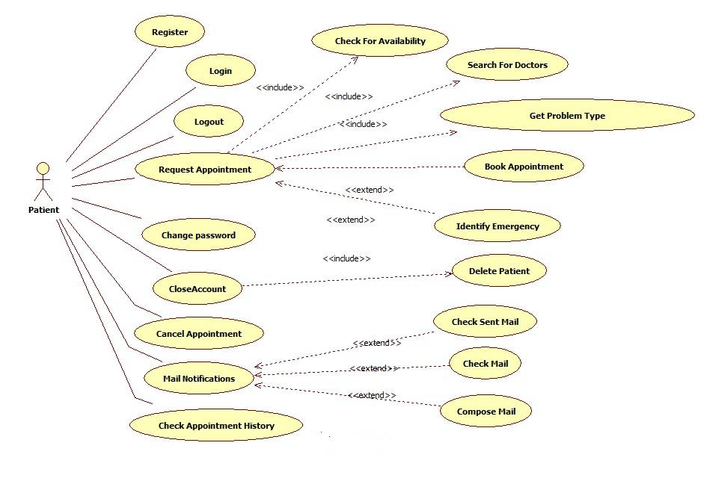
Figure 2: Use Case: Patient

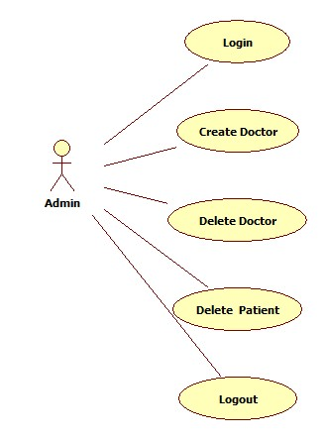
Figure 3: Use Case: Administrator

Requirement Analysis

Development Platform Requirement
Development Platform | Java EE 5
Web Server | Sun Java System Web Server 7.0
Application Server | Glassfish v3
IDE | Eclipse 3.5 - Ganymede
Database | MySQL 5.1

Functional Requirements
S. No. | Requirement
The system shall have three kinds of unique roles:
- Administrator: The administrator shall have complete control over the system. He shall be able to add, remove and modify the records of all the users in the system.
- Doctor: The doctor shall have the right to add, remove and modify his appointments.
- Patient: The patient shall have the right to book, cancel and modify his appointments.
Registration:
- Patient: The system shall provide an online registration form for the patient.
- Doctor: The system shall provide an online registration form for the doctor which shall be approved by the administrator.
 | All the users shall have to login to access the system and they need to logout of the system after use.
 | All the users shall have the right to change their passwords.
Any user shall have the access to book an appointment through the "Book a Doctor" form; the form shall contain the following required fields:
1. Doctor specialty.
2. Location
And the following optional fields:
1. Check box to look for "Non - Profit" doctors.
After submitting the form, all the doctors matching the input criteria shall be displayed. The list shall display 10 doctors per page in the following format:
- Doctors shall be displayed alphabetically, by last name.
- The list shall display the following columns - Doctors name and 5 dates with their appointment time from current date.
- Doctor’s photograph, name, qualification and address shall be displayed on the search result page.
- To book a doctor, the user shall navigate to the doctor’s detailed page.
When the user selects a doctor, the user is navigated to a new page that displays the following details about the doctor:
- List of available appointment.
- Link to “Book This Doctor”
- Qualifications
- Photograph
- The association of a doctor with medical organizations.
- Contact details.
- Ratings and feedbacks.
- Misc.
When the user clicks “Book this Doctor”, a new page shall open, the Doctor Booking form with the following fields:
- Visit reason
- Insurance number
- Credit card number (if the user does not have insurance).
- Date and time of appointment.
After submitting the Doctor Booking form, the user shall be displayed a confirmation page which contains the following:
- Appointment booking number.
- Doctor name.
- Doctor address.
- Appointment details
- Print this page option.
The patient shall be able to view his history, which shall have the following:
- Appointment History
- The user shall have an option to cancel an upcoming appointment.
- Medical records updated by the doctor.
The doctor and the patient shall have an option to interact on BookMyDoc after a confirmed visit:
- They send private message regarding his medical treatment.
- They can also check their sent and incoming messages.
Doctor shall manage his settings on his account page.
- Doctor shall cancel appointments specifically.
- Doctor shall update his appointment timings.
Doctor shall check his appointment history in tabular format
- Table lists out the patients with their appointment times
- Table contains link to change the patient history
Doctor shall update the patient history:
- Upload the prescription data.
- Modify the current prescription data.
Doctor shall apply for leave
- After approval, the appointments are cancelled
- Inform the patients
The administrator shall have the following rights:
- Create a PIN for a new doctor in the system.
- Delete a doctor.
- Delete a patient.
- Update details of doctors and patients.

Non – Functional Requirements
S. No. | Requirement
 | Accessibility: The system shall have user friendly and intuitive user interface since the targeted audiences are non technical people.
 | Dependency on other parties: The data storage shall be on Google Health. The system is dependent on Google Heath’s availability.
 | Documentation: The documentation of the application shall be comprehensive.
 | Efficiency: The system shall give quick response to user’s search queries.
 | Privacy and Security: The medical records and the contact information shall adhere to the privacy laws.
 | Scalability: The system shall be scalable enough.

Validation Criteria

Requirement Validation

Traceability Matrix
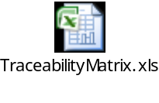

Review and Inspection
The following review and inspection techniques are used:
- Requirement function review was carried out by doctors and patients.
- Existing systems were studies and referenced.

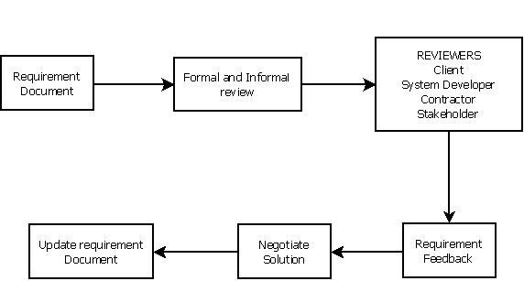

Test Plan Overview

Strategy Overview
- All requirements and design elements shall be tested.
- Consistent application test data shall be defined and input into the BookMyDoc Database prior to commencement of formal testing phases.
- Developer shall perform Unit Testing in development environment.
- The system shall be moved to the production environment for system testing.
- After the successful completion of the System Testing, the next step would be to conduct the Acceptance Testing.
- Unexpected results from all levels of testing (System / Acceptance) shall be documented in the Test Problem Report and communicated for rectification. Re-migration of code from production to Development environment shall be done to fix the reported defects. Once the fixes are verified in development, the code shall again be tested (System / Acceptance) with test scripts for which the unexpected results were documented. This process shall be repeated until the defects are closed.
- After the successful completion of all test levels, a Test Summary Report shall be prepared.

Testing Levels and Data
Following levels of testing shall be conducted:
- Unit Testing (informal)
- System Testing
- User Acceptance Testing

Data:
- For unit testing Data is used by developer and is not required to be provided by Business.
- For system testing Data is used by developer and is not required to be provided by Business.

Testing Prerequisites
The following documents should be completed and approved before commencing the system testing activity for the BookMyDoc Web site:
- BookMyDoc Requirements
- BookMyDoc Design
- BookMyDoc Test Plan
- BookMyDoc Test script(s)
In addition, the testers should have been identified and the environment should be available for testing.

Test Environment
The formal testing shall be performed in the QA environment. In order to execute test scripts, the tester shall need the following:
- PC with Microsoft Internet Explorer / Mozilla Firefox / Safari installed on Windows/Apple/Linux
- BookMyDoc Specific User Roles:
- Administrator
- Patient
- Doctor

System Test

Entry Criteria
- Unit testing has been performed
- All issues identified during Unit Testing have been resolved
- System test scripts are ready and approved

Objectives
The objective of system testing is to ensure that all the requirements stated in the BookMyDoc requirements document are met.

Approach
- Test Plan and Test Scripts for System Testing shall be distributed to the testers.
- Testers shall be given proper access permissions for testing.
- Testers shall execute the Test Scripts and log the actual results.
- Testers shall log any incidents in the Test Summary Report.

Data Requirements
User accounts shall be created on the system with all the roles (Administrator, Patient and Doctor) before the testing can be started.

Exit Criteria
- The application meets the expected results for all executed Test Scripts.
- All issues identified have been resolved and the testers have verified all test results.
- Any unexpected incidents to be documented in the Test Problem Report have been identified.
- Passed and signed system test scripts shall be handed over to System Custodian for inclusion in the Validation Package.

Appendix

Methodology Analysts
The requirements have been elucidated from a viewpoint oriented analysis.
- Direct viewpoint- The viewpoints of doctors and patients are considered since they will interact directly with the system. The viewpoint of Administrator, who shall authorize any changes in the system, is also considered.
- Domain Viewpoint- Requirements have been formulated in consideration of the healthcare domain. Information pertaining to medical records like the medical prescriptions, medical reports etc are highly insightful and important, which should be shown as is. Hence, this viewpoint is important criteria to be included in the requirements. The information fetched from various medical reports would pertain to respective formats, which should be included in the system during data entry. The Medical standards need to be effectively followed and terminologies must be incorporated for avoiding misunderstanding by developers and database managers.
- Indirect Viewpoint- Since this would be an online web portal, hence the UI should be appealing and user friendly to be used by general public and the doctors who might not be well aware of the computer usage. Also, Safety is to be ensured of user’s data by providing login details.
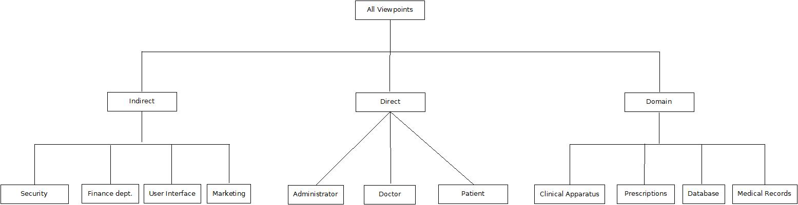

Elicitation Techniques
The requirements in the document have been elicited by following various techniques during the process-
- Interviewing and questionnaire- A group of varied mass were interviewed, including interviewees from within the medical domain (from web forums, blogs, personal interactions), outside the domain (general public, students) and developers (members of the project team).
- Brainstorming- Brainstorming sessions conducted by the project team, wherein the members provided valuable input for idea generation & idea reduction. Seldom innovative ideas surfaced during the process.
- Scenarios- One of the many considered scenarios is where Mr. A, who works as an engineer for a multinational company. Mr. A is working on an important project, with a closing by deadline. Mr. A feels an urgency to meet a dentist for evacuation. Unaware of any dentist in the vicinity of his office and home, Mr. A logs in to the BookMyDoc system. Mr. A performs a search of dentists in his area, on his way from office-home, and convenient timings as per the schedule. The system generates a list of available doctors as per the criteria, and Mr. A can fix an appointment easily. This would ease the undue hassle of searching contact details of various dentists and begging for convenient appointment timings. Mr. A can comfortable fixes the appointment from home, office or on the go in his car!
- Use Cases- The requirements incorporate use cases for login for user data security, registration for user information, and search for doctors/appointments, cancel appointments, messaging for effective interaction between doctors and patients.

References
The following documents have been referred to for the preparation of this SRS document:
- Complete Reference – Java By Herbert Schildt
- The J2EETM Tutorial By Stephanie Bodoff , Dale Green, Kim Haase, Eric Jendrock, Monica Pawlan, Beth Stearns
- The Java Servlet API White Paper - Sun Developer Network
- Software Engineering, 8th Edition – Ian Sommerville

UI Prototype
