학위논문 작성 유의사항

※ 논문업로드 전 반드시 지도교수의 확인 후 업로드 하시기 바랍니다.
※ 논문 작성은 아래 표의 논문규격과 작성글자체를 참조하여 작성바랍니다.
(논문규격, 글자체, 문단모양, 글자모양은 변경 불가능)
※ 5page의 논문목차부터는 논문 작성 예시로 항목구성, 본문구성 및 내용작성(표/그림 포함), 참고문헌표기법 등은 정해진 서식이 아니므로 수정 가능 합니다.
※ 논문업로드 시 본 페이지는 삭제 후 업로드 하세요.

1. 논문 규격 : A4 규격(210mm*297mm) (본문 38자 × 25행)
 | 위 | 아래 | 머리말 | 꼬리말 | 왼쪽 | 오른쪽 | 제본
한글 | 38.0mm | 38.0mm | 15.0mm | 15.0mm | 30.0mm | 30.0mm | 0
Word | 5.3cm | 5.3cm |  |  | 3cm | 3cm | 0cm

2. 작성글자체 : 명조, 신명조, 휴먼명조
◎ 문단모양 : 들여쓰기 3space, 본문 줄간격 200%(한글), 정렬방식 혼합
◎ 글자모양 :
▷ 큰 제 목 : 16point, 신명조, 진하게(가운데)
▷ 중간제목 : 14point, 신명조, 진하게
▷ 본 문 : 11point, 신명조
▷ 각 주 : 9point, 신명조

3. 항목구분번호 : 일정한 순서를 지켜 작성(하단 Box 예시 참조)
구분 | 예시A | 예시B | 크기 및 정렬
항목구성예시  (중간항목  생략가능 및 띄어쓰기 조정가능) | 제1장  제1절  1.  가.  1)  가) | Ⅰ.  1.  A.  1)  a.  (1) | 16p 진하게 가운데정렬  14p 진하게  11p (진하게)  11p  11p  11p

※ 본 페이지는 전자전기컴퓨터공학과 본심 대상자만 작성바랍니다.
학위 논문 제목 | 자율주행 차량의 페일세이프 운행을 위한 연속 센서 건강도 감시와 위험·잔여능력 기반 단계적 최소위험기동 감독
학과 | 전자전기컴퓨터공학과
학번 | 2025712335
이름 | 엄태욱
지도교수 | 국태용

1. 논문 요약 (Abstract)

자율주행 시스템의 센서 고장 대응은 대부분 "즉시 차로 내 정지"라는 단일 전략에 의존한다. 그러나 차로 내 정지는 후속 교통의 차단과 2차 충돌 위험을 만들고, 반대로 고장 상태의 계속 주행은 열화된 지각으로 위험에 노출되는 거리를 늘린다. 본 논문은 센서 고장을 이분법이 아닌 연속 건강도 점수로 추정하는 행동트리(Behavior Tree) 기반 감시 모듈과, 고장의 종류·정도와 잔여 기동 능력에 따라 갓길·주차장 대피(MRM_MOVE)와 순정 정차 위임(MRM_DEFER)을 구분 선택하고 대피 이동 중 보수적 고정 속도 상한(3.0 m/s)을 부과하는 MRM 감독자로 구성된 단계적 고장 대응 프레임워크를 제안한다.
검증은 Autoware 0.39.0과 CARLA 0.9.16의 폐루프 환경(Town07, 제한속도 15 km/h)에서 수행하였다. 총 1,862 유효 케이스의 단일 폐루프 실험으로 감시·대피 거동을 검증하였고, 고장 상태 주행거리(노출)를 무감시 순정의 대표 관찰 238~251 m 대비 감시+대피의 32~58 m로 단축함을 보였다(라이다 클러터는 275→11~12 m). 하드 페일은 고속 판정 경로로 1.5 s 설계 마감 안에 판정되며(실측 최대 1.20 s), 항법 고장 4종을 포함한 전 조건에서 100% 검출을 확인하였다. 안전성은 에고 충돌 센서 실시간 원장(RAW-HIT)과 보행자 물리 오라클의 이중 판정 체계 위에서 보행자 돌발 조우 수준으로 정량화하였다: 회피/충돌 경계는 4.2 m/s에서 8~11 m(모델 8.8 m와 일치), 3.0 m/s에서 7~8 m였다.
고장 상태의 8 m 조우 재현에서 순정 지속 주행은 전량 충돌한 반면 제안 저속 정착 순항은 전량 회피했고(0/10 대 8/8), 같은 정책도 감속 과도구간 조우에서는 충돌했다(2/2). 상한이 실제 성립한 정착 조우의 용량-반응 실험(상한 3종×거리 4종×10시드=120런, 사전 지정 1차 종결점)에서 상한 4.2 대 3.0 m/s는 8 m 쌍대 불일치 10:0(exact McNemar p=0.002)으로 충돌 감소 효과가 검출되었고, 회피/충돌 경계는 상한을 낮출수록 단조로 안쪽 이동했다(9 m 초과→약 7 m). 즉 최소위험기동의 선택은 즉시 충돌 위험과 차선 반환·차선 밖 대피 위치 확보 가능성 사이의 시간적 트레이드오프이며, 대피의 잔존 위험은 감지 후 과도구간에 집중된다 — 더 이른 감지와 더 빠른 감속이 전체 고장 대응 위험 창을 축소할 것임을 실험적으로 뒷받침하는, FTTI 이내 여유 확보 필요성에 대한 조우 수준의 정량적 근거를 제공한다.

Key Words: 자율주행, 페일세이프, 최소위험기동(MRM), 센서 고장 감지, FTTI

2. 논문 기여도 (Contribution)
학위 논문에서 소개된 대표적인 기존 연구들과 학위 논문에서 수행된 연구와의 차이점, 학위 논문의 학술적/기술적 기여도를 정량적/정성적으로 기술해 주십시오. 논문 기여도 작성 시 아래의 표를 이용해 주십시오.
기존 연구 | 학위 논문과의 차이점
[1] | Tang 등(Systems, 2026)은 복수 센서 고장에서 HAZOP 위험 분석과 TTC/THW 평가로 MRM 행동을 적응 선택한다. 본 논문은 고장 상태를 전제하지 않고 온라인 감시로 고장의 발생·종류·심각도 추정부터 수행하며, 잔여 지각·측위 능력을 결합해 대피/정차를 구분하고 대피 이동 속도까지 제한한다.
[2] | Xue 등(IV 2018, JICV 2019)은 전방 센서 고장을 전제로 MPC 안전 제약 하의 안전 구역 정차 폴백을 제안한다. 본 논문은 실제 오픈소스 스택(Autoware) 위 1,862 유효 케이스의 폐루프 검증과 판정 신뢰성이 확보된 보행자 조우 실험(용량-반응 120런, exact McNemar p=0.002)으로 검증 수준을 달리한다.
[1] J. Tang, C. Yang, and H. Nishimura, "Minimum risk maneuver strategy for automated driving system under multiple conditions of sensor failure," Systems, vol. 14, no. 1, 87, 2026.
[2] W. Xue, B. Yang, T. Kaizuka, K. Nakano, "A fallback approach for an automated vehicle encountering sensor failure in monitoring environment," IEEE IV, 2018.

학술적/기술적 기여도
정량적 측면 | 총 1,862 유효 케이스 단일 폐루프 검증; 검출률 96~100%(감내 설계 1개 조건 제외)·오발동 0/45; 고장 상태 노출 238~275 m → 11~58 m 단축; 하드 페일 판정 1.5 s 마감 내 완료(최대 1.20 s); 속도 상한 인과 효과 검출(8 m 쌍대 불일치 10:0, exact McNemar p=0.002), 회피/충돌 경계 단조 이동(9 m 초과→약 7 m).
정성적 측면 | 연속 건강도·잔여능력 기반 단계적 MRM 선택이라는 감독 계층 아키텍처(비침습 add-on); 시뮬레이션 충돌 판정의 이중 체계(실시간 원장+물리 오라클)와 판정 함정 규명이라는 방법론적 기여; 감지 후 과도구간에 잔존 위험이 집중됨을 보인 조우 수준 관찰(FTTI 내 여유 확보 필요성의 정량 근거).

3. 논문 발표 실적 (Publications and Awards)
학술지, 학회에 발표한 논문, 특허, 수상 실적을 아래 목록에 맞춰서 기재해 주십시오. 그 외 실적의 경우도 기재해 주십시오 (IEEE Trans. 형식의 reference 형태로 정리).

1) 국제 저널 실적
[1] Tae Wook Eum, Jun Hyeon Choi, Ye Chan An, Jin Ho Kim, and Tae Yong Kuc, "Visible-Face-Aware Weighted Anchor Refinement with Utility-Guided Selective Correction for Monocular 3D Object Detection," IEEE Transactions on Intelligent Vehicles (under review), 2026.
[2] Tae Wook Eum, Jun Hyeon Choi, Ye Chan An, Jin Ho Kim, and Tae Yong Kuc, "Graded Fault Response for Autonomous Driving via Continuous Sensor Health Monitoring and Risk/Capability-Aware MRM Supervision," IEEE Robotics and Automation Letters (submitted), 2026.

2) 국내 저널 실적
[1] 김진호, 엄태욱, 서동수, 최준현, 안예찬, 국태용, "차량 내 다중 센서 시간 오차 정합을 위한 시멘틱 기반 오프셋 추정 방법," 대한임베디드공학회논문지, 제20권 제4호, pp. 183-192, 2025.

3) 국제 학회 실적
[1] Tae Wook Eum, Jun Hyeon Choi, Ye Chan An, and Tae Yong Kuc, "Behavior Tree-Based Fail-Safe Mechanism for Autonomous Vehicles Using Digital Twin," in Proc. International Conference on Control, Automation and Systems (ICCAS), 2025.
[2] Tae Wook Eum, Jun Hyeon Choi, Ye Chan An, and Tae Yong Kuc, "Building CARLA Digital Twin Maps Directly from LiDAR-Only Point Clouds," in Proc. International Symposium on Advanced Intelligent Systems (ISIS), 2025.
[3] Tae Wook Eum, Jun Hyeon Choi, Ye Chan An, and Tae Yong Kuc, "Real-time Sensor Diagnosis and Behavior Tree-based Fault Handling Framework using ROS2 CDR Data Parsing," in Proc. IEEE International Conference on Ubiquitous Robots (UR), 2026.

4) 국내 학회 실적
[1] 엄태욱, 최준현, 안예찬, 국태용, "다중 센서 자율주행 차량을 위한 행동 트리 기반 의사결정 페일세이프 매커니즘," 한국지능시스템학회(KIIS) 춘계학술대회, 2025.
[2] 엄태욱, 최준현, 안예찬, 국태용, "자율주행 차량을 위한 위험도 기반 갓길 주차 페일세이프 매커니즘의 CARLA 시뮬레이터 기반 검증," 제어로봇시스템학회(ICROS) 학술대회, 2025.
[3] 엄태욱, 최준현, 안예찬, 국태용, "HD Map 기반 CARLA 시뮬레이터 초정밀 디지털트윈 맵 생성," 한국ITS학회 학술대회, 2025.
[4] 엄태욱, 최준현, 안예찬, 국태용, "모바일 로봇의 안전 운용을 위한 비헤이비어 트리 기반 페일세이프 구조," 한국지능시스템학회(KIIS) 추계학술대회, 2025.
[5] 엄태욱, 최준현, 안예찬, 국태용, "LiDAR 보정 신뢰도 피드백 기반 적응적 3D 다중 객체 추적," 한국자동차공학회(KSAE) 춘계학술대회, 2026.
5) 특허 및 수상 실적
6) 기타 실적

Master’s Thesis
Continuous Sensor Health Monitoring and Risk/Capability-aware Graded MRM supervision For Fail-Safe Operation of Autonomous Vehicles
Taewook Eum

Department of Electrical and Computer Engineering
The Graduate School
Sungkyunkwan University

Master’s Thesis
Continuous Sensor Health Monitoring and Risk/Capability-aware Graded MRM supervision
For Fail-Safe Operation of Autonomous Vehicles
Taewook Eum

Department of Electrical and Computer Engineering
The Graduate School
Sungkyunkwan University

Continuous Sensor Health Monitoring and Risk/Capability-aware Graded MRM supervision
For Fail-Safe Operation of Autonomous Vehicles

Taewook Eum
A Master's Thesis Submitted to the Department of Electrical and Computer Engineering and the Graduate School of Sungkyunkwan University in partial fulfillment of the requirements for the degree of Master of Science in Engineering

February 2027

Supervised by
Taeyong Kuc
Major Advisor

(Approval form 인정서 서식)
This certifies that the Master's Thesis
of Taewook Eum is approved.
심사위원장 signature
Committee Chair : Name
심사위원 signature
Committee Member : Taeyong Kuc
지도교수 signature
Major Advisor : Name
The Graduate School
Sungkyunkwan University
February 2027(*If you graduate August 2026, please write June 2026.)

Table of Contents
Abstract | ························ |  |  |  |  |  | i
1. Introduction | ························ |  |  |  |  |  | 1
1.1 Research Background |  | ···················· |  |  |  |  | 8
1.2 Research Questions |  | ···················· |  |  |  |  | 8
1.3 Contribution | ························ |  |  |  |  |  | 8
1.4 Thesis Organization |  | ···················· |  |  |  |  | 8
2. Background and Related Work |  |  | ·················· |  |  |  | 8
2.1 Standards and Regulatory Frameworks |  |  |  | ············· |  |  | 8
2.2 FTTI and the Derivation of Time Budgets |  |  |  |  | ········ |  | 8
2.3 Fault Detection Theory and Sensor Degradation Models |  |  |  |  |  | ·· | 8
2.4 Fallback and MRM Planning |  |  | ·················· |  |  |  | 8
2.5 Capability-Based Self-Monitoring and Runtime Monitoring |  |  |  |  |  | ·· | 8
2.6 Simulation-Based Evaluation and Fault Injection |  |  |  |  | ········ |  | 8
2.7 Comparison with Prior Work |  |  | ·················· |  |  |  | 8
3. Proposed System | ························ |  |  |  |  |  | 8
3.1 System Architecture |  | ···················· |  |  |  |  | 8
3.2 Sensor Scoring | ························ |  |  |  |  |  | 8
3.3 Spatial Sectors and Capability Synthesis |  |  |  | ············· |  |  | 8
3.4 Risk-Coupled Dynamic Detection Budget |  |  |  |  | ········ |  | 8
3.5 MRM Supervisor | ························ |  |  |  |  |  | 8
3.6 Conservative Low-Speed MRM Movement (Speed Cap) |  |  |  |  |  | ·· | 8
1.1 Research Background |  | ···················· |  |  |  |  | 8
1.1 Research Background |  | ···················· |  |  |  |  | 8
1.1 Research Background |  | ···················· |  |  |  |  | 8
1.1 Research Background |  | ···················· |  |  |  |  | 8
1.1 Research Background |  | ···················· |  |  |  |  | 8
1.1 Research Background |  | ···················· |  |  |  |  | 8
References | ························· |  |  |  |  |  | 24
Korean Abstract | ························· |  |  |  |  |  | 25

List of Tables
Table 1. | ························· | 15
Table 2. | ························· | 20

List of Figures
Fig.1. | ························· | 8
Fig.2. | ························· | 11
Fig.3. | ························· | 12
Abstract
Continuous Sensor Health Monitoring and
Risk/Capability-aware Graded MRM Supervision
for Fail-Safe Operation of Autonomous Vehicles

Sensor-fault handling in automated driving stacks largely relies on a single strategy — an immediate in-lane stop — which leaves the vehicle obstructing traffic, while undetected faults let the vehicle keep driving with degraded perception. This thesis proposes a graded fault-response framework consisting of (1) a behavior-tree-based monitor that estimates per-sensor health as continuous scores from freshness, quality, and physics channels, and (2) a supervisor that selects between shoulder/parking-lot evacuation (MRM_MOVE) and deferral to the stock stop (MRM_DEFER) according to fault type, severity, and remaining capability, and enforces a conservative fixed speed cap (3.0 m/s, below the model-derived upper bound of about 3.89 m/s from the stopping-distance model) during evacuation.
The framework was evaluated in a closed loop of Autoware 0.39.0 and CARLA 0.9.16 (Town07, 15 km/h speed limit). A total of 1,862 valid cases verified the monitoring and evacuation behavior: the detectors achieved 96-100% detection in every fault condition except by-design-tolerated mid LiDAR sparsification, with median detection latencies of about 1.0 s for hard fails (ledger re-measurement, simulation time) and 2.1-5.0 s for degradation faults (wall clock), zero false activations in 45 fault-free cases, and supervision reduced degraded-state driving exposure from 238-251 m (unmonitored representative observation, one run per fault type) to 32-58 m (LiDAR clutter 275 m to 11-12 m). Safety was quantified at the encounter level with a dual collision-verdict system — a real-time ego collision-sensor ledger (RAW-HIT) and a pedestrian-physics oracle — introduced after empirically discovering that a collision sensor attached to the pedestrian never fired.
Distance-ladder experiments located the avoid/collide boundary at 8-11 m for 4.2 m/s driving (consistent with the model prediction of 8.8 m) and at 7-8 m for 3.0 m/s (the model value 5.79 m is a lower-bound approximation). In fault-state 8 m encounter reproductions, native continuation collided in every run while the proposed low-speed settled cruise avoided in every run (0/10 vs 8/8), and the same policy collided during the deceleration transient (2/2). A dose-response experiment restricted to settled encounters where the cap actually held (3 caps × 4 spawn distances × 10 seeds = 120 runs, pre-specified primary endpoint) detected the collision-reduction effect of cap 4.2 vs 3.0 m/s with discordant pairs 10:0 at 8 m (exact McNemar p=0.002; settled regime, single fault type gn-mid), and the avoid/collide boundary moved inward monotonically with lower caps (from beyond 9 m to about 7 m). Hard failures are decided through an evidence-aware fast path within a 1.5-s design deadline (max 1.20 s measured). Limitations include the single map, the single 15 km/h speed limit, two launch corridors, and the version-specific scope of all Autoware observations.
Keywords: autonomous vehicle, fail-safe, minimal risk maneuver, sensor fault detection, FTT

Chapter 1. INTRODUCTION

1.1 Research Background

Automated driving systems at SAE J3016 Level 4 or higher cannot presuppose driver intervention; upon a fault they must reach a minimal risk condition (MRC) via a minimal risk maneuver (MRM) on their own. ISO 26262 requires detection and response to complete within the fault tolerant time interval (FTTI), and SOTIF (ISO 21448) requires managing hazards from sensor performance limitations.
The open-source stack Autoware provides comfortable_stop and emergency_stop as its default MRMs, but its diagnostics primarily target communication- and hardware-level anomalies such as topic silence and timeouts, leaving noise/degradation faults whose values stay within valid ranges outside the monitoring scope — in the unmonitored observations of the evaluated version and configuration (Autoware 0.39.0, Section 4.1), such faults left driving to continue without intervention (Section 5.2), and the available fallbacks were limited to in-lane stop-type MRMs (a fact limited to the evaluated version and configuration, not a claim about Autoware in general). Above all, no supervisory layer is provided that evaluates the kind and degree of a fault together with the remaining maneuvering capability, selects between evacuation and stopping, and limits the speed of the evacuation movement; the contribution of this study lies in that supervisory layer, not in the shoulder maneuver itself.
An in-lane stop is simple and immediate, but the stopped vehicle blocks following traffic and creates secondary-collision opportunities, a cost that persists until the lane occupancy is cleared. Conversely, continuing to drive with an undetected fault extends the distance exposed to hazards under degraded perception — in single-run-per-type unmonitored observations the stock stack effectively completed 238-275 m of the route with faults injected (only IMU noise stopped by itself at 71 m — Section 5.2). The design space of fault response thus has three axes: whether to stop now, how far to move, and, if moving, how fast.
When a human driver senses something wrong, the priority is to pull over to the shoulder as far as circumstances permit. Automating this shoulder-evacuation MRM requires three prior judgments (Figure 1.1): (i) distinguishing whether the fault is mild enough to allow moving to the shoulder or severe enough to require stopping immediately; (ii) a continuous evaluation of the kind and degree of the fault that makes this distinction possible (a binary normal/faulty state is insufficient); and (iii) managing the risk of movement itself in a degraded state — the stopping distance against a dart-out. This study implements these as risk/capability-based state transitions, a continuous health score, and a conservative capability-based speed cap (fixed 3.0 m/s), respectively.

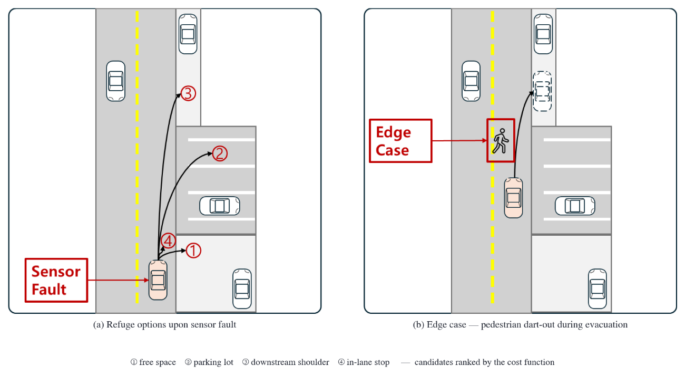
Figure 1.1. Problem setting. (a) The graded evacuation options upon sensor fault — ① free space, ② parking lot, ③ shoulder ahead, ④ in-lane stop — are ranked by a cost function. (b) Edge case of a dart-out pedestrian encounter during evacuation.
Finally, simulation-based safety claims stand only on the reliability of the collision verdict itself. This study empirically uncovered cases in which the simulator collision-sensor configuration remained silent, and in response built a dual verdict system — a real-time ledger of the ego collision sensor and a pedestrian physics oracle — as the basis of all safety conclusions (Section 4.5).
The proposed supervisory layer is an add-on layer that does not replace the stack itself. Monitoring operates solely by subscribing to sensor topics, intervention occurs only through standard interfaces, and stopping-maneuver execution is delegated to the stock stack. This non-intrusive design leaves the certification boundary of the base stack undisturbed while allowing decision- and execution-layer defects to be traced separately at the log level (Section 3.8), at the cost of execution quality being dependent on the base stack (Chapter 6).

1.2 Research Questions

RQ1. If sensor faults are estimated as a continuous health score, can the response strategy (evacuation vs. stop deferral) be selected differentially by fault kind and degree? How much does that selection reduce faulted-state exposure?
RQ2. What does a shoulder-evacuation MRM gain and lose against a stop-type MRM? What temporal structure does the trade-off between immediate collision risk and lane clearance / off-lane final position have?
RQ3. How does conservative low-speed movement under a fixed cap change safety at the dart-out encounter level, and what does its limiting condition — the transient before deceleration completes — imply?

1.3 Contribution

First, we propose a behavior-tree-based sensor monitoring module. It independently scores each sensor for freshness (timeout), quality (noise, valid ratio), and physical consistency (residuals, bias), and composes these across eight-direction spatial sectors and capability (perception, localization) layers into a continuous health score.
Second, we propose a risk/capability-aware MRM supervisor. It selects between shoulder/parking evacuation (MRM_MOVE) and deferral to the stock stop (MRM_DEFER) by health-score bands, chooses the refuge by a cost function over degraded-state exposure time, traffic-light observability, and sector deficits, and imposes a conservative fixed cap (3.0 m/s; below the model-derived bound of about 3.89 m/s) back-computed from the stopping-distance model d = vτ + v²/2a on the planning layer. The cap effect is verified at the causal level in a settled-encounter dose-response experiment (Section 5.6).
Third, we establish a dual scheme for simulation collision adjudication — the real-time ego collision-sensor ledger (RAW-HIT) and the pedestrian physics oracle — as a methodology, and identify the verdict pitfalls of runner exit labels and official infraction records.
Fourth, as a validation contribution we perform encounter-level and large-matrix verification. Using a pedestrian dart-out distance ladder we measure the per-speed avoid/collide boundary (8-11 m at 4.2 m/s, 7-8 m at 3.0 m/s) against the stopping-distance model, show through transient/settled encounter observations that residual evacuation risk concentrates in the post-detection transient, and quantify monitoring/evacuation behavior, exposure reduction, and the causal cap effect in a single closed-loop framework totalling 1,862 valid cases.
The novelty of this study lies not in the individual techniques (CUSUM, residual monitoring, noisy-OR fusion, the stopping-distance model), but in the system architecture that integrates them into a continuous health score and combines it with remaining capability, risk grace, and movement speed limiting to select MRMs in a graded manner, and in the encounter-level closed-loop demonstration whose verdict reliability is secured.

1.4 Thesis Organization

Chapter 2 reviews related standards and research; Chapter 3 describes the proposed system; Chapter 4 presents the experimental environment, fault model, adjudication methodology, and encounter designs; Chapter 5 presents results; Chapter 6 presents limitations and discussion; Chapter 7 concludes.

Chapter 2. BACKGROUND AND RELATED WORK

Related work is organized into six strands (Sections 2.1-2.6) and compared with this study in Section 2.7.

2.1 Standards and Regulatory Frameworks

The foundational frameworks of functional safety, SOTIF, and driving-automation taxonomy [1-3] and production-regulation/safety-case standards [4-7] consistently require runtime monitoring and degradation response. ISO 23793-1:2024 [51], which addresses MRM directly, specifies a type taxonomy and the principle of situation-dependent type selection but covers only the simplest types (straight-line and in-lane stops); shoulder stops are being standardized as Part 2.
As an adjacent-domain reference, the industrial driverless-truck standard ISO 3691-4 [60] combines monitored speed limits with stop functions under the principle of "limited speed for limited capability" instead of prohibiting degraded-state movement outright; the conservative low-speed MRM movement of this study (Section 3.6) transfers this principle to autonomous-driving MRM.

2.2 FTTI and the Derivation of Time Budgets

ISO 26262 (2nd ed.) defines the FTTI as the minimum time from fault occurrence to a possible hazardous event assuming no safety mechanism acts, but provides no concrete values — the FTTI is derived per safety goal, and Bosch's estimation method [8] derived 1.4-1.8 s in a lane-keeping-loss scenario. As risk metrics, TTC [9], its extensions [10], and RSS [11] are standard. This study implements this frame as a dynamic detection budget tied to driving risk (Section 3.4), and provides encounter-level evidence that residual evacuation risk concentrates in the post-detection transient (Section 5.4), supporting the need to shorten detection and response times.

2.3 Fault Detection Theory and Sensor Degradation Models

Classical FDI developed along residual generation/decision [12-15] and sequential change detection [16][17]; the LiDAR quality channel of this study borrows the CUSUM [16] (Section 3.2). These theories cover detection only; maneuver selection after detection is out of scope.
LiDAR degradation is organized by fault taxonomies [57], field measurements and physical models of soiling and rainfall [53-56], and adverse-weather simulation studies [20-23][58][59]. Our sparsification (lso) model follows measured soiling-induced detection-range reduction [55], and the clutter (lcl) model follows rain-scattering formulas [53] and near-range-biased clutter [54] (Section 4.2). Autoware preprocessing/diagnostics [18] and PCL [19] aim at outlier removal, a purpose distinct from continuous scoring of sensor condition.
The camera failure-mode taxonomy [24] is the reference for the cn/cf injections; for the IMU, separate evaluation of white noise and accumulating bias [25][26]; for GNSS, the failure-mode framework [62], urban error measurements [27], and integrity monitoring [28][29]; multipath-type correlated bias is injected following a first-order Gauss-Markov model [61].

2.4 Fallback and MRM Planning

Among safe-stop planning approaches, the trajectory-planning line [30-32] addresses parallel stop-trajectory maintenance, optimal control, and online verification, but takes the fault assessment and response choice as given. Emzivat et al. [33] proposed virtual obstacles and TTC-based deceleration as a fallback for impaired monitoring capability, and Reschka and Maurer [34] pointed out that the "safe state" is situation-dependent and an in-lane stop is not always safe — the same concern this study starts from.
The closest prior work is the sensor-fault-presupposing evacuation and adaptive MRM line. Xue et al. [49][50] presuppose a forward-sensor fault and propose safe-zone stop fallbacks under MPC constraints with a virtual-vehicle adaptive extension; Tang et al. [48] adaptively select MRM behaviors under multiple sensor faults using HAZOP risk analysis with virtual-object/TTC/THW evaluation, validated in a MATLAB-CARLA loop. The differences are threefold: (i) they presuppose the fault state whereas this study starts from online estimation of fault occurrence, kind, and severity; (ii) their selection criteria use surrounding-traffic TTC/THW whereas this study combines risk grace with remaining perception/localization capability and additionally limits the evacuation speed itself; (iii) their validation checks representative scenarios whereas this study performs closed-loop verification of 1,862 valid cases on a real stack (Autoware) with pedestrian-encounter experiments whose verdict reliability is methodologically secured.
The open-source stack Autoware [18] provides stop-type MRMs and shoulder pull-over search (goal_planner), but the evaluated version and configuration (Section 4.1) had no supervisory layer that differentially triggers responses and limits speed by health and remaining capability — that layer is the contribution of this study.

2.5 Capability-Based Self-Monitoring and Runtime Monitoring

The skill/ability graphs of Reschka et al. [35] and their development-process extension [36] model functional capabilities as hierarchical graphs for online monitoring and decision making; the sector-capability composition of this study (Section 3.3) couples capability scores directly to MRM level selection and the movement speed cap. Runtime monitor case studies [37], SMOF [38], and verification challenges [39] are adjacent lines, and behavior trees [40][41] serve as the implementation structure of the monitoring node based on BehaviorTree.CPP [42] (Section 3.1).

2.6 Simulation-Based Evaluation and Fault Injection

CARLA [43] is the standard platform for fault-injection research, and stack-targeted evaluations — DriveFI [44], resilience assessment [45], AV-FUZZER [46], Scenic [47] — inject faults to find vulnerabilities, the opposite direction from this study, in which the stack itself detects, grades, and responds to the injected faults (the same injection techniques are used here as verification means). The experimental infrastructure builds on AWCL [52], the TUM Autoware-CARLA leaderboard framework, as a fully automated harness restarting the simulator every case (Chapter 4). No prior report was found addressing the reliability of simulated collision verdicts at the methodology level; this study treats it in a formal section (Section 4.5).

2.7 Comparison with Prior Work

Table 2.1 compares the related lines with this study along six axes.

Table 2.1. Comparison of prior research lines with this study (○ explicit / △ partial or conceptual / × not addressed)
Research line (refs.) | Fault  det. | Cont.  health | Remain.  capab. | Graded  MRM sel. | Speed-lim.  move | Encounter  valid.
Standards [1-7][51][60] | Req. only | × | × | △ (taxonomy) | △ (industrial) | ×
Classical FDI [12-17] | ○ | △ (residual) | × | × | × | ×
Degradation models [20-29][53-59] | ○ (offline) | △ | × | × | × | ×
Trajectory planning [30-32] | × (given) | × | × | △ (stop traj.) | △ (decel.) | △
Fallback (Emzivat [33]) | △ | × | △ | △ | △ (TTC decel.) | ×
Fault-presupposing MRM [48-50] | × (given) | × | △ (surviving) | ○ (adaptive) | △ (decel.) | △ (scenarios)
Capability self-monitoring [34-36] | △ | ○ (capability) | ○ (concept) | △ (concept) | × | ×
Stock Autoware [18] | △ (timeouts) | × (binary) | × | △ (stop only) | × | ○
Fault-injection eval. [43-47] | × (injector) | × | × | × | × | ○
This study | ○ (11 types) | ○ (fresh×qual.) | ○ (loc/percep.) | ○ (bands) | ○ (inverted cap) | ○ (ledger-verified)

As Table 2.1 shows, studies addressing each axis exist, but no study was found that integrates online continuous health estimation of per-sensor freshness and quality, evacuation-vs-stop distinction by risk grace and remaining perception/localization capability, evacuation speed limited to a stopping-distance-inverted cap, and validation on a real stack with verdict-secured encounter experiments. The position of this study is the integrated supervisory layer from detection through selection and speed, and its empirical demonstration.

Chapter 3. PROPOSED SYSTEM

3.1 System Architecture

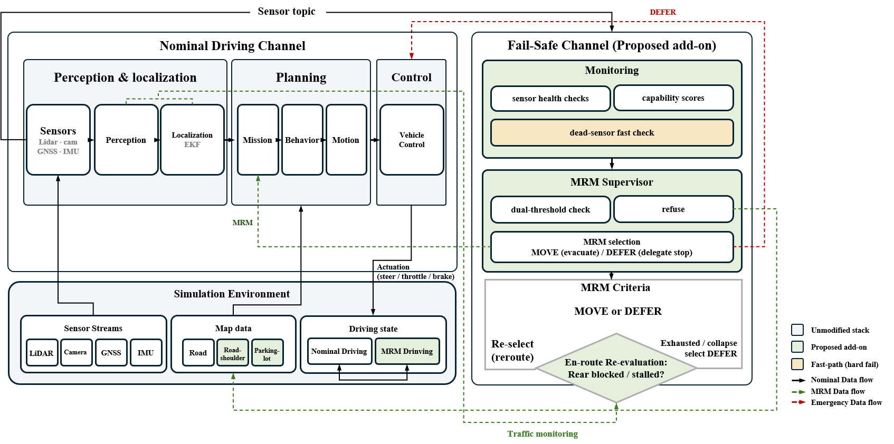
The proposed system consists of two independent nodes (Figure 3.1). The monitoring module inspects each sensor at 10 Hz on a behavior-tree basis (an implementation structure for parallel composition, module replacement, and execution tracing, not an algorithmic contribution), publishing per-sensor health scores (0-1); the detectors comprise three families — timeout (freshness), quality (noise, valid ratio), and physics (residual, bias). The MRM supervisor subscribes to the scores and runs a state machine: for evacuation it changes the route via the Autoware AD API and imposes a speed cap on the planning layer; for deferral it triggers the stock mrm_handler stop through the diagnostic graph. Stopping-maneuver execution is handled by goal_planner and mrm_handler, and main-stack modification is minimized by injecting monitoring units into the diagnostic graph.
Figure 3.1. Dual-channel structure of the proposed system. Left: the nominal driving channel of unmodified Autoware 0.39.0 (perception & localization → planning → control); right: the proposed supervisory layer. The monitoring stage subscribes read-only to sensor topics and produces health/capability scores; the decision stage selects MOVE (evacuate — reroute with a speed cap) / DEFER (delegate — inject a diagnostic ERROR) via dual-threshold checks and candidate search, and while moving re-evaluates rear occupancy and stalls, re-selecting or falling back to DEFER when exhausted. The bottom panel is the closed-loop simulation environment (CARLA). Dead sensors are decided immediately through the hard-fail fast path (Section 3.5).
Reception and evaluation cycles are separated: reception accumulates at native sensor rates (LiDAR 20 Hz, IMU 100 Hz, etc.) while evaluation runs at 10 Hz (evaluation-cycle delay ≤0.1 s). The 100 ms cycle is consistent with the AUTOSAR Watchdog Manager [7] periodic supervision structure and the decision cycle of the Autoware planning layer.

3.2 Sensor Scoring

- Freshness score
For the elapsed time age(t) since the last reception,

$timeout score=max(0, 1-age/τ_{detect})$ (1)

decays the score linearly. τ_detect is not a detection deadline but the time constant of freshness decay, tightened in coupling with driving risk (Section 3.4). Linear decay (rather than a step at expiry) lets the score cross the downstream band boundary before it is exhausted — under complete silence the capability score falls below the boundary before τ_detect fully elapses, enabling early transition. As an auxiliary device, a k-miss rule penalizes early to a "suspect" stage if nothing is received for 3× the moving median of the reception interval.

B. Quality score
For LiDAR, the standard deviation under a Gaussian assumption is recovered from the mean of neighboring-point range differences:

$σ_{est}=mean(|Δr|)×(\sqrt{π}/2),|Δr|<1m$ (2)

(the inversion of E|r1−r2| = 2σ/√π; differences over 1 m are excluded as genuine terrain boundaries). Scene-intrinsic roughness is absorbed by a baseline learned during the first 30 boot frames, but abrupt rises (over 1.5×) are not tracked so the fault cannot become its own baseline. The score is exp(−max(0, σ_est − base)/0.1) times a valid-point-ratio score — a relative anomaly score against the baseline, not an absolute noise estimator. A CUSUM sequential test (S = max(0, S + excess − k), drop when S > h) runs in parallel so detection delay is inversely proportional to fault magnitude. Camera quality applies the same structure to inter-frame pixel differences without the cumulative test (pixel difference rises naturally with scene motion). Sparsification is handled by the valid-ratio channel and clutter by the range-discontinuity channel.

C. Three localization channels
Each channel covers a different fault mode. (a) Residual channel: for the distance r between the GNSS measurement and the EKF output, loc_meas = exp(−max(0, r − base − 0.2)/0.55) (static frame offset calibrated at boot) — sensitive to GNSS noise and multipath-type correlated bias. (b) Bias channel: penalizes when the difference between 3-s means of IMU and EKF yaw rates persists above a threshold for 3 s — normal turning cancels in both signals while gyro bias remains only on the IMU side. (c) Silence channel: penalizes with exponential decay when GNSS input stops for 1 s or longer while driving — covering the residual channel's blind spot of freezing at the last value.

3.3 Spatial Sectors and Capability Synthesis

Sensor scores map to eight directional sectors (F, FL, FR, L, R, RL, RR, B) by mounting direction and field of view, fused in the monotone noisy-OR form

$sector=1-\prod_{i}{(1-s_{i})}$ (3)

(more sensors covering a sector make it more robust; the s_i are not claimed to be calibrated probabilities). Perception capability is the sector-weighted sum

$perception=\sum_{k}{w_{k}·{sector}_{k},w=\{F:0.30, FL/FR:0.15, L/R/B:0.10, RL/RR:0.05\}}$ (4)

combining obstacle perception and traffic-light observability at 0.6:0.4. The system health is

$health=min(perception, {cap}_{loc})$ (5)

following the worst capability (weakest-link principle). cap_loc is the minimum over the physical range check, position jump, and the residual/bias/silence channels. These localization channels reside in the supervisor process as an implementation matter but belong logically to the monitoring layer (the boundary in Figure 3.1 is logical). The behavior-tree composition of the monitoring module is shown in Figure 3.2.

3.4 Risk-Coupled Dynamic Detection Budget

The freshness decay time constant is coupled to driving risk:

$τ_{detect}(t)=min(τ_{fresh}, {TTC}_{cons}(t))$ (6)

The τ_detect(t) of Eq. (6) is used as the decay constant of Eq. (3.1) (τ_fresh is the nominal default); as TTC shortens the decay tightens, conservatively strengthening the detection criterion. TTC_cons is the minimum of nearest-obstacle TTC and planned-path/predicted-path crossing time, with a fail-conservative hold that decays the TTC lower bound using the last observed closing speed when the TTC source sensor is unhealthy.
We clarify the relation to the formal time-budget form. The design intent is

$T_{detect}+T_{response}+T_{margin}≤T_{hazard}$ (7)

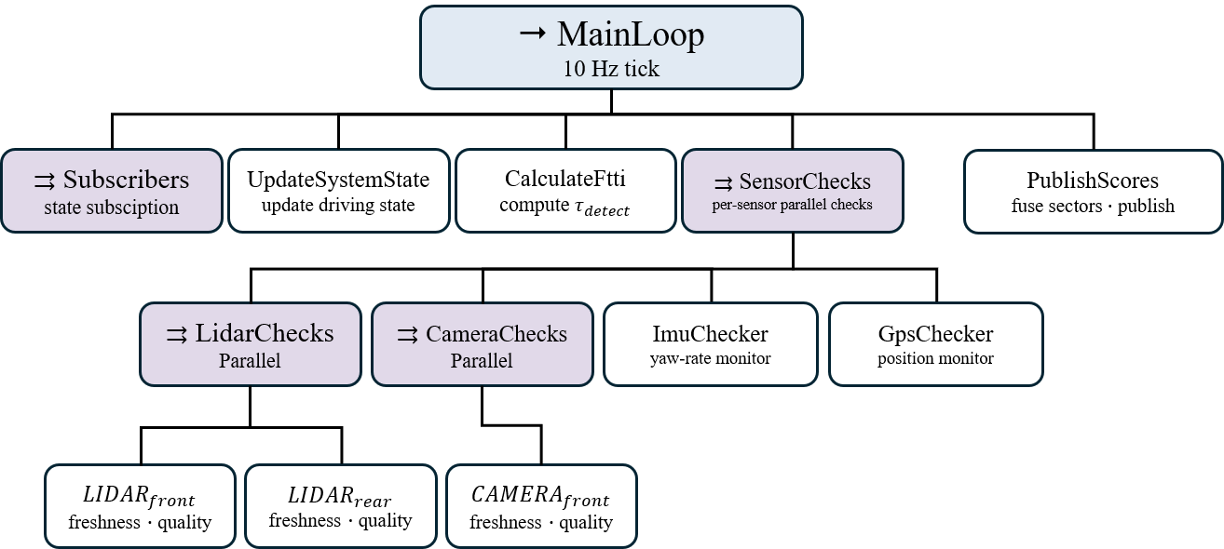
and, approximating T_hazard by the conservative TTC estimate, the strict detection deadline is TTC_cons − FRTI − margin. The current implementation is a risk-adaptive heuristic approximation that strengthens freshness decay as TTC shortens, rather than explicitly reserving FRTI and margin, and does not guarantee formal deadline compliance (explicit reservation and verification are future work — Section 6.6). Since degradation-fault detection is an accumulation of statistical evidence, the requirement is formalized as a severity curve T_detect(σ) ≤ T_hazard(σ): small faults are caught later but become hazardous later.
Figure 3.2. Behavior-tree structure of the monitoring module. The root Sequence executes state-subscription Parallel, driving-state update, detection-budget computation (Eq. 3.6), per-sensor inspection Parallel, and score publishing on every 10 Hz tick. PublishScores maps sensor scores (freshness × quality) to eight sectors, fuses them as 1−Π(1−s), and computes capability scores by weighted sum, publishing to /monitor/scores and /diagnostics (Eqs. 3.3, 3.4). Per-leaf quality-channel details follow Section 3.2.

3.5 MRM Supervisor

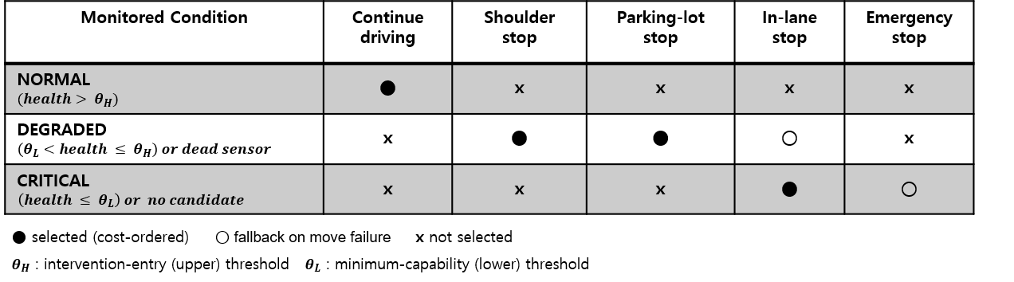
The supervisor switches its response by dual thresholds on health (upper 0.7, lower 0.3) (Figure 3.3): falling below the upper threshold triggers evacuation movement (MRM_MOVE), completion triggers evacuation parking (MRM_PARKED), and the floor or a localization-confidence collapse triggers deferral to the stock stop (MRM_DEFER). Safeguards against false activation include a post-boot health check, a route-change non-response watchdog, a candidate-stagnation blacklist, and a creep guard. Selection is not frozen while moving — sustained rear occupancy during a parking approach (within 10 m for 20 s) penalizes reversing parking candidates and demotes to a shoulder stop; stalls and non-responses get bounded retries; candidate exhaustion or an en-route health collapse falls back to DEFER (Figure 3.1).
Figure 3.3. MRM selection policy matrix by monitoring state. The dual thresholds separate NORMAL, DEGRADED, and CRITICAL; ● selection by cost order, ○ fallback on movement failure, × non-selection. A dead sensor goes directly to the degraded stage regardless of thresholds, and with no reachable candidate the state demotes to critical and defers to the stock stop.

The dual thresholds serve chattering prevention and grade separation; the decay constants were designed so that a wide insensitive gap lies between faulted and normal scores, so behavior is determined by the three-band structure rather than precise threshold placement.
The timing rules split by the nature of the evidence. Degradation (noise) faults are statistical evidence and require sustained confirmation: 1.0 s for band entry, 2.0 s at the floor (deferral is an irreversible terminal decision), and a 5.0 s recovery grace when localization confidence falls short of the movement minimum (0.5) — preventing terminal decisions on transient dips deeper than the settled value (measured 0.44 vs settled 0.58); varying the grace over 0.5-5.0 s left results unchanged (gn-mid, 10 repetitions per condition). Hard fails (confirmed death past the 850 ms freshness deadline), whose persistence of silence is itself accumulated evidence, skip these confirmations: with at least one live sensor remaining (simultaneous all-sensor silence is excluded as a frame-freeze artifact), band confirmation is skipped, and unrecoverable conditions defer immediately without grace or retry. Candidate route costs are precomputed during normal driving, removing selection latency at decision time; hard-fail decisions thus complete within the 1.5 s deadline (Section 5.7).
Refuge selection minimizes the cost (candidate layout in Figure 3.4):

$J(c)=w_{t}η(c)+w_{tl}n_{tl}(c)g(tl)+w_{sec}∑(1-{sector}_{req})+w_{loc}η(c)(1-loc)$ (8)


η(c) is the degraded-state exposure time (route time + expected wait per signal), g(tl) the traffic-light observability penalty (1/cap_tl − 1), sector_req the sector scores required to approach the candidate, and loc the localization confidence — the ISO 26262 view that risk accumulates per unit time, not distance. Route times and signal counts are computed on an in-house road-network graph parsed directly from the lanelet2 map, keeping the decision layer outside the influence of main-stack faults (signals counted by clustering stop-line regulatory elements — the discovery and correction of an initial defect is reported in Section 4.3). The key safeguard is the traffic-light observability gate: a candidate whose route passes signals no healthy camera can observe is excluded with J = ∞ (the signal-state source is selected fault-aware). Hard constraints add a minimum approach distance and minimum shoulder length; no precise tuning of the absolute weights is claimed (discrimination is dominated by the gate and approach distance).
Figure 3.4. Town07 evacuation candidate map — 16 shoulder candidates (lanelet shapes), 4 parking-lot candidates (polygons), and the reference route (dashed). Candidate route costs are computed on an in-house road-network graph; signalized intersections are subject to the observability gate.

3.6 Remaining-Capability-Based Conservative Low-Speed MRM Movement (Speed Cap)

Evacuation is movement under degraded perception, so stopping capability against a dart-out matters more than in normal driving. For an obstacle appearing at forward distance D_avail while traveling at speed v, stopping without collision requires, for reaction time τ and deceleration a,

$d_{safe}(v)=vτ+\frac{v^{2}}{2a}+d_{margin}≤D_{avail}$ (9)

Here τ≈1.5 s and a≈3.5 m/s² are not independently measured values but nominal lumped values calibrated to reproduce the measured ladder boundary (8-11 m); the formula is a design approximation for selecting the cap policy value, not a predictive safety model. In a dedicated braking experiment (fault-free stock, pedestrian at 14 m during 4.2 m/s cruise, n=5), braking onset lagged by 0.46±0.08 s with an effective deceleration of 2.87±0.20 m/s² — the onset delay is encounter-geometry-dependent (early precautionary braking under long preview vs an effective delay of ≈1.5 s in the 8 m near-boundary regime), so a single (τ, a) pair is a lumped approximation; agreement between the ladder boundary and the computed 8.8 m is a self-consistency check, not independent validation (Section 5.3). On entering MRM_MOVE the supervisor imposes a fixed 3.0 m/s cap on the planning layer, chosen in the band whose upper end is the model-inverted cap that still stops within an 8 m dart-out (≈3.9 m/s) and whose lower end is the requirement that evacuation completion time stay bounded; no optimization within the band was performed. The cap is delivered to the input side of the Autoware velocity-limit arbiter, and delivery is verified by measured vehicle speed rather than publish records — an interface mismatch that silently dropped the cap in earlier campaign runs was discovered exactly this way and corrected; the effect under an actually holding cap is verified in Section 5.6 (a health-proportional cap is implemented but unused — Table 4.3).

3.7 MRM Candidate Map Annotation

The refuge candidate layer (shoulders, parking lots) was built by manual annotation of road_shoulder/parking_lot subtypes on the lanelet2 map (criteria: minimum shoulder length to complete the maneuver, mainline connectivity, entry-polygon/goal consistency). Shoulder candidates are lanelets sharing a boundary with the mainline; parking-lot candidates are closed polygons; manual annotation limits the verification scope to the annotated segments (Chapter 6).

3.8 Boundary and Interface with the Execution Layer

The system's responsibility covers detection, decision, candidate selection, and the speed cap ("whether to evacuate, where, when, how fast"), delegating stopping-maneuver execution to Autoware. In MRM_MOVE the evacuation goal is delivered via AD API route resetting, executed by mission_planner replanning and the goal_planner pull-over (the shoulder-entry maneuver is a stock capability, unmodified in this work); in MRM_DEFER an ERROR is injected into the diagnostic graph to trigger the stock mrm_handler stop (a boundary separating decision from execution).

Chapter 4. EXPERIMENTAL ENVIRONMENT AND DESIGN

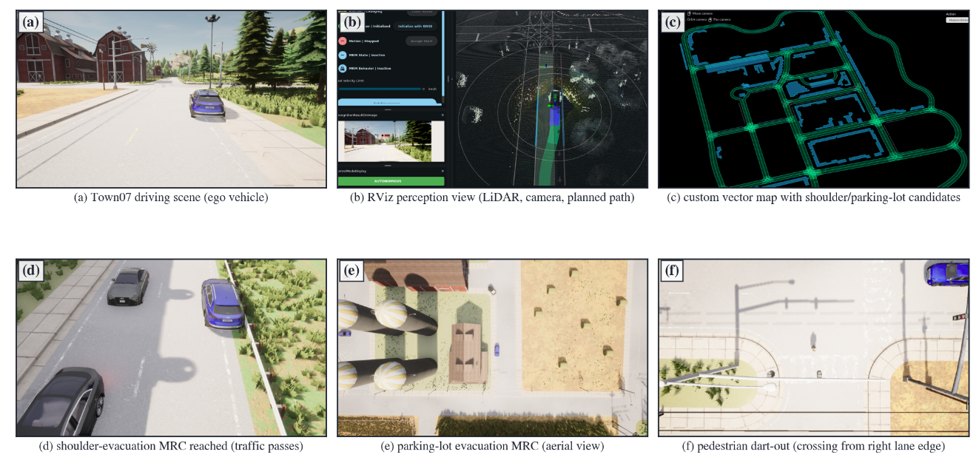
4.1 Experimental Environment
Figure 4.1. Representative execution views (actual run captures): (a) Town07 driving, (b) RViz perception, (c) candidate-annotated vector map, (d) shoulder-evacuation MRC (following traffic passing), (e) overhead view of parking-lot MRC, (f) pedestrian dart-out encounter (Section 4.4).

The stage is a closed loop coupling CARLA 0.9.16 and Autoware 0.39.0 (Figure 4.1). The integration builds on AWCL [52], the TUM Autoware-CARLA leaderboard framework (C++ bridge, vehicle digital twin, scenario runner); CARLA runs on the host and the bridge, leaderboard, and Autoware in independent containers. The map is a custom Town07 vector map annotated with shoulder/parking candidates, the speed limit 15 km/h (4.2 m/s), and the simulator is fully restarted every case for independence (CARLA_RESTART_EVERY=1).
A common runner automates the experiments; a case is defined by {method, fault, severity, traffic, repetition, injection time}. Methods are ours (proposed supervisor), baseline (same detection, deferral to the stock stop-type MRM), and mrm-off (non-intervention observation — passive scoring only). Baseline shares identical detection with the proposal to separate the response-strategy effect from detection performance; "no detection at all" is provided by mrm-off. The runner manages process lifetimes and archives per-case logs for post-hoc re-adjudication.
A ROS-topic-based automatic adjudicator classifies each case's termination into management labels (shoulder/parking evacuation completed, stock stop-type MRM completed, stalled during evacuation, hazard-event contact, hazardous stop, incident-free persistence, infrastructure failure) and records stop coordinates, lane occupancy, detection latency, faulted-state distance, and official collision records as CSV. The exit label is a first-pass management classification only, never the basis of safety adjudication (basis and pitfalls in Section 4.5).

4.2 Fault Model

Faults are injected inside the agent's sensor pipeline (Table 4.1 — reference literature and physical models in the injection-method column). The early simple Gaussian range noise (ln) was retired for weak correspondence to real fault modes and replaced by two physical models (lso, lcl). Injection times are drawn from deterministic case-key seeds for reproducibility; in the encounter experiments even the fault-waveform randomness is seed-fixed (FAULT_SEED) so paired conditions of the same seed experience an identical fault realization.

Table 4.1. Fault model
Abbrev. | Fault | Injection method | Severity
cf | Camera death | Frame transmission halted | -
cn | Camera noise | Gaussian pixel noise | low/mid/high
lf | LiDAR death | Point-cloud transmission halted | -
lso | LiDAR sparsification | Contamination-type dropout (physical model [55]) | low/mid/high
lcl | LiDAR clutter | Rain-scattering spurious returns (models [53][54]) | low/mid/high
gn | GNSS position noise | Gaussian position noise (EKF input) | low/mid/high
gb | GNSS correlated bias | First-order Gauss-Markov bias [61] | mid/high
imn | IMU noise | Gyro white noise | low/mid/high
imb | IMU gyro bias | Step-type constant bias | mid/high
imd | IMU bias drift | Time-proportional ramp | mid/high
gf | GNSS outage | Input silence | -

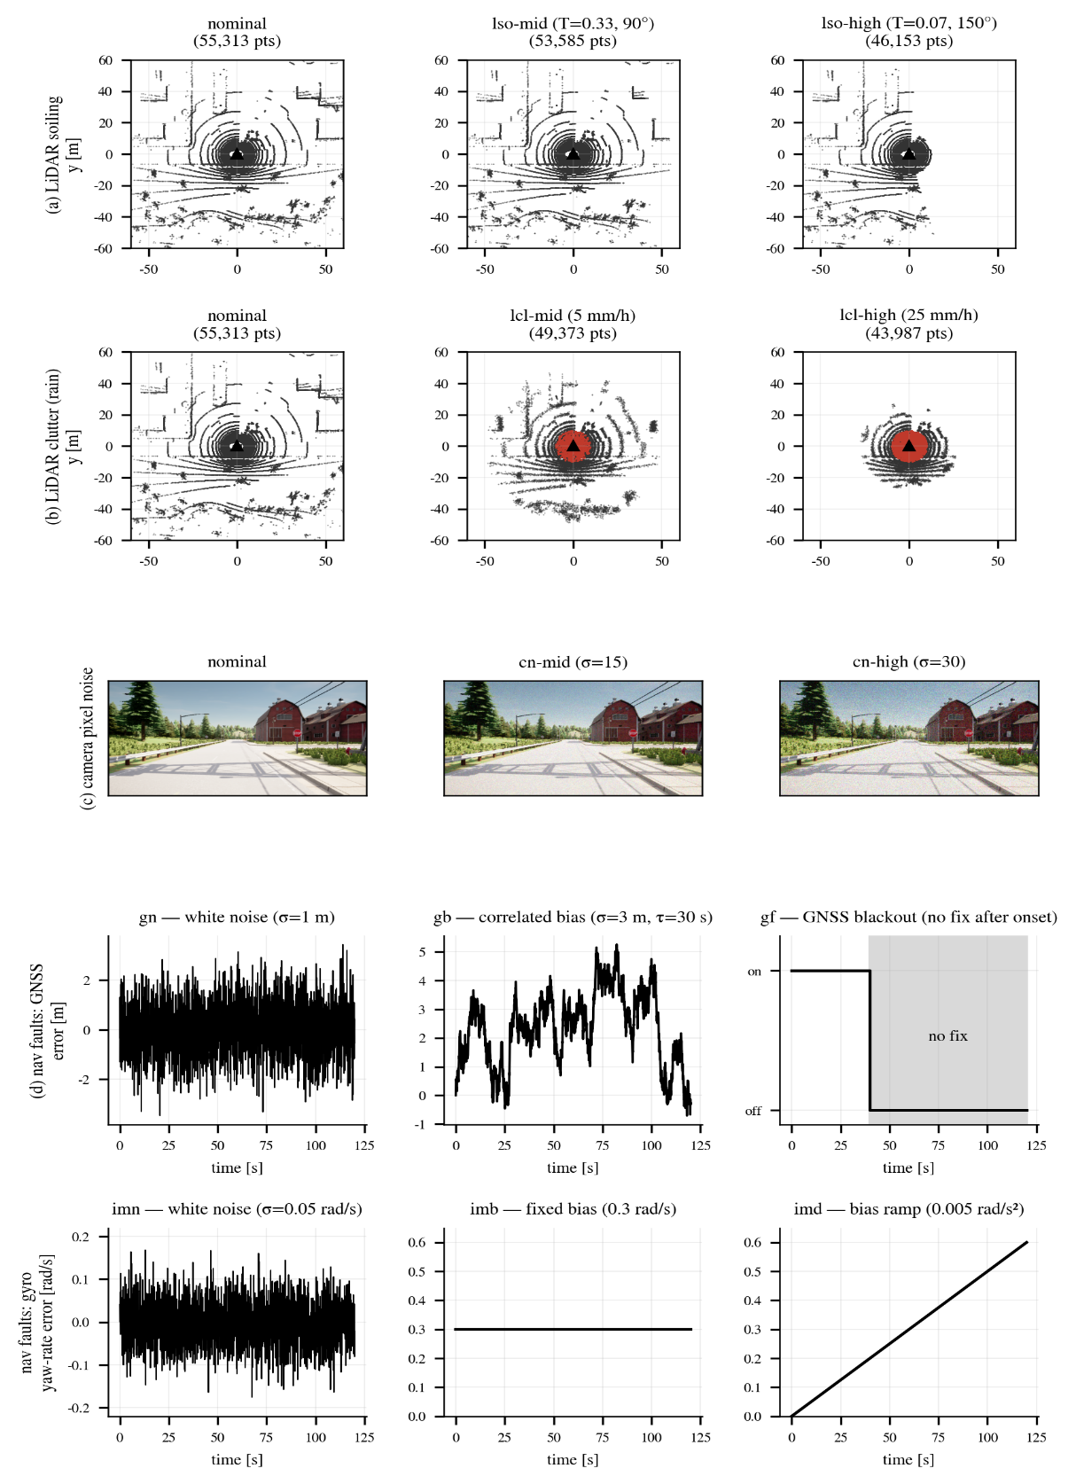
Figure 4.2. Sensor-level effects of fault injection — the injector's own physics applied to one measured Town07 LiDAR scan and camera frame (before/after). (a) LiDAR sparsification (lso), (b) LiDAR clutter (lcl, spurious returns in red), (c) camera pixel noise (cn), (d) GNSS fault waveforms (gn/gb/gf), (e) gyro fault waveforms (imn/imb/imd). Panel parameters are the injector's raw values for the severity definitions (representative values in Table 4.3).
4.3 Main Campaign Matrix

The main campaign is a fault × severity × traffic density (none/def/agg) × method (ours/baseline) × repetition matrix, executed serially by a battery script with infrastructure failures re-collected via a retry chain. The total valid count is 1,131 (39 short of the 1,170 plan, all in lcl-high — Table 4.2). This includes a full re-run of the 450 affected camera/navigation cases after a traffic-light miscount defect in the refuge cost function was uncovered and fixed (clustering method of Section 3.5) — the disclosure lets follow-up research treat map annotation quality as a hidden confounder of refuge selection.

Table 4.2. Main-campaign case accounting

This is example 1 of an equation:

$I_{d}=\frac{1}{2}\frac{W}{L}μC_{ox}{(V_{G}-V_{th})}^{2}$ (1)

The $C_{ox}$ was oxide capacitance, $μ$ was mobility, $V_{G}$ was gate voltage applied from parameter analyzer…

Figure 1.1. (A), (B), (C)…

Figure 1.1. This is a figure. Schemes follow another format. If there are multiple panels, they should be listed as: (A) Description of what is contained in the first panel; (B) Description of what is contained in the second panel. Figures should be placed in the main text near to the first time they are cited

Table 1.1. This is a table. Tables should be placed in the main text near to the first time they are cited

Title 1 | Title 2 | Title 3
entry 1 | data | data
entry 1 | data | data
entry 2 | data | data
entry 2 | data | data

References (16p)
(If the contents in this chapter are under review or already published, please write this sentence.)
* The contents of this chapter are in revision in Nature.
* The contents of this chapter were published in Science, 2019, 8, 1801660, IEEE Access, 2020, 12, 10456, and Nature Electronics, 2020, 328, 350.

List references here.(11P)
1. Author 1, A.B. et al. Title of the article (Capitalize the first alphabet only). Abbreviated Journal Name, Volume, page range (Year).
2. Author 2, C.D. et al. Title of the article. Abbreviated Journal Name, Volume, page range (Year).

Appendix (16p)

<Appendix 1> title(14p)
<Appendix 2> title(14p)

If you need Appendix, please use same form with main body text.
If you don’t have Appendix, Please delete this page.

논문요약

논문제목을 작성하시오(16P)

제출자 성명(11p)
OO학과(11p)
성균관대학교(11p)

여기부터 본문을 국문으로 작성하시기 바랍니다. 각 문단의 시작은 2space를 띄우고 작성하시기 바랍니다.

주제어: , , , ,

(Side Cover form표지측면 서식)
Master’s Thesis
Thesis title
2
0
2
6
영문성명(ex: Gilsan Jang)
(제본시에만 사용하세요.
온라인 제출 시 삭제 바랍니다.)
(Use only for binding. Please remove
this page when submitting online.)

