학위논문 작성 유의사항

※ 논문업로드 전 반드시 지도교수의 확인 후 업로드 하시기 바랍니다.
※ 논문 작성은 아래 표의 논문규격과 작성글자체를 참조하여 작성바랍니다.
(논문규격, 글자체, 문단모양, 글자모양은 변경 불가능)
※ 5page의 논문목차부터는 논문 작성 예시로 항목구성, 본문구성 및 내용작성(표/그림 포함), 참고문헌표기법 등은 정해진 서식이 아니므로 수정 가능 합니다.
※ 논문업로드 시 본 페이지는 삭제 후 업로드 하세요.

1. 논문 규격 : A4 규격(210mm*297mm) (본문 38자 × 25행)
 | 위 | 아래 | 머리말 | 꼬리말 | 왼쪽 | 오른쪽 | 제본
한글 | 38.0mm | 38.0mm | 15.0mm | 15.0mm | 30.0mm | 30.0mm | 0
Word | 5.3cm | 5.3cm |  |  | 3cm | 3cm | 0cm

2. 작성글자체 : 명조, 신명조, 휴먼명조
◎ 문단모양 : 들여쓰기 3space, 본문 줄간격 200%(한글), 정렬방식 혼합
◎ 글자모양 :
▷ 큰 제 목 : 16point, 신명조, 진하게(가운데)
▷ 중간제목 : 14point, 신명조, 진하게
▷ 본 문 : 11point, 신명조
▷ 각 주 : 9point, 신명조

3. 항목구분번호 : 일정한 순서를 지켜 작성(하단 Box 예시 참조)
구분 | 예시A | 예시B | 크기 및 정렬
항목구성예시  (중간항목  생략가능 및 띄어쓰기 조정가능) | 제1장  제1절  1.  가.  1)  가) | Ⅰ.  1.  A.  1)  a.  (1) | 16p 진하게 가운데정렬  14p 진하게  11p (진하게)  11p  11p  11p

※ 본 페이지는 전자전기컴퓨터공학과 본심 대상자만 작성바랍니다.
학위 논문 제목 | 자율주행 차량의 페일세이프 운행을 위한 연속 센서 건강도 감시와 위험·잔여능력 기반 단계적 최소위험기동 감독
학과 | 전자전기컴퓨터공학과
학번 | 2025712335
이름 | 엄태욱
지도교수 | 국태용

1. 논문 요약 (Abstract)

자율주행 시스템의 센서 고장 대응은 대부분 "즉시 차로 내 정지"라는 단일 전략에 의존한다. 그러나 차로 내 정지는 후속 교통의 차단과 2차 충돌 위험을 만들고, 반대로 고장 상태의 계속 주행은 열화된 지각으로 위험에 노출되는 거리를 늘린다. 본 논문은 센서 고장을 이분법이 아닌 연속 건강도 점수로 추정하는 행동트리(Behavior Tree) 기반 감시 모듈과, 고장의 종류·정도와 잔여 기동 능력에 따라 갓길·주차장 대피(MRM_MOVE)와 순정 정차 위임(MRM_DEFER)을 구분 선택하고 대피 이동 중 보수적 고정 속도 상한(3.0 m/s)을 부과하는 MRM 감독자로 구성된 단계적 고장 대응 프레임워크를 제안한다.
검증은 Autoware 0.39.0과 CARLA 0.9.16의 폐루프 환경(Town07, 제한속도 15 km/h)에서 수행하였다. 총 1,862 유효 케이스의 단일 폐루프 실험으로 감시·대피 거동을 검증하였고, 고장 상태 주행거리(노출)를 무감시 순정의 대표 관찰 238~251 m 대비 감시+대피의 32~58 m로 단축함을 보였다(라이다 클러터는 275→11~12 m). 하드 페일은 고속 판정 경로로 1.5 s 설계 마감 안에 판정되며(실측 최대 1.20 s), 항법 고장 4종을 포함한 전 조건에서 100% 검출을 확인하였다. 안전성은 에고 충돌 센서 실시간 원장(RAW-HIT)과 보행자 물리 오라클의 이중 판정 체계 위에서 보행자 돌발 조우 수준으로 정량화하였다: 회피/충돌 경계는 4.2 m/s에서 8~11 m(모델 8.8 m와 일치), 3.0 m/s에서 7~8 m였다.
고장 상태의 8 m 조우 재현에서 순정 지속 주행은 전량 충돌한 반면 제안 저속 정착 순항은 전량 회피했고(0/10 대 8/8), 같은 정책도 감속 과도구간 조우에서는 충돌했다(2/2). 상한이 실제 성립한 정착 조우의 용량-반응 실험(상한 3종×거리 4종×10시드=120런, 사전 지정 1차 종결점)에서 상한 4.2 대 3.0 m/s는 8 m 쌍대 불일치 10:0(exact McNemar p=0.002)으로 충돌 감소 효과가 검출되었고, 회피/충돌 경계는 상한을 낮출수록 단조로 안쪽 이동했다(9 m 초과→약 7 m). 즉 최소위험기동의 선택은 즉시 충돌 위험과 차선 반환·차선 밖 대피 위치 확보 가능성 사이의 시간적 트레이드오프이며, 대피의 잔존 위험은 감지 후 과도구간에 집중된다 — 더 이른 감지와 더 빠른 감속이 전체 고장 대응 위험 창을 축소할 것임을 실험적으로 뒷받침하는, FTTI 이내 여유 확보 필요성에 대한 조우 수준의 정량적 근거를 제공한다.

Key Words: 자율주행, 페일세이프, 최소위험기동(MRM), 센서 고장 감지, FTTI

2. 논문 기여도 (Contribution)
학위 논문에서 소개된 대표적인 기존 연구들과 학위 논문에서 수행된 연구와의 차이점, 학위 논문의 학술적/기술적 기여도를 정량적/정성적으로 기술해 주십시오. 논문 기여도 작성 시 아래의 표를 이용해 주십시오.
기존 연구 | 학위 논문과의 차이점
[1] | Tang 등(Systems, 2026)은 복수 센서 고장에서 HAZOP 위험 분석과 TTC/THW 평가로 MRM 행동을 적응 선택한다. 본 논문은 고장 상태를 전제하지 않고 온라인 감시로 고장의 발생·종류·심각도 추정부터 수행하며, 잔여 지각·측위 능력을 결합해 대피/정차를 구분하고 대피 이동 속도까지 제한한다.
[2] | Xue 등(IV 2018, JICV 2019)은 전방 센서 고장을 전제로 MPC 안전 제약 하의 안전 구역 정차 폴백을 제안한다. 본 논문은 실제 오픈소스 스택(Autoware) 위 1,862 유효 케이스의 폐루프 검증과 판정 신뢰성이 확보된 보행자 조우 실험(용량-반응 120런, exact McNemar p=0.002)으로 검증 수준을 달리한다.
[1] J. Tang, C. Yang, and H. Nishimura, "Minimum risk maneuver strategy for automated driving system under multiple conditions of sensor failure," Systems, vol. 14, no. 1, 87, 2026.
[2] W. Xue, B. Yang, T. Kaizuka, K. Nakano, "A fallback approach for an automated vehicle encountering sensor failure in monitoring environment," IEEE IV, 2018.

학술적/기술적 기여도
정량적 측면 | 총 1,862 유효 케이스 단일 폐루프 검증; 검출률 96~100%(감내 설계 1개 조건 제외)·오발동 0/45; 고장 상태 노출 238~275 m → 11~58 m 단축; 하드 페일 판정 1.5 s 마감 내 완료(최대 1.20 s); 속도 상한 인과 효과 검출(8 m 쌍대 불일치 10:0, exact McNemar p=0.002), 회피/충돌 경계 단조 이동(9 m 초과→약 7 m).
정성적 측면 | 연속 건강도·잔여능력 기반 단계적 MRM 선택이라는 감독 계층 아키텍처(비침습 add-on); 시뮬레이션 충돌 판정의 이중 체계(실시간 원장+물리 오라클)와 판정 함정 규명이라는 방법론적 기여; 감지 후 과도구간에 잔존 위험이 집중됨을 보인 조우 수준 관찰(FTTI 내 여유 확보 필요성의 정량 근거).

3. 논문 발표 실적 (Publications and Awards)
학술지, 학회에 발표한 논문, 특허, 수상 실적을 아래 목록에 맞춰서 기재해 주십시오. 그 외 실적의 경우도 기재해 주십시오 (IEEE Trans. 형식의 reference 형태로 정리).

1) 국제 저널 실적
[1] Tae Wook Eum, Jun Hyeon Choi, Ye Chan An, Jin Ho Kim, and Tae Yong Kuc, "Visible-Face-Aware Weighted Anchor Refinement with Utility-Guided Selective Correction for Monocular 3D Object Detection," IEEE Transactions on Intelligent Vehicles (under review), 2026.
[2] Tae Wook Eum, Jun Hyeon Choi, Ye Chan An, Jin Ho Kim, and Tae Yong Kuc, "Graded Fault Response for Autonomous Driving via Continuous Sensor Health Monitoring and Risk/Capability-Aware MRM Supervision," IEEE Robotics and Automation Letters (submitted), 2026.

2) 국내 저널 실적
[1] 김진호, 엄태욱, 서동수, 최준현, 안예찬, 국태용, "차량 내 다중 센서 시간 오차 정합을 위한 시멘틱 기반 오프셋 추정 방법," 대한임베디드공학회논문지, 제20권 제4호, pp. 183-192, 2025.

3) 국제 학회 실적
[1] Tae Wook Eum, Jun Hyeon Choi, Ye Chan An, and Tae Yong Kuc, "Behavior Tree-Based Fail-Safe Mechanism for Autonomous Vehicles Using Digital Twin," in Proc. International Conference on Control, Automation and Systems (ICCAS), 2025.
[2] Tae Wook Eum, Jun Hyeon Choi, Ye Chan An, and Tae Yong Kuc, "Building CARLA Digital Twin Maps Directly from LiDAR-Only Point Clouds," in Proc. International Symposium on Advanced Intelligent Systems (ISIS), 2025.
[3] Tae Wook Eum, Jun Hyeon Choi, Ye Chan An, and Tae Yong Kuc, "Real-time Sensor Diagnosis and Behavior Tree-based Fault Handling Framework using ROS2 CDR Data Parsing," in Proc. IEEE International Conference on Ubiquitous Robots (UR), 2026.

4) 국내 학회 실적
[1] 엄태욱, 최준현, 안예찬, 국태용, "다중 센서 자율주행 차량을 위한 행동 트리 기반 의사결정 페일세이프 매커니즘," 한국지능시스템학회(KIIS) 춘계학술대회, 2025.
[2] 엄태욱, 최준현, 안예찬, 국태용, "자율주행 차량을 위한 위험도 기반 갓길 주차 페일세이프 매커니즘의 CARLA 시뮬레이터 기반 검증," 제어로봇시스템학회(ICROS) 학술대회, 2025.
[3] 엄태욱, 최준현, 안예찬, 국태용, "HD Map 기반 CARLA 시뮬레이터 초정밀 디지털트윈 맵 생성," 한국ITS학회 학술대회, 2025.
[4] 엄태욱, 최준현, 안예찬, 국태용, "모바일 로봇의 안전 운용을 위한 비헤이비어 트리 기반 페일세이프 구조," 한국지능시스템학회(KIIS) 추계학술대회, 2025.
[5] 엄태욱, 최준현, 안예찬, 국태용, "LiDAR 보정 신뢰도 피드백 기반 적응적 3D 다중 객체 추적," 한국자동차공학회(KSAE) 춘계학술대회, 2026.
5) 특허 및 수상 실적
6) 기타 실적

Master’s Thesis
Continuous Sensor Health Monitoring and Risk/Capability-aware Graded MRM Supervision For Fail-Safe Operation of Autonomous Vehicles
Taewook Eum

Department of Electrical and Computer Engineering
The Graduate School
Sungkyunkwan University

Master’s Thesis
Continuous Sensor Health Monitoring and Risk/Capability-aware Graded MRM Supervision
For Fail-Safe Operation of Autonomous Vehicles
Taewook Eum

Department of Electrical and Computer Engineering
The Graduate School
Sungkyunkwan University

Continuous Sensor Health Monitoring and Risk/Capability-aware Graded MRM Supervision
For Fail-Safe Operation of Autonomous Vehicles

Taewook Eum
A Master's Thesis Submitted to the Department of Electrical and Computer Engineering and the Graduate School of Sungkyunkwan University in partial fulfillment of the requirements for the degree of Master of Science in Engineering

February 2027

Supervised by
Taeyong Kuc
Major Advisor

(Approval form 인정서 서식)
This certifies that the Master's Thesis
of Taewook Eum is approved.
심사위원장 signature
Committee Chair : Name
심사위원 signature
Committee Member : Taeyong Kuc
지도교수 signature
Major Advisor : Name
The Graduate School
Sungkyunkwan University
February 2027(*If you graduate August 2026, please write June 2026.)

Table of Contents
Abstract | ························ |  |  |  |  |  |  | i
1. Introduction | ························ |  |  |  |  |  |  | 1
1.1 Research Background |  | ···················· |  |  |  |  |  | 8
1.2 Research Questions |  | ···················· |  |  |  |  |  | 8
1.3 Contribution | ························ |  |  |  |  |  |  | 8
1.4 Thesis Organization |  | ···················· |  |  |  |  |  | 8
2. Background and Related Work |  |  | ·················· |  |  |  |  | 8
2.1 Standards and Regulatory Frameworks |  |  |  |  | ············· |  |  | 8
2.2 FTTI and the Derivation of Time Budgets |  |  |  |  | ········ |  |  | 8
2.3 Fault Detection Theory and Sensor Degradation Models |  |  |  |  |  |  | ·· | 8
2.4 Fallback and MRM Planning |  |  | ·················· |  |  |  |  | 8
2.5 Capability-Based Self-Monitoring and Runtime Monitoring |  |  |  |  |  |  | ·· | 8
2.6 Simulation-Based Evaluation and Fault Injection |  |  |  |  | ········ |  |  | 8
2.7 Comparison with Prior Work |  |  | ·················· |  |  |  |  | 8
3. Proposed System | ························ |  |  |  |  |  |  | 8
3.1 System Architecture |  | ···················· |  |  |  |  |  | 8
3.2 Sensor Scoring | ························ |  |  |  |  |  |  | 8
3.3 Spatial Sectors and Capability Synthesis |  |  |  |  | ············· |  |  | 8
3.4 Risk-Coupled Dynamic Detection Budget |  |  |  |  | ········ |  |  | 8
3.5 MRM Supervisor | ························ |  |  |  |  |  |  | 8
3.6 Conservative Low-Speed MRM Movement (Speed Cap) |  |  |  |  |  |  | ·· | 8
3.7 Implementation Boundary and Map Annotation |  |  |  |  | ········ |  |  | 21
4. Experimental Environment and Design |  |  |  |  | ········ |  |  | 23
4.1 Experimental Environment |  |  |  |  | ········ |  |  | 23
4.2 Fault Model | ························ |  |  |  |  |  |  | 24
4.3 Main Campaign Matrix |  |  | ·················· |  |  |  |  | 26
4.4 Pedestrian Dart-out Encounter Injector |  |  |  |  | ········ |  |  | 27
4.5 Collision Adjudication Methodology |  |  |  |  | ········ |  |  | 28
4.6 Distance Ladder and 8 m Encounter Experiment Design |  |  |  |  |  |  | ·· | 30
4.7 Metrics and Statistics |  |  | ·················· |  |  |  |  | 30
4.8 Reproducibility: Key Experimental Parameters |  |  |  |  |  |  | ·· | 31
5. Experimental Results |  | ···················· |  |  |  |  |  | 33
5.1 Main Campaign: Detection Performance and Per-Fault Behavior |  |  |  |  |  |  | ·· | 33
5.2 Exposure Metric: Degraded-State Driving Distance |  |  |  |  |  |  | ·· | 38
5.3 Distance Ladder: Measuring the Avoid/Collide Boundary |  |  |  |  |  |  | ·· | 38
5.4 The 8 m Encounter: Low-Speed MRM versus Stock |  |  |  |  |  |  | ·· | 40
5.5 Low-Speed Ladder: Shift of the Boundary |  |  |  |  | ········ |  |  | 41
5.6 Causal Verification of the Speed Cap: Dose-Response Experiment |  |  |  |  |  |  | ·· | 42
5.7 Hard-Fail Decision Latency: Verifying the 1.5 s Deadline |  |  |  |  |  |  | ·· | 44
6. Limitations and Discussion |  |  |  |  | ········ |  |  | 45
6.1 Temporal Trade-off, Transient Risk, and Speed Cap |  |  |  |  |  | ···· |  | 45
6.2 Lessons for Adjudication Methodology |  |  |  | ··········· |  |  |  | 45
6.3 The Cost of Design Conservatism and the Execution and Map Layers |  |  |  |  |  |  | ·· | 46
6.4 Limitations | ························ |  |  |  |  |  |  | 47
7. Conclusion | ························ |  |  |  |  |  |  | 49
References | ························ |  |  |  |  |  |  | 51
Korean Abstract | ························ |  |  |  |  |  |  | 56
Abstract | ························ |  |  |  |  |  | v
1. Introduction | ························ |  |  |  |  |  | 1
1.1 Research Background |  | ···················· |  |  |  |  | 1
1.2 Research Questions |  | ···················· |  |  |  |  | 3
1.3 Contribution | ························ |  |  |  |  |  | 4
2. Background and Related Work |  |  |  | ············· |  |  | 5
2.1 Standards and Regulatory Frameworks |  |  |  |  | ········· |  | 6
2.2 FTTI and the Derivation of Time Budgets |  |  |  |  | ········· |  | 6
2.3 Fault Detection Theory and Sensor Degradation Models |  |  |  |  |  | ···· | 7
2.4 Fallback and MRM Planning |  |  |  | ············· |  |  | 7
3. Proposed System |  | ···················· |  |  |  |  | 11
3.1 System Architecture |  | ···················· |  |  |  |  | 11
3.2 Sensor Scoring |  | ···················· |  |  |  |  | 13
3.3 Spatial Sectors and Capability Synthesis |  |  |  |  |  | ···· | 14
3.4 Risk-Coupled Dynamic Detection Budget |  |  |  |  | ········· |  | 15
3.5 MRM Supervisor |  | ···················· |  |  |  |  | 17
3.6 Conservative Low-Speed MRM Movement (Speed Cap) |  |  |  |  |  | ···· | 21
3.7 Implementation Boundary and Map Annotation |  |  |  |  |  | ···· | 22
4. Experimental Environment and Design |  |  |  |  | ········· |  | 22
4.1 Experimental Environment |  |  |  | ············· |  |  | 23
4.2 Fault Model | ························ |  |  |  |  |  | 24
4.3 Main Campaign Matrix |  |  | ·················· |  |  |  | 27
4.4 Pedestrian Dart-out Encounter Injector |  |  |  |  | ········· |  | 28
4.5 Collision Adjudication Methodology |  |  |  |  | ········· |  | 28
4.6 Distance Ladder and 8 m Encounter Experiment Design |  |  |  |  |  | ···· | 29
4.7 Metrics and Statistics |  |  | ·················· |  |  |  | 30
4.8 Reproducibility: Key Experimental Parameters |  |  |  |  |  | ···· | 31
5. Experimental Results |  | ···················· |  |  |  |  | 32
5.1 Main Campaign: Detection Performance and Per-Fault Behavior |  |  |  |  |  | ···· | 32
5.2 Exposure Metric: Degraded-State Driving Distance |  |  |  |  |  | ···· | 38
5.3 Distance Ladder: Measuring the Avoid/Collide Boundary |  |  |  |  |  | ···· | 38
5.4 The 8 m Encounter: Low-Speed MRM versus Stock |  |  |  |  |  | ···· | 40
5.5 Low-Speed Ladder: Shift of the Boundary |  |  |  |  | ········· |  | 42
5.6 Causal Verification of the Speed Cap: Dose-Response Experiment |  |  |  |  |  | ···· | 42
5.7 Hard-Fail Decision Latency: Verifying the 1.5 s Deadline |  |  |  |  |  | ···· | 45
6. Limitations and Discussion |  |  |  | ············· |  |  | 46
6.1 Temporal Trade-off, Transient Risk, and Speed Cap |  |  |  |  |  | ···· | 46
6.2 Lessons for Adjudication Methodology |  |  |  |  | ········· |  | 47
6.3 The Cost of Design Conservatism and the Execution/Map Layers |  |  |  |  |  | ···· | 47
6.4 Limitations | ························ |  |  |  |  |  | 48
7. Conclusion | ························ |  |  |  |  |  | 49
References | ························ |  |  |  |  |  | 50
논문요약 (Korean Abstract) |  | ···················· |  |  |  |  | 57

List of Tables
Table 2.1 | ························· | 15
Table 4.1 | ························· | 20
Table 4.2 | ························· | 15
Table 4.3 | ························· | 20
Table 5.1 | ························· | 15
Table 5.2 | ························· | 20
Table 5.3 | ························· | 15
Table 5.4 | ························· | 20
Table 5.5 | ························· | 15
Table 2.1. | ························· | 9
Table 4.1. | ························· | 25
Table 4.2. | ························· | 27
Table 4.3. | ························· | 31
Table 5.1. | ························· | 33
Table 5.2. | ························· | 37
Table 5.3. | ························· | 39
Table 5.4. | ························· | 43
Table 5.5. | ························· | 45

List of Figures
Fig.1.1 | ························· | 8
Fig.3.1 | ························· | 11
Fig.3.2 | ························· | 12
Fig.3.3 | ························· | 12
Fig.3.4 | ························· | 12
Fig.4.1 | ························· | 12
Fig.4.2 | ························· | 12
Fig.5.1 | ························· | 12
Fig.5.2 | ························· | 12
Fig.5.3 | ························· | 12
Fig.5.4 | ························· | 12
Fig. 1.1. | ························· | 3
Fig. 3.1. | ························· | 12
Fig. 3.2. | ························· | 15
Fig. 3.3. | ························· | 18
Fig. 3.4. | ························· | 20
Fig. 4.1. | ························· | 23
Fig. 4.2. | ························· | 26
Fig. 5.1. | ························· | 35
Fig. 5.2. | ························· | 37
Fig. 5.3. | ························· | 41
Fig. 5.4. | ························· | 44

Abstract
Continuous Sensor Health Monitoring and
Risk/Capability-aware Graded MRM Supervision
for Fail-Safe Operation of Autonomous Vehicles

Sensor-fault handling in automated driving stacks largely relies on a single strategy — an immediate in-lane stop — which leaves the vehicle obstructing traffic, while undetected faults let the vehicle keep driving with degraded perception. This thesis proposes a graded fault-response framework consisting of (1) a behavior-tree-based monitor that estimates per-sensor health as continuous scores from freshness, quality, and physics channels, and (2) a supervisor that selects between shoulder/parking-lot evacuation (MRM_MOVE) and deferral to the stock stop (MRM_DEFER) according to fault type, severity, and remaining capability, and enforces a conservative fixed speed cap (3.0 m/s, below the model-derived upper bound of about 3.89 m/s from the stopping-distance model) during evacuation.
The framework was evaluated in a closed loop of Autoware 0.39.0 and CARLA 0.9.16 (Town07, 15 km/h speed limit). A total of 1,862 valid cases verified the monitoring and evacuation behavior: the detectors achieved 96-100% detection in every fault condition except by-design-tolerated mid LiDAR sparsification, with median detection latencies of about 1.0 s for hard fails (ledger re-measurement, simulation time) and 2.1-5.0 s for degradation faults (wall clock), zero false activations in 45 fault-free cases, and supervision reduced degraded-state driving exposure from 238-251 m (unmonitored representative observation, one run per fault type) to 32-58 m (LiDAR clutter 275 m to 11-12 m). Safety was quantified at the encounter level with a dual collision-verdict system — a real-time ego collision-sensor ledger (RAW-HIT) and a pedestrian-physics oracle — introduced after empirically discovering that a collision sensor attached to the pedestrian never fired.
Distance-ladder experiments located the avoid/collide boundary at 8-11 m for 4.2 m/s driving (consistent with the model prediction of 8.8 m) and at 7-8 m for 3.0 m/s (the model value 5.79 m is a lower-bound approximation). In fault-state 8 m encounter reproductions, native continuation collided in every run while the proposed low-speed settled cruise avoided in every run (0/10 vs 8/8), and the same policy collided during the deceleration transient (2/2). A dose-response experiment restricted to settled encounters where the cap actually held (3 caps × 4 spawn distances × 10 seeds = 120 runs, pre-specified primary endpoint) detected the collision-reduction effect of cap 4.2 vs 3.0 m/s with discordant pairs 10:0 at 8 m (exact McNemar p=0.002; settled regime, single fault type gn-mid), and the avoid/collide boundary moved inward monotonically with lower caps (from beyond 9 m to about 7 m). Hard failures are decided through an evidence-aware fast path within a 1.5-s design deadline (max 1.20 s measured). Limitations include the single map, the single 15 km/h speed limit, two launch corridors, and the version-specific scope of all Autoware observations.
Keywords: autonomous vehicle, fail-safe, minimal risk maneuver, sensor fault detection, FTTI

Chapter 1. INTRODUCTION

1. Research Background

Automated driving systems at SAE J3016 Level 4 or higher cannot presuppose driver intervention; upon a fault they must reach a minimal risk condition (MRC) via a minimal risk maneuver (MRM) on their own. ISO 26262 requires detection and response to complete within the fault tolerant time interval (FTTI), and SOTIF (ISO 21448) requires managing hazards from sensor performance limitations.
The open-source stack Autoware provides comfortable_stop and emergency_stop as its default MRMs, but its diagnostics primarily target communication- and hardware-level anomalies such as topic silence and timeouts, leaving noise/degradation faults whose values stay within valid ranges outside the monitoring scop e — in the unmonitored observations of the evaluated version and configuration (Autoware 0.39.0, Section 4.1), such faults left driving to continue without intervention (Section 5.2), and the available fallbacks were limited to in-lane stop-type MRMs (a fact limited to the evaluated version and configuration, not a claim about Autoware in general). Above all, no supervisory layer is provided that evaluates the kind and degree of a fault together with the remaining maneuvering capability, selects between evacuation and stopping, and limits the speed of the evacuation movement; the contribution of this study lies in that supervisory layer, not in the shoulder maneuver itself.
An in-lane stop is simple and immediate, but the stopped vehicle blocks following traffic and creates secondary-collision opportunities, a cost that persists until the lane occupancy is cleared. Conversely, continuing to drive with an undetected fault extends the distance exposed to hazards under degraded perception — in single-run-per-type unmonitored observations the stock stack effectively completed 238-275 m of the route with faults injected (only IMU noise stopped by itself at 71 m — Section 5.2). The design space of fault response thus has three axes: whether to stop now, how far to move, and, if moving, how fast.
When a human driver senses something wrong, the priority is to pull over to the shoulder as far as circumstances permit. Automating this shoulder-evacuation MRM requires three prior judgments (Figure 1.1): (i) distinguishing whether the fault is mild enough to allow moving to the shoulder or severe enough to require stopping immediately; (ii) a continuous evaluation of the kind and degree of the fault that makes this distinction possible (a binary normal/faulty state is insufficient); and (iii) managing the risk of movement itself in a degraded state — the stopping distance against a dart-out. This study implements these as risk/capability-based state transitions, a continuous health score, and a conservative capability-based speed cap (fixed 3.0 m/s), respectively.

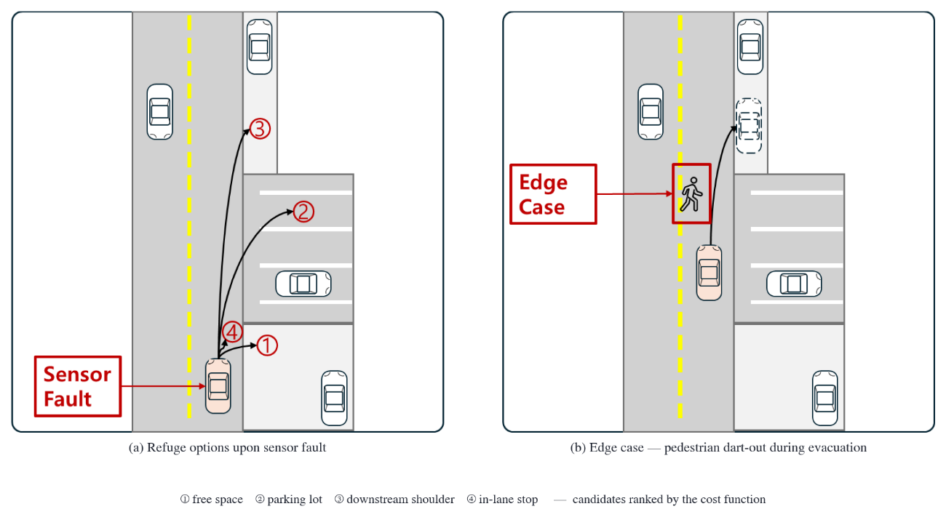
Figure 1.1. Problem setting. (a) The graded evacuation options upon sensor fault — ① free space, ② parking lot, ③ shoulder ahead, ④ in-lane stop — are ranked by a cost function. (b) Edge case of a dart-out pedestrian encounter during evacuation.

Finally, simulation-based safety claims stand only on the reliability of the collision verdict itself. This study empirically uncovered cases in which the simulator collision-sensor configuration remained silent, and in response built a dual verdict system — a real-time ledger of the ego collision sensor and a pedestrian physics oracle — as the basis of all safety conclusions (Section 4.5).

2. Research Questions

RQ1. If sensor faults are estimated as a continuous health score, can the response strategy (evacuation vs. stop deferral) be selected differentially by fault kind and degree? How much does that selection reduce faulted-state exposure?
RQ2. What does a shoulder-evacuation MRM gain and lose against a stop-type MRM? What temporal structure does the trade-off between immediate collision risk and lane clearance / off-lane final position have?
RQ3. How does conservative low-speed movement under a fixed cap change safety at the dart-out encounter level, and what does its limiting condition — the transient before deceleration completes — imply?

3. Contribution

First, we propose a behavior-tree-based sensor monitoring module. It independently scores each sensor for freshness (timeout), quality (noise, valid ratio), and physical consistency (residuals, bias), and composes these across eight-direction spatial sectors and capability (perception, localization) layers into a continuous health score.
Second, we propose a risk/capability-aware MRM supervisor. It selects between shoulder/parking evacuation (MRM_MOVE) and deferral to the stock stop (MRM_DEFER) by health-score bands, chooses the refuge by a cost function over degraded-state exposure time, traffic-light observability, and sector deficits, and imposes a conservative fixed cap (3.0 m/s; below the model-derived bound of about 3.89 m/s) back-computed from the stopping-distance model d = vτ + v²/2a on the planning layer. The cap effect is verified at the causal level in a settled-encounter dose-response experiment (Section 5.6).
Third, we establish a dual scheme for simulation collision adjudication — the real-time ego collision-sensor ledger (RAW-HIT) and the pedestrian physics oracle — as a methodology, and identify the verdict pitfalls of runner exit labels and official infraction records.
Fourth, as a validation contribution we perform encounter-level and large-matrix verification. Using a pedestrian dart-out distance ladder we measure the per-speed avoid/collide boundary (8-11 m at 4.2 m/s, 7-8 m at 3.0 m/s) against the stopping-distance model, show through transient/settled encounter observations that residual evacuation risk concentrates in the post-detection transient, and quantify monitoring/evacuation behavior, exposure reduction, and the causal cap effect in a single closed-loop framework totalling 1,862 valid cases.

1.4 Thesis Organization

Chapter 2 reviews related standards and research; Chapter 3 describes the proposed system; Chapter 4 presents the experimental environment, fault model, adjudication methodology, and encounter designs; Chapter 5 presents results; Chapter 6 presents limitations and discussion; Chapter 7 concludes.

Chapter 2. BACKGROUND AND RELATED WORK

Related work is organized into six strands (Sections 2.1-2.6) and compared with this study in Section 2.7. → Related work is organized into four strands (Sections 2.1-2.4), and Table 2.1 compares them with this study.

1. Standards and Regulatory Frameworks

The foundational frameworks of functional safety, SOTIF, and driving-automation taxonomy [1-3] and production-regulation/safety-case standards [4-7] consistently require runtime monitoring and degradation response. ISO 23793-1:2024 [51], which addresses MRM directly, specifies a type taxonomy and the principle of situation-dependent type selection but covers only the simplest types (straight-line and in-lane stops); shoulder stops are being standardized as Part 2.
As an adjacent-domain reference, the industrial driverless-truck standard ISO 3691-4 [60] combines monitored speed limits with stop functions under the principle of "limited speed for limited capability" instead of prohibiting degraded-state movement outright; the conservative low-speed MRM movement of this study (Section 3.6) transfers this principle to autonomous-driving MRM.

2. FTTI and the Derivation of Time Budgets

ISO 26262 (2nd ed.) defines the FTTI as the minimum time from fault occurrence to a possible hazardous event assuming no safety mechanism acts, but provides no concrete values — the FTTI is derived per safety goal, and Bosch's estimation method [8] derived 1.4-1.8 s in a lane-keeping-loss scenario. As risk metrics, TTC [9], its extensions [10], and RSS [11] are standard. This study implements this frame as a dynamic detection budget tied to driving risk (Section 3.4), and provides encounter-level evidence that residual evacuation risk concentrates in the post-detection transient (Section 5.4), supporting the need to shorten detection and response times.

3. Fault Detection Theory and Sensor Degradation Models

Classical FDI developed along residual generation/decision [12-15] and sequential change detection [16][17]; the LiDAR quality channel of this study borrows the CUSUM [16] (Section 3.2). These theories cover detection only; maneuver selection after detection is out of scope.
LiDAR degradation is organized by fault taxonomies [57], field measurements and physical models of soiling and rainfall [53-56], and adverse-weather simulation studies [20-23][58][59]. Our sparsification (lso) model follows measured soiling-induced detection-range reduction [55], and the clutter (lcl) model follows rain-scattering formulas [53] and near-range-biased clutter [54] (Section 4.2). Autoware preprocessing/diagnostics [18] and PCL [19] aim at outlier removal, a purpose distinct from continuous scoring of sensor condition.
The camera failure-mode taxonomy [24] is the reference for the cn/cf injections; for the IMU, separate evaluation of white noise and accumulating bias [25][26]; for GNSS, the failure-mode framework [62], urban error measurements [27], and integrity monitoring [28][29]; multipath-type correlated bias is injected following a first-order Gauss-Markov model [61].

4. Fallback and MRM Planning

Among safe-stop planning approaches, the trajectory-planning line [30-32] addresses parallel stop-trajectory maintenance, optimal control, and online verification, but takes the fault assessment and response choice as given. Emzivat et al. [33] proposed virtual obstacles and TTC-based deceleration as a fallback for impaired monitoring capability, and Reschka and Maurer [34] pointed out that the "safe state" is situation-dependent and an in-lane stop is not always safe — the same concern this study starts from.
The closest prior work is the sensor-fault-presupposing evacuation and adaptive MRM line. Xue et al. [49][50] presuppose a forward-sensor fault and propose safe-zone stop fallbacks under MPC constraints with a virtual-vehicle adaptive extension; Tang et al. [48] adaptively select MRM behaviors under multiple sensor faults using HAZOP risk analysis with virtual-object/TTC/THW evaluation, validated in a MATLAB-CARLA loop. The differences are threefold: (i) they presuppose the fault state whereas this study starts from online estimation of fault occurrence, kind, and severity; (ii) their selection criteria use surrounding-traffic TTC/THW whereas this study combines risk grace with remaining perception/localization capability and additionally limits the evacuation speed itself; (iii) their validation checks representative scenarios whereas this study performs closed-loop verification of 1,862 valid cases on a real stack (Autoware) with pedestrian-encounter experiments whose verdict reliability is methodologically secured.

2.5 Capability-Based Self-Monitoring and Runtime Monitoring

The skill/ability graphs of Reschka et al. [35] and their development-process extension [36] model functional capabilities as hierarchical graphs for online monitoring and decision making; the sector-capability composition of this study (Section 3.3) couples capability scores directly to MRM level selection and the movement speed cap. Runtime monitor case studies [37], SMOF [38], and verification challenges [39] are adjacent lines, and behavior trees [40][41] serve as the implementation structure of the monitoring node based on BehaviorTree.CPP [42] (Section 3.1).

2.6 Simulation-Based Evaluation and Fault Injection

CARLA [43] is the standard platform for fault-injection research, and stack-targeted evaluations — DriveFI [44], resilience assessment [45], AV-FUZZER [46], Scenic [47] — inject faults to find vulnerabilities, the opposite direction from this study, in which the stack itself detects, grades, and responds to the injected faults (the same injection techniques are used here as verification means). The experimental infrastructure builds on AWCL [52], the TUM Autoware-CARLA leaderboard framework, as a fully automated harness restarting the simulator every case (Chapter 4). No prior report was found addressing the reliability of simulated collision verdicts at the methodology level; this study treats it in a formal section (Section 4.5).

2.7 Comparison with Prior Work

Table 2.1 compares the related lines with this study along six axes.

Table 2.1. Comparison of prior research lines with this study (○ explicit / △ partial or conceptual / × not addressed)
Research line (refs.) | Fault  det. | Cont.  health | Remain.  capab. | Graded  MRM sel. | Speed-lim.  move | Encounter  valid.
Standards [1-7][51][60] | Req. only | × | × | △ (taxonomy) | △ (industrial) | ×
Classical FDI [12-17] | ○ | △ (residual) | × | × | × | ×
Degradation models [20-29][53-59] | ○ (offline) | △ | × | × | × | ×
Trajectory planning [30-32] | × (given) | × | × | △ (stop traj.) | △ (decel.) | △
Fallback (Emzivat [33]) | △ | × | △ | △ | △ (TTC decel.) | ×
Fault-presupposing MRM [48-50] | × (given) | × | △ (surviving) | ○ (adaptive) | △ (decel.) | △ (scenarios)
Capability self-monitoring [34-36] | △ | ○ (capability) | ○ (concept) | △ (concept) | × | ×
Stock Autoware [18] | △ (timeouts) | × (binary) | × | △ (stop only) | × | ○
Fault-injection eval. [43-47] | × (injector) | × | × | × | × | ○
This study | ○ (11 types) | ○ (fresh×qual.) | ○ (loc/percep.) | ○ (bands) | ○ (inverted cap) | ○ (ledger-verified)

As Table 2.1 shows, studies addressing each axis exist, but no study was found that integrates online continuous health estimation of per-sensor freshness and quality, evacuation-vs-stop distinction by risk grace and remaining perception/localization capability, evacuation speed limited to a stopping-distance-inverted cap, and validation on a real stack with verdict-secured encounter experiments. The position of this study is the integrated supervisory layer from detection through selection and speed, and its empirical demonstration.

Chapter 3. PROPOSED SYSTEM

1. System Architecture

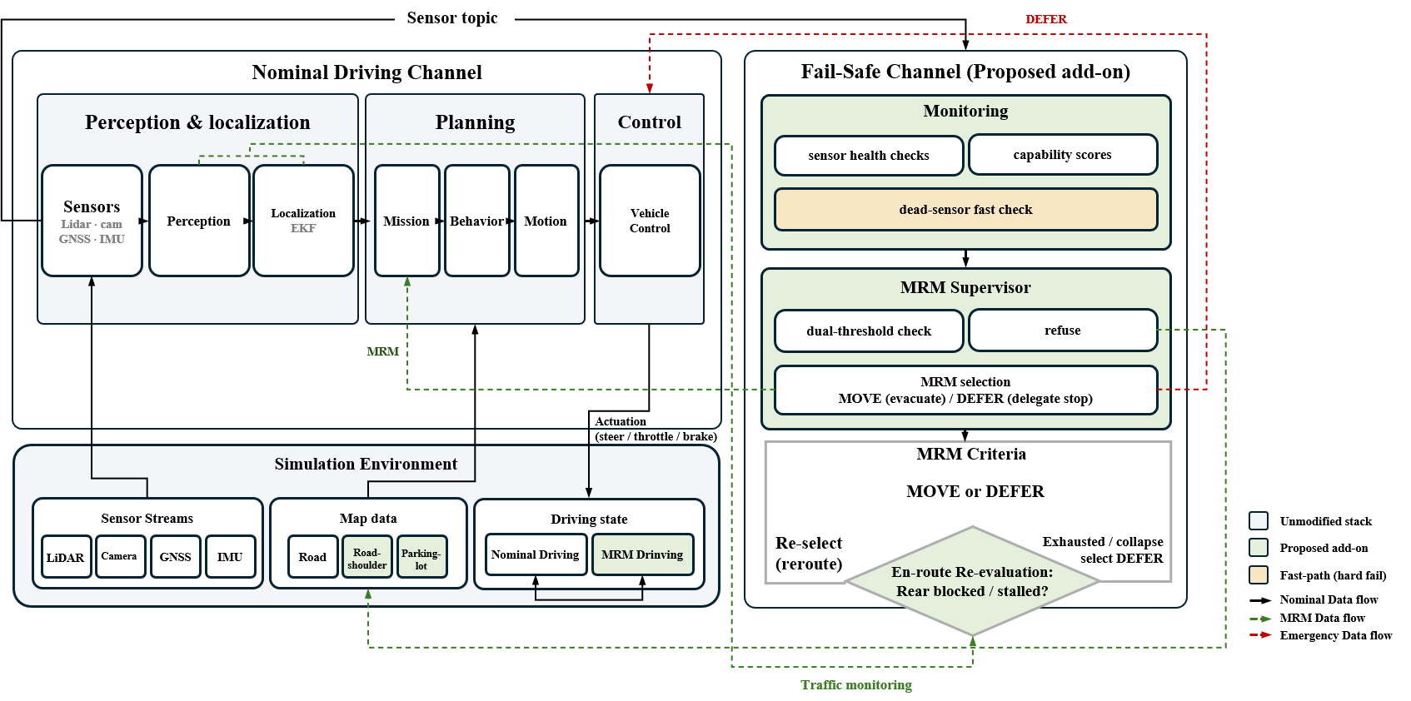
The proposed system consists of two independent nodes (Figure 3.1). The monitoring module inspects each sensor at 10 Hz on a behavior-tree basis (an implementation structure for parallel composition, module replacement, and execution tracing, not an algorithmic contribution), publishing per-sensor health scores (0-1); the detectors comprise three families — timeout (freshness), quality (noise, valid ratio), and physics (residual, bias). The MRM supervisor subscribes to the scores and runs a state machine: for evacuation it changes the route via the Autoware AD API and imposes a speed cap on the planning layer; for deferral it triggers the stock mrm_handler stop through the diagnostic graph. Stopping-maneuver execution is handled by goal_planner and mrm_handler, and main-stack modification is minimized by injecting monitoring units into the diagnostic graph.
Figure 3.1. Dual-channel structure of the proposed system. Left: the nominal driving channel of unmodified Autoware 0.39.0 (perception & localization → planning → control); right: the proposed supervisory layer.

Reception and evaluation cycles are separated: reception accumulates at native sensor rates (LiDAR 20 Hz, IMU 100 Hz, etc.) while evaluation runs at 10 Hz (evaluation-cycle delay ≤0.1 s). The 100 ms cycle is consistent with the AUTOSAR Watchdog Manager [7] periodic supervision structure and the decision cycle of the Autoware planning layer.

2. Sensor Scoring

- Freshness score

For the elapsed time age(t) since the last reception,

$timeout score=max(0, 1-age/τ_{detect})$ (1)

decays the score linearly. τ_detect is not a detection deadline but the time constant of freshness decay, tightened in coupling with driving risk (Section 3.4). Linear decay (rather than a step at expiry) lets the score cross the downstream band boundary before it is exhausted — under complete silence the capability score falls below the boundary before τ_detect fully elapses, enabling early transition. As an auxiliary device, a k-miss rule penalizes early to a "suspect" stage if nothing is received for 3× the moving median of the reception interval.

B. Quality score

For LiDAR, the standard deviation under a Gaussian assumption is recovered from the mean of neighboring-point range differences:

$σ_{est}=mean(|Δr|)×(\sqrt{π}/2),|Δr|<1m$ (2)

(the inversion of E|r1−r2| = 2σ/√π; differences over 1 m are excluded as genuine terrain boundaries). Scene-intrinsic roughness is absorbed by a baseline learned during the first 30 boot frames, but abrupt rises (over 1.5×) are not tracked so the fault cannot become its own baseline. The score is exp(−max(0, σ_est − base)/0.1) times a valid-point-ratio score — a relative anomaly score against the baseline, not an absolute noise estimator. A CUSUM sequential test (S = max(0, S + excess − k), drop when S > h) runs in parallel so detection delay is inversely proportional to fault magnitude. Camera quality applies the same structure to inter-frame pixel differences without the cumulative test (pixel difference rises naturally with scene motion). Sparsification is handled by the valid-ratio channel and clutter by the range-discontinuity channel.

- Three localization channels

Each channel covers a different fault mode. (a) Residual channel: for the distance r between the GNSS measurement and the EKF output, loc_meas = exp(−max(0, r − base − 0.2)/0.55) (static frame offset calibrated at boot) — sensitive to GNSS noise and multipath-type correlated bias. (b) Bias channel: penalizes when the difference between 3-s means of IMU and EKF yaw rates persists above a threshold for 3 s — normal turning cancels in both signals while gyro bias remains only on the IMU side. (c) Silence channel: penalizes with exponential decay when GNSS input stops for 1 s or longer while driving — covering the residual channel's blind spot of freezing at the last value.

3. Spatial Sectors and Capability Synthesis

Sensor scores map to eight directional sectors (F, FL, FR, L, R, RL, RR, B) by mounting direction and field of view, fused in the monotone noisy-OR form

$sector=1-\prod_{i}{(1-s_{i})}$ (3)

(more sensors covering a sector make it more robust; the s_i are not claimed to be calibrated probabilities). Perception capability is the sector-weighted sum

$perception=\sum_{k}{w_{k}·{sector}_{k},w=\{F:0.30, FL/FR:0.15, L/R/B:0.10, RL/RR:0.05\}}$ (4)

combining obstacle perception and traffic-light observability at 0.6:0.4. The system health is

$health=min(perception, {cap}_{loc})$ (5)

following the worst capability (weakest-link principle). cap_loc is the minimum over the physical range check, position jump, and the residual/bias/silence channels. These localization channels reside in the supervisor process as an implementation matter but belong logically to the monitoring layer (the boundary in Figure 3.1 is logical). The behavior-tree composition of the monitoring module is shown in Figure 3.2.

4. Risk-Coupled Dynamic Detection Budget

The freshness decay time constant is coupled to driving risk:

$τ_{detect}(t)=min(τ_{fresh}, {TTC}_{cons}(t))$ (6)

The τ_detect(t) of Eq. (6) is used as the decay constant of Eq. (1) (τ_fresh is the nominal default); as TTC shortens the decay tightens, conservatively strengthening the detection criterion. TTC_cons is the minimum of nearest-obstacle TTC and planned-path/predicted-path crossing time, with a fail-conservative hold that decays the TTC lower bound using the last observed closing speed when the TTC source sensor is unhealthy.
We clarify the relation to the formal time-budget form. The design intent is

$T_{detect}+T_{response}+T_{margin}≤T_{hazard}$ (7)

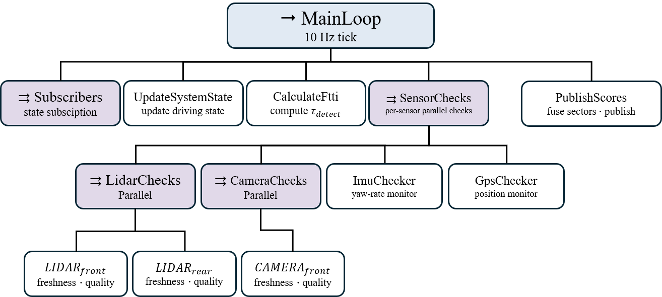
and, approximating T_hazard by the conservative TTC estimate, the strict detection deadline is TTC_cons − FRTI − margin. The current implementation is a risk-adaptive heuristic approximation that strengthens freshness decay as TTC shortens, rather than explicitly reserving FRTI and margin, and does not guarantee formal deadline compliance (explicit reservation and verification are future work — Section 6.4). Since degradation-fault detection is an accumulation of statistical evidence, the requirement is formalized as a severity curve T_detect(σ) ≤ T_hazard(σ): small faults are caught later but become hazardous later.
Figure 3.2. Behavior-tree structure of the monitoring module.

5. MRM Supervisor

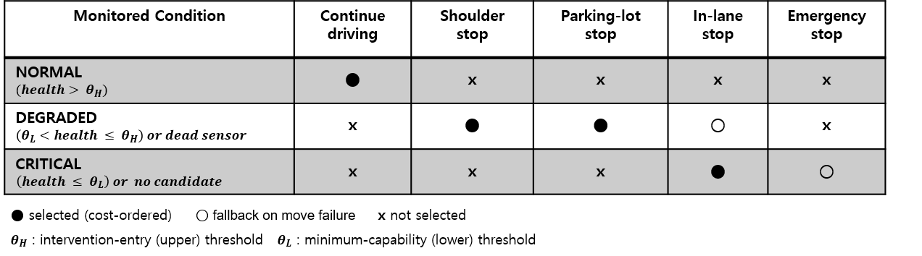
The supervisor switches its response by dual thresholds on health (upper 0.7, lower 0.3) (Figure 3.3): falling below the upper threshold triggers evacuation movement (MRM_MOVE), completion triggers evacuation parking (MRM_PARKED), and the floor or a localization-confidence collapse triggers deferral to the stock stop (MRM_DEFER). Safeguards against false activation include a post-boot health check, a route-change non-response watchdog, a candidate-stagnation blacklist, and a creep guard. Selection is not frozen while moving — sustained rear occupancy during a parking approach (within 10 m for 20 s) penalizes reversing parking candidates and demotes to a shoulder stop; stalls and non-responses get bounded retries; candidate exhaustion or an en-route health collapse falls back to DEFER (Figure 3.1).
Figure 3.3. MRM selection policy matrix by monitoring state. The dual thresholds separate NORMAL, DEGRADED, and CRITICAL; ● selection by cost order, ○ fallback on movement failure, × non-selection. A dead sensor goes directly to the degraded stage regardless of thresholds, and with no reachable candidate the state demotes to critical and defers to the stock stop.

The dual thresholds serve chattering prevention and grade separation; the decay constants were designed so that a wide insensitive gap lies between faulted and normal scores, so behavior is determined by the three-band structure rather than precise threshold placement.
The timing rules split by the nature of the evidence. Degradation (noise) faults are statistical evidence and require sustained confirmation: 1.0 s for band entry, 2.0 s at the floor (deferral is an irreversible terminal decision), and a 5.0 s recovery grace when localization confidence falls short of the movement minimum (0.5) — preventing terminal decisions on transient dips deeper than the settled value (measured 0.44 vs settled 0.58); varying the grace over 0.5-5.0 s left results unchanged (gn-mid, 10 repetitions per condition). Hard fails (confirmed death past the 850 ms freshness deadline), whose persistence of silence is itself accumulated evidence, skip these confirmations: with at least one live sensor remaining (simultaneous all-sensor silence is excluded as a frame-freeze artifact), band confirmation is skipped, and unrecoverable conditions defer immediately without grace or retry. Candidate route costs are precomputed during normal driving, removing selection latency at decision time; hard-fail decisions thus complete within the 1.5 s deadline (Section 5.7).
Refuge selection minimizes the cost (candidate layout in Figure 3.4):

$J(c)=w_{t}η(c)+w_{tl}n_{tl}(c)g(tl)+w_{sec}∑(1-{sector}_{req})+w_{loc}η(c)(1-loc)$ (8)


η(c) is the degraded-state exposure time (route time + expected wait per signal), g(tl) the traffic-light observability penalty (1/cap_tl − 1), sector_req the sector scores required to approach the candidate, and loc the localization confidence — the ISO 26262 view that risk accumulates per unit time, not distance. Route times and signal counts are computed on an in-house road-network graph parsed directly from the lanelet2 map, keeping the decision layer outside the influence of main-stack faults (signals counted by clustering stop-line regulatory elements — the discovery and correction of an initial defect is reported in Section 4.3). The key safeguard is the traffic-light observability gate: a candidate whose route passes signals no healthy camera can observe is excluded with J = ∞ (the signal-state source is selected fault-aware). Hard constraints add a minimum approach distance and minimum shoulder length; no precise tuning of the absolute weights is claimed (discrimination is dominated by the gate and approach distance).
Figure 3.4. Town07 evacuation candidate map — 16 shoulder candidates (lanelet shapes), 4 parking-lot candidates (polygons), and the reference route (dashed). Candidate route costs are computed on an in-house road-network graph; signalized intersections are subject to the observability gate.

6. Remaining-Capability-Based Conservative Low-Speed MRM Movement (Speed Cap)

Evacuation is movement under degraded perception, so stopping capability against a dart-out matters more than in normal driving. For an obstacle appearing at forward distance D_avail while traveling at speed v, stopping without collision requires, for reaction time τ and deceleration a,

$d_{safe}(v)=vτ+\frac{v^{2}}{2a}+d_{margin}≤D_{avail}$ (9)

Here τ≈1.5 s and a≈3.5 m/s² are not independently measured values but nominal lumped values calibrated to reproduce the measured ladder boundary (8-11 m); the formula is a design approximation for selecting the cap policy value, not a predictive safety model. In a dedicated braking experiment (fault-free stock, pedestrian at 14 m during 4.2 m/s cruise, n=5), braking onset lagged by 0.46±0.08 s with an effective deceleration of 2.87±0.20 m/s² — the onset delay is encounter-geometry-dependent (early precautionary braking under long preview vs an effective delay of ≈1.5 s in the 8 m near-boundary regime), so a single (τ, a) pair is a lumped approximation; agreement between the ladder boundary and the computed 8.8 m is a self-consistency check, not independent validation (Section 5.3). On entering MRM_MOVE the supervisor imposes a fixed 3.0 m/s cap on the planning layer, chosen in the band whose upper end is the model-inverted cap that still stops within an 8 m dart-out (≈3.9 m/s) and whose lower end is the requirement that evacuation completion time stay bounded; no optimization within the band was performed. The cap is delivered to the input side of the Autoware velocity-limit arbiter, and delivery is verified by measured vehicle speed rather than publish records — an interface mismatch that silently dropped the cap in earlier campaign runs was discovered exactly this way and corrected; the effect under an actually holding cap is verified in Section 5.6 (a health-proportional cap is implemented but unused — Table 4.3).

7. Implementation Boundary and Map Annotation

The refuge candidate layer (shoulders, parking lots) was built by manual annotation of road_shoulder/parking_lot subtypes on the lanelet2 map (criteria: minimum shoulder length to complete the maneuver, mainline connectivity, entry-polygon/goal consistency). Shoulder candidates are lanelets sharing a boundary with the mainline; parking-lot candidates are closed polygons; manual annotation limits the verification scope to the annotated segments (Chapter 6).
The system's responsibility covers detection, decision, candidate selection, and the speed cap ("whether to evacuate, where, when, how fast"), delegating stopping-maneuver execution to Autoware. In MRM_MOVE the evacuation goal is delivered via AD API route resetting, executed by mission_planner replanning and the goal_planner pull-over (the shoulder-entry maneuver is a stock capability, unmodified in this work); in MRM_DEFER an ERROR is injected into the diagnostic graph to trigger the stock mrm_handler stop (a boundary separating decision from execution).

Chapter 4. EXPERIMENTAL ENVIRONMENT AND DESIGN

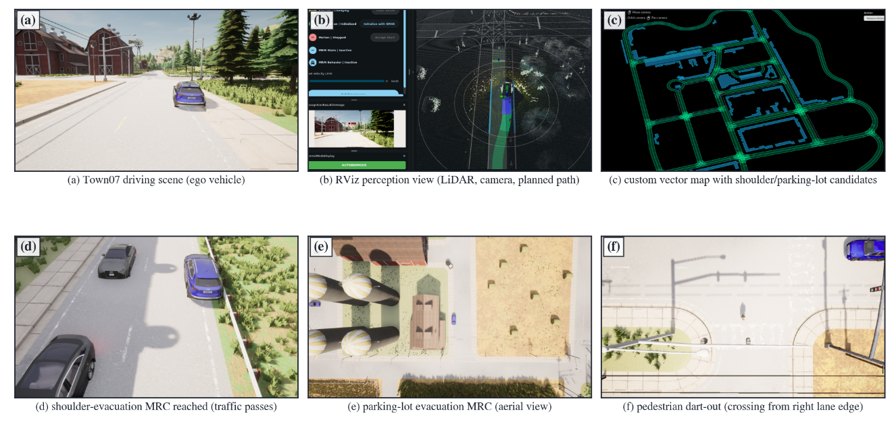
4.1 Experimental Environment → 1. Experimental Environment
Figure 4.1. Representative execution views (actual run captures): (a) Town07 driving, (b) RViz perception, (c) candidate-annotated vector map, (d) shoulder-evacuation MRC (following traffic passing), (e) overhead view of parking-lot MRC, (f) pedestrian dart-out encounter (Section 4.4).

The stage is a closed loop coupling CARLA 0.9.16 and Autoware 0.39.0 (Figure 4.1). The integration builds on AWCL [52], the TUM Autoware-CARLA leaderboard framework (C++ bridge, vehicle digital twin, scenario runner); CARLA runs on the host and the bridge, leaderboard, and Autoware in independent containers. The map is a custom Town07 vector map annotated with shoulder/parking candidates, the speed limit 15 km/h (4.2 m/s), and the simulator is fully restarted every case for independence (CARLA_RESTART_EVERY=1).
A common runner automates the experiments; a case is defined by {method, fault, severity, traffic, repetition, injection time}. Methods are ours (proposed supervisor), baseline (same detection, deferral to the stock stop-type MRM), and mrm-off (non-intervention observation — passive scoring only). Baseline shares identical detection with the proposal to separate the response-strategy effect from detection performance; "no detection at all" is provided by mrm-off. The runner manages process lifetimes and archives per-case logs for post-hoc re-adjudication.
A ROS-topic-based automatic adjudicator classifies each case's termination into management labels (shoulder/parking evacuation completed, stock stop-type MRM completed, stalled during evacuation, hazard-event contact, hazardous stop, incident-free persistence, infrastructure failure) and records stop coordinates, lane occupancy, detection latency, faulted-state distance, and official collision records as CSV. The exit label is a first-pass management classification only, never the basis of safety adjudication (basis and pitfalls in Section 4.5).

4.2 Fault Model → 2. Fault Model

Faults are injected inside the agent's sensor pipeline (Table 4.1 — reference literature and physical models in the injection-method column). The early simple Gaussian range noise (ln) was retired for weak correspondence to real fault modes and replaced by two physical models (lso, lcl). Injection times are drawn from deterministic case-key seeds for reproducibility; in the encounter experiments even the fault-waveform randomness is seed-fixed (FAULT_SEED) so paired conditions of the same seed experience an identical fault realization.

Table 4.1. Fault model
Abbrev. | Fault | Injection method | Severity
cf | Camera death | Frame transmission halted | -
cn | Camera noise | Gaussian pixel noise | low/mid/high
lf | LiDAR death | Point-cloud transmission halted | -
lso | LiDAR sparsification | Contamination-type dropout (physical model [55]) | low/mid/high
lcl | LiDAR clutter | Rain-scattering spurious returns (models [53][54]) | low/mid/high
gn | GNSS position noise | Gaussian position noise (EKF input) | low/mid/high
gb | GNSS correlated bias | First-order Gauss-Markov bias [61] | mid/high
imn | IMU noise | Gyro white noise | low/mid/high
imb | IMU gyro bias | Step-type constant bias | mid/high
imd | IMU bias drift | Time-proportional ramp | mid/high
gf | GNSS outage | Input silence | -

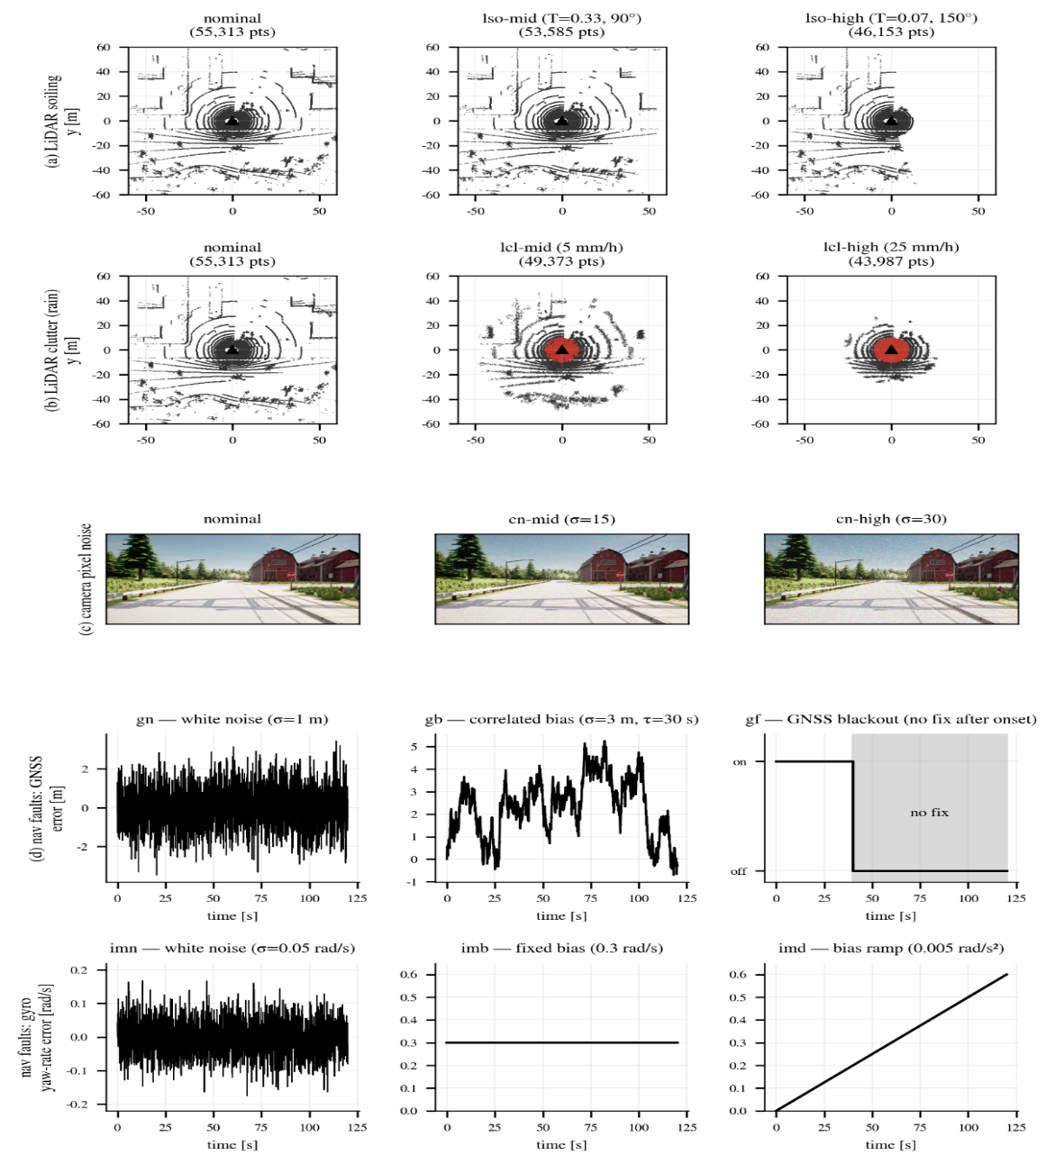
Figure 4.2. Sensor-level effects of fault injection — the injector's own physics applied to one measured Town07 LiDAR scan and camera frame (before/after). (a) LiDAR sparsification (lso), (b) LiDAR clutter (lcl, spurious returns in red), (c) camera pixel noise (cn), (d) GNSS fault waveforms (gn/gb/gf), (e) gyro fault waveforms (imn/imb/imd). Panel parameters are the injector's raw values for the severity definitions (representative values in Table 4.3).

3. Main Campaign Matrix

The main campaign is a fault × severity × traffic density (none/def/agg) × method (ours/baseline) × repetition matrix, executed serially by a battery script with infrastructure failures re-collected via a retry chain. The total valid count is 1,131 (39 short of the 1,170 plan, all in lcl-high — Table 4.2). This includes a full re-run of the 450 affected camera/navigation cases after a traffic-light miscount defect in the refuge cost function was uncovered and fixed (clustering method of Section 3.5) — the disclosure lets follow-up research treat map annotation quality as a hidden confounder of refuge selection.

Table 4.2. Main-campaign case accounting
Block | Severity | Valid cases
cf | - | 90
cn | mid/high | 180
gn | mid/high | 180
lso | mid/high | 180
lcl | mid/high | 141
imn | mid/high | 180
lf | - | 90
nf | - | 90
Total |  | 1,131
nf is the false-activation control. The lcl block is smaller because its final high-severity batch was halted; one imn CARLA_DIED row and other infrastructure failures (CARLA_DIED/SETUP_FAIL) were replaced by same-condition re-runs, fixed in the merge script.

Traffic density has three levels — none, defensive, aggressive — and defensive traffic applies courtesy rules (7 m minimum gap to stopped vehicles, no respawning near refuges) so evacuation-completion adjudication is not contaminated by NPC spawn artifacts.

4. Pedestrian Dart-out Encounter Injector

An independent process (hazard_injector) in the leaderboard container injects pedestrian dart-out crossings — a decoupled design that modifies neither agent nor runner.
Encounters are launched only after the compared driving state is established (settlement trigger), fault-waveform and pedestrian randomness are seed-fixed across paired conditions (FAULT_SEED), and walking speed and ego–pedestrian trajectories are verified and recorded online; runs with lost records or failed manipulation checks are rejected and re-run (Sections 4.5 and 4.7; launch geometry in Table 4.3).

5. Collision Adjudication Methodology

This section formally reports an adjudication-reliability incident and its reconstruction. The initial implementation adjudicated collisions with a collision sensor attached to the pedestrian, but measurement confirmed this sensor never fired in CARLA — silent even in cases where the official adjudicator confirmed a collision. A ROS-listener death additionally lost separation records, so many non-intervention-arm cases were misjudged as "avoided" without evidence; this was uncovered by video review, and all affected data were discarded and re-run.
The reconstructed system has two layers. The primary ground truth is the real-time ledger of the ego collision sensor: the callback of the sensor.other.collision attached by the official adjudicator (CollisionTest) is patched to write, the moment a collision occurs, the counterpart actor identifier to a file (RAW-HIT ledger) — unlike official infraction tallies it survives early/forced termination, and endpoint-structure grazes are classified separately. Consistency audits comprise the pedestrian physics oracle (kinematic anomalies at collision — flung 12-28 m: speed >4.5 m/s or a >5 m jump within 1 s) and the separation stream (not fully independent, same physics engine)
Verdict pitfalls of the runner exit labels: (i) the collision label may include endpoint-structure contacts (distinguish by ledger counterpart actor); (ii) the hazardous-stop label may include post-collision stops; (iii) official infractions are saved only on natural termination — a recording gap in an early-terminated case is not evidence of no collision. All encounter-level safety figures in this thesis are ledger-based.
The clock for latency figures is unified to simulation time.

6. Distance Ladder and 8 m Encounter Experiment Design

Spawn distance was varied as a ladder to measure the per-speed avoid/collide boundary. (i) Fault-free ladder: fault-free stock, {14, 11, 8, 6, 5} m × n=4 at a normal-driving (4.2 m/s) waypoint. (ii) Blinded ladder: stock under complete LiDAR degradation (lso-high), same ladder. (iii) 8 m encounter comparison: proposed low-speed MRM vs stock under gn-mid (EKF input contaminated only, perception intact) — cf excluded (signal reading impossible, encounters do not form) and gn-high excluded (mostly comfort stops); (iv) Low-speed ladder: {8, 7, 6, 5} m at 3.0 m/s cruise gn‑high excluded (mostly comfort stops). (iv) Low‑speed ladder:{8, 7, 6, 5} m at 3.0 m/s cruise (Section 5.5). (Section 5.5). (v) Dose-response experiment: caps {4.2, 3.6, 3.0} m/s × distances {6, 7, 8, 9} m × 10 seeds (S12-S21, per-seed randomness fixed — Table 4.3; gn-mid, injection at 25 s) = 120 runs. Launch uses the settlement trigger (spawn D m ahead only once the supervisor is in MRM_MOVE and measured speed has stayed in the cap-specific band for 1.0 s), (v) Dose‑response experiment: caps {4.2, 3.6, 3.0} m/s × distances {6, 7, 8, 9} m × 10 seeds (S12‑S21, per‑seed randomness fixed — Table 4.3; gn‑mid, injection at 25 s) = 120 runs. Launch uses the settlement trigger (spawn D m ahead only once the supervisor is in MRM_MOVE and measured speed has stayed in the cap‑specific band for 1.0 s) (Section 5.6). (Section 5.6). Adjudication follows the ledger standard of Section 4.5 (the pre-ledger exception is stated in Section 5.3).

7. Metrics and Statistics

The primary encounter-level metric is the collision rate, reported with Wilson 95% confidence intervals. Inferential testing is pre-specified as the single primary endpoint of the dose-response experiment — the paired 4.2↔3.0 m/s collision difference at the 8 m spawn (exact McNemar) — with the remaining combinations reported only as boundary characterization (descriptive statistics with Wilson CIs; in small samples the exact McNemar p is discrete: 5:0 gives p=0.0625 and 6:0 first crosses 0.05 at p=0.03125). Fisher's exact test is used for unpaired auxiliary comparisons. As the manipulation check, a run with no launch within 420 s or a first-tick speed outside the band (±0.15 m/s) is rejected regardless of outcome and re-run under identical conditions. Exposure is defined as deg_dist, the distance from injection to reaching MRC.

8. Reproducibility: Key Experimental Parameters

Key parameters are summarized in Table 4.3, exactly as used in the experiments, with supporting sections indicated.

Table 4.3. Summary of key experimental parameters
Item | Value
State-transition thresholds | upper 0.7 / lower 0.3
Freshness deadline τ_fresh | 850 ms
CUSUM parameters | k = 0.5×fault-free baseline (adaptive) · h = 0.5 m/30
Execution environment | Autoware 0.39.0 · CARLA 0.9.16 · ROS 2 Humble·synchronous,  fixed step 0.05 s
MRM speed cap | 3.0 m/s (fixed)
Stopping-distance model | τ=1.5 s, a=3.5 m/s²
Cost weights · hard constraints | w_t=7.0/s · w_tl=200 · w_sec=500 · w_loc=14/s · signal wait 15 s · shoulder‑MRC penalty 175 · min approach 25 m · min shoulder 7.0 m (violators J=∞)
Launch geometry · walking speed · seeds | ahead {6, 7, 8, 9} m · start at right lane edge +0.5 m · jitter ±0.2 m · walk {2.5, 3.0} m/s (per‑seed blocks) · seeds S12‑S21, fault/pedestrian randomness seed‑fixed
Fault severity (mid/high) | cn 15/30 (pixel σ) · imn 0.5/1.5 (gyro σ) · gn 1.0/2.5 (position σ, m) · lso 0.33:90 / 0.07:150 · lcl 5:1500 / 25:4000 (raw injector values)
Dose-response launch bands | settlement trigger: 4.2→[3.85, 4.45] · 3.6→[3.25, 3.75] · 3.0→[2.65, 3.15] m/s, 1.0 s continuous, spread ≤0.25 (mutually disjoint)
Traffic-light control | all frozen green

Chapter 5. EXPERIMENTAL RESULTS

1. Main Campaign: Detection Performance and Per-Fault Behavior

We begin with detection performance (the premise of RQ1). Table 5.1 summarizes per-condition detection rates and median latencies. The proposed detectors achieved 96-100% in 11 of 12 fault conditions (median latency: hard fails ~1.0 s by ledger re-measurement, degradation faults 2.1-5.0 s), with zero false activations in the 45 fault-free (nf) controls. The sole exception, mid LiDAR sparsification (lso-mid, 0.02), lies by design in the tolerated band above the threshold — about 55 m of effective detection range remains after this dropout level, health does not reach the intervention condition, and the supervisor deliberately continues driving (Table 5.2). Since "tolerance as designed" cannot yet be separated from quality-channel insensitivity, the rates of Table 5.1 should be read as intervention eligibility, with the separation stated as future work. The four navigation faults (gb correlated bias, gf outage, imb gyro bias, imd bias ramp) were evaluated in a navigation-extension matrix of identical structure (45 cases per condition and method, identical seed pairing): detection was 100% in every condition over 611/630 valid cases (Table 5.1, †), all converging to localization-confidence-based deferral, the same design manifestation as gn-high. Three observations: (i) imd latency is inversely related to ramp slope (median 8.6 vs 5.4 s) — small faults are caught later but become dangerous later; (ii) gf latency is bimodal (median ~3 s while driving; 21-40 s when the outage coincides with a red-light stop — an intended delay of the silence-decay speed condition, and the two modes are reported separately); (iii) the deferral stop mode split by family: GNSS produced comfortable stops, IMU all hard stops — with corrupted rotational sense the execution layer demotes trajectory following to a hard stop.

Table 5.1. Detection rate and median latency per fault condition (main campaign and navigation extension†, proposed detectors)
Fault | Severity | n | Det. rate | Median latency (s)
cf camera death | - | 45 | 1.00 | 0.98*
cn camera noise | mid/high | 45/45 | 0.98/1.00 | 3.3/3.2
gn GNSS position noise | mid/high | 45/45 | 1.00/1.00 | 2.1/4.4
imn IMU gyro noise | mid/high | 45/45 | 1.00/0.98 | 4.8/3.7
lcl LiDAR clutter | mid/high | 45/26 | 1.00/0.96 | 4.8/4.5
lf LiDAR death | - | 45 | 1.00 | 1.00*
lso LiDAR sparsification | mid/high | 45/45 | 0.02/0.98 | -(tolerated)/5.0
gb† GNSS correlated bias | mid/high | 45/45 | 1.00/1.00 | 3.0/2.3
gf† GNSS outage | - | 45 | 1.00 | 3.2 (driving; bimodal — text)
imb† IMU gyro bias | mid/high | 43/45 | 1.00/1.00 | 3.6/3.2
imd† IMU bias ramp | mid/high | 43/44 | 1.00/1.00 | 8.6/5.4
Zero false activations in 45 fault-free (nf) controls. "-" for lso-mid: no median reported (1/45 detected). †Navigation extension (identical structure and seed pairing; baseline arm also 100%). *Hard-fail latencies are ledger-based simulation time (distributions in Table 5.5); others wall clock.


Figure 5.1. Detection-latency distributions per condition (proposed arm, from injection). Top: main campaign; bottom: navigation extension; death rows (*) are ledger-based simulation-time re-measurements (Section 5.7). Bars mark medians; the gf right tail is red-light-stop injections detected after restart. Hard-fail rows (simulation time) and the rest (wall clock) live in different clock domains.

Behind the binary rates lies the continuous signal (Figure 5.2). The decision variable of the state transitions (0.7/0.3) is the perception channel (localization stays intact under LiDAR degradation, so the min takes perception), and it separates into distinct bands by severity: fault-free never falls below 0.7 after warm-up (measured minimum 0.71 — consistent with zero false activations), mid severity stays in the tolerated band (the basis of lso-mid non-intervention), and high severity departs below threshold immediately on injection — the basis of the graded three-regime transition. The obstacle channel is dedicated to the MRM movement gate, so its sub-0.7 fluctuations do not contradict the zero false activations; the navigation family (gn, imn) is decided by the localization channels, so this observation applies to the LiDAR-degradation channels of /monitor/scores. Score-structure robustness was checked by offline re-adjudication of five representative traces: varying the upper threshold over 0.65-0.75 and the obstacle:signal weight over 0.5:0.5-0.7:0.3 left all verdicts unchanged (fault-free minimum 0.71 and tolerated minimum 0.75 vs intervention maximum 0.54 — a wide separation); a trace-level check, not a campaign re-run.

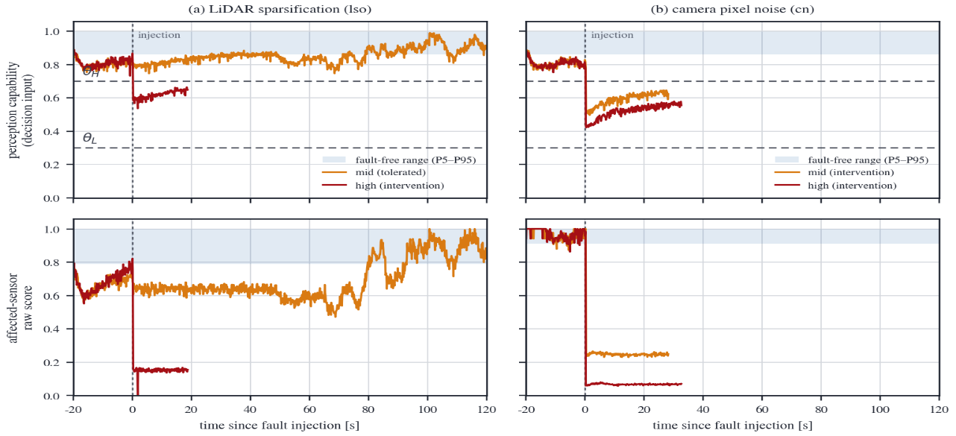
Next, evacuation behavior (Table 5.2; 1,131 valid cases, proposed arm). For faults preserving the capability to move, the proposal evacuated while baseline stopped in lane in every case — baseline's zero evacuations are the definitional consequence of its policy, not failures. Under camera death (cf) the proposal completed shoulder evacuation in 16 of 45; the rest split into 27 intended stop deferrals (MRM_DEFER) and 2 maneuver incompletions — deferral is the supervisor's intended policy choice that moving in this state is dangerous. One factor limiting the completion rate is the intended conservatism of the traffic-light observability gate. Camera noise (cn) reached the shoulder in 25 of 90.
Figure 5.2. Continuous decision signals under LiDAR sparsification and camera noise. Top: perception-capability score with thresholds θH = 0.7 and θL = 0.3; bottom: affected-sensor score. Mid lso remains tolerated, whereas high-severity faults cross θH.

Table 5.2. Evacuation behavior in the main campaign (proposed arm)
Fault | Cases | Shoulder/parking reached | Notes
cf camera death | 45 | shoulder 16 | baseline: in-lane stop in all cases
cn camera noise | 90 | shoulder 25
gn GNSS position noise | 90 | shoulder 41 + parking 1 | severity determines behavior (text)
lso-mid LiDAR sparsification | - | deliberate continued driving | judged not hazardous; deg_dist 255 m
Severity-determined branching was most pronounced in the navigation family: gn-mid led to shoulder evacuation in 40 of 45 while gn-high converged to comfortable-stop deferral in 42 of 45 — movement is abandoned when localization confidence falls below the movement minimum. Conversely under lso-mid the supervisor chose non-intervention (deg_dist 255 m) — response proportional to degree, not stop-at-every-anomaly. Caveat: the matrix cases contain no pedestrian injections, and case-level "zero collisions" rests on pre-ledger data, so it is not used as safety evidence (Section 6.4).

2. Exposure Metric: Degraded-State Driving Distance

The primary utility of monitoring is shortening degraded-state exposure. Unmonitored (mrm-off, one run per type), the stock stack effectively completed the route: camera death 238, camera noise 240, GNSS noise 251, LiDAR sparsification 264, LiDAR clutter 275 m (only IMU noise self-stopped at 71 m). Excluding the deliberate lso-mid, detect+evacuate gave 32-58 m and detect+stop 9-18 m in the camera/navigation families (LiDAR clutter and IMU noise 11-12 and 8-9 m). Without monitoring the exposure is the whole route; with it, exposure becomes a policy variable — the stop minimizes exposure at the cost of lane occupancy, evacuation accepts tens of meters of controlled exposure for lane clearance and an off-lane position. The safety-side cost is quantified by the encounter experiments of Sections 5.4-5.6.

3. Distance Ladder: Measuring the Avoid/Collide Boundary

The fault-free stock ladder at 4.2 m/s shows a clean staircase: 14 and 11 m fully avoided (per distance, 2 of 4 runs are post-ledger with ledger/oracle verdicts and 2 pre-ledger with runner-label/video verdicts), 8/6/5 m fully collided (Table 5.3, Figure 5.3). The boundary thus lies in 8-11 m, agreeing with the model prediction d(4.2)=8.8 m, establishing that (i) the 8 m choice in later experiments sits just below the boundary where avoidance becomes physically impossible, and (ii) the design approximation is self-consistent in the near-boundary regime (same data as its calibration — not independent validation, Section 3.6).

Table 5.3. Distance ladder results — fault-free 4.2 m/s, blinded (lso-high), and low-speed 3.0 m/s (ledger adjudication)

Spawn distance | Fault-free stock 4.2 m/s (n=4) | Blinded (lso-high) stock | Low-speed 3.0 m/s (Sec. 5.5)
14 m | avoided 4/4 | frozen before encounter (blocking road) | -
11 m | avoided 4/4 | frozen before encounter (blocking road) | -
8 m | collided 4/4 | collided | avoided 8/8 (settled cruise, Sec. 5.6)
7 m | - | - | collided 2/2
6 m | collided 4/4 | collided | collided 2/2
5 m | collided 4/4 | collided (6/6 at ≤8 m) | collided 2/2

The same ladder blinded (lso-high) failed differently: at 14/11 m an empty-point-cloud freeze stopped the vehicle mid-road before the encounter (4/4), and at ≤8 m every run collided (6/6). In short, a blinded vehicle either stands still or strikes — unmonitored degraded driving resolves into collision or lane blocking, neither an MRC.

4. The 8 m Encounter: Low-Speed MRM versus Stock


Under gn-mid (EKF input contaminated only; perception intact, so all three conditions share detection capability and only speed/policy effects are compared), an 8 m dart-out gave: stock (holding 4.2 m/s) collided in all 10 runs (0/10 avoided); the proposed low-speed settled cruise (measured encounter speed ~3.0 m/s; Section 5.6) avoided all 8 and completed shoulder evacuation (8/8; auxiliary Fisher p=2.3×10⁻⁵). Since 8 m is shorter than the required stopping distance at 4.2 m/s (8.8 m) but longer than at 3.0 m/s (5.79 m), the outcome is exactly what the physics model predicts. The critical finding is the third condition: the same proposed system collided in both runs when the encounter fell in the deceleration transient (encounter speeds 3.5-3.8 m/s). Protection of the low-speed MRM is effective only after deceleration completes; residual risk concentrates in the post-detection transient (Section 6.1).
Figure 5.3. Stopping-distance model vs measured boundaries (shaded bands). The 4.2 m/s measured boundary (8-11 m) matches the model's 8.8 m; at 3.0 m/s the prediction 5.79 m underestimates the measured 7-8 m (lower-bound approximation, planner reaction variance). The dashed line marks the 8 m spawn used later.

5. Low-Speed Ladder: Shift of the Boundary

In low-speed settled cruise (nominal 3.0 m/s cap configured), lowering the spawn distance gives (Table 5.3, right column): 8 m avoided 8/8 (Section 5.4), 7/6/5 m collided 2/2 each — the 3.0 m/s boundary lies in 7-8 m. Compared with 8-11 m at 4.2 m/s, reduced encounter speed moved the boundary inward. Three points: the low speed of this ladder stems from the restart profile rather than the explicit cap (Section 5.6), so the axis is measured encounter speed; launch protocols differ from the 4.2 ladder (the comparison axis is encounters during constant-speed cruise); and the measured boundary (7-8 m) lies outside the pure model prediction (5.79 m) — explained by moving-target margin and the post-restart acceleration profile, so the model is a lower-bound approximation. Together, the per-speed boundaries 4.2 → 8-11 m and ~3.0 → 7-8 m show that low-speed encounters physically narrow the range of unavoidable dart-outs, with effect and limit (the transient) consistently explained by stopping-distance physics.

6. Causal Verification of the Speed Cap: Settled-Encounter Dose-Response Experiment

The two ladders used different launch protocols, limiting direct cross-speed comparison; a controlled dose-response experiment was therefore run exclusively on settled encounters where the cap actually held.
The design is a paired matrix of caps {4.2, 3.6, 3.0} m/s × distances {6, 7, 8, 9} m × 10 seeds = 120 runs (Section 4.6 (v)). The 4.2 arm is a high-cap control practically equal to the road limit (15 km/h ≈ 4.17 m/s); the three arms use the identical external velocity-limit interface differing only in value. Launch uses the settlement trigger (band residence 1.0 s, spread ≤0.25 m/s), guaranteeing an encounter under a holding cap at trigger level. The primary endpoint (8 m, paired 4.2↔3.0 exact McNemar) and the manipulation-check adoption rule were pre-specified before data collection (Section 4.7). The 120 adopted runs are analyzed (5 failing runs were rejected before outcome inspection and replaced); adjudication is ego-ledger (RAW-HIT) based.

Table 5.4. Dose-response results — collisions in settled encounters (n=10 seeds per cell, ledger adjudication)

Speed cap | 6 m | 7 m | 8 m | 9 m | Estimated boundary
4.2 m/s (high-cap control) | 10/10 | 10/10 | 10/10 | 10/10 | beyond 9 m
3.6 m/s | 10/10 | 10/10 | 10/10 | 2/10 | about 9 m
3.0 m/s (policy value) | 8/10 | 5/10 | 0/10 | 0/10 | about 7 m
Manipulation check (first-tick measured speeds): 4.2 arm 4.05-4.13 (median 4.08), 3.6 arm 3.37-3.58 (3.52), 3.0 arm 2.60-3.07 (2.81) m/s — all within the required band ±0.15 m/s. Minimum pedestrian gaps in avoidance runs are 1.8-5.4 m, i.e., genuine encounters.

Results are monotone along both axes (Table 5.4, Figure 5.4). At the pre-specified 8 m endpoint, cap 4.2 collided in all ten seeds and 3.0 avoided in all ten — discordant pairs 10:0, exact McNemar two-sided p=0.002: the explicit cap's collision-reduction effect is detected with unanimous seed-level directionality once the cap actually holds. In the boundary characterization the boundary is beyond 9 m at 4.2 (consistent with the 8-11 m ladder), about 9 m at 3.6 (2/10), and about 7 m at 3.0 (5/10 at 7 m, 0/10 at ≥8 m) — moving inward monotonically; the 3.0 arm's 7 m 5/10 corroborates the low-speed ladder's 7-8 m interval.

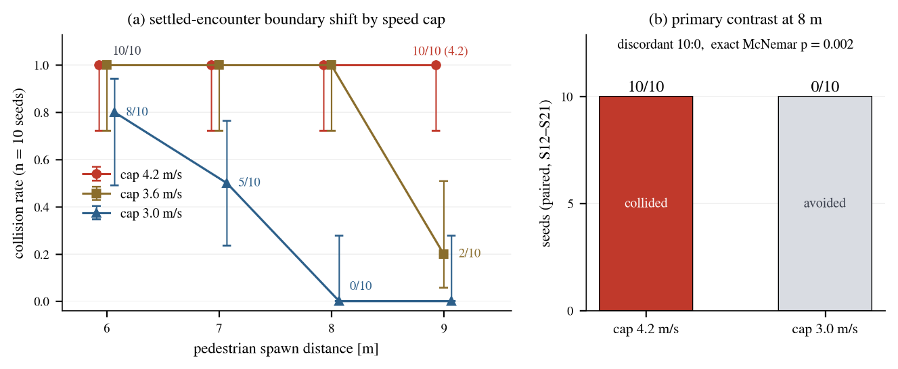
Interpretation limits: the causal conclusion is restricted to the settled regime where the cap holds; the transient risk before deceleration completes is outside this experiment — the cap does not remove the transient, it creates the post-settling physical margin. No optimality is claimed for 3.0 m/s (the 3.6 arm's 9 m onset only locates an intermediate dose), and the n=10 cells, single fault (gn-mid), and single corridor restrictions remain.
Figure 5.4. Dose-response experiment (120 runs, ledger adjudication). (a) Collision rate vs spawn distance per cap (Wilson 95% CI) — the boundary moves inward as the cap is lowered. (b) Pre-specified primary contrast at 8 m: 10/10 vs 0/10, discordant 10:0, exact McNemar p=0.002.

7. Hard-Fail Decision Latency: Verifying the 1.5 s Deadline

A 1.5 s deadline is set as a design specification (internal requirement) for hard-fail detection and decision — not an FTTI-compliance claim (Section 3.4). The budget comprises the 850 ms freshness deadline plus ~0.15 s for score propagation and transition (the fast path of Section 3.5), totalling ~1.0 s. Compliance was verified in ledger-based simulation time over the full cf/lf matrices (Table 5.5, Figure 5.1; latency n counts parsable-ledger runs, MRM denominators count post-ledger adjudicable runs, both below 90 after simulator-failure exclusion): across all subtypes the median was ~1.0 s and the maximum 1.20 s with no violations, and MRM attainment was maintained in full. The deadline is limited to hard fails; degradation-fault decisions follow the severity-proportional principle (Section 3.4).

Table 5.5. Hard-fail detection/decision latency (simulation time, ledger basis) and 1.5 s deadline compliance

Subtype | n | Median [s] | P95 [s] | Max [s] | >1.5 s | MRM reached
cf-proposed | 38 | 0.98 | 1.05 | 1.10 | 0 | 44/44
cf-baseline | 40 | 1.00 | 1.05 | 1.10 | 0 | 44/44
lf-proposed | 41 | 1.00 | 1.15 | 1.20 | 0 | 33/33
lf-baseline | 40 | 1.00 | 1.15 | 1.20 | 0 | 35/35
Decision latency = fault activation (injector ledger) to first MRM state transition (supervisor ledger), simulation time.

Chapter 6. LIMITATIONS AND DISCUSSION

1. Temporal Trade‑off, Transient Risk, and Speed Cap

The structure running through the experiments is the temporal trade-off between stop-type and evacuation-type MRMs. The in-lane stop minimizes immediate collision risk at the price of sustained lane occupancy (Section 5.2); evacuation accepts controlled moving exposure and transient residual risk but on success returns the lane and moves off-lane (lane clearance is an indicator of relinquished occupancy, not proof of final-position safety; secondary shoulder risks were not directly compared). Neither is unconditionally superior; the choice should follow the fault's temporal structure — concrete selection variables for the ISO 23793-1 framework.
That the same policy collided in transient encounters and avoided in settled ones signifies temporal localization of residual risk — when the encounter occurs dominates the outcome. The post-detection transient runs from detection to settled speed; the overall fault-response risk window runs from fault onset to settled speed (T_detect + T_deceleration). The results support, as a measurable proposition, that earlier detection and faster deceleration (in tension with comfort and rear-end risk) shrink this window — an observational comparison, not a causal manipulation of detection timing, so it must not be read as an effect-size estimate.
The cap's role follows from this: it verifiably shifts the avoidance boundary inward once the commanded speed holds, but gives no protection in the transient where the cap speed does not yet hold (measured 3.5–3.8 m/s) — an explicit re‑acceleration‑suppressing upper bound that is effective only after deceleration completes.

2. Lessons for Adjudication Methodology

The lesson of the collision-sensor silence incident (Section 4.5) is general: in simulation-based safety evaluation, "zero collisions" is meaningful only after the verdict channel is proven alive — addressed here by positive-control verification, physics-oracle cross-checks, and explicit statement of label/infraction pitfalls.

3. The Cost of Design Conservatism and the Execution and Map Layers

One factor limiting the evacuation completion rate is the cost of intended conservatism: the traffic-light observability gate shrinks the candidate set under camera-family faults (cf 16/45), and mitigations (detour search, relaxed V2X trust) would introduce new trust assumptions, so the conservative default was retained. Execution-layer dependence is explicit: the shoulder-entry maneuver is delegated to the stock goal_planner, so incompletions mix the decision layer's deferral choice with execution-layer maneuver failures (cf: 27 vs 2), distinguished at the log level (Section 3.7). At the map layer, manual annotation limits verification scope, and the signal miscount (Section 4.3) showed annotation quality to be a hidden confounder — the fundamental remedy is automated HD-map attribute extraction and verification.

6. Limitations → 4. Limitations

The numerical results are limited as follows. (i) Generalizability: the evaluation uses one map (Town07), one speed limit (15 km/h), two launch corridors, and Autoware 0.39.0; therefore, the reported boundaries and dose-response values are specific to this low-speed ODD, while the generalizable claims are structural rather than numerical. (ii) Dose-response cells contain n=10 with wide CIs, so point estimates may shift with larger samples despite the pre-specified test and reported CIs. (iii) Campaign-level collision-free status in Table 4.2 predates the ledger and was not re-verified. (iv) Encounter-model limitations include the lateral min-gap criterion (1.25 m) and the commanded-to-measured pedestrian-speed gap caused by post-spawn acceleration (n=90, median 2.46–2.50 m/s); boundary interpretation therefore relies on measured motion. (v) The dynamic detection budget (τ_detect) was not ablated against a fixed deadline, and formal detection-deadline compliance could not be quantified without hazard-time instrumentation and explicit FRTI/margin reservation. (vi) No real-vehicle validation was conducted.
Chapter 7. CONCLUSION

This study proposed behavior-tree-based monitoring that estimates sensor faults as continuous health scores, together with an MRM supervision layer that selects between evacuation and stop deferral by fault kind, severity, and remaining capability, imposing a conservative fixed cap (3.0 m/s) back-computed from stopping distance on evacuation movement, validated in an Autoware-CARLA closed loop.
Three conclusions follow. First, shoulder evacuation is not a panacea — stopping and evacuation form a temporal trade-off between immediate collision risk and lane clearance / off-lane position, and the choice must follow the fault's temporal structure. Second, evacuation's residual risk concentrates in the post-detection transient while settled low speed verifiably moves the avoidance boundary inward — supporting earlier detection and faster deceleration to shrink the overall fault-response risk window (not a causal manipulation experiment), an encounter-level quantitative basis for widening the FTTI margin. Third, simulation-based safety claims hold only on a validated adjudication framework — the dual ledger/physics-oracle verdict and the explicit identification of recording pitfalls are the methodological contribution underpinning the figures.
Future work will extend the evaluation to broader ODDs, maps, and real vehicles, formalize the FRTI-aware detection budget, and evaluate the health-proportional speed cap and deceleration profile.
References
1. ISO 26262:2018, Road vehicles — Functional safety.
2. ISO 21448:2022, Road vehicles — Safety of the intended functionality.
3. SAE J3016_202104, Taxonomy and Definitions for Terms Related to Driving Automation Systems for On-Road Motor Vehicles, 2021.
4. UNECE Regulation No. 157, Uniform provisions concerning the approval of vehicles with regard to Automated Lane Keeping Systems (ALKS), 2021.
5. UL 4600, Standard for Safety for the Evaluation of Autonomous Products, 3rd ed., 2023.
6. ISO/TR 4804:2020, Road vehicles — Safety and cybersecurity for automated driving systems — Design, verification and validation.
7. AUTOSAR, Specification of Watchdog Manager, R23-11.
8. Robert Bosch GmbH, "Method and apparatus for determining fault tolerant time interval (FTTI) of autonomous driving assistance system," U.S. Patent US12347247B2.
9. J. C. Hayward, "Near-miss determination through use of a scale of danger," Highway Research Record, no. 384, 1972.
10. M. M. Minderhoud and P. H. L. Bovy, "Extended time-to-collision measures for road traffic safety assessment," Accident Analysis & Prevention, vol. 33, no. 1, 2001.
11. S. Shalev-Shwartz, S. Shammah, and A. Shashua, "On a formal model of safe and scalable self-driving cars," arXiv:1708.06374, 2017.
12. A. S. Willsky, "A survey of design methods for failure detection in dynamic systems," Automatica, vol. 12, no. 6, 1976.
13. R. Isermann, "Model-based fault-detection and diagnosis — status and applications," Annual Reviews in Control, vol. 29, no. 1, 2005.
14. R. Isermann, Fault-Diagnosis Systems: An Introduction from Fault Detection to Fault Tolerance, Springer, 2006.
15. Z. Gao, C. Cecati, and S. X. Ding, "A survey of fault diagnosis and fault-tolerant techniques — Part I (pp. 3757-3767); Part II (pp. 3768-3774)," IEEE Transactions on Industrial Electronics, vol. 62, no. 6, 2015.
16. E. S. Page, "Continuous inspection schemes," Biometrika, vol. 41, no. 1/2, 1954.
17. M. Basseville and I. V. Nikiforov, Detection of Abrupt Changes: Theory and Application, Prentice Hall, 1993.
18. Autoware Foundation, "autoware.universe documentation: ring_outlier_filter, blockage_diag, mrm_handler, goal_planner" (evaluated version 0.39.0). https://autowarefoundation.github.io/autoware.universe/
19. R. B. Rusu and S. Cousins, "3D is here: Point Cloud Library (PCL)," Proc. IEEE ICRA, 2011.
20. M. Bijelic, T. Gruber, and W. Ritter, "A benchmark for lidar sensors in fog: Is detection breaking down?" Proc. IEEE Intelligent Vehicles Symposium, 2018.
21. R. Heinzler, P. Schindler, J. Seekircher, W. Ritter, and W. Stork, "Weather influence and classification with automotive lidar sensors," Proc. IEEE Intelligent Vehicles Symposium, 2019.
22. C. Zhang et al., "LiDAR degradation quantification for autonomous driving in rain," Proc. IEEE/RSJ IROS, 2021.
23. J. Kim, B.-j. Park, and J. Kim, "Empirical analysis of autonomous vehicle's LiDAR detection performance degradation for actual road driving in rain and fog," Sensors, vol. 23, no. 6, 2972, 2023.
24. F. Secci and A. Ceccarelli, "On failures of RGB cameras and their effects in autonomous driving applications," Proc. IEEE ISSRE, 2020.
25. N. El-Sheimy, H. Hou, and X. Niu, "Analysis and modeling of inertial sensors using Allan variance," IEEE Transactions on Instrumentation and Measurement, vol. 57, no. 1, 2008.
26. V. Suvorkin, M. Garcia-Fernandez, G. González-Casado, M. Li, and A. Rovira-Garcia, "Assessment of noise of MEMS IMU sensors of different grades for GNSS/IMU navigation," Sensors, vol. 24, no. 6, 1953, 2024.
27. S. Khanafseh et al., "GNSS multipath error modeling for automotive applications," Proc. ION GNSS+, 2018.
28. N. Zhu, J. Marais, D. Bétaille, and M. Berbineau, "GNSS position integrity in urban environments: A review of literature," IEEE Transactions on Intelligent Transportation Systems, vol. 19, no. 9, 2018.
29. T. G. R. Reid et al., "Localization requirements for autonomous vehicles," SAE International Journal of Connected and Automated Vehicles, vol. 2, no. 3, 2019.
30. S. Magdici and M. Althoff, "Fail-safe motion planning of autonomous vehicles," Proc. IEEE ITSC, 2016.
31. L. Svensson et al., "Safe stop trajectory planning for highly automated vehicles: An optimal control problem formulation," Proc. IEEE Intelligent Vehicles Symposium, 2018.
32. C. Pek, S. Manzinger, M. Koschi, and M. Althoff, "Using online verification to prevent autonomous vehicles from causing accidents," Nature Machine Intelligence, vol. 2, 2020.
33. Y. Emzivat, J. Ibanez-Guzman, P. Martinet, and O. H. Roux, "Dynamic driving task fallback for an automated driving system whose ability to monitor the driving environment has been compromised," Proc. IEEE Intelligent Vehicles Symposium, 2017.
34. A. Reschka and M. Maurer, "Conditions for a safe state of automated road vehicles," it — Information Technology, vol. 57, no. 4, 2015.
35. A. Reschka, G. Bagschik, S. Ulbrich, M. Nolte, and M. Maurer, "Ability and skill graphs for system modeling, online monitoring, and decision support for vehicle guidance systems," Proc. IEEE Intelligent Vehicles Symposium, 2015.
36. M. Nolte, G. Bagschik, I. Jatzkowski, T. Stolte, A. Reschka, and M. Maurer, "Towards a skill- and ability-based development process for self-aware automated road vehicles," Proc. IEEE ITSC, 2017.
37. A. Kane, O. Chowdhury, A. Datta, and P. Koopman, "A case study on runtime monitoring of an autonomous research vehicle (ARV) system," Proc. Runtime Verification (RV), 2015.
38. M. Machin, J. Guiochet, H. Waeselynck, J.-P. Blanquart, M. Roy, and L. Masson, "SMOF: A safety monitoring framework for autonomous systems," IEEE Transactions on Systems, Man, and Cybernetics: Systems, vol. 48, no. 5, 2018.
39. P. Koopman and M. Wagner, "Challenges in autonomous vehicle testing and validation," SAE International Journal of Transportation Safety, vol. 4, no. 1, 2016.
40. M. Colledanchise and P. Ögren, Behavior Trees in Robotics and AI: An Introduction, CRC Press, 2018.
41. M. Iovino, E. Scukins, J. Styrud, P. Ögren, and C. Smith, "A survey of behavior trees in robotics and AI," Robotics and Autonomous Systems, vol. 154, 2022.
42. D. Faconti, BehaviorTree.CPP (v4) / behaviortree_ros2, github.com/BehaviorTree/BehaviorTree.CPP.
43. A. Dosovitskiy, G. Ros, F. Codevilla, A. López, and V. Koltun, "CARLA: An open urban driving simulator," Proc. Conference on Robot Learning (CoRL), 2017.
44. S. Jha et al., "ML-based fault injection for autonomous vehicles: A case for Bayesian fault injection," Proc. IEEE/IFIP DSN, 2019.
45. S. H. Rubaiyat, Y. Qin, and H. Alemzadeh, "Experimental resilience assessment of an open-source driving agent," Proc. IEEE PRDC, 2018.
46. G. Li et al., "AV-FUZZER: Finding safety violations in autonomous driving systems," Proc. IEEE ISSRE, 2020.
47. D. J. Fremont et al., "Scenic: A language for scenario specification and scene generation," Proc. ACM PLDI, 2019.
48. J. Tang, C. Yang, and H. Nishimura, "Minimum risk maneuver strategy for automated driving system under multiple conditions of sensor failure," Systems, vol. 14, no. 1, 87, 2026.
49. W. Xue, B. Yang, T. Kaizuka, and K. Nakano, "A fallback approach for an automated vehicle encountering sensor failure in monitoring environment," Proc. IEEE Intelligent Vehicles Symposium, 2018.
50. W. Xue, B. Yang, T. Kaizuka, and K. Nakano, "An adaptive model predictive approach for automated vehicle control in fallback procedure based on virtual vehicle scheme," Journal of Intelligent and Connected Vehicles, vol. 2, no. 2, pp. 67-77, 2019.
51. ISO 23793-1:2024, Intelligent transport systems — Minimal risk manoeuvre (MRM) for automated driving — Part 1: Framework, straight-stop and in-lane stop.
52. G. Kaljavesi, D. Majstorovic, M. Clement, and F. Diermeyer, "Empirical mapping of technical bottlenecks in autonomous driving: A cross-platform evaluation of simulated and real-world performance," Preprint, 2026. (autoware_carla_leaderboard, TUM Institute of Automotive Technology)
53. C. Goodin, D. Carruth, M. Doude, and C. Hudson, "Predicting the influence of rain on LIDAR in ADAS," Electronics, vol. 8, no. 1, 89, 2019.
54. V. Kilic et al., "LISA: Lidar light scattering augmentation for physics-based deep learning of lidar point clouds in adverse weather," arXiv:2107.07004, 2021.
55. M. Trierweiler, P. Caldelas, G. Gröninger, T. Peterseim, and C. Neumann, "Influence of sensor blockage on automotive LiDAR systems," Proc. IEEE SENSORS, 2019.
56. C. Schlager et al., "Contaminations on lidar sensor covers: Performance degradation analysis," IEEE Open Journal of Intelligent Transportation Systems, vol. 3, 2022.
57. T. Goelles, B. Schlager, and S. Muckenhuber, "Fault detection, isolation, identification and recovery (FDIIR) methods for automotive perception sensors including a detailed literature survey for lidar," Sensors, vol. 20, no. 13, 3662, 2020.
58. M. Hahner, C. Sakaridis, D. Dai, and L. Van Gool, "Fog simulation on real LiDAR point clouds for 3D object detection in adverse weather," Proc. IEEE/CVF ICCV, 2021.
59. M. Hahner et al., "LiDAR snowfall simulation for robust 3D object detection," Proc. IEEE/CVF CVPR, 2022.
60. ISO 3691-4:2023, Industrial trucks — Safety requirements and verification — Part 4: Driverless industrial trucks and their systems.
61. S. Langel, O. García Crespillo, and M. Joerger, "Overbounding the effect of uncertain Gauss-Markov noise in Kalman filtering," NAVIGATION, Journal of the Institute of Navigation, vol. 68, no. 2, 2021.
62. U. I. Bhatti and W. Y. Ochieng, "Failure modes and models for integrated GPS/INS systems," The Journal of Navigation, vol. 60, no. 2, pp. 327-348, 2007.
논문요약

자율주행 차량의 페일세이프 운행을 위한
연속 센서 건강도 감시와
위험·잔여능력 기반 단계적 최소위험기동 감독

엄태욱
전자전기컴퓨터공학과
성균관대학교

자율주행 시스템의 센서 고장 대응은 대부분 "즉시 차로 내 정지"라는 단일 전략에 의존한다. 그러나 차로 내 정지는 후속 교통의 차단과 2차 충돌 위험을 만들고, 반대로 고장 상태의 계속 주행은 열화된 지각으로 위험에 노출되는 거리를 늘린다. 본 논문은 센서 고장을 이분법이 아닌 연속 건강도 점수로 추정하는 행동트리(Behavior Tree) 기반 감시 모듈과, 고장의 종류·정도와 잔여 기동 능력에 따라 갓길·주차장 대피(MRM_MOVE)와 순정 정차 위임(MRM_DEFER)을 구분 선택하고 대피 이동 중 보수적 고정 속도 상한(3.0 m/s)을 부과하는 MRM 감독자로 구성된 단계적 고장 대응 프레임워크를 제안한다.
검증은 Autoware 0.39.0과 CARLA 0.9.16의 폐루프 환경(Town07, 제한속도 15 km/h)에서 수행하였다. 총 1,862 유효 케이스의 단일 폐루프 실험으로 감시·대피 거동을 검증하였고, 고장 상태 주행거리(노출)를 무감시 순정의 대표 관찰 238~251 m 대비 감시+대피의 32~58 m로 단축함을 보였다(라이다 클러터는 275→11~12 m). 하드 페일은 고속 판정 경로로 1.5 s 설계 마감 안에 판정되며(실측 최대 1.20 s), 항법 고장 4종을 포함한 전 조건에서 100% 검출을 확인하였다. 안전성은 에고 충돌 센서 실시간 원장(RAW-HIT)과 보행자 물리 오라클의 이중 판정 체계 위에서 보행자 돌발 조우 수준으로 정량화하였다: 회피/충돌 경계는 4.2 m/s에서 8~11 m(모델 8.8 m와 일치), 3.0 m/s에서 7~8 m였다.
고장 상태의 8 m 조우 재현에서 순정 지속 주행은 전량 충돌한 반면 제안 저속 정착 순항은 전량 회피했고(0/10 대 8/8), 같은 정책도 감속 과도구간 조우에서는 충돌했다(2/2). 상한이 실제 성립한 정착 조우의 용량-반응 실험(상한 3종×거리 4종×10시드=120런, 사전 지정 1차 종결점)에서 상한 4.2 대 3.0 m/s는 8 m 쌍대 불일치 10:0(exact McNemar p=0.002)으로 충돌 감소 효과가 검출되었고, 회피/충돌 경계는 상한을 낮출수록 단조로 안쪽 이동했다(9 m 초과→약 7 m). 즉 최소위험기동의 선택은 즉시 충돌 위험과 차선 반환·차선 밖 대피 위치 확보 가능성 사이의 시간적 트레이드오프이며, 대피의 잔존 위험은 감지 후 과도구간에 집중된다 — 더 이른 감지와 더 빠른 감속이 전체 고장 대응 위험 창을 축소할 것임을 실험적으로 뒷받침하는, FTTI 이내 여유 확보 필요성에 대한 조우 수준의 정량적 근거를 제공한다.
주제어: 자율주행, 페일세이프, 최소위험기동(MRM), 센서 고장 감지, FTTI

(Side Cover form표지측면 서식)
Master’s Thesis
Thesis title
2
0
2
6
영문성명(ex: Gilsan Jang)
(제본시에만 사용하세요.
온라인 제출 시 삭제 바랍니다.)
(Use only for binding. Please remove
this page when submitting online.)

