Graded Fault Response for Autonomous Driving via Behavior-Tree-based Sensor Health Monitoring and Risk/Capability-aware MRM Supervision
○○○
Department of Electrical and Computer Engineering, Sungkyunkwan University

Abstract
Sensor-fault handling in automated driving stacks largely reduces to a single strategy — an immediate in-lane stop — which leaves the vehicle obstructing live traffic, while undetected faults let it keep driving on degraded perception. This paper presents a graded fault-response framework composed of a behavior-tree monitor that estimates per-sensor health as continuous scores from freshness, quality, and physics channels, and a supervisor that selects between shoulder/parking-lot evacuation and deferral to the stock in-lane stop according to fault type, severity, and remaining capability, enforcing a 3.0 m/s speed cap during evacuation. The framework runs as an add-on to an unmodified Autoware 0.39.0 stack in closed loop with CARLA 0.9.16. Across 1,131 valid cases the detector reached 96–100% detection with 2.1–5.0 s median latency in 11 of 12 fault conditions and zero false activations in 45 fault-free cases, and supervision cut degraded-state driving exposure from 238–275 m to 32–58 m. Complete sensor silence is decided through a hard-fail fast path that met a 1.5 s detection-to-decision deadline in every case (max 1.20 s). A paired four-arm ablation with a standardized pedestrian dart-out shows that the choice between stopping and evacuating is a temporal trade-off: residual evacuation risk concentrates in the deceleration transient (11/20), while the same policy in settled cruise avoided all encounters (0/8). A supplementary campaign extended the fault model to correlated GNSS bias, GNSS outage, and IMU bias/drift (611 valid cases, 100% detection).
Keywords: autonomous driving, functional safety, minimal risk maneuver, FTTI, sensor fault detection, behavior tree
1. Introduction
Production-grade automated driving stacks ship with a minimal-risk-maneuver (MRM) repertoire that, in practice, collapses to one behavior: when a fault is severe enough to be noticed, stop in the current lane. This single strategy has two failure modes at opposite ends of the severity spectrum. When it fires, the vehicle becomes a stationary obstacle in a live lane, exposing following traffic to a hazard the stop was meant to remove; when it does not fire — because the fault degrades perception without tripping a binary diagnostic — the vehicle simply keeps driving with senses it no longer has. Figure 1 illustrates the setting: a vehicle that detects a sensor fault on a two-lane rural road usually has better options than its own lane, including adjacent free space, a parking lot, or a downstream shoulder, but exploiting them requires knowing how much capability remains and whether the maneuver itself is still safe, including against edge cases such as a pedestrian darting out during the evacuation.
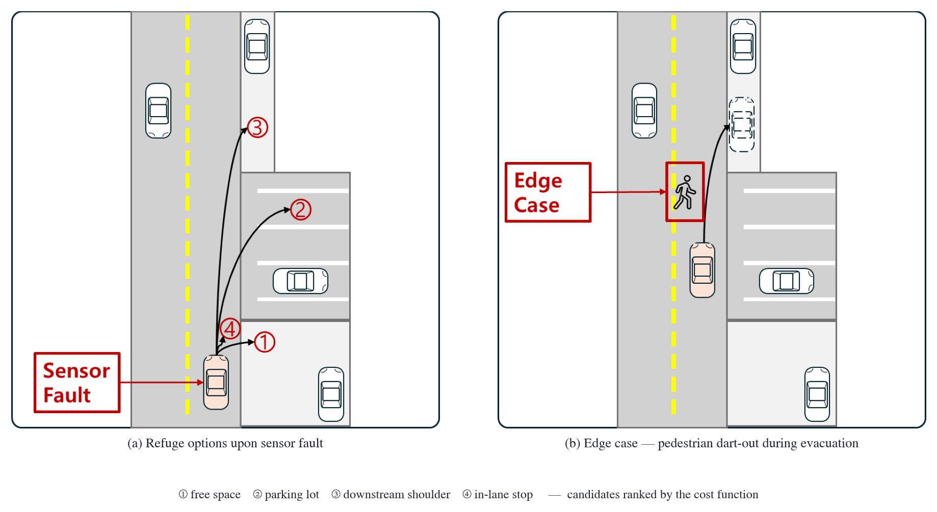
Fig. 1. Problem setting: graded refuge options upon a sensor fault (a) and the pedestrian dart-out edge case during evacuation (b). Candidates are ranked by a cost function.
We propose a graded fault-response framework built from two cooperating components: a behavior-tree monitor (CDR Monitor) that turns raw sensor streams into continuous per-sensor and per-sector health scores, and a supervisor (MRM Supervisor) that maps the monitored condition to one of five responses — continue, shoulder stop, parking-lot stop, in-lane stop, or emergency stop — using dual health thresholds and a time-denominated cost function over pre-annotated refuge candidates. The framework attaches to an unmodified Autoware stack through read-only topic subscriptions and the standard AD API and diagnostics interfaces, so the nominal driving channel is never altered.
The contributions are: (1) a monitoring design that produces graded health estimates rather than binary faults, with an evidence-aware fast path that decides complete sensor silence within a 1.5 s deadline; (2) a capability-aware MRM selection policy with an explicit quality ordering over minimal-risk conditions and a conservative 3.0 m/s evacuation speed cap derived from a stopping-distance model; (3) a closed-loop evaluation of 1,131 valid cases plus a 611-case supplementary campaign over an eleven-type physics-grounded fault model; and (4) an empirical characterization of the stop-versus-evacuate trade-off, including a two-regime analysis showing that evacuation risk concentrates in the detection-to-deceleration transient.
2. Related Work
Autoware [1] provides in-lane MRMs (comfortable and emergency stop) triggered by its diagnostics graph, but offers no built-in notion of evacuating to a refuge, and its fault handling is binary. Standards frame the requirements we target: ISO 26262 [4] demands a bounded time to a safe state and defines the fault-tolerant time interval (FTTI); UNECE Regulation No. 157 [6] requires an MRM that ends in a standstill with risk minimized during the maneuver; ISO 23793-1 [5] classifies MRM types for low-speed automated driving, distinguishing in-lane stops from maneuvers to safer stopping positions; SAE J3016 [7] defines the minimal risk condition (MRC) the maneuver must reach. Our policy operationalizes these concepts as an explicit, testable selection matrix. The fault model draws on the LiDAR degradation literature: the fault taxonomy of Goelles et al. [8], measured rain attenuation and clutter models [9, 10], adverse-weather point-cloud simulation [11, 12], and measured cover-soiling effects [13]. The experimental infrastructure builds on CARLA [2], the Autoware–CARLA leaderboard integration of Kaljavesi et al. [3], and a custom Town07 lanelet2 map annotated with refuge candidates.
3. System Design
3.1 Architecture
Figure 2 shows the architecture. The CARLA server feeds a bridge that converts sensor topics for the Autoware stack; sensor faults are injected inside this bridge conversion layer, so the faulted data reaches the nominal stack and the proposed supervision layer identically. The CDR Monitor subscribes read-only to the same sensor topics and publishes health scores at 10 Hz; the MRM Supervisor consumes the scores and, when intervention is warranted, acts on the stack only through public interfaces — a reroute request with a speed cap for evacuation (MOVE), or an injected diagnostic ERROR that delegates to the stock in-lane stop (DEFER). Autoware itself runs unmodified.
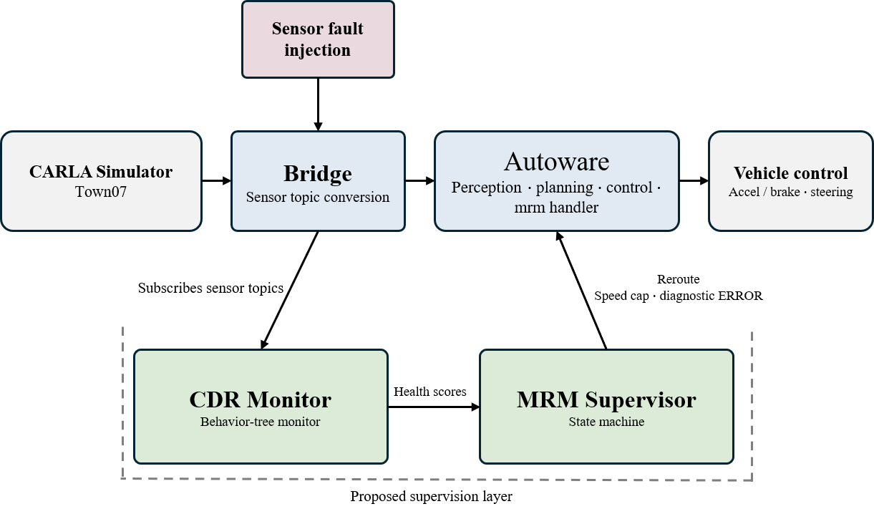
Fig. 2. System architecture. The proposed supervision layer (CDR Monitor and MRM Supervisor) attaches to an unmodified Autoware stack; faults are injected in the bridge, upstream of both the stack and the monitor.
3.2 Behavior-tree health monitoring
The monitor is a behavior tree ticked at 10 Hz (Figure 3). A sequence node updates the driving state, then a parallel node runs per-sensor checkers — front and rear LiDAR, camera, IMU, and GNSS — each scoring its stream on freshness (message arrival against a deadline), quality (e.g., point count, pixel statistics), and physical consistency (e.g., yaw-rate plausibility, EKF residuals). Channel scores are fused into per-sector capability scores that express what the vehicle can still perceive in each direction, which is the currency the supervisor reasons in. Two failure classes get distinct treatment: gradual degradation passes through band debouncing to suppress transients, whereas complete silence — a dead sensor — takes a hard-fail fast path: once the freshness deadline (1.0 s) is exceeded, debouncing and recovery holds are skipped because the silence itself is persistent evidence, and the monitor commits to a decision within a 1.5 s detection-to-decision deadline.
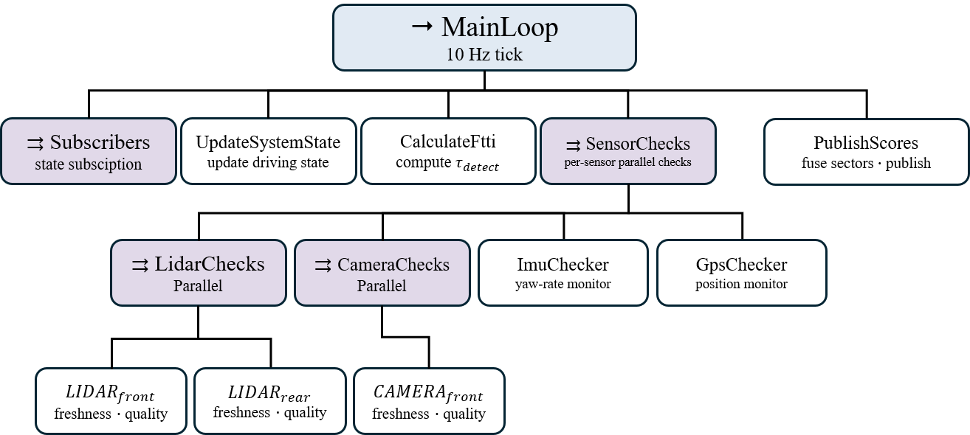
Fig. 3. Behavior-tree structure of the CDR Monitor (10 Hz tick): state update, parallel per-sensor checks, and sector/capability fusion.
3.3 MRM selection policy
Table 1 gives the selection policy. Dual thresholds partition the health estimate: above the intervention-entry threshold θH the vehicle continues; in the band between θH and the minimum-capability threshold θL — or immediately upon a dead sensor — the supervisor evacuates (MOVE), choosing among shoulder and parking-lot candidates ranked by a cost function, with the in-lane stop as fallback if the maneuver fails; below θL, or when no candidate is reachable, it delegates the stop to the stock stack (DEFER), with the emergency stop as the final fallback. The cost of a candidate is dominated by the exposure time η it implies — route time under the speed limits plus expected signal waits — following the time-to-safe-state framing of ISO 26262: risk accumulates per second of degraded driving, not per meter. Additional terms penalize routes through traffic lights when camera capability is low, penalize candidates whose required perception sectors are unhealthy, and encode the MRC quality ordering (a parking lot fully clears the roadway; a shoulder stop may partially occupy it) as a fixed penalty on shoulder candidates.
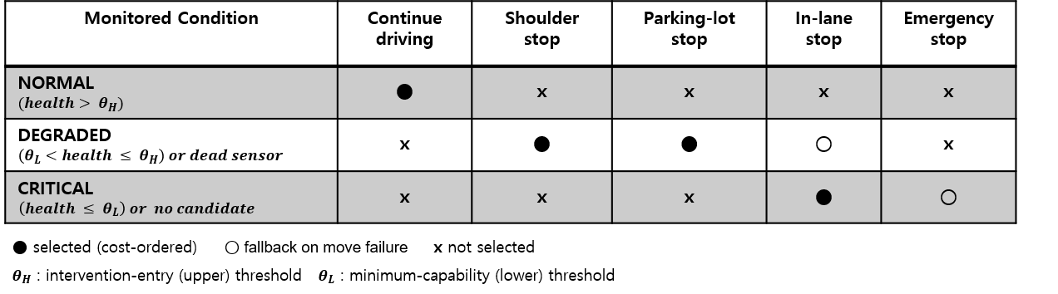
Table 1. MRM selection policy by monitored condition. ● selected (cost-ordered), ○ fallback on move failure, × not selected.
During evacuation the supervisor enforces a fixed 3.0 m/s speed cap. The value comes from a stopping-distance model d(v) = vτ + v²/2a with an empirically identified effective reaction time τ = 1.5 s and deceleration a = 3.5 m/s²: 3.0 m/s keeps the required stopping distance (5.8 m) inside the 8 m encounter envelope used in our edge-case experiments, whereas the uncapped evacuation speed of 4.2 m/s requires 8.8 m and cannot stop in time. Section 5.3 validates the model against measured avoid/collide boundaries.
3.4 Refuge candidate map
Candidates are not searched online; they are pre-annotated in a custom lanelet2 map of Town07 (Figure 4): 16 shoulder lanelets tagged road_shoulder and 4 parking-lot polygons with individual parking spaces. Pockets too short for a moving pull-over are excluded at extraction time. Along the reference route the nearest candidate is never far — median 4.3 m, worst case 23.4 m straight-line — so a bounded-time evacuation is available from any point of the operational design domain; where such coverage cannot be guaranteed, the policy answer is DEFER, not a longer drive.

Fig. 4. Pre-annotated refuge candidates on the custom Town07 lanelet2 map: 16 shoulder lanelets (red), 4 parking-lot polygons (blue), and the reference route (dashed).
4. Experimental Setup
All experiments run in a closed loop of CARLA 0.9.16 and Autoware 0.39.0 on Town07 under a 15 km/h speed limit, orchestrated through the CARLA leaderboard for case execution and official scoring [3]. Figure 5 shows representative scenes: the nominal driving environment, the perception view, the annotated vector map, the two evacuation MRCs (shoulder and parking lot), and the pedestrian dart-out used in the edge-case study. Timing metrics are reported in simulation time throughout.

Fig. 5. Representative scenes: (a) Town07 driving scene, (b) RViz perception view, (c) custom vector map with refuge candidates, (d) shoulder-evacuation MRC with traffic passing, (e) parking-lot evacuation MRC, (f) pedestrian dart-out.
The fault model (Figure 6) covers eleven types across four sensor families, grounded in the measurement literature where physics matters: LiDAR soiling as sector-local transmittance loss with threshold-dependent dropout [8, 13], rain as Beer–Lambert attenuation with near-range clutter [9, 10], camera pixel noise, dead sensors (camera and LiDAR stream freeze), and navigation faults — GNSS white noise, first-order Gauss–Markov correlated bias, GNSS outage, and gyro white noise, fixed bias, and bias ramp. Each type is injected at mid and high severity inside the bridge.
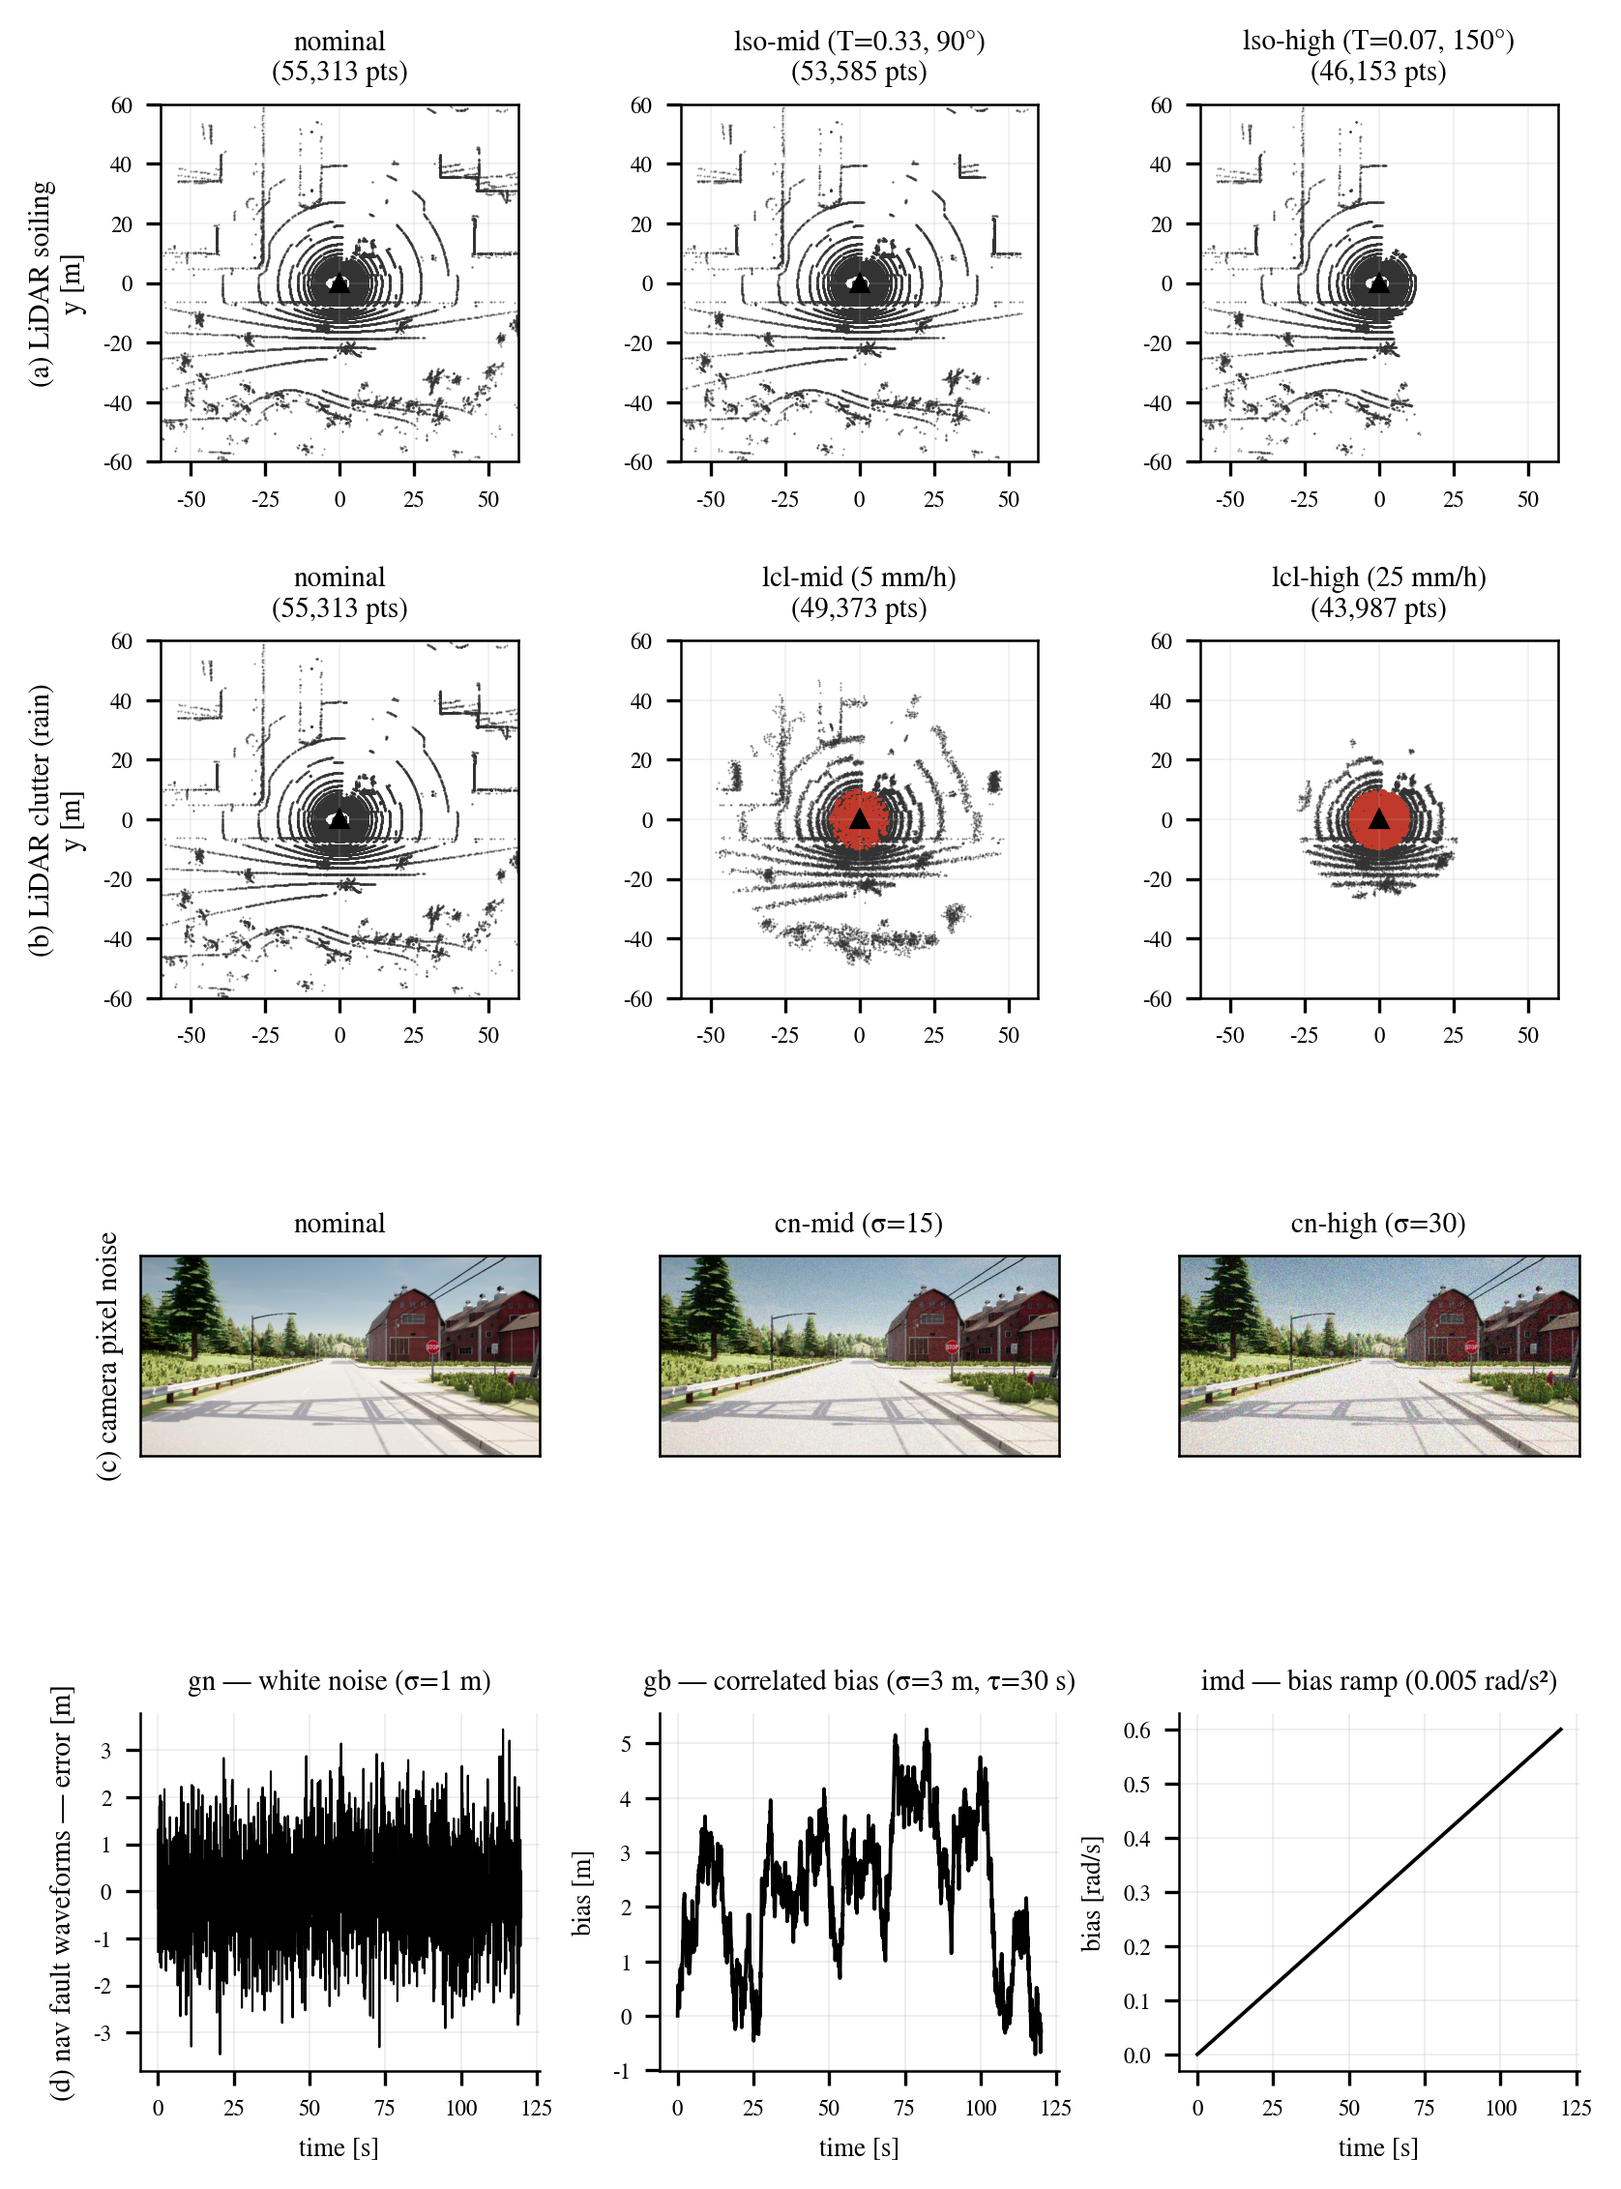
Fig. 6. Sensor fault model: (a) LiDAR soiling, (b) LiDAR rain clutter, (c) camera pixel noise, (d) navigation fault waveforms.
The main campaign comprises 1,131 valid cases over fault types, severities, traffic densities, and methods (proposed versus unsupervised stock), with 45 fault-free cases for false-activation measurement; a supplementary campaign of 611 valid cases covers the navigation fault extension at the same protocol scale. The edge-case study is a paired, same-seed, four-arm ablation over 20 seeds: a pedestrian crosses from the right lane edge 8 m ahead, launched at detection + 3 s by a behavior-independent trigger so all arms face identical relative geometry. Collision outcomes are established by a triple verdict system — a real-time ego collision-sensor ledger, a walker-physics oracle, and a human visual cross-check — introduced after we found that a walker-attached collision sensor never fires and that runner exit labels and official infraction records can both mislead; we document this as a methodological caution for CARLA-based safety claims.
5. Results
5.1 Detection
Figure 7 summarizes detection latency per fault condition. The monitor detected 96–100% of injected faults in 11 of 12 main-campaign conditions with median latencies of 2.1–5.0 s; the exception is mild LiDAR sparsification, tolerated by design as it does not reduce driving capability. No false activation occurred in 45 fault-free cases. The supplementary navigation campaign reached 100% detection in all conditions, with a dose–response relationship for the gyro bias ramp (slower ramps take longer to cross detection thresholds) and a bimodal latency for GNSS outage depending on whether injection occurred while moving or while waiting at a signal. Dead-sensor conditions exercise the hard-fail fast path: across the full camera/LiDAR-freeze matrix the detection-to-decision time was about 1.0 s at the median — dominated by the freshness deadline — with a maximum of 1.20 s and zero violations of the 1.5 s deadline, and every case completed its MRM.

Fig. 7. Detection latency by fault condition (proposed arm; dead-sensor rows re-measured through the hard-fail fast path in simulation time).
5.2 Exposure reduction
The purpose of evacuation is to shorten the time the vehicle spends driving on degraded senses. Measured as degraded-state driving distance, supervision reduced exposure from 238–275 m under the unsupervised stock stack to 32–58 m with detect-and-evacuate for camera and localization faults. The comparison between stop styles is also informative: the in-lane stop yields zero post-encounter moving exposure but occupies the driving lane beyond the observation horizon, whereas evacuation spends a median of 37.2 m of controlled low-speed motion and then clears the roadway — the two responses trade different kinds of exposure, which is precisely what a graded policy should arbitrate.
5.3 Stopping-distance model validation
Distance-ladder experiments located the avoid/collide boundary at 8–11 m for 4.2 m/s driving and at 7–8 m for 3.0 m/s (Figure 8). The model reproduces the uncapped boundary closely (prediction 8.8 m) and is optimistic at the capped speed (prediction 5.8 m against a measured 7–8 m band), the gap reflecting planner reaction variance; both measurements support the design conclusion that 4.2 m/s cannot stop within the 8 m envelope while 3.0 m/s can, with margin at the model level and marginally in the worst measured case.

Fig. 8. Stopping-distance model d(v)=vτ+v²/2a (τ=1.5 s, a=3.5 m/s²) against measured avoid/collide boundaries from the distance ladder.
5.4 Stop versus evacuate: the edge case
In the four-arm ablation, native continuation collided in 14 of 20 seeds, detection with in-lane stop in 0 of 20, uncapped evacuation in 10 of 20, and capped evacuation in 11 of 20 (exact McNemar, native versus capped evacuation: p = 0.375). The explicit cap prevented no additional collisions in this sample — we report this without an equivalence claim. The decisive observation is temporal: every evacuation-arm collision occurred during the detection-to-deceleration transient, while the same capped-evacuation policy facing encounters in settled cruise after deceleration avoided all of them (0/8). The stop-versus-evacuate choice is thus a trade-off between immediate collision risk during the transient, which favors stopping, and the terminal benefit of clearing the lane, which favors evacuation when it succeeds — observational evidence, from a two-regime comparison rather than a causal manipulation, that shortening detection and deceleration is where additional safety is to be found, in line with the FTTI framing.
Figure 9 completes the picture on the benefit side. Among the 20 evacuation-arm cases, 7 collided (reported separately as failed lane clearance), 6 cleared the driving lane within the observation horizon with an observed median of 11.0 s, and 7 had not cleared by the horizon and are right-censored; the Kaplan–Meier survival of lane occupancy ends at 0.538, so the median clearance time is not reached within the horizon. Evacuation, when it works, converts a permanent lane obstruction into a bounded clearing process, but the censored fraction shows the conversion is not guaranteed within a short horizon.
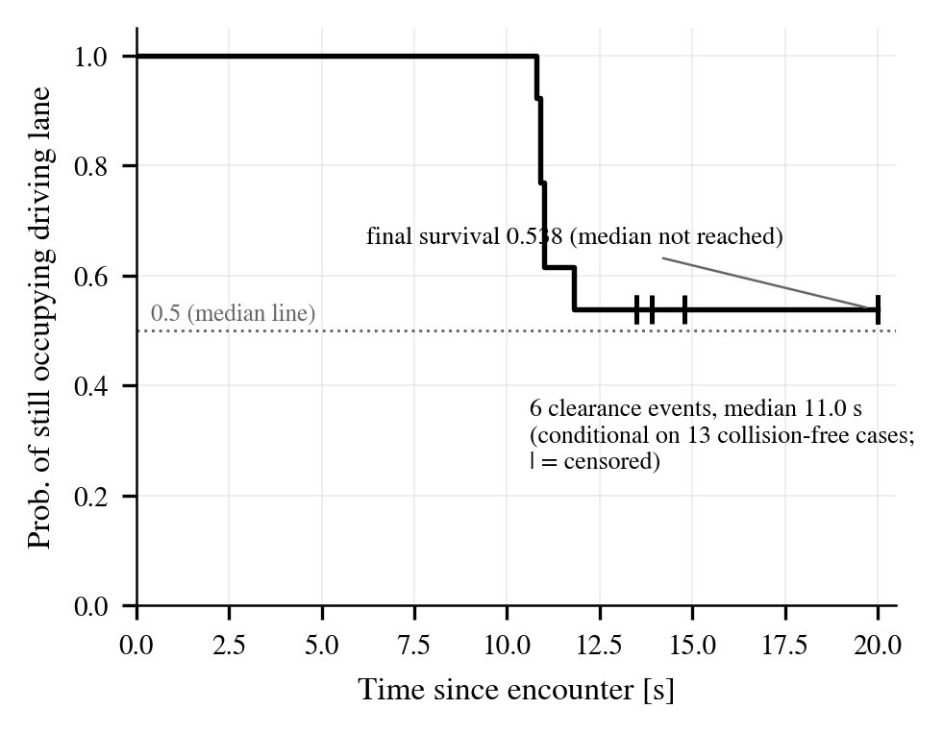
Fig. 9. Kaplan–Meier curve of driving-lane occupancy after the encounter (evacuation arms; ticks mark censored cases). Terminal survival 0.538; median not reached within the horizon.
6. Limitations
The evaluation uses a single map, a single 15 km/h speed limit, and two launch corridors, and all stack-specific observations are tied to Autoware 0.39.0. The two-regime transient analysis is observational: encounter timing was standardized relative to detection, not manipulated causally. The ablation sample (20 seeds) is small for arm-to-arm comparisons, which is why we report exact McNemar statistics and abstain from equivalence claims. Refuge coverage is a property of the annotated map; deployments on sparser road networks would rely on the DEFER branch more often, and an absolute exposure-time ceiling on candidate selection is a natural hardening we identify for future work.
7. Conclusion
A graded fault response — continuous health monitoring feeding a capability-aware choice among refuge options — can be attached to a production automated driving stack without modifying it, detects a physics-grounded spectrum of sensor faults reliably and within hard deadlines for dead sensors, and materially shortens degraded-state exposure relative to both silent continuation and the ubiquitous in-lane stop. The edge-case study tempers the promise with a precise boundary: during the detection transient, stopping remains the safer reflex, and the payoff of evacuation is realized after deceleration settles. Making that transient shorter is the clearest path to making graded responses strictly dominant.
References
[1] S. Kato et al., "Autoware on Board: Enabling Autonomous Vehicles with Embedded Systems," Proc. ACM/IEEE ICCPS, 2018.
[2] A. Dosovitskiy, G. Ros, F. Codevilla, A. Lopez, and V. Koltun, "CARLA: An Open Urban Driving Simulator," Proc. CoRL, 2017.
[3] G. Kaljavesi, D. Majstorovic, M. Clement, and F. Diermeyer, "Empirical Mapping of Technical Bottlenecks in Autonomous Driving: A Cross-Platform Evaluation of Simulated and Real-World Performance," preprint, 2026.
[4] ISO 26262:2018, Road Vehicles — Functional Safety.
[5] ISO 23793-1:2022, Intelligent Transport Systems — Minimal Risk Manoeuvre (MRM) for Automated Driving — Part 1.
[6] UNECE Regulation No. 157, Automated Lane Keeping Systems (ALKS), 2021.
[7] SAE J3016, Taxonomy and Definitions for Terms Related to Driving Automation Systems, 2021.
[8] T. Goelles, B. Schlager, and S. Muckenhuber, "Fault Detection, Isolation, Identification and Recovery (FDIIR) Methods for Automotive Perception Sensors Including a Detailed Literature Survey for Lidar," Sensors, vol. 20, no. 13, p. 3662, 2020.
[9] C. Goodin, D. Carruth, M. Doude, and C. Hudson, "Predicting the Influence of Rain on LIDAR in ADAS," Electronics, vol. 8, no. 1, p. 89, 2019.
[10] V. Kilic et al., "Lidar Light Scattering Augmentation (LISA): Physics-Based Simulation of Adverse Weather Conditions for 3D Object Detection," arXiv:2107.07004, 2021.
[11] M. Hahner, C. Sakaridis, D. Dai, and L. Van Gool, "Fog Simulation on Real LiDAR Point Clouds for 3D Object Detection in Adverse Weather," Proc. IEEE/CVF ICCV, 2021.
[12] M. Hahner et al., "LiDAR Snowfall Simulation for Robust 3D Object Detection," Proc. IEEE/CVF CVPR, 2022.
[13] M. Trierweiler, T. Peterseim, and C. Neumann, "Automotive LiDAR Pollution Detection System Based on Total Internal Reflection Techniques," IEEE SENSORS, 2019.

