Our Application

It is a college assistant application that helps with the following:

1. Keeps track of your ATTENDANCE in real-time.
2. Helps you calculate your GPA and CGPA.
3. Displays your time TIME-TABLE and corresponding class rooms.
4. Provides pocket friendly FOYER FOOD SUGGESTIONS.

With our application, your college day becomes easier and more systematic to manage. You will no longer need to worry or stress about what your attendance is, never worry about where your next lecture is or which subject it is on, never remember your CIA marks when you scribble to calculate your GPA and never ponder “What can I eat and not spend too much money on?”.

# Features

# Attendance Tracker:

This module keeps track of your attendance daily.

It shows your individual attendance in every subject which is updated on the click of a button.

A handy feature also lets you know the number of lectures you can bunk or must attend to have 75% attendance.

# Time-Table:

This module lets you access your timetable.

It lets you modify it as well.

A handy feature is lets you see where your lecture is as well.

# GPA Calculator:

This module stores and calculates your GPA of individual subjects.

It also calculates your CGPA.

# Foyer Suggestions:

This module gives you suggestions about what you can buy from the canteen based on how much money you have.

# Our Approach

We followed the INCREMENTAL MODEL.

We started out by asking some students which functions they would like.

We then started to build one functionality at a time.

Thus, we followed the BOTTOM UP APPROACH of software designing.













# App Flow



# 

# DataFlow

dataflow.png

dataflow2.png

# 

# Use Case:

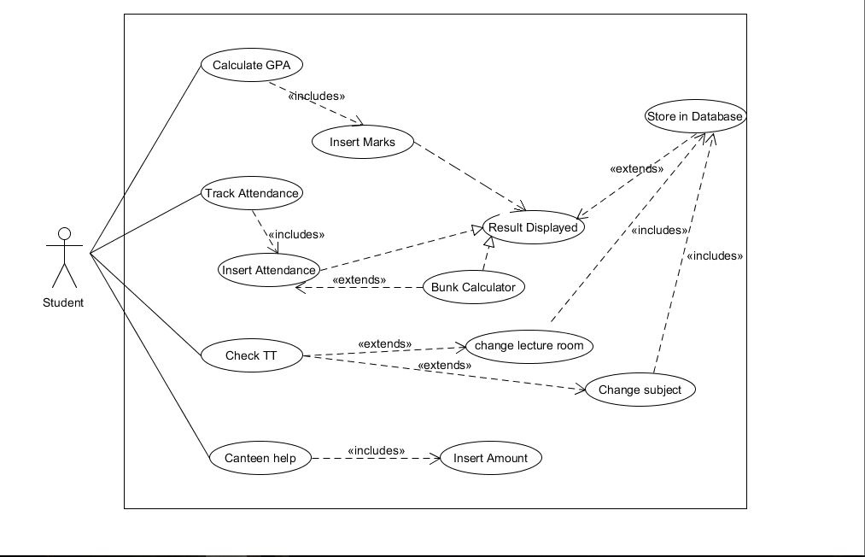

# 

# 

# 

# Softwares used.

To have a record system for the time table, attendance, GPA and canteen dishes, We created a database using Sqlite3, A database that can be created using CLI in Windows or Linux. We did not want to host a server using SQL Server or MySQL, since the program was intended to be used offline. So we decided to go for Sqlite3. Another difference between server-based database softwares and Sqlite3 is that Sqlite3 doesn’t support stored procedures.

The syntax of Sqlite3 is quite similar to that of other databases, like MySQL or Oracle.

The GUI was designed using Dreamweaver, Brackets and Vim.

Dreamweaver is a proprietary software of Adobe, which provides an environment to create web applications and GUIs. Some of the languages we used are HTML, CSS, JavaScript and JQuery.

Brackets is a text editor available on GitHub. Vim is the ancient highly modular text editor.

We used Electron API to use HTML, CSS and Javascript to build the program that can run natively on any Operating System.

Electron is available as a NodeJs package easily setup with the npm package manager itself.

To connect and use the SQLite3 database we used a ‘sql.js’ javascript tool.

sql.js is written purely in javascript.

All the sources to the above mentioned tools and API can be found at the end of this documentation page.

Most of the program logic has been written in JavaScript.

# 

Foyer

Are you bored of eating the same thing every day? Are you the one who has tried everything and doesn't know what to eat, or you're simply someone with a bit of cash and don't know what to do with it? Let FA clear all those dilemmas for you.

**1)** Let’s Get Started:

Click on the “Find out More” button to use the functionalities of FoyerAssistant

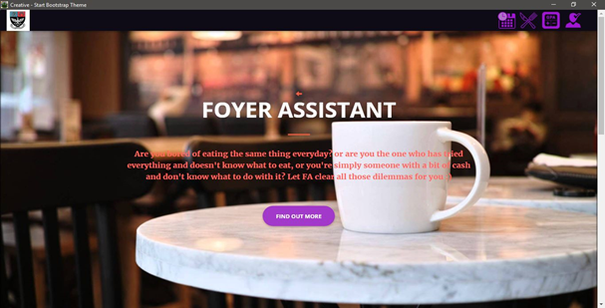

**2)** Insert the amount in the text field

Insert the amount you wish to spend and then click on “Get Started” and watch the app do its magic. For ex- 25

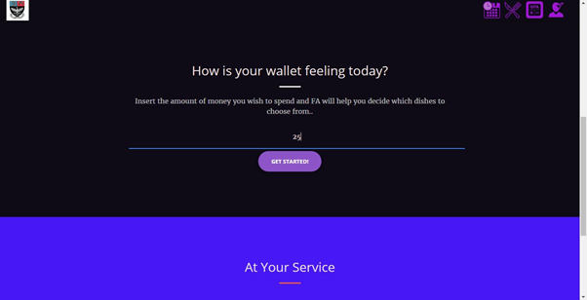

You will see all the dishes available in the range of 5 rupees from your inserted amount. From the dishes you can pick which one suits you the best and enjoy the delicious dish made with love to get you through Autonomy.

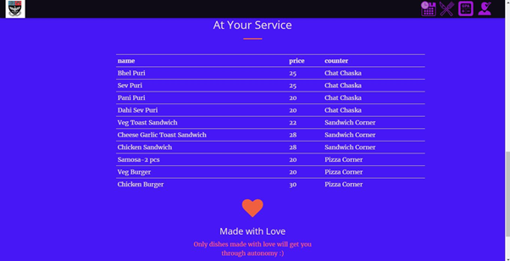

Timetable

Well, if you’re one of those who daily misses a lecture or forgets their class then TT assistant serves right up your alley. By clicking on the Home Page You’re redirected to your class’ Timetable for the current semester and et’ voila! You’re up to date with not only your class but by **hovering** on the tabs it’ll show you your LR too. J

However, since TT changes frequently and without notice, you have an option to update the Timetable. You can do so with the help of following steps.

- **To change a subject**:

o click on the tab and a popup menu will appear

o click ok

o On the bottom right a dialog will allow you to change the Subject

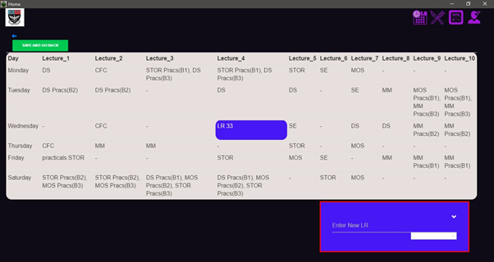

o Click on the white drop down to open a list of subjects from which you can choose to replace the current lecture.

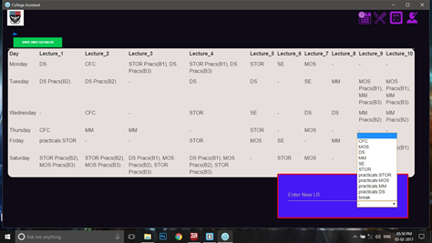

o Insert the change in Timetable if any or keep blank if you want to delete a Lecture from that time tab.

o Click the “save to db” button on top left to save your changes.

o Your Timetable has been updated J

- **To change an LR:**

o Click on the tab and a popup menu will appear.

o Insert the new LR

- 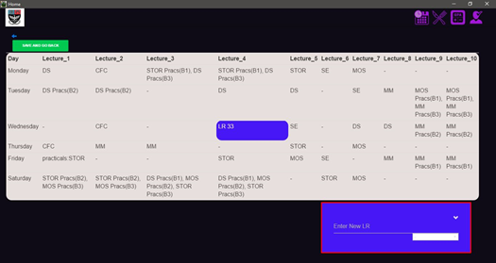

o Click the “save to db” button to save your changes to the database.

o Your Timetable has been updated

# 

GPA CALCULATOR  
 The GPA calculator of our application helps you to keep easy tabs on your marks in each CIA and End Semester exam you appear for. You just have to enter the marks you’ve scored in each of these tests in the app, and it will be stored in our offline database.   
Our software will automatically calculate your total marks/ percentage, and your GPA for you, based on our college's system for allocating GPA. These changes will be saved so that you have no problem accessing your marks in the future.

**To enter marks:**

1. Click on the name of the subject you want to enter marks for.

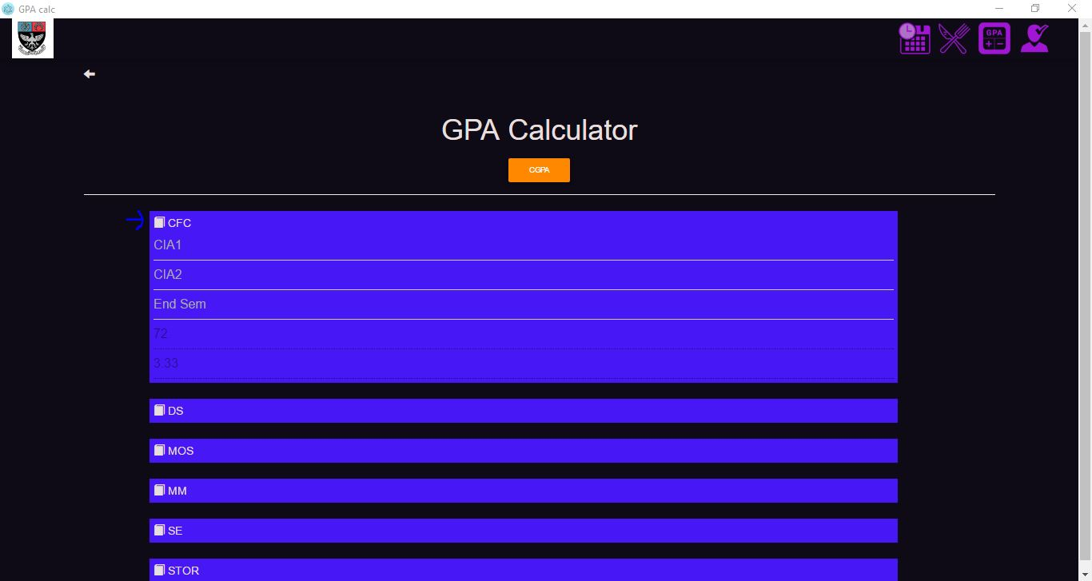

1. Enter your marks in the CIA or End Semester fields, whichever is relevant.
2. Simply click on the Total of Subject or GPA of Subject text field to get the data calculated for both these fields.

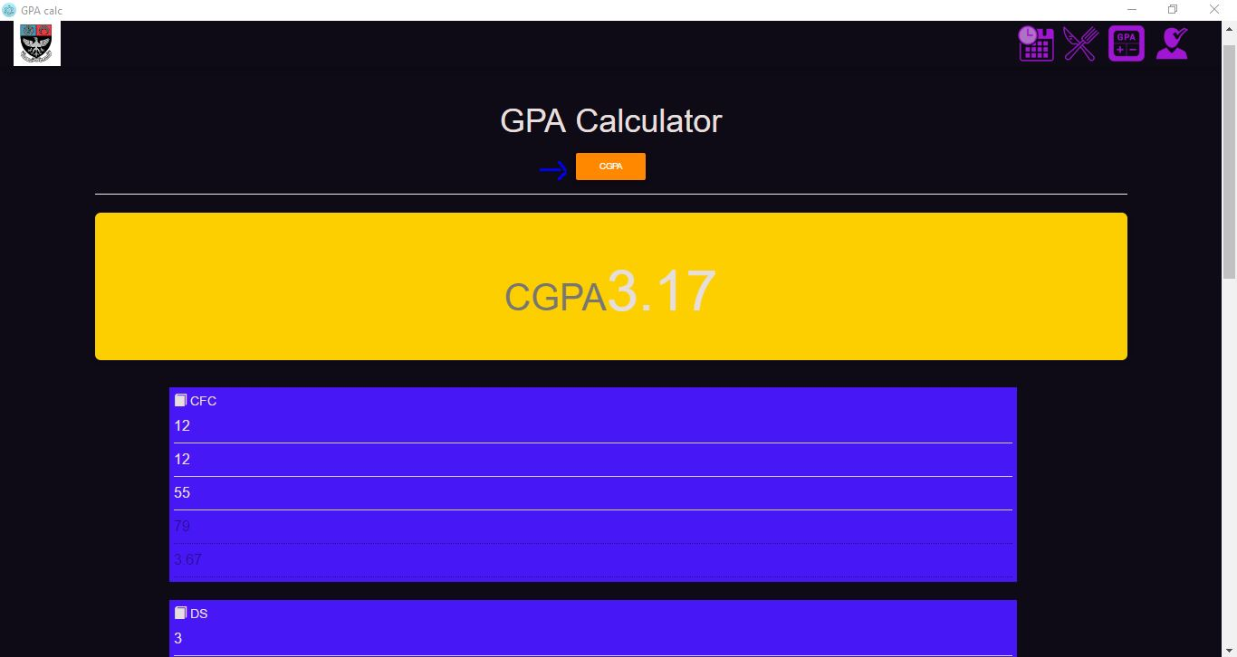

If you wish to see your CGPA, click on the yellow ‘CGPA’ button on the top.

ATTENDANCE CALCULATOR  
Probably the most sought-after feature of our application, the Attendance Calculator helps you maintain a record of how many lectures you’ve actually attended. You have access to three buttons- one for if you’ve attended a lecture, one for if you’ve missed a lecture, and one to tell you how many lectures you can afford to miss.  
This feature has been implemented so that students can maintain a fair record of their attendance, and can know if the college has miscalculated their attendance.

**How to use this feature:**

1. Click on the subject you wish to update attendance on. Three buttons should appear next to that subject.

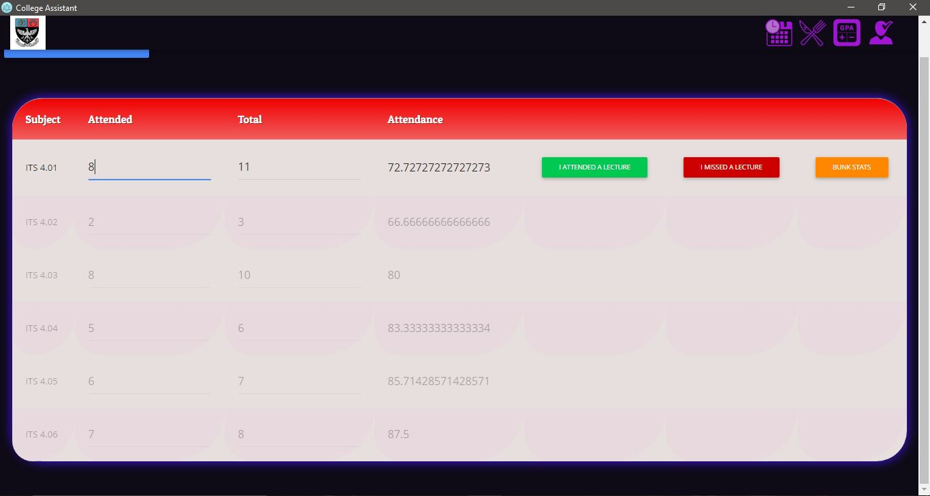

1. The ‘Attended a Lecture’ button is to be used if you've attended a lecture. This will increment the number of lectures attended, and also the total number of lectures.
2. The ‘I Missed a Lecture’ button is to be used if you've missed a lecture. This will increment just the total number of lectures.

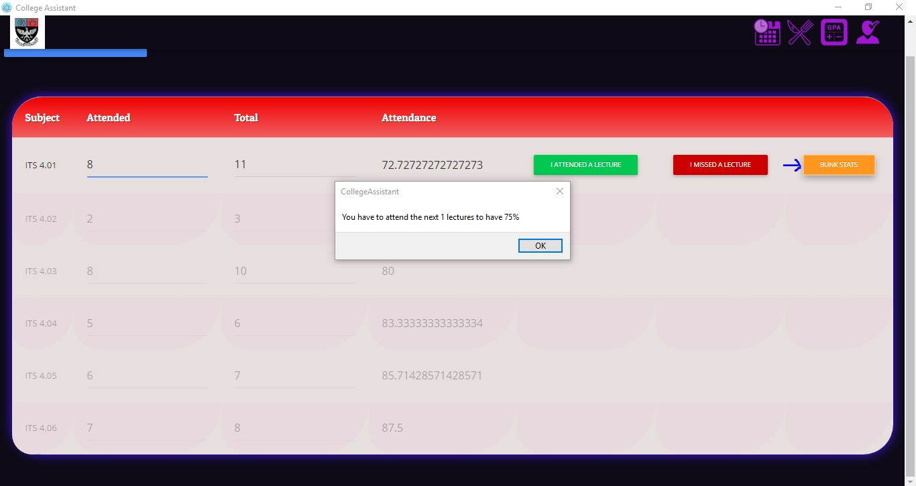

1. The ‘Bunk Stats’ button will tell you how many lectures you can bunk for that subject.

Of course, we aren't trying to encourage our peers to maintain a 75% attendance, but still, this is a handy tool for students in all streams. They can know beforehand if they can afford to miss any more lectures, and can then weigh their priorities accordingly. Is that movie at Metro really worth missing lectures for?

Also, since we now have a leave application available to us in college, we can fill it in well in advance if we know we're going to be missing some lectures, and that our attendance won't drop below 75%.

**ER DIAGRAMS FOR THE DATABASE:**

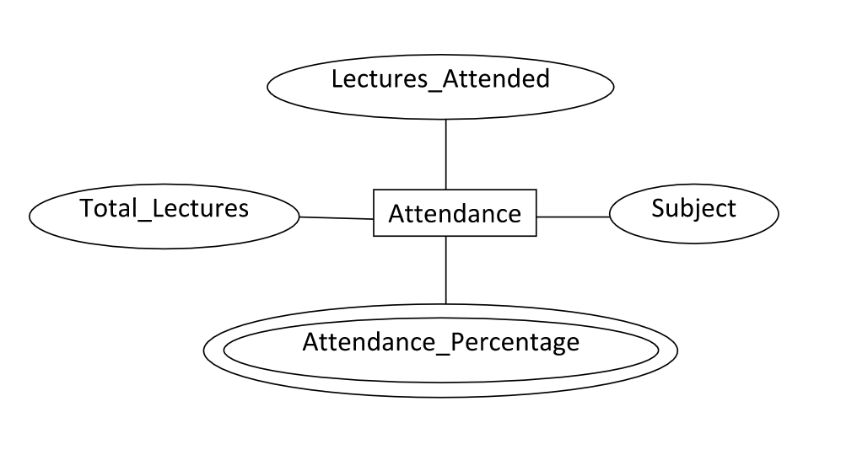

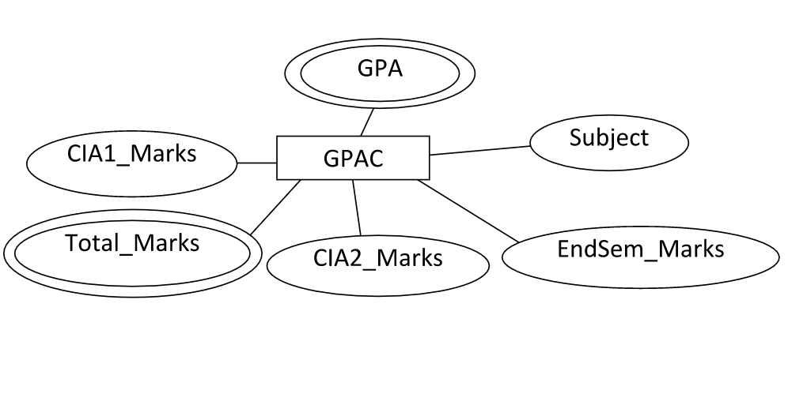

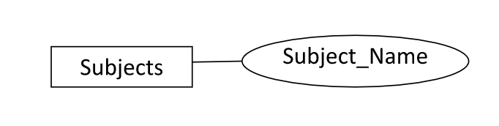

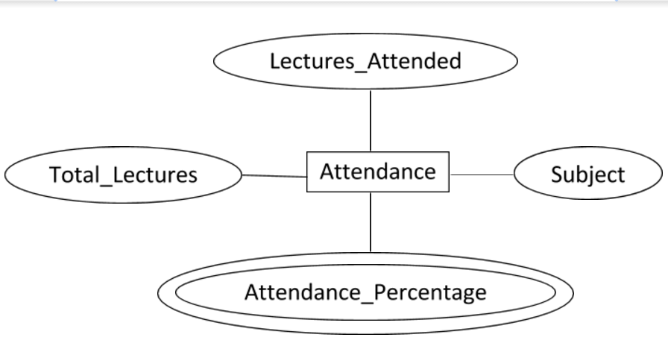

# 

## Testing & Errors

# **Attendance Calculator**

Issues faced were

· When the user changes the input sometimes calculation would result in NaN(not a number). To overcome this, we had to add an extra line in a function as a flag to ensure calculations would only occur if the inputs entered were numbers(numeric).

· Another silly error we encountered was when the user would press ‘I Attended A Lecture’ the number of lectures would increase but the total number of lectures would not. To resolve this error, we needed to copy the global variable used for storing number of lectures and increment it.

· A subsequent error occurred on resolving the previous error. When both, total lectures and attended lectures had been incremented, the attendance percentage being displayed was the result the of calculations with previous values. To solve this problem, we simply had to create a universal function that would call the function for calculation with changed values, depending on whether you attended a lecture or did not attend it.

# **GPA Calculator**

After completing the attendance calculator, it was much easier for us to write the code for the GPA calculator. We encountered lesser issues such as:

· GPA would be displayed even if all marks weren’t input. Thus, we had to ensure that while sum of all marks was NaN nothing would be displayed.

· Users were initially able to enter strings and change their GPA after calculation.

We converted the input type to text and then disabled the output boxes.

# **Time-Table Viewer**

This feature was a little hard to make as there had to be real time interaction with the database.

The problems that occurred were as follows:

· Retrieving column, row and cell where user clicked was returning different objects. A better understanding and black box testing helped us identify the objects and use the thereafter.

· When a user would change the timetable via the popup menu once, every successive change would provide only the value of the first change. To overcome this, we stored all the changes temporarily and then executed all the queries when the user saves and goes back.

# **Foyer Assistant**

Foyer Assistant was pretty easy when it came to database. It’s functionality was simple as the output just had to be in the range of 5 from the user input. The challenging part was of building the interface. The interactive user interface was only made possible because of “Parallax scrolling” a sought out feature used in today’s web pages a lot. The problems faced to achieve parallax scrolling was-

Scrolling didn’t work even after using the correct Bootstrap properties. The fault lied in not having the relevant dependencies which restricted the properties from functioning to fullest.

Another silly problem we came across was that the animation would not work after getting Parallax scrolling to work. This was stupid because the jquery plugins used for scrolling overrode the animation script and didn’t allow it to run.

# **Database**

The sql.js documentation was very helpful for us to understand the syntax so that functions can be built for our specific needs.

The problems encountered :

· Some data was not retrieved from the database due to the default sql.js property of not allowing the memory growth required for the operation.

· The solution was to switch to another version of sql.js which allowed for dynamic memory growth.

# 

# GUI Construction

We all sat down together at the discussion part of the project to jot down the details about how we want our GUI to work and how it will look.

We discussed the Layout of the pages and also how to make them all have similar page structure.

Each and every member of the group added his idea to the list of Page specifications which would be later used by use to create a demo GUI for our Application.

We have mainly used Bootstrap and MDB Bootstrap(Material Design) and Creative Bootstrap for our Page animations and looks

## PAGES:

* Home Page(/)
  + Header
    - Navbar (College Logo-extreme left & Navbar Menu-extreme right[Hamburger Dropdown menu<- if screen resized], fixed position)
  + Body
    - Menu Div
      * 4 Sections
      * Each with relatable bg images and icon
      * Css for Divs
        + Page load animation(FadeIn and SlideIn)
        + Hover animation(not implemented as it clashed previous feature)
* Attendance(/)
  + Same Navbar in Header
  + Body
    - Save to Database and Go back Button
    - Back button for navigation to home page
    - Attendance Table
      * Attended and Total Lectures in two fields
      * Buttons to facilitate the process of marking an attended lecture and a missed lecture
      * Button to get attendance status from the values in table
      * Field to show Attendance Percentage
    - CSS for Table
      * Should be mostly plain
* Timetable(/)
  + Same Navbar in Header
  + Body
    - Save to Database and Go back to Homepage Button
    - Back button for navigation to home page
    - Time table
      * A 'Day' field and All the Lecture fields(numbered)
      * User can edit Lecture Room and Lecture by clicking on a cell
      * Give alert when user clicks on a cell
      * CSS for tables
        + Show lecture room on hover on cell
        + Load animation
        + Onclick show editing box
      * Table Edit Div
        + Input field for New Lecture Room(changes after entering new value)
        + Dropdown menu for new Lecture
* GPA(/)
  + Same Navbar in Header
  + Body
    - Back button for navigation to home page
    - Header says "GPA Calculator"
    - A button to show the hidden CGPA div
    - CGPA div(color coded according to the CGPA obtained like red, orange green)
    - Six Subject Divs
      * Each clickable to toggle dropdown of the div
      * 5 input fields(CIA1, CIA2, End Sem, Total*, GPA of subject*,[* -> input field disabled])
    - CSS
      * Subject div onClick toggle hidden subject form
      * CGPA button onClick shows CGPA div with Animation
      * CGPA field color coded
* Foyer Assistant(/foyer)
  + Same Navbar in Header
  + Body
    - First Div
      * Back button for navigation to home page
      * Header says "Foyer Assistant"
      * Some catchy info about the page
      * A button to Scroll to next div in Page(hyperlink)
    - Second Div
      * Catchy Header
      * Input field to enter money available to spend on food
      * Button to send value to DB and to Scroll to next Div
    - Third Div
      * Header says "At your Service'
      * Table with the result of DB search of food items that fall in budget
      * Catchy text with bobbing heart
    - CSS for divs
      * Use Page scroll animation to goto divs in page
      * Table show animation
      * Glyphicon of heart with bounce animation

Source Code:

### Home Page:

<!DOCTYPE html PUBLIC "-//W3C//DTD XHTML 1.0 Transitional//EN" "http://www.w3.org/TR/xhtml1/DTD/xhtml1-transitional.dtd">

<html xmlns="http://www.w3.org/1999/xhtml">

<head>

<meta http-equiv="Content-Type" content="text/html; charset=utf-8" />

<title>College Assistant</title>

<!--for better viewing experience in all types of devicecs-->

<meta name="viewport" content="width=device-width, inital scale=1.0" />

<!--Latest compiled and minified css-->

<link rel="stylesheet" href="css/bootstrap.min.css">

<!--Optional Theme-->

<link rel="stylesheet" href="css/bootstrap-theme.min.css">

<link href="css/index.css" rel="stylesheet" type="text/css" />

<link rel="stylesheet" href="css/bootCustom.css" />

<link rel="stylesheet" href="css/mdb.min.css" />

<!--javascripts-->

<script>window.$ = window.jQuery = require("./js/jquery-3.1.1.min.js")</script>

<script src="js/jquery-3.1.1.min.js"></script>

<script src="js/jquery-ui.js"></script>

<!--<script src="js/btn.js"></script>-->

<script src="js/bootstrap.min.js"></script>

</head>

<body class="body">

<div class="navbar navbar-default navbar-fixed-top">

<!--Navbar-->

<div class="container-fluid">

<!--Div for the Logo-->

<div class="navbar-header navbar-left">

<img src="Logos/St-Xavier-logo.gif" width="52" height="50;" id="logoNav" />

<button type="button" class="navbar-toggle" data-toggle="collapse" data-target="#mainNavBar">

<span class=" glyphicon glyphicon-menu-hamburger"></span>

</button>

</div>

<div class=" collapse navbar-collapse navbar-right" id= "mainNavBar" style=" padding-right:15px">

<ul class=" nav navbar-nav">

<li class="active"><a href="TimeTable.html" style=" background-image: url(Logos/resr/cal_1.png); background-repeat: no-repeat; background-position:center; background-size:cover; width:50px; height:50px"></a ></li>

<li ><a href="#" style=" background-image: url(Logos/resr/foyer_1.png); background-repeat: no-repeat; background-position:center; background-size:cover; width:50px; height:50px; padding:10px"></a></li>

<li ><a href="gpa.html" style=" background-image: url(Logos/resr/gpa_1.png); background-repeat: no-repeat; background-position:center; background-size:cover; width:50px; height:50px; padding-right:20px"></a></li>

<li ><a href="Real-Time.html" style=" background-image: url(Logos/resr/attendence.png); background-repeat: no-repeat; background-position:center; background-size:cover; width:50px; height:50px; padding:10px"></a></li>

</ul>

</div>

</div>

</div>

<!-- BTN MENU-->

<div id="dv_btn" class="container dv ">

<div class="row">

<a href="Real-Time.html">

<div id="icon1" class="jumbotron icon anim col-lg-offset-1 col-lg-2 animated slideInDown" >

<img src="Logos/resr/attendence.png" width="100px" height="100px" id="ico1" >

</div>

</a>

<a href="TimeTable.html">

<div id="icon2" class="jumbotron icon anim col-lg-2 col-lg-offset-1 animated slideInUp">

<img src="Logos/resr/cal_1.png" width="100px" height="100px" id="ico2" >

</div>

</a>

<a href="gpa.html">

<div id="icon3" class="jumbotron icon anim col-lg-2 col-lg-offset-1 animated slideInLeft">

<img src="Logos/resr/gpa_1.png" width="100px" height="100px" id="ico2" >

</div>

</a>

<a href="foyer/index.html">

<div id="icon4" class="jumbotron icon anim col-lg-2 col-lg-offset-1 animated slideInRight">

<img src="Logos/resr/foyer_1.png" width="100px" height="100px" id="ico2" >

</div>

</a>

</div>

</div>

</body>

</html>

### Attendance Calculator:

<html>

<head>

<!--for better viewing experience in all types of devicecs-->

<meta name="viewport" content="width=device-width, inital scale=1.0" />

<!--Latest compiled and minified css-->

<link rel="stylesheet" href="css/bootstrap.min.css"/>

<!--Optional Theme-->

<link rel="stylesheet" href="css/bootstrap-theme.min.css">

<link href="css/bootstrap.css" rel="stylesheet" type="text/css" />

<link rel="stylesheet" href="css/bootCustom.css" />

<link rel="stylesheet" href="css/mdb.min.css" />

<style>

.btn1{

display: none;

}

</style>

<script>window.$ = window.jQuery = require("./js/jquery-3.1.1.min.js")</script>

<script type="text/javascript" src="BunkCalc.js"></script>

<link rel="stylesheet" href="Attendance.css"/>

</head>

<body>

<div class="navbar navbar-default navbar-fixed-top">

<!--Navbar-->

<div class="container-fluid">

<!--Div for the Logo-->

<div class="navbar-header navbar-left">

<img src="Logos/St-Xavier-logo.gif" width="52" height="50;" id="logoNav" />

<button type="button" class="navbar-toggle" data-toggle="collapse" data-target="#mainNavBar">

<span class=" glyphicon glyphicon-menu-hamburger"></span>

</button>

</div>

<div class=" collapse navbar-collapse navbar-right" id= "mainNavBar" style=" padding-right:15px">

<ul class=" nav navbar-nav">

<li class="active"><a href="TimeTable.html" style=" background-image: url(Logos/resr/cal_1.png); background-repeat: no-repeat; background-position:center; background-size:cover; width:50px; height:50px"></a ></li>

<li ><a href="foyer/index.html" style=" background-image: url(Logos/resr/foyer_1.png); background-repeat: no-repeat; background-position:center; background-size:cover; width:50px; height:50px; padding:10px"></a></li>

<li ><a href="gpa.html" style=" background-image: url(Logos/resr/gpa_1.png); background-repeat: no-repeat; background-position:center; background-size:cover; width:50px; height:50px; padding-right:20px"></a></li>

<li ><a href="Real-Time.html" style=" background-image: url(Logos/resr/attendence.png); background-repeat: no-repeat; background-position:center; background-size:cover; width:50px; height:50px; padding:10px"></a></li>

</ul>

</div>

</div>

</div>

<br><br><br><input type="button" style="float:left" value="Save in DB and Back" onClick="enterInDB()" class="btn btn-primary"/>

&nbsp;&nbsp;<a href="index.html"><i class="glyphicon glyphicon-arrow-left"></i></a>

<table class="animated bounceIn">

<tr>

<thead>

<th>Subject</th>

<th>Attended</th>

<th>Total</th>

<th>Attendance</th>

<th></th>

<th></th>

<th></th>

</tr>

</thead>

<tr id="R1" onClick="getButtons(this.id)">

<td>ITS 4.01</td>

<td><input type="text" id="num11" value="0" onChange="getAttend(1,this.id)" placeholder="Attended"></td>

<td><input type="text" id="num12" value="0" onChange="callAttend(this.id)" placeholder="Total Lectures"></td>

<td><input type="text" id="s1" name="ans" placeholder="Current Attendance"></td>

<td><input class="btn1 btn-sm btn btn-success" type="button" id="b11" value="I Attended A Lecture" onClick="changeVal(this.id)"></td>

<td><input class="btn1 btn-sm btn btn-danger" type="button" id="b12" value="I Missed A Lecture" onClick="changeVal(this.id)"></td>

<td><input class="btn1 btn-sm btn btn-warning" type="button" id="b13" value="Bunk Stats" onClick="calcBunk(this.id)"></td>

</tr>

<tr id="R2" onClick="getButtons(this.id)">

<td>ITS 4.02</td>

<td><input type="text" id="num21" value="0" onChange="getAttend(1,this.id)" placeholder="Attended"></td>

<td><input type="text" id="num22" value="0" onChange="callAttend(this.id)" placeholder="Total Lectures"></td>

<td><input type="text" id="s2" name="ans" placeholder="Current Attendance"></td>

<td><input class="btn1 btn-sm btn btn-success" type="button" id="b21" value="I Attended A Lecture" onClick="changeVal(this.id)"></td>

<td><input class="btn1 btn-sm btn btn-danger" type="button" id="b22" value="I Missed A Lecture" onClick="changeVal(this.id)"></td>

<td><input class="btn1 btn-sm btn btn-warning" type="button" id="b23" value="Bunk Stats" onClick="calcBunk(this.id)"></td>

</tr>

<tr id="R3" onClick="getButtons(this.id)">

<td>ITS 4.03</td>

<td><input type="text" id="num31" value="0" onChange="getAttend(1,this.id)" placeholder="Attended"></td>

<td><input type="text" id="num32" value="0" onChange="callAttend(this.id)" placeholder="Total Lectures"></td>

<td><input type="text" id="s3" name="ans" placeholder="Current Attendance"></td>

<td><input class="btn1 btn-sm btn btn-success" type="button" id="b31" value="I Attended A Lecture" onClick="changeVal(this.id)"></td>

<td><input class="btn1 btn-sm btn btn-danger" type="button" id="b32" value="I Missed A Lecture" onClick="changeVal(this.id)"></td>

<td><input class="btn1 btn-sm btn btn-warning" type="button" id="b33" value="Bunk Stats" onClick="calcBunk(this.id)"></td>

</tr>

<tr id="R4" onClick="getButtons(this.id)">

<td>ITS 4.04</td>

<td><input type="text" id="num41" value="0" onChange="getAttend(1,this.id)" placeholder="Attended"></td>

<td><input type="text" id="num42" value="0" onChange="callAttend(this.id)" placeholder="Total Lectures"></td>

<td><input type="text" id="s4" name="ans" placeholder="Current Attendance"></td>

<td><input class="btn1 btn-sm btn btn-success" type="button" id="b41" value="I Attended A Lecture" onClick="changeVal(this.id)"></td>

<td><input class="btn1 btn-sm btn btn-danger" type="button" id="b42" value="I Missed A Lecture" onClick="changeVal(this.id)"></td>

<td><input class="btn1 btn-sm btn btn-warning" type="button" id="b43" value="Bunk Stats" onClick="calcBunk(this.id)"></td>

</tr>

<tr id="R5" onClick="getButtons(this.id)">

<td>ITS 4.05</td>

<td><input type="text" id="num51" value="0" onChange="getAttend(1,this.id)" placeholder="Attended"></td>

<td><input type="text" id="num52" value="0" onChange="callAttend(this.id)" placeholder="Total Lectures"></td>

<td><input type="text" id="s5" name="ans" placeholder="Current Attendance"></td>

<td><input class="btn1 btn-sm btn btn-success" type="button" id="b51" value="I Attended A Lecture" onClick="changeVal(this.id)"></td>

<td><input class="btn1 btn-sm btn btn-danger" type="button" id="b52" value="I Missed A Lecture" onClick="changeVal(this.id)"></td>

<td><input class="btn1 btn-sm btn btn-warning" type="button" id="b53" value="Bunk Stats" onClick="calcBunk(this.id)"></td>

</tr>

<tr id="R6" onClick="getButtons(this.id)">

<td>ITS 4.06</td>

<td><input type="text" id="num61" value="0" onChange="getAttend(1,this.id)" placeholder="Attended"></td>

<td><input type="text" id="num62" value="0" onChange="callAttend(this.id)" placeholder="Total Lectures"></td>

<td><input type="text" id="s6" name="ans" placeholder="Current Attendance"></td>

<td><input class="btn1 btn-sm btn btn-success" type="button" id="b61" value="I Attended A Lecture" onClick="changeVal(this.id)"></td>

<td><input class="btn1 btn-sm btn btn-danger" type="button" id="b62" value="I Missed A Lecture" onClick="changeVal(this.id)"></td>

<td><input class="btn1 btn-sm btn btn-warning" type="button" id="b63" value="Bunk Stats" onClick="calcBunk(this.id)"></td>

</tr>

<script>

enterFromDB();

</script>

<script src="js/index.js"></script>

<script src="js/jquery-3.1.1.min.js"></script>

<script src="js/bootstrap.min.js"></script>

</body>

</html>

### Timetable:

<html>

<head>

<link rel="stylesheet" href="css/bootstrap.min.css">

<link rel="stylesheet" href="css/bootstrap-grid.min.css">

<link rel="stylesheet" href="css/mdb.min.css">

<link rel="stylesheet" href="css/bootCustom.css">

<script>window.$ = window.jQuery = require("./js/jquery-3.1.1.js")</script>

<script src="js/bootstrap.min.js" type="text/javascript"></script>

<style>

body{

background-color: #0e0b16;

}

#tab{

background-color: #0e0b16;

height: 95%;

width: 100%;

box-shadow: none !important;

overflow: visible;

}

#tab1{

background-color: inherit;

max-height: 100%;

width: 100%;

overflow: visible;

}

#ddmenu{

display:none;

position:fixed;

right:5%;

bottom:0;

border:solid #F00;

width: auto;

height: auto;

background-color: #4717f6;

color: #e7dfdd;

}

.table1{

position: absolute;

top: 90px;

background-color: #e7dfdd;

border-radius: 15px !important;

box-shadow: 4px 4px rgba(0,0,0,0.1);

}

.no-gutter > [class*='col-'] {

padding:0;

}

.no-gutter > [class*='jumbotron'] {

padding:0;

}

select{color: black;}

</style>

</head>

<body>

<div class="navbar navbar-default navbar-fixed-top">

<!--Navbar-->

<div class="container-fluid">

<!--Div for the Logo-->

<div class="navbar-header navbar-left">

<img src="Logos/St-Xavier-logo.gif" width="52" height="50;" id="logoNav" />

<button type="button" class="navbar-toggle" data-toggle="collapse" data-target="#mainNavBar">

<span class=" glyphicon glyphicon-menu-hamburger"></span>

</button>

</div>

<div class=" collapse navbar-collapse navbar-right" id= "mainNavBar" style=" padding-right:15px">

<ul class=" nav navbar-nav">

<li class="active"><a href="TimeTable.html" style=" background-image: url(Logos/resr/cal_1.png); background-repeat: no-repeat; background-position:center; background-size:cover; width:50px; height:50px"></a ></li>

<li ><a href="foyer/index.html" style=" background-image: url(Logos/resr/foyer_1.png); background-repeat: no-repeat; background-position:center; background-size:cover; width:50px; height:50px; padding:10px"></a></li>

<li ><a href="gpa.html" style=" background-image: url(Logos/resr/gpa_1.png); background-repeat: no-repeat; background-position:center; background-size:cover; width:50px; height:50px; padding-right:20px"></a></li>

<li ><a href="Real-Time.html" style=" background-image: url(Logos/resr/attendence.png); background-repeat: no-repeat; background-position:center; background-size:cover; width:50px; height:50px; padding:10px"></a></li>

</ul>

</div>

</div>

</div>

<!--Table Div-->

<div class="jumbotron table-responsive no-gutter" id="tab">

<div class="row no-gutter" id="tab1"><p class="col-xs-12" id="displaytable"></p></div><!--Div in which <p> holds table-->

<!--A button to save chaned data to Database and go back to Home page-->

<br><a href="index.html"><i class="glyphicon glyphicon-arrow-left"></i></a><br>

<a href="Home.html" onClick="saveandback()" class="btn btn-success btn-sm animated pulse infinite"><b>Save and Go Back</b>

</a>

</div>

<!--Menu that Pops up when you click on a table cell to edit it-->

<div id="ddmenu" align="right" class="jumbotron animated">

<i class="glyphicon glyphicon-chevron-down" onclick="menDown();"></i><!--icon to hide the div-->

<input type="text" name="lr" placeholder="Enter New LR" id="LR" onChange="getLR()" ><!--TO enter new LR no.-->

<select id="menu" onChange="getValue()"></select> <!--subject selector menu-->

</div>

### Time Table Javascript:

<!-- ........vv SCRIPTS vv.......... -->

<script>

var prevSub;

var cday; //neeeded

var crow; //needed

var hrow;

var hday;

var queryString='';

var pseudoid;

var subj;

var subjectstring='';

var db = require('./db');

var subjects=db.getSubjects();

var thetable = db.retreiveFromDB('select * from TimeTable;');

document.getElementById('displaytable').innerHTML = db.printTable(thetable);

subjectstring += "<option value='-'> - </option>";

for (var inside in subjects)

{

subjectstring += "<option value='" + subjects[inside] + "'>" + subjects[inside] + "</option>";

}

document.getElementById('menu').innerHTML = subjectstring;

$('document').ready(function()

{

//$('#tableid').ready(function(){});

$('td').on('click', function()

{

pseudoid=$(this);

var column=$(this).siblings().addBack().index(this);

column++;

cday=$(this).siblings().first().html();

var rowstring='#tableid th:nth-of-type(' + column + ')';

crow=$(rowstring).html();

if(crow=="Day")

{

alert("Can't edit days");

}

else

{

$('#ddmenu').show();

$('#ddmenu').removeClass('hinge');

$('#ddmenu').addClass('bounceIn');

//alert(cday+" "+crow);

}

// var newdata=getValue();

// alert(newdata);

});

$('td').hover(function()

{

prevSub=$(this).html();

pseudoid=$(this);

var column=$(this).siblings().addBack().index(this);

column++;

hday=$(this).siblings().first().html();

var rowstring='#tableid th:nth-of-type(' + column + ')';

hrow=$(rowstring).html();

column--;

if(hrow=="Day")

{

}

else

{

$(this).css('background-color','#4717f6');

$(this).css('color','#e7dfdd');

//$(this).css('background-color','#4717f6');

var col = "LR_"+column;

//Enter query to get LR from DB here with parameters below

// db.retreiveSingleFromDB("select " + col + " from LectureRooms where Day='" + hday + "';");

$(this).html(db.retreiveSingleFromDB("select " + col + " from LectureRooms where Day='" + hday + "';"));

}

},

function()

{

$(this).css('background-color','#e7dfdd');

$(this).css('border-radius' ,'15px');

$(this).css('color','#373737');

$(this).html(prevSub);

});

})

function getLR()//Select the LR from the menu for TimeTable

{

var new_LR=document.getElementById('LR').value;

var thecheap=crow.split("_");

var theLR="LR_"+thecheap[1];

// alert(new_LR);

// alert(theLR+" "+cday);

db.inputtoDB("update LectureRooms set " + theLR +"='" + new_LR + "' where Day='" + cday + "';" );

//add query here to insert new LR into DB with above parameters

document.getElementById('ddmenu').style.display='none';

}

function getValue()//gets selected value from pop up menu

{

var selected = document.getElementById('menu');

subj = selected.options[selected.selectedIndex].text;

document.getElementById('ddmenu').style.display='none';

if(row!="Day")

{

$(pseudoid).html(subj);

queryString+="update TimeTable set " + row + "='" + subj + "' where Day='" + day + "';" ;

}

alert(queryString);

}

function saveandback()

{

db.inputtoDB(queryString);

window.location.href='index.html';

}

//function to hide edit menu

function menDown(){

var d = document.getElementById("ddmenu");

d.className += " hinge";

}

</script>

</body>

</html>

### GPA Calculator:

<!DOCTYPE HTML>

<html>

<head><title>GPA calc</title>

<!--for better viewing experience in all types of devicecs-->

<meta name="viewport" content="width=device-width, inital scale=1.0" />

<!--Latest compiled and minified css-->

<link href="css/bootstrap.min.css" rel="stylesheet"></script>

<link href="css/mdb.min.css" rel="stylesheet"></script>

<link rel="stylesheet" href="css/bootCustom.css" />

<script>window.$ = window.jQuery = require("./js/jquery-3.1.1.min")</script>

<style>

body{

background-color: #0e0b16 ;

color: #e7dfdd;

}

.jumbotron{

background-color: greenyellow;

display: none;

width: auto;

}

.gpafld{

background-color: #4717f6;

width:80%;

padding: 5px;

}

a{

text-decoration: none;

color: #e7dfdd;

}

a:active{color:#e7dfdd;}

a:hover{color:#e7dfdd;}

a:visited{color:#e7dfdd;}

a:selected{color:#e7dfdd;}

</style>

</head>

<body>

<div class="navbar navbar-default navbar-fixed-top">

<!--Navbar-->

<div class="container-fluid">

<!--Div for the Logo-->

<div class="navbar-header navbar-left">

<img src="Logos/St-Xavier-logo.gif" width="52" height="50;" id="logoNav" />

<button type="button" class="navbar-toggle" data-toggle="collapse" data-target="#mainNavBar">

<span class=" glyphicon glyphicon-menu-hamburger"></span>

</button>

</div>

<div class=" collapse navbar-collapse navbar-right" id= "mainNavBar" style=" padding-right:15px">

<ul class=" nav navbar-nav">

<li class="active"><a href="TimeTable.html" style=" background-image: url(Logos/resr/cal_1.png); background-repeat: no-repeat; background-position:center; background-size:cover; width:50px; height:50px"></a ></li>

<li ><a href="foyer/index.html" style=" background-image: url(Logos/resr/foyer_1.png); background-repeat: no-repeat; background-position:center; background-size:cover; width:50px; height:50px; padding:10px"></a></li>

<li ><a href="gpa.html" style=" background-image: url(Logos/resr/gpa_1.png); background-repeat: no-repeat; background-position:center; background-size:cover; width:50px; height:50px; padding-right:20px"></a></li>

<li ><a href="Real-Time.html" style=" background-image: url(Logos/resr/attendence.png); background-repeat: no-repeat; background-position:center; background-size:cover; width:50px; height:50px; padding:10px"></a></li>

</ul>

</div>

</div>

</div>

<!--creating a primary div which contains all data-->

<div class="container"><br><br><br>

<a href="index.html"><i class="glyphicon glyphicon-arrow-left"></i></a>

<!--page header div-->

<div class="page-header text-center"><h1>GPA Calculator</h1>

<input type="button" class="btn btn-warning btn-sm" value="CGPA" onClick="getCGPA();" id="getgp"></div>

<div class="jumbotron text-center animated zoomInUp" id="cgpdiv"><h1 id="cgpa">CGPA</h1></div>

<!--Divs for entering the subject marks with glyphicon-icon-->

<div class="row animated rubberBand"><!--Dividing the page into a 12 column row and using col-??-?? to assign columns to components-->

<!--Form for Subject 1-->

<div class="col-lg-offset-1 col-lg-12 gpafld"><i class="glyphicon glyphicon-book"></i>

<a href="#f1" data-toggle="collapse" id="sub1s"></a>

<div id="f1" class="collapse"><form name="sub1">

<input id="sub1c1" type="number" max="20" placeholder="CIA1" name="cia1" onChange="showGPA(this.form)">

<input id="sub1c2" type="number" max="20" placeholder="CIA2" name="cia2" onChange="showGPA(this.form)">

<input id="sub1es" type="number" max="80" placeholder="End Sem" name="exam" onChange="showGPA(this.form)">

<input id="sub1ts" type="text" placeholder="Total of Subject" name="total" disabled>

<input id="sub1gpa" type="text" placeholder="GPA of Subject" name="gpa" disabled>

</form></div>

</div></div><br>

<!--Form for Subject 2-->

<div class="row animated rubberBand">

<div class="col-lg-offset-1 col-lg-12 gpafld"><i class="glyphicon glyphicon-book"></i>

<a href="#f2" data-toggle="collapse" id="sub2s"></a>

<div id="f2" class="collapse"><form name="sub2">

<input id="sub2c1" type="number" max="20" placeholder="CIA1" name="cia1" onChange="showGPA(this.form)">

<input id="sub2c2" type="number" max="20" placeholder="CIA2" name="cia2" onChange="showGPA(this.form)">

<input id="sub2es" type="number" max="80" placeholder="End Sem" name="exam" onChange="showGPA(this.form)">

<input id="sub2ts" type="text" placeholder="Total of Subject" name="total" disabled>

<input id="sub2gpa" type="text" placeholder="GPA of Subject" name="gpa" disabled>

</form></div>

</div></div><br>

<!--Form for Subject 3-->

<div class="row animated rubberBand">

<div class="col-lg-offset-1 col-lg-12 gpafld"><i class="glyphicon glyphicon-book"></i>

<a href="#f3" data-toggle="collapse" id="sub3s"></a>

<div id="f3" class="collapse"><form name="sub3">

<input id="sub3c1" type="number" max="20" placeholder="CIA1" name="cia1" onChange="showGPA(this.form)">

<input id="sub3c2" type="number" max="20" placeholder="CIA2" name="cia2" onChange="showGPA(this.form)">

<input id="sub3es" type="number" max="80" placeholder="End Sem" name="exam" onChange="showGPA(this.form)">

<input id="sub3ts" type="text" placeholder="Total of Subject" name="total" disabled>

<input id="sub3gpa" type="text" placeholder="GPA of Subject" name="gpa" disabled>

</form></div>

</div></div><br>

<!--Form for Subject 4-->

<div class="row animated rubberBand">

<div class="col-lg-offset-1 col-lg-12 gpafld"><i class="glyphicon glyphicon-book"></i>

<a href="#f4" data-toggle="collapse" id="sub4s"></a>

<div id="f4" class="collapse"><form name="sub4">

<input id="sub4c1" type="number" max="20" placeholder="CIA1" name="cia1" onChange="showGPA(this.form)">

<input id="sub4c2" type="number" max="20" placeholder="CIA2" name="cia2" onChange="showGPA(this.form)">

<input id="sub4es" type="number" max="80" placeholder="End Sem" name="exam" onChange="showGPA(this.form)">

<input id="sub4ts" type="text" placeholder="Total of Subject" name="total" disabled>

<input id="sub4gpa" type="text" placeholder="GPA of Subject" name="gpa" disabled>

</form></div>

</div></div><br>

<!--Form for Subject 5-->

<div class="row animated rubberBand">

<div class="col-lg-offset-1 col-lg-12 gpafld"><i class="glyphicon glyphicon-book"></i>

<a href="#f5" data-toggle="collapse" id="sub5s"></a>

<div id="f5" class="collapse"><form name="sub5">

<input id="sub5c1" type="number" max="20" placeholder="CIA1" name="cia1" onChange="showGPA(this.form)">

<input id="sub5c2" type="number" max="20" placeholder="CIA2" name="cia2" onChange="showGPA(this.form)">

<input id="sub5es" type="number" max="80" placeholder="End Sem" name="exam" onChange="showGPA(this.form)">

<input id="sub5ts" type="text" placeholder="Total of Subject" name="total" disabled>

<input id="sub5gpa" type="text" placeholder="GPA of Subject" name="gpa" disabled>

</form></div>

</div></div><br>

<!--Form for Subject 6-->

<div class="row animated rubberBand">

<div class="col-lg-offset-1 col-lg-12 gpafld"><i class="glyphicon glyphicon-book"></i>

<a href="#f6" data-toggle="collapse" id="sub6s"></a>

<div id="f6" class="collapse"><form name="sub6">

<input id="sub6c1" type="number" max="20" placeholder="CIA1" name="cia1" onChange="showGPA(this.form)">

<input id="sub6c2" type="number" max="20" placeholder="CIA2" name="cia2" onChange="showGPA(this.form)">

<input id="sub6es" type="number" max="80" placeholder="End Sem" name="exam" onChange="showGPA(this.form)">

<input id="sub6ts" type="text" placeholder="Total of Subject" name="total" disabled>

<input id="sub6gpa" type="text" placeholder="GPA of Subject" name="gpa" disabled>

</form></div>

</div></div>

</div>

<p id='testis'></p>

<script src="js/jquery-3.1.1.js"></script>

<script src="js/bootstrap.min.js"></script>

<script src="js/jquery-ui.js"></script>

<script type="text/javascript" src="GPAcalc.js"></script>

<script>

$(document).ready(function(){

$("#getgp").click(function(){

$("#cgpdiv").fadeToggle("slow");

});

});

var subjects=db.getSubjects();

document.getElementById('sub1s').innerHTML = subjects[0];

document.getElementById('sub3s').innerHTML = subjects[1];

document.getElementById('sub2s').innerHTML = subjects[2];

document.getElementById('sub4s').innerHTML = subjects[3];

document.getElementById('sub5s').innerHTML = subjects[4];

document.getElementById('sub6s').innerHTML = subjects[5];

enterFromDB();

</script>

</body>

</html>

### Foyer Assistant:

<!DOCTYPE html>

<html lang="en">

<head>

<meta charset="utf-8">

<meta http-equiv="X-UA-Compatible" content="IE=edge">

<meta name="viewport" content="width=device-width, initial-scale=1">

<meta name="description" content="">

<meta name="author" content="">

<title>Foyer Assistant</title>

<!-- Bootstrap Core CSS -->

<link href="vendor/bootstrap/css/bootstrap.min.css" rel="stylesheet">

<link href="css/mdb.min.css" rel="stylesheet">

<!-- Custom Fonts -->

<link href="vendor/font-awesome/css/font-awesome.min.css" rel="stylesheet" type="text/css">

<link href='https://fonts.googleapis.com/css?family=Open+Sans:300italic,400italic,600italic,700italic,800italic,400,300,600,700,800' rel='stylesheet' type='text/css'>

<link href='https://fonts.googleapis.com/css?family=Merriweather:400,300,300italic,400italic,700,700italic,900,900italic' rel='stylesheet' type='text/css'>

<!-- Plugin CSS -->

<link href="vendor/magnific-popup/magnific-popup.css" rel="stylesheet">

<!-- Theme CSS -->

<link href="css/creative.min.css" rel="stylesheet">

<!-- HTML5 Shim and Respond.js IE8 support of HTML5 elements and media queries -->

<!-- WARNING: Respond.js doesn't work if you view the page via file:// -->

<!--[if lt IE 9]>

<script src="https://oss.maxcdn.com/libs/html5shiv/3.7.0/html5shiv.js"></script>

<script src="https://oss.maxcdn.com/libs/respond.js/1.4.2/respond.min.js"></script>

<![endif]-->

<link rel="stylesheet" href="../css/bootCustom.css">

<style>

.table1{border: 0 !important;}

input{text-align: center;}

</style>

<script>window.$ = window.jQuery = require("./vendor/jquery/jquery.min.js")</script>

</head>

<body id="page-top" style="background: #0e0b16;">

<div class="navbar navbar-default navbar-fixed-top">

<!--Navbar-->

<div class="container-fluid">

<!--Div for the Logo-->

<div class="navbar-header navbar-left">

<img src="../Logos/St-Xavier-logo.gif" width="52" height="50;" id="logoNav" />

<button type="button" class="navbar-toggle" data-toggle="collapse" data-target="#mainNavBar">

<span class=" glyphicon glyphicon-menu-hamburger"></span>

</button>

</div>

<div class=" collapse navbar-collapse navbar-right" id= "mainNavBar" style=" padding-right:15px">

<ul class=" nav navbar-nav">

<li class="active"><a href="../TimeTable.html" style=" background-image: url(../Logos/resr/cal_1.png); background-repeat: no-repeat; background-position:center; background-size:cover; width:50px; height:50px"></a ></li>

<li ><a href="index.html" style=" background-image: url(../Logos/resr/foyer_1.png); background-repeat: no-repeat; background-position:center; background-size:cover; width:50px; height:50px; padding:10px"></a></li>

<li ><a href="../gpa.html" style=" background-image: url(../Logos/resr/gpa_1.png); background-repeat: no-repeat; background-position:center; background-size:cover; width:50px; height:50px; padding-right:20px"></a></li>

<li ><a href="../Real-Time.html" style=" background-image: url(../Logos/resr/attendence.png); background-repeat: no-repeat; background-position:center; background-size:cover; width:50px; height:50px; padding:10px"></a></li>

</ul>

</div>

</div>

</div>

<header>

<div class="header-content">

<a href="../index.html"><i class="glyphicon glyphicon-arrow-left"></i></a>

<div class="header-content-inner">

<h1 id="homeHeading">Foyer assistant</h1>

<hr>

<p style="color:#ff6961"><strong>Are you bored of eating the same thing everyday? or are you the one who has tried everything and doesn't know what to eat, or you're simply someone with a bit of cash and don't know what to do with it? Let FA clear all those dilemmas for you :)</strong></p>

<a href="#about" class="btn btn-primary btn-xl page-scroll" style="background:#a239ca">Find Out More</a>

</div>

</div>

</header>

<section class="bg-primary" id="about" style="background:#0e0b16; color:#e7dfdd;">

<div class="container" style="background:#0e0b16">

<div class="row">

<div class="col-lg-8 col-lg-offset-2 text-center">

<h2 class="section-heading">How is your wallet feeling today?</h2>

<hr class="light">

<p class="text-faded">Insert the amount of money you wish to spend and FA will help you decide which dishes to choose from..</p><input class="input-lg" style="color:e7dfdd" type="text" id="budget"/>

<a href="#services" class="page-scroll btn btn-default btn-xl sr-button" style="background:#a239ca" onclick="getDish(document.getElementById('budget').value);">Get Started!</a>

</div>

</div>

</div>

</section>

<section id="services" style="background-color:#4717f6; color:#e7dfdd;">

<div class="container">

<div class="row">

<div class="col-lg-12 text-center">

<h2 class="section-heading">At Your Service</h2>

<hr class="primary"><br>

</div>

</div>

<p class="col-lg-9 col-lg-offset-2" id="listid"></p>

</div>

<br><br>

<div class="container">

<div class = "row">

<div class="col-md-offset-4 col-lg--offset-4 col-lg-4 col-md-7 text-center" style="position:relative; bottom:80px;" id="love">

<div class="service-box">

<i class="fa fa-4x fa-heart text-primary sr-icons animated bounce infinite"></i>

<h3>Made with Love</h3>

<p class="text-muted" style="color:#ff6961">Only dishes made with love will get you through autonomy :)</p>

</div>

</div>

</div>

</div>

</section>

<!-- jQuery -->

<script src="vendor/jquery/jquery.min.js"></script>

<!-- Bootstrap Core JavaScript -->

<script src="vendor/bootstrap/js/bootstrap.min.js"></script>

<!-- Plugin JavaScript -->

<script src="vendor/jquery/jquery.easing.min.js"></script>

<script src="vendor/scrollreveal/scrollreveal.min.js"></script>

<script src="vendor/magnific-popup/jquery.magnific-popup.min.js"></script>

<!-- Theme JavaScript -->

<script src="js/creative.min.js"></script>

### Foyer Assistant JavaScript:

<script>

var db = require('./db');

function getDish(data)

{

//alert(data);

var dish1 = parseInt(data)-5;

//alert(dish1);

var dish2 = parseInt(data)+5;

//alert(dish2);

var thedish = db.retreiveFromDB('select * from Dishes where price between '+dish1+' and '+dish2+';');

document.getElementById('listid').innerHTML = db.printTable(thedish);

}

</script>

</body>

</html>

### GPA Calculator JavaScript:

// JavaScript Document

var db = require('./db');

function showGPA(form)

{

var c1 = parseInt(form.cia1.value);// CIA1 Marks(from db)

var c2 = parseInt(form.cia2.value);// CIA2 Marks(from db)

var exam = parseInt(form.exam.value);// End Sem marks(from db)

var flag=true;

if(c1>20||c2>20||exam>60)//CIA marks have to be more than 20

{

flag=false;

alert("Cannot exceed total marks");

}

var total = c1+c2+exam;//store in db

if(!isNaN(c1+c2+exam)&&flag)

{

form.total.value=total;

var gpa=getGPA(total);

form.gpa.value=gpa;

}

}

function getGPA(total)//function calculates GPA of particular subject

{

var gpa=0;

if(total>=85)

{

gpa=4;

}

if(total<85&&total>=75)

{

gpa=3.67;

}

if(total<75&&total>=70)

{

gpa=3.33;

}

if(total<70&&total>=60)

{

gpa=3;

}

if(total<60&&total>=55)

{

gpa=2.67;

}

if(total<55&&total>=50)

{

gpa=2.33;

}

if(total<50&&total>=45)

{

gpa=2;

}

if(total>=40&&total<45)

{

gpa=1;

}

if(total<40)

{

gpa=0;

}

return gpa;

}

function getCGPA()//function that calculates CGPA using all subjects

{

var sub1_gpa=parseInt(document.sub1.gpa.value);

var sub2_gpa=parseInt(document.sub2.gpa.value);

var sub3_gpa=parseInt(document.sub3.gpa.value);

var sub4_gpa=parseInt(document.sub4.gpa.value);

var sub5_gpa=parseInt(document.sub5.gpa.value);

var sub6_gpa=parseInt(document.sub6.gpa.value);

var cgpa=((sub1_gpa*3)+(sub2_gpa*3)+(sub3_gpa*3)+(sub4_gpa*3)+(sub5_gpa*3)+(sub6_gpa*3));

//alert(cgpa);

cgpa=cgpa/18;

cgpa = cgpa.toFixed(2);

if(cgpa<2.5)

{document.getElementById('cgpdiv').style.backgroundColor="#E4252D";}

else if(cgpa>2.5 && cgpa<3.33)

{document.getElementById('cgpdiv').style.backgroundColor="#ffd000";}

else if(cgpa>3.33)

{document.getElementById('cgpdiv').style.backgroundColor="greenyellow";}

document.getElementById('cgpa').innerHTML="<small>CGPA</small>"+cgpa;

//document.getElementById('cgpdiv').style.display="block";

}

function enterInDB(){

var upadatequery="";

var sub1=document.getElementById('sub1s').innerHTML;

var sub2=document.getElementById('sub2s').innerHTML;

var sub3=document.getElementById('sub3s').innerHTML;

var sub4=document.getElementById('sub4s').innerHTML;

var sub5=document.getElementById('sub5s').innerHTML;

var sub6=document.getElementById('sub6s').innerHTML;

var sub1c1=document.getElementById('sub1c1').value;

var sub1c2=document.getElementById('sub1c2').value;

var sub1es=document.getElementById('sub1es').value;

var sub1ts=document.getElementById('sub1ts').value;

var sub1gpa=document.getElementById('sub1gpa').value;

var sub2c1=document.getElementById('sub2c1').value;

var sub2c2=document.getElementById('sub2c2').value;

var sub2es=document.getElementById('sub2es').value;

var sub2ts=document.getElementById('sub2ts').value;

var sub2gpa=document.getElementById('sub2gpa').value;

var sub3c1=document.getElementById('sub3c1').value;

var sub3c2=document.getElementById('sub3c2').value;

var sub3es=document.getElementById('sub3es').value;

var sub3ts=document.getElementById('sub3ts').value;

var sub3gpa=document.getElementById('sub3gpa').value;

var sub4c1=document.getElementById('sub4c1').value;

var sub4c2=document.getElementById('sub4c2').value;

var sub4es=document.getElementById('sub4es').value;

var sub4ts=document.getElementById('sub4ts').value;

var sub4gpa=document.getElementById('sub4gpa').value;

var sub5c1=document.getElementById('sub5c1').value;

var sub5c2=document.getElementById('sub5c2').value;

var sub5es=document.getElementById('sub5es').value;

var sub5ts=document.getElementById('sub5ts').value;

var sub5gpa=document.getElementById('sub5gpa').value;

var sub6c1=document.getElementById('sub6c1').value;

var sub6c2=document.getElementById('sub6c2').value;

var sub6es=document.getElementById('sub6es').value;

var sub6ts=document.getElementById('sub6ts').value;

var sub6gpa=document.getElementById('sub6gpa').value;

upadatequery+="update GPAC set CIA1_Marks=" + sub1c1 + ", CIA2_Marks=" + sub1c2 + ", Endsem_Marks=" + sub1es + ", Total_Marks=" + sub1ts + ", GPA=" + sub1gpa + " where Subject='" + sub1 + "';";

upadatequery+="update GPAC set CIA1_Marks=" + sub2c1 + ", CIA2_Marks=" + sub2c2 + ", Endsem_Marks=" + sub2es + ", Total_Marks=" + sub2ts + ", GPA=" + sub2gpa + " where Subject='" + sub2 + "';";

upadatequery+="update GPAC set CIA1_Marks=" + sub3c1 + ", CIA2_Marks=" + sub3c2 + ", Endsem_Marks=" + sub3es + ", Total_Marks=" + sub3ts + ", GPA=" + sub3gpa + " where Subject='" + sub3 + "';";

upadatequery+="update GPAC set CIA1_Marks=" + sub4c1 + ", CIA2_Marks=" + sub4c2 + ", Endsem_Marks=" + sub4es + ", Total_Marks=" + sub4ts + ", GPA=" + sub4gpa + " where Subject='" + sub4 + "';";

upadatequery+="update GPAC set CIA1_Marks=" + sub5c1 + ", CIA2_Marks=" + sub5c2 + ", Endsem_Marks=" + sub5es + ", Total_Marks=" + sub5ts + ", GPA=" + sub5gpa + " where Subject='" + sub5 + "';";

upadatequery+="update GPAC set CIA1_Marks=" + sub6c1 + ", CIA2_Marks=" + sub6c2 + ", Endsem_Marks=" + sub6es + ", Total_Marks=" + sub6ts + ", GPA=" + sub6gpa + " where Subject='" + sub6 + "';";

db.inputtoDB(upadatequery);

window.location.href='index.html';

}

function enterFromDB(){

document.getElementById('sub1c1').value=db.retreiveSingleFromDB("select CIA1_Marks from GPAC where Subject='"+ document.getElementById('sub1s').innerHTML +"';");

document.getElementById('sub2c1').value=db.retreiveSingleFromDB("select CIA1_Marks from GPAC where Subject='"+ document.getElementById('sub2s').innerHTML +"';");

document.getElementById('sub3c1').value=db.retreiveSingleFromDB("select CIA1_Marks from GPAC where Subject='"+ document.getElementById('sub3s').innerHTML +"';");

document.getElementById('sub1c2').value=db.retreiveSingleFromDB("select CIA2_Marks from GPAC where Subject='"+ document.getElementById('sub1s').innerHTML +"';");

document.getElementById('sub2c2').value=db.retreiveSingleFromDB("select CIA2_Marks from GPAC where Subject='"+ document.getElementById('sub2s').innerHTML +"';");

document.getElementById('sub3c2').value=db.retreiveSingleFromDB("select CIA2_Marks from GPAC where Subject='"+ document.getElementById('sub3s').innerHTML +"';");

document.getElementById('sub1es').value=db.retreiveSingleFromDB("select EndSem_Marks from GPAC where Subject='"+ document.getElementById('sub1s').innerHTML +"';");

document.getElementById('sub2es').value=db.retreiveSingleFromDB("select EndSem_Marks from GPAC where Subject='"+ document.getElementById('sub2s').innerHTML +"';");

document.getElementById('sub3es').value=db.retreiveSingleFromDB("select EndSem_Marks from GPAC where Subject='"+ document.getElementById('sub3s').innerHTML +"';");

//

document.getElementById('sub1ts').value=db.retreiveSingleFromDB("select Total_Marks from GPAC where Subject='"+ document.getElementById('sub1s').innerHTML +"';");

document.getElementById('sub2ts').value=db.retreiveSingleFromDB("select Total_Marks from GPAC where Subject='"+ document.getElementById('sub2s').innerHTML +"';");

document.getElementById('sub3ts').value=db.retreiveSingleFromDB("select Total_Marks from GPAC where Subject='"+ document.getElementById('sub3s').innerHTML +"';");

document.getElementById('sub1gpa').value=db.retreiveSingleFromDB("select GPA from GPAC where Subject='"+ document.getElementById('sub1s').innerHTML +"';");

document.getElementById('sub2gpa').value=db.retreiveSingleFromDB("select GPA from GPAC where Subject='"+ document.getElementById('sub2s').innerHTML +"';");

document.getElementById('sub3gpa').value=db.retreiveSingleFromDB("select GPA from GPAC where Subject='"+ document.getElementById('sub3s').innerHTML +"';");

//

document.getElementById('sub4c1').value=db.retreiveSingleFromDB("select CIA1_Marks from GPAC where Subject='"+ document.getElementById('sub4s').innerHTML +"';");

document.getElementById('sub5c1').value=db.retreiveSingleFromDB("select CIA1_Marks from GPAC where Subject='"+ document.getElementById('sub5s').innerHTML +"';");

document.getElementById('sub6c1').value=db.retreiveSingleFromDB("select CIA1_Marks from GPAC where Subject='"+ document.getElementById('sub6s').innerHTML +"';");

document.getElementById('sub4c2').value=db.retreiveSingleFromDB("select CIA2_Marks from GPAC where Subject='"+ document.getElementById('sub4s').innerHTML +"';");

document.getElementById('sub5c2').value=db.retreiveSingleFromDB("select CIA2_Marks from GPAC where Subject='"+ document.getElementById('sub5s').innerHTML +"';");

document.getElementById('sub6c2').value=db.retreiveSingleFromDB("select CIA2_Marks from GPAC where Subject='"+ document.getElementById('sub6s').innerHTML +"';");

document.getElementById('sub4es').value=db.retreiveSingleFromDB("select EndSem_Marks from GPAC where Subject='"+ document.getElementById('sub4s').innerHTML +"';");

document.getElementById('sub5es').value=db.retreiveSingleFromDB("select EndSem_Marks from GPAC where Subject='"+ document.getElementById('sub5s').innerHTML +"';");

document.getElementById('sub6es').value=db.retreiveSingleFromDB("select EndSem_Marks from GPAC where Subject='"+ document.getElementById('sub6s').innerHTML +"';");

//

document.getElementById('sub4ts').value=db.retreiveSingleFromDB("select Total_Marks from GPAC where Subject='"+ document.getElementById('sub4s').innerHTML +"';");

document.getElementById('sub5ts').value=db.retreiveSingleFromDB("select Total_Marks from GPAC where Subject='"+ document.getElementById('sub5s').innerHTML +"';");

document.getElementById('sub6ts').value=db.retreiveSingleFromDB("select Total_Marks from GPAC where Subject='"+ document.getElementById('sub6s').innerHTML +"';");

document.getElementById('sub4gpa').value=db.retreiveSingleFromDB("select GPA from GPAC where Subject='"+ document.getElementById('sub4s').innerHTML +"';");

document.getElementById('sub5gpa').value=db.retreiveSingleFromDB("select GPA from GPAC where Subject='"+ document.getElementById('sub5s').innerHTML +"';");

document.getElementById('sub6gpa').value=db.retreiveSingleFromDB("select GPA from GPAC where Subject='"+ document.getElementById('sub6s').innerHTML +"';");

}

### Attendance Bunk Calculator:

// JavaScript Document

var db=require('./db');

function getButtons(rid) //function to display the hidden button

{

rid=rid.substring(1,2);

;

for(var i=1;i<7;i++)

{

for(var j=1;j<4;j++)

{

var b="b";

b=b+i;

b=b+j;

document.getElementById(b).style.display='none';

}

}

var b1="b"+rid+"1";

var b2="b"+rid+"2";

var b3="b"+rid+"3";

document.getElementById(b1).style.display='block';

document.getElementById(b2).style.display='block';

document.getElementById(b3).style.display='block';

}

function changeVal(id) //function to return the inputed value

{

var rno = id.substring(1,2);

var button_type = parseInt(id.substring(2,3));

var n1="num";

n1=n1+rno;

var n2=n1;

n1=n1+1;

n2=n2+2;

var num1 = parseInt(document.getElementById(n1).value);

var num2 = parseInt(document.getElementById(n2).value);

if(button_type==1)

{

num1=num1+1;

document.getElementById(n1).value=num1;

getAttend(1,n1);

}

if(button_type==2)

{

num2=num2+1;

document.getElementById(n2).value=num2;

callAttend(n2);

}

}

function callAttend(id)//function used to call callAttend if different button is pressed

{

var x = id.substring(0,4);

x=x+1;

getAttend(0,x);

}

function getAttend(z,id)//function to get Attendance for particular subject

{

var tid=id.substring(0,4);

var n=id.substring(3,4);

tid=tid+2;

var a=parseInt(document.getElementById(id).value);

var t=parseInt(document.getElementById(tid).value);

var cid = 's';

cid=cid+n;

if(z==1)

{

t=t+1;

document.getElementById(tid).value=t;

}

//displays attendance

if(isNaN(a+t)||t<a)

{

document.getElementById(tid).value=a;

t=a;

}

if((a/t)>-1)

{

document.getElementById(cid).value=((a/t)*100);

}

}

function calcBunk(id)//function that calculates the number of lectures you can miss/attend

{

var n1='num';

n1= n1+id.substring(1,2);

var n2=n1;

n1=n1+1;

n2=n2+2;

var a=parseInt(document.getElementById(n1).value);

var t=parseInt(document.getElementById(n2).value);

//when current attendance more than 75

if((a*100/t)>75)

{

showBunk(a,t);//call showBunk

}

//when current attendance exactly 75

else if(((a*100)/t)==75)

{

alert("You have exactly 75% attendance");//display message

}

//when current attendance less than 75

else

{

showAttend(a,t);//call showAttend

}

}

function showBunk(a,t)//shows number of lectures you can bunk

{

//calculates number of lectures you can miss

var miss = (((4*a)-(3*t))/3);

miss = round_down(miss);//remove decimal place and round down

if(miss===0)

{

alert("You need to attend the next lecture");//display approporiate message

}

else

{

var message = "You can miss the next "+miss+" lectures and have 75%";//display appropriate message

alert(message);

}

}

function showAttend(a,t)//shows number of lectures you have to attend

{

//calculates number of lectures you have to attend

var attend = ((3*t)-(4*a));

var message = "You have to attend the next "+attend+" lectures to have 75%";//display appropriate message

alert(message);

}

function round_down(n)//function to round off decimal

{

//used to get rid of decimal point and get lower bound

var temp=Math.floor(n);

return temp;

}

function enterInDB(){

var per401=document.getElementById('s1').value;

var per402=document.getElementById('s2').value;

var per403=document.getElementById('s3').value; ////Attendance_percentage

var per404=document.getElementById('s4').value;

var per405=document.getElementById('s5').value;

var per406=document.getElementById('s6').value;

var num12=document.getElementById('num12').value;

var num22=document.getElementById('num22').value;

var num32=document.getElementById('num32').value;////Total_lectures

var num42=document.getElementById('num42').value;

var num52=document.getElementById('num52').value;

var num62=document.getElementById('num62').value;

var num11=document.getElementById('num11').value;

var num21=document.getElementById('num21').value;

var num31=document.getElementById('num31').value;////lectures_attended

var num41=document.getElementById('num41').value;

var num51=document.getElementById('num51').value;

var num61=document.getElementById('num61').value;

db.inputtoDB("update Attendance set Lectures_attended="+ num11 + ",Total_lectures=" + num12 + ",Attendance_percentage=" + per401 + " where Subject='ITS_401'");

db.inputtoDB("update Attendance set Lectures_attended=" + num21 + ",Total_lectures=" + num22 + ",Attendance_percentage=" + per402 + " where Subject='ITS_402'");

db.inputtoDB("update Attendance set Lectures_attended=" + num31 + ",Total_lectures=" + num32 + ",Attendance_percentage=" + per403 + " where Subject='ITS_403'");

db.inputtoDB("update Attendance set Lectures_attended=" + num41 + ",Total_lectures=" + num42 + ",Attendance_percentage=" + per404 + " where Subject='ITS_404'");

db.inputtoDB("update Attendance set Lectures_attended=" + num51 + ",Total_lectures=" + num52 + ",Attendance_percentage=" + per405 + " where Subject='ITS_405'");

db.inputtoDB("update Attendance set Lectures_attended=" + num61 + ",Total_lectures=" + num62 + ",Attendance_percentage=" + per406 + " where Subject='ITS_406'");

window.location.href = "./index.html";

}

function enterFromDB(){

document.getElementById('num11').value=db.retreiveSingleFromDB("select Lectures_attended from Attendance where Subject='ITS_401'");

document.getElementById('num21').value=db.retreiveSingleFromDB("select Lectures_attended from Attendance where Subject='ITS_402'");

document.getElementById('num31').value=db.retreiveSingleFromDB("select Lectures_attended from Attendance where Subject='ITS_403'");

document.getElementById('num41').value=db.retreiveSingleFromDB("select Lectures_attended from Attendance where Subject='ITS_404'");

document.getElementById('num51').value=db.retreiveSingleFromDB("select Lectures_attended from Attendance where Subject='ITS_405'");

document.getElementById('num61').value=db.retreiveSingleFromDB("select Lectures_attended from Attendance where Subject='ITS_406'");

document.getElementById('num12').value=db.retreiveSingleFromDB("select Total_lectures from Attendance where Subject='ITS_401'");

document.getElementById('num22').value=db.retreiveSingleFromDB("select Total_lectures from Attendance where Subject='ITS_402'");

document.getElementById('num32').value=db.retreiveSingleFromDB("select Total_lectures from Attendance where Subject='ITS_403'");

document.getElementById('num42').value=db.retreiveSingleFromDB("select Total_lectures from Attendance where Subject='ITS_404'");

document.getElementById('num52').value=db.retreiveSingleFromDB("select Total_lectures from Attendance where Subject='ITS_405'");

document.getElementById('num62').value=db.retreiveSingleFromDB("select Total_lectures from Attendance where Subject='ITS_406'");

document.getElementById('s1').value=db.retreiveSingleFromDB("select Attendance_percentage from Attendance where Subject='ITS_401'");

document.getElementById('s2').value=db.retreiveSingleFromDB("select Attendance_percentage from Attendance where Subject='ITS_402'");

document.getElementById('s3').value=db.retreiveSingleFromDB("select Attendance_percentage from Attendance where Subject='ITS_403'");

document.getElementById('s4').value=db.retreiveSingleFromDB("select Attendance_percentage from Attendance where Subject='ITS_404'");

document.getElementById('s5').value=db.retreiveSingleFromDB("select Attendance_percentage from Attendance where Subject='ITS_405'");

document.getElementById('s6').value=db.retreiveSingleFromDB("select Attendance_percentage from Attendance where Subject='ITS_406'");

}

### Database Retrieval JavaScript:

// -------vv IMPORTS vv ----------

var fs = require('fs'); //the fs module of nodejs helps to read write files on the system

var SQL = require('./js/sql.js'); // SQL.js database manager, Compiled with

//Allow memory growth as needed flag set.

// -------^^ IMPORTS ^^ ----------

var inputtoDB = function(thequery){

//-- function to input/update to the database file ------

var file = fs.readFileSync('./test.db'); //Reads the file test.db from the harddisk

var db = new SQL.Database(file); //create a database object from the database file provided

db.run(thequery); //run the query provided in the function

var data = db.export(); // call the export method to convert the modified db object to a array

var thebuffer = new Buffer(data); // convert the array to a buffer so as to write to be able to write to disk

fs.writeFileSync("./test.db", thebuffer); // write to disk overwrite filename test.db with the new modified db

};

var retreiveFromDB = function (thequery) {

// function to retreive values from db in [{columns:['a','b','c'], values:[[0,'hello','friend'],[1,'world','white']]}]

// format.

var file = fs.readFileSync('./test.db'); //read the file

var db = new SQL.Database(file);// load the db

return db.exec(thequery); //return the result after executing the query

};

var printTable = function(data){

//function to print any result from retreiveFromDB in a HTML tabular format

// [{columns:['a','b','c'], values:[[0,'hello','friend'],[1,'world','white']]}]

var tablestring='<table id="tableid" class="table1 table table-condensed animated swing"><tr>';

for (var inside in data[0]) { // outermost loop inside becomes 'columns' and 'values'

for (var i = 0; i < data[0][inside].length; i++) {

// inner loop executes for the number of value in key 'inside'

if ( data[0][inside][i].constructor === Array )

{ // checks if the value is a array (to check if its a header or data of table)

for (var x = 0; x < data[0][inside][i].length; x++)

{

// executes for the number of times the element inside the array

if(x === 0) { tablestring+='<tr>'; }

tablestring+= '<td>' + data[0][inside][i][x] + '</td>';

// prints the value inside the array and concatenate the tablestring

}

}

else {

tablestring+= '<th>' + data[0][inside][i] + '</th>';

// if the value wasn't a table data..but a table header print it on screen

}

}

}

tablestring+='</table>';

// console.log(tablestring);

return tablestring; //return the table

};

var retreiveSingleFromDB = function(thequery){ // return a single string from a query

var lolol=retreiveFromDB(thequery); // retreive fom db

return (db.printTable(lolol).split('<td>')[1].split('</td>')[0]); // hac and sclash to get the string within

// td tag

};

var getSubjects = function(){

//return a array of subjects from the database

var subjects=[];

var goti=retreiveFromDB('select * from Subjects;');

//console.log(goti);

for (var i = 0; i < goti[0].values.length; i++) {

for (var x = 0; x < goti[0]['values'][i].length; x++)

{

subjects.push(goti[0]['values'][i][x]); //push method of array

}

}

return subjects;

};

var printLL = function(data){

//var data=[{columns:['a','b','c'], values:[[0,'hello','elliot'],[1,'world','white']]}];

var LLstring='<div id="dishid" class = "jumbotron"><ul id="ulid" class="animated pulse">';

for (var inside in data[0]) {

for (var i = 0; i < data[0][inside].length; i++) {

for (var x = 0; x < data[0][inside][i].length; x++)

{

LLstring+= '<li>' + data[0][inside][i][x] + '</li>';

}

}

}

LLstring+='</ul>';

return LLstring;

};

//-------------------vv MODULES vv ----------------

module.exports.printTable = printTable;

module.exports.printLL = printLL;

module.exports.inputtoDB = inputtoDB;

module.exports.retreiveFromDB = retreiveFromDB;

module.exports.retreiveSingleFromDB = retreiveSingleFromDB;

module.exports.getSubjects = getSubjects;

//--------------------^^ MODULES ^^ ----------------

//exports the functions to be used in other files.

### 

Sources/bibliography/acknowledgments

* sql.js : [https://github.com/kripken/sql.js](https://github.com/kripken/sql.js/)
* electron : <https://github.com/electron/electron>
* electron-packager : https://github.com/electron-userland/electron-packager