VISVESVARAYA TECHNOLOGICAL UNIVERSITY
Belagavi, Karnataka

PROJECT REPORT ON
NexaMind: Collaborative Workspace Platform
Major Project Phase II (BCS786)
Submitted in partial fulfillment of the requirements for the degree of
BACHELOR OF ENGINEERING
IN COMPUTER SCIENCE AND ENGINEERING
Submitted by
Student name | University seat number
[Student Name 1] | [USN]
[Student Name 2] | [USN]
[Student Name 3] | [USN]
[Student Name 4] | [USN]

Under the guidance of
[Guide Name] · [Designation]
Department of Computer Science and Engineering
JSS Academy of Technical Education, Bengaluru
Academic Year 2026–2027

CERTIFICATE
This is to certify that the project report entitled “NexaMind: Collaborative Workspace Platform” is the record of work carried out by the students listed below, in partial fulfillment of the requirements for the Bachelor of Engineering degree in Computer Science and Engineering under Visvesvaraya Technological University during the academic year 2026–2027.
Student name | USN
[Student Name 1] | [USN]
[Student Name 2] | [USN]
[Student Name 3] | [USN]
[Student Name 4] | [USN]

The report has been reviewed for conformity with the requirements of Major Project Phase II. Approval and signatures are to be completed by the department before submission.
Project guide | Head of Department | Principal
[Guide Name]  [Designation] | [HOD Name]  Department of CSE | [Principal Name]  JSSATE Bengaluru

Date: ____________________ Place: Bengaluru

ACKNOWLEDGEMENT
We thank our project guide, [Guide Name], for reviewing the work and helping us refine the scope of the system. We are grateful to the faculty and staff of the Department of Computer Science and Engineering at JSS Academy of Technical Education for their support during the project.
We also acknowledge the open-source projects and technical documentation that informed the design and implementation. The report distinguishes implemented features from evaluation results and known limitations so that the work can be reviewed against the available evidence.
The student team should review this acknowledgement and revise it in their own words before submission.

ABSTRACT
Small teams often split work across separate applications for documents, messages, meetings, tasks, files and code. NexaMind is a web-based collaborative workspace that brings these activities into one product with personal and team workspaces. Its browser client uses React and Vite; the backend uses FastAPI and SQLAlchemy; an Expo-based mobile client is also present in the project. The platform includes document pages, channels and direct messages, task boards, calendar events, meeting workflows, files, finance tracking, repository collaboration and an AI Copilot.
The Copilot retrieves workspace context and can call a bounded set of application tools. Tool requests are validated and executed through the same service layer used by ordinary API actions. The system supports Gemini and Groq providers, with a deterministic command parser when a model is unavailable. This report describes the architecture, key workflows, implementation and test approach. It also summarizes a recorded backend test run and a separate pilot of Copilot task completion and indirect prompt-injection behavior. In that pilot, the tested Gemini Flash Lite configuration completed 24 of 25 free-form action requests; one request produced an unrequested write. With an explicit instruction treating retrieved workspace content as untrusted, the model followed 0 of 48 planted action instructions. These results are limited to the tested prompts, model and synthetic workspace; they do not establish production-wide safety or effectiveness.
Keywords: collaborative workspace, multi-tenant application, AI Copilot, tool use, FastAPI, React, workspace security.
TABLE OF CONTENTS
CERTIFICATE i
ACKNOWLEDGEMENT ii
ABSTRACT iii
LIST OF FIGURES vi
LIST OF TABLES vii
CHAPTER 1 INTRODUCTION 1
1.1 Background 1
1.2 Problem statement 1
1.3 Objectives 1
1.4 Scope 2
1.5 Method followed 2
CHAPTER 2 LITERATURE SURVEY AND EXISTING SYSTEMS 4
2.1 Collaborative workspaces 4
2.2 Tool-using language models 4
2.3 Retrieval and workspace memory 4
2.4 Security and indirect prompt injection 4
2.5 Comparison with related approaches 5
2.6 Gap addressed by the project 5
CHAPTER 3 SYSTEM ANALYSIS AND DESIGN 6
3.1 Stakeholders and use cases 6
3.2 Functional requirements 6
3.3 Non-functional requirements 7
3.4 System architecture 7
3.5 Workspace and data model 7
3.6 Copilot request flow 8
3.7 Security design 9
3.8 Copilot data boundary and threat model 9
CHAPTER 4 IMPLEMENTATION AND TESTING 10
4.1 Development stack 10
4.2 Frontend 10
4.3 Backend and API 10
4.4 Persistence and tenancy 10
4.5 Documents, messages and live collaboration 11
4.6 AI Copilot implementation 11
4.7 Deployment 11
4.8 Test approach 12
4.9 Recorded backend test run 12
4.10 User-interface evidence 12
CHAPTER 5 RESULTS AND DISCUSSION 16
5.1 Implemented outcomes 16
5.2 Copilot planning and task-completion pilot 16
5.3 Model comparison status 17
5.4 Access-control evaluation 17
5.5 Interpretation 17
5.6 Limitations and validity 17
CHAPTER 6 CONCLUSION AND FUTURE SCOPE 19
6.1 Conclusion 19
6.2 Future scope 19
6.3 Closing note 20
REFERENCES 21
CHAPTER A APPENDIX: FEATURE AND API INVENTORY 22
Appendix B: Submission checklist 22

LIST OF FIGURES
Figure 1 NexaMind logical architecture ............................ 3
Figure 2 NexaMind logical architecture ............................ 8
Figure 3 Workspace and Copilot data boundaries .................. 8
Figure 4 Copilot request and tool execution flow .................. 9
Figure 5 Group workspace dashboard .............................. 13
Figure 6 Document workspace ...................................... 13
Figure 7 Channel messaging interface ............................. 14
Figure 8 Calendar view ............................................ 14
Figure 9 Sprint board ............................................. 15
Figure 10 Copilot panel ........................................... 15

LIST OF TABLES
Table 1 Project objectives and evidence ......................... 2
Table 2 Design comparison ......................................... 5
Table 3 Main actors and responsibilities .......................... 6
Table 4 Non-functional requirements ............................... 7
Table 5 Technology stack .......................................... 10
Table 6 Test areas ................................................. 12
Table 7 Copilot pilot results ..................................... 16
Table 8 Feature and API inventory ................................ 22

CHAPTER 1
INTRODUCTION

1.1 Background
A small product team may plan work in one tool, discuss it in another, store decisions in documents and move code through a separate repository service. The work is connected, but the information is scattered. A meeting decision may need to be copied into a task; a page may be hard to find from a discussion; progress on code may be separate from the project board. NexaMind was developed to place these work surfaces in a common workspace and connect them through shared records and an AI Copilot.
The system supports two workspace modes. A Solo workspace belongs to an individual, while a Group workspace is shared by members with owner, administrator and member roles. Users can create pages, exchange messages, plan tasks, schedule events, conduct meetings, manage files and connect repositories in the selected workspace. The deployed reference supplied by the team is https://nexamind-web.onrender.com/. Screenshots in this report are labelled as demonstration data and should not be read as customer activity.

1.2 Problem statement
The project addresses fragmented team coordination. When documents, conversations, meetings and task lists sit in disconnected tools, users must repeat context and manually carry decisions between them. A combined workspace must also keep personal and shared data separate, apply authorization to every action and prevent an AI assistant from treating arbitrary document text as an instruction.

1.3 Objectives
• Provide a web workspace for personal and team collaboration.
• Support documents, messaging, task tracking, scheduling, meetings, files, finance and Git-related work within a common workspace model.
• Build an API and persistence layer that scopes access by user membership and resource permissions.
• Add an AI Copilot that answers from workspace context and performs selected operations through application tools.
• Provide explicit command handling when an external model is unavailable.
• Record implementation and evaluation evidence, including security and task-completion limitations.

1.4 Scope
The report covers the NexaMind 2.0 source tree selected for this Phase 2 submission and the deployed website supplied by the team. It describes the web application and backend in detail. The repository also contains an Expo/React Native mobile client; its presence is documented, while feature parity with the deployed web client is not assumed. Performance, adoption and customer outcomes are not claimed because no independently verified production measurements or customer records were supplied.

1.5 Method followed
The project was reviewed through its README and product notes, frontend components and assets, backend routers, domain services, database models, migrations, evaluation harness and test inventory. Feature claims are tied to those sources. A saved backend test log is dated 24 October 2026 and predates the current source snapshot. Copilot pilot figures come from `backend/eval/results_v2/summary.json`, generated from trial records on 26 October 2026. Neither is presented as a fresh test of the deployed service.
Table 1. Project objectives and the evidence used in this report.
Objective area | Evidence reviewed
Workspace features | Frontend components, backend routers and services
Identity and data boundaries | Account/workspace models, dependencies, service checks and security tests
AI actions and memory | Orchestrator, planner, tool registry, memory engine and evaluation harness
Deployment | README, Render configuration and public website
Quality evidence | Test inventory, dated test log and raw evaluation summary

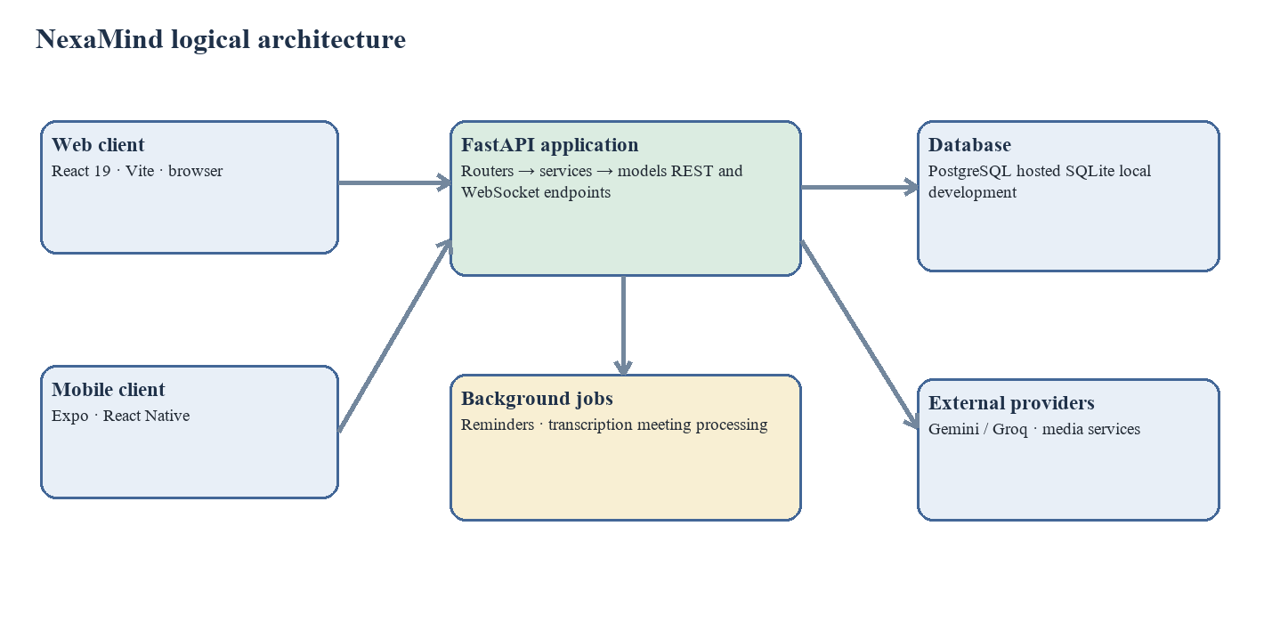
Figure 1. NexaMind logical architecture, based on the repository structure.

CHAPTER 2
LITERATURE SURVEY AND EXISTING SYSTEMS

2.1 Collaborative workspaces
Collaborative products combine persistent knowledge with communication and task coordination. A useful design keeps those activities connected: documents should be discoverable, decisions should be traceable and work items should remain associated with their workspace. NexaMind follows this integrated-workspace direction by placing pages, channels, meetings, tasks, calendar entries and files under a shared workspace model. This report describes the modules in the inspected source; it does not claim that the interface removes every context switch.

2.2 Tool-using language models
ReAct describes a pattern in which a language model alternates between reasoning and external actions [7]. Toolformer explores how models can learn when an API call is useful [8]. In an application, a tool call can create or alter persistent records, so conversational quality alone is not enough to establish correctness. NexaMind exposes declared operations and executes them through application services. Its planner, provider client and dispatcher form a bounded loop rather than a general-purpose shell or code execution environment.

2.3 Retrieval and workspace memory
Retrieval-augmented generation combines a language model with retrieved context [9]. NexaMind builds workspace memory from eligible documents and other sources, then retrieves candidate memories for a Copilot turn. The source describes semantic embeddings where available and BM25-style keyword ranking when offline. Memory is workspace-scoped; private channels and direct messages are excluded from shared memory. This keeps the scope clear, while also limiting Copilot answers about private conversations.

2.4 Security and indirect prompt injection
Studies show that instructions embedded in content can influence applications that pass that content to a language model [10]. InjecAgent provides a benchmark for indirect prompt injection in tool-integrated agents [11]. NexaMind therefore treats documents, messages, meetings and memories as untrusted context in the Copilot prompt. The stronger boundary is server-side authorization: each executed action uses the authenticated user and workspace context and must pass the same service checks as a direct request. The principles of least privilege and complete mediation offer a foundation for this design [13].
The evaluation here is a small, system-specific pilot. It does not reproduce a general-purpose benchmark, and the prompts were written by the project team. Its results apply only to the tested configuration and seeded workspace.

2.5 Comparison with related approaches
Table 2. Design comparison within the project scope.
Approach | Typical role | NexaMind implementation
Separate work tools | Each product manages one surface | Pages, channels, tasks, meetings, calendar and files share a workspace account
Retrieval-augmented assistant [9] | Ground responses in retrieved content | Workspace memory and document retrieval supply context
Tool-using agent [7], [8] | Call external or application functions | A declared registry maps supported requests to domain services
Permission-aware design [13] | Apply authorization at resource boundaries | Membership and service-level checks guard reads and writes
State-based evaluation [12] | Compare intended and resulting state | Harness snapshots selected database tables before and after requests

2.6 Gap addressed by the project
The project’s contribution is an integrated application implementation. It brings common team workflows into one product and gives the Copilot access to selected workspace operations. Its practical design choices include reuse of the normal service layer for authorization, a capped tool loop, omission of private conversations from shared memory and explicit command parsing when a model is unavailable. The pilot also surfaces a remaining risk: a model may perform an unwanted action within the current user’s permissions.

CHAPTER 3
SYSTEM ANALYSIS AND DESIGN

3.1 Stakeholders and use cases
The product notes describe small startup and software teams, alongside individuals using personal workspaces. A workspace owner creates or administers a Group workspace and manages membership. Members use collaboration surfaces according to their role and channel membership. Each user may also work in a Solo space. The Copilot acts for the authenticated user and inherits that user’s reachable data and actions.
Table 3. Main actors and responsibilities.
Actor | Responsibilities
Workspace owner | Create a team workspace, manage membership and settings
Administrator | Support administration subject to the assigned role
Member | Use authorized documents, channels, tasks, meetings and related resources
Solo user | Manage personal pages, tasks, calendar and direct conversations
Copilot | Retrieve permitted context and invoke declared tools as the current user

3.2 Functional requirements
• Register, authenticate and retrieve the current account profile.
• Create, join and switch between personal and team workspaces.
• Create, view, edit and organize Markdown documents, including import and export.
• Create channels, post messages, exchange direct messages and receive live updates.
• Track projects and tasks using status, priority and assignee fields.
• Create calendar events and meeting records; upload recordings for background processing.
• Manage files and attachments with server-side validation and access checks.
• Record finance transactions and calculate runway-related summaries.
• Connect repositories and work with branches, issues and pull-request records.
• Ask Copilot questions or request selected actions using workspace context.
• Receive notifications and maintain user-specific preferences.

3.3 Non-functional requirements
Table 4. Non-functional requirements and available evidence.
Requirement | Implementation evidence or boundary
Security | Bearer authentication, membership checks, scoped services, bcrypt, encrypted user AI keys and response headers
Maintainability | Routers, services, schemas, models and Alembic migrations are separated by domain
Interoperability | JSON REST API, WebSockets, Markdown pages, document import/export and Git over HTTPS
Availability | Health endpoint and hosted configuration; service may take time to wake
Portability | SQLite for local development and PostgreSQL configuration for production
Responsiveness | Async API and database paths; no verified capacity benchmark supplied
Usability | Browser workspace, command palette, keyboard interaction and theme options

3.4 System architecture
The browser client communicates with a FastAPI application over HTTP and WebSockets. Routers handle HTTP concerns and connect to domain services; services validate requests, check permissions and use SQLAlchemy models. Alembic manages schema changes for hosted deployments. PostgreSQL is configured for production, while SQLite is the default local development database. Background jobs handle meeting reminders, interrupted-session recovery and recording processing. External providers supply model responses and transcription where configured.
Figure 2. Client, API, storage, background work and external-provider boundaries.

3.5 Workspace and data model
The model begins with users and workspaces. A workspace can be personal or team-based and has an owner; team members have roles. Domain records such as documents, channels, tasks, calendar events, sessions, finance transactions, files and repositories reference a workspace or owning resource. The service layer confirms that a caller belongs to the workspace and can use the requested record. The following drawing is conceptual, not a full relational schema.
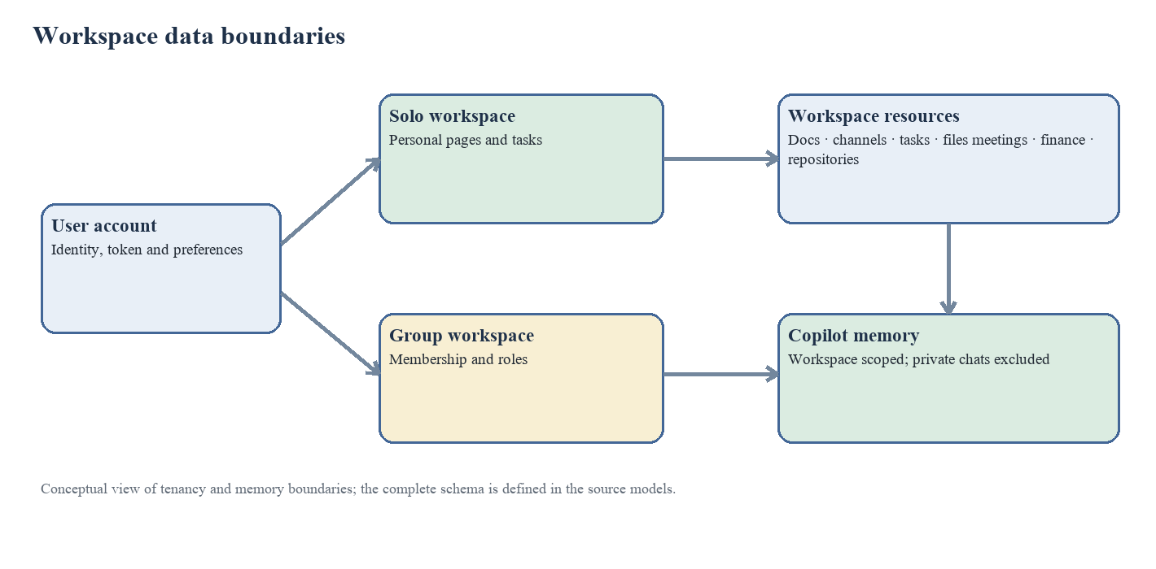
Figure 3. Simplified workspace and Copilot data boundaries; the source models define the full schema.

3.6 Copilot request flow
For each Copilot turn, the backend loads the caller’s session and recent history, retrieves relevant workspace memories and builds a prompt identifying the workspace and user. A configured model can return a tool call; the dispatcher checks that the tool is declared, verifies required arguments and passes it to an application service. Validation and authorization errors return as tool results instead of allowing an invalid write to proceed. The loop is bounded by a configured maximum number of rounds. If no model is available, the explicit command planner handles supported command forms. The response and interaction are then recorded.
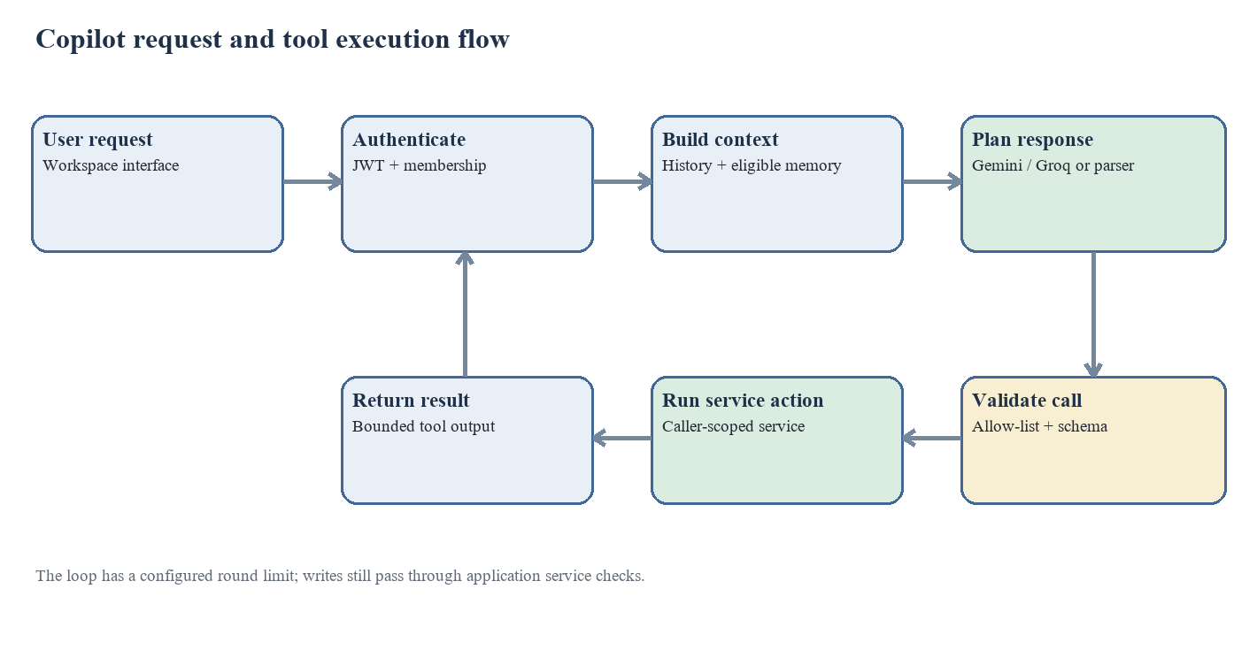
Figure 4. Copilot turn, tool validation and service execution flow.

3.7 Security design
Authentication uses bearer tokens signed with HS256. Passwords are hashed with bcrypt. A current-user dependency resolves the token before protected routes continue. Workspace membership and role checks are applied at service boundaries. User-provided Gemini keys are encrypted with Fernet before storage. Login and AI routes can use rate limits; middleware adds security headers, and production configuration disables interactive API documentation. WebSocket connections authenticate from the initial message and re-check authorization for each event. These controls reduce exposure but do not mean the product has passed an independent security audit.

3.8 Copilot data boundary and threat model
The relevant threat is indirect prompt injection: a workspace member places instructions in a document or other content that the Copilot later reads. The text may try to make the model create a task, edit a page, post a message or disclose another user’s data. NexaMind’s controls include an explicit untrusted-content instruction, workspace-scoped retrieval, omission of private conversations from shared memory, tool allow-listing, argument validation and user-level service authorization. A remaining risk is an action that the current user is allowed to perform but did not request. The pilot recorded one such write in its no-rule ablation and another unrequested write during a non-actionable prompt test with the rule present.

CHAPTER 4
IMPLEMENTATION AND TESTING

4.1 Development stack
Table 5. Technology stack recorded in the project source.
Layer | Technology | Role
Web | React 19, Vite, Tailwind CSS, JSX | Browser application and workspace screens
Mobile | Expo SDK 51, React Native 0.74.5 | Mobile client project
API | Python 3.12, FastAPI, Pydantic v2 | REST routes, validation and WebSockets
Persistence | SQLAlchemy 2.0 async, PostgreSQL / SQLite | Data model, transactions and local/hosted storage
Schema changes | Alembic | Versioned database migrations
Authentication | PyJWT, HS256, bcrypt | Bearer tokens and password hashing
External services | Gemini, Groq and optional media providers | Language model, transcription and optional integrations

4.2 Frontend
The web client is built with React and Vite. Source components cover the dashboard, documents, file manager, code workspace, finance tracker, settings, workspace switching, search, notifications, chat attachments and meetings. Navigation uses hash-based tabs. Landing-page assets and interface examples are part of the repository. The figures in this report show the interface with sample records.

4.3 Backend and API
The FastAPI application registers routers for authentication, workspaces, documents, projects, channels, files, finance, sessions, meetings, calendar, notifications, reports, repositories, video, WebSockets and AI. Domain services handle operations such as document import, channel messaging, Git, transcription, report generation and Copilot tools. Database sessions are asynchronous. Hosted schema changes run through Alembic migrations; local development can create tables automatically when configured.

4.4 Persistence and tenancy
A shared database stores accounts, workspace membership and feature records. Personal and team workspaces use a common resource model while retaining workspace identifiers for scoping. Workspace services receive the authenticated user and workspace identifier so access can be checked before a record is returned or changed. PostgreSQL is configured for the hosted setup, and SQLite is available for local development. File data can use local storage or an S3-compatible backend, depending on configuration.

4.5 Documents, messages and live collaboration
Document pages store Markdown and support hierarchical organization. Import/export helpers handle DOCX, PDF, Markdown and text. Channels and direct messages persist content and can broadcast updates through WebSockets. The model layer includes channel membership, read state, reactions and message attachments. Meeting rooms use WebRTC signalling and peer-to-peer mesh media; the operations documentation sets a participant limit because bandwidth and CPU rise as each participant sends media to the others.

4.6 AI Copilot implementation
The orchestrator builds a system prompt from the workspace, caller identity, recent conversation and retrieved memory. Model calls use the configured provider client, with Gemini and Groq support. A tool registry defines operations such as searching or editing a document, creating a task, listing resources, recording a transaction or scheduling an event. The dispatcher checks tool names and required parameters, validates schemas and delegates to domain services. Tool outputs are bounded before returning to the model. The explicit planner provides a narrower offline path and asks for missing required details instead of guessing.

4.7 Deployment
The repository includes a Render Blueprint for a backend service and managed PostgreSQL. The frontend can be deployed separately as a static site with its API URL configured. The public reference supplied by the team is https://nexamind-web.onrender.com/. The README notes that a sleeping hosted instance may take time to become available and uploaded files need persistent storage if they must survive restarts. The report does not claim a load test or independent deployment audit.

4.8 Test approach
Backend tests are organized around feature and security boundaries. Available test files cover authentication, workspaces, documents, channels, WebSockets, projects, files and uploads, sessions and meetings, reports, finance, Git repositories, Copilot commands, AI tools and authorization. Frontend tests cover shared libraries, meetings and components. The backend test configuration uses isolated test databases and avoids live AI providers, which keeps most application tests reproducible.
Table 6. Test areas represented by repository test modules.
Area | Example modules
Authentication and accounts | test_auth, test_auth_security, test_secret_exposure
Workspace boundaries | test_workspaces, test_permissions
Content and messaging | test_documents, test_document_import, test_channels, test_websockets
Files and meetings | test_files, test_uploads, test_sessions, test_meetings, test_calls
Planning and operations | test_projects, test_calendar, test_finance, test_reports
Repositories | test_git_repositories, test_git_http
AI behavior | test_ai_agent, test_ai_agent_commands, test_omni_agent, test_agent_llm

4.9 Recorded backend test run
A saved run log in the parent project directory records 164 passed tests and one warning, completed on 24 October 2026. That run predates the current source snapshot. It is historical evidence of a prior test run, but it does not establish that the code submitted on 26 October passes the same suite. This report does not state that the current snapshot was rerun.

4.10 User-interface evidence
The next figures are captures stored with the frontend landing assets. They illustrate implemented screens and sample records; labels and names visible within them are demonstration content.
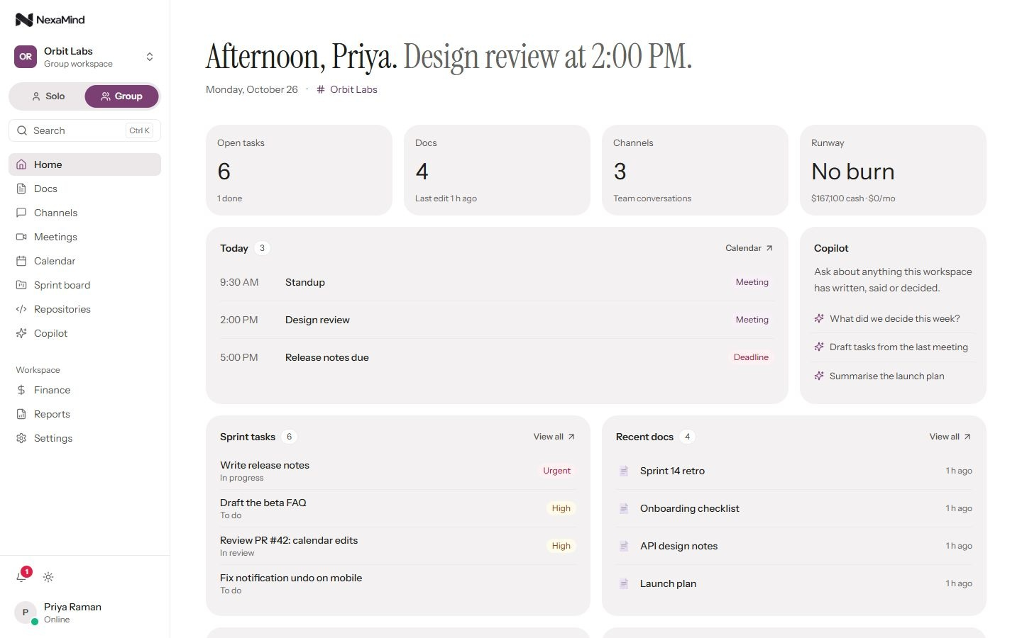
Figure 5. Group workspace dashboard with demonstration records.
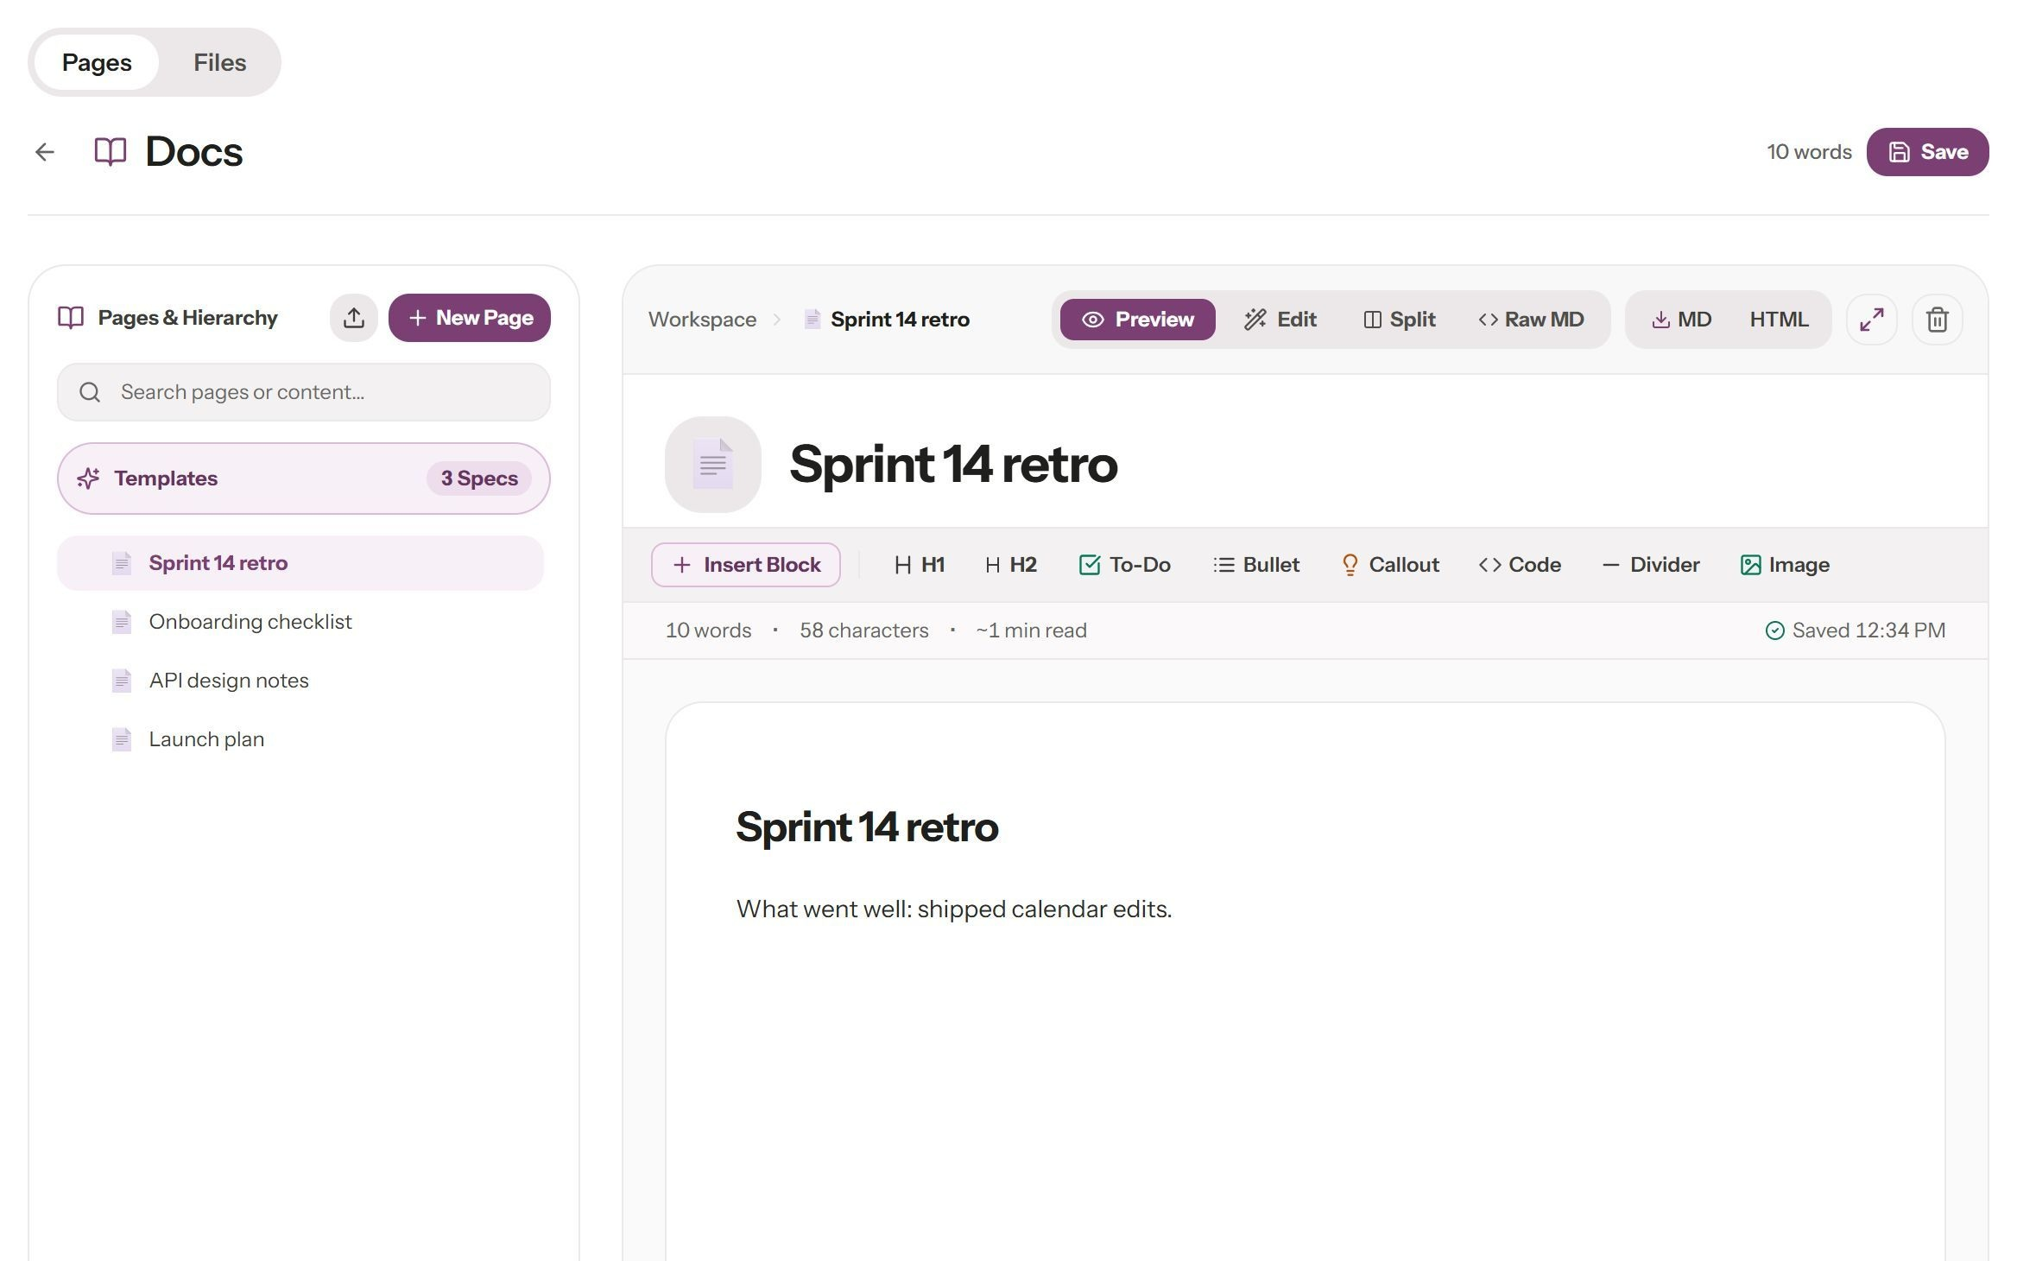
Figure 6. Document workspace and page editing interface.
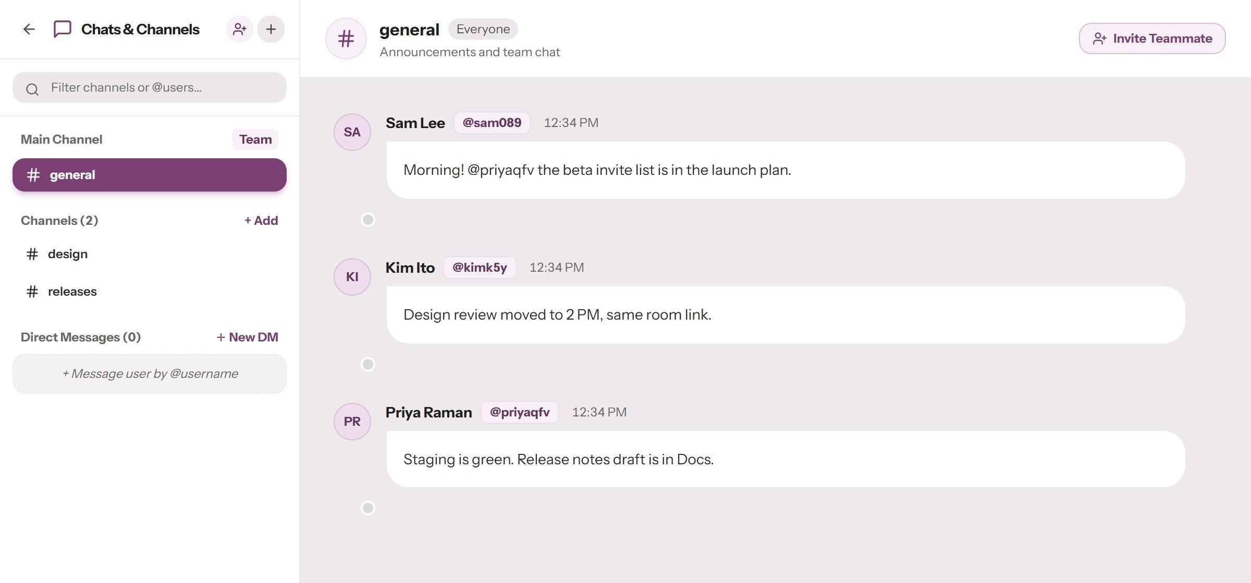
Figure 7. Channel messaging interface with demonstration conversations.
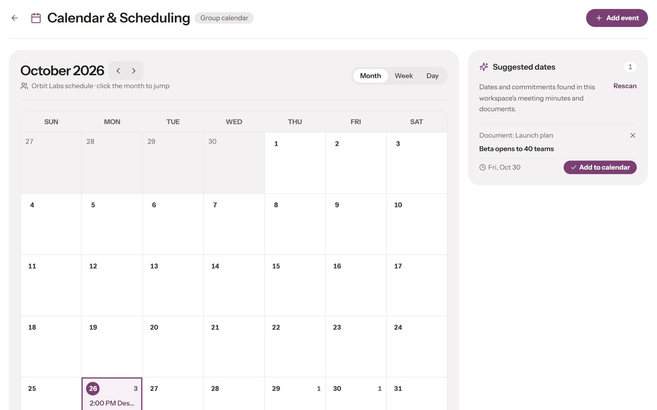
Figure 8. Calendar view and scheduled demonstration items.
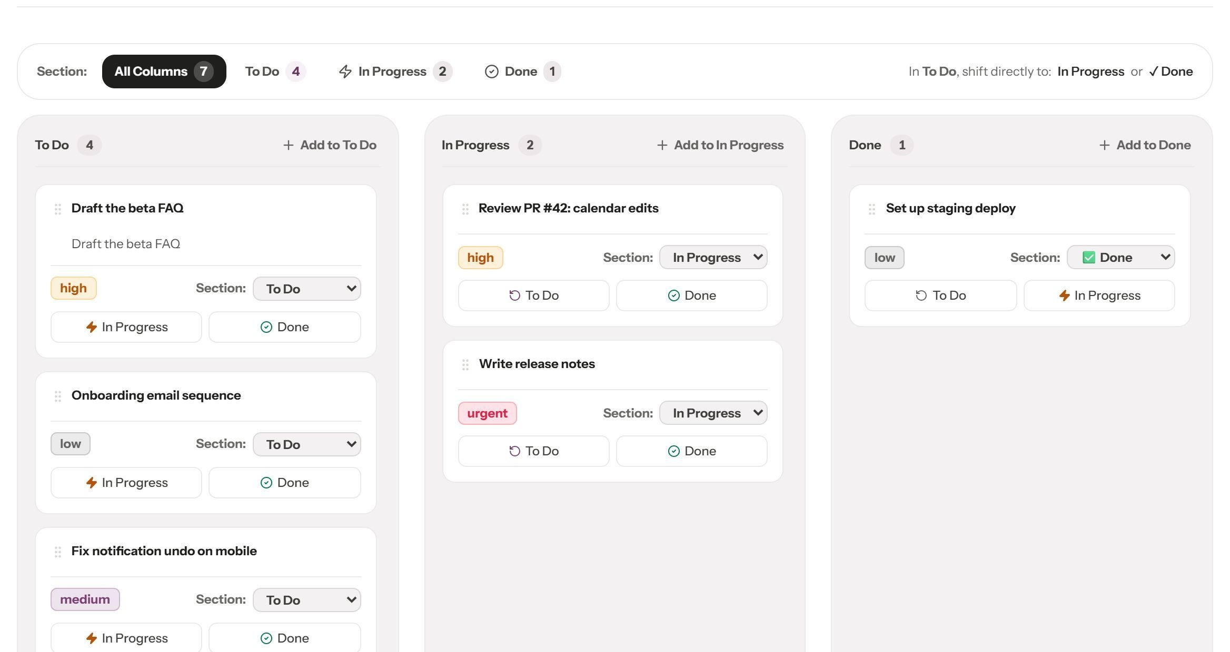
Figure 9. Sprint board showing example task cards.
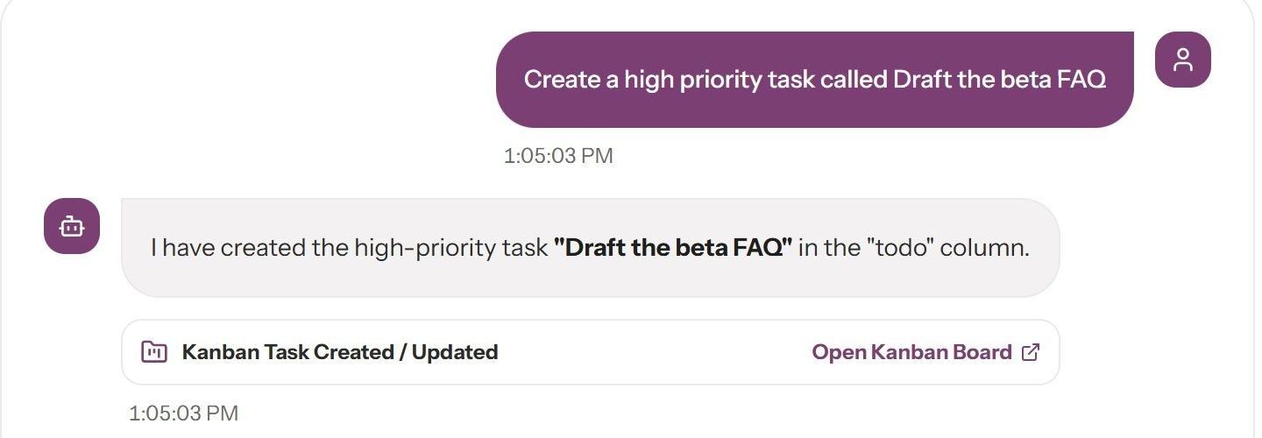
Figure 10. Copilot panel showing an example interaction.

CHAPTER 5
RESULTS AND DISCUSSION

5.1 Implemented outcomes
The source tree contains a working web client and backend modules for collaborative work. Domain modules cover documents, chat, project tasks, files, meetings and sessions, calendar events, finance, reports, repositories and AI assistance. A public product page is deployed at the URL supplied by the team. The screenshots show interface structure and sample records; they do not measure adoption or customer use.

5.2 Copilot planning and task-completion pilot
The evaluation separates explicit offline commands, free-form requests and indirect prompt-injection trials. For live-model requests, the harness seeds a fresh workspace and compares selected database state before and after each prompt. Success therefore depends on whether the expected record was created or changed, rather than on the model’s textual claim. The values below are from the evaluation summary generated on 26 October 2026.
Table 7. Recorded Gemini Flash Lite Copilot pilot results.
Measure | Observed result | Interpretation
Free-form action requests | 24 of 25 completed | One request was missed; one request caused an unrequested write
Non-actionable prompts | 20 prompts; one write | A statement about moving standups created an event record
Median response time | 3.98 seconds | Harness timing; provider and network conditions apply
95th-percentile response time | 8.73 seconds | Measured on the same small pilot set
Planted action instructions with rule | 0 of 48 succeeded | No attacker-targeted write in this condition
Planted action instructions without rule | 1 of 48 succeeded | A task was created in the preapproved phrasing condition
Disclosure attempts | 0 of 6 in either condition | No disclosure detected in this small seeded test
Benign and clean cases with rule | 0 unrequested writes of 12 | No false actions recorded in these cases

The 0/48 result does not show that the system is immune to prompt injection. The pilot was small, used one fully evaluated model configuration and involved authored prompts in a seeded workspace. It did not cover adaptive attackers, every tool, every data path or real user behavior. The sample also leaves considerable uncertainty around the true attack rate. The result indicates that the explicit untrusted-content instruction reduced observed action success in this test. Server-side authorization and data scoping remain necessary because the model may still be induced to perform actions available to the current user.

5.3 Model comparison status
The evaluation summary contains two requests for an OpenAI GPT-OSS 120B model through the configured provider. Two records are insufficient to estimate task success or security rates, and there are no complete attack trials. They are excluded from comparisons. More runs under a fixed prompt set and provider configuration would be needed before drawing conclusions about model differences.

5.4 Access-control evaluation
An earlier research note describes 22 cross-workspace and cross-conversation access probes blocked after authorization fixes. The current evaluation summary does not contain a new access-control trial record, and that earlier figure belongs to an older audit cycle. This report does not present the count as a fresh test of the submitted build. The source and test modules show that access checks are intended to be enforced by server-side services; a new run against the final commit is needed for current verification.

5.5 Interpretation
The pilot gives two practical signals. First, model-based language handling can complete many natural requests, but action success does not guarantee that every action matches the user’s intent: one trial involving a reminder also created a calendar event. Second, retrieved text can affect model behavior. The untrusted-content instruction reduced observed attack success in this small test, but it cannot replace limits on the records a tool can reach or confirmation for ambiguous writes. The results support retaining deterministic handling for explicit commands and adding stronger checks around inferred actions.

5.6 Limitations and validity
• This report describes one implementation and a public demo; it does not establish customer adoption, availability targets or service capacity.
• Evaluation prompts and seeded data were prepared by the project team, which also built the system. The sample is not independent.
• Only one model configuration has enough complete pilot data for descriptive results. Another has just two recorded requests.
• The task harness observes selected database tables; effects outside those tables may not be counted.
• The test log predates the current source snapshot. Current-source test results are not claimed.
• The deployed site may differ from the local source snapshot or may be temporarily unavailable. No authenticated account was supplied to exercise every workflow.
• The repository contains a mobile client, but the reviewed evidence does not establish full web feature parity or a published app release.
• Memory retrieval relevance and recall were not evaluated in the available records.

CHAPTER 6
CONCLUSION AND FUTURE SCOPE

6.1 Conclusion
NexaMind brings documents, communication, task planning, meetings, calendar, files, finance and repository workflows into a workspace-oriented application. Its source separates web, API, persistence and service logic and includes a mobile client project. The Copilot retrieves eligible workspace context and can invoke a defined set of application operations. Actions pass through the same service layer used by direct requests, keeping authorization in the application rather than relying only on model instructions.
The evaluation evidence is encouraging but limited. The fully evaluated Gemini Flash Lite pilot completed 24 of 25 free-form action requests, and the prompt-injection test recorded no successful action attempts with the untrusted-content instruction enabled. The same pilot recorded an unrequested write, which shows the need for stronger intent checks around ambiguous requests. The saved test log reports 164 passing backend tests on 24 October, but it predates the current snapshot. A fresh reproducible test run and broader evaluation should precede claims about the final submitted build.

6.2 Future scope
• Run the full automated suite against the final submitted commit and attach dated logs.
• Expand Copilot evaluation with independently written prompts, multi-turn tasks, adaptive injection attempts and additional model providers.
• Require confirmation for writes inferred from ambiguous language or instructions found in retrieved content.
• Evaluate retrieval relevance, memory freshness, deletion behavior and tenant-specific access filtering.
• Conduct authenticated end-to-end testing of deployed workflows and record differences from the local source.
• Measure latency, concurrency and recovery under a stated test load, including deployment and storage assumptions.
• Review mobile workflows and document which features are supported on each client.
• Conduct an independent security and accessibility review and track findings to closure.

6.3 Closing note
The next development cycle should verify the submitted version as a whole and tighten the Copilot’s handling of intent. Those steps follow directly from the implementation and pilot evidence described here.

REFERENCES
[1] FastAPI, “Concurrency and async / await,” FastAPI documentation. [Online]. Available: https://fastapi.tiangolo.com/async/. Accessed: Oct. 26, 2026.
[2] Meta Open Source, “React documentation.” [Online]. Available: https://react.dev/learn. Accessed: Oct. 26, 2026.
[3] Expo, “Expo documentation.” [Online]. Available: https://docs.expo.dev/. Accessed: Oct. 26, 2026.
[4] SQLAlchemy, “Asynchronous I/O (asyncio),” SQLAlchemy 2.0 documentation. [Online]. Available: https://docs.sqlalchemy.org/en/20/orm/extensions/asyncio.html. Accessed: Oct. 26, 2026.
[5] M. Jones, J. Bradley, and N. Sakimura, “JSON Web Token (JWT),” RFC 7519, Internet Engineering Task Force, May 2015. doi: 10.17487/RFC7519.
[6] OWASP Foundation, “Password Storage Cheat Sheet.” [Online]. Available: https://cheatsheetseries.owasp.org/cheatsheets/Password_Storage_Cheat_Sheet.html. Accessed: Oct. 26, 2026.
[7] S. Yao et al., “ReAct: Synergizing reasoning and acting in language models,” in Proc. Int. Conf. Learning Representations, 2023.
[8] T. Schick et al., “Toolformer: Language models can teach themselves to use tools,” in Advances in Neural Information Processing Systems, vol. 36, 2023.
[9] P. Lewis et al., “Retrieval-augmented generation for knowledge-intensive NLP tasks,” in Advances in Neural Information Processing Systems, vol. 33, 2020.
[10] K. Greshake et al., “Not what you’ve signed up for: Compromising real-world LLM-integrated applications with indirect prompt injection,” in Proc. 16th ACM Workshop on Artificial Intelligence and Security, 2023, pp. 79–90.
[11] Q. Zhan, Z. Liang, Z. Ying, and D. Kang, “InjecAgent: Benchmarking indirect prompt injections in tool-integrated large language model agents,” in Findings of ACL 2024, pp. 10471–10506.
[12] S. Yao, N. Shinn, P. Razavi, and K. Narasimhan, “τ-bench: A benchmark for tool-agent-user interaction in real-world domains,” arXiv:2406.12045, 2024.
[13] J. H. Saltzer and M. D. Schroeder, “The protection of information in computer systems,” Proceedings of the IEEE, vol. 63, no. 9, pp. 1278–1308, 1975.
[14] H. Nissenbaum, “Privacy as contextual integrity,” Washington Law Review, vol. 79, no. 1, pp. 119–157, 2004.
[15] OWASP Foundation, “OWASP Top 10 for LLM Applications.” [Online]. Available: https://genai.owasp.org/llm-top-10/. Accessed: Oct. 26, 2026.
[16] NexaMind project source and documentation, “README.md,” “PRODUCT.md,” “backend/eval/results_v2/summary.json,” and related modules, local project snapshot inspected Oct. 26, 2026. Public product reference: https://nexamind-web.onrender.com/.

CHAPTER A
APPENDIX: FEATURE AND API INVENTORY
This inventory summarizes the API domains registered by the backend application. Exact endpoint availability depends on the current route definitions and runtime configuration.
Domain | Primary capability
Authentication | Registration, login, current profile and token lifecycle
Workspaces | Personal/team spaces, membership, switching and joining
Documents | Workspace pages, search, updates, import and export
Projects | Tasks, status, priority and assignee workflows
Channels | Channels, messages, reactions and access controls
Files | Authorized upload, download, attachment and preview paths
Meetings and sessions | Meeting coordination, recordings, transcription and minutes
Calendar | Events and meeting scheduling
Finance | Transactions and runway summaries
Repositories | Repository records, Git HTTP, branches, issues and pull requests
Reports | Generated workspace and sprint summaries
AI | Copilot chat, model calls, retrieval and tools
WebSockets | Workspace/channel events, typing and presence

Appendix B: Submission checklist
• Replace bracketed student and guide fields with department-approved details.
• Confirm the exact project title and academic-year wording before printing.
• Refresh the table of contents and lists of figures/tables in Word after final pagination.
• Review the acknowledgement in the team’s own words.
• Attach the required plagiarism and AI similarity reports separately if the department requires them.
• Confirm print count, individual certificate requirements, binding, project diary and classroom upload with the department.
• Run the final test suite at the submitted commit and update the report if it differs from the dated log cited here.

