-------- 📊 Telco Customer Churn Analysis – SQL Queries -------

-- DATA EXPLORATION

1) to Check 10 Rows
select * from customer_churn
limit 10;
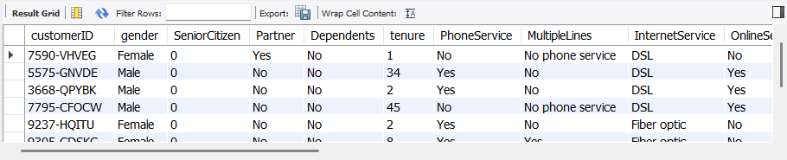

2) Count Rows
select count(*)
from customer_churn;
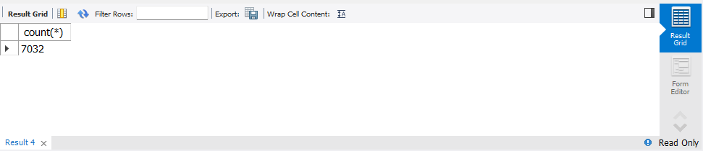

-- DATA CLEANING

3) Converting Data Types
alter table customer_churn
modify TotalCharges decimal(10,2);

4) Checking Missing Values
select count(*) from customer_churn
where TotalCharges is null;

5) Removing Missing Values
delete from customer_churn
where totalcharges is null;

-- CUSTOMER OVERVIEW

6) Total Customers
select count(*)
from customer_churn;

7) Total Churned Customers
select count(*)
from customer_churn
where churn = 'Yes';

8) Churn Rate Calculation
select count(case when churn = 'Yes' then 1 end)*100.0 / count(*) as churn_rate
from customer_churn;
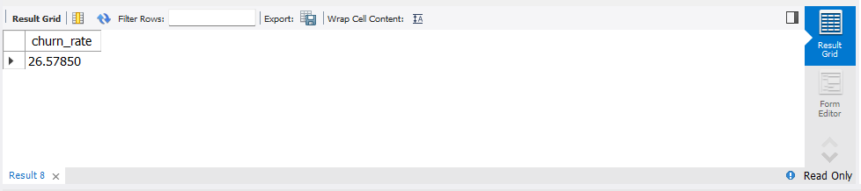

-- REVENUE IMPACT ANALYSIS

9) Revenue Lost Due to Churn
select sum(monthlycharges) as revenue_lost
from customer_churn
where churn = 'Yes';
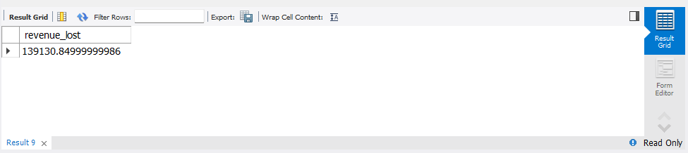

-- CHURN DRIVER ANALYSIS

10) Contract Type Analysis
select contract,
count(*) as customer,
sum(case when churn = 'Yes' then 1 else 0 end) as churned
from customer_churn
group by contract;
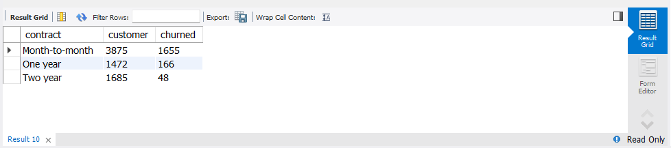

11) Internet Service Impact on Churn
select internetservice,
count(*) as customers,
sum(case when churn = 'Yes' then 1 else 0 end) as churned
from customer_churn
group by InternetService;
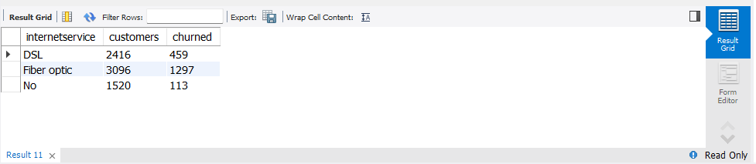

12) Payment Method Analysis
SELECT
PaymentMethod,
COUNT(*) AS customers,
SUM(CASE WHEN churn='Yes' THEN 1 ELSE 0 END) AS churned
FROM customer_churn
GROUP BY PaymentMethod;
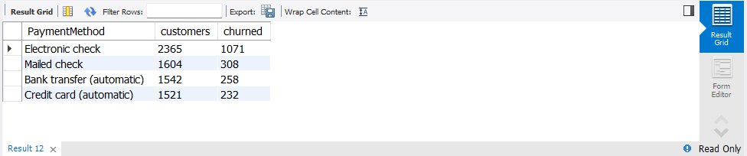

-- CUSTOMER BEHAVIOUR ANALYSIS

13) Tenure vs Churn Analysis
SELECT
tenure,
COUNT(*) AS customers,
SUM(CASE WHEN churn='Yes' THEN 1 ELSE 0 END) AS churned
FROM customer_churn
GROUP BY tenure
ORDER BY tenure;
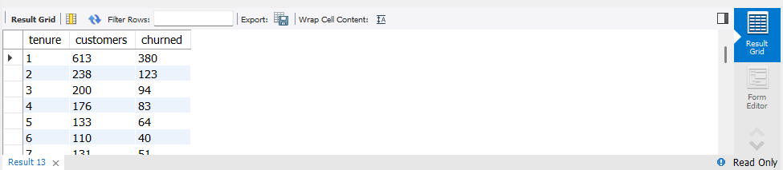

-- CUSTOMER VALUE SEGMENTATION

14) High Value Customers
select
customerid,
sum(monthlycharges) as total_value
from customer_churn
group by customerid
order by total_value desc
limit 10;
