**Step 1:** Install Node js from <https://nodejs.org/en/download/> as per your system configuration and install it.

**Step 2:** Type below command to install Angular cli where –g used to install it globally.

**Command:**

G:\nodejs > npm install –g @angular/cli

**Step 3:** Download and install VS(visual studio) code ide for code manipulations.

<https://code.visualstudio.com/Download>

**Step 4:** Now everything setup. So create first angular project.

**Command:**

G:\nodejs > ng new projectname

For Ex:

G:\nodejs > ng new angapp

Select normal CSS and type – “Y” for routing to be added in your project.

**Step 5:** Add angular material in your project for easy creation of pages. Go to your project folder and type the below command. Also, select the properties to be included such as color, browser animations etc.

**Command:**

G:\nodejs\angapp > ng add @angular/material

**Step 6:** To create components execute the below commands.

**Command:**

G:\nodejs\angapp > ng g c componentname

For Ex:

G:\nodejs\angapp > ng g c home –skipTests=true

Here skipTests=true used to skip the spec.ts file, which is used for testing purpose.

**Step 7:** To create Service execute the below command.

**Command:**

G:\nodejs\angapp > ng g s servicename

For Ex:

G:\nodejs\angapp > ng g s users –skipTests=true

It will create a service and you can also use command: ng generate service servicename.

**Step 8:** To install express.

**Command:**

G:\nodejs\angapp > npm install -g express

It will install the express globally and this will be used for creating server and listening on that.

**Step 9:** To install express generator to allow using express in windows command.

**Command:**

G:\nodejs\angapp > npm install -g express-generator

You can execute this command outside project as well.

**Step 10:** To configure server side using express.

**Command:**

G:\nodejs\angapp > express --view=hbs expressappname

Here you can use view such as pug, hbs etc and give your express app name.

For Ex:

G:\nodejs\angapp > express --view=hbs expressapp

Then go to the expressapp folder and execute the below command to install the dependencies.

**Command:**

G:\nodejs\angapp\ expressapp > npm install

Here, you can use command: “npm i” as well.

**Step 11:** To install mongoose, cors and encryption for the password.

**Command:**

G:\nodejs\angapp\expressapp>npm i --save mongoose cors bcrypt

**Step 12:** To use passport.js --> it’s an authentication middleware for node.js.

For more info: [www.passportjs.org/docs/username-password/](http://www.passportjs.org/docs/username-password/)

**Command:**

G:\nodejs\angapp\expressapp> npm i --save passport passport-local express-session

**express-session** --> used by passport to provide persistence session functionality and provides cookies and other activities.

**Step 13:** To keep your session available even after restarting the express application.

For more info: <https://www.npmjs.com/package/connect-mongo>

**Command:**

G:\nodejs\angapp\expressapp> npm i --save connect-mongo

**Step 14:** Download the mongodb jar file and extract it in your local machine where just create a folder called “data” and inside this folder create one more folder called “db”.

<https://www.mongodb.com/download-center/community>

Once you are done with this then go to the extracted file directory and execute the below command to run your mongodb server.

Go to mongodb extracted file directory:

G: > cd /mongodb/mongodb-win32-x86_64-2008plus-ssl-4.0.6/bin

Execute below command to run server.

**Command:**

G:\ mongodb\mongodb-win32-x86_64-2008plus-ssl-4.0.6\bin > mongod.exe --dbpath "G:\mongodb\data"

To connect to the mongodb server you can use below command:

**Command:**

G:\ mongodb\mongodb-win32-x86_64-2008plus-ssl-4.0.6\bin > mongo.exe

**Step 15:** To start your angular application, you need to start three windows terminals.

First: Start angular application.

**Command:**

G:\nodejs\angapp > ng serve –o

Second: Start mongodb server as the steps mentioned above.

Third: Start your express app.

**Command:**

G:\nodejs\angapp\expressapp > npm start

Or you can install nodemon for better use.

**Command:**

G:\nodejs\angapp > npm install –g nodemon

This allows to do not restart the server again as it will refresh after any changes in server side coding.

So, to use nodemon type the below command.

**Command:**

G:\nodejs\angapp\ expressapp > nodemon

**************************************************************************************************************SCREENSHOTS****************************************************************************************************************************

**Login Page:**

Here your session will be stored using express-session.

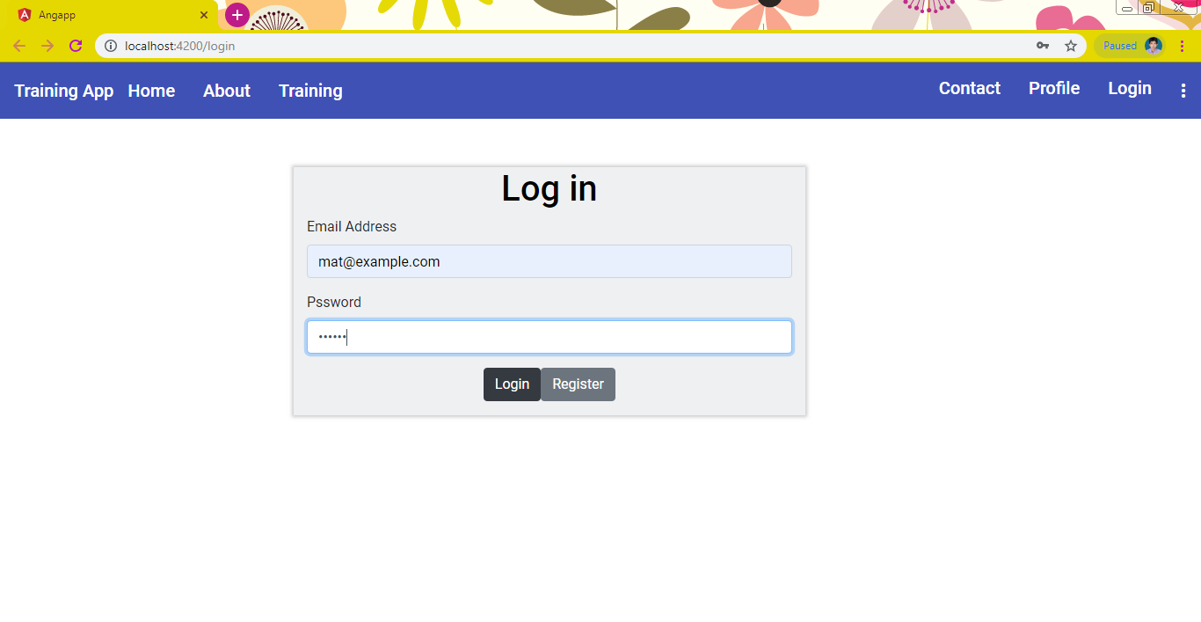

**Userhome page:**

Here you will find out options as mentioned below.

Buttons:

**UPDATE:** To update your user details such as username, email ids etc.

**TRAININGS:** To view the available training to apply for.

**VIEW:** To view the trainings you have already applied.

**LOGOUT:** To logout from the application.

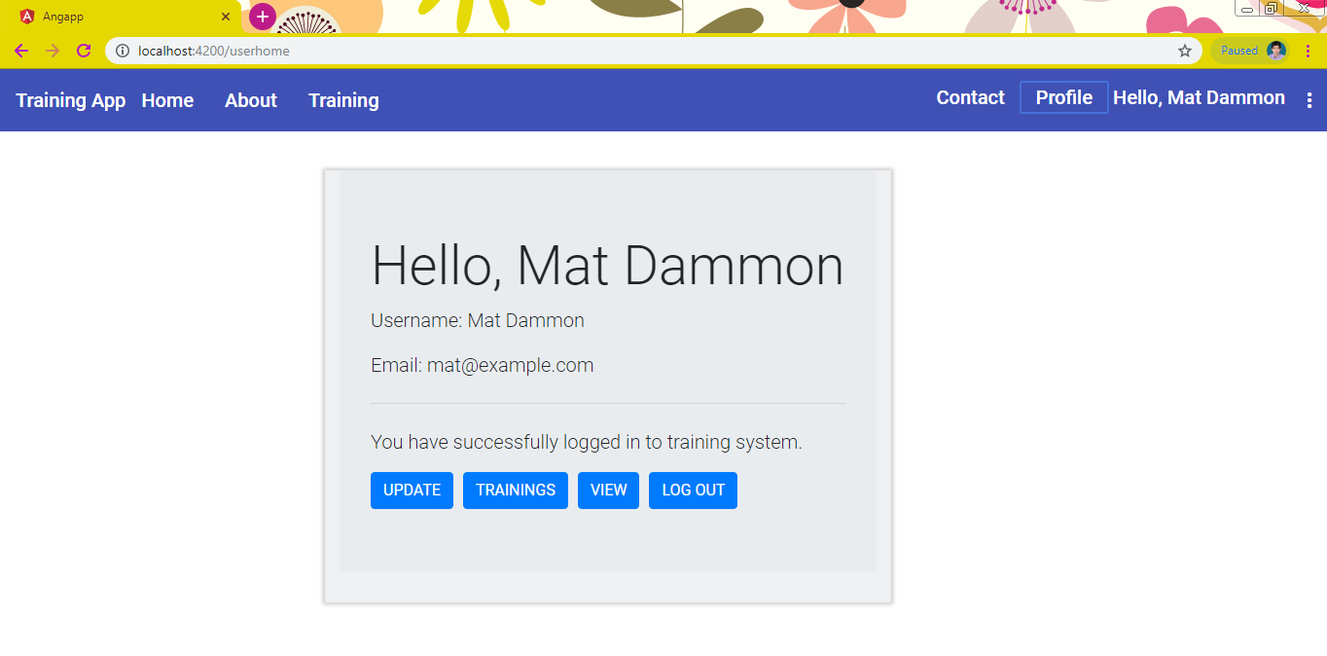

**User details edit page:**

Here you can update your details.

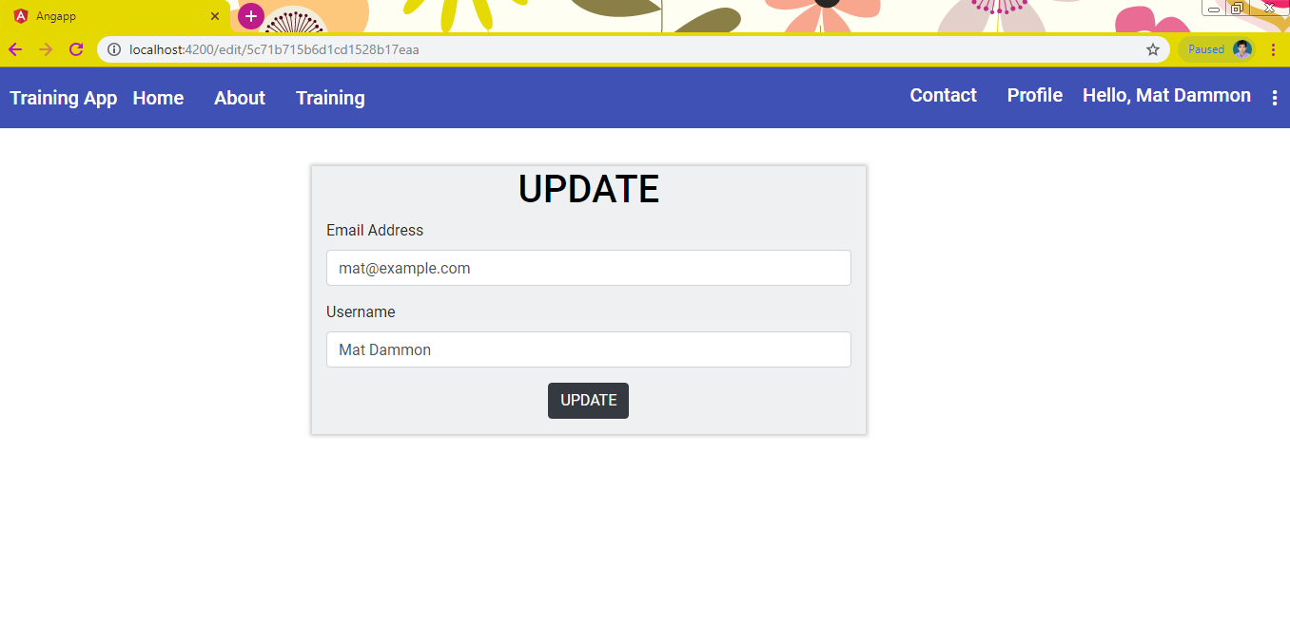

**User available training page:**

Here you will find out the available trainings and click on the Apply button to apply for that training.

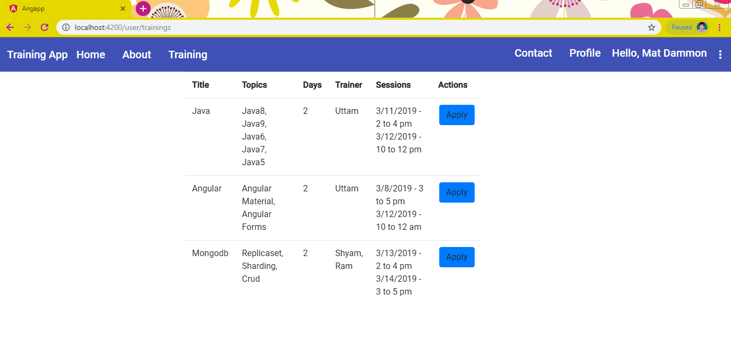

**User applied training view page:**

Here you can view all your trainings, which you have already applied.

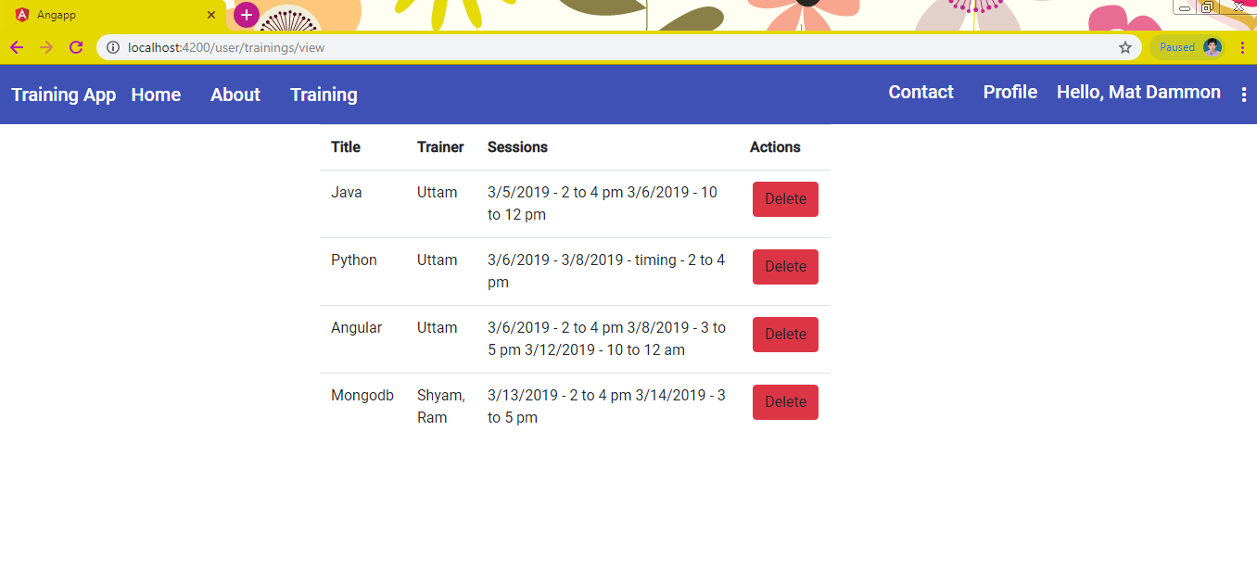

**Training options:**

Here you will get two options, add training and view the trainings.

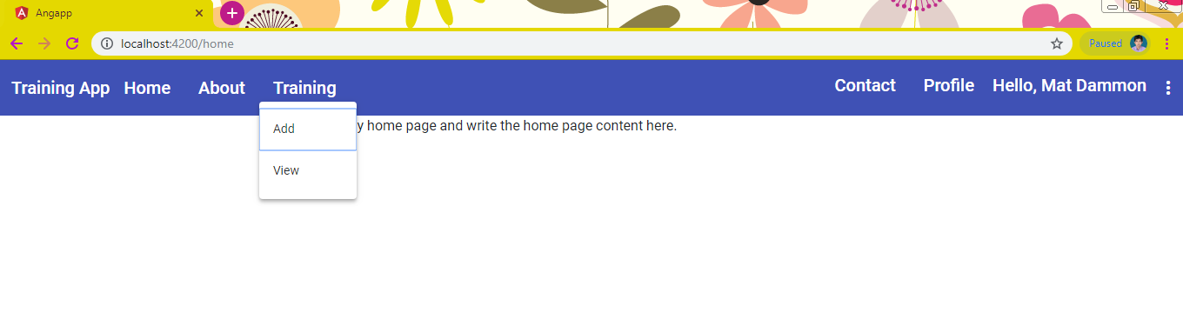

**Training add details page:**

This is training add form, where you can enter the form values accordingly.

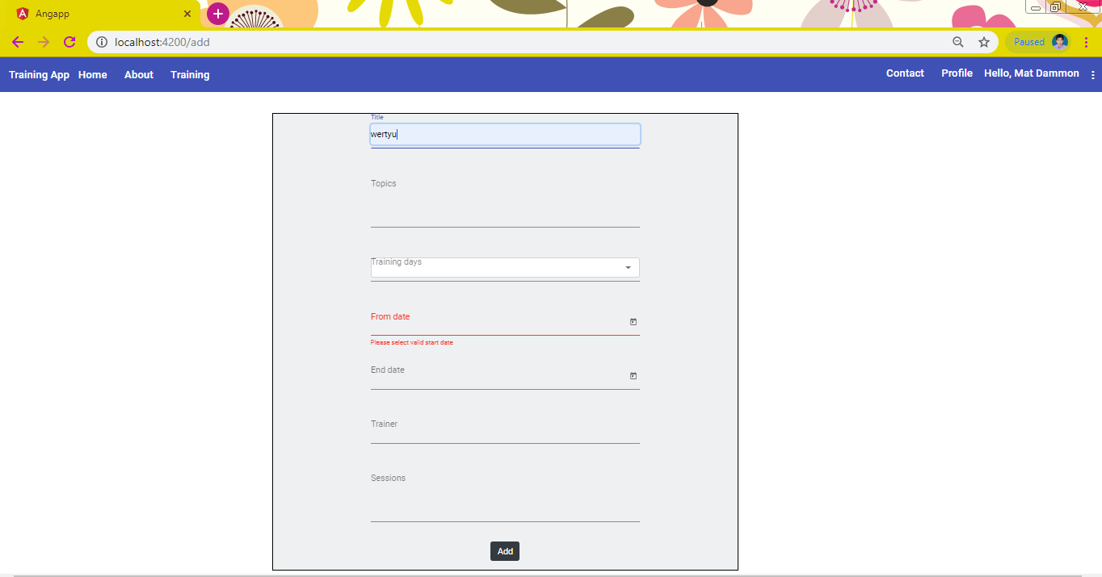

**Training view page:**

Here you can view all the trainings. Also, you will get the options to view the users applied for this training, update the training details and Delete the training.

**Users**: View all users who have applied for this training.

**Edit:** Update the training details.

**Delete:** Delete the existing training.

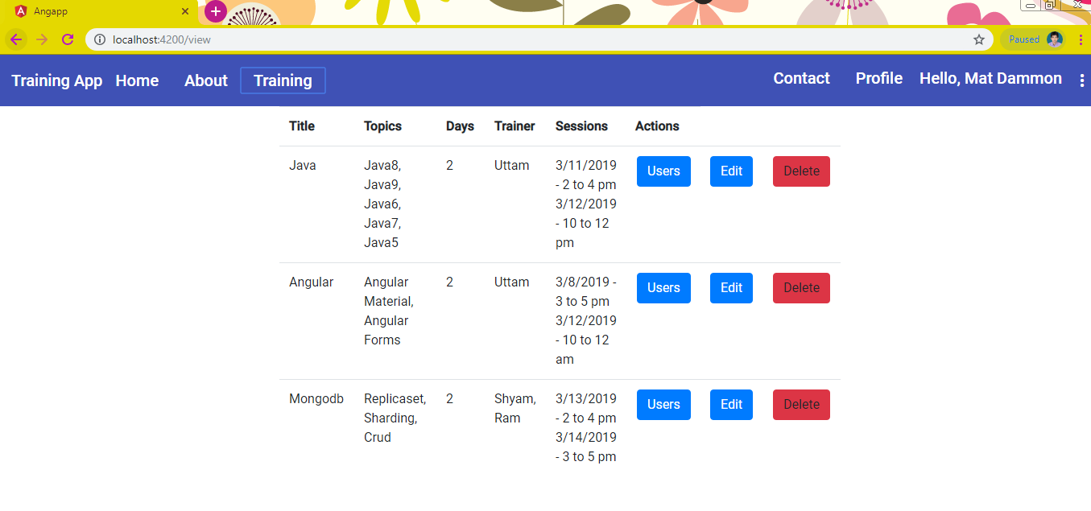

**Users applied for specific training:**

Users who have applied for the specific training.

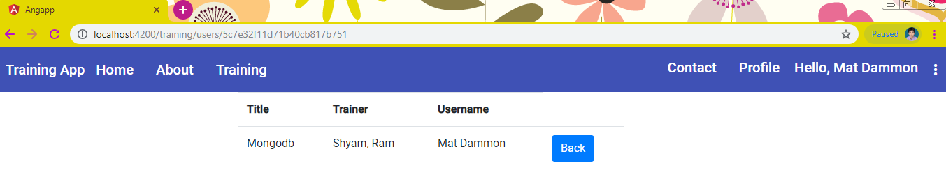

**Training edit form:**

Here you can edit the training details as per the details validations.

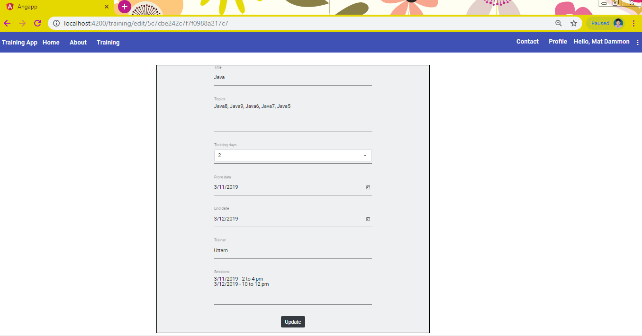

**More options:**

At the right corner you can view more options such as check voicemail etc.

I have not developed anything for these.

