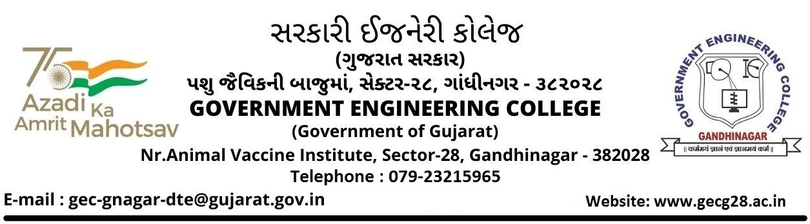

Date: 26/SEPTEMBER/2023

**Sub: Smart India Hackathon 2023 – Nomination**

I am pleased to nominate the below team from our college to participate in Smart India Hackathon 2023. AICTE Application No/ UGC Registration/ AISHE code No for our college is _C-309__.

**Team: YOUR TEAM NAME**

|  |  |  |  |  |
| --- | --- | --- | --- | --- |
|  | Name | Gender (M/F) | Email Id | Mobile No. |
| Team Leader | Chhatrapalsinh  Zala | M | chhatrapalsinhzala7@gmail.com | 7069956127 |
| Team Member | XYZ | M | XYZ |  |
| Team Member | XYZ | M | XYZ |  |
| Team Member | XYZ | M | XYZ |  |
| Team Member | XYZ | F | XYZ |  |
| Team Member | XYZ | F | XYZ |  |
| Mentor 1  (Optional) | XYZ | M | XYZ |  |
| Mentor 2  (Optional) |  |  |  |  |

Sincerely,

The Principal