- 2.1.2 Conceptual View
- 2.1.8 Data View
- Information / Data Dictionary section

✅ 1. Detailed Conceptual Data Model
(Business-level, technology-agnostic)
1.1 Conceptual Model – Purpose
The conceptual data model explains what information the system manages, why it exists, and how key healthcare concepts relate, without implementation details.
Design principles applied
- Patient-centric
- DDD bounded contexts
- Healthcare compliance (clinical vs non-clinical separation)
- Alignment with FHIR resources

1.2 Conceptual Data Domains
Domain | Description
Patient Management | Patient identity, demographics, contact preferences
Consent Management | Legal consent for care, data usage, notifications
Care Coordination | Care plans, activities, milestones
Clinical Governance | Protocols, rules, eligibility
Engagement | Notifications, reminders, interactions
Audit & Compliance | Immutable records of actions
Reporting & Analytics | Read-optimized insights

1.3 Conceptual Data Model Diagram (Numbered)
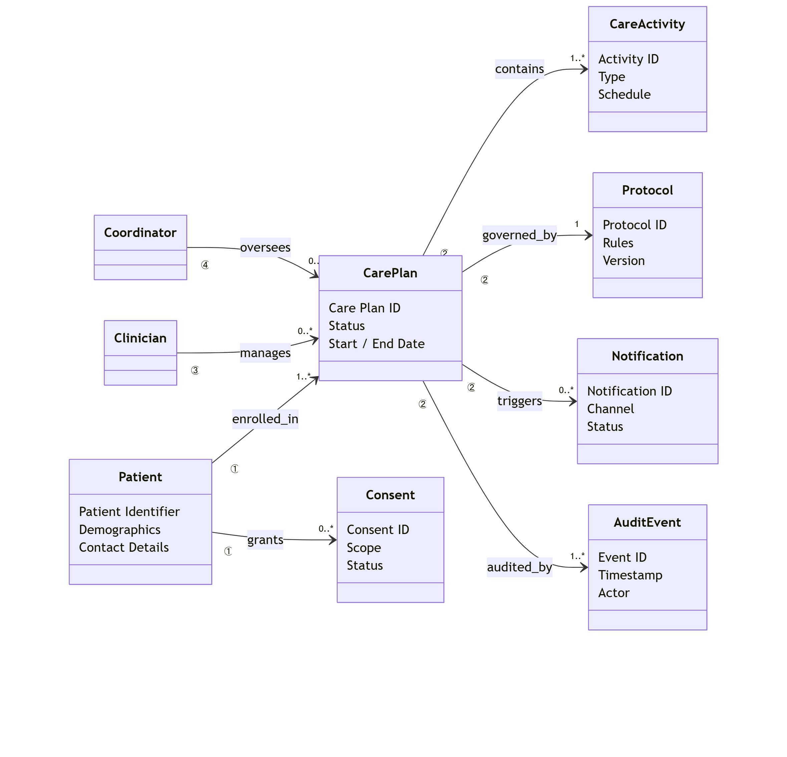
1.4 Conceptual Relationships (Explained)
# | Relationship | Meaning
① → ② | Patient → CarePlan | A patient may have multiple care plans
② → Activity | CarePlan → CareActivity | Care plan is composed of steps/tasks
② → Protocol | CarePlan → Protocol | Care plan must adhere to protocol
① → Consent | Patient → Consent | Patient grants/revokes consent
② → Notification | CarePlan → Notification | Events trigger engagement
All → AuditEvent | Any entity → Audit | Every action is auditable

✅ 2. Logical Data Model (HLD-Level, Service-Aligned)
2.1 Data Ownership by Microservice
Microservice | Owns Data | Store Type
Patient Service | Patient Profile | Azure SQL / Cosmos DB
Consent Service | Consent Records | Azure SQL
Care Plan Service | Care Plans, Activities | FHIR Store
Protocol Service | Clinical Rules | Azure SQL
Notification Service | Messages | Cosmos DB
Audit Service | Audit Events | Append-only Store
✅ No shared databases
✅ Database-per-service enforced

2.2 Logical Data Flow (Numbered)
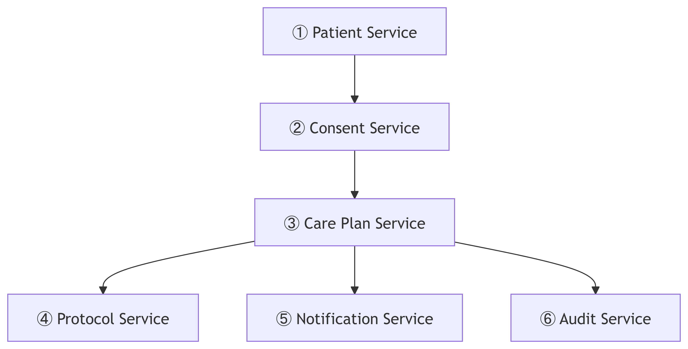
✅ 3. Data Dictionary (Detailed & Review-Ready)

3.1 Patient (Master Entity)
Attribute | Type | Description
PatientId | UUID | System-generated identifier
ExternalPatientId | String | EHR/HIS reference
FirstName | String | Patient given name
LastName | String | Patient family name
DateOfBirth | Date | DOB
Gender | Code | Standard code set
ContactDetails | Object | Phone, email
Status | Enum | Active / Inactive
FHIR Mapping: Patient resource

3.2 Consent
Attribute | Type | Description
ConsentId | UUID | Unique consent record
PatientId | UUID | Linked patient
Scope | Enum | Care / Data / Messaging
GrantedOn | DateTime | Consent grant date
RevokedOn | DateTime | Revocation date
Status | Enum | Active / Revoked / Expired
FHIR Mapping: Consent resource

3.3 CarePlan
Attribute | Type | Description
CarePlanId | UUID | Care plan identifier
PatientId | UUID | Subject
ProtocolId | UUID | Governing protocol
Status | Enum | Draft / Active / Completed
StartDate | Date | Plan start
EndDate | Date | Plan end
Version | Int | Versioning
FHIR Mapping: CarePlan

3.4 CareActivity
Attribute | Type | Description
ActivityId | UUID | Activity identifier
CarePlanId | UUID | Parent care plan
Type | Enum | Medication / Visit / Test
Schedule | String | Cron / timing
Status | Enum | Pending / Completed
FHIR Mapping: CarePlan.activity

3.5 Protocol
Attribute | Type | Description
ProtocolId | UUID | Protocol identifier
Name | String | Protocol name
Version | String | Clinical version
Rules | JSON | Eligibility, constraints
EffectiveFrom | Date | Validity start
FHIR Mapping: PlanDefinition

3.6 Notification
Attribute | Type | Description
NotificationId | UUID | Message identifier
CarePlanId | UUID | Trigger source
Channel | Enum | SMS / Email / Push
Message | String | Content
Status | Enum | Sent / Failed / Pending
SentAt | DateTime | Dispatch time

3.7 AuditEvent (Immutable)
Attribute | Type | Description
AuditEventId | UUID | Event identifier
EntityType | String | CarePlan, Consent, etc.
EntityId | UUID | Entity reference
Action | Enum | Create / Update / Delete
Actor | String | User/System
Timestamp | DateTime | Event time
CorrelationId | UUID | Saga / request trace
FHIR Mapping: AuditEvent

✅ 4. Key Governance Rules (Critical for ARB)
✅ Clinical data never bypasses consent
✅ CarePlan activation requires:
- Protocol validation ✅
- Active consent ✅
✅ AuditEvent is append-only
✅ Reporting uses read replicas / projections only

✅ 5. One-Line Summary (Use in HLD)
The conceptual and logical data model is patient-centric, FHIR-aligned, service-owned, and designed to ensure clinical safety, regulatory compliance, and complete auditability across the healthcare engagement platform.

