Cognizant – Upgrade2Architect
Health Care Patient Engagement & Care Coordination Platform
High Level Design and Architecture Document
1.0.0

 | Prepared By / Last Updated By | Reviewed By | Approved By
Name | Uttam Kumar Bhatia
Role | Architect / Tech Lead
Signature
Date | 18-May-2026

Table of Contents
1.0 Introduction 3
1.1 Purpose of this document 3
1.2 Scope 3
1.3 Out of scope 3
1.4 Intended Audience 3
1.5 Acronyms 3
2.0 System Architecture 3
2.1 Architectural Views 3
2.1.1 Functional View 4
2.1.2 Conceptual View 6
2.1.3 Logical View 8
2.1.4 Functional Architecture View 10
2.1.5 Technology View 15
2.1.6 Integration View 18
2.1.7 Implementation View 19
2.1.8 Data View 22
2.1.9 Deployment View 23
2.1.10 Security View 27
2.1.11 Process View 30
2.2 System Interfaces 32
2.3 Reporting 32
3.0 Prototype Design 33
3.1.1 Wireframe/ Visual Design 34
4.0 Technology, Tools and Frameworks 34
5.0 Solution Recommendations 34
5.1 Technical recommendations 34
5.2 Infrastructure recommendations 34
6.0 Reference 34
7.0 Change Log 34

- Introduction
  - Purpose of this document
Document High level Design and Architecture for Health Care Patient Engagement & Care Coordination Platform.
  - Scope
- Patient onboarding & profile management
- Appointment scheduling
- Care coordination workflows
- Notifications & communication
  - Out of scope
- Electronic Health Records (FHIR-compliant)
- Teleconsultation integration
- Remote monitoring device ingestion
  - Intended Audience
Internal Technical teams, Architects, Developers, IT Security, DelEx.
  - Acronyms
S. No | Acronym | Expansion
- System Architecture
  - Architectural Views
The architecture of a system can be depicted in multiple views that makes it easy to understand from a specific perspective. Design team is free to decide and merge views as applicable to simplify diagram creation. For vendor/3rd party products some of the views may be available as part of vendor provided docs and must be explored for reuse/reference here.
    - Functional View
      - Key Business Processes
- Patient Onboarding & Profile Management
- Consent Management
- Appointment Scheduling and management
- Tele-medicine Consultation
- Clinical Documentation and EHR Management
- Remote Patient Monitoring.
- Care Plan Management
- Alert Management
- Monitoring and Analytics
- External System Integration – FHIR and Device
      - Architecturally Significant Use Cases/Functional Requirements
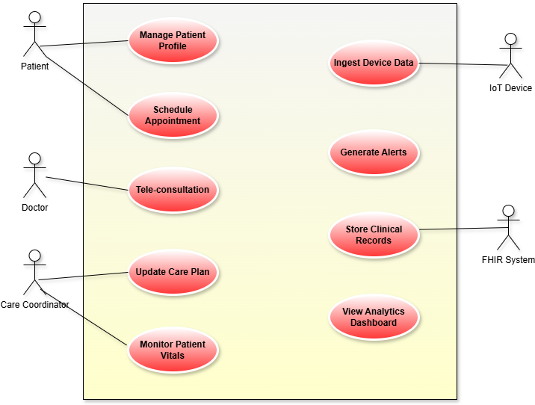
      - Functional Modules
# | Module | Description
1 | Patient Management | Manage patient onboarding and profile data
2 | Consent Management | Captures and tracks patient consent with versioning
3 | Appointment Management | Handles scheduling and management of appointments
4 | Telemedicine Service | Enables virtual consultations and records notes
5 | Medical Records / HER | Maintains clinical data in FHIR format
6 | Care Plan Management | Manages treatment plans and updates
7 | Device Data Ingestion | Captures and validates IoT device data
8 | Telemetry Processing | Processes device data into meaningful events
9 | Alert Management | Generates alerts and manages escalation workflows
10 | Analytics & Monitoring | Provides reports, KPIs, and patient insights
11 | Notification Service | Sends alerts and updates via multiple channels
12 | Identity & Access Mgmt | Handles authentication and role-based access
13 | Integration Services | Integrates with FHIR systems, devices, and external apps

    - Conceptual View
      - Actors
Category | Actors
Primary Human Actors | Patient, Agent, Doctor, Care Coordinator
Internal Actors | Company Staff, System Administrator
Core External Actors (In Scope) | Identity Provider, Notification Gateway, Document Validation, Bank/Payment, IoT Devices

Patient
Description: Individual receiving care
Role in System: Views records, attends tele-consultations, receives alerts
Utility: Consumer: health data, notifications

Agent / Care Facilitator
Description: Supports patient onboarding and submissions
Role in System: Submits applications, documents, claims
Utility: Consumer + Supplier: workflows + patient data
Doctor / Clinician
Description: Medical professional
Role in System: Consults, updates records, manages care plans
Utility: Consumer + Supplier: clinical data + decisions
Care Coordinator
Description: Manages patient care plans
Role in System: Updates care plans, handles alerts
Utility: Consumer + Supplier: alerts + coordination
Company Staff
Description: Operations staff
Role in System: Approvals, monitoring, admin workflows
Utility: Consumer + Supplier: decisions + reports
System Administration
Description
Administrative user responsible for system governance.
Role in System: Manages user access (unlock/reset), Configures system settings
Utility: Supplier + Consumer: Supplies: configuration and admin actions, Consumes: system logs and alerts.
      - System Components
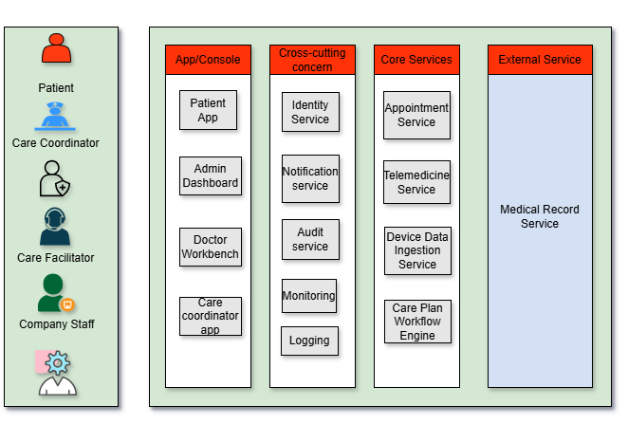
    - Logical View
This view must depict the following at a generic level:
- All layers applicable like Actors/Roles (User), Devices/End Points (Client), Presentation, Services, Persistence, Integrations (including external).
- Depict common/cross-cutting/infrastructural elements such as Security, Logging, Monitoring, Availability, Scalability, Caching as vertical layers
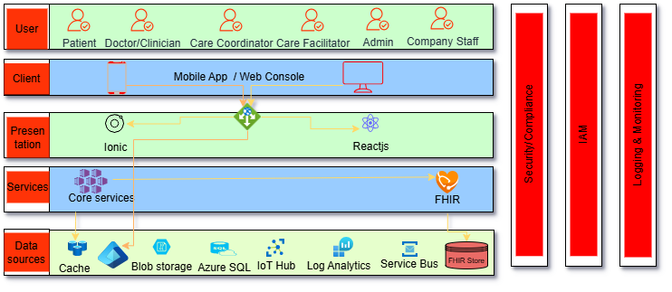

    - Functional Architecture View
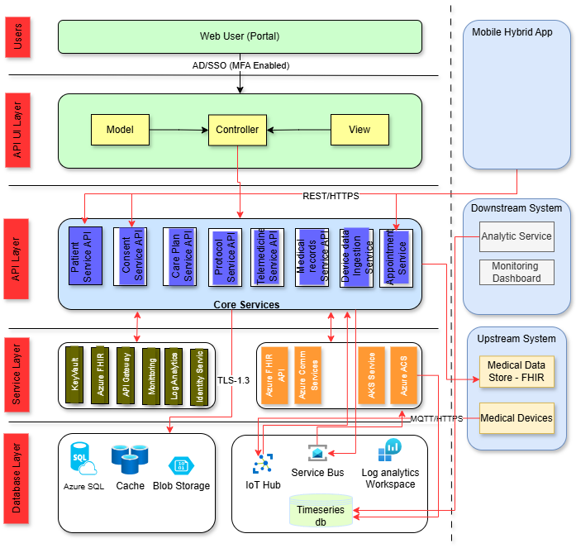
Fig. Functional Architecture View
Tier 1 – User Type (User Interaction Layer)
Web Application (Portal)
- User accesses Healthcare Portal via browser
- Request is routed through Load Balancer to an available application node
- User authentication is performed via Active Directory / SSO with MFA
- Upon successful login, user is granted role-based access to the application
Mobile Hybrid App
- User opens Healthcare Mobile Hybrid Application (installed on device)
- Authentication is performed using OAuth 2.0 / Token-based authentication
- Secure APIs are accessed to retrieve:
  - Patient data
  - Appointments
  - Alerts and monitoring information
- Data is rendered on mobile UI for user interaction
Tier 2 – Presentation Layer (Application UI Layer)
Web Application (MVC Pattern)
- Application follows Model – Controller – View architecture
- Different user roles (Patient, Doctor, Care Coordinator, Admin):
  - Get access to specific dashboards, screens, and reports
Features include:
- Patient registration
- Consent management
- Care plan visualization
- Telemedicine interface
- Appointment scheduling

Tier 3 – API Façade (API Layer)
Core API Services (REST / HTTPS – TLS 1.2+)
- UI communicates with backend using secure REST APIs over HTTPS
- APIs exposed for domain-specific functionalities:
API | Function
Patient Service API | Manage patient profiles
Consent Service API | Manage consent agreements
Care Plan Service API | Manage care plans
Protocol Service API | Define clinical protocols
Telemedicine Service API | Handle virtual consultation
Medical Records Service API | Manage EHR data
Device Data Ingestion API | Capture IoT device data
Appointment Service API | Manage scheduling

Mobile API
- Mobile app consumes APIs via:
  - OAuth2 Token authentication
- Supports secure interaction for:
  - Device data
  - Alerts
  - Appointments
  - Medical history
Tier 4 – Services Façade (Core Service Layer)
Internal Services Communication
- All services communicate using:
  - TLS 1.3 secure communication
  - Internal service orchestration
- Services include:
Component | Description | Access Type
Key Vault | Secure storage for secrets/keys | MSI
Azure FHIR Service | Healthcare data storage (FHIR standard) | Secure API
API Gateway | Central API routing & governance | Authenticated
Monitoring / Logging | Tracks logs and analytics | Internal
Identity Service | Manages authentication/authorization | Internal

Device & Data Services
Service | Purpose
Protocol Service | Normalize device protocols (MQTT/HTTP)
Device Data Ingestion Service | Validate & enrich incoming IoT data
Telemetry Service | Convert telemetry into meaningful events
Medical Record Service | Convert events into clinical records
Integration with Azure Services
- Azure Functions / API Apps used for processing
- Azure OMS / Log Analytics used for monitoring
- Azure MI / Identity Services for authentication
Tier 4.1 – External Systems (Upstream & Downstream)
Upstream Systems
- External systems push/pull healthcare data
External System | Purpose
FHIR Medical Data Store | Central healthcare data repository
Medical Devices (IoT) | Provide patient vitals data

Communication Security
- Communication uses:
  - Certificate-based authentication OR OAuth
  - IP whitelisting
  - Encrypted payload (TLS / approved cryptographic standards)
Downstream Systems
- Consume processed data:
System | Purpose
Analytics Service | Reports and insights
Monitoring Dashboard | Real-time health monitoring

Tier 5 – Database Layer
Primary Data Stores
Database | Usage
Azure SQL | Structured application data
Cache (Redis) | Fast data access
Blob Storage | Unstructured documents

IoT & Event Data Storage
Store | Purpose
Service Bus | Event streaming & messaging
IoT Hub | Device ingestion & telemetry intake
Time-Series DB | Store historical telemetry data

FHIR Medical Data Store
- Stores clinical data in standardized format:
  - Patient
  - Observation
  - Encounter
- Acts as system of record for healthcare data
Tier 5.1 – Batch Layer
- Batch processing jobs include:
  - Bulk device data aggregation
  - Historical analytics computation
  - Report generation
- Technologies used:
  - Spring-batch jobs
  - Event-driven processing pipelines
  - Data transformation pipelines
External Tools / Services Used
- Azure IoT Hub → Device data ingestion
- Azure Service Bus → Messaging backbone
- Azure Log Analytics Workspace → Monitoring
- Azure Key Vault → Secrets management
- Azure FHIR Service → Healthcare data store
Reports
- Reporting generated using:
  - Analytics Service layer
  - Monitoring Dashboards
- Provides:
  - Patient vitals trends
  - Alerts and SLA tracking
  - Clinical insights
    - Technology View
Component Name | Technology | Version / Comments
Web Portal (UI) | Angular / React | Angular 16+ / React 18
Mobile Hybrid App | React Native – Ionic | Cross-platform mobile
Authentication / Identity | Azure AD + OAuth2 + OIDC | MFA + SSO integration
API Gateway | Application Gateway, Azure Front Door | Central API routing
Patient API Service | Spring Boot | REST APIs, stateless microservice
Appointment Service API | Spring Boot | Scheduler + availability management
Care Plan Service API | Spring Boot | Domain-driven microservice
Telemedicine Service | Azure Communication Services (ACS) | Video/audio conferencing
Medical Record Service | Spring Boot + HAPI FHIR | FHIR transformation layer
Consent Service | Spring Boot | Versioned consent management
Device Data Ingestion Service | Spring Boot / Spring Cloud Stream | Event-driven ingestion
Protocol Service | Spring Boot / Netty / MQTT (Eclipse Mosquitto) | Device protocol handling
Telemetry Service | Kafka Streams / Spring Cloud Stream | Real-time stream processing
Alert Management Service | Drools / Rule Engine / Spring Boot | Clinical rule evaluation
Notification Service | Azure Communication Services (ACS) | (Replaces Twilio/SendGrid – see below)
Analytics Service | Azure Data Explorer | Batch + streaming analytics
Integration Layer (FHIR APIs) | HAPI FHIR Server | FHIR R4 standard
IoT Hub | Azure IoT Hub | MQTT / HTTPS ingestion
Event Streaming | Azure Event Hub | High-throughput streaming
Messaging / Queue | Azure Service Bus | Async messaging
Time-Series Database | Azure Data Explorer | Optimized for telemetry
Application Database | Azure SQL | ACID transactional DB
Cache | Redis | Distributed caching
Object Storage | Azure Blob Storage / S3 | Unstructured data
FHIR Medical Data Store | Azure Health Data Services / HAPI FHIR DB | Clinical system of record
Logging & Monitoring | Azure Monitor | Observability
Secrets Management | Azure Key Vault / HashiCorp Vault | Secure secrets
Batch Processing | Spring Batch | ETL / reporting
Containerization | Docker + Kubernetes (AKS/EKS) | Microservices deployment
CI/CD Pipeline | Jenkins / Azure DevOps / GitHub Actions | Automated pipeline

Security
# | Security Area | Description
1 | Identity & Access Management | Azure AD with OAuth2, MFA-enabled access, RBAC enforcement, and break-glass access with audit
2 | API & Application Security | API Gateway enforces authentication, authorization, rate limiting; HTTPS (TLS 1.2/1.3) with input validation (OWASP controls)
3 | Data Security & Protection | Encryption at rest (AES-256) and in transit (TLS); PII/PHI protection, masking, and regulatory data retention policies
4 | IoT & Device Security | Device authentication via certificates/keys using IoT Hub; secure protocols (MQTT over TLS); payload validation
5 | Event & Messaging Security | Secure Service Bus/Event Hub with SAS/MSI; encrypted messaging, audit logs, and dead-letter handling
6 | FHIR & Clinical Data Security | OAuth2-protected FHIR APIs; role-based clinical access; audit trails and versioning of medical records
7 | Network Security | VNet isolation, private endpoints, NSGs, IP whitelisting, and WAF-protected public endpoints
8 | Secrets & Key Management | Azure Key Vault for secure storage; secrets accessed via Managed Identity; periodic key rotation
9 | Monitoring & Audit | Centralized logging (Azure Monitor); immutable audit logs; alerts for suspicious activities
10 | External System Security | Secure integrations using certificates/OAuth; encrypted payloads; IP-based access restrictions
11 | Compliance & Governance | Alignment with HIPAA, ISO 27001, SOC 2; controls for auditability, access control, and incident response
12 | Secure Communication (ACS) | Azure Communication Services ensures secure telemedicine, messaging, and notifications with encrypted channels

Logging
# | Logging Area | Description
1 | Platform Logging | Azure Monitor & Log Analytics for centralized logging; SIEM for security events
2 | Application Logging | Spring Boot logging using SLF4J + Logback/Log4j2 with structured JSON logs
3 | API Logging | API Gateway logs requests, responses, latency; sensitive data masked
4 | Exception Logging | Centralized error handling with stack traces and correlation IDs
5 | IoT Logging | IoT Hub logs device events, ingestion, and failures
6 | Audit Logging | Immutable logs for user actions, clinical data access, and system changes
7 | Security Logging | Logs authentication, authorization failures, and suspicious activities
8 | Data Access Logging | Tracks DB and FHIR data access with identity and operations
9 | Log Retention | Automated retention and archival (Blob/cold storage)
10 | Monitoring & Alerts | Integrated with dashboards and alerting systems for proactive monitoring

Monitoring
# | Monitoring Area | Description
1 | Platform Monitoring | Azure Monitor tracks infrastructure, services, and system health metrics
2 | APM (Application Monitoring) | Application Insights for tracing, latency, and error tracking
3 | API Monitoring | API Gateway tracks requests, performance, SLA breaches
4 | IoT Monitoring | IoT Hub tracks device connectivity, ingestion, failures
5 | Event/Messaging Monitoring | Service Bus monitors queue depth, throughput, failures
6 | Database Monitoring | Tracks SQL, Time-Series DB, FHIR performance and query metrics
7 | Alerting & Incident Management | Threshold-based alerts integrated with notification & incident tools
8 | Health & Availability | Service health checks and uptime monitoring
9 | Compliance Monitoring | Tracks SLA, audit logs, and clinical system access

Availability
# | Availability Area | Description
1 | High Availability Architecture | Multi-zone/multi-region deployment with load balancing
2 | Auto-Scaling | Dynamic scaling based on load (AKS)
3 | Fault Tolerance | Circuit breakers, retries, bulkhead isolation
4 | Data Availability | Replication, backups, point-in-time recovery
5 | Disaster Recovery | RTO ≤ 1h, RPO ≤ 15m with failover strategy
6 | Event-Driven Resilience | Messaging layer buffers load (Service Bus)
7 | IoT Availability | Reliable ingestion via IoT Hub and pipeline
8 | Health Checks & Self-Healing | Automated recovery using Kubernetes and probes
9 | Monitoring Integration | Alerts and dashboards for proactive issue detection
10 | Integration Resilience | Retry, fallback, timeout handling for external systems

Caching
# | Caching Area | Description
1 | Caching Architecture | Distributed Redis cache for high-performance in-memory storage
2 | Application Caching | Spring Cache used in services for frequently accessed data
3 | Data Strategy | Cache non-sensitive, frequently used data with TTL
4 | IoT Caching | Short-term caching of telemetry data for dashboards
5 | Performance Optimization | Reduces latency and database load
    - Integration View
App ID | App Name | Integration Type | Data Elements Transferred / Received | Authentication Type | Mode of Integration | Intermediate Systems | Frequency
INT-01 | Identity Provider (Azure AD) | Upstream | User credentials, tokens, identity claims | OAuth2 / SSO | API (Auth endpoint) | None | Real-time
INT-02 | Patient Service DB | Internal | Patient demographics, profile data | MSI / DB credentials | DB (Tables/Views) | None | Real-time
INT-03 | Appointment Service | Internal | Appointment details, schedules | OAuth2 (service-to-service) | API (REST – GET/POST) | None | Real-time
INT-04 | Medical Record Service | Internal | Clinical records, observations | OAuth2 / MSI | API (REST/FHIR) | None | Real-time
INT-05 | FHIR Medical Data Store | Downstream | Patient, Observation, Encounter data | OAuth2 Token | API (FHIR REST – GET/POST/PUT) | FHIR Gateway | Real-time
INT-06 | IoT Hub | Upstream | Device telemetry (BP, glucose, HR) | Device certs / keys | MQTT / HTTPS | IoT Hub | Real-time
INT-07 | Device Data Ingestion Service | Internal | Raw telemetry data | Service identity (MSI) | Event / API | Event Hub | Real-time
INT-08 | Telemetry Service | Internal | Processed telemetry events | Service authentication | Event streaming | Service Bus | Real-time
INT-09 | Alert Service | Internal | Alert events (critical vitals) | OAuth2 / MSI | Event subscription | Service Bus | Real-time
INT-10 | Azure Communication Services (ACS) | Downstream | Notifications (SMS, Email, Push) | API Key / Managed Identity | API (REST) | None | Real-time
INT-11 | Analytics Service | Internal | Aggregated metrics, trends | Service authentication | Event + API | Data Pipeline | Near real-time / batch
INT-12 | Time-Series Database | Internal | Telemetry time-series data | DB credentials / MSI | DB (Insert/Query) | None | Real-time
INT-13 | Redis Cache | Internal | Cached reference data | Auth token | Cache API | None | Real-time
INT-14 | Logging & Monitoring (Azure Monitor) | External/Internal | Logs, metrics, traces | MSI / Agent-based auth | Agent/API | SIEM(Sentinel) | Near real-time

    - Implementation View
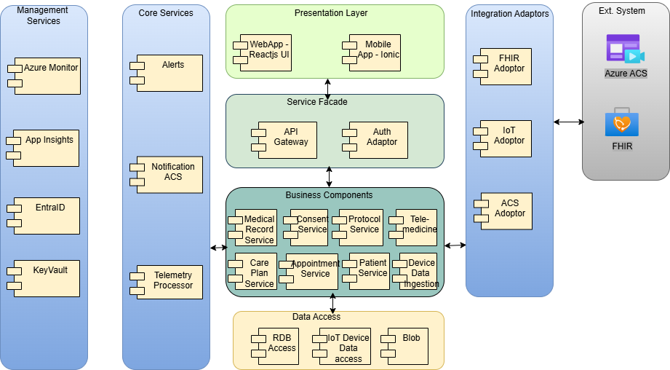
Fig. Implementation View
Each of the layers of the above architecture is explained in more detail:
Presentation Layer
The Presentation Layer consists of Web and Mobile user interfaces built using ReactJS (WebApp) and Ionic (Mobile App). These components enable end-user interaction and provide responsive access to healthcare services such as appointments, teleconsultations, and care plans. The layer handles input capture, UI rendering, and communicates securely with backend APIs.
Services Façade
The Services Façade layer provides a centralized API access point using components such as API Gateway and Authentication Adapter. It is responsible for request routing, token validation (OAuth2/Azure AD), API aggregation, and security enforcement. This layer abstracts backend complexity from clients and standardizes API consumption.
Business Components
The Business Components layer contains core domain microservices. These services implement business logic, domain workflows, and healthcare functionalities, ensuring modularity, scalability, and independent deployment.
Data Access
The Data Access layer provides structured access to underlying data stores using components such as:
  - RDB access (Azure SQL)
  - IoT Device Data access
  - Blob storage
It manages data persistence, retrieval, and abstraction, ensuring optimized access patterns while supporting transactional, telemetry, and unstructured data storage.
Management Services
The Management Services layer includes operational and governance tools. This layer enables monitoring, logging, identity management, and secure configuration handling, ensuring platform reliability, observability, and compliance.
Core Services
The Core Services layer provides shared backend capabilities including:
  - Alert management
  - Notification services (via Azure Communication Services – ACS)
  - Telemetry processing
These services support cross-functional operations like event processing, alert generation, and communication, and are reused across business workflows.
Integration Adapters
The Integration Adapters layer enables communication with external systems using:
  - FHIR Adapter → Clinical data interoperability
  - IoT Adapter → Device telemetry integration
  - ACS Adapter → Notifications and communication
This layer handles protocol transformation, external API integration, and data exchange, ensuring seamless interoperability with external healthcare and IoT ecosystems.
Sequence Diagrams:

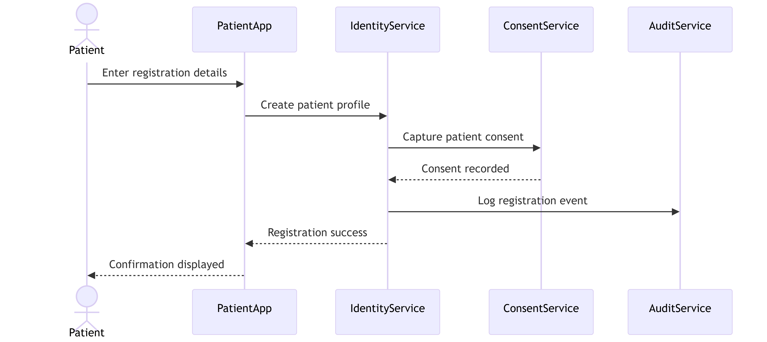
Fig. Patient Registration & Profile Management

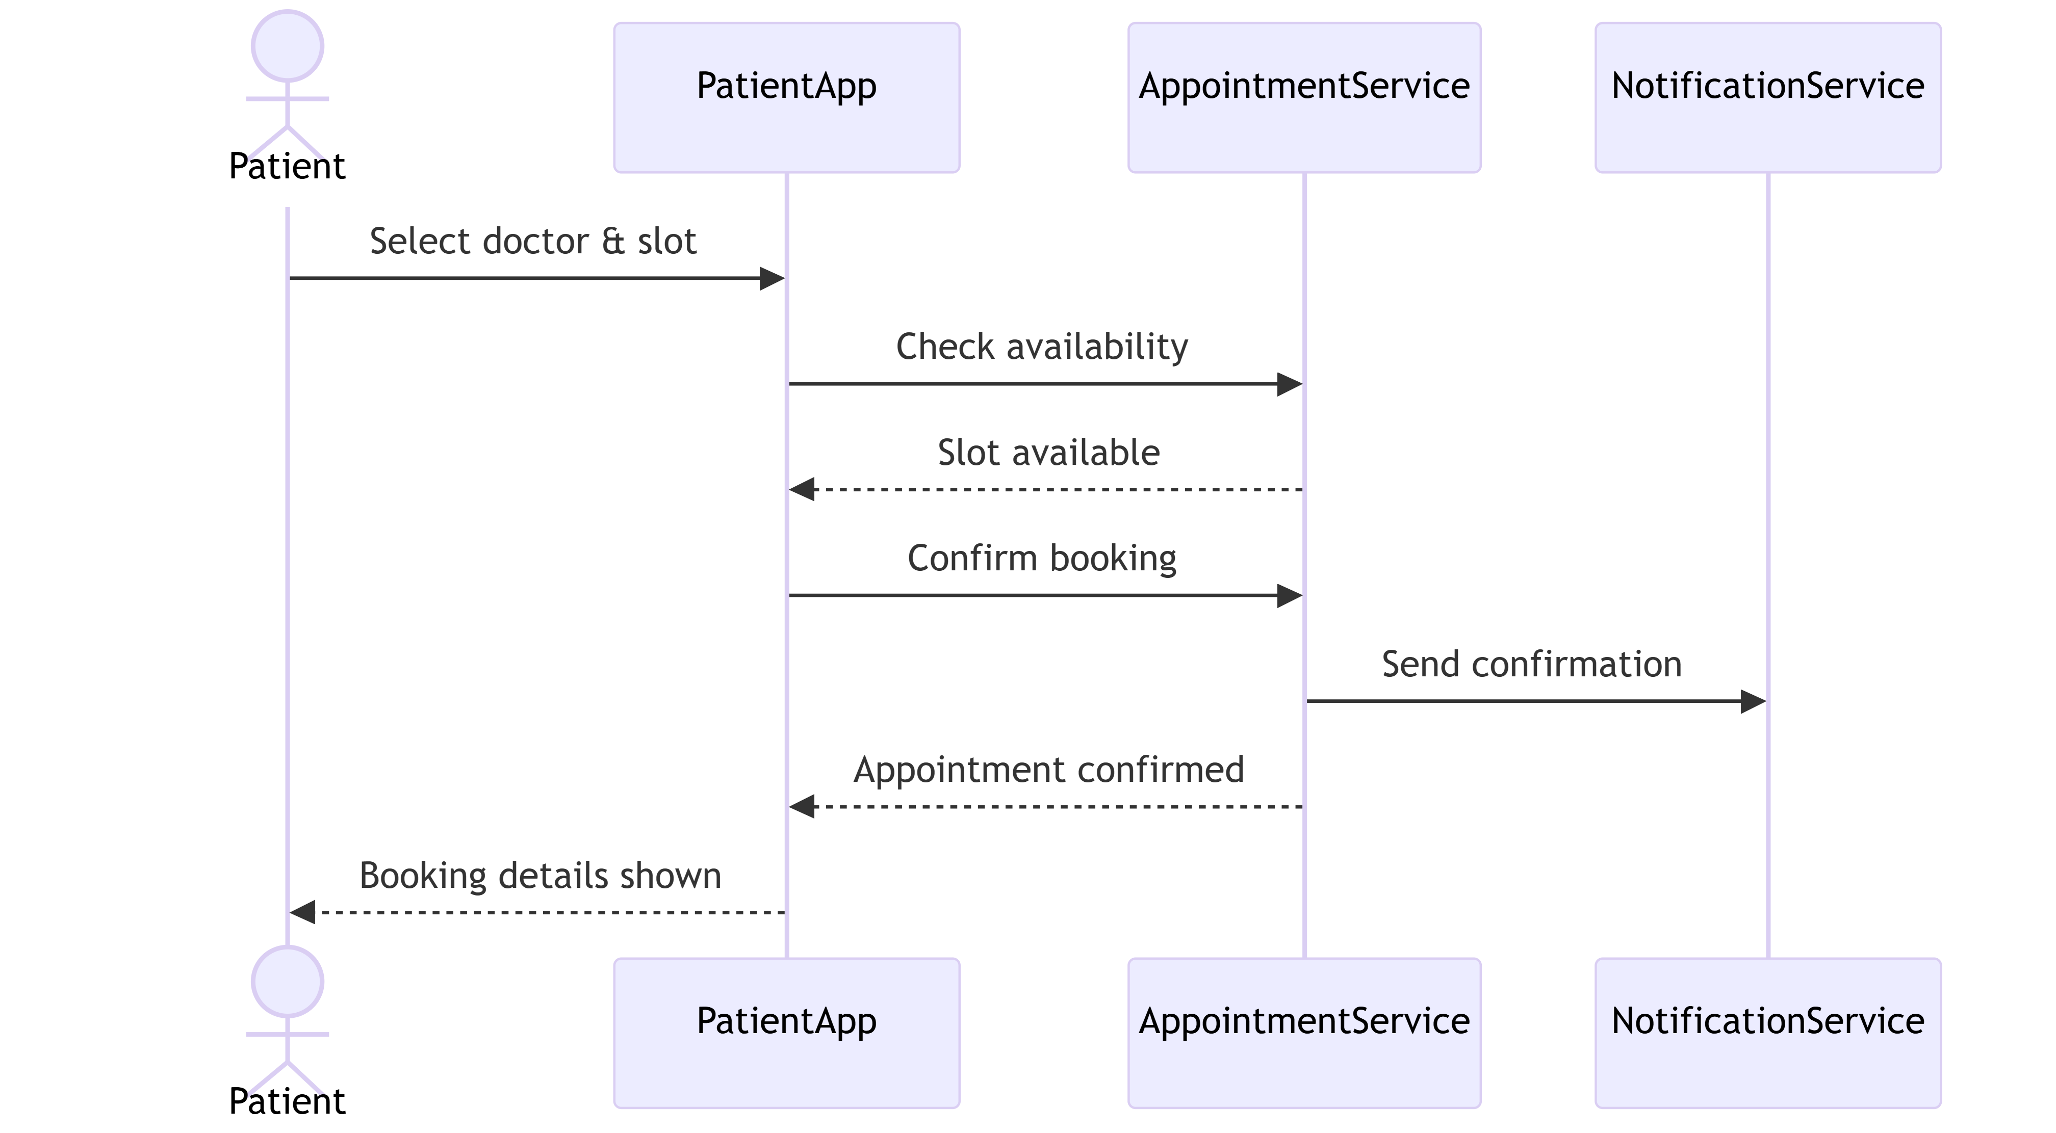
Fig. Patient Journey – Sequence Diagram

    - Data View
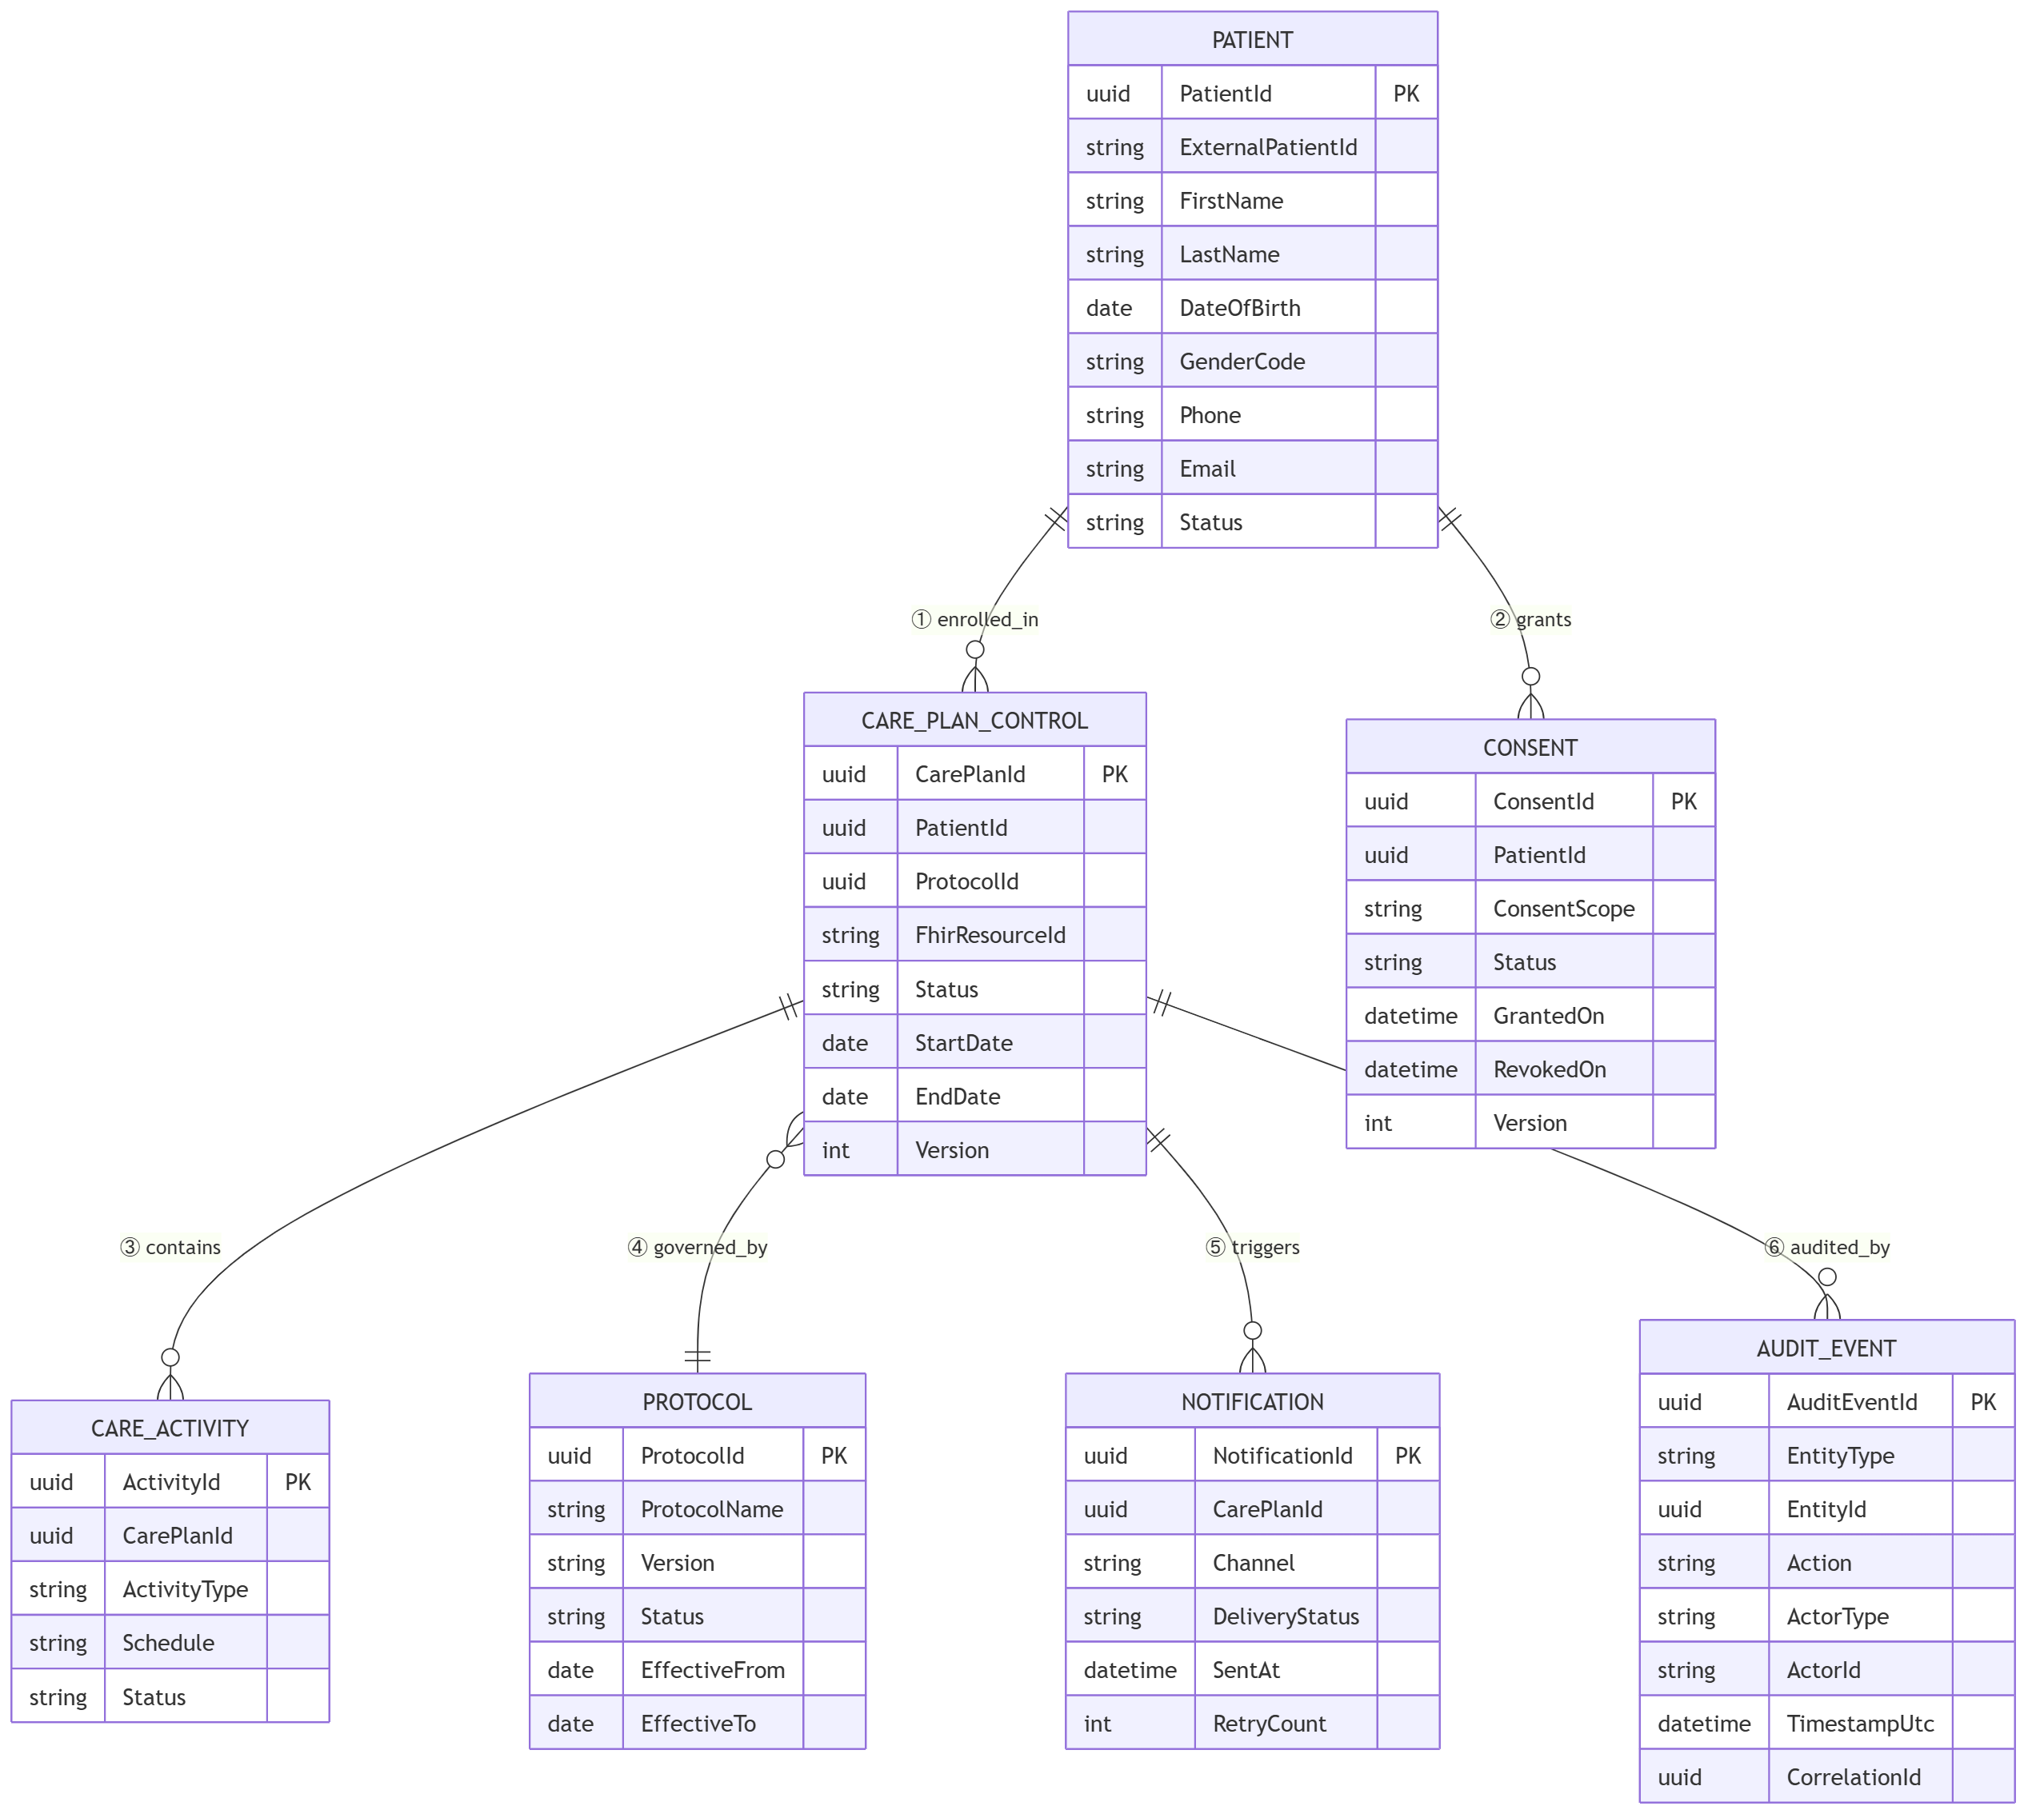
Fig. ER-Diagram

Relationship | Description
Patient → CarePlan | A patient may have multiple care plans
Patient → Consent | Consent is patient-owned and versioned
CarePlan → Activity | Care plan consists of activities
CarePlan → Protocol | Care plan follows one protocol
CarePlan → Notification | Events trigger notifications
Any Entity → Audit | All actions are audit-logged

ER Entity | FHIR Resource
PATIENT | Patient
CONSENT | Consent
CARE_PLAN_CONTROL | CarePlan (control + orchestration)
CARE_ACTIVITY | CarePlan.activity
PROTOCOL | PlanDefinition
AUDIT_EVENT | AuditEvent
NOTIFICATION | Communication (logical mapping)

    - Deployment View
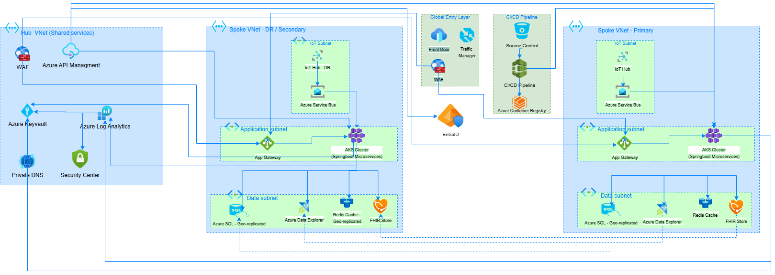
Fig. Deployment View
      - Tiers
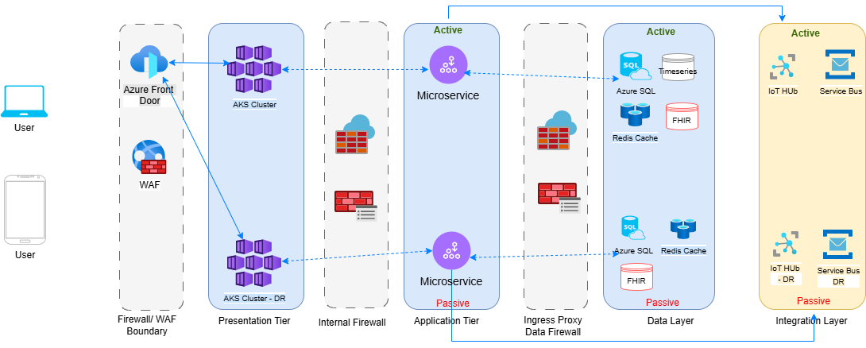
Fig. Deployment View - Tiers
      - Logical Infrastructure
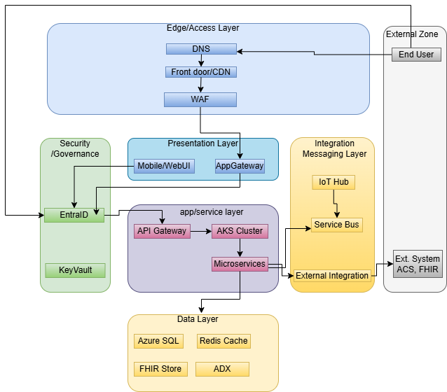
Fig. Logical Infrastructure
      - Physical Infrastructure
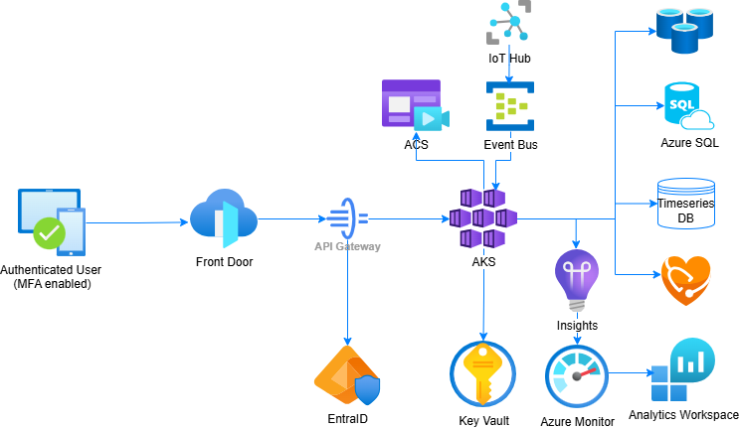
Fig. Physical Infrastructure

      - Product Deployment Model
Fig. Deployment Model
    - Security View
      - Secure Design Considerations
Authentication Design
OAuth2 / OpenID Connect via Azure Entra ID
MFA mandatory for clinicians, admins, and external access
Conditional access (device compliance, geo-restrictions)
Managed Identities (MSI) for service-to-service auth
JWT tokens with short expiry & rotation
Ensures strong identity assurance and Zero Trust access
Authorization & Access Control
RBAC + ABAC with Least Privilege and SoD
Roles: Patient, Clinician, Coordinator, Admin
Fine-grained permissions (read vs modify)
Enforcement at:
- API Gateway (coarse)
- Microservices (fine)
Protection:
- JWT-signed tokens (tamper-proof)
- No client-side trust
- Privilege changes fully audited
Input & Data Validation
Validation at API gateway + application layer
Enforces:
- Data type, format, length
- FHIR/JSON schema compliance
Protects against:
- SQL Injection, XSS, command injection
- Output encoding for UI safety
Data Protection
At Rest: AES-256 encryption
In Transit: TLS 1.2+
In Use: Secure processing (AKS, FHIR)
Data lifecycle controls:
- Retention, anonymization, controlled deletion
- Special protection for PHI / PII
Cryptography & Key Management
AES-256 (storage), RSA-2048+ (exchange), SHA-256 (hashing)
JWT signing for secure transactions
Azure Key Vault:
- Key storage, rotation, RBAC access
- HSM-backed keys
No hardcoded secrets/credentials

Accountability (Audit & Logging)
All actions logged (Create/Read/Update/Delete)
Includes:
- Actor, timestamp, entity, correlation ID
Centralized logging:
- Azure Monitor, Log Analytics, Sentinel
- Append-only, tamper-proof audit logs
Secure Integrations & Communication
External: OAuth2, JWT, mTLS, certificates
Internal: Service Bus, private endpoints
Network controls:
- VNet isolation, IP whitelisting
- All communication is encrypted, authenticated, integrity-protected
Error Handling
No sensitive data in error messages
Standardized responses
Secure exception logging (no PHI exposure)
Fail-secure design
Session Management
Stateless JWT-based sessions
Token expiry + refresh rotation
Protection against:
- Hijacking, replay attacks
- Secure cookies (web) + token-based APIs
Security by Design
Database: Encryption + RBAC, no direct exposure
Config: Secrets in Key Vault only
App Layer: Hardened AKS, container scanning
Network: NSG, private endpoints, WAF, Front Door
Privacy by Design
Data minimization
Consent-driven access
Pseudonymization for analytics
Role-restricted PHI access
Supports compliance via:
- Audit logs
- Retention policies
- Consent validation

      - Infrastructure Design

Refer to the document in the below link: Section 1, 2, 3 for (Azure) & 5 for (AWS)
https://cognizantonline.sharepoint.com/:w:/r/sites/ITEA/Documents/Standards/Onecognizant-%20HLD.doc?d=wb1a21b5b8a2b48dba7ab3ab0a3a26f30&csf=1&web=1&e=5Pvc7s
    - Process View
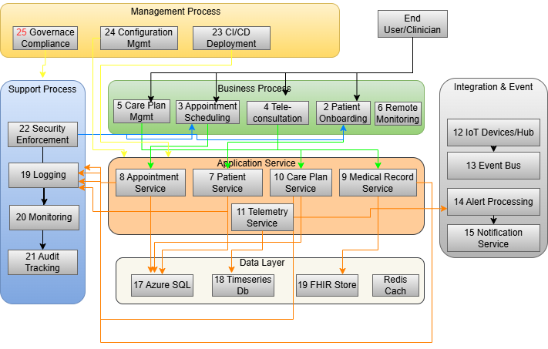
Fig. Process View
1. Management Processes
These provide governance and direction for the platform:
- Governance & Compliance (25) ensures adherence to healthcare regulations and policies.
- Configuration Management (24) controls environment and application settings.
- CI/CD Deployment (23) enables automated, secure, and consistent releases.
These processes govern and control all downstream business and application processes.

2. Business Processes (Core Healthcare Workflows)
These represent mission-critical patient engagement workflows:
- Patient Onboarding (2) – registration and identity setup
- Care Plan Management (5) – creation and lifecycle of care plans
- Appointment Scheduling (3) – booking clinician interactions
- Tele-consultation (4) – virtual care delivery
- Remote Monitoring (6) – continuous health data capture
These processes are clinician- and patient-driven and orchestrate system behavior through structured workflows (Saga-based execution).
3. Application Service Processes
Business processes are executed through domain microservices:
- Patient Service (7) – manages patient data
- Care Plan Service (10) – orchestrates care workflows
- Appointment Service (8) – manages scheduling
- Medical Record Service (9) – handles clinical records
- Telemetry Service (11) – processes remote monitoring data
These services form the execution layer, processing requests and coordinating across subsystems.
4. Integration & Event Processes
External interactions and asynchronous processing are handled via:
- IoT Devices / Hub (12) – collects patient health data
- Event Bus (13) – enables decoupled communication
- Alert Processing (14) – evaluates events for triggers
- Notification Service (15) – delivers alerts and reminders
These processes enable real-time, event-driven engagement.
5. Data Layer Processes
Application services persist and retrieve data from:
- Azure SQL (17) – structured operational data
- Timeseries DB (18) – telemetry / monitoring data
- FHIR Store (19) – clinical healthcare data
- Redis Cache – performance optimization
These ensure data consistency, scalability, and regulatory compliance.
6. Support Processes
These ensure platform stability and operational reliability:
- Security Enforcement (22) – access control and protection
- Logging (19) – system activity tracking
- Monitoring (20) – performance and availability tracking
- Audit Tracking (21) – compliance and traceability
These operate continuously across all layers.
  - System Interfaces
<<Provide details about the technologies/methods that will be used to satisfy the requirements related to external interfaces. TBD
  - Reporting
<<Please provide details as to how reporting requirements will be addressed using the proposed architecture. Also need to mention all details as to how data for reporting will be extracted and maintained in reporting database. Whether there will be separate reporting database or same online database will be used. All critical decisions need to be mentioned here and provide explanation for the same>> TBD
- Prototype Design
Fig. ER-Diagram
Relationship | Meaning
Patient → CarePlan | A patient may have multiple care plans
Patient → Consent | Consent is patient-owned and versioned
CarePlan → Activity | Care plan consists of activities
CarePlan → Protocol | Care plan follows one protocol
CarePlan → Notification | Events trigger notifications
Any Entity → Audit | All actions are audit-logged

ER Entity | FHIR Resource
PATIENT | Patient
CONSENT | Consent
CARE_PLAN_CONTROL | CarePlan (control + orchestration)
CARE_ACTIVITY | CarePlan.activity
PROTOCOL | PlanDefinition
AUDIT_EVENT | AuditEvent
NOTIFICATION | Communication (logical mapping)

Store | Purpose
Service Bus | Event streaming & messaging
IoT Hub | Device ingestion & telemetry intake
Time-Series DB | Store historical telemetry data
    - Wireframe/ Visual Design
- Technology, Tools and Frameworks
- Solution Recommendations
  - Technical recommendations
  - Infrastructure recommendations
- Reference
< In this section references can be provided w.r.t. the requirements and scope documents>
Corporate Security Policy
Enterprise/Corporate Infrastructure/Deployment Architecture
1C Exception Logging Service
- Change Log
Version Number | Changes Made
V1.0.0 | Initial baseline created on 24-05-2026 by Uttam Kumar Bhatia
 | Section No. | Changed By | Effective Date | Changes Effected
 | NA | NA | NA | NA

