Log Parser

Technical Documentation

Version 1.00

Revision History

Date | Version | Description | Author
2018-11-20 | 1.0 | Final | Uttam Kumar Bhatia

Table of Contents
1. Introduction 4
1.1 Purpose of this document 4
1.2 Intended Audience 4
1.3 Scope 4
1.4 Definitions and acronyms 4
1.4.1 Definitions 4
1.4.2 Acronyms and abbreviations 5
2. General overview 5
2.1 Technologies used 5
2.2 General functioning 5
2.3 Error handling & Logging 5
3. Technical requirement 5
3.1 Client requirement 5
3.2 Server Requirement 6
4. LogParser structure 6
5. Architecture 7
5.1 High Level Architecture 7
5.2 Create Json file Sequence Diagram 8
5.3 Chunk & Process Json Data file Sequence Diagram 9
6. References 10

Introduction

Purpose of this document

The purpose of this document is to give technical information about LogParser design and implementation.

Intended Audience

The intended audiences are:
- Supervisors, to analyze the design and implementation of LogParser.
- Future developers to extend or use some ideas of LogParser project.

Scope

This document will describe the design and some technical issues of LogParser project. Further documents could be found on Github.

Definitions and acronyms

Definitions

Keyword | Definitions
Codehaus Jackson API | API provided by codehaus

Acronyms and abbreviations

Acronym or  abbreviation | Definitions
MVC | Model View Controller
UML | Unified Modeling Language

General overview

Technologies used

- Spring boot
- Spring MVC
- Codehaus Jackson API
- Java 8 – Stream/Concurrent APIs
- JSP/Jquery/HTML/CSS
- TDD, Spring Test, Mockito, Hamcrest

General functioning

The following are the major system functionalities:
- Create Json Data file of any size.
- Chunk Large Json Data file into many chunks of small file and concurrently search event id in smaller files.
- Process the created file asynchronous manner.
- View the processed record in Jquery Datatable asynchronously.
- Spinner indicating the ongoing process.

Error Handling & Logging

As the architecture is three tires, exception handling was done on each layer separately. The layer that was faced with an exception, raise a new exception to the upper layer if needed. And logging the exception or some info in log file.

Technical requirement

Client requirement

As LogParser is a problem based solution – processing large json files upto Gigabyte. Have implemented the solution using WebApplication.

Server Requirement

The following technologies are required for LogParser server.

- H2 Database
- Spring boot embedded Tomcat

Java 8 - Stream & Concurrent API

Heavily used the Java 8 stream and Concurrent APIs to make the application faster and efficient to handle large datasets of any Json file as per the given structure in problem statement by Client.

LogParser Source structure

There are four sub-folders inside main. Figure 1 shows the files we had for implementation.
Java resource folder contains java files for implementation of three tier architecture.
Test folder contains Junit test cases which represent TDD approach to product develoment.
Resources folder contains Configuration Management related files- which provide capability of configurability at compile time and runtime as well.
Document folder contains Docs i.e. Technical Specification, User Guide & Developer Guide.

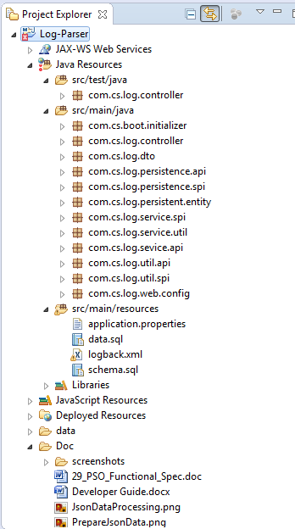
Figure 1: File structure of LogParser. It contains Test folder for TDD, Java folder, resources and Doc for Documentations.

Architecture

Architectural design consisted of high level architecture and detail design including sequence diagrams.

High Level Architecture
Figure 2: High level architecture of LogParser

Create Json file Sequence Diagram
This sequence diagram is depicting all the interactions between the layers that serve the user request.

Figure 3: Create Json Data File Sequence Diagram

Chunk & Process Json Data File Sequence Diagram
This sequence diagram is depicting all the interactions between the layers that serve the user request
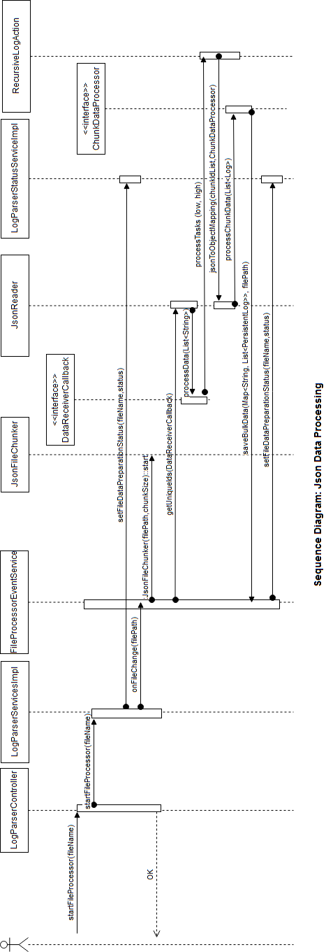
Figure 5: Process Json Data File Sequence Diagram

References

- Spring boot, https://spring.io/projects/spring-boot
- TDD Hamcres, http://hamcrest.org/JavaHamcrest
- Codehaus Jackson, https://github.com/codehaus/jackson
- Mockito Java Test Cases, https://site.mockito.org
- H2 Database, http://www.h2database.com/html/main.html

