Sample Emails content
- These emails are for example/sample purpose only.
- All emails will have header and footer. AFP logo will be placed left-aligned in header. Footer will be replica of the Assessment Tool.
- Any words in between “{“ and “}” will be replaced with the real value. For example, in the first email, “{User’s First Name}” will be replaced with the user’s actual first name.
- The links may not be accurate link.

Invitation code email
When: From admin section of the site, when admin invites a user
To: Actual user.
Subject: AFP Corporate Training Skills Assessment - Invitation Code
Email body:

Dear {User’s First Name},
We would like to invite you to use the AFP Corporate Training Skills Assessment tool.
Please click here to complete your registration using the invitation code listed below. You will be required to set up a profile with a username and password allowing you to use the tool at your convenience.
Invitation code: 899198
Please do not share this code, and use it within thirty days.

If you have any questions, please contact me at rpinover@AFPonline.org or +1 301.961.8884.

Regards,
Robert Pinover
Client Success Specialist
Association for Financial Professionals (AFP)

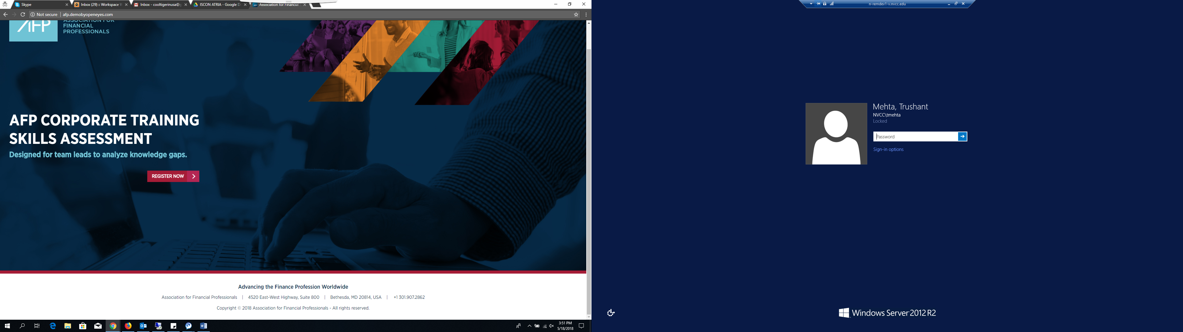

Registration completion email
When: A user complete the registration
Email # 1:
To: Actual user.
Subject: AFP Corporate Training Skills Assessment - Registration
Email body:
Dear {User’s First Name},
You have successfully registered for the AFP Corporate Training Skills Assessment tool. To access your account, please click here.

If you have any questions, please contact me at rpinover@AFPonline.org or +1 301.961.8884.
Regards,
Robert Pinover
Client Success Specialist
Association for Financial Professionals (AFP)

Email # 2:
To: Admin user
Subject: Assessment Tool – {Company} Successful Registration
Email body:

The following person has completed their assessment tool registration:

Company: {Company name}
First name: {User’s First Name}
Last name: {User’s Last Name}
Email: {User’s email address}
Phone: {User’s phone number}

Please click here to visit the user profile.

Forgot password email
When: A user forgot his/her password and use the “Forgot password” link on the login page
Subject: AFP Corporate Training Skills Assessment – Reset Password Request
To: Whoever has requested including Admin, Sales Person and/or actual user.
Email body:
Dear {Actual User’s First Name},
A reset password request has been generated for your AFP assessment tool account.
Please click here to reset your password.
If you made the request by mistake, please ignore this email and your password will not be changed.
If you have any questions, please contact me at rpinover@AFPonline.org or +1 301.961.8884.
Regards,
Robert Pinover
Client Success Specialist
Association for Financial Professionals (AFP)

Change password email
When: A logged in user change the existing password
To: Whoever has requested including Admin, Sales Person and/or actual user.
Subject: AFP Corporate Training Skills Assessment – Password Change

Email body:
Dear {Actual User’s First Name},
Your AFP assessment tool account password has been changed. Click here to access your account.
If you did not request this change, please go to your account and set up a new password for security purposes.

If you have any questions, please contact me at rpinover@AFPonline.org or +1 301.961.8884.
Regards,
Robert Pinover
Client Success Specialist
Association for Financial Professionals (AFP)

Assessment began email
When: A user starts an assessment
To: Admin user
Subject: Assessment Tool – {Company} Started
Email body:

The following person has started an assessment:

Company: {Company name}
First name: {User’s First Name}
Last name: {User’s Last Name}
Email: {User’s email address}
Phone: {User’s phone number}
Assessment name: {Assessment name given by user}
Team Size: {Team size chosen by user}

For more details, click here to go to the admin section of the tool.

Assessment past due
When: An assessment is not completed after certain number of days
Subject: AFP Corporate Training Skills Assessment – Please Complete

Email #1:
To: Actual user
Email body:
Dear {User’s First Name},
We noticed that you have not completed this assessment:.

Assessment name: {Assessment name given by user}
Team Size: {Team size chosen by user}
Assessment started on: {Assessment Start date}
Please click here to accessyour account to complete yourassessment.

If you have any questions, please contact me at rpinover@AFPonline.org or +1 301.961.8884.
Regards,
Robert Pinover
Client Success Specialist
Association for Financial Professionals (AFP)

Email #2:
Subject line – Assessment Tool – {Company} Incomplete Assessment
To: Admin user
Email body:

The following user started an assessment 10 days ago but has not completed it:

Company: {Company name}
First name: {User’s First Name}
Last name: {User’s Last Name}
Email: {User’s email address}
Phone: {User’s phone number}
Assessment name: {Assessment name given by user}
Team Size: {Team size chosen by user}
Assessment started on: {Assessment Start date}

For more details, click here to go to the admin section of the tool.

