A

Project Report On

“Interview.AI”

(CE451 - Software Project Major)

Prepared by
Neel Dudhat (22DCE028)

Under the Supervision of
Prof. Prashant Jadav

Submitted to
Charotar University of Science & Technology (CHARUSAT) for the Partial Fulfillment of the Requirements for the
Degree of Bachelor of Technology (B.Tech.)
in Computer Engineering (CE)
for 8th semester B. Tech

Submitted at

Accredited with Grade A+ by NAAC


DEPARTMENT OF COMPUTER ENGINEERING
Devang Patel Institute of Advance Technology and Research (DEPSTAR) Faculty of Technology & Engineering (FTE), CHARUSAT
At: Changa, Dist: Anand, Pin: 388421.
May, 2026

DECLARATION BY THE CANDIDATE/CANDIDATES

I hereby declare that the project report entitled “Interview preparation system” submitted by us to the Devang Patel Institute of Advanced Technology and Research, Changa, in partial fulfillment of the requirements for the conferment of the degree of B.Tech in Computer Engineering from the Department of Computer Engineering, DEPSTAR-FTE, CHARUSAT, constitutes a record of genuine CE451 Software Project Major (project work) conducted by us under the esteemed guidance of Prof. Prashant Jadav. Furthermore, we affirm that the work executed and documented in this project report has not been submitted elsewhere, either in part or in entirety, and represents original work, intended for the attainment of any other degree or diploma at this institute or any other institution or university.

Neel Dudhat – 22DCE028

Prof. Prashant Jadav

Assistant Professor

Department of Computer Engineering, DEPSTAR-FTE, CHARUSAT-Changa.

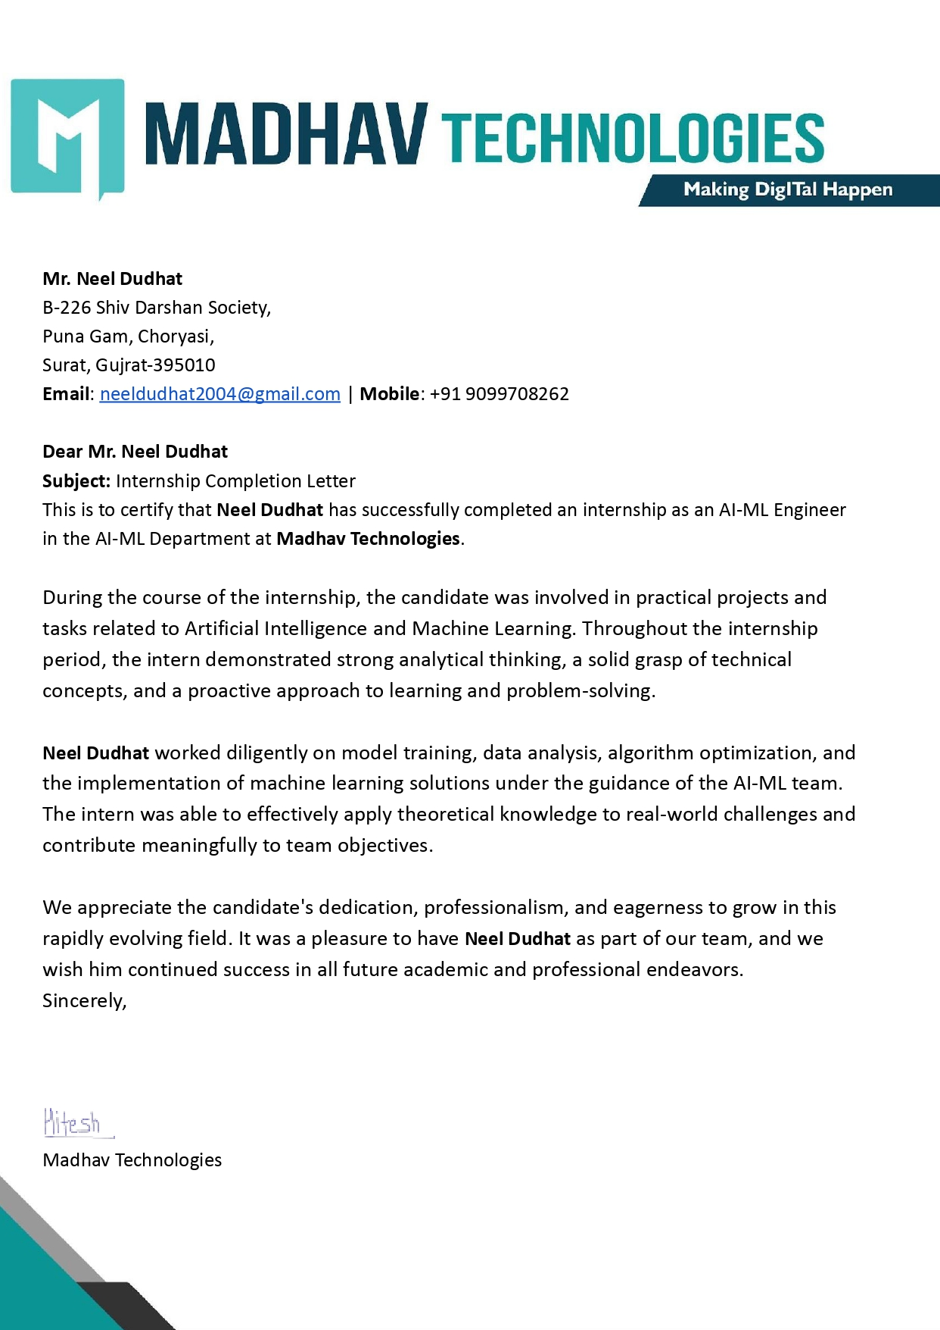


Accredited with Grade A+ by NAAC

CERTIFICATE

This is to certify that the report entitled “Interview Preparation System” is a bonafide work carried out by Neel Dudhat (22DCE028) under the guidance and supervision of Prof. Prashant Jadav & Mr. Hitesh Kachdiya for the subject Software Project Major (CE451) of 8th Semester of Bachelor of Technology in Computer Engineering at Devang Patel Institute of Advance Technology and Research (DEPSTAR), Faculty of Technology & Engineering (FTE) – CHARUSAT, Gujarat.

To the best of my knowledge and belief, this work embodies the work of candidate himself, has duly been completed, and fulfills the requirement of the ordinance relating to the B.Tech. Degree of the University and is up to the standard in respect of content, presentation and language for being referred by the examiner(s).

Under the supervision of,  Prof. Prashant Jadav  Assistant Professor  Department of Computer Engineering. DEPSTAR-FTE, CHARUSAT, Changa, Gujarat | Mr. Hitesh Kachdiya  Senior Software Engineer Madhav Technologies
Dr. Chirag Patel
Head- Department of Computer Engineering
DEPSTAR-FTE,
CHARUSAT, Changa, Gujarat

Devang Patel Institute of Advance Technology and Research

(DEPSTAR)
Faculty of Technology & Engineering (FTE), CHARUSAT
At: Changa, Ta. Petlad, Dist. Anand, Pin:388421. Gujarat.

ABSTRACT

The internship report presents an overview of my internship experience at Madhav Technologies. The primary objectives of the internship were to gain practical knowledge in JavaScript, Next JS, Sequelize, AI and PostgreSQL and develop essential skills for professional growth.
Throughout the internship, activities included conducting research, collaborating with team members on various projects, attending meetings and training sessions, and contributing to the development of specific initiatives. The report highlights the insights gained, challenges encountered, and the value of the internship experience in enhancing my understanding of the industry.

PRJ2025CE106 ACKNOWLEDGEMENT

ACKNOWLEDGEMENT

I am privileged to have this opportunity to express my heartfelt gratitude and acknowledge the never-ending support and valuable contributions of everyone involved in my development project.
First and foremost, I would like to express my sincere gratitude to my counselor, Prof. Prashant Jadav. Their continuous support, patience, motivation, and immense knowledge have been instrumental in shaping my project study and driving my research forward.
I extend my sincere thanks to HOD Dr. Chirag Patel for providing me with the opportunity to work on a summer internship and present the same.
I would also like to thank Mr. Hitesh Kachdiya (CO-Founder) for their complete support during the time period of my Internship and for assisting me whenever I encountered challenges. Their guidance has been invaluable.
Once again, I extend my deepest appreciation to everyone involved, and I am truly privileged to have had the opportunity to work with such a remarkable and supportive team.

TABLE OF CONTENTS

Sr No. | Index | Page No.
I | Abstract | V
II | Acknowledgement | VII
III | Table of Contents | VIII
IV | List of Figures | X
Chapter 1 | Introduction | 1
1.1 | Project Overview | 1
1.2 | Objectives | 2
1.3 | Scope | 3
1.4 | Tools & Technologies | 4
Chapter 2 | Project Management | 5
2.1 | Project Planning | 5
 | 2.1.1 Project development approach | 7
Chapter 3 | System Requirements Study | 8
3.1 | User Characteristics | 8
3.2 | Hardware & Software Requirements | 10
 | 3.2.1 Hardware Requirements | 10
 | 3.2.2 Software Requirements | 10
3.3 | Assumptions & Constraints | 11
 | 3.3.1 Assumptions | 11
 | 3.3.2 Constraints | 12
Chapter 4 | System Analysis | 13
4.1 | Study of Existing System | 13
4.2 | Limitations of Existing System | 14
4.3 | Requirements of Proposed System | 15
 | 4.3.1 Functional Requirements | 15
 | 4.3.2 Non-Functional Requirements | 16
4.4 | Feasibility Study | 17
 | 4.4.1 Does the system contribute to the overall  objectives of the organization? | 17
 | 4.4.2 Can the system be implemented using the current  technology and within constraints? | 17
 | 4.4.3 Can the system be integrated with other systems  which are already in place? | 17
4.5 | Activity/Process in New System | 18
4.6 | Features of New System | 19
4.7 | Use Case Diagram | 20

4.8 | Class Diagram | 21
4.9 | Sequence Diagram | 22
Chapter 5 | System Design | 23
5.1 | Screen Layout | 23
Chapter 6 | Future Enhancements | 32
6.1 | Future Enhancement | 32
Chapter 7 | Testing | 33
Chapter 8 | Conclusion And Discussion | 38
8.1 | Self Analysis of Project Viabilities | 38
8.2 | Problem Encountered and Possible Solutions | 39
8.3 | Summary of Project Work | 39
 | Bibliography | 40

LIST OF FIGURES

No. | Fig No. | Figure Name | Page
1 | 4.7 | Use Case Diagram | 20
2 | 4.8 | Class Diagram | 21
3 | 4.9 | Sequence Diagram | 22
4 | 5.1 | Home Page | 23
5 | 5.2 | Sign Up Page | 24
6 | 5.3 | Sign In Page (Admin) | 24
7 | 5.4 | Add Category Page | 25
8 | 5.5 | View Categories Page | 25
9 | 5.6 | Add Sub-category Page | 26
10 | 5.7 | View Sub-categories Page | 26
11 | 5.8 | Add Question Page | 27
12 | 5.9 | View Questions Page | 27
13 | 5.10 | Phase no: 1 | 28
14 | 5.11 | Phase no: 1 | 28
15 | 5.12 | Phase no: 1 | 29
16 | 5.13 | Phase no: 2 | 29
17 | 5.14 | Phase no: 2 | 30
18 | 5.15 | Phase no: 2 | 30
19 | 5.16 | Phase no: 2 | 31
20 | 5.17 | Phase no: 2 | 31

CHAPTER 1: INTRODUCTION

PROJECT OVERVIEW

Interview.AI is a responsive web application designed to help users practice interview skills and receive AI-powered feedback. The platform includes an admin panel for managing interview questions and categories, and a user panel for practicing interviews with real-time AI feedback. The system leverages modern web technologies to provide an intuitive, secure, and efficient interview practice experience.

The application was developed during an internship where full-stack development skills were applied to create a complete end-to-end solution. By combining cutting-edge technologies with practical interview preparation needs, Interview.AI addresses the common challenges faced by job seekers who want to improve their interview performance through guided practice and personalized feedback.

The project utilizes Next.js for the frontend, Express.js for the backend, PostgreSQL for database management, and integrates the Gemini 1.5 Flash API for AI-powered feedback generation. This technology stack enables the system to provide responsive interfaces, secure data management, and intelligent response analysis that helps users refine their interview skills effectively.

OBJECTIVES

The primary objectives of the Interview.AI project were to:

    - Develop a Comprehensive Interview Practice Platform: Create a full-featured application that allows users to practice interviews in various categories and receive intelligent feedback.
    - Implement AI-Powered Feedback: Integrate the Gemini 1.5 Flash model to provide real-time, context-aware feedback on user responses.
    - Support Multiple Input Methods: Enable users to input responses via text or voice, enhancing the realism of the practice experience.
    - Create a Robust Admin System: Develop an admin panel for managing categories, subcategories, and questions, with comprehensive CRUD operations.
    - Establish Secure Authentication: Implement JWT-based authentication with role-based access control to protect user data and system resources.
    - Enable Content Extraction: Build a pipeline for generating questions from various document formats (PDF, DOCX, CSV) and web URLs.
    - Ensure Scalability and Maintainability: Design the system architecture to support future enhancements and scale efficiently as user numbers grow.
    - Develop Technical Skills: Gain hands-on experience with modern web development technologies and best practices in a production environment.

SCOPE

The scope of the Interview.AI project encompasses:

- Authentication System: Secure login and registration with JWT-based authentication
- Admin Panel: Management of categories, subcategories, and questions
- User Panel: Interface for practicing interviews with text/voice input options
- AI Integration: Gemini 1.5 Flash model for real-time feedback on user responses
- Content Extraction: Pipeline for generating questions from PDF, DOCX, CSV files and web URLs
- Deployment: Full-stack deployment on cloud platforms (Vercel, Render, AWS RDS)

The system is designed to be scalable, allowing for future enhancements and additional features as needed. It provides a comprehensive solution for interview preparation, with features catering to both administrators managing content and users practicing interviews.

TOOLS & TECHNOLOGIES

The Interview.AI project utilizes a modern technology stack to ensure robust performance, scalability, and maintainability:

Frontend

- Next.js: React framework for building user interfaces
- TailwindCSS: Utility-first CSS framework for styling
- Redux: State management library
- Formik & Yup: Form handling and validation

Backend

- Express.js: Web application framework for Node.js
- Sequelize: ORM for PostgreSQL database
- JWT: Authentication mechanism

Database

- PostgreSQL: Relational database hosted on AWS RDS

AI/ML

- Gemini 1.5 Flash API: For AI-powered feedback and suggestions

Development Tools

- VS Code: Code editor
- Git: Version control

Deployment

- Vercel: Frontend hosting
- Render: Backend hosting
- AWS RDS: Database hosting

CHAPTER 2: PROJECT MANAGEMENT

PROJECT PLANNING
The Interview.AI project followed an agile development methodology, with work organized into weekly sprints. Each sprint focused on specific features or system components, with regular review sessions and adjustments based on feedback.

The project timeline covered approximately 3 months (January-March 2026), structured across the following phases:

- Preliminary Training & Environment Setup (January 2026)

  - JavaScript fundamentals
  - Development environment configuration
  - Technology stack familiarization

- Authentication Framework & Core Architecture (January - February 2026)

  - Authentication system implementation
  - Role-based access control development
  - Basic interface implementation

- Administrative Interface Development (February - March 2026)

  - Category and subcategory management implementation
  - Question management interface development
  - Data validation and CRUD operations implementation

- User Interface & AI Integration (March 2026)

  - User experience development
  - Gemini API integration
  - Voice input capability implementation
  - Response assessment system development

- Validation & Deployment (Late March 2026)

  - Comprehensive system testing
  - Performance optimization
  - Production environment deployment

This phased approach enabled incremental development and continuous validation of system components.

PROJECT DEVELOPMENT APPROACH

The project implemented an Agile development approach, emphasizing:

      - Iterative Implementation: Features developed incrementally through weekly sprint cycles
      - Continuous Feedback: Weekly progress reviews and supervisor consultations ensured alignment with requirements
      - Component-Based Architecture: Modules developed independently to enhance maintainability
      - Continuous Integration: Regular incorporation of new features into the primary codebase
      - Technical Documentation: Ongoing documentation of code, APIs, and system functionality

The Agile methodology proved effective for this initiative, providing flexibility to address emerging requirements and ensuring the final solution met user expectations.

CHAPTER 3: SYSTEM REQUIREMENTS STUDY

USER CHARACTERISTICS

Administrative Users (Admins) Target Users:
  - Hiring Managers
  - Career Coaches
  - Platform Moderators
  - Corporate HR Teams

Characteristics:

  - Technical Proficiency: Moderate to advanced (comfortable with dashboards, bulk uploads, and analytics).
  - Goals: Manage content, track user engagement, and ensure question quality.

Behaviour:
    - Prefer structured workflows (e.g., categorizing questions by job roles).
    - Need granular control (CRUD operations for questions/categories).
    - Require real-time system analytics (usage metrics, feedback trends).
  - Constraints: Time-sensitive tasks; minimal tolerance for UI complexity.

Standard Users (Job Seekers) Target Users:
  - Students (fresh graduates)
  - Early-career professionals
  - Career changers
  - Immigrants preparing for local job markets

Characteristics:

  - Technical Proficiency: Basic to intermediate (may need guidance for voice input/AI features).
  - Goals: Practice interviews, receive actionable feedback, and build confidence.

Behaviour:
    - Prefer quick setup and intuitive navigation.
    - Engage in short, focused sessions (15–30 mins).
    - Value multi-modal input (text/voice) and personalized feedback.

Constraints:
    - Interview anxiety (need encouraging UI).
    - Variable hardware (e.g., microphone quality).
    - Limited patience for slow load times.

HARDWARE& SOFTWARE REQUIREMENTS

PHYSICAL EQUIPMENT NEEDS

Server Infrastructure:

      - Processing: Modern multi-core processor
      - Memory: 8GB minimum (16GB recommended)
      - Storage: 256GB SSD or higher
      - Network: High-bandwidth internet connection

Client Requirements:

      - Processing: Intel i5 or equivalent
      - Memory: 8GB or higher
      - Storage: 50MB available space for web application
      - Audio input (microphone) for speech recognition

SOFTWARE ENVIRONMENT NEEDS

Development Environment:

      - Operating System: Windows, macOS, or Linux
      - Code Editor: VS Code
      - Version Control: Git repository

ASSUMPTIONS & CONSTRAINTS

Assumptions

System Functionality

  - Admin will manage categories, subcategories, and questions.
  - Users will submit answers via text or voice input for AI feedback.
  - Gemini API will provide real-time, context-aware suggestions.
  - The system will be hosted on Vercel (Frontend), Render (Backend), and AWS RDS (Database).
  - All modules (authentication, document parsing, AI feedback) are tested before deployment.
  - The frontend will be responsive and compatible with modern browsers (Chrome, Firefox, Edge, Safari).

User Interaction

  - Users will provide valid text/voice inputs for AI analysis.
  - Uploaded documents (PDF, DOCX, CSV) will be in the correct format.
  - JWT authentication will securely manage user sessions.

Technical Infrastructure

  - AWS RDS (PostgreSQL) will handle database operations without downtime.
  - Render’s backend hosting will support API request loads.
  - Vercel will ensure fast frontend performance.

Constraints

Development Constraints

  - No third-party UI frameworks—TailwindCSS is used for styling, but no Bootstrap/React.
  - Backend is built with Express.js (Node.js)—no Django, Laravel, or Spring Boot.
  - Database is strictly PostgreSQL—no MongoDB or Firebase integration.

Security & Performance

  - Data is not end-to-end encrypted (only basic JWT authentication).
  - AI feedback depends on Gemini API availability (subject to rate limits).

Performance relies on AWS RDS and Render’s free-tier limitations.
  - No offline mode—internet connectivity is required for all features.

Functional Limits

  - Role-based access control (Admin/User)—no multi-level permissions.
  - File uploads have size restrictions (PDF/DOCX/CSV ≤ 10MB).
  - Voice input works only on supported browsers (Chrome, Firefox).

CHAPTER 4: SYSTEM ANALYSIS

STUDY OF EXISTING SYSTEMS

The current system is designed as a responsive web application with both admin and user panels that facilitate interview preparation through AI-powered feedback.

The system currently has:

- A frontend built with Next.js and TailwindCSS
- A backend using Express.js with PostgreSQL database and Sequelize ORM
- JWT authentication for secure user login and registration
- Role-based access control separating admin and user functionalities
- An admin panel for managing categories, subcategories, and questions
- A user panel allowing users to practice interview questions and receive AI-powered feedback
- Integration with the Gemini 1.5 Flash API for providing intelligent feedback on user responses
- Content extraction from various file formats (PDF, DOCX, CSV) and web URLs
- Deployment on Vercel (frontend), Render (backend), and AWS RDS (database)

LIMITATIONS OF EXISTING SYSTEMS

While the system appears well-developed, several potential weaknesses can be identified:

- Limited Scalability: The current implementation may face challenges handling large numbers of concurrent users without performance degradation.
- Security Vulnerabilities: While JWT authentication is implemented, there might be potential issues related to token refresh mechanisms and session persistence.
- Limited Offline Functionality: The application appears to require constant internet connectivity for API requests, particularly for the Gemini API integration.
- UI/UX Limitations: Some UI optimizations and styling refinements were mentioned as pending in weekly reports, suggesting the interface may not be fully polished.
- Content Extraction Challenges: The document parsing system might struggle with complex document formats or poorly structured content.
- Feedback Accuracy Limitations: AI-powered suggestions might not always be accurate or contextually appropriate for specialized technical interviews.
- Limited Customization: The current system doesn't appear to allow users to customize their learning experience based on their skill level or industry focus.

REQUIREMENTS OF PROPOSED SYSTEM

FUNCTIONAL REQUIREMENTS

User Management

  - User registration and authentication using JWT
  - Role-based access control (admin vs. regular users)
  - User profile management and customization

Admin Panel Functionality

  - Create and read categories and subcategories
  - Manage interview questions for different categories
  - View user analytics and system usage statistics
  - Content moderation and quality control

Content Management

  - Import questions from various file formats (PDF, DOCX, CSV)
  - Extract content from web URLs for question generation
  - Organize questions hierarchically by categories and subcategories

User Panel Functionality

  - Browse categories and select interview topics
  - Practice answering interview questions in text format
  - Submit answers via voice input with transcription
  - Receive AI-powered feedback and improvement suggestions
  - Track progress and performance metrics

AI Integration

  - Generate contextually relevant interview questions based on uploaded content
  - Provide real-time feedback on user responses using Gemini API
  - Offer personalized improvement suggestions for each answer
  - Adapt difficulty based on user performance

NON-FUNCTIONAL REQUIREMENTS

Performance

  - The system should handle at least 100 concurrent users without degradation
  - Response time for regular operations should be under 2 seconds
  - AI feedback generation should complete within 5 seconds

Security

  - Secure authentication with proper token management
  - Data encryption for sensitive information
  - Protection against common web vulnerabilities (XSS, CSRF, SQL injection)

Usability

  - Clear navigation and user flow
  - Intuitive and responsive UI across devices (desktop, tablet, mobile)

Reliability

  - System uptime of at least 99.5%
  - Graceful degradation when external services are unavailable

Scalability

  - Horizontal scaling capability for increased user load
  - Database optimization for growing data volumes
  - Caching mechanisms for frequently accessed content

Maintainability

  - Well-documented code following industry standards
  - Modular architecture for easy updates and extensions
  - Comprehensive logging and monitoring
  - Automated testing for critical components

  - Feasibility Study

Does the system contribute to the overall objectives of the organization?
YES

Can the system be implemented using the current technology and within the given cost and schedule constraints?
YES

Can the system be integrated with other systems which are already in place?
YES

  - Activity/Process in New System

User Registration & Authentication

  - Register account with required details
  - Login with credentials
  - Access features based on role permissions

Admin Operations

  - Manage categories and subcategories
  - Create and organize interview questions
  - Monitor user activities and system usage

User Interview Practice

  - Select category/topic of interest
  - View and answer interview questions
  - Submit responses via text or voice input
  - Receive AI-powered feedback
  - Track progress and improvement

Content Management

  - Upload documents for question generation
  - Extract content from files or URLs
  - Organize content into structured categories
  - Update or modify existing content

  - Features of New System

AI-Powered Feedback System

  - Real-time analysis of user responses
  - Personalized improvement suggestions
  - Context-aware feedback based on question type

Multi-Format Content Support

  - PDF, DOCX, CSV file processing
  - Web URL content extraction
  - Optimized parsing for question generation

Voice Input Capability

  - Speech-to-text conversion
  - Natural language processing
  - Practice speaking interview responses

Role-Based Access Control

  - Admin panel with complete management capabilities
  - User panel with practice and tracking features
  - Secure authentication with JWT

Responsive UI Design

  - TailwindCSS implementation
  - Mobile-friendly interface
  - Intuitive navigation and user experience

Secure Data Management

  - PostgreSQL database with Sequelize ORM
  - AWS RDS hosting for reliability
  - Data encryption and secure access

  - Use Case Diagram
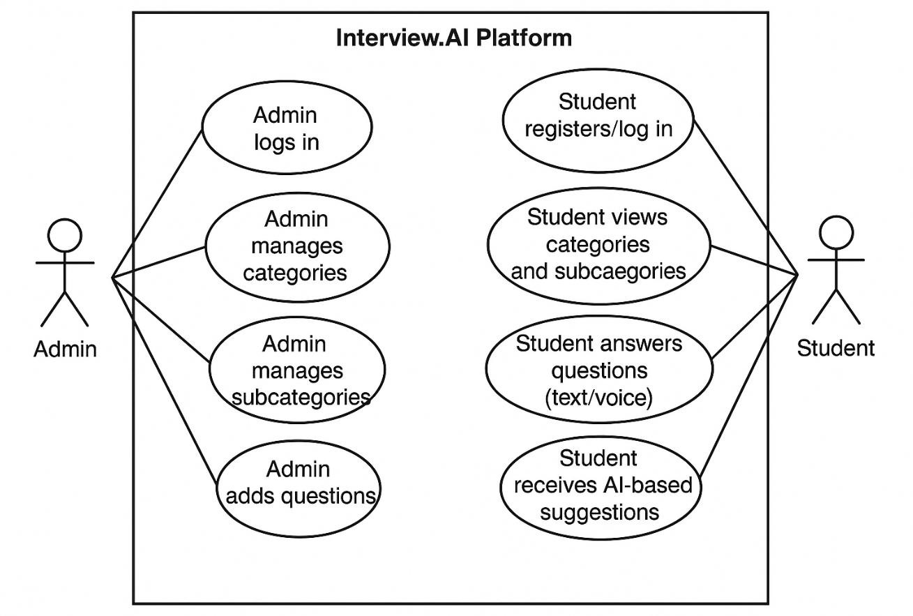

  - Class Diagram
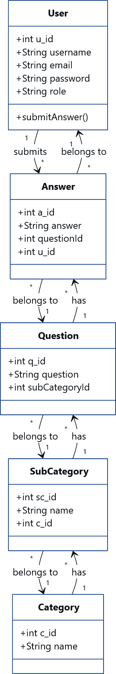

  - Sequence Diagram
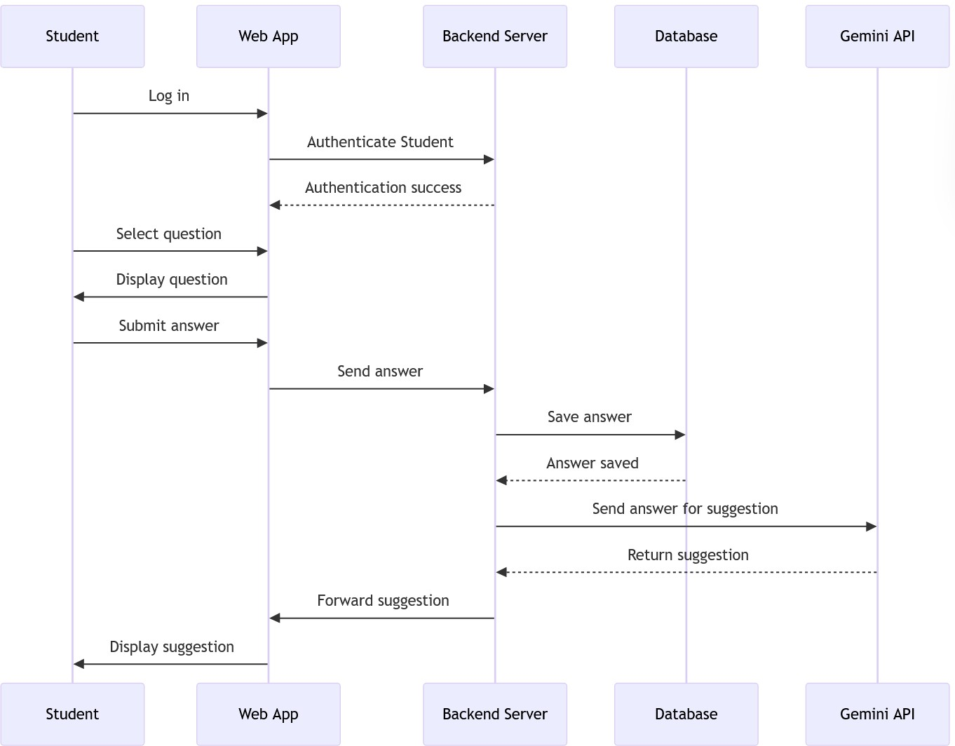

CHAPTER 5 : SYSTEM DIAGRAM

SCREEN LAYOUT
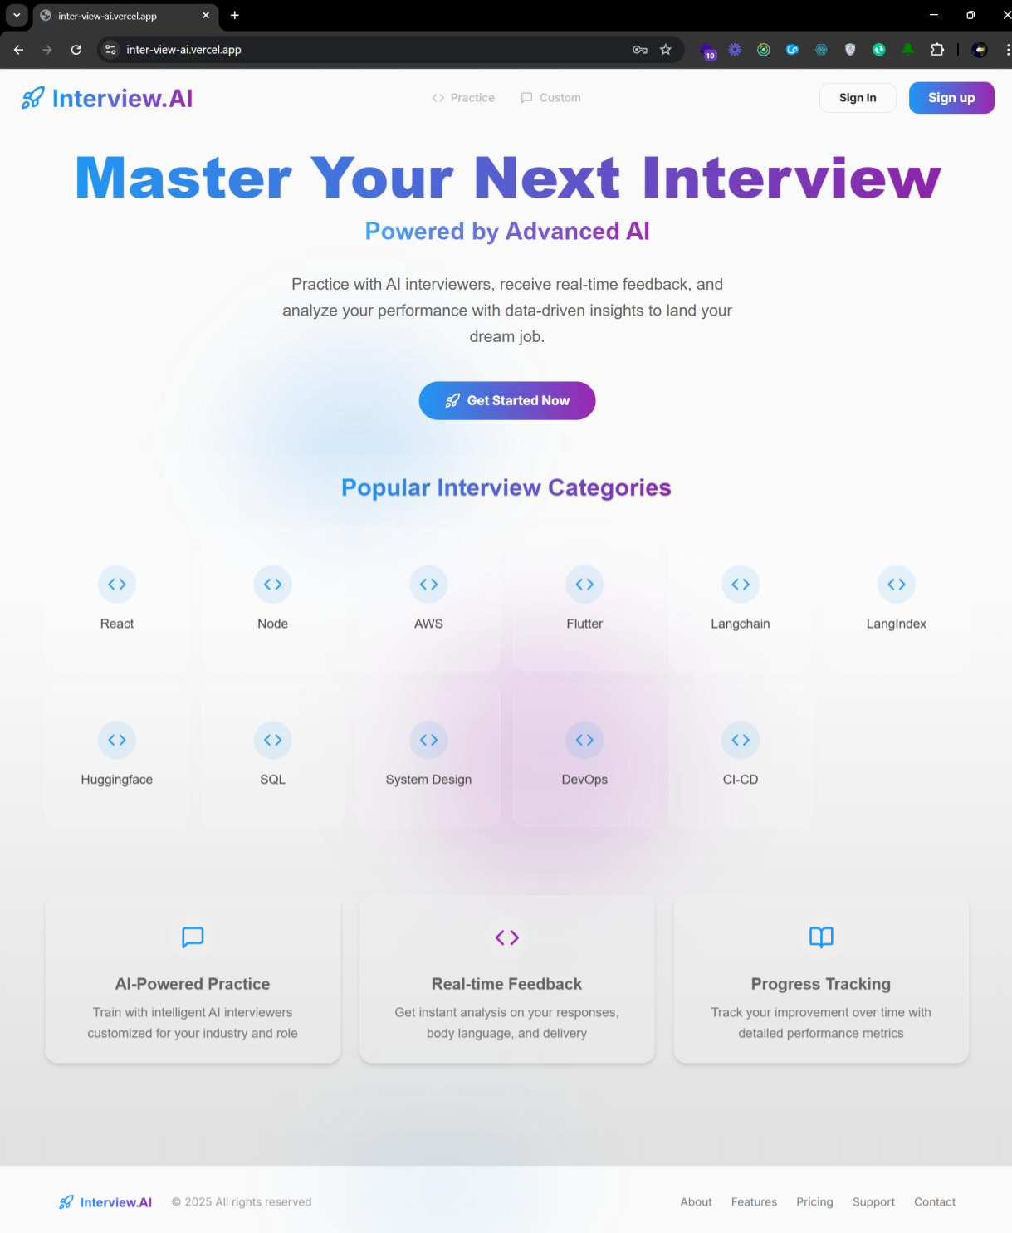
Fig 5.1: Home Page


Fig 5.2: Sign Up Page


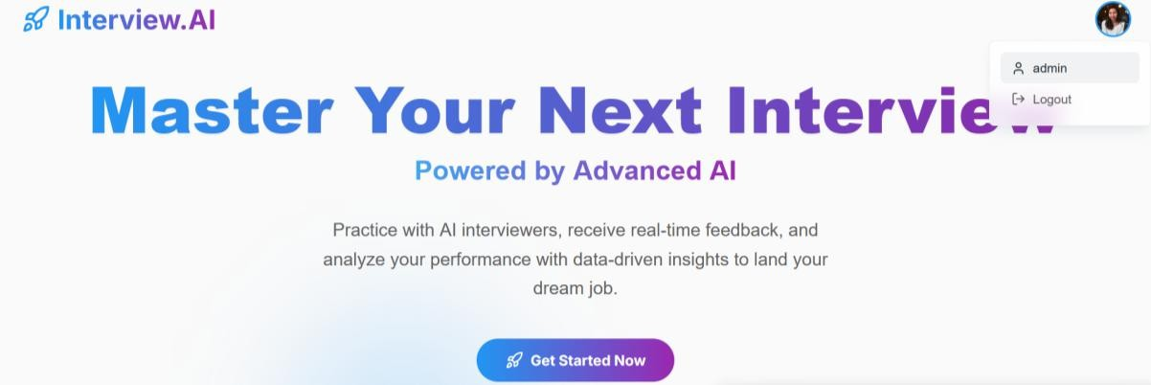

Fig 5.3 Sign In Page (Admin)

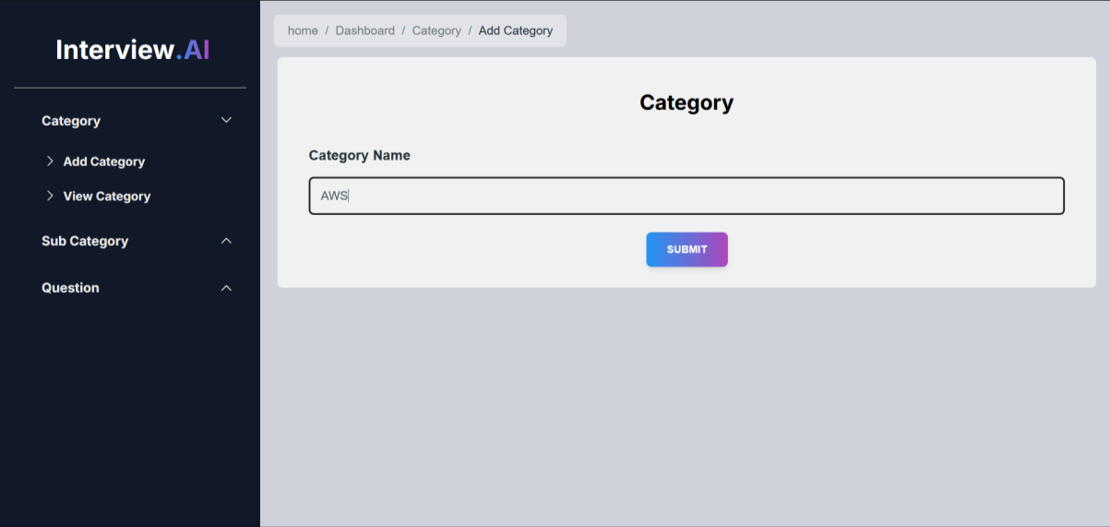
Fig 5.4 Add Category Page
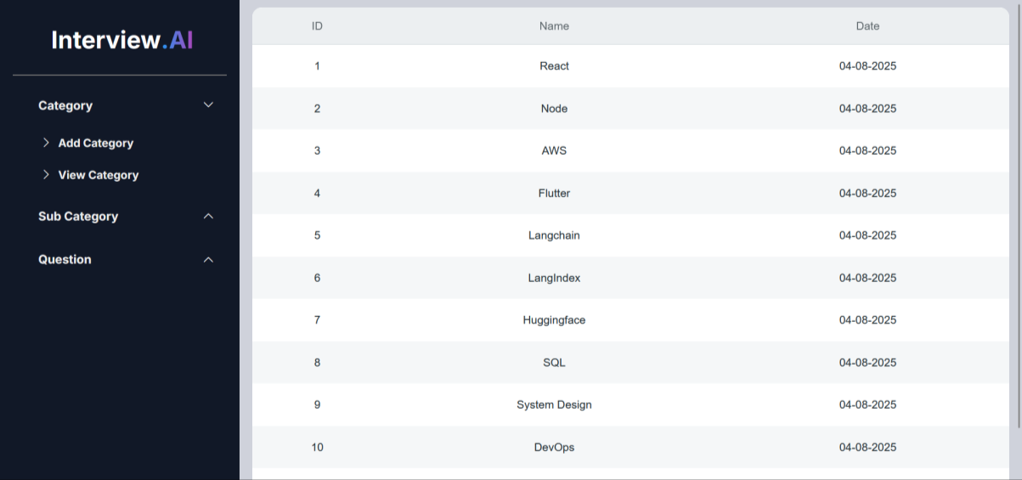
Fig 5.5 View Categories Page

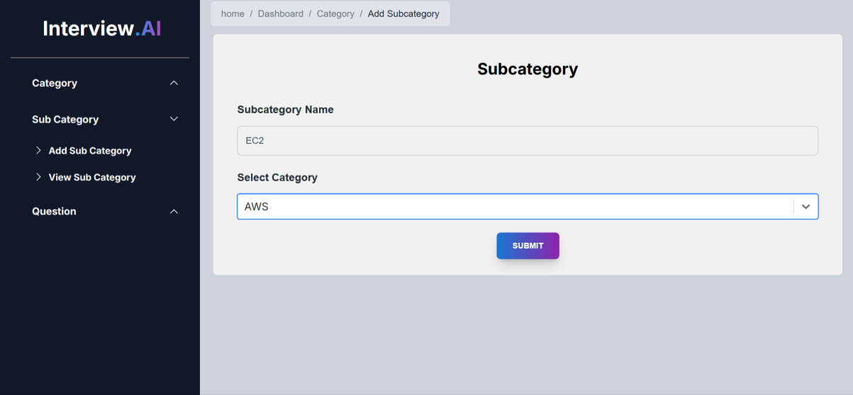
Fig 5.6 Add Sub-category Page

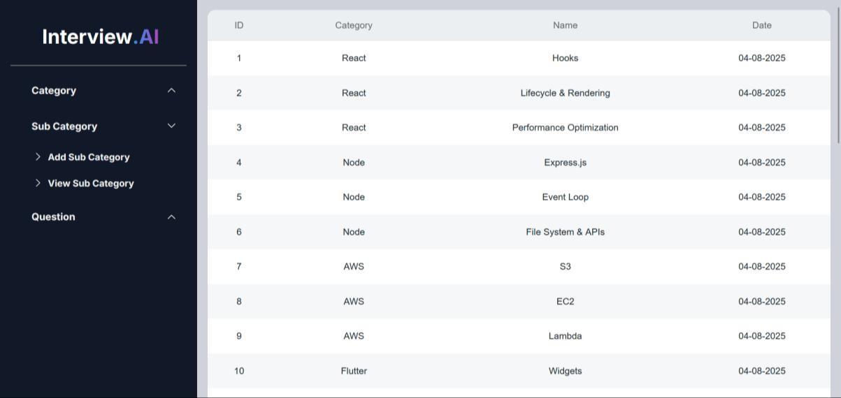
Fig 5.7 View Sub- categories Page

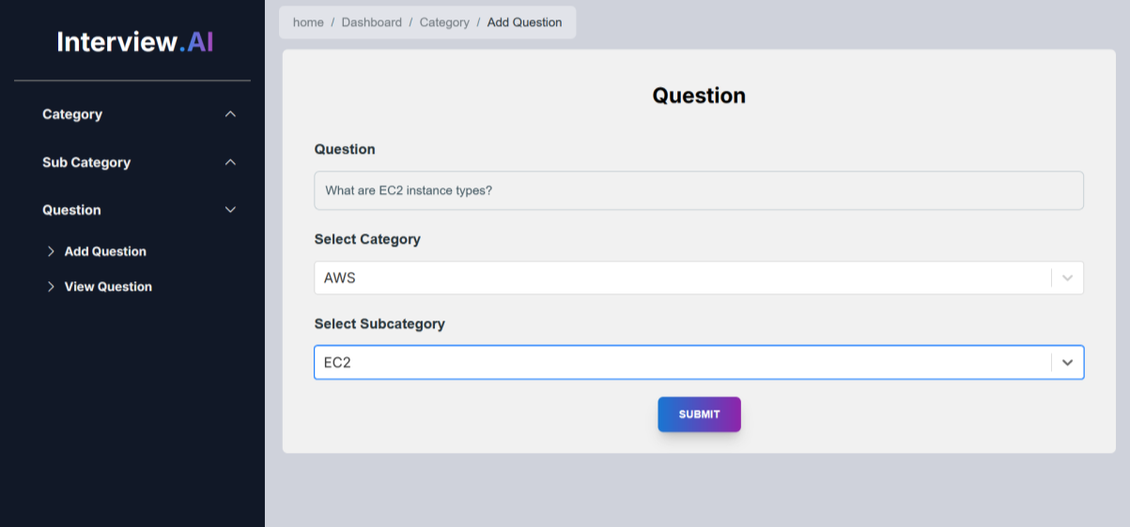
Fig 5.8 Add Question Page

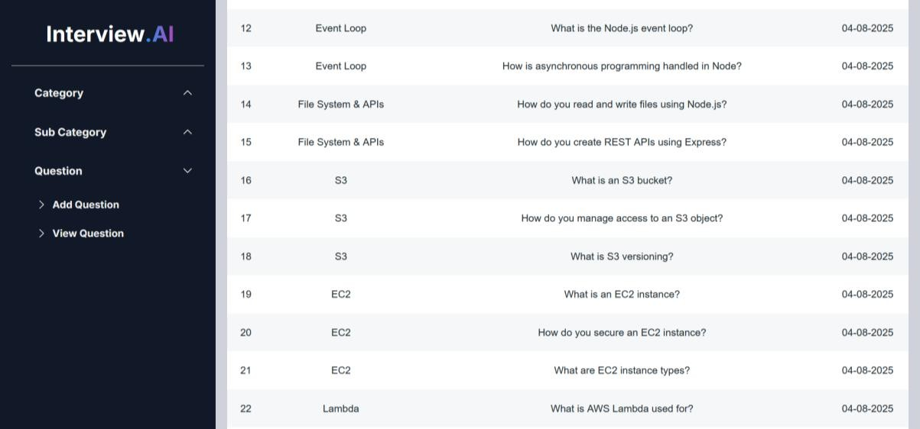
Fig 5.9 View Questions Page

Phase No: 1 (Admin-Generated Questions)

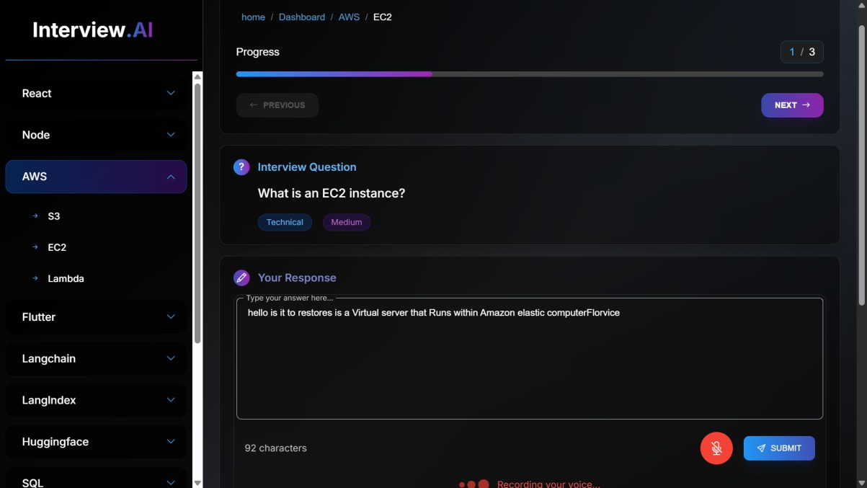
Fig 5.10 Phase no: 1

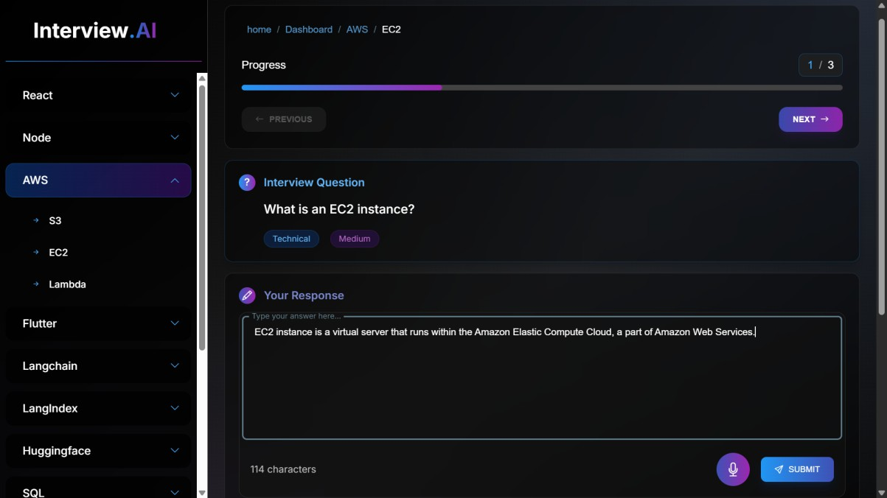
Fig 5.11 Phase no: 1

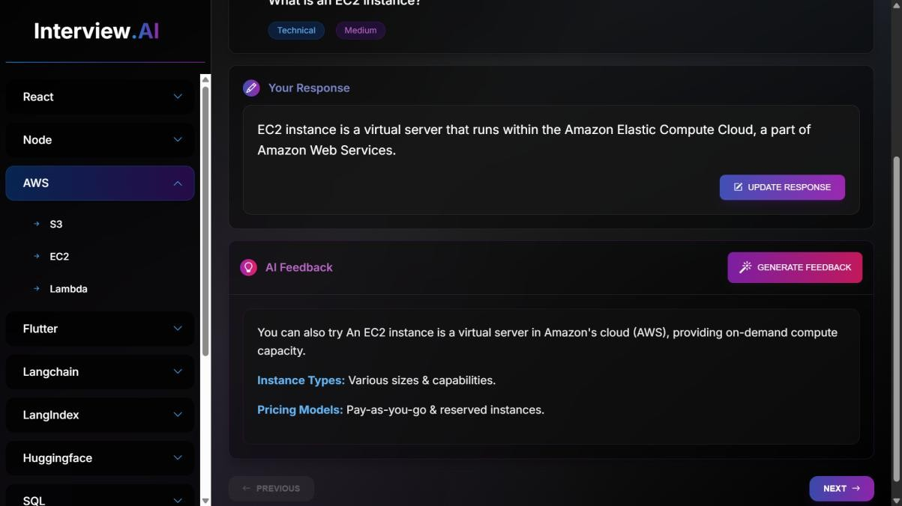
Fig 5.12 Phase no: 1

Phase No: 2 (User-Generated Questions)

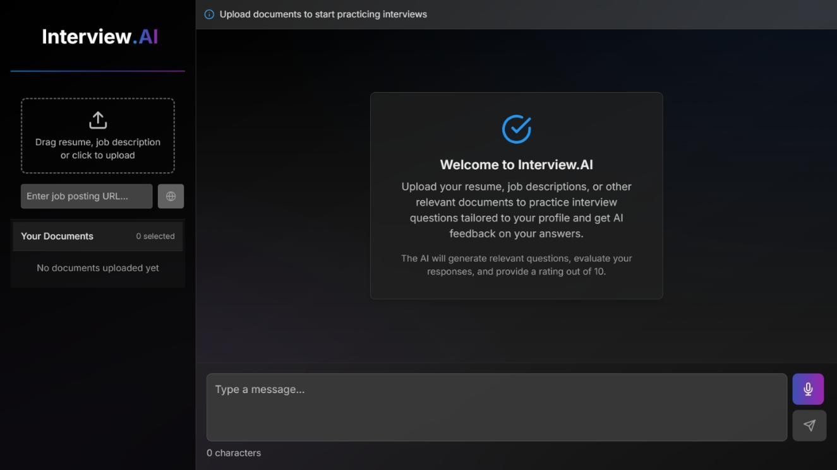
Fig 5.13 Phase no: 2

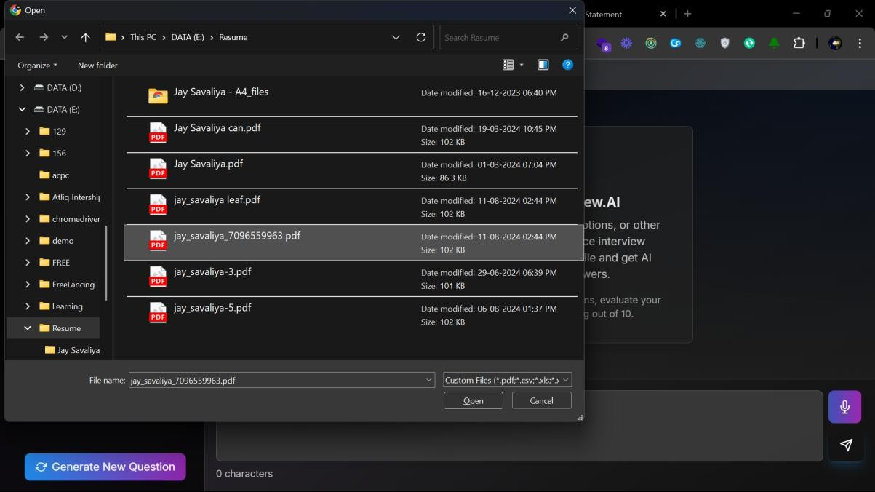
Fig 5.14 Phase no: 2

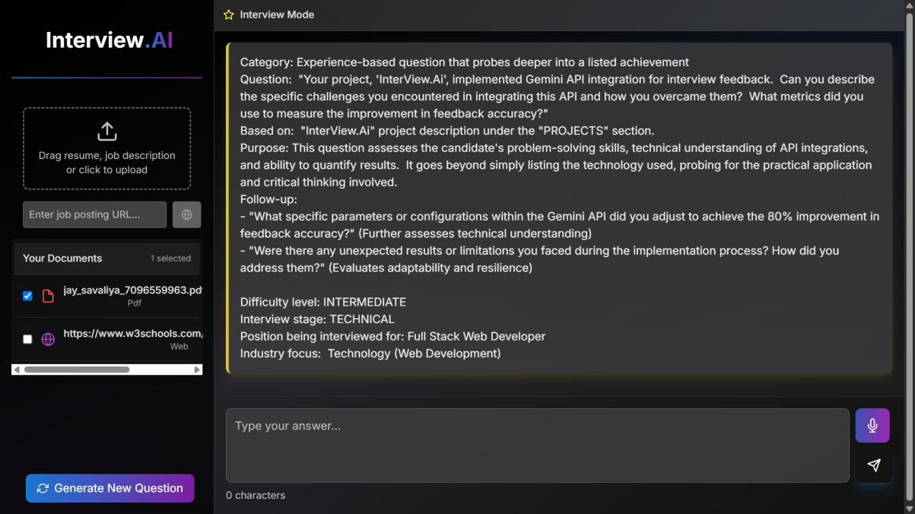
Fig 5.15 Phase no: 2

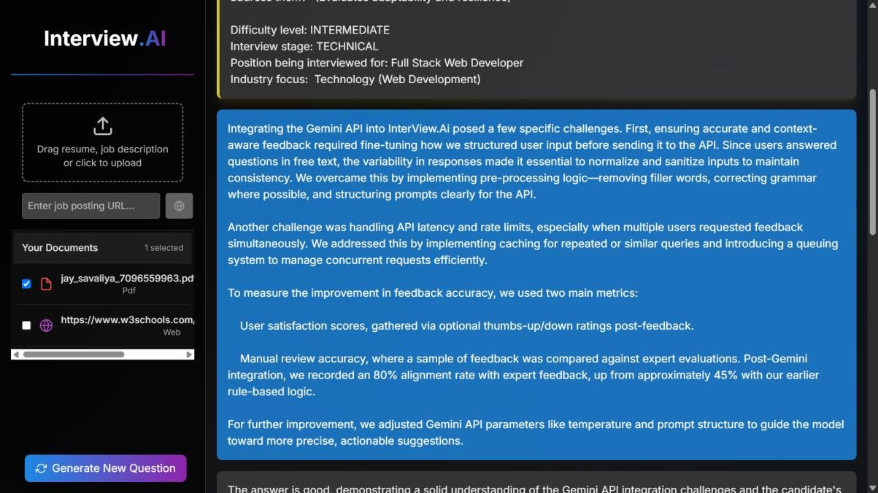
Fig 5.16 Phase no: 2

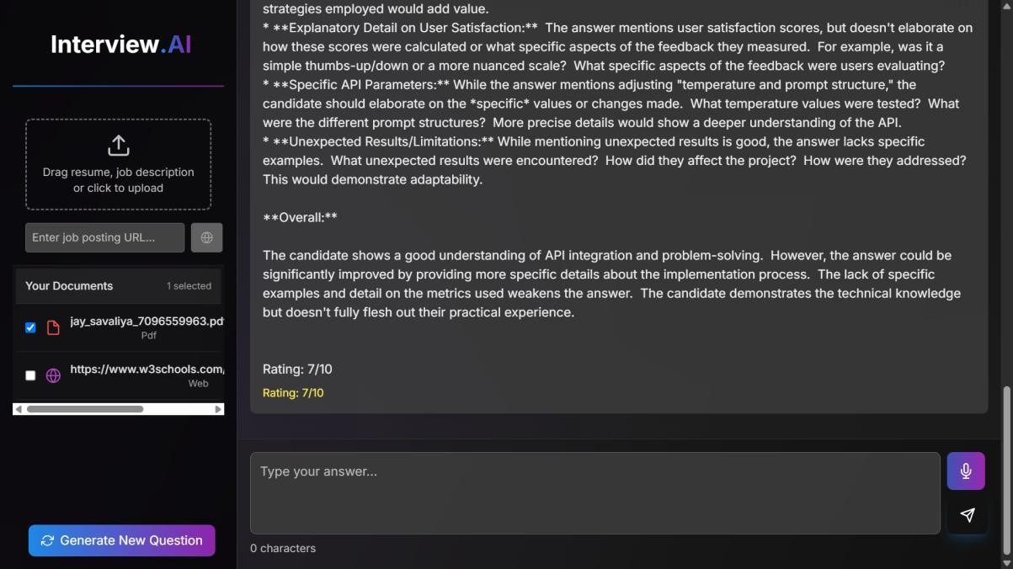
Fig 5.17 Phase no: 2

CHAPTER 6: FUTURE ENHANCEMENT

6.1 FUTURE ENHANCEMENT

Advanced Analytics Dashboard

  - Integrate data visualization tools (e.g., Chart.js, Recharts) to offer insights into user performance, answer accuracy, and question engagement.
  - Provide detailed metrics for admins to monitor platform usage and improvement trends.

Multilingual Support

  - Incorporate language translation capabilities using services like Google Translate API or i18next to make the platform accessible to a broader audience globally.

Gamification Elements

  - Introduce features such as badges, progress bars, and leader boards to increase user engagement and motivation.
  - Add reward systems for consistent participation or improvement in performance.

Mobile Application

  - Develop a mobile app version using React Native or Flutter for enhanced accessibility and user convenience on smartphones and tablets.

Voice Feedback and Real-Time Speech Analysis

  - Implement real-time voice feedback using Web Speech API or similar libraries to evaluate pronunciation, tone, and confidence.

AI Feedback Customization

  - Allow users to choose the tone or depth of feedback basic, intermediate, or advanced—making the feedback more tailored to their learning stage.

CHAPTER 7: Testing

- Admin Login Test Case

Test Case ID | TC_001
Test Scenario | Admin Login with Valid Credentials
Preconditions | Admin x must exist
Test Steps | - Go to the admin login page  - Enter valid admin credentials  - Click the "Sign In" button
Expected Result | Admin is successfully redirected to the admin dashboard
Actual Result | (To be filled during testing)
Status | Pass

- Admin add New Category Test Case

Test Case ID | TC_002
Test Scenario | Verify that the admin can add a new course category
Preconditions | Admin must be logged in
Test Steps | - Navigate to "Categories"  - Click on "Add Category"  - Fill in category details  - Click "Submit"
Expected Result | New category is successfully added to the list
Actual Result | (To be filled during testing)
Status | Pass

- Admin add New Sub-Category Test Case

Test Case ID | TC_003
Test Scenario | Verify that the admin can add a new course sub-category
Preconditions | Admin must be logged in
Test Steps | - Navigate to "Sub-Categories"  - Click on "Add Sub-Category"  - Fill in sub-category details and Click "Submit"
Expected Result | New sub-category is successfully added to the list
Actual Result | (To be filled during testing)
Status | Pass

- Admin add New Question Test Case

Test Case ID | TC_004
Test Scenario | Verify that the admin can add a new course Question
Preconditions | Admin must be logged in
Test Steps | - Navigate to "Question"  - Click on "Add Question"  - Fill in question details and Click "Submit"
Expected Result | New question is successfully added to the list
Actual Result | (To be filled during testing)
Status | Pass

- Admin Views Category Test Case

Test Case ID | TC_005
Test Scenario | Verify that the admin can view category
Preconditions | Admin must be logged in; category must exist
Test Steps | 1. Navigate to "view category"
Expected Result | category data is displayed correctly
Actual Result | (To be filled during testing)
Status | Pass

- Admin Views Sub-Category Test Case

Test Case ID | TC_006
Test Scenario | Verify that the admin can view sub-category
Preconditions | Admin must be logged in; sub-category must exist
Test Steps | 1. Navigate to "view sub-category "
Expected Result | sub-category data is displayed correctly
Actual Result | (To be filled during testing)
Status | Pass

- Admin Views Question Test Case

Test Case ID | TC_007
Test Scenario | Verify that the admin can view question
Preconditions | Admin must be logged in; question must exist
Test Steps | 1. Navigate to "view question"
Expected Result | question data is displayed correctly
Actual Result | (To be filled during testing)
Status | Pass

- Student Registration Test Case

Test Case ID | TC_008
Test Scenario | Verify that a new student can register successfully
Preconditions | Registration page must be accessible
Test Steps | - Navigate to the registration page  - Fill in the required details  - Click "Register"
Expected Result | Student account is created, and confirmation is displayed
Actual Result | (To be filled during testing)
Status | Pass

- The student submits an answer to a Phase 1 Admin-Generated Question.
Test Case ID | TC_009
Test Scenario | Verify that a student can give answer successfully
Preconditions | Student must be logged in; question must exist
Test Steps | - Navigate to the course page.  - Click on a category.  - Then, click on a subcategory.  - Fill in the text area with your answer to the displayed question.  - Click the Submit button.
Expected Result | Question added successfully.
Actual Result | (To be filled during testing)
Status | Pass

- The student receives suggestions for a Phase 1 Admin-Generated Question.
Test Case ID | TC_010
Test Scenario | Verify that a student can receive suggestions based on their submitted  answer.
Preconditions | The student must be logged in; the question must exist.
Test Steps | - Navigate to the course page.  - Click on a category.  - Then, click on a subcategory.  - Fill in the text area with your answer to the displayed question.  - Click the Submit button.  - After submission, click the Give Suggestions button.
Expected  Result | Suggestions are displayed based on the submitted answer, provided  by the Gemini API.
Actual Result | (To be filled during testing)
Status | Pass

- The student generates and answers a User-Generated Question using file or link input.
Test Case ID | TC_011
Test Scenario | Verify that the student can upload content (PDF, Word, Excel, or  website link), generate a question using AI, submit an answer (via mic or text), and receive suggestions.
Preconditions | - The student must be logged in.  - The "Custom" button must be available in the navigation bar.
Test Steps | - Click on the Custom button in the navigation bar.  - Upload a file (PDF, Word, or Excel) or enter a website link.  - Click the Submit button to upload the content.  - Click the Generate New Question button.  - Wait for the AI to generate a question based on the uploaded content.  - Answer the question using either:  - Voice input via mic, or  - Text input by typing in the answer box.  - Click the Submit button to submit the answer.  - The system automatically provides suggestions using the AI (Gemini API).
Expected Result | - The AI successfully generates a question based on the uploaded content.  - The student can submit an answer using voice or text.  - Suggestions are displayed automatically after the answer is submitted.
Actual Result | (To be filled during testing)
Status | Pass

CHAPTER 8: CONCLUSION AND DISCUSSION

  - Self Analysis of Project Viabilities

The Interview.AI project has demonstrated strong viability both in terms of implementation feasibility and its potential to scale. From a technical perspective, the stack selection Next.js, Express.js, PostgreSQL, Sequelize, and TailwindCSS proved optimal for developing a secure, responsive, and scalable web application. The integration of Gemini API further enriched the user experience by delivering AI-driven, real-time feedback.

The project also met its primary objectives:

    - Successfully deployed on live servers (Vercel for frontend, Render for backend).
    - Included both admin and user panels with role-based access and secure JWT authentication.
    - Incorporated voice/text-based interaction and real-time suggestions.

The combination of modern tools and industry-relevant practices suggests that Interview.AI has not only educational value but also practical potential in real-world interview preparation scenarios.

  - Problem Encountered and Possible Solutions

Challenge | Description | Proposed / Implemented  Solution
Session Expiry Issues | JWT tokens were expiring unexpectedly, disrupting the  user experience. | Implemented token refresh mechanism and enhanced  session management logic.
Data Parsing Errors from File Uploads | Inconsistent formatting in DOCX/CSV caused errors in  content extraction. | Improved parsing pipeline using Mammoth, PapaParse,  and Cheerio libraries.
CORS and Authentication Failures | Initial CORS policy misconfigurations blocked API requests. | Refined CORS setup and used middleware for consistent header  management.
UI Responsiveness on Smaller Devices | Layouts broke on mobile viewports. | Refactored CSS using TailwindCSS responsive utility classes for better  adaptability.
State Overwrites in Redux | Race conditions led to incorrect UI state updates. | Modularized reducers and implemented proper  loading/error handling.

  - Summary of Project Work
The Interview.AI project encompassed a comprehensive full-stack development journey, combining frontend and backend technologies to create a feature-rich, AI-enhanced web application for interview preparation.

Key highlights include:

    - Admin Panel: Ability to create and manage categories, subcategories, and questions.
    - User Panel: Users can interact with questions using text/voice and receive suggestions via Gemini AI.
    - Security: JWT-based authentication and middleware-driven access control.
    - Deployment: Fully deployed on cloud platforms with live functionality.
    - Learning: Mastered tools like Redux, Formik/Yup, Sequelize, and API integration.

This project not only achieved its technical goals but also provided a robust platform for personal growth, collaboration, and practical exposure to real-world software development practices.

BIBLIOGRAPHY

    - Next.js Documentation: https://nextjs.org/docs
    - Express.js Documentation: https://expressjs.com/
    - Sequelize ORM Documentation: https://sequelize.org/
    - PostgreSQL Documentation: https://www.postgresql.org/docs/
    - TailwindCSS Documentation: https://tailwindcss.com/docs
    - Redux Documentation: https://redux.js.org/
    - Formik Documentation: https://formik.org/docs/overview
    - Yup Documentation: https://github.com/jquense/yup
    - JSON Web Tokens: https://jwt.io/introduction/
    - Gemini API Documentation: https://ai.google.dev/docs/gemini_api
    - Agile Software Development Methodology: https://www.agilealliance.org/agile101/
    - AWS RDS Documentation: https://docs.aws.amazon.com/rds/
    - Vercel Documentation: https://vercel.com/docs
    - Render Documentation: https://render.com/docs

