Part 1:

Install Material UI from

<https://mui.com/>

Part 2:

To create buttons of various size use following code:

For icons, install the following (the command is available on mui.com)

npm install @mui/icons-material

Code for the buttons with icons

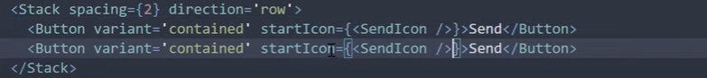

Using IconButton

Import IconButton from material ui

Use the following code



