Applying Probability and Statistics to Evaluate a Machine Learning Model
Weather Type Classification: Decision Tree (baseline) vs Random Forest (improved)
Item | Details
Course | MSIS 2026–27
Submitted by | Abhay Burye, Jalesh Kumar and Uttam K
Dataset | Kaggle – Weather Type Classification (nikhil7280/weather-type-classification)
Code | weather_ml_stats.py (Python 3, scikit-learn, SciPy)
Repository | https://github.com/uttamk1/APS-PROJECT

Research question: Does the improved model perform better than the baseline, or could the observed difference be due to variation in the test sample?
Short answer: The Random Forest scored slightly higher (accuracy 91.21% vs 90.83%, +0.38 percentage points), but the 95% confidence interval of the difference includes zero and a two-proportion z-test gives z = 0.48, p = 0.63. At α = 0.05 we fail to reject H₀: the gain could be explained by test-sample variation.

1. Problem Statement and Dataset

1.1 Problem statement
When a new model scores higher than an old one on a test set, it is tempting to call it better. But a test set is only one random sample of all the data the model could meet. A different sample would give slightly different scores, so a small gap may simply be noise. This project applies sampling, estimation and hypothesis testing to decide whether an observed improvement is meaningful and reliable.
The task is a multi-class classification problem: predict the current weather type (Rainy, Sunny, Cloudy or Snowy) from meteorological readings. A Decision Tree is the baseline and a tuned Random Forest is the improved model. Both are evaluated on exactly the same held-out test set, and the following hypotheses are tested:
- H₀ (null): the two models have the same probability of classifying a test observation correctly; any difference in accuracy is due to sampling variation.
- H₁ (alternative): the two models have different probabilities of a correct classification (two-sided).
- Significance level α = 0.05, chosen before looking at the results.

1.2 Dataset
The dataset is the public Weather Type Classification dataset from Kaggle. It has 13,200 observations and 11 columns: 10 predictor variables and the target Weather Type. The four classes are perfectly balanced (3,300 rows each, 25%), so accuracy and balanced accuracy coincide and no re-weighting was needed. No exact duplicate rows were found.
Variable | Type | Description / values
Temperature | Numeric | Degrees Celsius (−25 to 109)
Humidity | Numeric | Relative humidity, %
Wind Speed | Numeric | km/h (0 to 48.5)
Precipitation (%) | Numeric | Chance / intensity of precipitation, %
Cloud Cover | Categorical | clear, partly cloudy, cloudy, overcast
Atmospheric Pressure | Numeric | hPa (≈800 to 1,199)
UV Index | Numeric | 0 to 14
Season | Categorical | Spring, Summer, Autumn, Winter
Visibility (km) | Numeric | 0 to 20 km
Location | Categorical | coastal, inland, mountain
Weather Type (target) | Categorical | Rainy, Sunny, Cloudy, Snowy
Table 1. Variables in the dataset

1.3 Data preparation
- Duplicates are removed before splitting, so an identical row can never appear in both training and test data (leakage).
- Impossible values: Humidity and Precipitation are percentages, yet the raw data contains values up to 109%. Values outside 0–100 are set to missing.
- Imputation: missing numeric values are filled with the training-set median (robust to skew and outliers) and categorical values with the training-set mode. This happens inside a scikit-learn Pipeline, so the test set never influences preprocessing.
- Encoding: the three categorical predictors are one-hot encoded. Scaling is not required for tree-based models.

1.4 Exploratory statistics
Table 2 summarises each numeric feature (after cleaning) with measures of centre, spread and shape.
Feature | Mean | Median | Variance | Std dev | Min | Max | Skew
Temperature | 19.13 | 21.00 | 302.28 | 17.39 | −25.0 | 109.0 | 0.22
Humidity | 67.52 | 69.00 | 376.21 | 19.40 | 20.0 | 100.0 | −0.50
Wind Speed | 9.83 | 9.00 | 47.73 | 6.91 | 0.0 | 48.5 | 1.36
Precipitation (%) | 52.07 | 56.00 | 968.43 | 31.12 | 0.0 | 100.0 | −0.16
Atm. Pressure | 1005.83 | 1007.65 | 1383.81 | 37.20 | 800.12 | 1199.21 | −0.29
UV Index | 4.01 | 3.00 | 14.87 | 3.86 | 0.0 | 14.0 | 0.90
Visibility (km) | 5.46 | 5.00 | 11.37 | 3.37 | 0.0 | 20.0 | 1.23
Table 2. Descriptive statistics of the numeric features
Wind Speed, UV Index and Visibility are right-skewed (mean above median), which is why the median rather than the mean is used for imputation. Temperatures up to 109 °C are physically implausible and suggest the data is partly synthetic; they were kept because there is no unambiguous cut-off, and this is listed as a limitation.
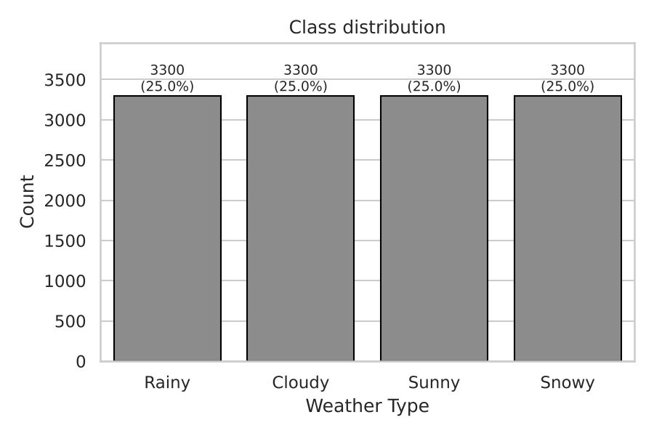
Figure 1. Class distribution: the four weather types are equally represented
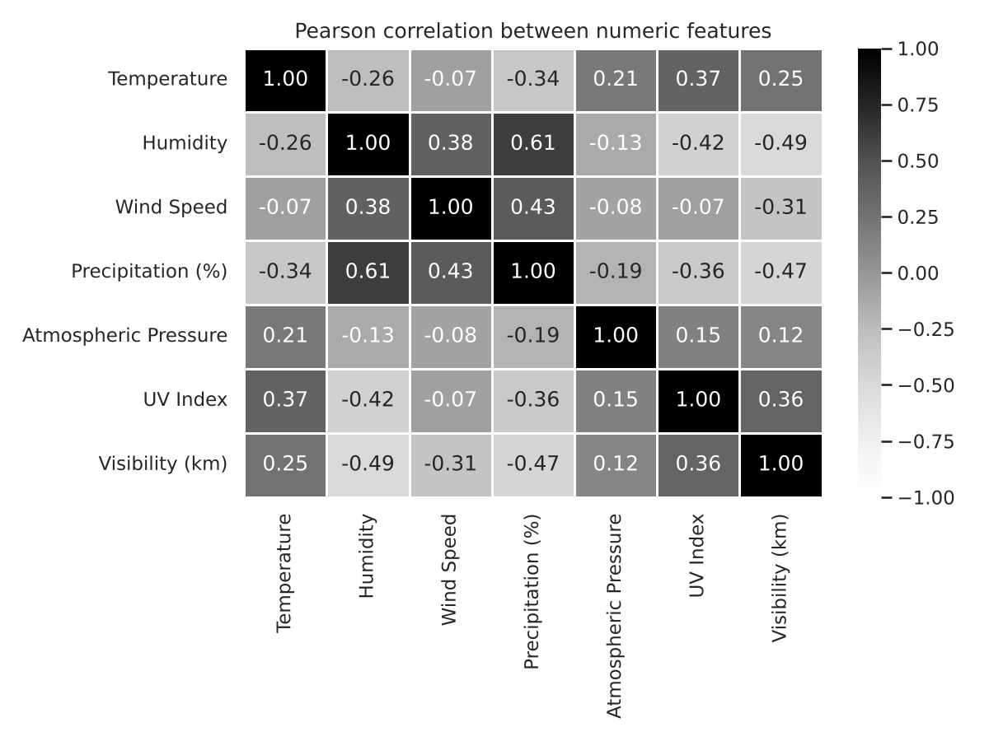
Figure 2. Pearson correlation between numeric features

2. Sampling and Experimental Methodology

2.1 Train–test split (stratified random sampling)
The cleaned data is split once into 80% training (10,560 rows) and 20% test (2,640 rows) with stratified random sampling, so each weather type keeps its 25% share in both sets. The random seed is fixed (SEED = 42) so the split, the models and the bootstrap are fully reproducible. The test set is used only once, for the final evaluation of both models.
Both models predict the same 2,640 test rows, so any difference in their scores comes from the models and not from different test data.

2.2 Models
 | Baseline: Decision Tree | Improved: Random Forest
Idea | One tree; splits that most reduce Gini impurity | Ensemble of trees, each fitted on a bootstrap sample with random feature subsets; majority vote
Settings | scikit-learn defaults (grew to depth 23, 595 leaves) | Tuned: 200 trees, max depth 20, min samples per leaf 1, √p features per split
Tuning | None | Grid search over n_estimators {200, 400}, max_depth {None, 20}, min_samples_leaf {1, 2} with 5-fold stratified cross-validation on the training set only (scoring: macro F1)
Expected weakness | High variance / overfitting | Less interpretable, slower
Table 3. Baseline and improved models

2.3 Evaluation metrics
Accuracy (share of correct predictions) is the primary metric, because the classes are balanced and accuracy is a simple proportion that the confidence interval and z-test work on directly. Balanced accuracy, macro-averaged precision, recall and F1 are reported as supporting metrics, together with confusion matrices.

2.4 Sampling: bootstrap resampling of the test set
The test set is only one sample. To see how much accuracy would change with a different sample, the test set is resampled:
- Draw 2,640 rows with replacement from the test set.
- Compute the accuracy of both models on these rows, and their difference.
- Repeat B = 2,000 times. The middle 95% of the 2,000 values (2.5th to 97.5th percentile) is the bootstrap 95% confidence interval.

2.5 Confidence interval for accuracy
Accuracy is a proportion (correct predictions ÷ test rows), so each prediction is a Bernoulli trial and the number correct follows a binomial distribution. With n = 2,640 the normal approximation applies, giving:
SE = √( p̂ (1 − p̂) / n ) 95% CI = p̂ ± 1.96 × SE
For the difference between the two accuracies the standard error is SE = √( p̂₁(1 − p̂₁)/n + p̂₂(1 − p̂₂)/n ). If the 95% CI of the difference contains 0, a zero difference is plausible and the improvement is not established.

2.6 Hypothesis test: two-proportion z-test
- H₀: p_RF = p_DT (the two models have the same accuracy)
- H₁: p_RF ≠ p_DT (two-sided), significance level α = 0.05
Using the pooled proportion p̂ = (x₁ + x₂) / (n₁ + n₂), the test statistic is:
z = (p̂₂ − p̂₁) / √( p̂ (1 − p̂) (1/n₁ + 1/n₂) )
Under H₀, z follows the standard normal distribution. H₀ is rejected if |z| > 1.96, equivalently if the p-value is below 0.05.

2.7 Robustness check
The intervals and the test condition on one particular split. As a descriptive check, the script retrains both models on 10 further random 80/20 splits (seeds 100–109) and records how often the Random Forest wins. No p-value is computed from these runs.

3. Observations, Decision and Limitations

3.1 Performance on the same held-out test set
Metric | Decision Tree | Random Forest | Difference (RF − DT)
Accuracy | 0.9083 | 0.9121 | +0.0038
Balanced accuracy | 0.9083 | 0.9121 | +0.0038
Macro precision | 0.9086 | 0.9136 | +0.0049
Macro recall | 0.9083 | 0.9121 | +0.0038
Macro F1 | 0.9084 | 0.9124 | +0.0040
Table 4. Point estimates on the 2,640-row test set
The Random Forest is ahead on every metric, but only by about 0.4 percentage points: 2,408 correct predictions against 2,398, a gap of 10 rows out of 2,640.
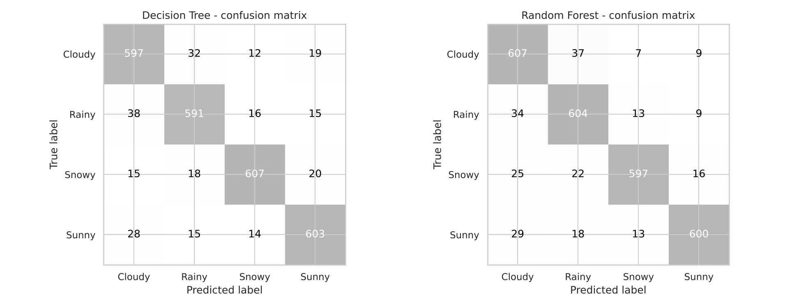
Figure 3. Confusion matrices of both models on the same test set

3.2 Confidence intervals
Measure | Estimate | Standard error | 95% CI (normal) | 95% CI (bootstrap)
Accuracy – Decision Tree | 0.9083 | 0.0056 | [0.8973, 0.9193] | [0.8973, 0.9193]
Accuracy – Random Forest | 0.9121 | 0.0055 | [0.9013, 0.9229] | [0.9011, 0.9227]
Difference (RF − DT) | +0.0038 | 0.0079 | [−0.0116, +0.0192] | [−0.0042, +0.0114]
Table 5. Accuracy estimates with 95% confidence intervals
The two accuracy intervals overlap almost completely, and the interval for the difference contains 0 with both methods. The normal-approximation and bootstrap intervals for each model agree to three decimal places, which confirms the simple formula works well here. The bootstrap interval for the difference is narrower because it keeps the pairing (both models scored on the same resampled rows).
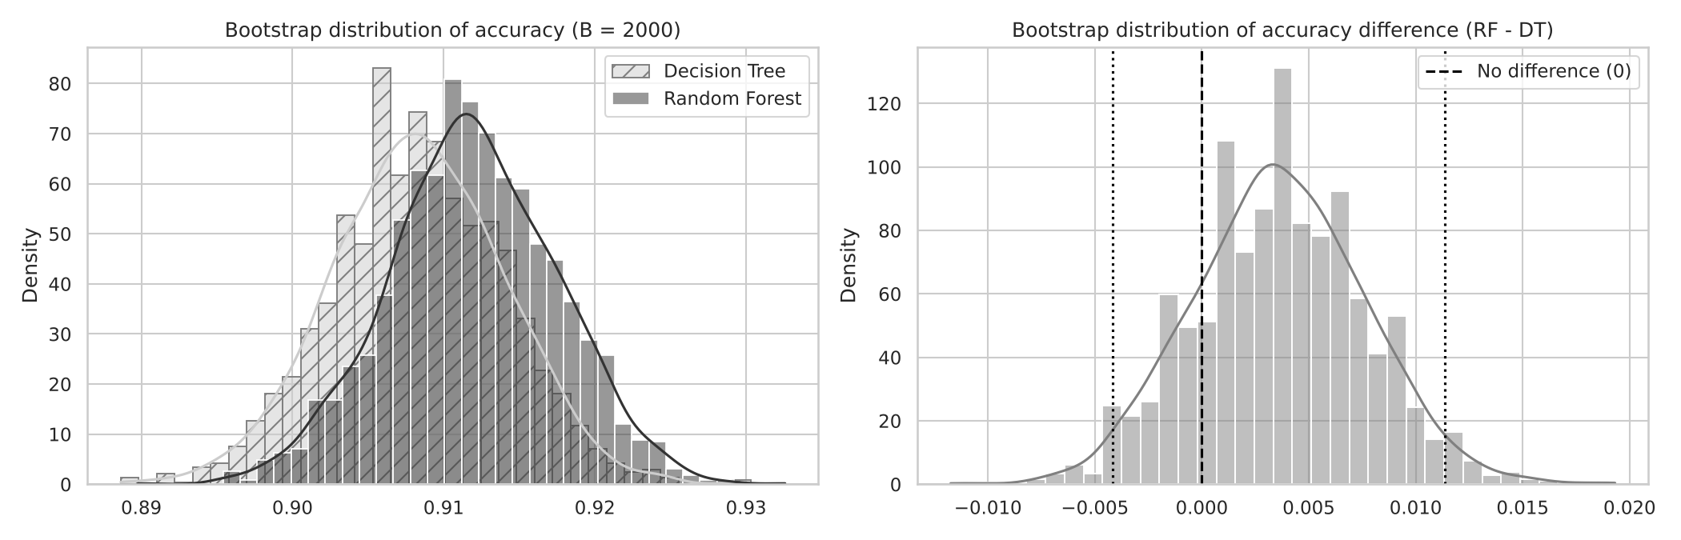
Figure 4. Bootstrap distributions of accuracy (left) and of the difference RF − DT (right); 0 lies inside the 95% interval

3.3 Hypothesis test: two-proportion z-test
Quantity | Value
Correct predictions | Decision Tree 2,398 / 2,640 · Random Forest 2,408 / 2,640
Sample proportions | p̂₁ = 0.9083 · p̂₂ = 0.9121
Pooled proportion p̂ | (2,398 + 2,408) / 5,280 = 0.9102
Standard error | √(0.9102 × 0.0898 × (1/2,640 + 1/2,640)) = 0.00787
Test statistic z | (0.9121 − 0.9083) / 0.00787 = 0.48
Critical value (α = 0.05, two-sided) | ±1.96
p-value (two-sided) | 0.630
p-value (one-sided, H₁: RF better) | 0.315
Decision | |z| = 0.48 < 1.96 and p = 0.63 > 0.05 → Fail to reject H₀
Table 6. Two-proportion z-test, worked step by step
The observed difference is only about half a standard error away from zero. A difference this large or larger would appear by chance about 63% of the time if the two models were really equally accurate. Even the one-sided test in favour of the Random Forest (p = 0.32) is far from the 0.05 threshold.
Robustness check: on 10 further random splits the Random Forest scored higher every time, but only by +0.38 to +1.21 points (mean +0.77 points). Each of those gaps is smaller than the ±1.5-point uncertainty of a single test set, so none would be significant on its own. The Random Forest may well have a small real edge, but it is too small for one test set of 2,640 rows to confirm.

3.4 Decision
We fail to reject H₀ at α = 0.05. The Random Forest's observed improvement (+0.38 percentage points) is small compared with the sampling variability of the test set: the 95% CI of the difference includes 0, and the z-test gives z = 0.48 (well below 1.96) and p = 0.63. The difference could plausibly be due to variation in the test sample, so we cannot claim the Random Forest is really better on this data.
This does not prove that the models are identical. It only means this test set does not give enough evidence of a difference. A gap of 0.4 percentage points is simply too small to separate from noise with 2,640 test rows. Detecting a gap of this size reliably would need a much larger test set. In practice, the simpler and more interpretable Decision Tree performs about as well as the Random Forest here.

3.5 Limitations
- Synthetic or noisy data: the dataset contains impossible values (humidity and precipitation above 100%, temperatures up to 109 °C), suggesting it is partly generated. Results may not transfer to real weather records.
- Classification, not forecasting: the label describes current conditions; the models cannot predict future weather.
- Possible label leakage: features such as precipitation, cloud cover, UV index and visibility nearly describe the weather type itself, which can inflate both models' scores and shrink the room for improvement.
- Single split: the confidence intervals and the z-test measure test-sample variation only, not variation from a different training set. Section 2.7's repeated splits are descriptive only.
- Unequal tuning effort: the baseline uses default settings while the Random Forest is tuned, so the comparison mixes the effect of the algorithm with the effect of tuning.
- Multiple metrics: several metrics are reported. To avoid cherry-picking, accuracy with the z-test was fixed in advance as the primary test.
- Simple test ignores pairing: the z-test treats the two accuracies as independent samples, but both models were scored on the same rows. This makes the test slightly conservative (wider interval); it does not change the conclusion here.
- Statistical power: the test set is large in absolute terms but small relative to the effect size, so a real but tiny improvement may go undetected (a Type II error is possible).

4. Where Probability and Statistics Are Used
Stage | Concept / technique | Purpose in this project
Exploratory analysis | Mean, median, variance, standard deviation, skewness, Pearson correlation | Describe the centre, spread and shape of each feature and how features relate
Preprocessing | Median and mode as robust estimators | Impute missing / impossible values without being pulled by skew or outliers
Train–test split | Stratified random sampling | Draw a representative test sample with the same class proportions as the population
Random Forest | Bootstrap sampling (bagging), random feature subsets, majority vote | Reduce the variance of single trees
Model tuning | k-fold cross-validation (mean CV score as an estimate) | Estimate generalisation performance without touching the test set
Evaluation | Accuracy, precision, recall, F1 as empirical probabilities | Estimate P(correct), P(true class | predicted class) and P(predicted class | true class)
Prediction | Class probabilities from the forest's votes | The predicted class is the one with the highest estimated probability
Sampling | Bootstrap resampling of the test set (sampling with replacement) | See how much accuracy would change with a different test sample
Confidence interval | Standard error of a proportion, normal approximation to the binomial, 95% CI (p̂ ± 1.96·SE) | Give a range of plausible values for each accuracy and for the difference
Hypothesis test | Two-proportion z-test, standard normal distribution, p-value, α = 0.05, critical value ±1.96 | Decide whether the difference in accuracy is statistically significant
Interpretation | Type I / Type II error, statistical power | Explain what 'fail to reject' does and does not mean
Table 8. Probability and statistics used at each stage

Reproducing the results
Install the requirements (pip install -r requirements.txt), place weather_classification_data.csv next to the script (or let it download through kagglehub), and run python weather_ml_stats.py. All tables and figures in this report are written to the outputs/ folder. Every random step uses SEED = 42, so the numbers are identical on every run.

References
- nikhil7280 (Kaggle user). Weather Type Classification [dataset]. Kaggle. https://www.kaggle.com/datasets/nikhil7280/weather-type-classification
- Montgomery, D. C., & Runger, G. C. (2014). Applied Statistics and Probability for Engineers (6th ed.). Wiley. (Two-proportion z-test, confidence intervals for proportions.)
- Efron, B., & Tibshirani, R. J. (1993). An Introduction to the Bootstrap. Chapman & Hall.
- Breiman, L. (2001). Random forests. Machine Learning, 45(1), 5–32.
- Pedregosa, F., et al. (2011). Scikit-learn: Machine learning in Python. JMLR, 12, 2825–2830.

