Applying Probability and Statistics to Evaluate a Machine Learning Model
Weather Type Classification: Logistic Regression (baseline) vs Random Forest (improved)
Item | Details
Course | MSIS 2026–27
Submitted by | Abhay Burye, Jalesh Kumar and Uttam K
Dataset | Kaggle – Weather Type Classification (nikhil7280/weather-type-classification)
Code | weather_ml_stats.py (Python 3, scikit-learn, SciPy)
Repository | https://github.com/uttamk1/APS-PROJECT

Research question: Does the improved model perform better than the baseline, or could the observed difference be due to variation in the test sample?
Short answer: Yes. The tuned Random Forest reached 91.21% accuracy against 86.67% for the Logistic Regression baseline, a gain of +4.55 percentage points. The 95% confidence interval of the gain is [+2.86, +6.23] points, which excludes zero, and the two-proportion z-test gives z = 5.27, p < 0.001. At α = 0.05 we reject H₀: the improvement is real and not explained by test-sample variation.

1. Problem Statement and Dataset

1.1 Problem statement
When a new model scores higher than an old one on a test set, it is tempting to call it better. But a test set is only one random sample of all the data the model could meet. A different sample would give slightly different scores, so a small gap may simply be noise. This project applies sampling, estimation and hypothesis testing to decide whether an observed improvement is meaningful and reliable.
The task is a multi-class classification problem: predict the current weather type (Rainy, Sunny, Cloudy or Snowy) from meteorological readings. A simple Logistic Regression is the baseline and a tuned Random Forest is the improved model. Both are evaluated on exactly the same held-out test set, and the following hypotheses are tested:
- H₀ (null): the two models have the same probability of classifying a test observation correctly; any difference in accuracy is due to sampling variation.
- H₁ (alternative): the two models have different probabilities of a correct classification (two-sided).
- Significance level α = 0.05, chosen before looking at the results.

1.2 Dataset
The dataset is the public Weather Type Classification dataset from Kaggle. It has 13,200 observations and 11 columns: 10 predictor variables and the target Weather Type. The four classes are perfectly balanced (3,300 rows each, 25%), so accuracy and balanced accuracy coincide and no re-weighting was needed. No exact duplicate rows were found.
Variable | Type | Description / values
Temperature | Numeric | Degrees Celsius (−25 to 109)
Humidity | Numeric | Relative humidity, %
Wind Speed | Numeric | km/h (0 to 48.5)
Precipitation (%) | Numeric | Chance / intensity of precipitation, %
Cloud Cover | Categorical | clear, partly cloudy, cloudy, overcast
Atmospheric Pressure | Numeric | hPa (≈800 to 1,199)
UV Index | Numeric | 0 to 14
Season | Categorical | Spring, Summer, Autumn, Winter
Visibility (km) | Numeric | 0 to 20 km
Location | Categorical | coastal, inland, mountain
Weather Type (target) | Categorical | Rainy, Sunny, Cloudy, Snowy
Table 1. Variables in the dataset

1.3 Data preparation
- Duplicates are removed before splitting, so an identical row can never appear in both training and test data (leakage).
- Impossible values: Humidity and Precipitation are percentages, yet the raw data contains values up to 109%. Values outside 0–100 are set to missing (416 humidity values and 392 precipitation values).
- Imputation: missing numeric values are filled with the training-set median (robust to skew and outliers) and categorical values with the training-set mode. This happens inside a scikit-learn Pipeline, so the test set never influences preprocessing.
- Encoding: the three categorical predictors are one-hot encoded. Scaling is not required for tree-based models.

1.4 Exploratory statistics
Table 2 summarises each numeric feature (after cleaning) with measures of centre, spread and shape.
Feature | Mean | Median | Variance | Std dev | Min | Max | Skew
Temperature | 19.13 | 21.00 | 302.28 | 17.39 | −25.0 | 109.0 | 0.22
Humidity | 67.52 | 69.00 | 376.21 | 19.40 | 20.0 | 100.0 | −0.50
Wind Speed | 9.83 | 9.00 | 47.73 | 6.91 | 0.0 | 48.5 | 1.36
Precipitation (%) | 52.07 | 56.00 | 968.43 | 31.12 | 0.0 | 100.0 | −0.16
Atm. Pressure | 1005.83 | 1007.65 | 1383.81 | 37.20 | 800.12 | 1199.21 | −0.29
UV Index | 4.01 | 3.00 | 14.87 | 3.86 | 0.0 | 14.0 | 0.90
Visibility (km) | 5.46 | 5.00 | 11.37 | 3.37 | 0.0 | 20.0 | 1.23
Table 2. Descriptive statistics of the numeric features
Wind Speed, UV Index and Visibility are right-skewed (mean above median), which is why the median rather than the mean is used for imputation. Temperatures up to 109 °C are physically implausible and suggest the data is partly synthetic; they were kept because there is no unambiguous cut-off, and this is listed as a limitation.
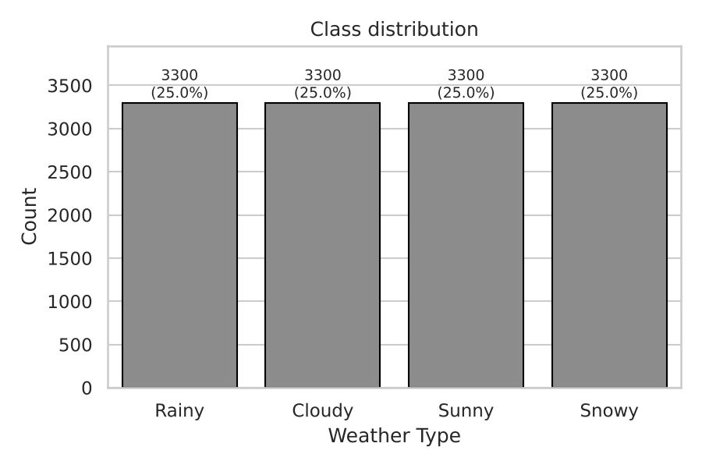
Figure 1. Class distribution: the four weather types are equally represented
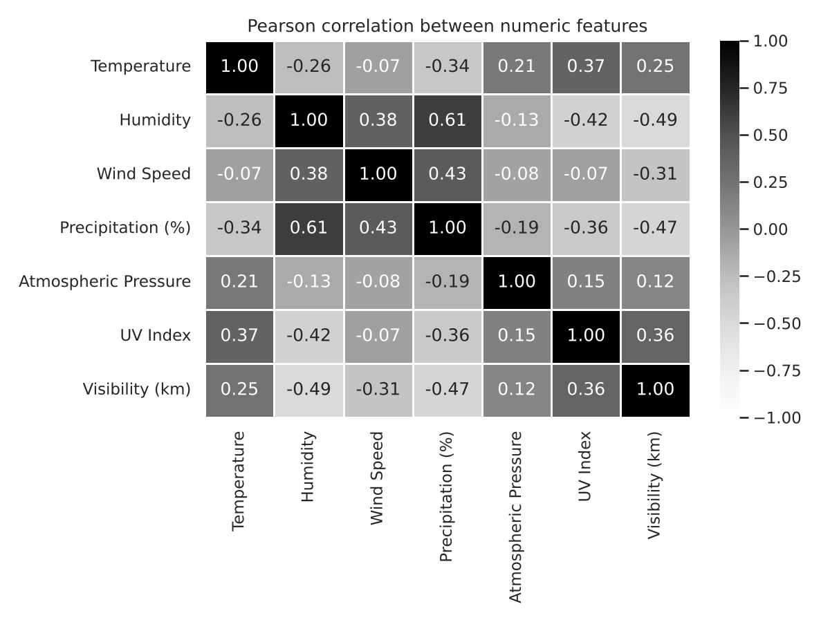
Figure 2. Pearson correlation between numeric features

2. Sampling and Experimental Methodology

2.1 Train–test split (stratified random sampling)
The cleaned data is split once into 80% training (10,560 rows) and 20% test (2,640 rows) with stratified random sampling, so each weather type keeps its 25% share in both sets. The random seed is fixed (SEED = 42) so the split, the models and the bootstrap are fully reproducible. The test set is used only once, for the final evaluation of both models.
Both models predict the same 2,640 test rows, so any difference in their scores comes from the models and not from different test data.

2.2 Models
 | Baseline: Logistic Regression | Improved: Random Forest
Idea | Linear model: a weighted sum of the features is turned into class probabilities with the softmax function | Ensemble of decision trees, each fitted on a bootstrap sample with random feature subsets; majority vote
Settings | Default settings; numeric features standardised (z-scores), categories one-hot encoded | Tuned: 200 trees, max depth 20, min samples per leaf 1, √p features per split
Tuning | None | Grid search over n_estimators {200, 400}, max_depth {None, 20}, min_samples_leaf {1, 2} with 5-fold stratified CV on the training set only. A tuned Gradient Boosting model was also tried; the Random Forest had the higher CV accuracy (0.917 vs 0.915) and was chosen
Mean 5-fold CV accuracy | 0.873 | 0.917
Expected weakness | Can only draw straight-line boundaries between classes | Less interpretable, slower
Table 3. Baseline and improved models

2.3 Evaluation metrics
Accuracy (share of correct predictions) is the primary metric, because the classes are balanced and accuracy is a simple proportion that the confidence interval and z-test work on directly. Balanced accuracy, macro-averaged precision, recall and F1 are reported as supporting metrics, together with confusion matrices.

2.4 Sampling: bootstrap resampling of the test set
The test set is only one sample. To see how much accuracy would change with a different sample, the test set is resampled:
- Draw 2,640 rows with replacement from the test set.
- Compute the accuracy of both models on these rows, and their difference.
- Repeat B = 2,000 times. The middle 95% of the 2,000 values (2.5th to 97.5th percentile) is the bootstrap 95% confidence interval.

2.5 Confidence interval for accuracy
Accuracy is a proportion (correct predictions ÷ test rows), so each prediction is a Bernoulli trial and the number correct follows a binomial distribution. With n = 2,640 the normal approximation applies, giving:
SE = √( p̂ (1 − p̂) / n ) 95% CI = p̂ ± 1.96 × SE
For the difference between the two accuracies the standard error is SE = √( p̂₁(1 − p̂₁)/n + p̂₂(1 − p̂₂)/n ). If the 95% CI of the difference contains 0, a zero difference is plausible and the improvement is not established.

2.6 Hypothesis test: two-proportion z-test
- H₀: p_RF = p_LR (the two models have the same accuracy)
- H₁: p_RF ≠ p_LR (two-sided), significance level α = 0.05
Using the pooled proportion p̂ = (x₁ + x₂) / (n₁ + n₂), the test statistic is:
z = (p̂₂ − p̂₁) / √( p̂ (1 − p̂) (1/n₁ + 1/n₂) )
Under H₀, z follows the standard normal distribution. H₀ is rejected if |z| > 1.96, equivalently if the p-value is below 0.05.

2.7 Robustness check
The intervals and the test condition on one particular split. As a descriptive check, the script retrains both models on 10 further random 80/20 splits (seeds 100–109) and records how often the Random Forest wins. No p-value is computed from these runs.

3. Observations, Decision and Limitations

3.1 Performance on the same held-out test set
Metric | Logistic Regression | Random Forest | Difference (RF − LR)
Accuracy | 0.8667 | 0.9121 | +0.0455
Balanced accuracy | 0.8667 | 0.9121 | +0.0455
Macro precision | 0.8676 | 0.9136 | +0.0460
Macro recall | 0.8667 | 0.9121 | +0.0455
Macro F1 | 0.8668 | 0.9124 | +0.0456
Table 4. Point estimates on the 2,640-row test set
The Random Forest is ahead on every metric by about 4.5 percentage points: 2,408 correct predictions against 2,288, i.e. 120 more test rows classified correctly out of 2,640. In terms of errors, the Random Forest makes 232 mistakes against the baseline's 352, about one third fewer.
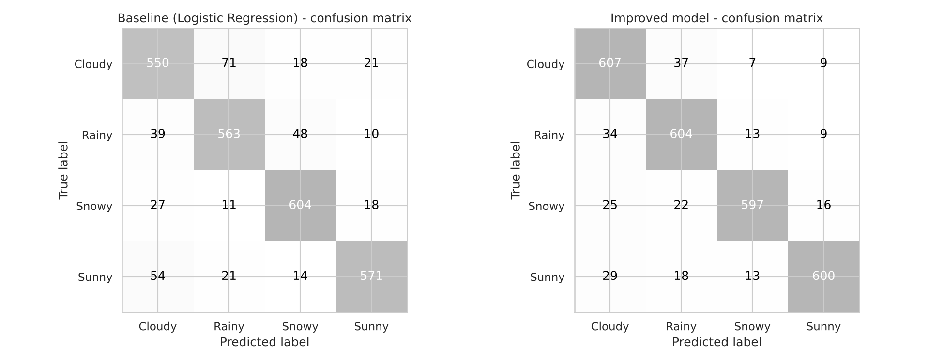
Figure 3. Confusion matrices of both models on the same test set

3.2 Confidence intervals
Measure | Estimate | Standard error | 95% CI (normal) | 95% CI (bootstrap)
Accuracy – Logistic Regression | 0.8667 | 0.0066 | [0.8537, 0.8796] | [0.8530, 0.8799]
Accuracy – Random Forest | 0.9121 | 0.0055 | [0.9013, 0.9229] | [0.9011, 0.9227]
Difference (RF − LR) | +0.0455 | 0.0086 | [+0.0286, +0.0623] | [+0.0352, +0.0564]
Table 5. Accuracy estimates with 95% confidence intervals
The two accuracy intervals do not overlap: the lowest plausible accuracy of the Random Forest (90.1%) is above the highest plausible accuracy of the baseline (88.0%). The interval for the difference, +2.9 to +6.2 percentage points, lies entirely above 0 with both methods. The normal-approximation and bootstrap intervals for each model agree closely, which confirms the simple formula works well here. The bootstrap interval for the difference is narrower because it keeps the pairing (both models scored on the same resampled rows).
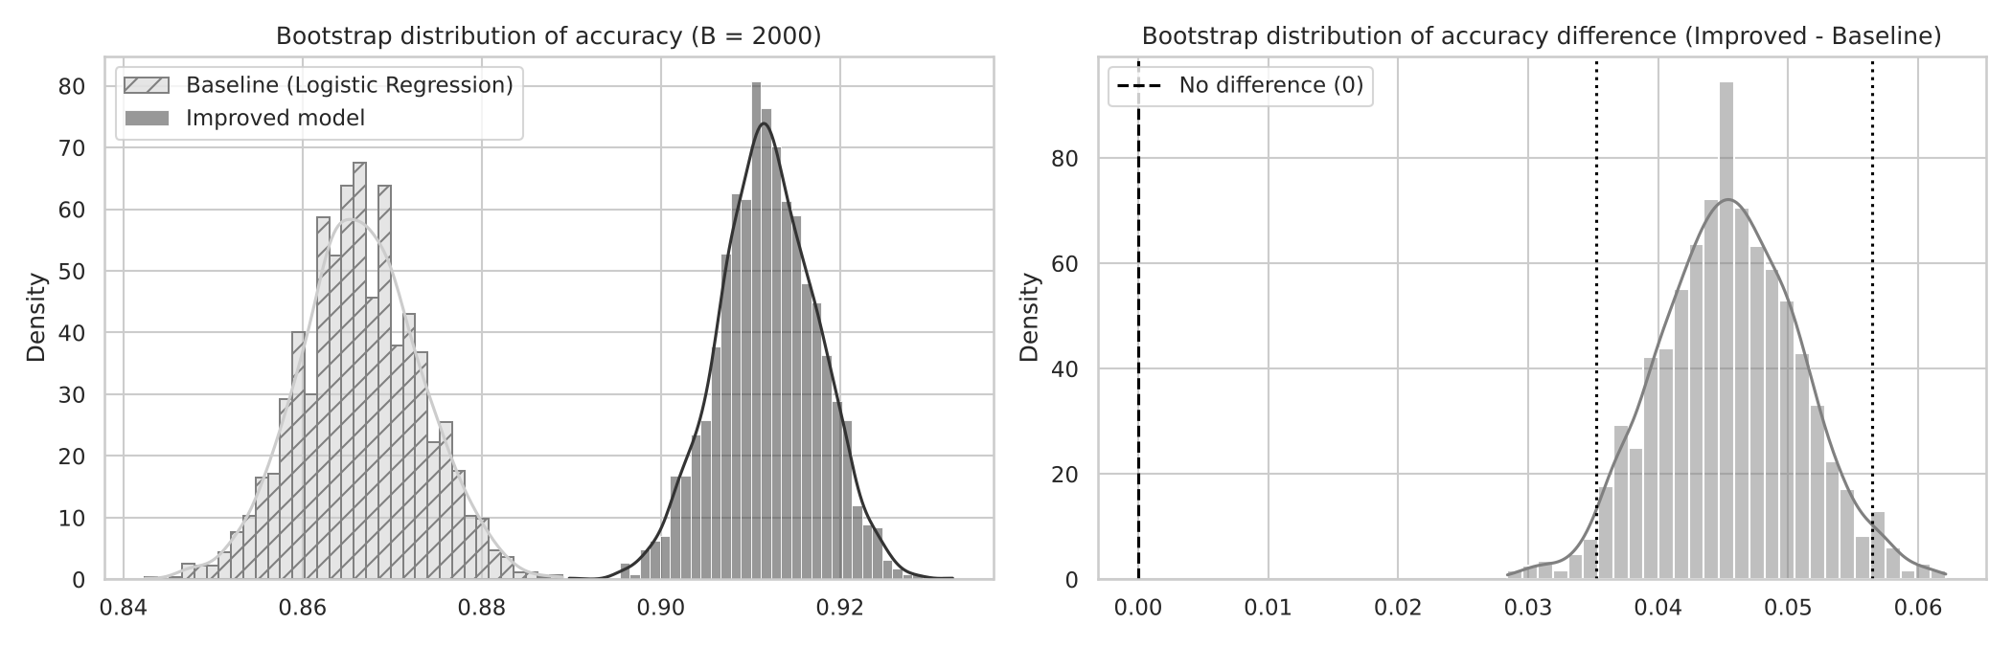
Figure 4. Bootstrap distributions of accuracy (left) and of the difference RF − LR (right); 0 lies far outside the 95% interval

3.3 Hypothesis test: two-proportion z-test
Quantity | Value
Correct predictions | Logistic Regression 2,288 / 2,640 · Random Forest 2,408 / 2,640
Sample proportions | p̂₁ = 0.8667 · p̂₂ = 0.9121
Pooled proportion p̂ | (2,288 + 2,408) / 5,280 = 0.8894
Standard error | √(0.8894 × 0.1106 × (1/2,640 + 1/2,640)) = 0.00863
Test statistic z | (0.9121 − 0.8667) / 0.00863 = 5.27
Critical value (α = 0.05, two-sided) | ±1.96
p-value (two-sided) | 1.4 × 10⁻⁷ (p < 0.001)
p-value (one-sided, H₁: RF better) | 7.0 × 10⁻⁸
Decision | |z| = 5.27 > 1.96 and p < 0.05 → Reject H₀
Table 6. Two-proportion z-test, worked step by step
The observed difference is more than five standard errors away from zero. If the two models were really equally accurate, a gap this large would appear by chance only about once in seven million test sets. The robustness check agrees: on 10 out of 10 further random splits the Random Forest beat the baseline, by +3.3 to +5.4 points (mean +4.3 points).

3.4 Decision
We reject H₀ at α = 0.05. The Random Forest's improvement of +4.55 percentage points is about five times larger than its standard error: the 95% CI of the difference [+2.86, +6.23] points excludes 0, and the z-test gives z = 5.27, p < 0.001. The improvement is very unlikely to be due to variation in the test sample; the Random Forest is genuinely better than the baseline on this data.
Statistical significance says the gain is real; whether it is important is a practical question. Here it means about 45 fewer misclassified observations per 1,000, which is a meaningful reduction in errors. A side finding is also worth noting: an earlier comparison with a single Decision Tree baseline (90.83%) gave only +0.38 points, with p = 0.63, which was not significant. So the gain comes from moving from a linear model to a tree-based model, while the ensemble adds little over a single tree on this dataset.

3.5 Limitations
- Synthetic or noisy data: the dataset contains impossible values (humidity and precipitation above 100%, temperatures up to 109 °C), suggesting it is partly generated. Results may not transfer to real weather records.
- Classification, not forecasting: the label describes current conditions; the models cannot predict future weather.
- Possible label leakage: features such as precipitation, cloud cover, UV index and visibility nearly describe the weather type itself, which can inflate both models' scores and shrink the room for improvement.
- Single split: the confidence intervals and the z-test measure test-sample variation only, not variation from a different training set. Section 2.7's repeated splits are descriptive only.
- Unequal tuning effort: the baseline uses default settings while the Random Forest is tuned, so the comparison mixes the effect of the algorithm with the effect of tuning.
- Model selection: the improved model was chosen from two candidates using cross-validation on the training data only, so the test set was not used to pick the winner.
- Multiple metrics: several metrics are reported. To avoid cherry-picking, accuracy with the z-test was fixed in advance as the primary test.
- Simple test ignores pairing: the z-test treats the two accuracies as independent samples, but both models were scored on the same rows. This makes the test slightly conservative (wider interval); the result is significant even so.
- Type I error: rejecting H₀ at α = 0.05 still carries a small chance of a false positive, although with p < 0.001 this risk is very low.

4. Where Probability and Statistics Are Used
Stage | Concept / technique | Purpose in this project
Exploratory analysis | Mean, median, variance, standard deviation, skewness, Pearson correlation | Describe the centre, spread and shape of each feature and how features relate
Preprocessing | Median and mode as robust estimators | Impute missing / impossible values without being pulled by skew or outliers
Train–test split | Stratified random sampling | Draw a representative test sample with the same class proportions as the population
Random Forest | Bootstrap sampling (bagging), random feature subsets, majority vote | Reduce the variance of single trees
Model tuning | k-fold cross-validation (mean CV score as an estimate) | Estimate generalisation performance without touching the test set
Evaluation | Accuracy, precision, recall, F1 as empirical probabilities | Estimate P(correct), P(true class | predicted class) and P(predicted class | true class)
Baseline model | Logistic Regression: softmax probabilities, maximum-likelihood estimation; standardisation (z-scores) | Estimate P(weather type | readings) with a linear model
Prediction | Class probabilities from the forest's votes | The predicted class is the one with the highest estimated probability
Sampling | Bootstrap resampling of the test set (sampling with replacement) | See how much accuracy would change with a different test sample
Confidence interval | Standard error of a proportion, normal approximation to the binomial, 95% CI (p̂ ± 1.96·SE) | Give a range of plausible values for each accuracy and for the difference
Hypothesis test | Two-proportion z-test, standard normal distribution, p-value, α = 0.05, critical value ±1.96 | Decide whether the difference in accuracy is statistically significant
Interpretation | Type I / Type II error, statistical vs practical significance | Explain what rejecting H₀ does and does not mean
Table 8. Probability and statistics used at each stage

Reproducing the results
Install the requirements (pip install -r requirements.txt), place weather_classification_data.csv next to the script (or let it download through kagglehub), and run python weather_ml_stats.py. All tables and figures in this report are written to the outputs/ folder. Every random step uses SEED = 42, so the numbers are identical on every run.

References
- nikhil7280 (Kaggle user). Weather Type Classification [dataset]. Kaggle. https://www.kaggle.com/datasets/nikhil7280/weather-type-classification
- Montgomery, D. C., & Runger, G. C. (2014). Applied Statistics and Probability for Engineers (6th ed.). Wiley. (Two-proportion z-test, confidence intervals for proportions.)
- Efron, B., & Tibshirani, R. J. (1993). An Introduction to the Bootstrap. Chapman & Hall.
- Breiman, L. (2001). Random forests. Machine Learning, 45(1), 5–32.
- Pedregosa, F., et al. (2011). Scikit-learn: Machine learning in Python. JMLR, 12, 2825–2830.

