# CAREER OBJECTIVE

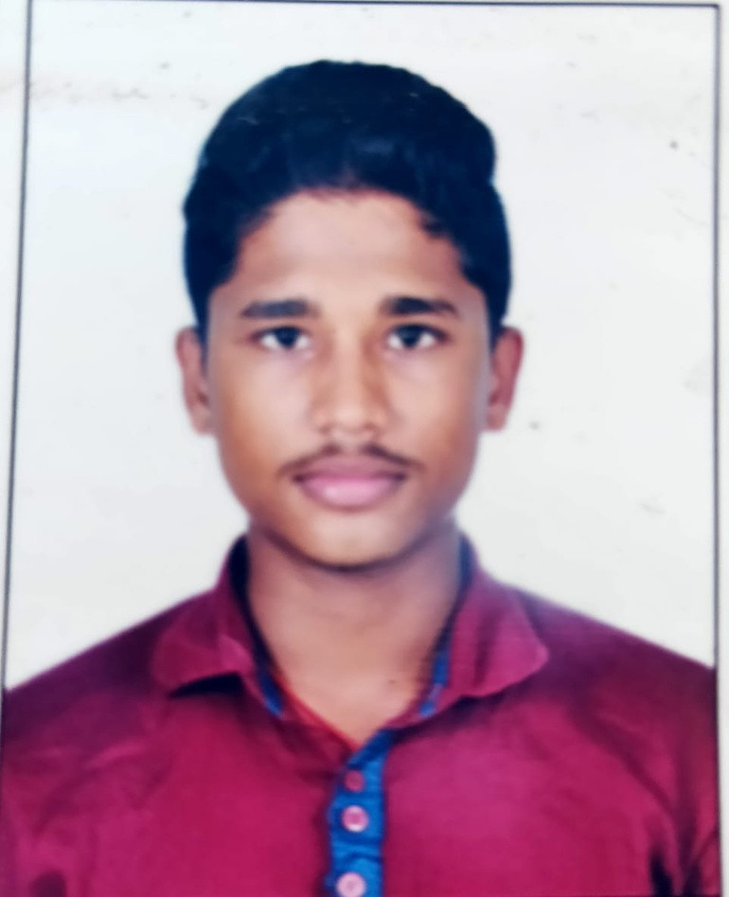

**Padala Nitish Kumar Rao**

To seek, achieve and maintain a position in order to utilize my technical skills and other traits that offer professional growth and experience while being productive, innovative and resourceful to the recruiting organization.

# PERSONAL DETAILS

[nitishpadala1502@gmail.com](mailto:nitishpadala1502@gmail.com)

+91-8100168954



Titagarh, Kolkata-700096

# ADDITIONAL SKILLSET

Good Communication Skills. Collaborative and ethical in working.

Ability to learn new things quickly.

# EXTRACURRICULAR ACTIVITIES

College level champion in Badminton.

# EDUCATIONAL QUALIFICATION

|  |  |  |  |
| --- | --- | --- | --- |
| **Year** | **Degree** | **Institute** | **CGPA/**  **%** |
| 2022 | B. Tech in Computer Science and  Engineering | Swami Vivekananda Institute of Science and Technology, Kolkata-700124 | 8.82 |
| 2018 | XII | Sri Chaitanya Junior College Vishakhapatnam | 86.4 |
| 2016 | X | Sri Chaitanya EM School,\  Vishakhapatnam | 8.8 |

**TECHNICAL SKILLS**

JAVA, C, C++

Oracle DBMS SQL

# PROJECTS

**"Nifty/Sensex going Bullish or Bearish."** as a team member.

# DECLARATION

I solemnly declare that, all the above statements are true to the best of my knowledge.

**Date : 4/07/2022**

**Place:** Kolkata **Signature:** Padala Nitish Kumar Rao