***UTTAM KUMAR MOHANTA***

*At/Po:- Rairangpur* 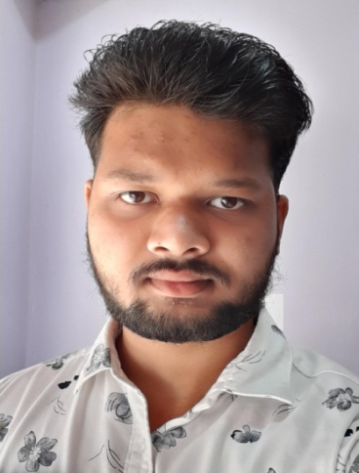

*Dist:- Mayurbhanj*

*State:- Odisha*

*Pin:- 757043*

*Mob:-9348964678, 9583722121*

*Email:-uttamkumarmohanta73@gmail.com*

|  |
| --- |
| **Objective** |

To serve the organization to the best of my knowledge and ability and to develop simultaneously my career and the organization.

|  |
| --- |
| **Personal Details** |

* Father’s Name : Jayanta Kumar Mohanta
* Date of Birth : 4th May 2000
* Sex : Male
* Nationality : Indian
* Religion : Hindu
* Marital Status : Unmarried
* Languages known : English, Hindi, Oriya.

|  |
| --- |
| **Academic qualification** |

|  |  |  |  |  |  |
| --- | --- | --- | --- | --- | --- |
| **Sl.No** | **Exam passed** | **Institute** | **Board/ University** | **Year of passing** | **Percentage**  **(%)** |
| 1 | 10th | Saraswati Shishu/Vidya Mandir,  Rairangpur | HSE,Odisha | 2015 | 66.66 |
| 2 | +2Sc | Hi-Tech +2 science college,Bbsr | CHSE,Odisha | 2018 | 49.99 |
| 3 | BCA | MPC Autonomous college, baripada | North orissa university | 2021 | __ |

|  |
| --- |
| **Strength** |

Sincere, Hardworking,Self-confidence and Communication Skill.

|  |
| --- |
| **Declaration** |

I hereby declare that all the above written particulars are true and correct to the best of my knowledge and belief.

**Place: Signature**

**Bhubaneswar**

