

Soumya Ranjan Parida

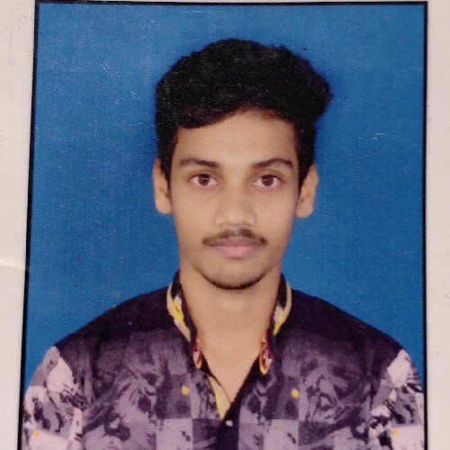Anladuba,Rairangpur,Mayurbhanj,Odisha 8327709025 | [soumyaparida53556@gmail.com](mailto:soumyaparida53556@gmail.com)

OBJECTIVE

To enhance my professional skills, capabilities and knowledge in an organization which recognizes the value of hard work and trusts me with responsibilities and challenges.

PERSONAL DETAILS

Date of Birth : 01/08/2000

EDUCATION



Saraswati shishu vidya mandir,Rairangpur

# 2015

Higher secondary 72%



Jhadeswar +2 science residential college,balasore

# 2017

Intermediate 72%



Gandhi institute of technology and management,bhubaneswar,odisha

# 2021

Electrical & Electronics Engineering/ B.Tech

7.8 CGPA

SKILLS

Decision making Problem solving

PROJECTS

ALLUMINIUM AIR BATTERY

The Al–air battery has proven to be very attractive as an eﬃcient and sustainable technology for energy storage and conversion with the capability of power large electronic devices and vehicles.

ACTIVITIES

Farming activities

Watching Documanteris and sports over the weekends Cooking

LANGUAGES

English Hindi Odia