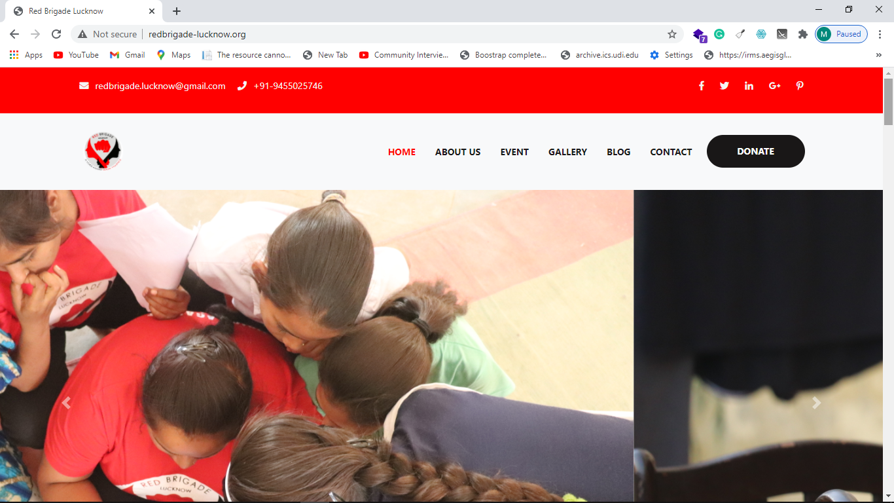

Menus of the Websites—

Home About us Our Work Achievements Research & Publications Donate Contact us

About us- ---→Red Brigade
----→ Our Team
---→Red Brigade←----

About US
WE ARE RED BRIGADE LUCKNOW
To create a society with FLOW (Fearless life of Women).
-→ Fight against Sexual -Violence - Trained 1,57,000 Women with NISHATRA (Self-Defense).

-→ Raising powerful voice against Sexual-Violence- Performed over 700 Nukkad-Naatak (Street Play) and 225 Seminars. To create an engaging platform involving several institutions and organizations.
-→To Create Women Leadership.
-→ Survivor Support- Rehabilitated more than 200 Sexual Violence Survivors including 5 Rape Victims.
-→ To bring to the fore the power of women in shaping the history – National Women’s Day and bring to the public domain the role of women in the national freedom struggle of India.
--→ Economic self-sufficiency of Women – Skill development of more than 300 women.
-→ Research – Conducted different programmes for the honour and safety of women.
-→Intervention in COVID-19 crisis: Distributed Ration Kit & daily use items to about 20000 people.
-→Educational Support to poor Girls: We have been mobilizing people to extend financial support for education of poor girls.

After Clicking More About

Journey: The initiative of voice against sexual violence was started by Usha Vishwakarma, along with a group of 15 young women and girls. Most of them including Usha Vishwakarma are sexual violence survivors from lower strata of socio-economic structure; based out of Madiyaon in Lucknow, they formed a group named Red Brigade Lucknow in 2011 to fight and raise the voice against sexual violence.

NISHASTRA - Fight Against Sexual Violence “NISHASTRA”( New Instrument against Sexual Harassment and Stand Against Rape Aggression) is a blend of learning’s of various techniques, incidences, situations & real experiences shared by sexual violence survivors of our group and self-defense techniques of many countries which specifically fits for self-defense against sexual violence, till date we have trained over 1,50,000 girls/women with NISHASTRA, 56,000 out of this was done under the CAVACH Mission of Uttar Pradesh Government and the rest across 7 States and almost 50 prestigious organizations to name a few like Many Universities, Railways, Metros, Banks, Police, Professional Educational Institutions etc.

After Clicking More About

Raising Powerful Voice against Sexual-Violence-
To participate and build movements which address all kinds of discrimination and oppression against women. Till date we have performed over 700 Nukkad-Naatak (Street Plays) & have organized around 225 seminars for raising awareness & voices against sexual violence.

To create women leadership- Several programs have been organized in order to create leadership of the women from the marginalized sections. During its programs Red Brigade Lucknow brings to the light the power of unseen women leaders.
Till date more than 100 such women leaders have been brought to the fore.

-→ Survivor Support-
We have succeeded in rehabilitating more than 200 sexual violence survivors including 5 rape victims most of them from marginalized backgrounds through activism, legal, educational and counselling support. Some of them have gone on to become strong leaders in their own communities.

To bring to the fore the power of women in shaping the history-
- In 2018 Red Brigade Lucknow, for the first time in the history of the independent India celebrated the “National Women’s Day” at the birthplace of Sarojini Naidu.
- To further build a momentum and taking the story of the struggle of Sarojini Naidu to the masses, a march of more than 3000 kms from 13th February (Birth Anniversary) and birth place (Golden Threshold Hyderabad) till 2nd March (Death Anniversary) and Lucknow (Salvation place) of Sarojini Naidu was conducted.
- In 2019 marking the 140st Anniversary we conducted “Salute to Sarojini” events at 140 places in Lucknow. Likewise, several events were organized from 13th February to 2nd March in the year 2020 as well.
- This year we are taking out a million meters (1000 kms) Scooty march in the villages of Lucknow, workshops on Self-Defense and Digital Literacy will also be conducted during this march.

- --→ Economic self-sufficiency of Women – Started ‘Sabal Kendra’ for women economic empowerment. This Jackfruit Food Point is the first of its kind in Northern India providing more than 25 dishes of Jackfruit and special food for pregnant women.
- ‘Apna Hunar Prashikshan Kendra’ for imparting skill development training to women.

-→Intervention in COVID-19 crisis:
Red Brigade Lucknow has during the crisis:
- Distributed Ration Kit & Daily use items to about 20000 people.
- Distributed 25000 Cooked meal packet.
- Distributed 18000 Milk and Oatmeal packet distributed to children.
- Ensured greater women participation in the project by assuring that the relief items were delivered in the hands of the women of the beneficiary household.
- Conducted counselling of many women victims of domestic violence as there was a sudden spurt in the number of cases during the lockdown.
-→Educational Support to poor Girls: Red Brigade Lucknow continuously supports for the education of girls from the marginalized sections, right from primary schooling to professional education and courses.
Till date we have supported education of more than 500 girls.

----→ Our Team<---

----→ Our Work <---

----→ Achievements<---
Recognitions and Awards:
Red Brigade Lucknow’s initiatives have been noticed by more than fifty countries; they have filmed the documentaries, along with the massive coverage in print media.
- Usha Vishwakarma the Founder & Chief Managing Trustee of Red Brigade Lucknow is awarded and recognised with the following:
- Forbes India Magazine Self-made Women 2020 India’s Top 20 Women Achievers.
- Rani Laxmi Bai award (by Govt. of Uttar Pradesh).
- The title “100 Women Achievers of India” (by Honourable President of India) and many more prestigious awards.

- RBL has been invited as special guests on popular TV programs like Stree Shakti (Doordarshan) ,Kaun Banega Crorepati (Sony) , No More Kamzor (Star Plus), Savdhan India (Life OK), Live Zindagi (Network 18) and many more.
----→ Research & Publications <--- Red Brigade conducts research programs centering around women safety, honor and their role in the freedom movement of India. Several prestigious institutions across the world have done research and publications on Red Brigade Lucknow.
Media Coverage
Video
Gallery

OUR EVENTS: Our events are focused towards the overall empowerment of women and amplifying the voice against sexual violence.

OUR BLOGS: Learning resources on women empowerment.

You can be part of this movement to achieve F.L.O.W (Fearless Life of Women)

OUR MAIN EVENTS-
100 Days 100 School Raat Ka Ujaala Prerna yatra
100 Days 100 School-

Raat Ka Ujaala

Prerna yatra

WE ARE REDBRIGADE LUCKNOW
Organization Facts
→Founded in 2012
→Registered as a Trust of Red Brigade Lucknow in 2016 (India trust act 1882)
→Founder and Chairperson – Ms. USHA VISHWAKARMA
→Trustees and Board (8 Members)
→Advisory Board (4 Members)

About Us
In 2011, Usha Vishwakarma along with a group of 15 girls, most of them being victims of one or other form of sexual assault decided to fight back. Founder Usha started her activism journey with a belief that education leads to a life with dignity, but this belief was broken when she survived an attempt of rape by a co-worker in 2006. Perturbed by this she registered a group Red Brigade Lucknow as a Trust (under the Indian Trusts Act, 1882) in December 2016, with a mission & vision to establish a society where women live with dignity and safety.

Realizing that the emancipation of women from fear and discrimination needs an all dimensional approach it focuses on:
- Creating an engaging platform led by survivors, to raise and strengthen the voice against all kinds of violence and oppression of the women.
- Empowering them with self-defence skills to combat violence.
- Creating feminist leadership.
- Fighting for justice of marginalized women and girl survivors, through activism, legal aid, media mobilization, educational and counselling support, livelihood training etc.
- Participating with and building movements which address all kinds of discrimination and oppression against women.
- Bringing to the fore the power of women in shaping the history.

OUR REAM

Executive Team

- Usha Vishwakarma → (Founder, Chief Managing Trustee and Master Trainer of Nishashtra Kala)

Dr.SATYABRAT SINGH → Co-Founder and Secretary

- LAXMI VISHWAKARMA → Trustee, Master Trainer of Self-Defence and Head of Nukkad Team

- Kavita Bharti → Core Team Member, Program Co-ordinator and Marm chikitsak

- Manshi Singh → Core Team Member and Program Co-ordinator

- Poonam → Trustee

ADVISORY TEAM
- Rakhi Kishore → Advisor, Social Activist on Women Issues and Animal Activist
- Jyoita Mondal → Advisor and Trans-Gender Activist and Trans-Gender Judge
- Renuka Tandon → Advisor and Working on Women Farmers
- Kumud Shrivastav → Counsellor and Working with Survivor

LEGAL CELL
- Suniti Sachan → Trustee and Law Advisor

- Nitin Mishra → Legal Advisor

- Azhar faiz Khan → Legal Advisor

- Kamlesh Singh → Legal Advisor

