**DHCP Topology:**

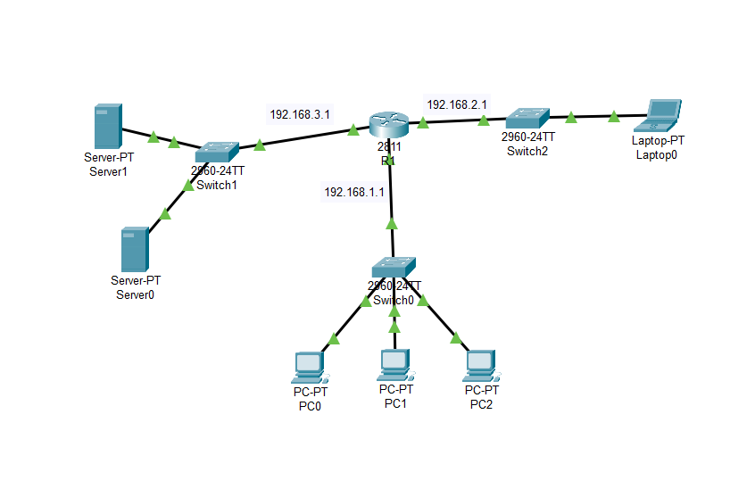

**Commands:**

LAN Configuration:

**R1>CLI>**

* en
* conf t
* Interface gigaEthernet 0/0
* ip address 192.168.1.1 255.255.255.0
* no shut
* exit
* Interface gigaEthernet 0/1
* ip address 192.168.2.1 255.255.255.0
* no shut
* Interface gigaEthernet 0/2
* ip address 192.168.3.1 255.255.255.0
* no shut
* ip dhcp pool dhcp_server1
* network 192.168.1.0 255.255.255.0
* default-router 192.168.1.1
* dns-server 192.168.3.5
* ip dhcp pool dhcp_server2
* network 192.168.2.0 255.255.255.0
* default-router 192.168.2.1
* dns-server 192.168.3.5
* exit

Configure DNS server:

DNS server -> Services -> DNS -> on

Web Server Configuration:

Web server -> Services -> http -> on

**VLAN Topology:**

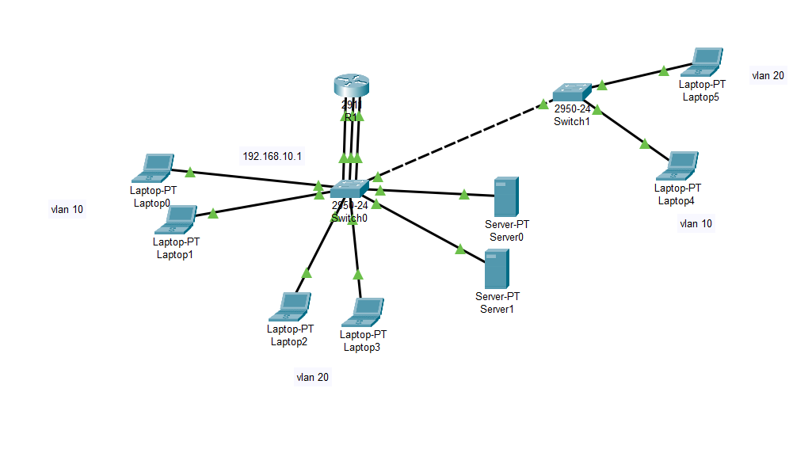

**VLAN 10** = faculties = 192.168.10.0/24

G.W: 192.168.10.1

**VLAN 20** = students = 192.168.20.0/24

G.W: 192.168.20.1

**VLAN30** = server = 192.168.30.0/24

G.W: 192.168.30.1

**Switch0> CLI>**

**Commands:**

* vlan 10
* name faculties
* vlan 20
* name students
* vlan 30
* name servers
* Interface fastEthernet 0/1
* switchport mode access
* Interface range fastEthernet 0/4-5
* switchport access vlan 10
* Interface fastEthernet 0/2
* switchport mode access
* Interface range fastEthernet 0/6-7
* switchport access vlan 20
* Interface fastEthernet 0/3
* switchport mode access
* Interface range fastEthernet 0/8-9
* switchport access vlan 30

**Trunking:**

**Switch1>CLI>**

* Interface fastEthernet 0/10
* switchport mode trunk
* switchport trunk allowed vlan 10,20

**Switch2>CLI>**

* Interface fastEthernet 0/1
* switchport mode trunk
* switchport trunk allowed vlan 10,20
* vlan 10
* name students
* vlan 20
* name faculties
* Interface fastEthernet 0/2
* switchport mode access
* Interface range fastEthernet 0/2
* switchport access vlan 10
* Interface fastEthernet 0/3
* switchport mode access
* Interface range fastEthernet 0/3
* switchport access vlan 20

**Inter VLAN:**

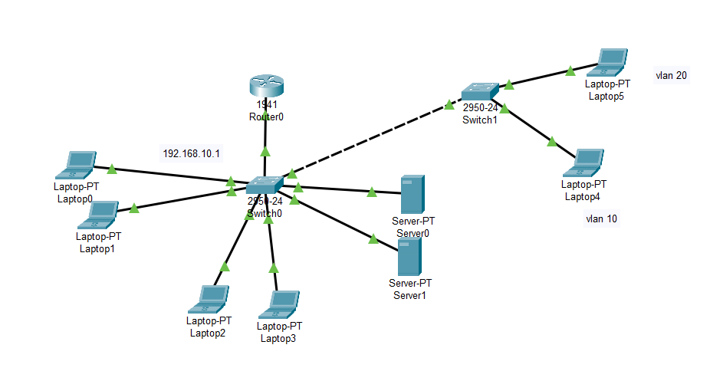

**Swithc0>CLI>**

* Interface fastEthernet 0/1
* switchport mode trunk
* switchport trunk allowed vlan 10,20

**Router0>CLI>**

* Interface gigaEthernet 0/0
* no shut
* exit
* Interface gigaEthernet 0/0.10
* exit
* Interface gigaEthernet 0/0.20
* exit
* Interface gigaEthernet 0/0.30
* exit
* Interface gigaEthernet 0/0.10
* encapsulation dot1Q 10
* ip address 192.168.10.1 255.255.255.0
* exit
* Interface gigaEthernet 0/0.20
* encapsulation dot1Q 20
* ip address 192.168.20.1 255.255.255.0
* exit
* Interface gigaEthernet 0/0.30
* encapsulation dot1Q 30
* ip address 192.168.30.1 255.255.255.0
* exit

**RIP Routing:**

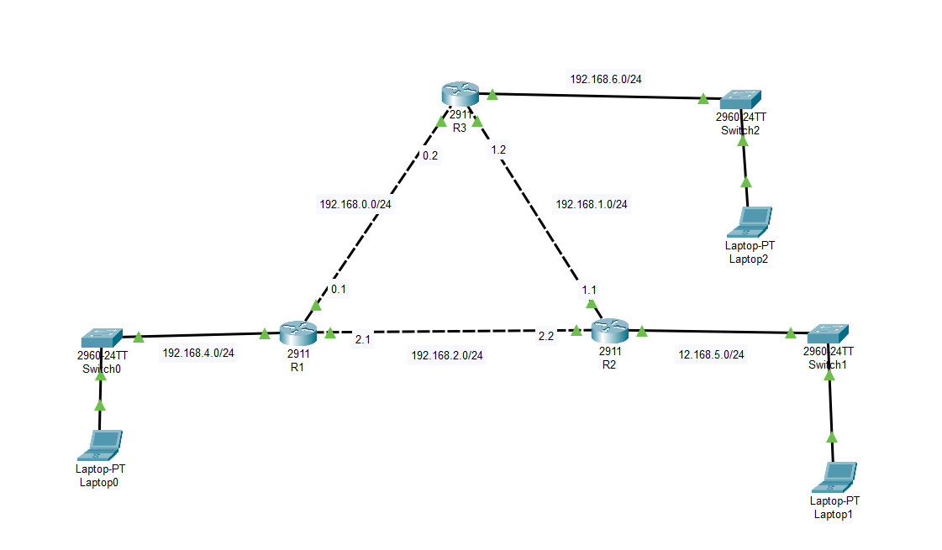

**R1>CLI>**

Commands:

**LAN Configuration:**

* Interface gigaEthernet 0/0
* ip address 192.168.2.1 255.255.255.0
* no shut
* exit
* Interface gigaEthernet 0/1
* ip address 192.168.0.1 255.255.255.0
* no shut
* exit
* Interface gigaEthernet 0/2
* ip address 12.168.4.1 255.255.255.0
* no shut
* exit

**R2>CLI>**

* Interface gigaEthernet 0/0
* ip address 192.168.2.2 255.255.255.0
* no shut
* exit
* Interface gigaEthernet 0/1
* ip address 192.168.1.1 255.255.255.0
* no shut
* exit
* Interface gigaEthernet 0/2
* ip address 12.168.5.1 255.255.255.0
* no shut
* exit

**R3>CLI>**

* Interface gigaEthernet 0/0
* ip address 192.168.0.2 255.255.255.0
* no shut
* exit
* Interface gigaEthernet 0/1
* ip address 192.168.1.2 255.255.255.0
* no shut
* exit
* Interface gigaEthernet 0/2
* ip address 12.168.6.1 255.255.255.0
* no shut
* exit

**R1>CLI>**

* router rip
* version 2
* network 192.168.0.0
* network 192.168.2.0
* network 192.168.4.0

**R2>CLI**

* router rip
* version 2
* network 192.168.1.0
* network 192.168.2.0
* network 192.168.5.0

**R3>CLI>**

* router rip
* version 2
* network 192.168.0.0
* network 192.168.1.0
* network 192.168.6.0

**OSPF Routing:**

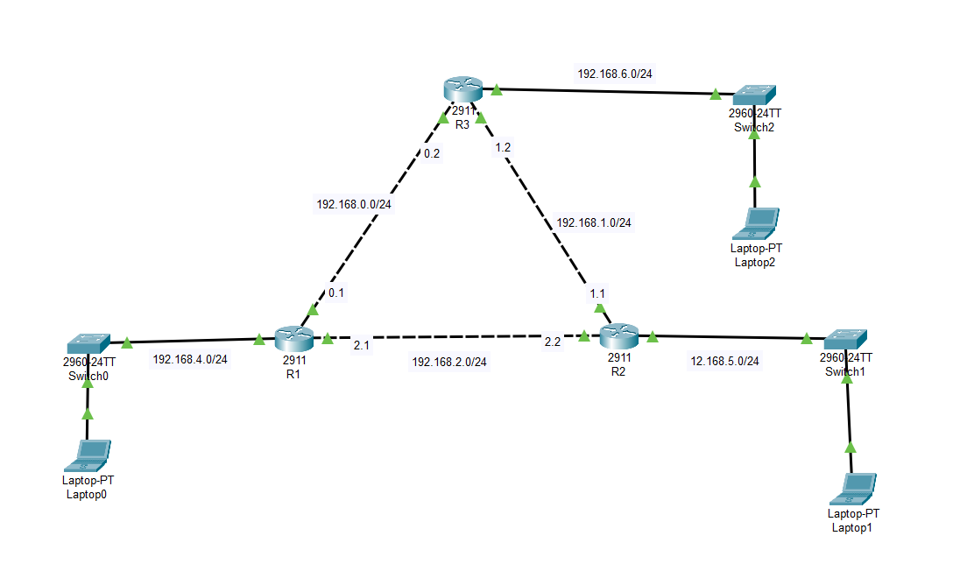

**R1>CLI>**

Commands:

* router ospf 1
* network 192.168.4.0 0.0.0.255 area 0
* network 192.168.2.0 0.0.0.255 area 0
* network 192.168.0.0 0.0.0.255 area 0

**R2>CLI>**

* router ospf 2
* network 192.168.1.0 0.0.0.255 area 0
* network 192.168.2.0 0.0.0.255 area 0
* network 192.168.5.0 0.0.0.255 area 0

**R3>CLI>**

* router ospf 3
* network 192.168.0.0 0.0.0.255 area 0
* network 192.168.1.0 0.0.0.255 area 0
* network 192.168.6.0 0.0.0.255 area 0

**NAT/PAT:**

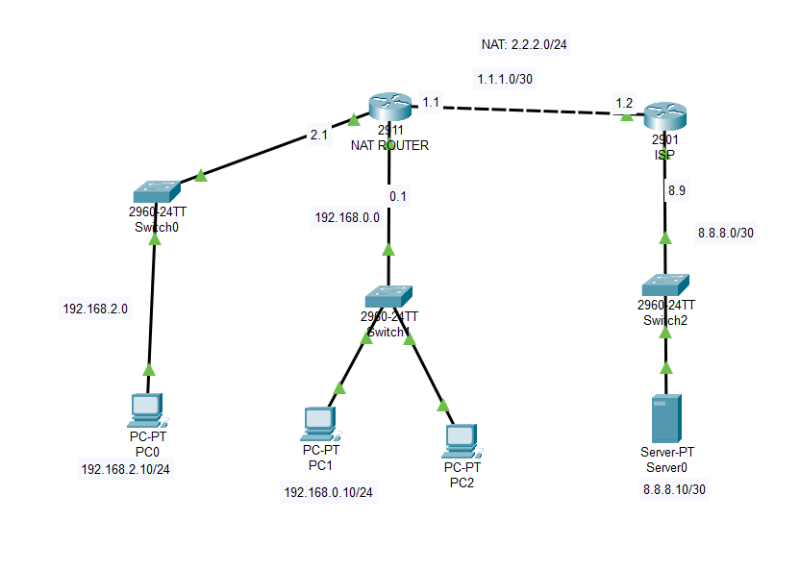

**Lan Configuration:**

**NAT ROUTER>**

* Interface gigaEthernet 0/0
* ip address 192.168.2.1 255.255.255.0
* no shut
* exit
* Interface gigaEthernet 0/1
* ip address 192.168.0.0 255.255.255.0
* no shut
* exit
* Interface gigaEthernet 0/2
* ip address 1.1.1.1 255.255.255.0
* no shut
* exit

**ISP**

* Interface gigaEthernet 0/0
* ip address 192.168.1.2 255.255.255.0
* no shut
* exit
* Interface gigaEthernet 0/1
* ip address 8.8.8.1 255.255.255.0
* no shut
* exit
* ip route 2.2.2.0 255.255.255.0 1.1.1.1

**NAT ROUTER>CLI>**

* ip route 0.0.0.0 0.0.0.0 1.1.1.2
* access-list 1 permit 192.168.0.0 0.0.0.255
* ip nat pool NAT_POOL 2.2.2.1 2.2.2.2 netmask 255.255.255.0
* ip nat inside source list 1 pool NAT_POOL overload
* Interface gigaEthernet 0/0
* ip nat inside
* Interface gigaEthernet 0/1
* ip nat outside

**FINAL ASSIGNMENT:**

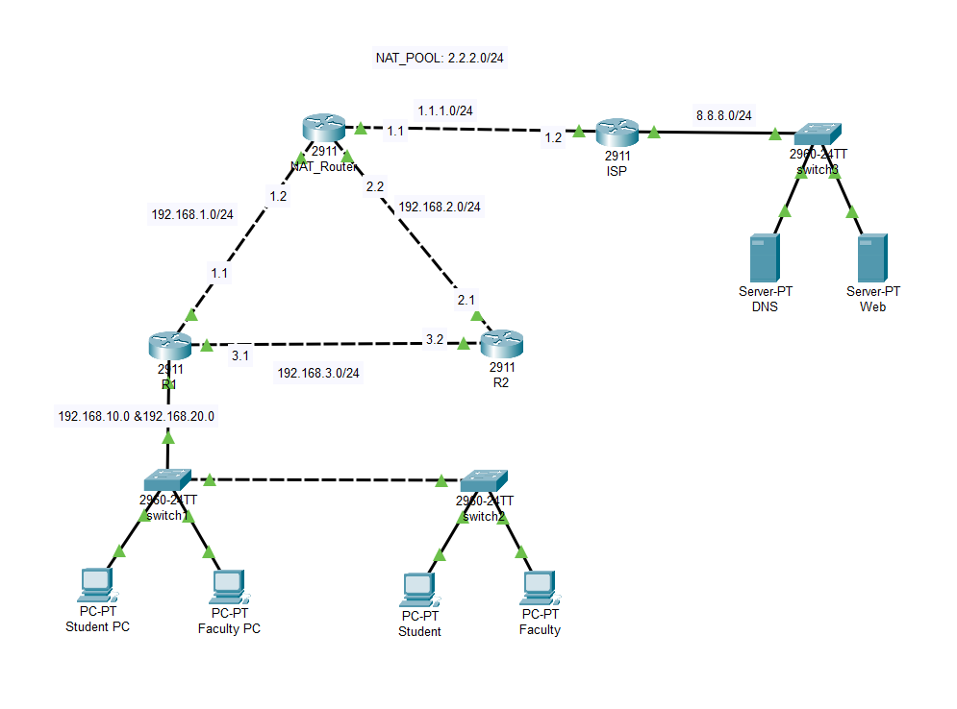

**Configure VLAN:**

**Switch1>CLI:**

* en
* conf t
* vlan 10
* name student
* vlan 20
* name faculty
* exit
* Interface range fastEthernet 0/2-3
* switchport access vlan 10
* Interface range fastEthernet 0/4-5
* switchport access vlan 20
* exit

**Trunking:**

**Switch1>CLI>**

* Interface fastEthernet 0/1
* switchport mode trunk
* switchport trunk allowed vlan 10,20
* Interface fastEthernet 0/10
* switchport mode trunk
* switchport trunk allowed vlan 10,20

**Switch2>CLI:**

* en
* conf t
* Interface fastEthernet 0/1
* switchport mode trunk
* switchport trunk allowed vlan 10,20
* exit
* vlan 10
* name student
* vlan 20
* name faculty
* Interface fastEthernet 0/2
* switchport access vlan 10
* Interface fastEthernet 0/3
* switchport access vlan 20

**Inter-VLAN Configuration:**

**R1>CLI:**

* en
* conf t
* Interface gigaEthernet 0/2
* no shut
* exit
* Interface gigaEthernet 0/2.10
* exit
* Interface gigaEthernet 0/2.20
* exit
* Interface gigaEthernet 0/2.10
* encapsulation dot1Q 10
* ip address 192.168.10.1 255.255.255.0
* exit
* Interface gigaEthernet 0/2.20
* encapsulation dot1Q 20
* ip address 192.168.20.1 255.255.255.0
* exit

**DHCP Configuration:**

**R1>CLI:**

* ip dhcp pool student
* network 192.168.10.0 255.255.255.0
* default-router 192.168.10.1
* dns-server 8.8.8.10
* exit
* ip dhcp pool faculty
* network 192.168.20.0 255.255.255.0
* default-router 192.168.20.1
* dns-server 8.8.8.10
* exit

**RIP Configuration:**

**R1>CLI:**

* en
* conf t
* router rip
* version 2
* network 192.168.1.0
* network 192.168.3.0
* network 192.168.10.0
* network 192.168.20.0
* ip route 0.0.0.0 0.0.0.0 192.168.1.2
* ip route 0.0.0.0 0.0.0.0 192.168.2.2

**R2>CLI:**

* router rip
* version 2
* network 192.168.2.0
* network 192.168.3.0
* ip route 0.0.0.0 0.0.0.0 92.168.2.2

**NAT ROUTER>CLI:**

* router rip
* version 2
* network 192.168.1.0
* network 192.168.2.0

**NAT/PAT Configuration:**

**ISP>CLI:**

* ip route 2.2.2.0 255.255.255.0 1.1.1.1

**NAT ROUTER>CLI:**

* ip route 0.0.0.0 0.0.0.0 1.1.1.2
* access-list 1 permit 192.168.1.0 0.0.0.255
* ip nat pool NAT_POOL 2.2.2.1 2.2.2.2 netmask 255.255.255.0
* ip nat inside source list 1 pool NAT_POOL overload
* Interface gigabitEthernet 0/0
* ip nat inside
* Interface gigabitEthernet 0/1
* ip nat inside
* Interface gigabitEthernet 0/2
* ip nat outside
* access-list 1 permit 192.168.2.0 0.0.0.255
* access-list 1 permit 192.168.10.0 0.0.0.255
* access-list 1 permit 192.168.20.0 0.0.0.255

**DNS Server Configuration:**

DNS server -> Services -> DNS -> on

**Web Server Configuration:**

Web Server -> Services -> Http -> on

**OUTPUT/TESTING:**

**Ping testing:**

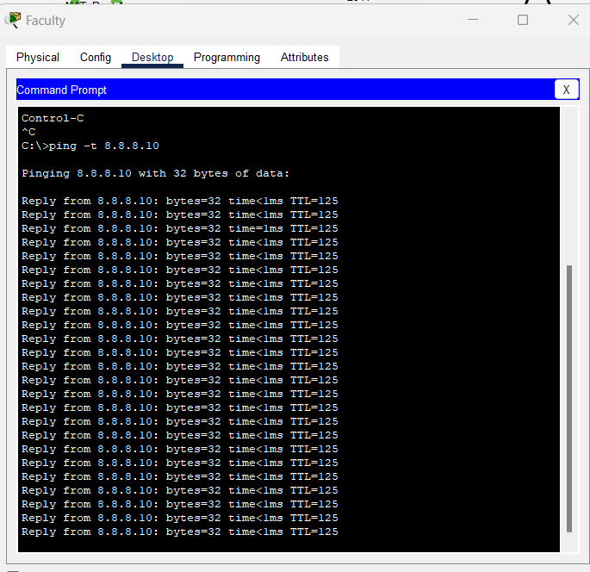

**DNS/Web Server testing:**

