Project Proposal

On

**<<Futsal Management System>>**

Uttam Tamang

00172895

Computing Project

Level 5 Diploma in Computing

Softwarica College of IT and E-Commerce

Kathmandu, Nepal

Jan 4th, 2019

Submitted to: Kiran Rana

**Introduction**

**Project Introduction**

Project that I am currently working on falls under L5DC’s Module Computing Project. Aim of this project is to reflect student’s learning over their three semester of study (L4DC and 1st semester of L5DC) and preparing them for real world project in their respective field of interest.

Futsal Management System is the project that I am working on. The system is all about keeping record of information about clients and their reservation or booking information. Information will be recorded in such a way that it will provide data availability and prevention from data duplication, thus providing systematic management of business process.

**Justification for Project**

**Background of the project**

Project that I am currently developing is mainly focused as solution for handling pre-booking of Futsal Field, that is made by respective customers. System will allow customer to place their booking according to date and time available. So, system will permit customer log in and displays information about date and time for that ground, cost for that ground before booking. As cost for the ground can be varies according to time.

Futsal Management System will be web-based application with **primary focus** of providing user friendly UI, which allows customer can access to application easily and place their booking procedure from anywhere and anytime. This automated system will reduce time consuming paper work and phone calls as well as stores important information in database securely and properly. Database will be kept secure and backup regularly so that efficiency could be maintained and data storing process will become easier.

**Problem Statement**

Currently, organization is fully dependent upon general visit to management office and filling paper-based documentation or unnecessary amount of phone call for placing booking their booking to particular ground on particular time frame. The main problem with this system is that it is complex and time consuming for both management staff and client.

Consequently, booking process is not always easy for clients. Specially, doesn’t allows them to place their booking from anywhere and whenever they want. Because, if they want a reservation, they are bound to be visit in registration office and if they are known clients then they have to make phone calls which will never sure for correct and effective reservation.

So, mission of project has been to providing features which will minimize or completely remove these problems and maintain a healthy relationship among business process and clients.

**Description of the project**

**Features**

Features of the project includes

* User registration (Admin/Client) and login
* Check available timeslots
* Check respective cost according to time
* Place booking (Client)
* Display their booking
* View booking made by clients (Admin)
* Accept/Reject Booking
* Manage personal information’s
* Auto delete function if client doesn’t appear on time.
* Etc.

**Project Scope**

**Scope and Limitation of project**

**Scope**

As per problem statement of project, scope of project is providing functionality that meets requirements specified at problem statement. Which includes mainly about replacing manual task with automated system or other simpler ways. For example, storing record of client’s information with form filling at registration office with physical visit should replace with web-based registration from anywhere user wants. Similarly, good UI design, easy ground reservation, accept and rejection of reservation made and automatic reservation removing functionality as per rules and policy are scope of the project.

**Limitation**

Current project in developed with such vision that it will manage reservation and record keeping/tracking functionalities. However, projects lack upon accepting online payment system. Which requires clients for short visit in office for payment of their reservation.

**Aims and Objectives**

**Following are the Aim and Objectives of project:**

**Aim**

* To maintain customer as well as employee Satisfaction

**Objectives**

* Firstly, all reservation system will made online as well as done from registration office.
* Reduce every possible manual task with automation system.
* User friendly UI design.
* Reliable and secure record system.

**Aim**

* promote sport and healthy environment in society.

**Objectives**

* Providing well facilitated sport ground at possible lower cost.
* Keeping record of user feedbacks and necessary Improvements.
* Providing reward system for customers as per their achieved milestones.

**Development Methodology**

**Methodology Used**

Waterfall methodology is use for development of this project. Waterfall model is commonly used software development methodology guaranteeing the success of the working software. It’s consisting of different phases which ensures your success development process of the project.

Advantage of waterfall model includes:

* Easy to understand and use
* Fixed and clear phases and rules that you have to follow when you move from one phase to another.
* Easy maintenance
* You can review your progression over time
* Well documentation

Diagrammatic representation of waterfall model is given below:

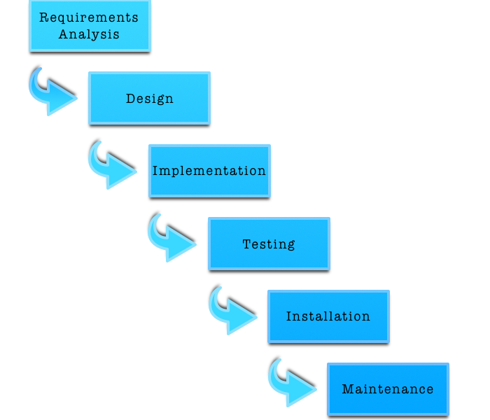

Figure 1 waterfall mode

**Different phases of waterfall model and their goals:**

**Requirement analysis**

* System requirements that need to be established are completely captured and documented.

**System Design**

* With help of first phase of waterfall model system design is prepared in this phase and then overall system architecture is prepared.

**Implementation**

* In this phase, system is developed in small programs which are called units.
* This phase is also known as **Development and Coding**.

**Testing**

* Now, those units get integrated in this phase and perform testing in order to prevent from defects/faults and failure.

**Deployment/Installation of system**

* After testing now software is installed or get released

**Maintenance**

* After installation of software, identified issues and defects gets resolved with release of patches as well as newer versions of that software.

**Design Pattern**

Generally, design patterns are those solution which helps in commonly occurring problem in software design. Usually, they act as template explaining how to solve those problems.

**MVC (Model View Controller) design pattern** is the one which I have choose as it is commonly used architectural pattern for UI design.

It divides system into three different parts yet interconnected with each other and allocate specific responsibilities.

Different parts and their responsibilities:

**Model**

* Central part and independent to UI
* It manages data, logic, rules of the application
* It receives data od an application with help of controller

**View**

* Basically, view handles UI design of an application

**Controller**

* It accepts user inputs and translate it as command for Model or View.

Advantage of MVC design pattern are as follows:

* It allows simultaneous development of divided parts i.e. Model, View and Controller
* Low coupling in system architecture
* High cohesion in code structure
* It facilitates multiple view for model.

**Diagrammatic representation of design pattern is given below:**

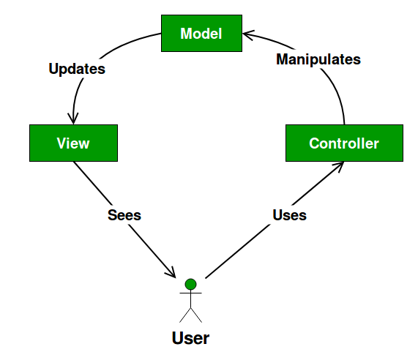

Figure 2 MVC design pattern

**System Architecture**

Structural design of a system that automates work is known as system architecture (Anon., 2018). Also, it can be defined as conceptual model which represents structure, behavior and view of your system. It involves system components and developed sub-system together to implement complete system.

In this project I am going to use 3-tire system architecture which is also commonly known as Client-Server architecture in this architecture functional process logic, data access, data recording system and UI design are developed and maintained as independent modules on separate platforms. (Anon., 2018)

**Three layers of 3-tire architecture are:**

* **Presentation layer**

Displays view of your system i.e. UI. It sends contents to browser in form of HTML/CSS/JS.

* **Application layer**

Application server is used and processes business logic for an application.

* **Data layer**

It is simply Database management system, which lets you access over application data.

**Diagrammatic representation of 3-tire system architecture is:**

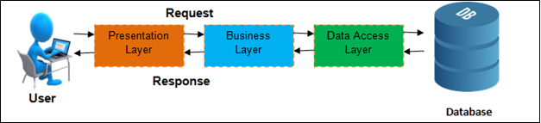

Figure 3 3-Tier Architecture

**Why 3-tire over 2-tire system architecture?**

2-tire architecture involves direct interaction between client with server but 3-tire includes business layer in between client and server thus maintaining extra layer of security. The reason behind choosing 3-tire system architecture over 2-tire system architecture is because, 3-tire architecture provides greater scalability and data security. And client data availability is very important in present technology.

**Work Breakdown Structure (WBS)/Scheduling**

Work breakdown structure is simply a process of breaking down your project into smaller manageable parts, so that you can understand and manage easily as well as more effectively. Generally, WBS is represented as Tree like structure with different task and their interrelated sub tasks.

Diagrammatic representation of WBS scheduling is:

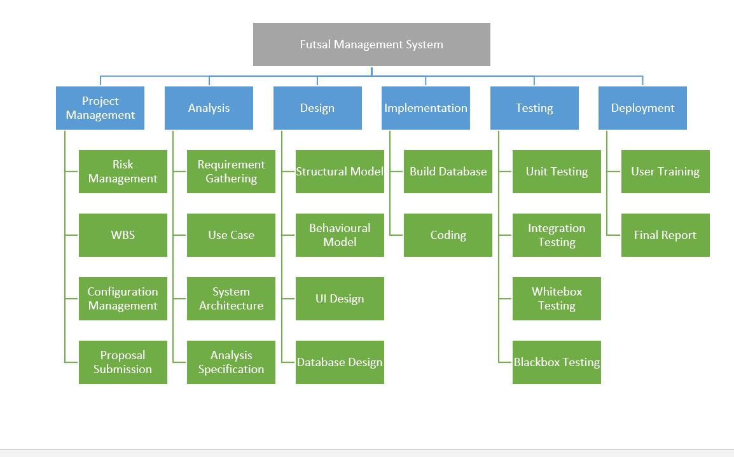

Figure 4 WBS Scheduling

**4.2 Milestones**

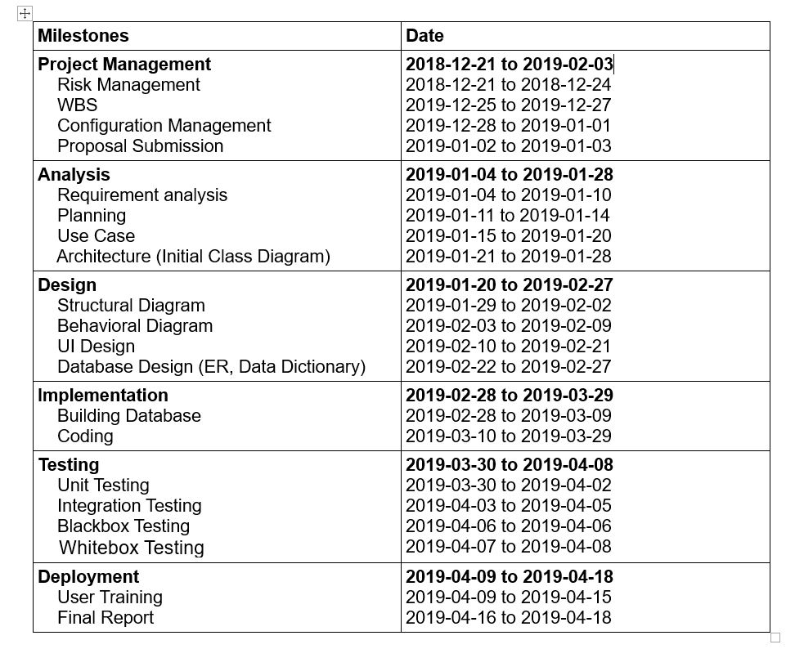

Figure 5 Milestone

**Description of Milestones:**

* **Project Management (14 days)**
  + 4 days for Risk Management
  + 3 days for WBS
  + 5 days for Configuration Management
  + 2 days for Proposal Submission
* **Analysis (25 days)**
  + 7 days for Requirement Analysis
  + 4 days for Use Case Diagram
  + 6 days for Architecture (Initial class diagram)
  + 8 days for Analysis Specification
* **Design (30 days)**
  + 5 days for Structural Model
  + 7 days for Behavioral Model
  + 12 days for UI Design
  + 6 days for Database Design
* **Implementation (30days)**
  + 10 days for Build Database
  + 20 days for Coding
* **Testing (10 days)**
  + 4 days for Unit Testing
  + 3 days for integration Testing
  + 1 days for Blackbox testing
  + 2 days for Whitebox testing
* **Deployment (10 days)**
  + 7 days for User training
  + 3 days for Final report

**Scheduling / Gantt Chart**

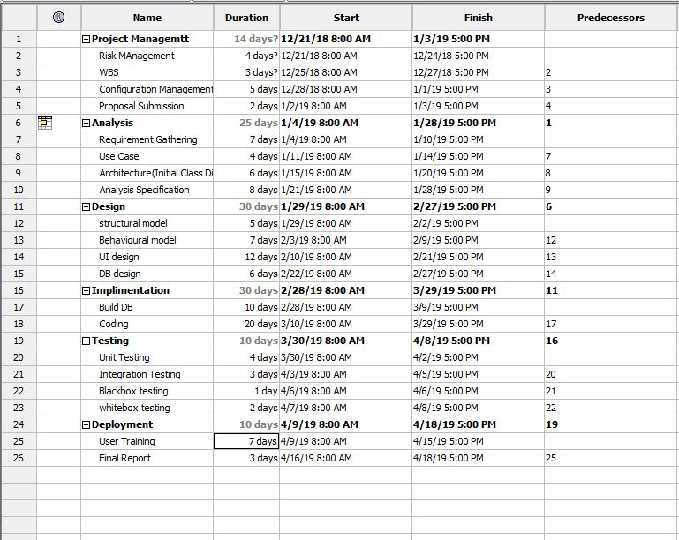

Figure 6 Gantt chart1

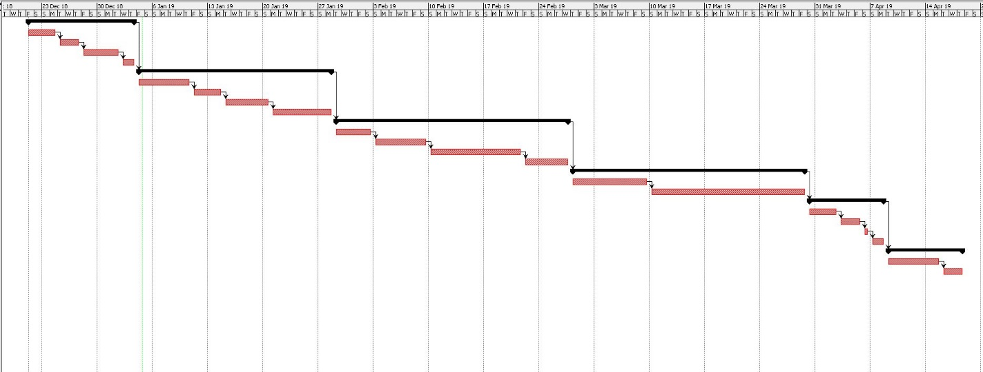

Figure 7 Gantt chart 2

**Risk Management**

Method of finding, evaluating and monitoring threats for completion of project and minimizing probability of risk and prioritization of risk is known as Risk Management for that project. Lack of resources, financial uncertainty, legal issues, strategies failure, server failure, natural disaster are common threats for development of a project. (Anon., 2016)

Some potential threats, their impact on project and Solutions:

|  |  |  |  |  |  |
| --- | --- | --- | --- | --- | --- |
| **SN** | **Risk** | **Likelihood** | **Consequences** | **Impact** | **Solution** |
| 1. | Insufficient resources | 2 | 3 | 6 | Keep each and every resource that you are going to use in a sufficient amount. |
| 2. | Server failure | 1 | 5 | 5 | Facility of a backup system can be done. Either cloud based or physical. |
| 3. | Delay in Development | 2 | 5 | 10 | Strict scheduling and planning with collaboration among team will lead to quicker development. |
| 4. | Productivity Issues of developers | 2 | 4 | 8 | By not taking lightly any project and keeping motivated to every member will overcome this issue. |
| 5. | Badly Designed UI | 1 | 4 | 4 | With preforming good requirement gathering as well as collaborative UI designing between user and Developer be solution for this. |
| 6. | Uncertain Growth of requirements | 1 | 4 | 4 | Having certain level of contract between client and developer and good requirement analysis solve this issue. |
| 7. | Overly Featured | 2 | 2 | 4 | By preventing developer from show off their skill by adding unnecessary features. |
| 8. | Financial Issues | 1 | 4 | 4 | Always schedule and planning budget accordingly will help with this situation. |
| 9. | Outdated Developer’s Skill | 1 | 5 | 5 | Employee training and encouraging for learning new skill will solve this problem. |

**6. Configuration Management**

Configuration management of a project refers to collection of processes, activities, tools and methods which is performed by professionals to manage items and resources during the project life cycle. Usually, administrators or professionals uses configuration management to authenticate a change made during to one configuration item has on other systems. These items could be both hardware or software even documentations.

**7. Conclusion of the project**

**8. References**