



Android project proposal

On

**House Buying/Selling/Renting Platform**

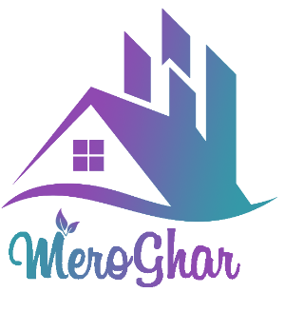

Submitted by: Uttam Tamang

Batch: Sep 2019 Section C

Module Leader: Kiran Rana

**Table of Contents**

**1. Introduction** 3

**a. Project Introduction** 3

**b. Justification of the project** 3

**Background of the project** 3

**Problem Statement** 3

**c. Description of the project** 3

**Feature of the project includes:** 3

**2. Aims and Objective of the project** 4

**3. Development Methodology** 4

**a. Description of the methodology** 4

**b. Design Pattern** 6

**4. Configuration Management** 7

**5. Prototyping** 8

**6. Conclusion** 14

**7. References** 14

# **1. Introduction**

## **a. Project Introduction**

**MeroGha**r is the mobile application that operates under Android OS, and it is developed with the purpose of simplifying and providing a platform to search houses/properties for buying, selling or renting services. It is an online marketing platform where the buyer/tenant and seller/owner can communicate each other directly without a middleman about their properties. Hence, MeroGhar operates as a bridge between the buyer and the seller.

My task for this project involves designing and implementing the mobile application that allows authenticated user to add their properties, view list of others properties and make transaction via their android phones/tablets. Likewise, I will be responsible to design system in such an away that improves user experience and meets every functionality that is essential for these types of system.

## **b. Justification of the project**

### **Background of the project**

There are various websites, mobile phone applications around android market but Lacks in knowledge of existing system as well as complex and not having user friendly user interface are reason for people to choose middleman for searching these properties.

This project will outshine those flaws of existing system by providing safe, secure and reliable solution. The major vision of this system is to connect genuine users, cut off cost of middleman as well as provide them large number of property options so that they don’t have to make unnecessary compromises and ensures higher user satisfaction.

### **Problem Statement**

Even though many tasks can be done via online, searching real estate properties are done via different contacts/middleman. These contacts can be relatives, friends or real estate agents. The major drawbacks of this process are it becomes costly, hectic, time consuming and even doesn’t allow to have multiple choices as it have limited information about those types of properties. Which results in settle down for properties that they might not be interested in, as well as forces to make compromises.

## **c. Description of the project**

Description of MeroGhar can be explained through its features.

### **Feature of the project includes:**

* **Login and Registration**

System will allow any type of users (Buyer/tenant or Owner/Seller) to register themselves and log in into system.

* **Adding new property details**

Seller/Owner will be allowed to post their property details.

* **Updating new property**

Seller/Owner will be allowed to Edit or Update their property details.

* **Delete/Remove property**

Seller/Owner will be allowed to delete or remove their property as their needs.

* **Search property**

Buyer/Tenant will allow to search for properties as their requirements (location, costs etc.)

* **Filter/Shorting (location, Property type, Cost)**

This feature will help buyer/tenant for shorting property list as per their requirements.

* **Adding property into Wishlist**

After finding appropriate properties buyer/tenant can pin property in their Wishlist which will help them in unnecessary searching of that property next time as well as allows them to search others.

* **Posting comment**

When user find doubts about property, they will be allowed to post their comment to that property for clarifications.

* **Reporting suspicious property detail**

If user finds some property to be suspicious(fake) they will allow to report that post, where higher level User (Admin) can had a look on it and take appropriate actions.

* **Location finding**

This will include within property details so buyers/tenants will simply get an idea about surrounding places with that property.

# **2. Aims and Objective of the project**

**Aim**

To develop a platform under Android OS, that connects different interested users and simplifies buying/selling/renting process of a house/property via android devices.

**Objectives**

* Effective plan for Development of system.
* Development of simple User Interface
* Includes Security Mechanism
* Continuous take feedbacks and make improvements
* Risk Management Processes

# **3. Development Methodology**

## **a. Description of the methodology**

Waterfall model is one of the best software development methodology with ensuring the success development of the software. It falls under hard approach od software development which mean you have to follow development rules, where it contains its pre-defined and well-arranged phases to ensure successful development of the software. Thus, I have chosen waterfall methodology as my development methodology of the project.

Waterfall methodology holds following advantages:

* Methodology is easy to understand as well as easy to use
* Fixed and clear phases and rules that you have to follow when you move from one phase to another.
* Maintenance process is easy
* Review your progression overtime
* Well documentation

**Different phases of waterfall model and their goals:**

**Requirement analysis**

* Requirements of the system is collected and documented.

**System Design**

* Design of the system as well as system architecture is prepared in this step with help of collected requirements

**Implementation**

* This phase is also known as **Development and Coding**.
* In this phase, system is developed in small programs which are called units.

**Testing**.

* Now those units get integrated and tested to search for faults and failures.

**Deployment/Installation of system**

* After successful testing of the software, now it gets installed or released

**Maintenance**

* After installation of software, identified issues and defects gets resolved with release of patches as well as newer versions of that software.

**Diagram of Waterfall model.**

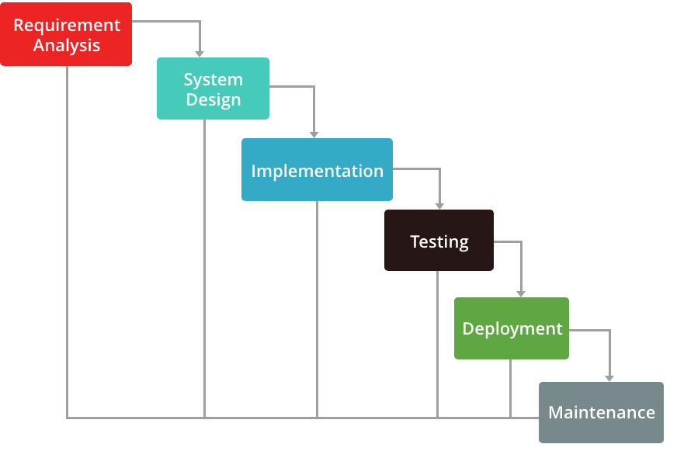

Figure 1 Waterfall Model

## **b. Design Pattern**

Design patterns are simply work as a template or a blueprint that help you to overcome perticular design problem in your code explaining how to solve them. They are typical solution and usually helps in common problems in software design.

**MVC (Model View Controller) design pattern** is the one which I have choose as it is commonly used architectural pattern for UI design.

It divides system into three different parts yet interconnected with each other and allocate specific responsibilities.

Different parts and their responsibilities:

**Model**

* Central part and independent to UI
* It manages data, logic, rules of the application
* It receives data of an application with help of controller

**View**

* Basically, view handles UI design of an application

**Controller**

* It accepts user inputs and translate it as command for Model or View.

**Advantage of MVC design pattern are as follows:**

* It allows simultaneous development of divided parts i.e. Model, View and Controller
* Low coupling in system architecture
* High cohesion in code structure
* It facilitates multiple view for model.

**Diagram of MVC Design Pattern.**

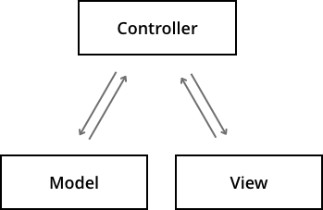

Figure 2 MVC Design pattern

# **4. Configuration Management**

Configuration management of a project refers to collection of processes, activities, tools and methods which is performed by professionals to manage items and resources during the project life cycle. Usually, administrators or professionals uses configuration management to authenticate a change made during to one configuration item has on other systems. These items could be both hardware or software even documentations.

Git provide **version control** mechanism which will be provide extra edge in development, maintenance and backup of the system. Version control simply means a system that records changes in a file or collection of files over time so that you can recall specific version later.

Thus, I have used git as my configuration management (back up) tool.

**GitHub Screenshot**

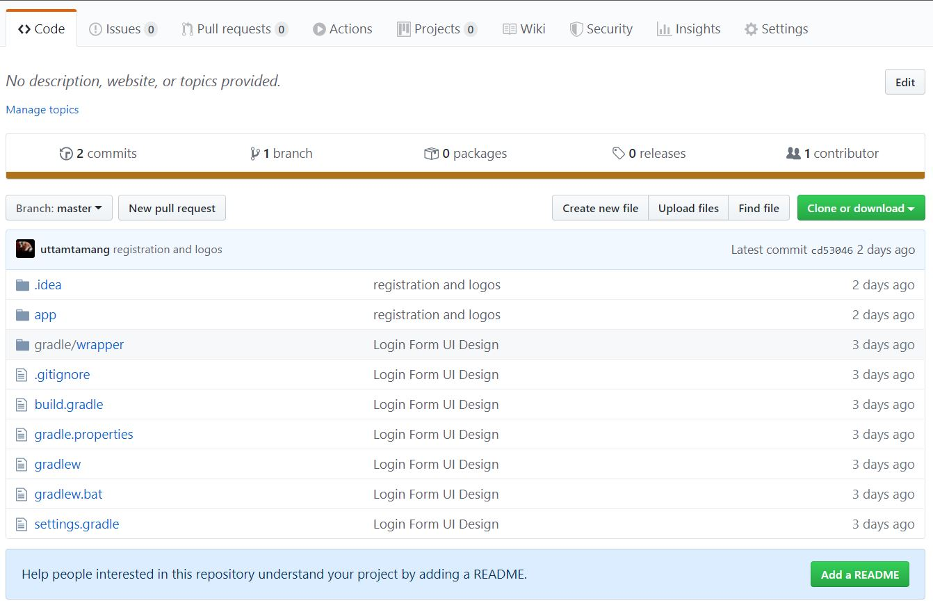

Figure 3 GitHub Screenshot

# **5. Prototyping**

Prototyping is usually a part of Requirement analysis part of a software development life cycle, where development process of a model of a system is carried out. However, it is an iterative process and these models are simply designed in order to help system designer build an information system that is efficient and easy to use by end user. (Anon., 2012)

Advantages of Prototyping includes:

* Development time gets minimized.
* Development cost gets minimized.
* Promotes user involvement.
* Continuous feedback process.
* Maintain satisfaction for both end user and developer
* Development transparency

**Login Form**

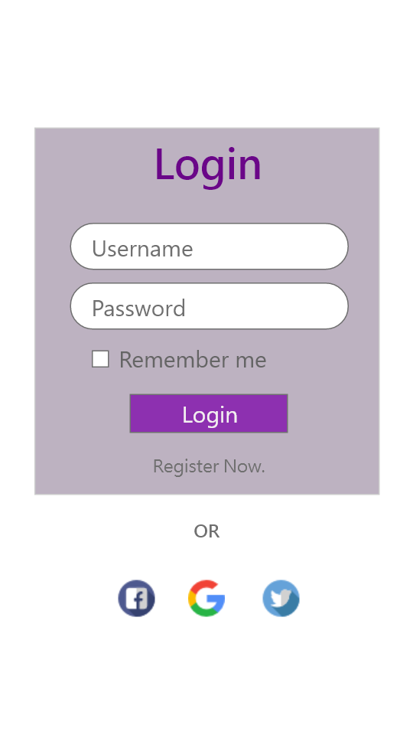

Figure 4 Log in System

**Registration**

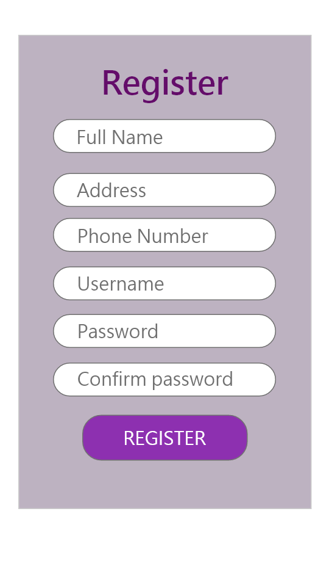

Figure 5 Registration Form

**Dashboard**

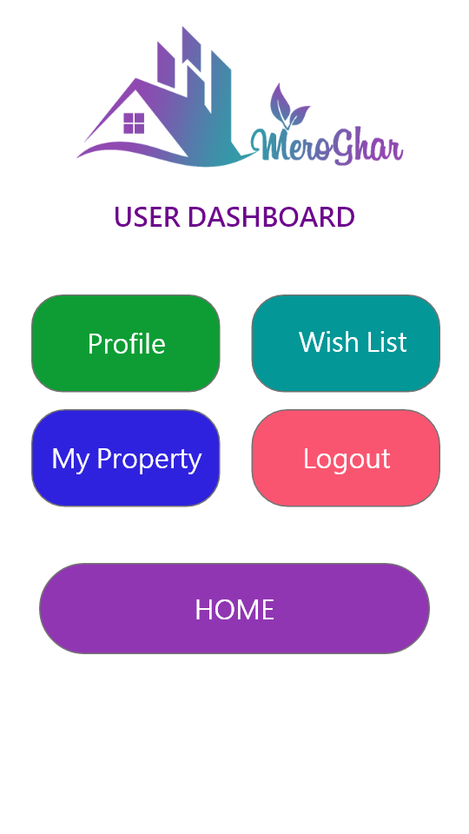

Figure 6 Dashboard

**Home**

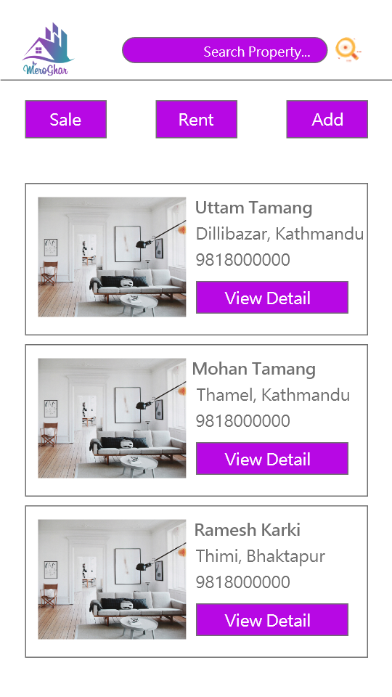

Figure 7 Home Page

**Detail** **View**

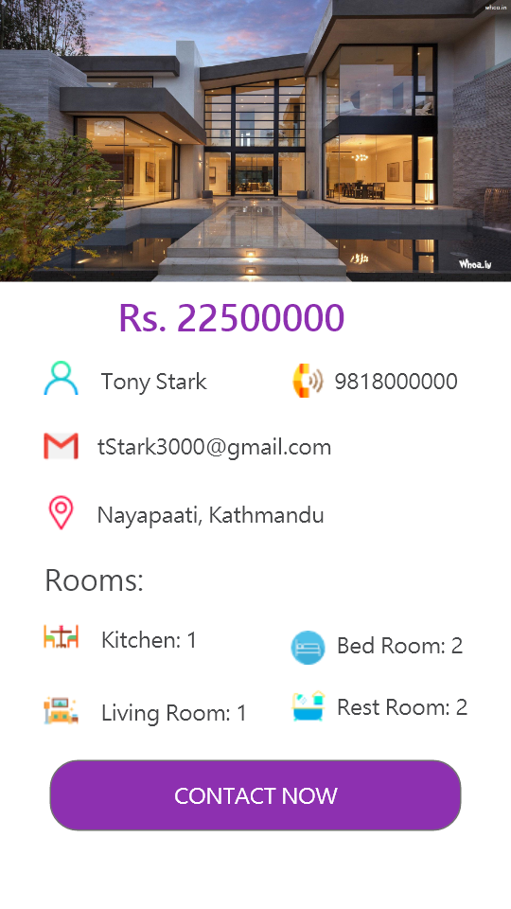

Figure 8 View Detail Page

# **6. Conclusion**

Completion of this proposal was able to outline my aim, objectives and major features of my project/software along with used software development methodology and Design pattern. Similarly, this documentation will provide information about what my project, what are its advantages, where will it can be implemented and who are the users for this system. Likewise, I have included several UI designs prototypes which will further adds up how system will expected to look.

However, this is not finalized product. Final product will be much richer in feature, Designs and other performance improvements.

# **7. References**

Anon., 2012. *umsl.edu.* [Online]   
Available at: http://www.umsl.edu/~sauterv/analysis/prototyping/proto.html#:~:targetText=Prototyping%20is%20the%20process%20of,to%20manipulate%20for%20end%20users.  
[Accessed 27 11 2019].

Anon., 2016. *refactoring.guru.* [Online]   
Available at: https://refactoring.guru/design-patterns  
[Accessed 27 11 2019].