##################################################################################

############################# LOGISTIC ~ REGRESSION ##############################

##################################################################################

#### Importing packages and loading dataset ############

import pandas as pd

import numpy as np

import matplotlib.pyplot as plt

affair_data= pd.read_csv("C:\\Users\\home\\Desktop\\Data Science Assignments\\Python_codes\Logistic_Regression\\affairs.csv")

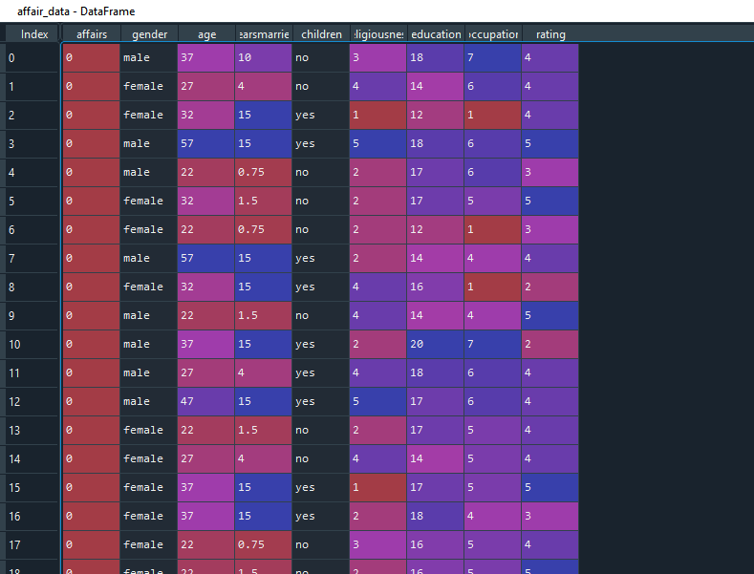

########### DATA CLEANING ########################

affair_data.head(5)

affair_data.isnull()#so there are no null or missing values in the dataset

affair_data.duplicated(subset=None, keep='first')#there are no duplicate values

############### Exploratory data analysis(EDA) ################

affair_data.describe()

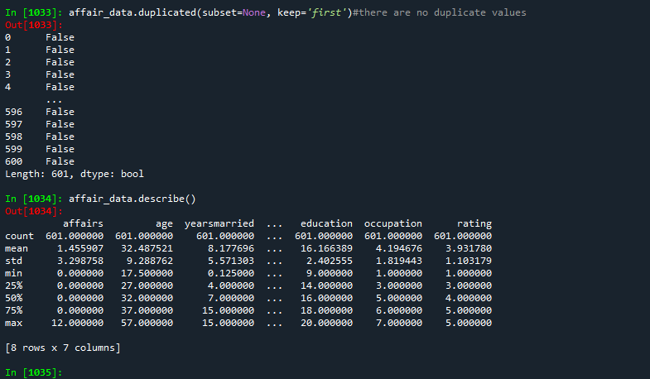

affair_data.columns

# Getting the barplot for the categorical columns

import seaborn as sb

sb.countplot(x="gender",data=affair_data,palette="hls")

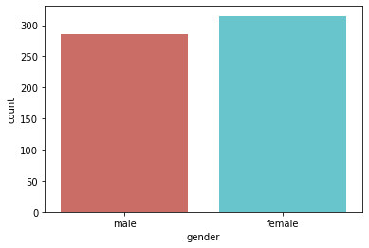

sb.countplot(x="children",data=affair_data,palette="hls")

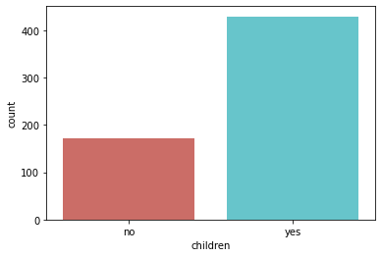

affair_data["gender"].value_counts()

#female 315

#male 286

affair_data["age"].value_counts()

affair_data["yearsmarried"].value_counts()

affair_data["religiousness"].value_counts()

affair_data["education"].value_counts()

affair_data["occupation"].value_counts()

affair_data["rating"].value_counts()

plt.boxplot(affair_data["age"])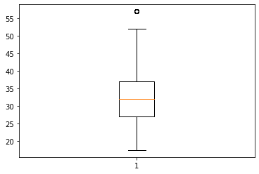

plt.boxplot(affair_data["yearsmarried"])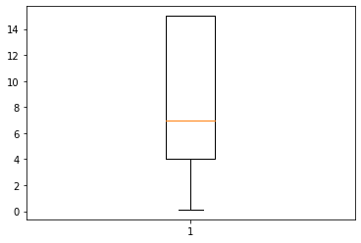

plt.boxplot(affair_data["education"])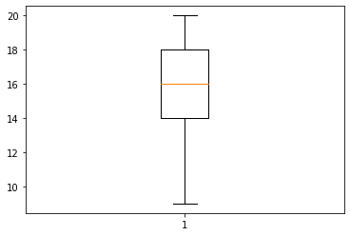

plt.boxplot(affair_data["occupation"])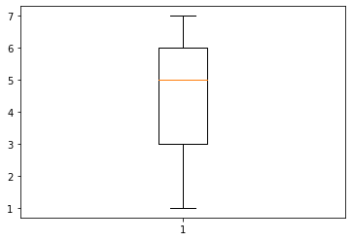

plt.boxplot(affair_data["rating"])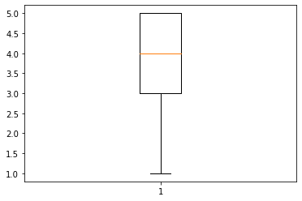

plt.boxplot(affair_data["religiousness"])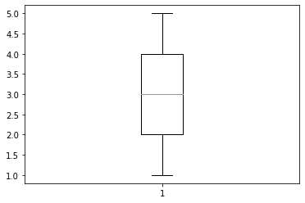

plt.boxplot(affair_data["affairs"])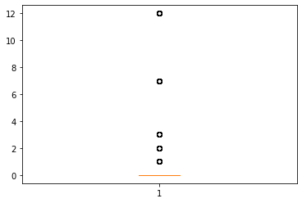

#calculating the interquantile range

q25 = affair_data.quantile(0.25)#lower 25%

q75 = affair_data.quantile(0.75)#upper 25%

iqr= q75-q25 #50% of the data

lower_bound = q25 - (1.5 * iqr)

upper_bound = q75 + (1.5* iqr)

out_25= (affair_data < (q25 - (1.5 * iqr)))

out_75 = (affair_data> (q75+(1.5 * iqr)))

#we now have the IQR scores, it’s time to get hold on outliers.

#The above code will give an output with some true and false values.

#The data point where we have False that means these values are valid whereas True indicates presence of an outlier.

##Checking for outliers below lower_bound.

out_25["age"].value_counts()

out_25["affairs"].value_counts()

out_25["children"].value_counts()

out_25["education"].value_counts()

out_25["gender"].value_counts()

out_25["occupation"].value_counts()

out_25["rating"].value_counts()

out_25["religiousness"].value_counts()

out_25["yearsmarried"].value_counts()

## There are no outliers below lower bound.

## Checking for outliers above upper bound

out_75["age"].value_counts() ## 22 are outliers

out_75["affairs"].value_counts() ## 150 are outliers

out_75["children"].value_counts()

out_75["education"].value_counts()

out_75["gender"].value_counts()

out_75["occupation"].value_counts()

out_75["rating"].value_counts()

out_75["religiousness"].value_counts()

out_75["yearsmarried"].value_counts()

## There are no outliers above upper bound.

## log transformation for age, to convert the outliers

x= np.log(affair_data["age"])

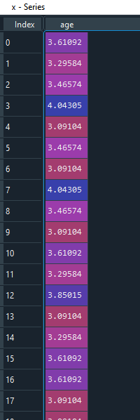

plt.boxplot(x)

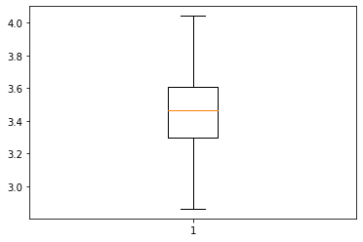

q_25 = np.log(affair_data["age"]).quantile(0.25)

q_75 = np.log(affair_data["age"]).quantile(0.75)

iqr2 = q_75-q_25

lower_bound_one = q_25 - (1.5 * iqr2)

upper_bound_one = q_75 + (1.5* iqr2)

out_25_one= (np.log(affair_data["age"]) < lower_bound_one)

out_75_one = (np.log(affair_data["age"])> upper_bound_one)

out_25_one.value_counts()## no outliers

out_75_one.value_counts()## no outliers

affair_data.isnull().sum()# no null values

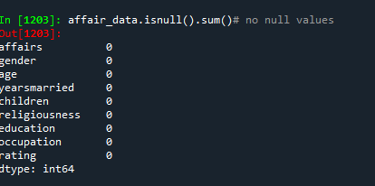

## Creating dummies for gender and children

affairs_dummy = pd.get_dummies(affair_data[["gender","children"]])

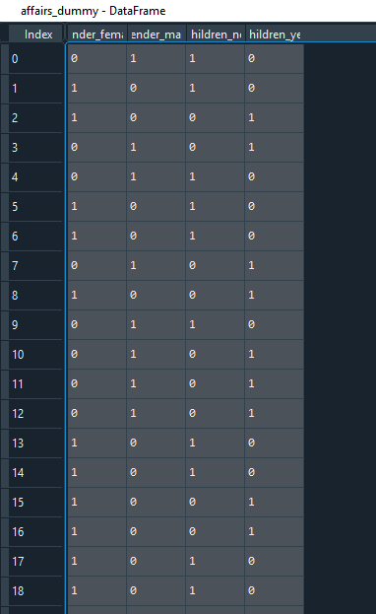

#affair2 =pd.get_dummies(affair,drop_first =True)

affair1= affair_data.drop(["gender"], axis=1)

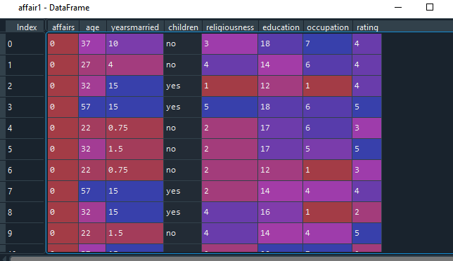

affair2 = affair1.drop(["children"],axis=1)

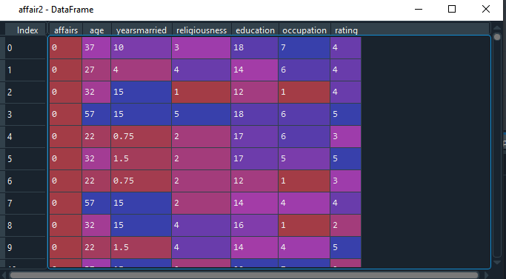

affair2= pd.concat([affair2,affairs_dummy],axis=1)

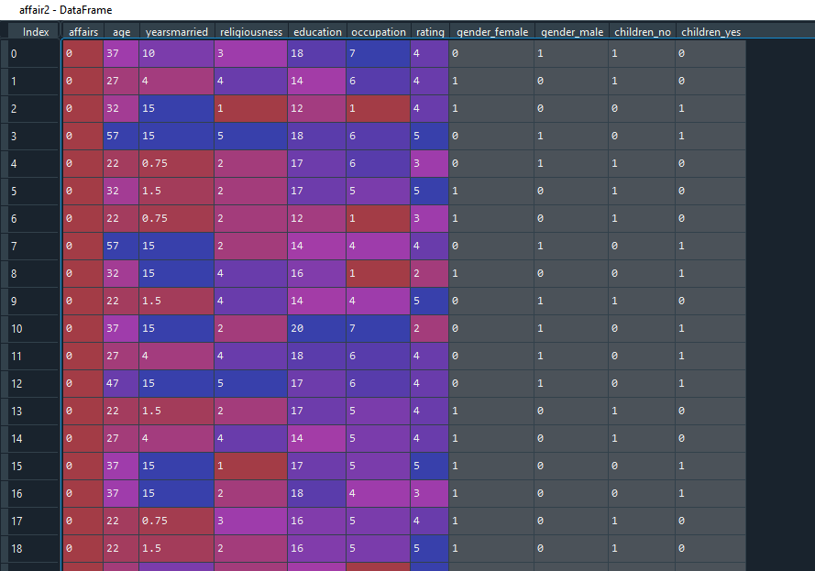

affair2["AF"]=1

affair2.loc[affair2.affairs==0,"AF"]=0

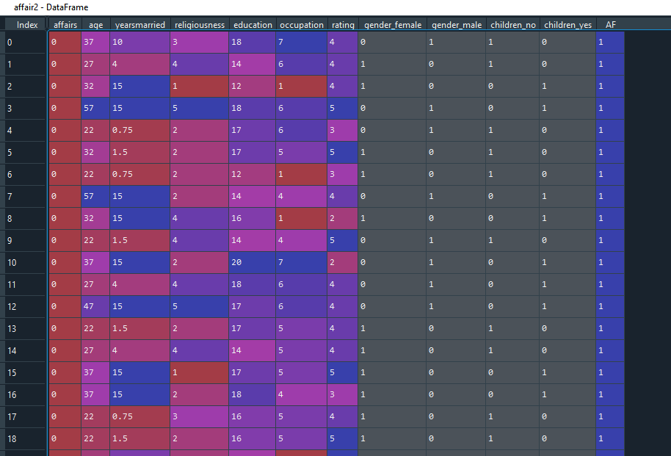

affair2=affair2.drop(["affairs"],axis=1)

affair2=affair2.iloc[:,[10,0,1,2,3,4,5,6,7,8,9]]

affair2.info()

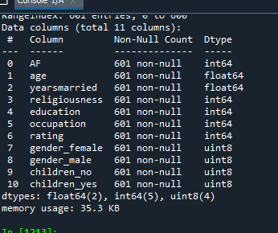

## coverting religiousness and rating into factors, as it is ordinal data

affair2["religiousness"]= pd.Categorical(affair2["religiousness"])

affair2["rating"]=pd.Categorical(affair2["rating"])

#affair2["occupation"]=pd.Categorical(affair2["occupation"])

#affair2["gender_male"]=pd.Categorical(affair2["gender_male"])

#affair2["children_yes"]= pd.Categorical(affair2["children_yes"])

#creating the model

from sklearn.model_selection import train_test_split

train_data,test_data = train_test_split(affair2,test_size = 0.2)

train_data.to_csv("training_data.csv",encoding="utf-8")

test_data.to_csv("testing_data.csv",encoding= "utf-8")

import statsmodels.formula.api as sm

## trailone

model_one = sm.logit("AF~np.log(age)+yearsmarried+religiousness+rating+occupation+education+gender_female+gender_male+children_no+children_yes", data= train_data).fit()

model_one.summary()

model_one.summary2()

## AIC= 503.2311

from scipy import stats

import scipy.stats as st

st.chisqprob = lambda chisq, df:stats.chi2.sf(chisq,df)

y_pred = model_one.predict(train_data)

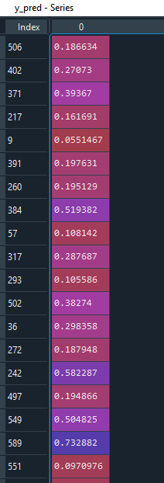

train_data["pred_prob"]=y_pred

train_data["Af_val"]=np.zeros(480)

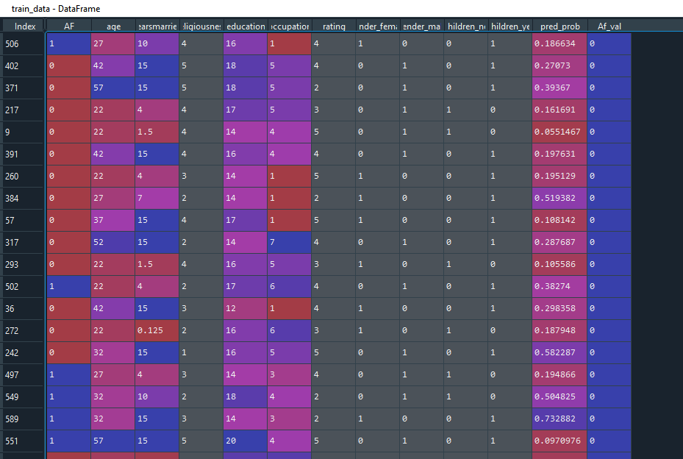

train_data.loc[y_pred>=0.50,"Af_val"]=1

train_data.Af_val

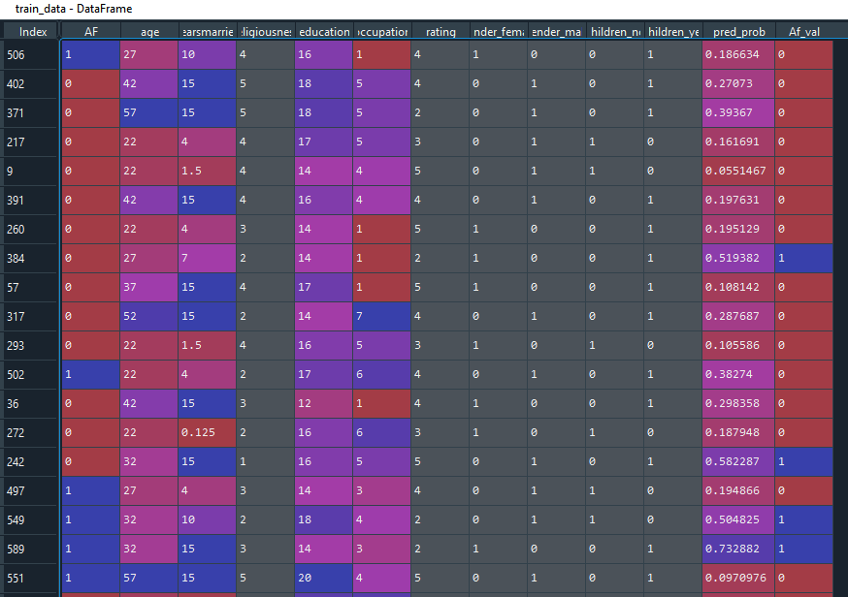

from sklearn.metrics import classification_report

classification = classification_report(train_data["Af_val"],train_data["AF"])

#confusion matrix

confusion_matrx = pd.crosstab(train_data["AF"],train_data["Af_val"])

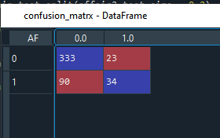

##accuracy

accuracy = (333+34)/(333+34+23+90) ##0.7645833333333333

76.5%

##ROC curve

from sklearn import metrics

#fpr=> false positive rate

#tpr=> true positive rate

fpr,tpr,threshold = metrics.roc_curve(train_data["AF"], y_pred)

plt.plot(fpr,tpr);plt.xlabel("False positive rate");plt.ylabel("True positive rate")

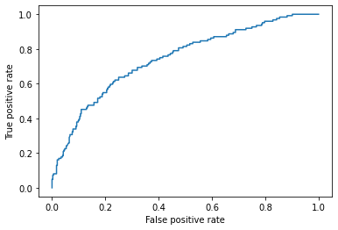

roc_auc = metrics.auc(fpr,tpr) ## 0.7436004893077202

## test data

test_pred = model_one.predict(test_data)

test_data["pred_test"] = test_pred

test_data["test_val"]= np.zeros(121)

test_data.loc[test_pred>=0.5,"test_val"]=1

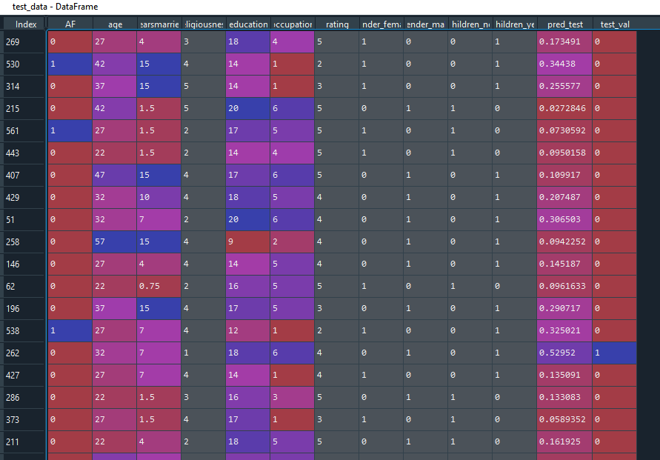

## confusion matrix

confusion_matrix_test1 = pd.crosstab(test_data["AF"],test_data["test_val"])

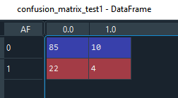

##accuracy

accuracy_test= (85+4)/(85+4+22+10) ## 0.7355371900826446

############ trails for perfect cut-off value 0.58

y_pred1 = model_one.predict(train_data)

train_data["pred_prob1"]=y_pred1

train_data["Af_val1"]=np.zeros(480)

train_data.loc[y_pred1>=0.58,"Af_val1"]=1

train_data.Af_val1

train_data["Af_val1"].value_counts()

#0.0 447

#1.0 33

from sklearn.metrics import classification_report

classification = classification_report(train_data["Af_val1"],train_data["AF"])

#confusion matrix

confusion_matrx1= pd.crosstab(train_data["AF"],train_data["Af_val1"])

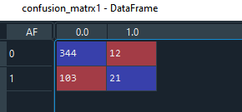

##accuracy

accuracy1 = (344+21)/(344+21+12+103)## 0.7604166666666666

fpr2,tpr2,threshold2 = metrics.roc_curve(train_data["AF"], y_pred1)

plt.plot(fpr2,tpr2);plt.xlabel("False positive rate");plt.ylabel("True positive rate")



roc_auc1 = metrics.auc(fpr, tpr) ##0.7436004893077202

## test data

test_pred1 = model_one.predict(test_data)

test_data["pred_test1"] = test_pred1

test_data["test_val1"]= np.zeros(121)

test_data.loc[test_pred>=0.58,"test_val1"]=1

## confusion matrix

confusion_matrix_test2 = pd.crosstab(test_data["AF"],test_data["test_val1"])

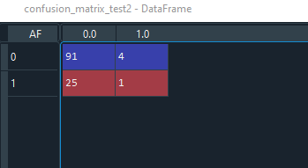

##accuracy

accuracy_test1= (91+1)/(25+4+91+1) ## 0.7603305785123967

########################################################trail two##############################################

### as all the variables are insignificant i would remove education, occupation, gender and children to build the model.

model_two = sm.logit("AF~np.log(age)+yearsmarried+religiousness+rating", data = train_data).fit()

model_two.summary()

model_two.summary2()

#AIC: 500.3136

y_pred2 = model_two.predict(train_data)

train_data["pred_prob2"]=y_pred2

train_data["Af_val2"]=np.zeros(480)

train_data.loc[y_pred2>=0.5,"Af_val2"]=1

classification1 = classification_report(train_data["Af_val2"],train_data["AF"])

## confusion matrix

confusion_matrix2 = pd.crosstab(train_data["AF"], train_data["Af_val2"])

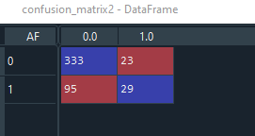

## accuracy

accuracy2 = (333+29)/(333+29+23+95)

##0.7541666666666667

fpr3,tpr3, threshold3 = metrics.roc_curve(train_data["AF"],y_pred2)

plt.plot(fpr,tpr);plt.xlabel("false positive rate");plt.ylabel("True positive rate")

roc_auc2 = metrics.auc(fpr,tpr)## 0.7436004893077202

## for test data

test_pred2= model_two.predict(test_data)

test_data["pred_test2"]=test_pred2

test_data["test_val2"]= np.zeros(121)

test_data.loc[test_pred2>=0.5,"test_val2"]=1

confusion_matrix_test3 = pd.crosstab(test_data["AF"],test_data["test_val2"])

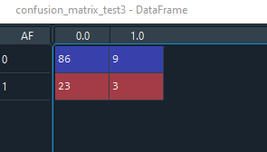

accuracy2 = (86+3)/(86+3+23+9) ## 0.7355371900826446

## Checking for different cut off values 0.58

y_pred3 = model_two.predict(train_data)

train_data["pred_prob3"]=y_pred3

train_data["Af_val3"]= np.zeros(480)

train_data.loc[y_pred3>=0.54,"Af_val3"]=1

classification2 = classification_report(train_data["Af_val3"],train_data["AF"])

# confusion matrix

confusion_matrix3 = pd.crosstab(train_data["AF"],train_data["Af_val3"])

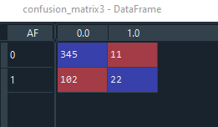

accuracy3= (345+22)/(345+22+11+102)

## 0.7645833333333333

fpr4,tpr4,threshold4 = metrics.roc_curve(train_data["AF"],y_pred3)

plt.plot(fpr,tpr);plt.xlabel("False positive rate");plt.ylabel("True positive rate")

roc_auc3 = metrics.auc(fpr,tpr) ## 0.7436004893077202

## test data

test_pred3 = model_two.predict(test_data)

test_data["pred_test3"]=test_pred3

test_data["test_val3"] = np.zeros(121)

test_data.loc[test_pred3>=0.54,"test_val3"]=1

confusion_matrix_test4= pd.crosstab(test_data["AF"],test_data["test_val3"])

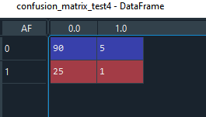

accuracy_test3 = (90+1)/(90+1+25+5) ## 0.7520661157024794

###model_two is selected and with the cut off value as 0.54. As it has least fpr and high tpr.