########## Packages Required #########

library(plyr)

library(corpcor)

install.packages("mvinfluence")

library(mvinfluence)

library(car)

library(corpcor)

#######reading and understanding the data #######

Startups_Data<-read.csv(file.choose())

View(Startups_Data)

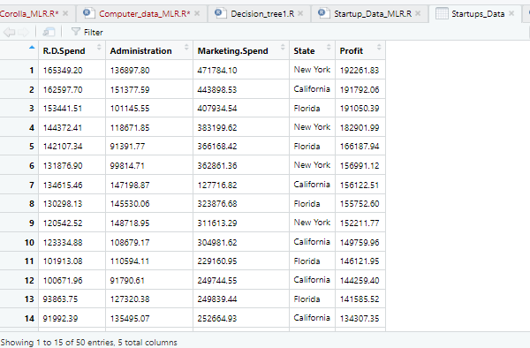

class(Startups_Data)

Startups_Data$State <- revalue(Startups_Data$State,

c("New York"="0", "California"="1", "Florida"="2"))

View(Startups_Data$State)

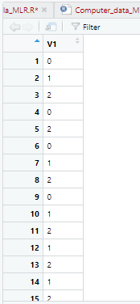

names(Startups_Data)

C:\Users\home\Pictures\Screenshots\Screenshot (486).png

attach(Startups_Data)

Startups_Data <- cbind(RD_Spend=R.D.Spend,Administration,Marketing_Spend=Marketing.Spend,State,Profit)

?cbind

names(Startups_Data)

Startups_Data <- as.data.frame(Startups_Data)

attach(Startups_Data) # Basically to avoid reference of Data Set name(Startups) in this report.

summary(Startups_Data)

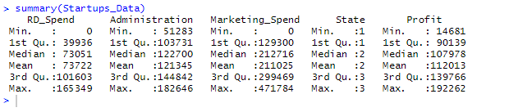

############ Steps of analysis for MLR #####

# Exploratory data analysis:

# 1. Measures of central tendency

# 2. Measures of dispersion

# 3. Third moment business decision

# 4. Fourth moment business decision

# 5. Probability distributions of variables

# 6. Graphical representations (Histogram, Box plot, Dot plot, Stem & Leaf plot, Bar plot, etc.)

plot(R.D.Spend, Profit)

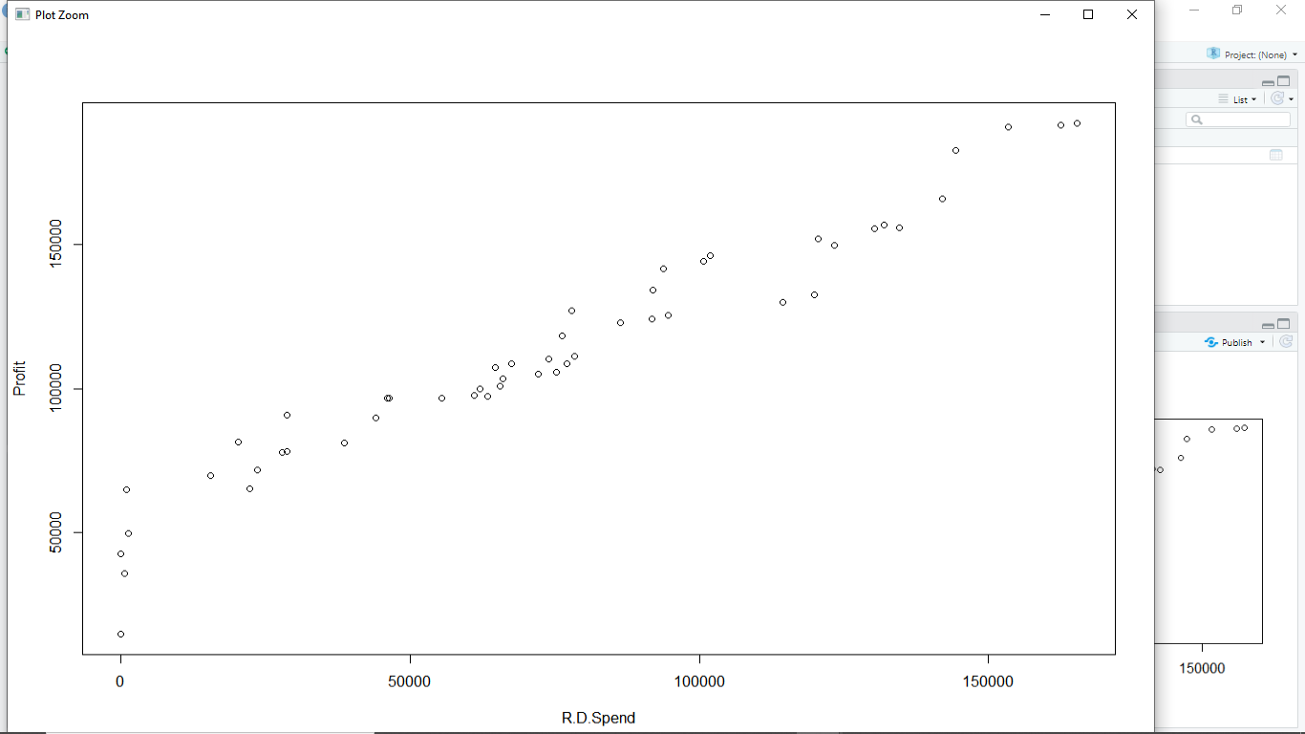

plot(Administration, Profit)

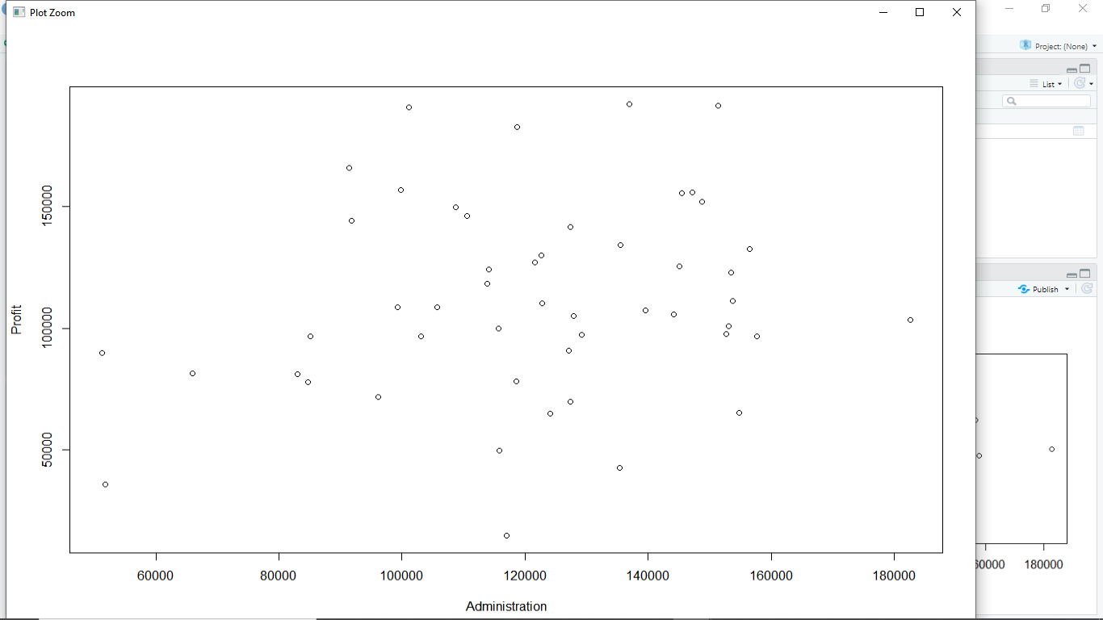

plot(Marketing_Spend, Profit)

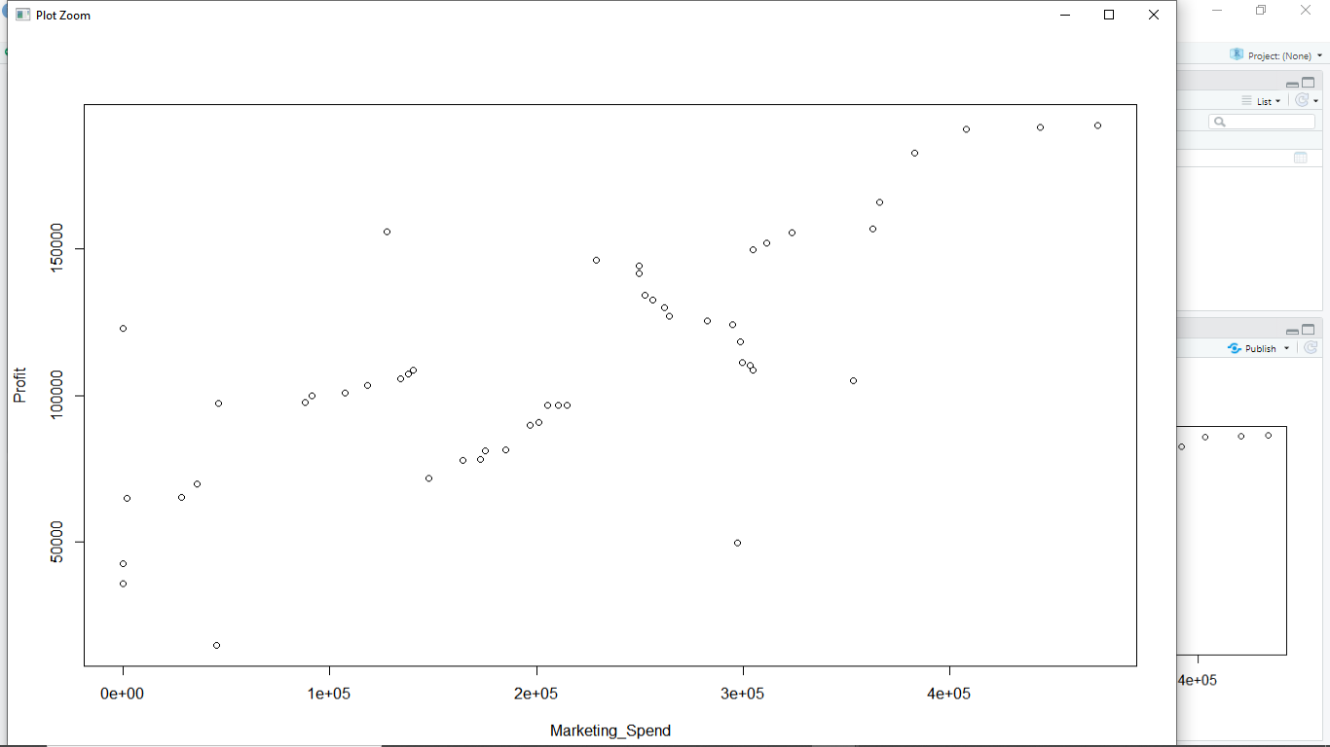

plot(State, Profit)

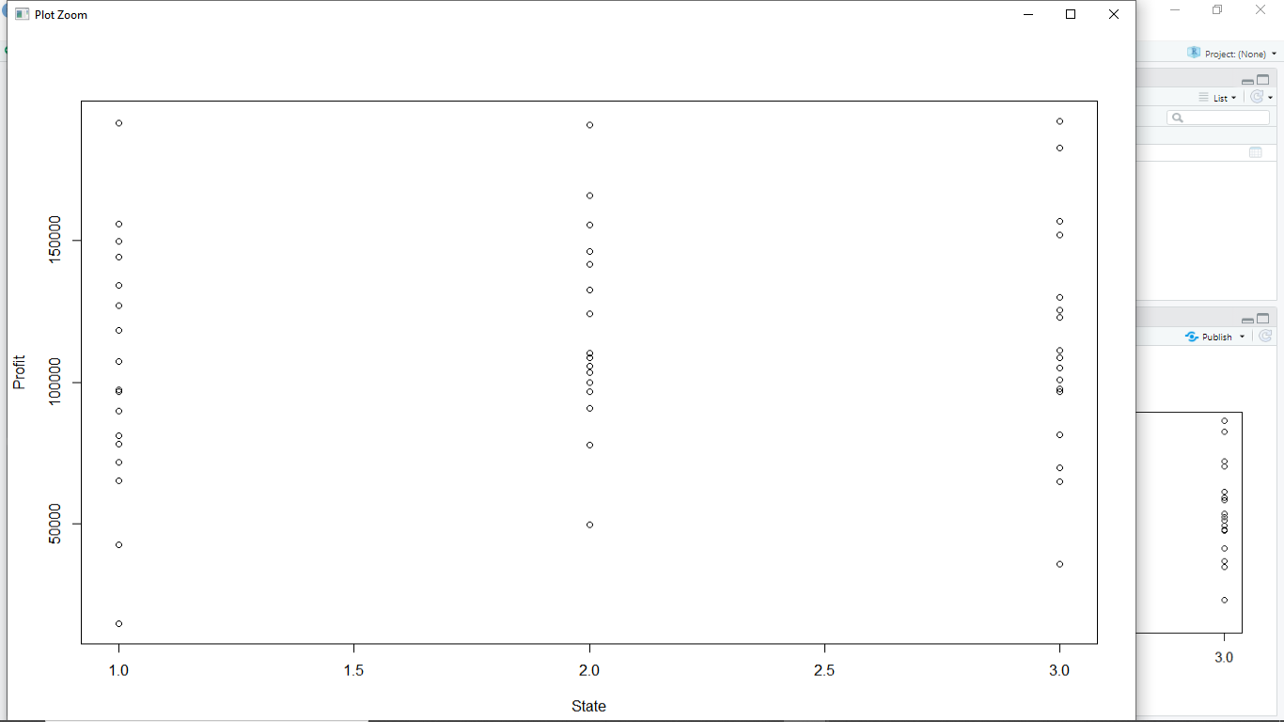

windows()

# 7. Find the correlation between Output (Profit) & inputs (R.D_Spend, Administration, Marketing_Spend, State) - SCATTER DIAGRAM

pairs(Startups_Data)

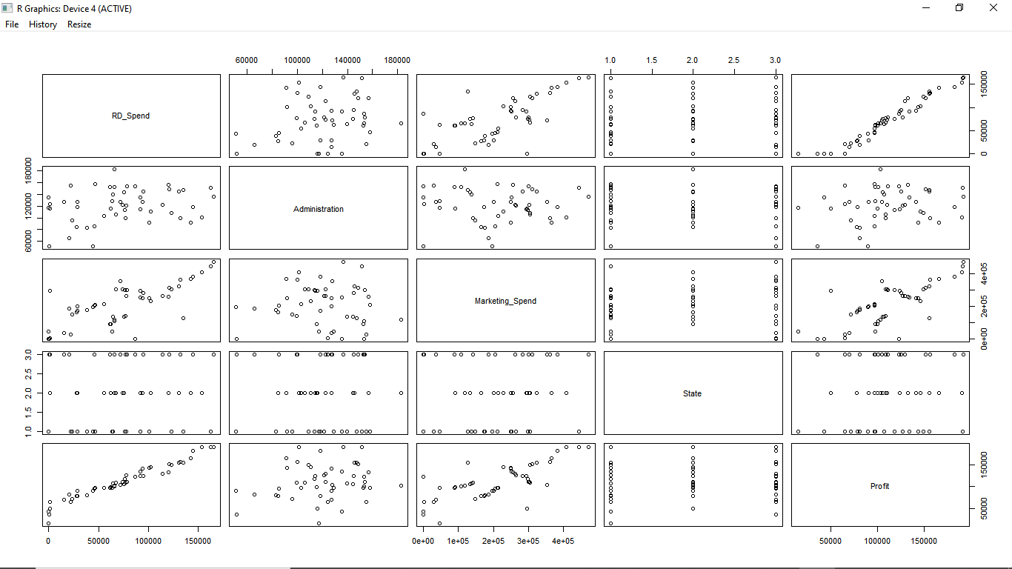

# 8. Correlation coefficient - Strength & Direction of correlation

cor(Startups_Data)

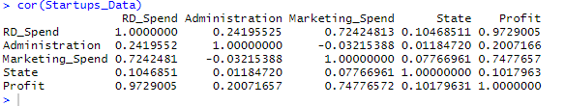

# The Linear Model of interest

Model.Startups_Data <- lm(Profit~RD_Spend+Administration+Marketing_Spend+State)

summary(Model.Startups_Data)#Multiple R-squared: 0.9507

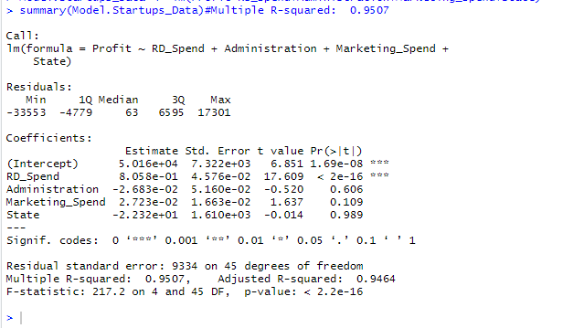

Model.Startups_Data1 <- lm(Profit~RD_Spend+log(Administration))

summary(Model.Startups_Data1)#Multiple R-squared: 0.9474

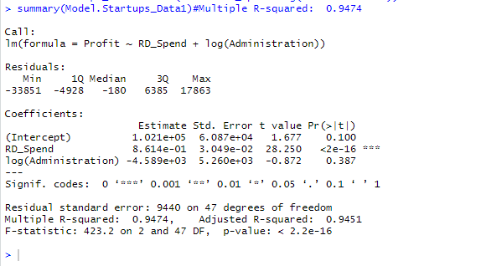

###Model.Startups_Data2 <- lm(Profit~RD_Spend+Administration+Marketing_Spend+log(State))

##summary(Model.Startups_Data2)

### Scatter plot matrix with Correlations inserted in graph

panel.cor <- function(x, y, digits=2, prefix="", cex.cor)

{

usr <- par("usr"); on.exit(par(usr))

par(usr = c(0, 1, 0, 1))

r = (cor(x, y))

txt <- format(c(r, 0.123456789), digits=digits)[1]

txt <- paste(prefix, txt, sep="")

if(missing(cex.cor)) cex <- 0.4/strwidth(txt)

text(0.5, 0.5, txt, cex = cex)

}

pairs(Startups_Data, upper.panel=panel.cor,main="Scatter Plot Matrix with Correlation Coefficients")

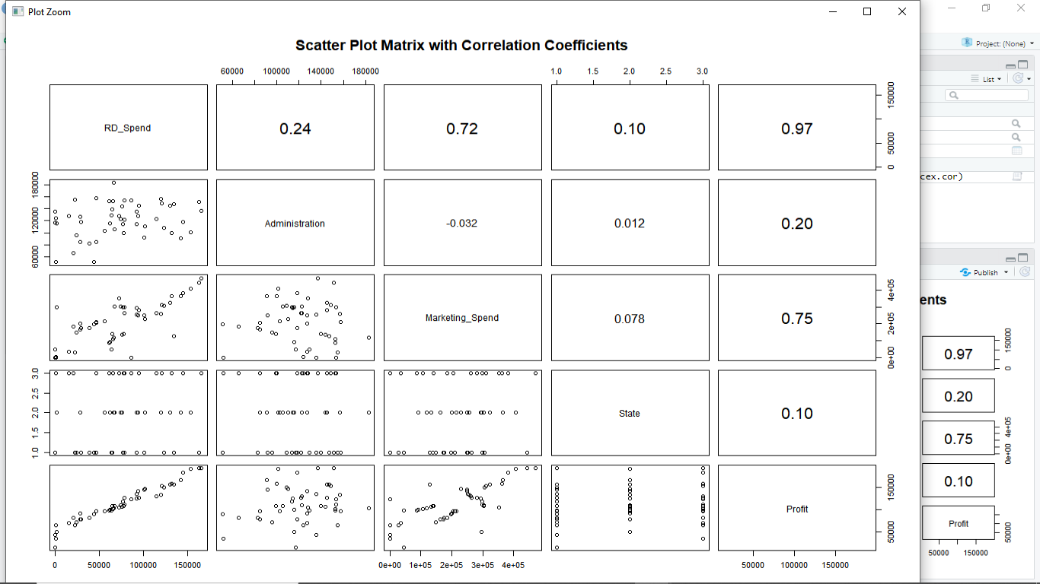

### Partial Correlation matrix - Pure correlation between the variables

cor2pcor(cor(Startups_Data))

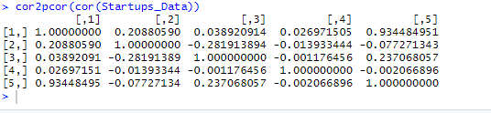

# It is better to delete a single observation rather than entire variable to get rid of collinearity problem

# Deletion Diagnostics for identifying influential variable

influence.measures(Model.Startups_Data)

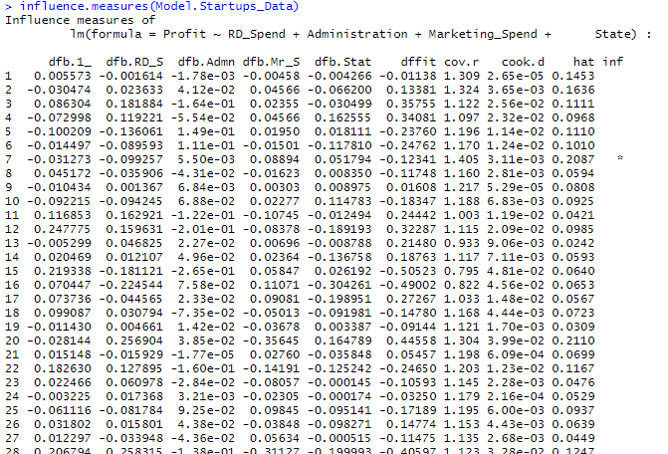

influenceIndexPlot(Model.Startups_Data, id.n=3) # Index Plots of the influence measures

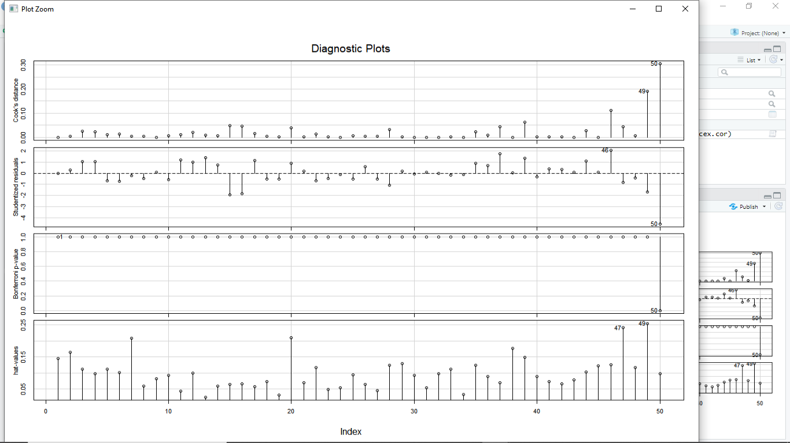

influencePlot(Model.Startups_Data, id.n=3) # A user friendly representation of the above

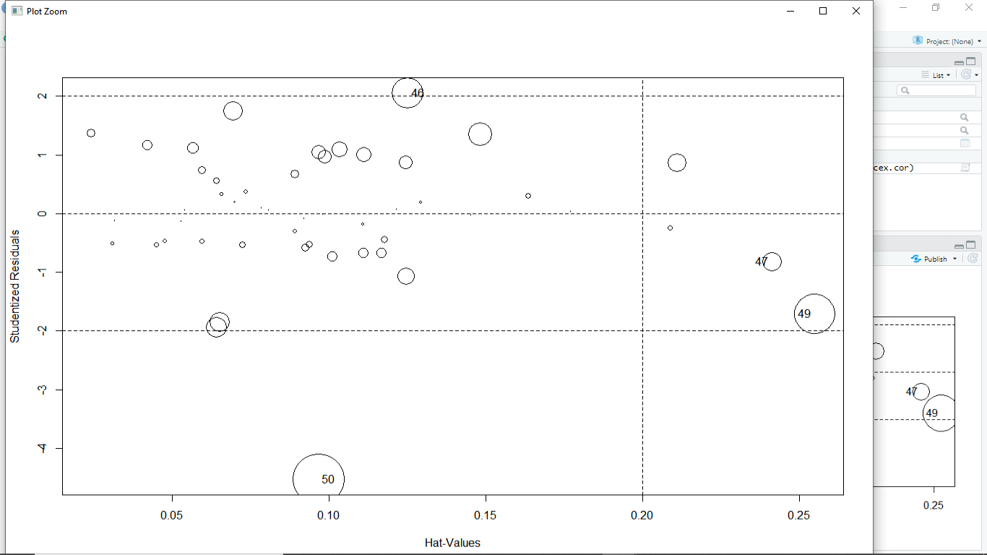

#############****** Logarthimic Transformation *******##############

Model.Startups_Data_Log<-lm(Profit~RD_Spend+log(Administration)+Marketing_Spend+log(State),data=Startups_Data[-c(49,50),])

summary(Model.Startups_Data_Log) #Adjusted R2 Value = 0.9591 ,Multiple R-squared: 0.9625

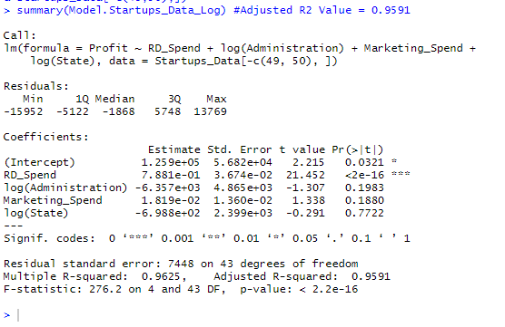

confint(Model.Startups_Data_Log,level=0.95)

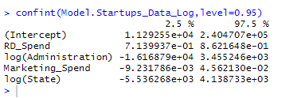

predict(Model.Startups_Data_Log,interval="predict")

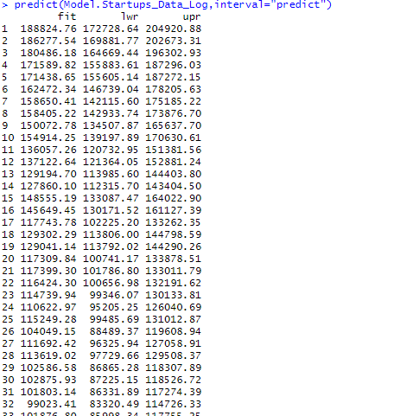

Model.Startups_Data_Fin1<-lm(Profit~RD_Spend+Administration+Marketing_Spend+State,data=Startups_Data[-c(49,50),])

summary(Model.Startups_Data_Fin1) # Adjusted R2 Value is0.9593 ,Multiple R-squared: 0.9627

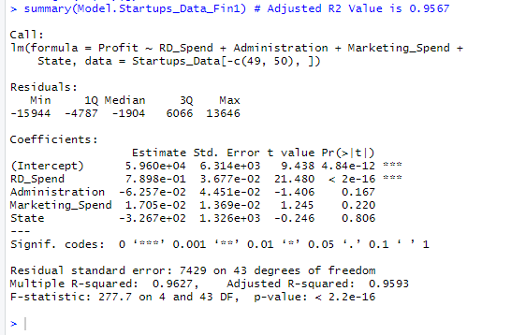

##########*********** Exponential Transformation ***********###########

Model.Startups_Data_exp<-lm(log(Profit)~RD_Spend+Administration+Marketing_Spend+State,data=Startups_Data[-c(49,50),])

summary(Model.Startups_Data_exp) #Adjusted R2 Value is 0.9182,Multiple R-squared: 0.9252,

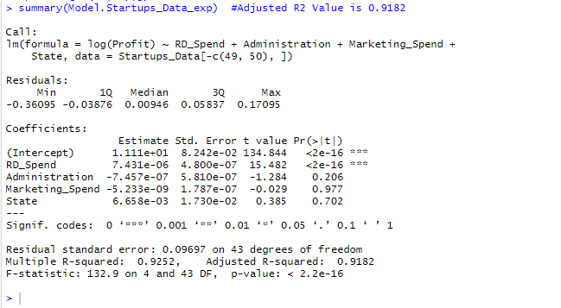

Model.Startups_Data_exp1<-lm(log(Profit)~RD_Spend+Marketing_Spend,data=Startups_Data[-c(49,50),])

summary(Model.Startups_Data_exp1) #Multiple R-squared: 0.9221, Adjusted R-squared: 0.9187

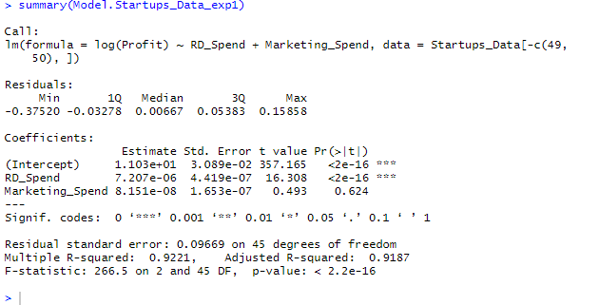

##################********** Quadratic Model *******************##############

Model.Startups_Data_Quad <- lm(Profit~RD_Spend+I(RD_Spend^2)+Administration+I(Administration^2)

+Marketing_Spend+I(Marketing_Spend^2)+State+I(State^2),data=Startups_Data[-c(49,50),])

summary(Model.Startups_Data_Quad) #Multiple R-squared: 0.9641, Adjusted R-squared: 0.9567

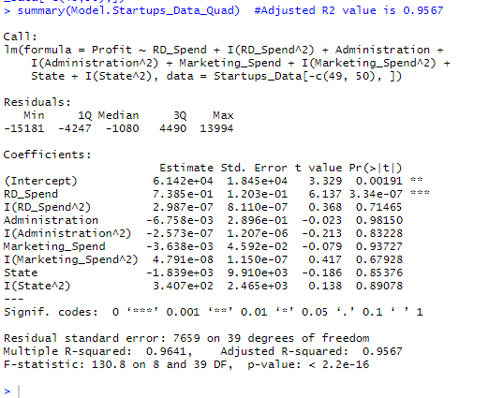

confint(Model.Startups_Data_Quad,level=0.95)

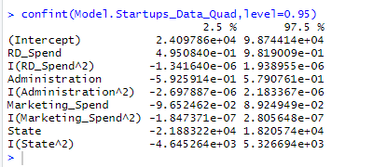

predict(Model.Startups_Data_Quad,interval="predict")

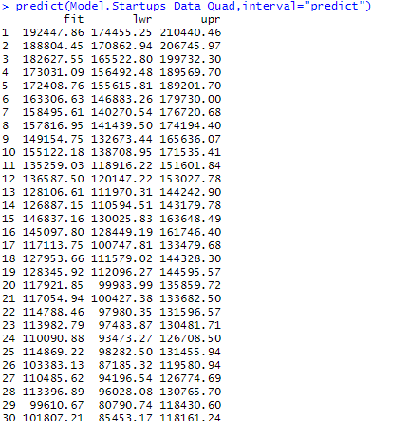

Model.Startups_Data_Quad1 <- lm(Profit~RD_Spend+I(RD_Spend^2)+Marketing_Spend+I(Marketing_Spend^2)

,data=Startups_Data[-c(49,50),])

summary(Model.Startups_Data_Quad1) #Multiple R-squared: 0.962, Adjusted R-squared: 0.9585

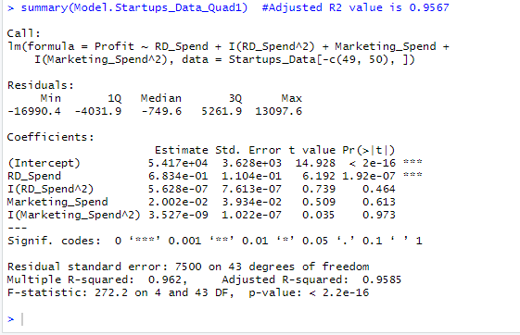

#################***** Poly Modal **********################

Model.Startups_Data_Poly <- lm(Profit~RD_Spend+I(RD_Spend^2)+I(RD_Spend^3)+

Administration+I(Administration^2)+I(Administration^3)+

Marketing_Spend+I(Marketing_Spend^2)+I(Marketing_Spend^3)+

State+I(State^2)+I(State^3),data=Startups_Data[-c(49,50),])

summary(Model.Startups_Data_Poly) #Multiple R-squared: 0.967, Adjusted R-squared: 0.9569

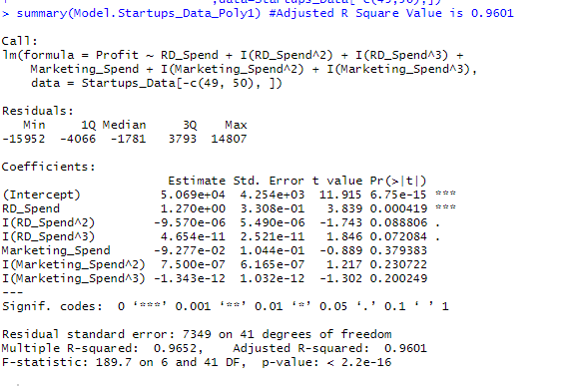

Model.Startups_Data_Poly1 <- lm(Profit~RD_Spend+I(RD_Spend^2)+I(RD_Spend^3)+

Marketing_Spend+I(Marketing_Spend^2)+I(Marketing_Spend^3)

,data=Startups_Data[-c(49,50),])

summary(Model.Startups_Data_Poly1) #Multiple R-squared: 0.9652, Adjusted R-squared: 0.9601

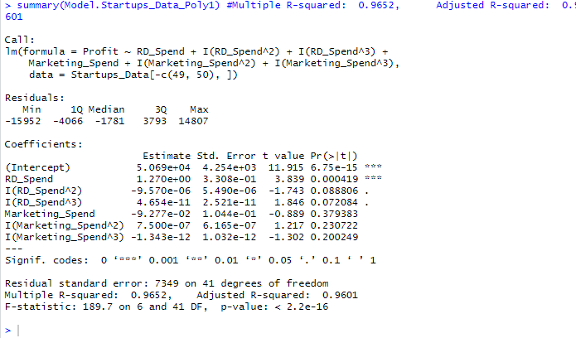

### Variance Inflation Factors is a formal way to check for collinearity

vif(Model.Startups_Data_Log) # VIF is > 10 => collinearity

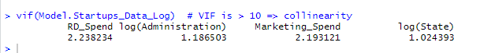

avPlots(Model.Startups_Data_Log, id.n=2, id.cex=0.7) # Added Variable Plots

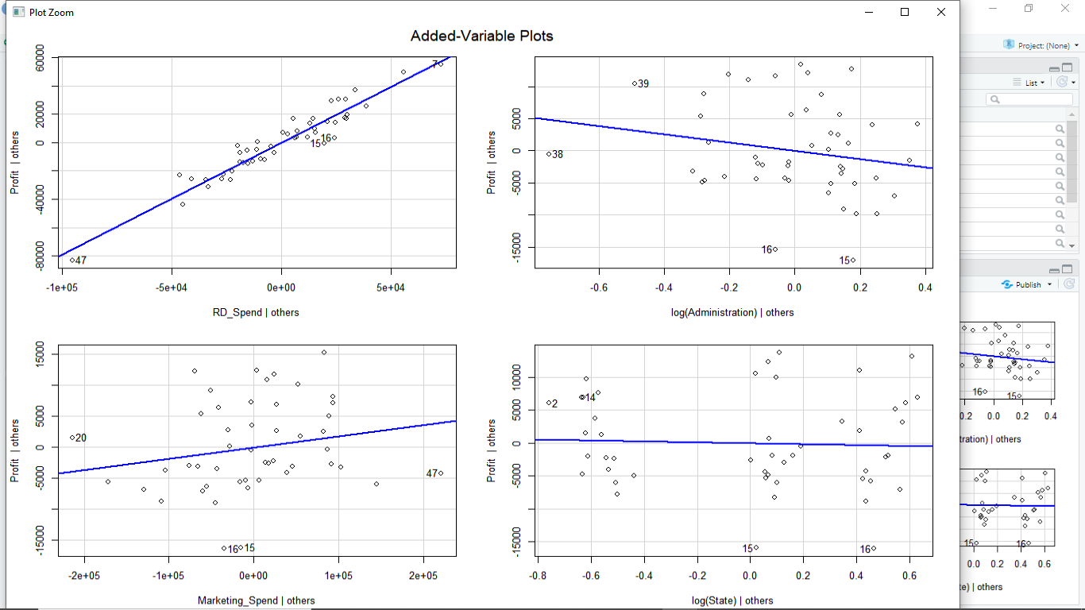

################### Final Model ####################

FinalModel<-lm(Profit~RD_Spend+log(Administration)+Marketing_Spend+

log(State),data=Startups_Data[-c(49,50),])

summary(FinalModel) #Multiple R-squared: 0.9625, Adjusted R-squared: 0.9591

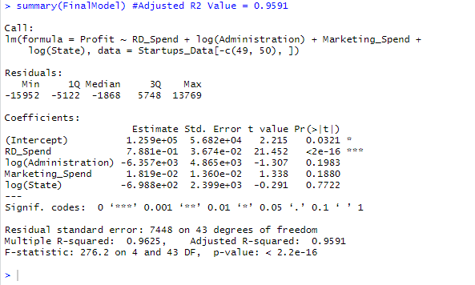

Profit_Predict <- predict(FinalModel,interval="predict")

Final <- cbind(Startups_Data$RD_Spend,Startups_Data$Administration,Startups_Data$Marketing_Spend,

Startups_Data$State,Startups_Data$Profit,Profit_Predict)

View(Final)

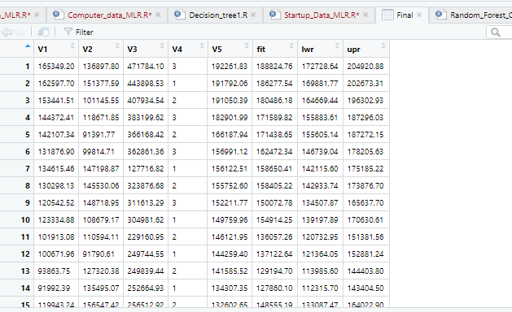

################# Evaluate model LINE assumptions ###################

plot(FinalModel)# Residual Plots, QQ-Plos, Std. Residuals vs Fitted, Cook's distance

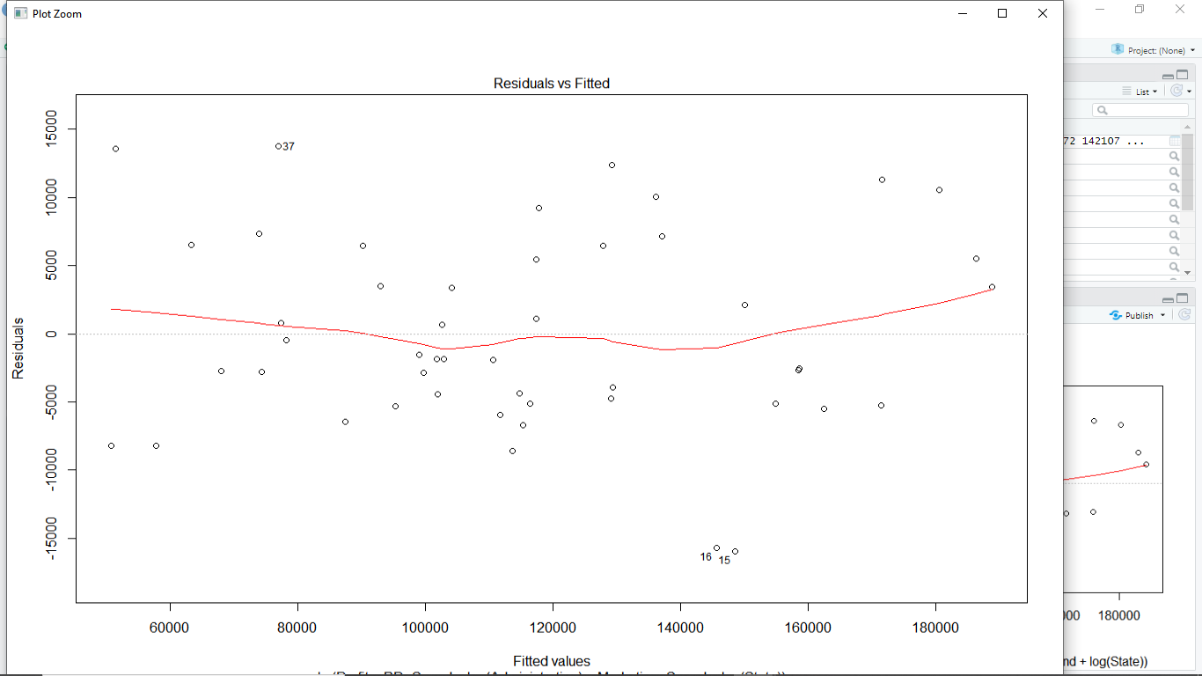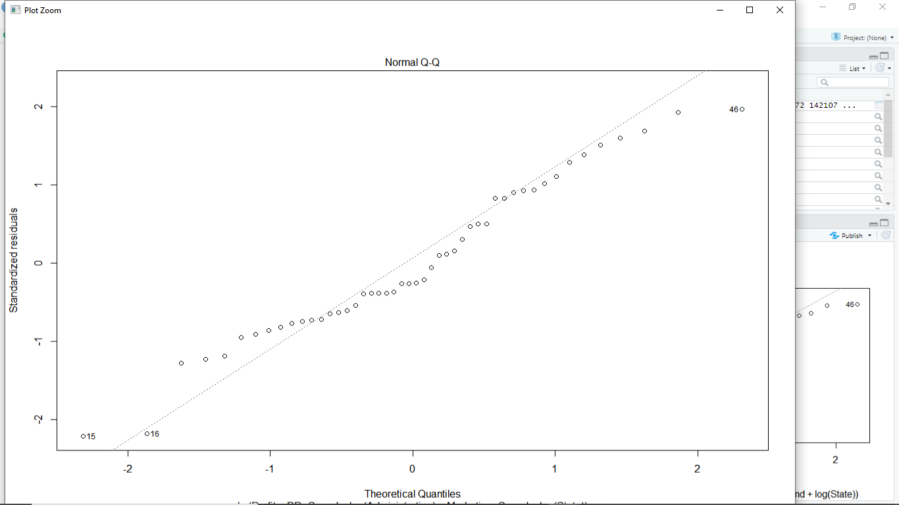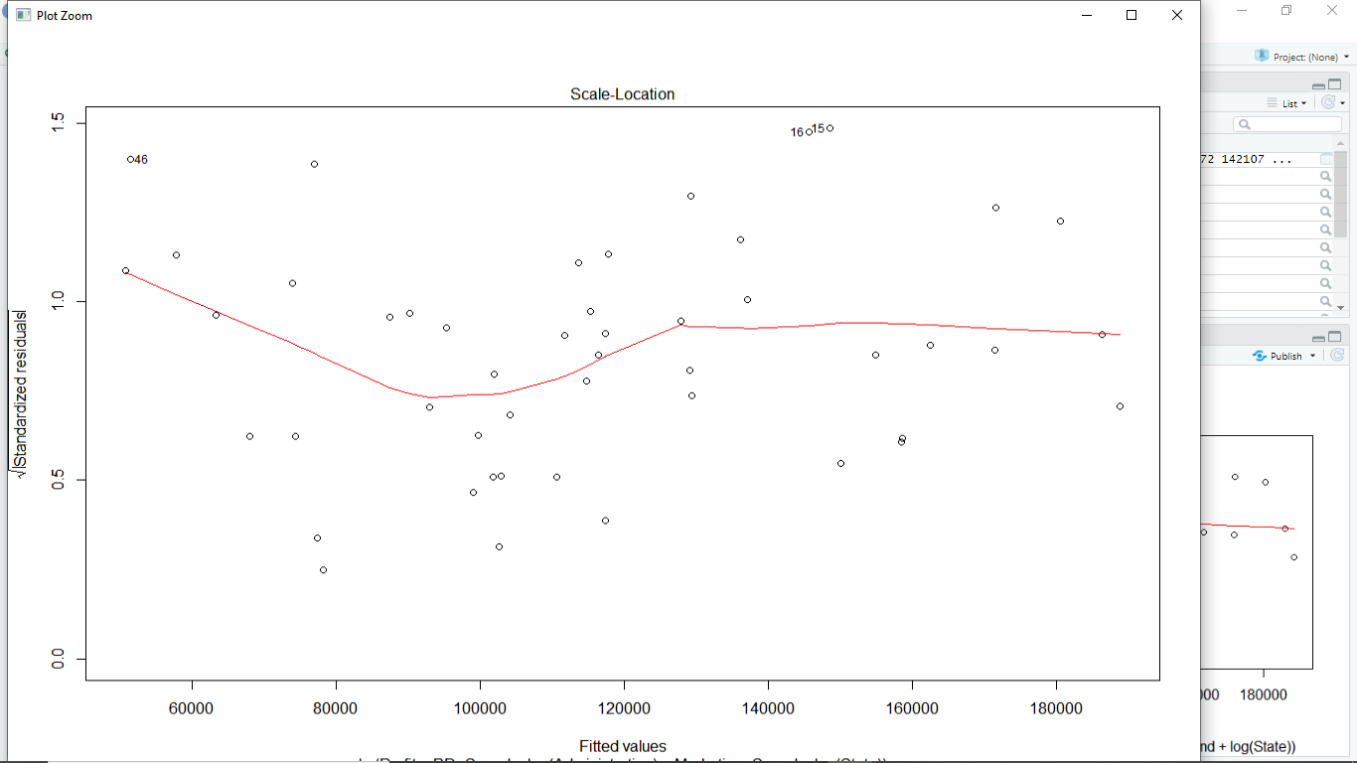

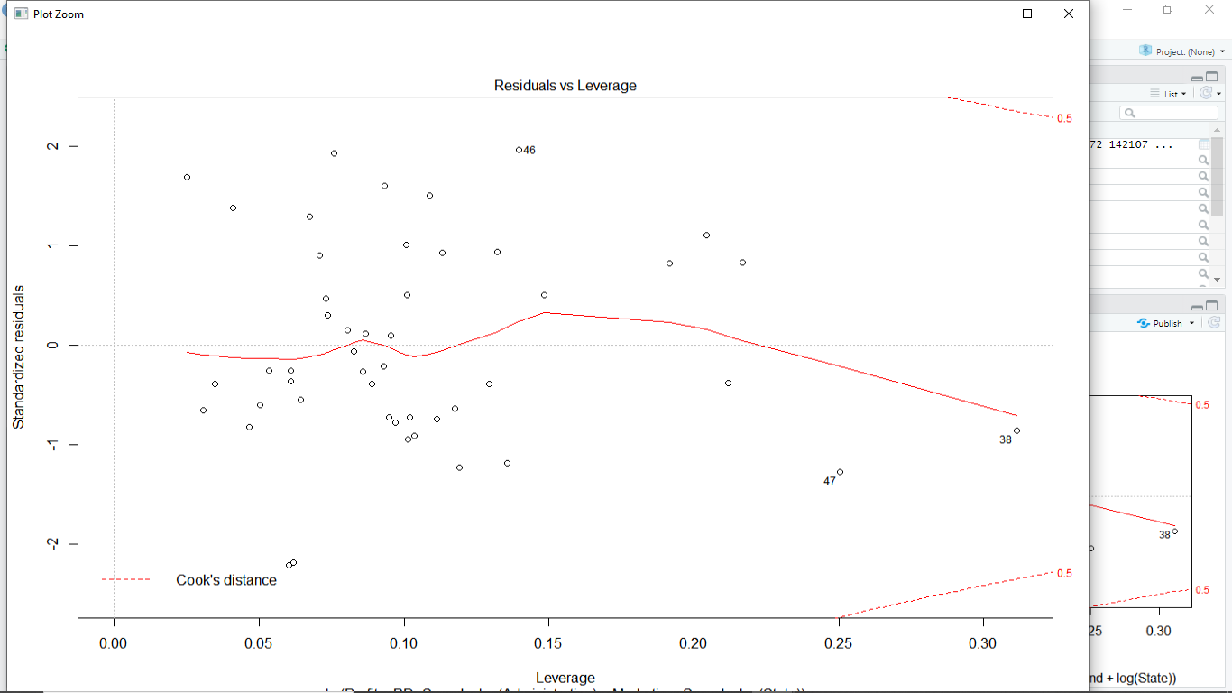

qqPlot(FinalModel, id.n=5) # QQ plots of studentized residuals, helps identify outliers

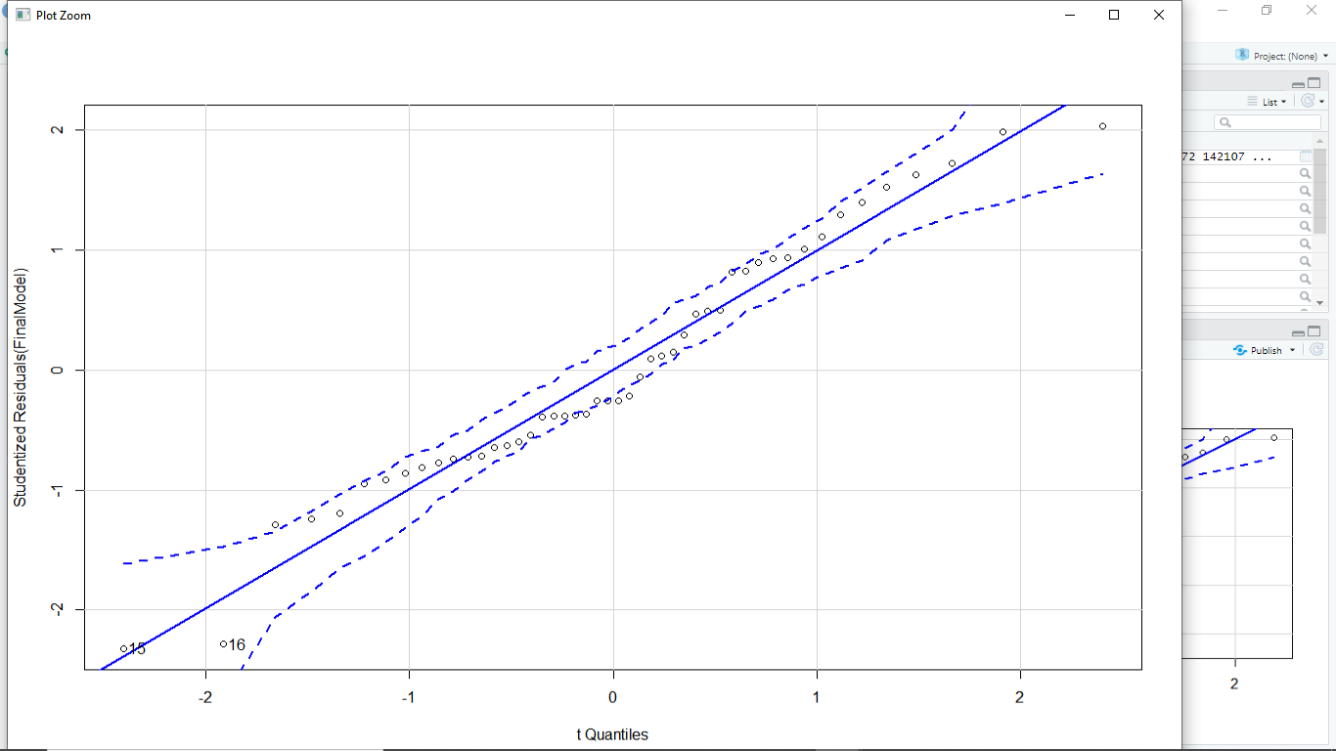

stepAIC(FinalModel) # backward

?stepAIC

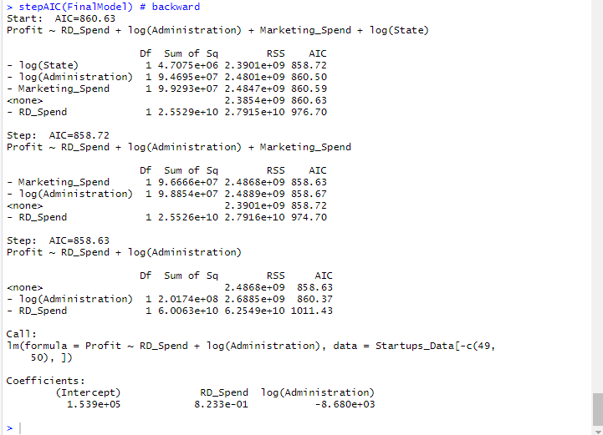

# Lower the AIC value better is the model. AIC is used only if you build multiple models.