############# Packages required ###########

library(e1071)

library(car)

############ Reading and understanding the data ###########

Computer_Data<-read.csv(file.choose())

nrow(Computer_Data)

#[1] 6259

ncol(Computer_Data)

#[1] 11

names(Computer_Data)



#FIrst moment business decision

summary(Computer_Data)

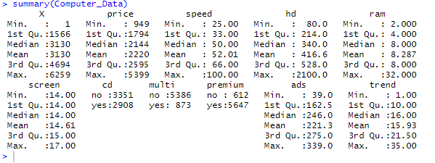

attach(Computer_Data)

View(Computer_Data)

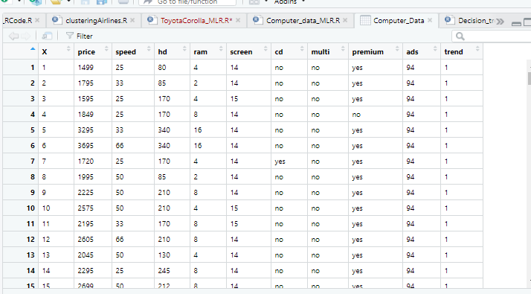

Computer_Data<-Computer_Data[,-1]

orgdata<-Computer_Data

View(orgdata)

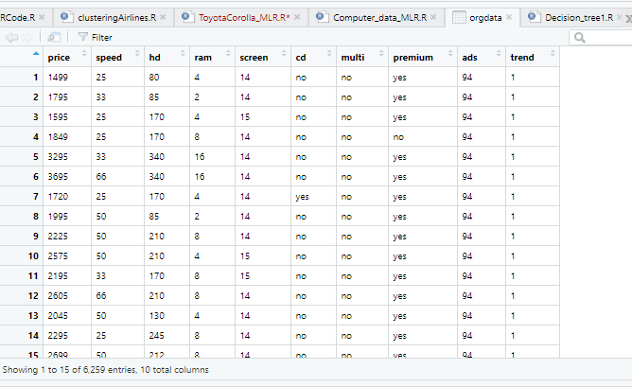

#second moment business decision

####standard deviation

sd(price)#[1] 580.804

sd(speed)#[1] 21.15774

sd(hd)#[1] 258.5484

sd(ram)#[1] 5.631099

sd(screen)#[1] 0.9051152

sd(ads)#[1] 74.83528

sd(trend)#[1] 7.873984

####### Varience#####

var(price)

#[1] 337333.2

var(speed)

#[1] 447.6498

var(hd)

#[1] 66847.3

var(ram)

#[1] 31.70928

var(screen)

#[1] 0.8192336

var(ads)

#[1] 5600.32

var(trend)

#[1] 61.99962

#### Third moment busines decision

##skewness####

skewness(price)

#[1] 0.7113836

skewness(speed)

#[1] 0.6566931

skewness(hd)

#[1] 1.377359

skewness(ram)

#[1] 1.385538

skewness(screen)

# [1] 1.633225

skewness(ads)

#[1] -0.5530629

skewness(trend)

#[1] 0.236556

# Fourth Moment Business Decision

###Kurtosis

kurtosis(price)

#[1] 0.7276838

kurtosis(speed)

#[1] -0.2770616

kurtosis(hd)

#[1] 2.447798

kurtosis(ram)

#[1] 1.458699

kurtosis(screen)

# [1] 1.847838

kurtosis(ads)

#[1] -0.5411566

kurtosis(trend)

#[1] -0.6752971

########## Exploratory Data analysis ###########

plot(speed,price)

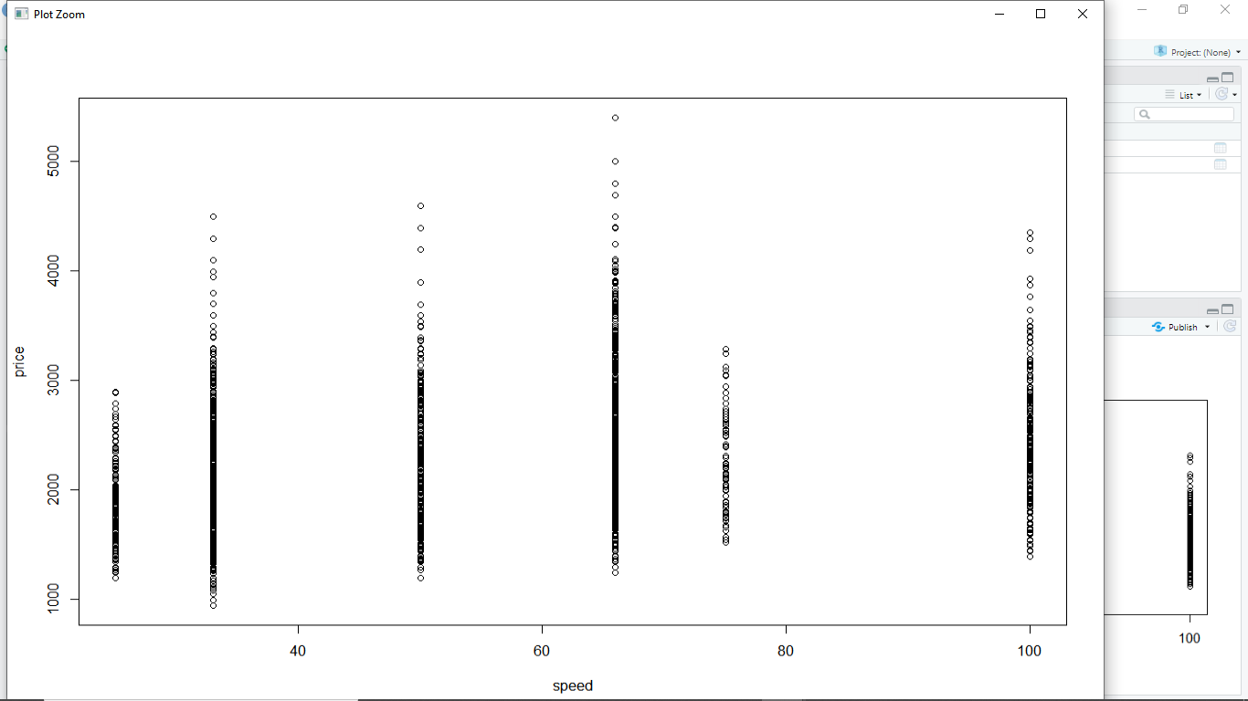

plot(hd, price)

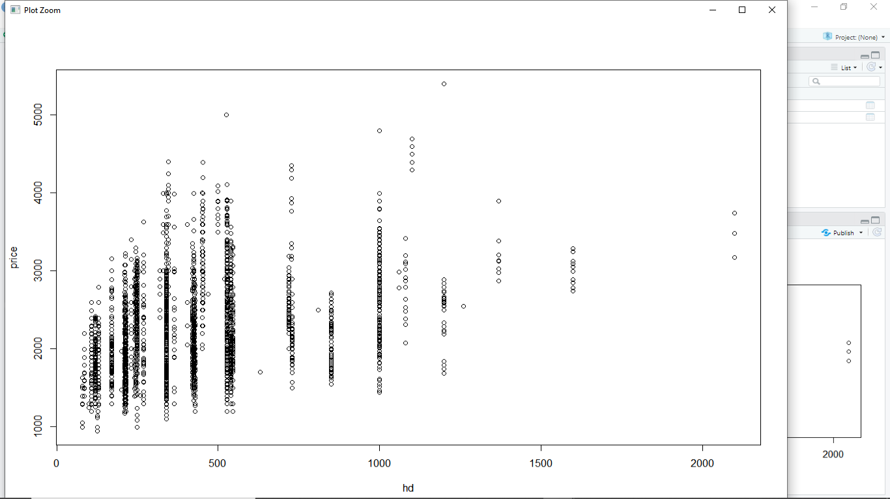

plot(ram, price)

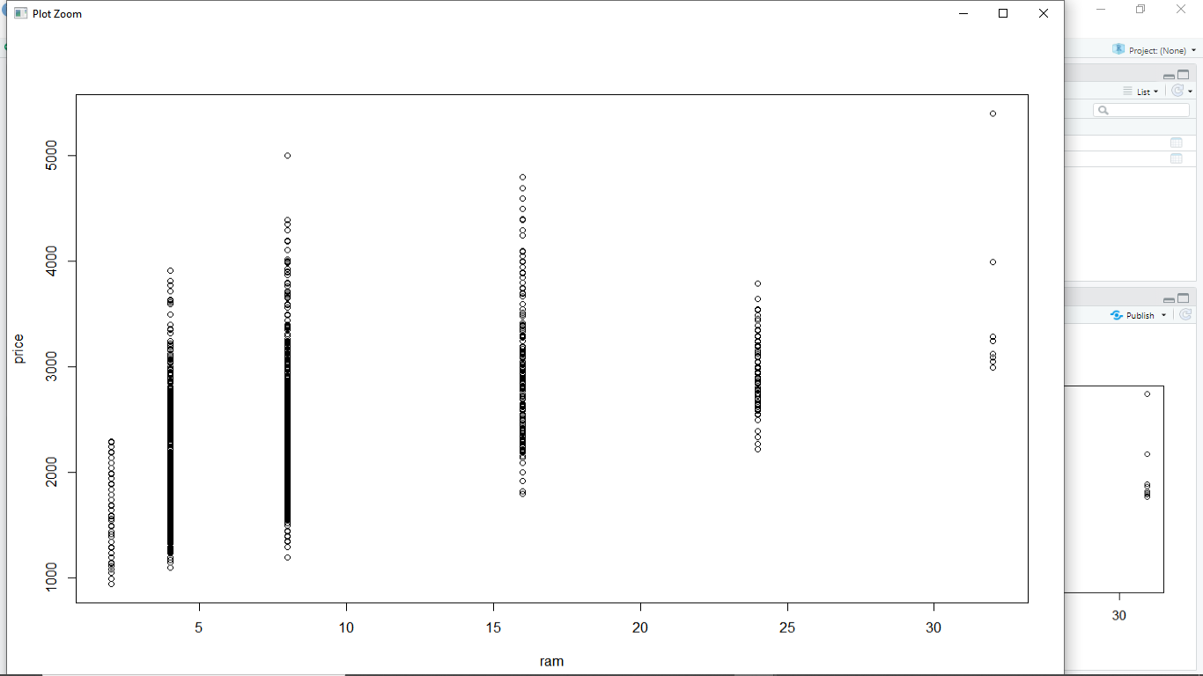

plot(screen, price)

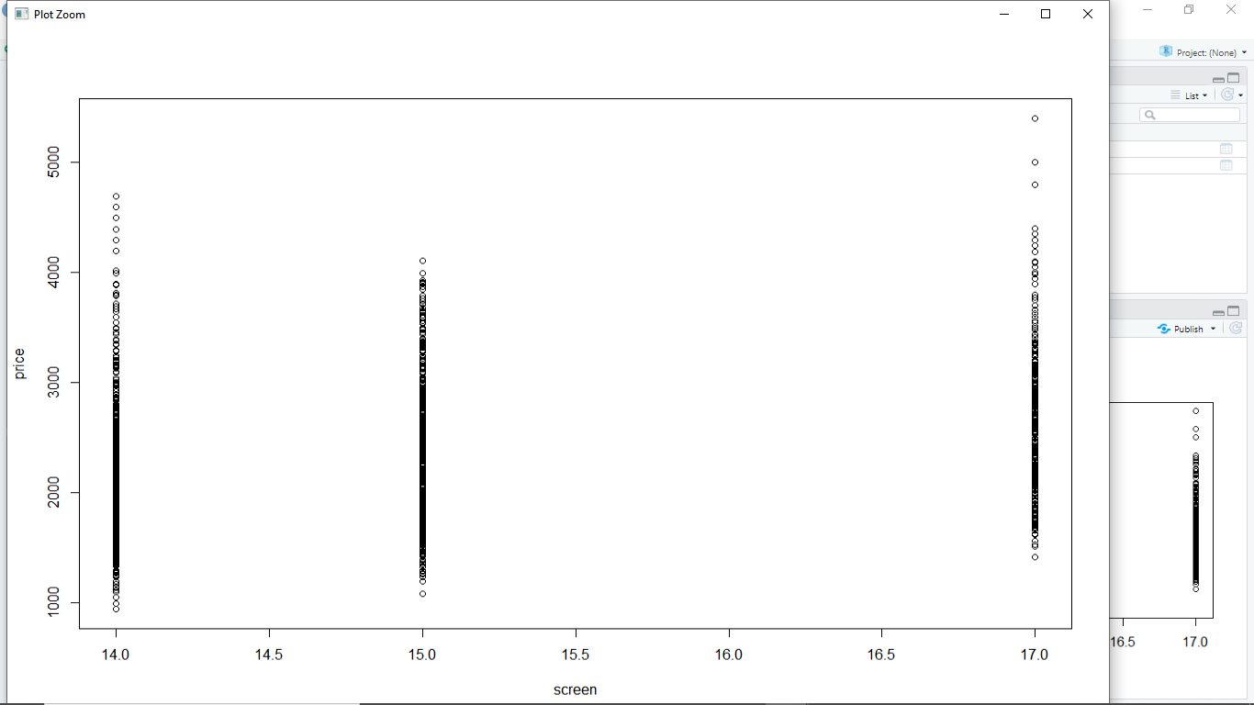

plot(ads, price)

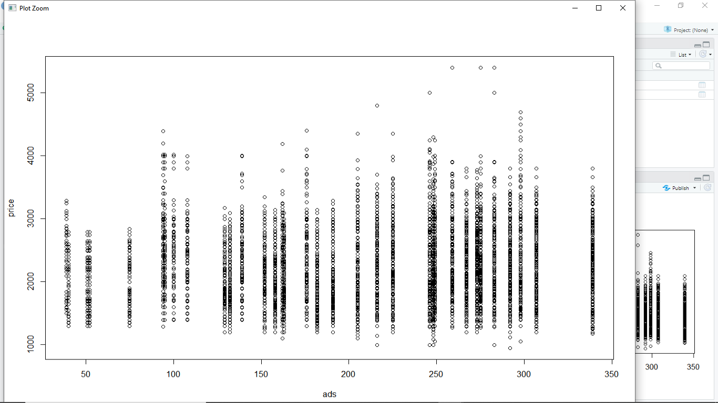

plot(trend, price)

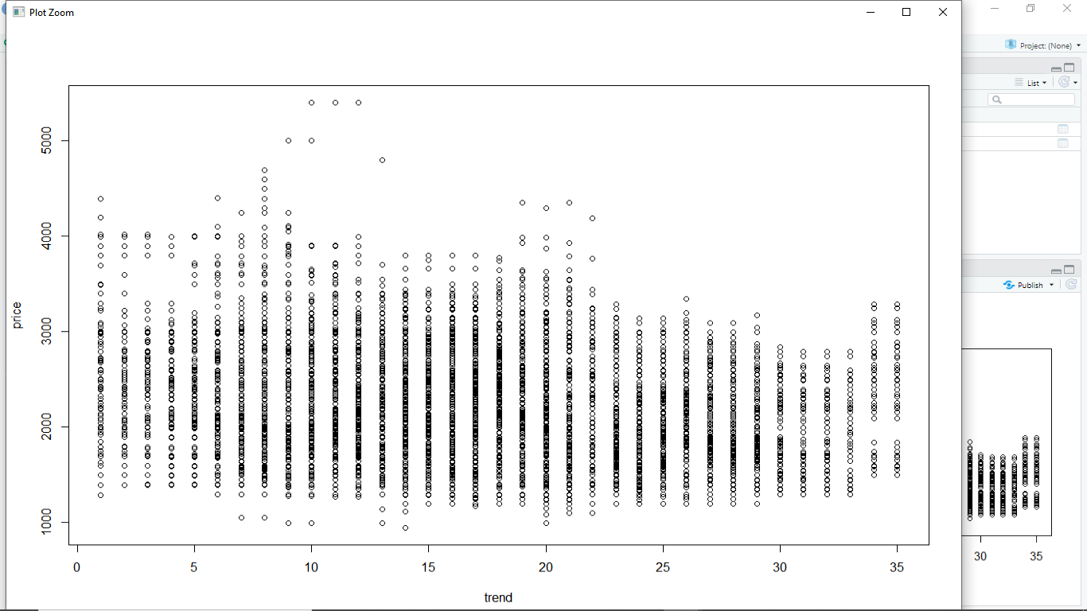

plot(cd, price)

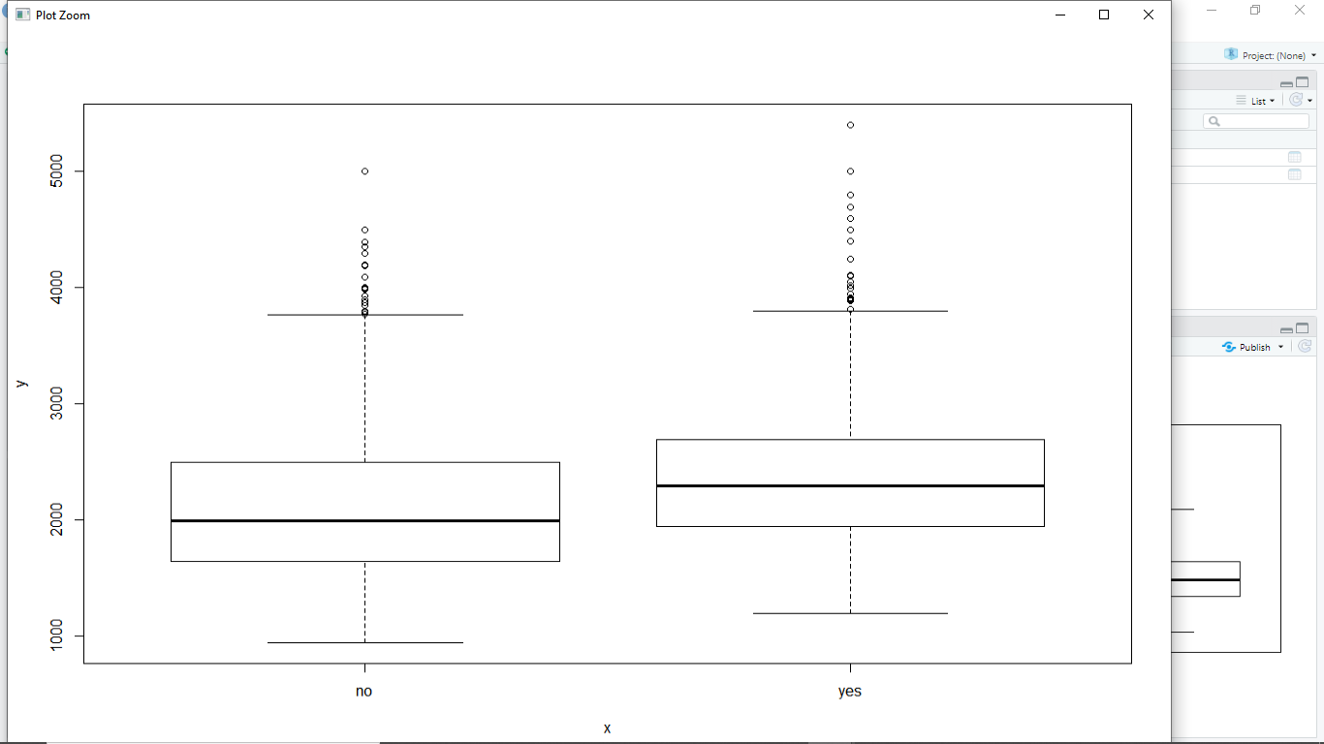

plot(multi, price)

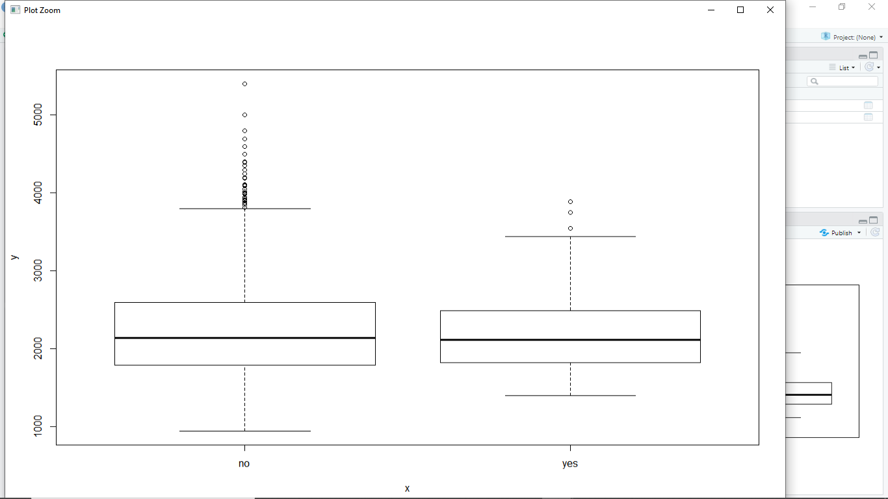

plot(premium, price)

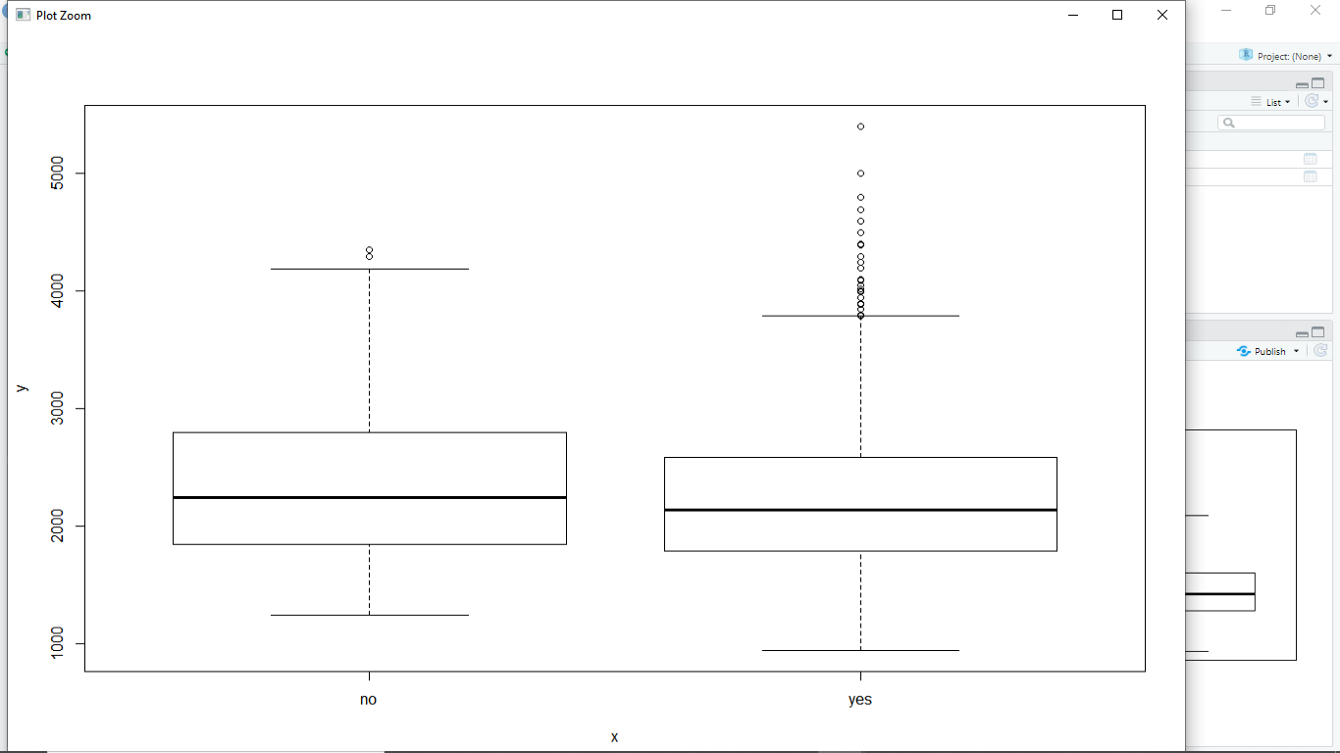

pairs(Computer_Data)

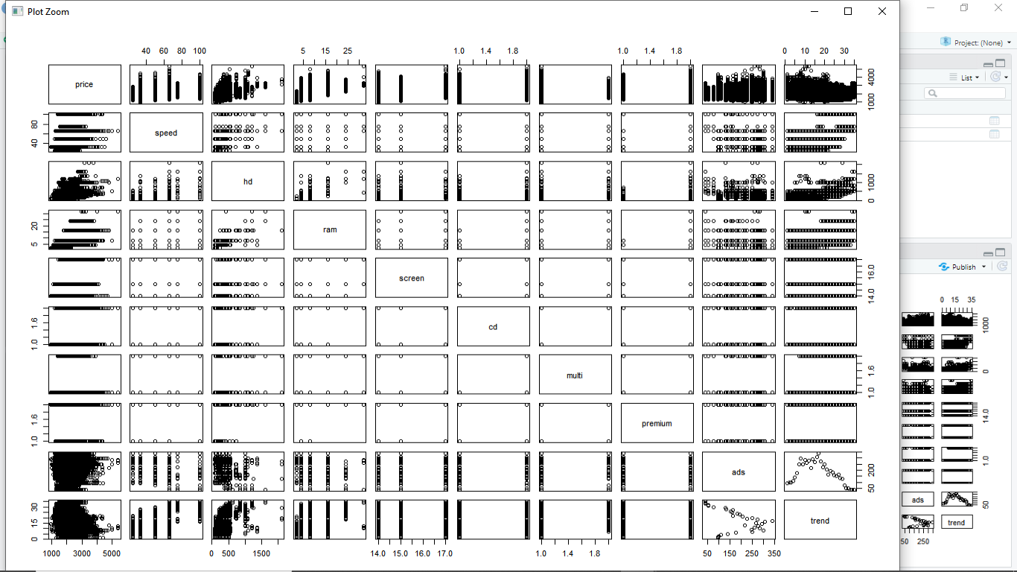

# Correlation Coefficient matrix - Strength & Direction of Correlation

##cor(Computer_Data)

model <- lm(price ~ speed + hd + ram + screen + ads + trend + cd + multi + premium, data = Computer_Data)

summary(model)#Multiple R-squared: 0.7756

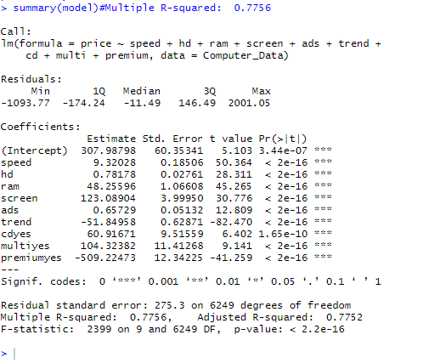

model2 <- lm(price ~ ., data = Computer_Data[-c(1441, 1701),])

summary(model2)#Multiple R-squared: 0.7777

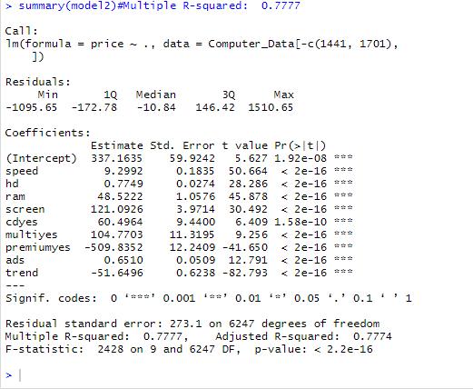

###### Finding out the influencial record #####

influence.measures(model)

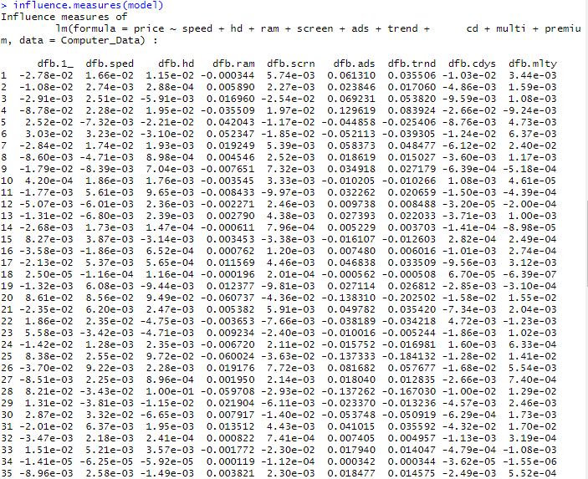

###################### plotting influential measures############

influenceIndexPlot(model)

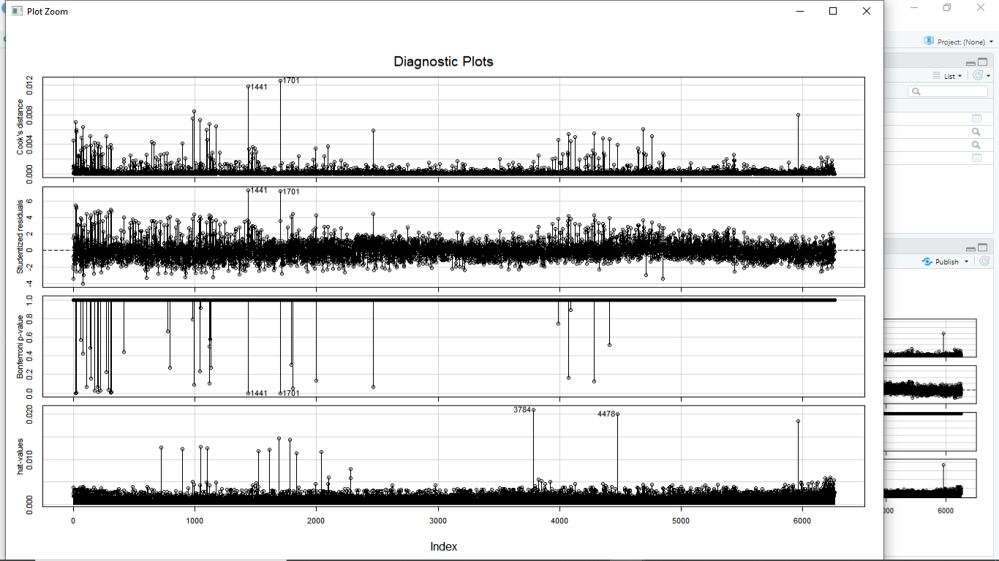

influencePlot(model)

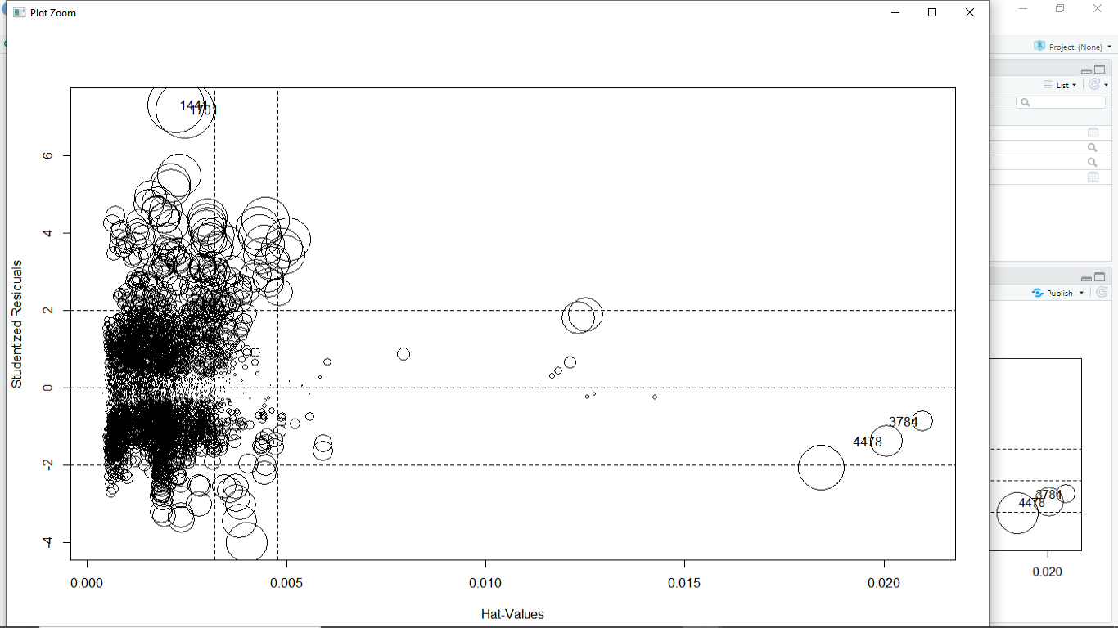

# Applying VIF function on model built on all inputs

## Variance Inflation factor to check collinearity b/n variables

vif(model2)

C:\Users\home\Pictures\Screenshots\Screenshot (475).png

avPlots(model2)

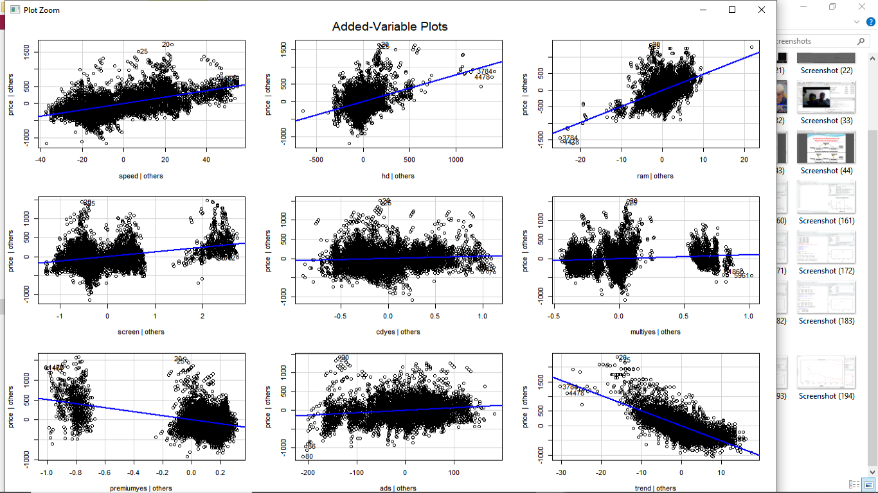

model3 <- lm(price ~ speed + hd + ram + screen + ads + trend + premium, data = Computer_Data[-c(1441, 1701),])

summary(model3)#Multiple R-squared: 0.7701

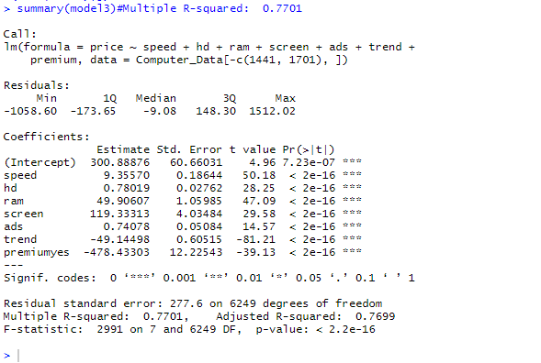

avPlots(model3)

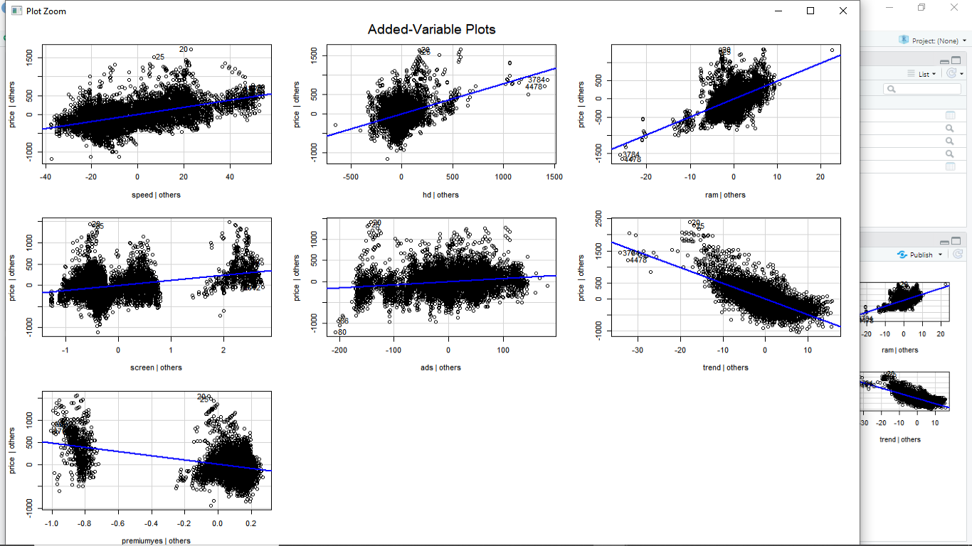

plot(model)

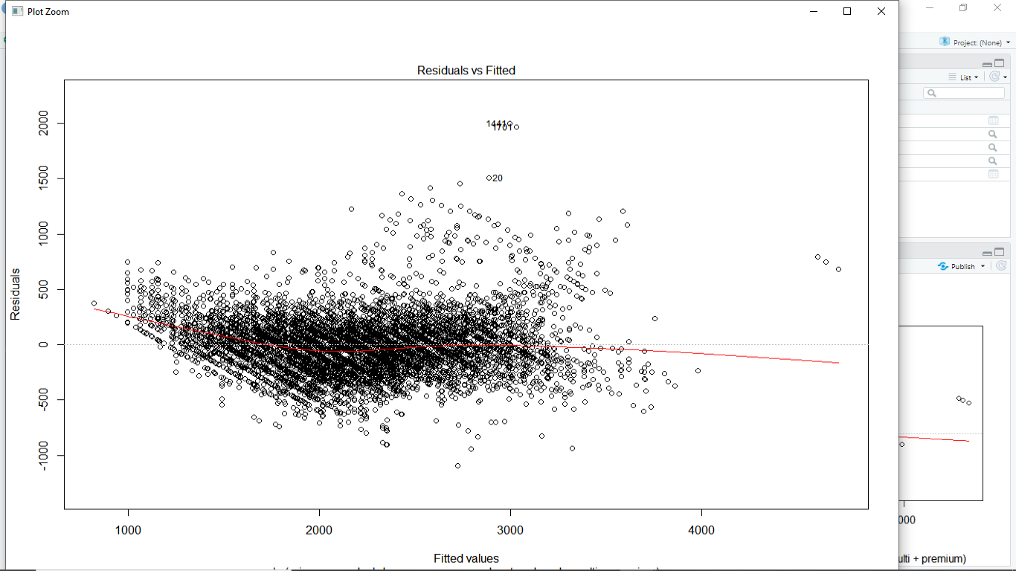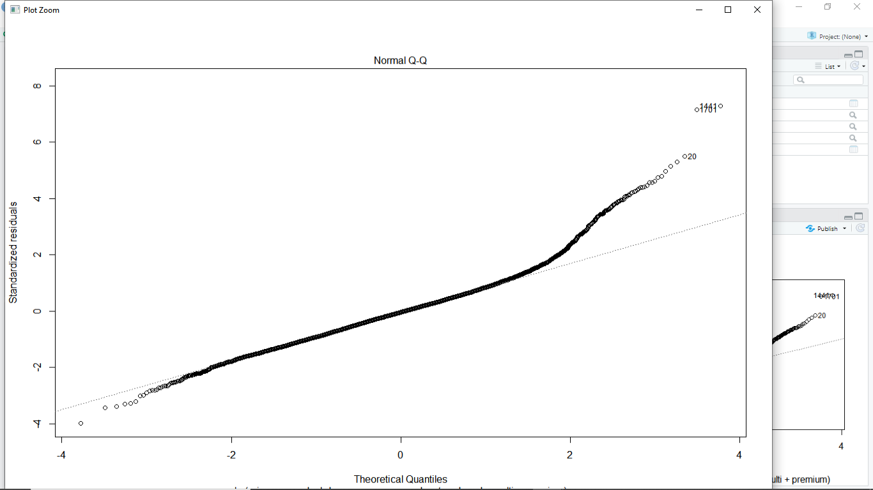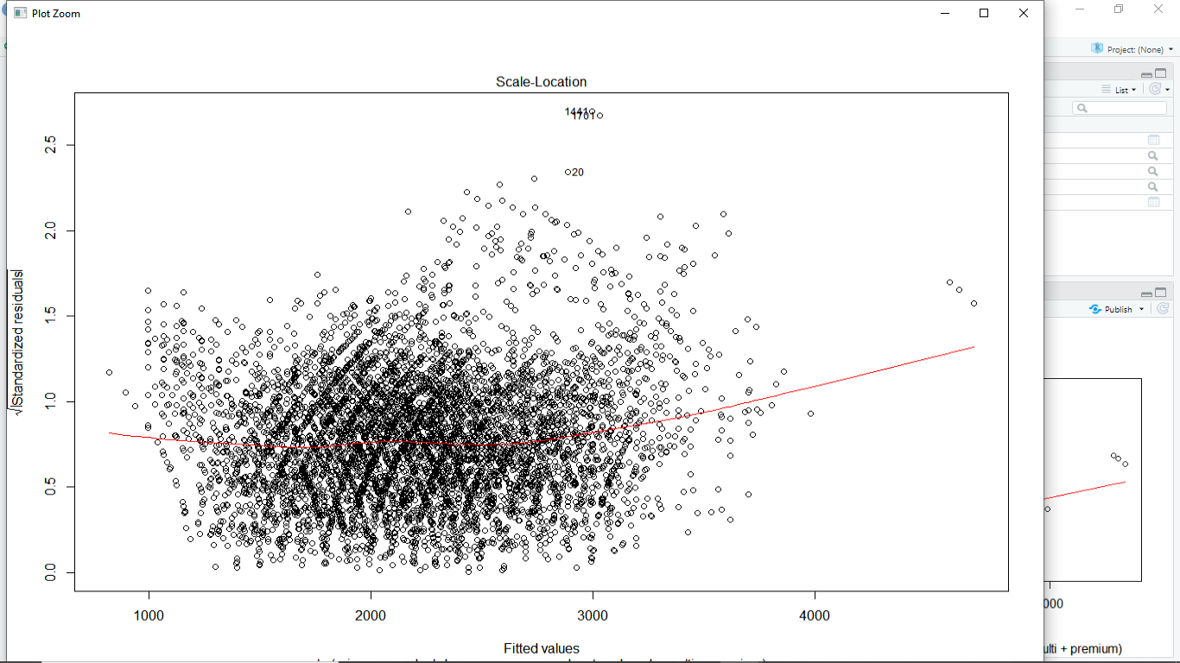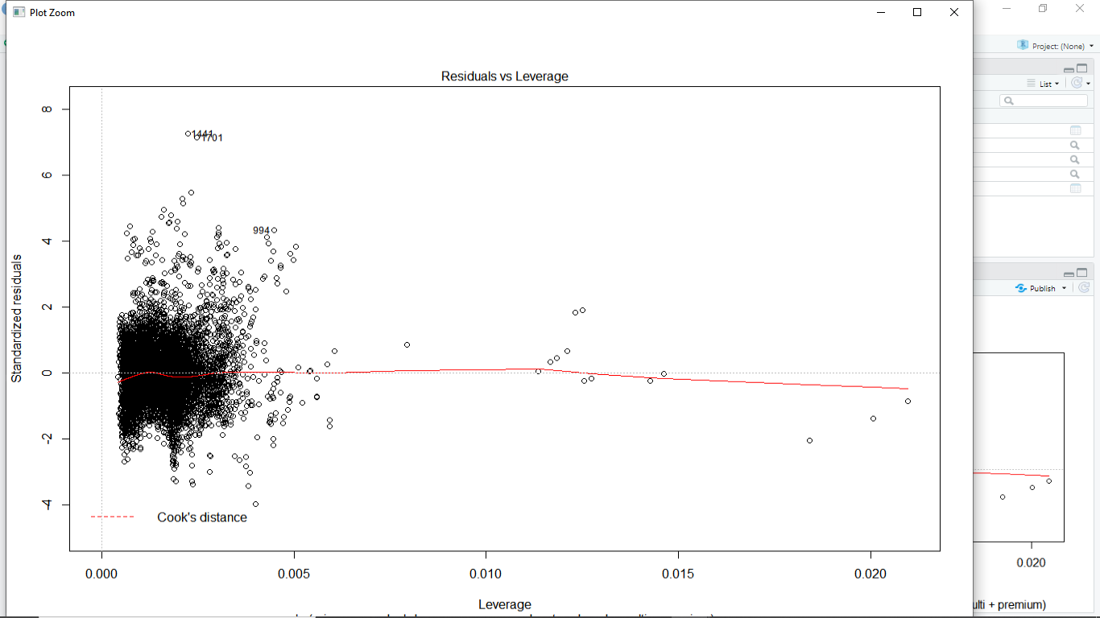

qqPlot(model)

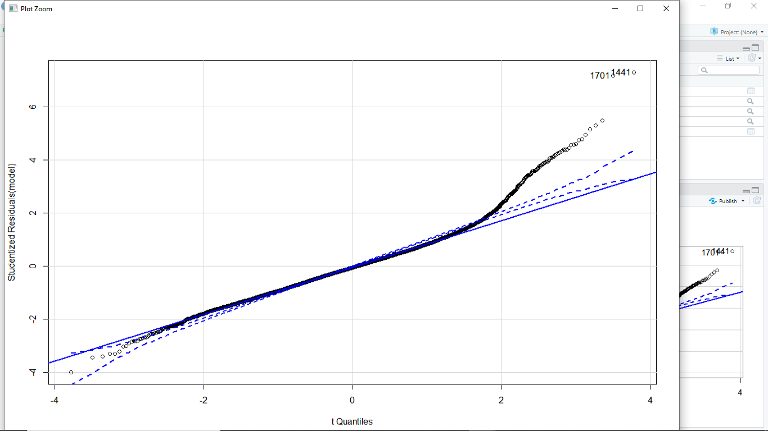

#[1] 1441 1701