# INSTALLATION OF KUBERNETES ON AWS-EC2 INSTANCE

**Step 1:**Launch 2 instances on aws one for master and other for a slave.

Run the following commands for installing kubeadm, as root (both master and slave)

Sudo su

apt-get update

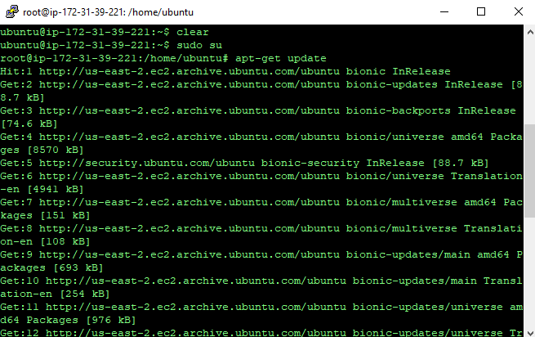

**Step 2 : type the following commands**

apt-get install docker.io #install docker

apt-get update && apt-get install -y apt-transport-https curl 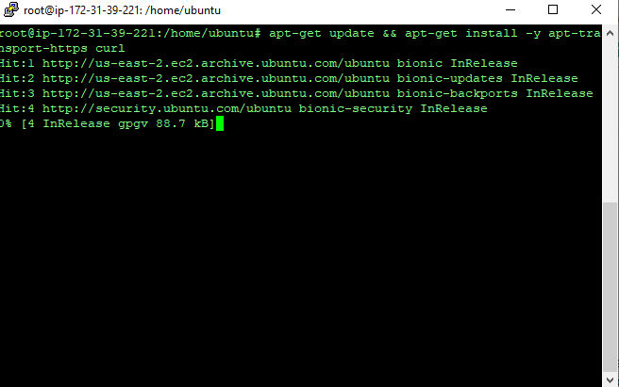

**Step 3:**

curl -s https://packages.cloud.google.com/apt/doc/apt-key.gpg | apt-key add -

cat <<EOF > /etc/apt/sources.list.d/kubernetes.list

deb https://apt.kubernetes.io/ kubernetes-xenial main

EOF

apt-get update

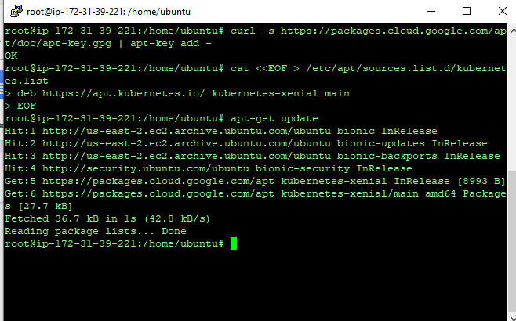

**Step 4:**

apt-get install -y kubelet kubeadm kubectl Kubernetes-cni

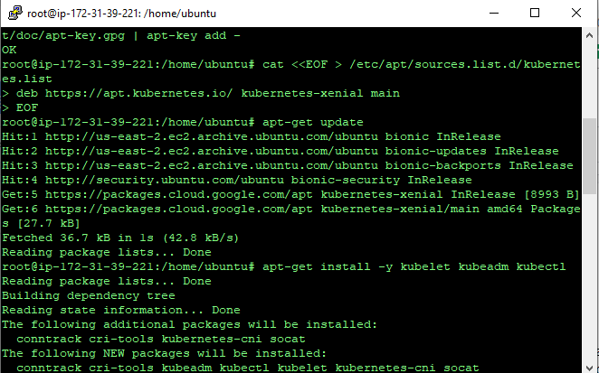

**Step 5: Creating cluster , run the following commands to create a cluster**

**Initializing kubeadm on master using**:

kubeadm init --apiserver-advertise-address=<master privateip> --pod-network-cidr=192.168.0.0/16 --ignore-preflight-errors=NumCPU

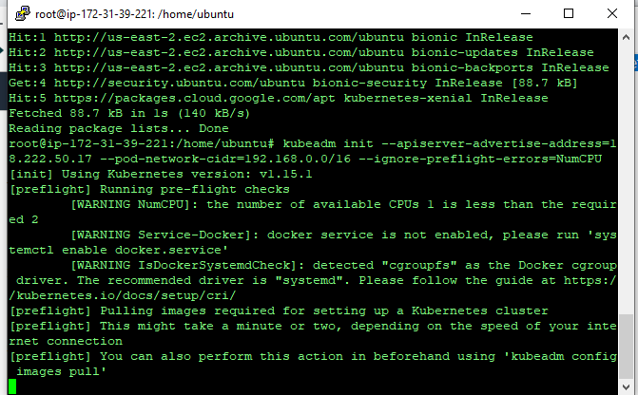

**Step 6:**

Once you execute the command above then you’ll be presented with a join token as shown in the screenshot now copy that and paste it in slave.

That command looks something like this:

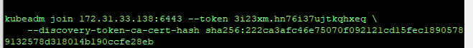

**Step 7:** Once you run the command in the slave you should receive something like below shown .

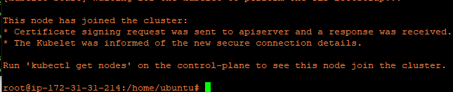

**Step 8: Now on master:**

Exit as root and run the following commands as a normal user (you can do so by pressing **ctrl +D**)

 mkdir -p $HOME/.kube

 sudo cp -i /etc/kubernetes/admin.conf $HOME/.kube/config

 sudo chown $(id -u):$(id -g) $HOME/.kube/config

Now if you do

kubectl get nodes

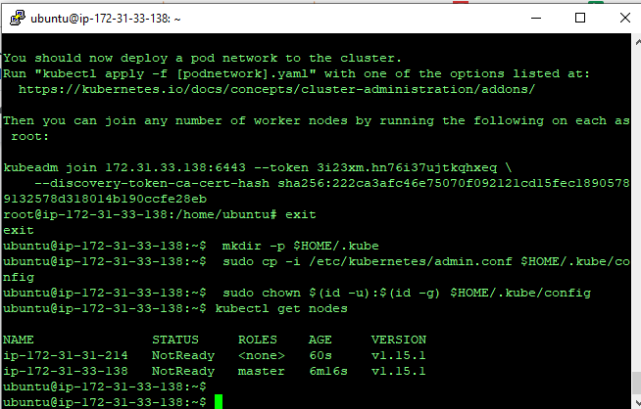

It shows the nodes but the status is not ready because we haven’t installed the network plugin

**Step 9:** Installing network plugin

kubectl apply -f <https://docs.projectcalico.org/v3.8/manifests/calico.yaml>

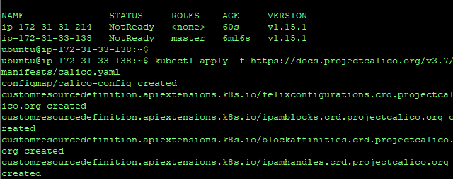

**Step 10 :** Check weather network installation was success by running the following commands

kubectl get pods --all-namespaces

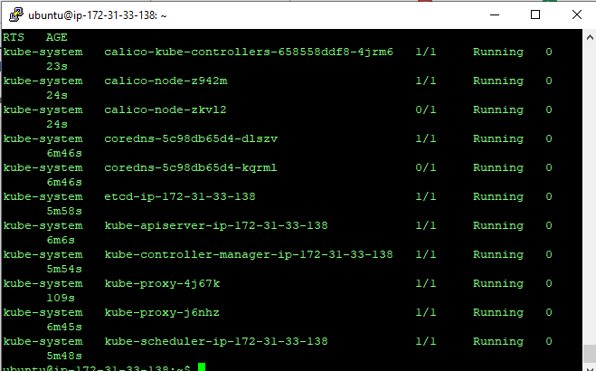

PODS are now in running state

To check if the installation is complete run the following command

kubectl get nodes

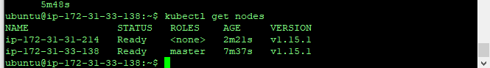

Then you can see all nodes are in ready status. Thus, we have successfully installed kubernetes.