**System Analysis And Design Question Solution for midterm exam**

**2014-1(a) What is information system analysis and design. Write down the role of a system analyst.**

**2013- 1(c) Describe the different stages of System Development Life Cycle (SDLC) briefly.**

**2013- 2(a) What is a candidate system ? describe the consideration in deciding on a candidate system specifically.**

**2013-2(b) Discuss why a new system might not meet user requirements?**

**2013-4(b) Question: What is data flor diagram (DFD) ? what basic rules are relavant to construct a DFD?**

**2014- 3(b) Describe three commonly used method for performing economic cost-benifit analysis.**

**2014-5(c) Distinguish between the following:**

1. **Physical and logical Design**
2. **HIPO and IPO**

**2014-3(d)Question: A data dictonary is structured repository of data about data- discuss**

**2014- 4(a) What is decomposition and balancing ? how can you determine if DFDs are not balanced?**

**2014-6(a) What is testing ? What are the type of system testing?**

Solutions

**2014-1(a) What is information system analysis and design. Write down the role of a system analyst.**

**Answer**:

Businesses and organizations use various types of information systems to support their business functions. Each of these information systems has a particular purpose.It includes the entire process of planning, building, deploying, using, updating, and maintaining an information system. The analysis and design of information system provides the essential knowledge for maintaing all the above process of the informations system.

**Role of a system analyst :**

* Identify, understand and plan for organizational and human impacts of planned systems.
* Ensure that new technical requirements are properly integrated with existing processes.
* Plan a system flow from the ground up.
* Interact with internal users and customers to learn requirements and take step.
* Write technical requirements from a critical phase.
* Interact with software architect to understand software limitations.
* Help programmers during system development.
* Document requirements or contribute to user manuals.
* Whenever a development process is conducted, the system analyst is responsible for designing components and providing that information to the developer.

**2013- 1(c) Describe the different stages of System Development Life Cycle (SDLC) briefly.**

Answer:

Systems Development Life Cycle is a systematic approach which explicitly breaks down the work into phases that are required to implement either new or modified Information System. The different stages of system development life cycle is given below:

**Feasibility Study or Planning**

• Define the problem and scope of existing system.

• Overview the new system and determine its objectives.

• Confirm project feasibility and produce the project Schedule.

• During this phase, threats, constraints, integration and security of system are also considered.

• A feasibility report for the entire project is created at the end of this phase.

**Analysis and Specification**

• Gather, analyze, and validate the information.

• Define the requirements and prototypes for new system.

• Evaluate the alternatives and prioritize the requirements.

• Examine the information needs of end-user and enhances the system goal.

• Requirements of the system is prepared at the end of this phase.

**System Design**

• Includes the design of application, network, databases, user interfaces, and system interfaces.

• Transform the SRS document into logical structure, which contains detailed and complete set of specifications that can be implemented in a programming language.

• Create a contingency, training, maintenance, and operation plan.

• Review the proposed design. Ensure that the final design must meet the requirements stated in SRS document.

• Finally, prepare a design document which will be used during next phases.

**Implementation**

• Implement the design into source code through coding.

• Combine all the modules together into training environment that detects errors and defects.

• A test report which contains errors is prepared through test plan that includes test related tasks such as test case generation, testing criteria, and resource allocation for testing.

• Integrate the information system into its environment and install the new system.

**Maintenance/Support**

• Include all the activities such as phone support or physical on-site support for users that is required once the system is installing.

• Implement the changes that software might undergo over a period of time, or implement any new requirements after the software is deployed at the customer location.

• It also includes handling the residual errors and resolve any issues that may exist in the system even after the testing phase.

• Maintenance and support may be needed for a longer time for large systems and for a short time for smaller systems.

**2013- 2(a) What is a candidate system ? describe the consideration in deciding on a candidate system specifically.**

Answer:

A candidate system is approached after the analyst has a through understanding of user needs & problems. A viable solution is worked out and then communicates the same. Candidate systems often cut across the boundaries of users in the organization. For example, a billing system may involve users in the sales order department, the credit department, the warehouse and the accounting department. To make sure that all users’ needs are met, a project from that represents each user works with the analysis to carry out a system development project.

**Considerations for candidate system**

In today’s business, there is more demand for computer services than there are resources available to meet the demand. The demand is made up of the following:

1. Operations of existing system.

2. Maintenance that focuses on “patching” programs – often representing over 50 percent of maintenance.

3. Enhancements that involve major modifications in program structure or equipment.

4. Requests for candidate systems.

All these demands require resource – human, financial, and technological. On the human side, the computer department has to provide the following: 

* Computer operators to run equipment. 
* Data entry personnel. 
* Systems analysts to define and design specifications. 
* Application programmers to convert system specifications to computer programs.
* Maintenance programmers to repair errors. 
* Supervisors, project leaders, and managers to coordinate the jobs with the users.

**2013-2(b) Discuss why a new system might not meet user requirements ?**

**Answer:**

**2013-4(b) Question: What is data flor diagram (DFD) ? what basic rules are relavant to construct a DFD?**

Answer:

Data Flow Diagrams(DFD):

It is a technique developed by Larry Constantine to express the requirements of system in a graphical form.

• It shows the flow of data between various functions of system and specifies how the current system is implemented.

• It is an initial stage of design phase that functionally divides the requirement specifications down to the lowest level of detail.

• Its graphical nature makes it a good communication tool between user and analyst or analyst and system designer.

• It gives an overview of what data a system processes, what transformations are performed, what data are stored, what results are produced and where they flow.

Basic Elements of DFD:

DFD is easy to understand and quite effective when the required design is not clear and the user wants a notational language for communication. However, it requires a large number of iterations for obtaining the most accurate and complete solution.

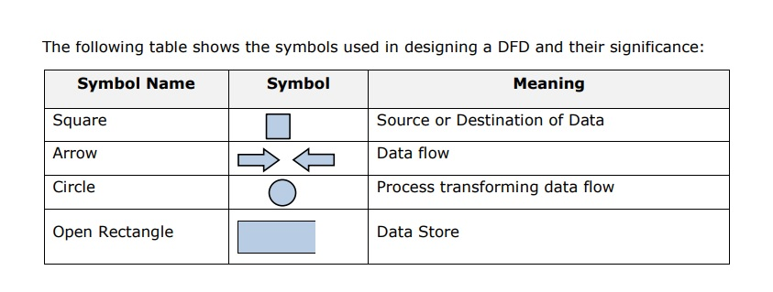

**2014- 3(b) Describe three commonly used method for performing economic cost-benifit analysis.**

There are three popular techniques for assessing cost-benefit analysis or economic feasibility.  
· **Payback analysis technique** is a simple and popular method for determining if and when an investment will pay for itself. Because system development costs are incurred before benefits are accrue, it will take some time for the benefits to overtake accrued and continuing cost.  
· **Return-on-investment (ROI) analysis** is a technique that compares the lifetime profitability of alternative solutions or projects. The ROI for a solution or project is a percentage rate that measures the relationship between the amount the business gets back from an investment and the amount invested. The lifetime ROI for a potential solution or project is calculated as follows:  
Lifetime ROI = (Estimated lifetime benefits - Estimated Lifetime Costs) / Estimated lifetime costs  
· **Net Present Value** is an analysis technique that compares the annual discounted costs and benefits of alternative solutions.

**2014-5(c) Distinguish between the following:**

1. **Physical and logical Design**
2. **HIPO and IPO**

Answer: (i)

A logical design defines what must take place, not how it will be accomplished. Logicaldesigns do not address the actual methods of implementation. In contrast, a physical designis like a set of blueprints for the actual construction of a building.

(ii)

## HIPO Diagram

HIPO (Hierarchical Input Process Output) diagram is a combination of two organized method to analyze the system and provide the means of documentation. HIPO model was developed by IBM in year 1970.

HIPO diagram represents the hierarchy of modules in the software system. Analyst uses HIPO diagram in order to obtain high-level view of system functions. It decomposes functions into sub-functions in a hierarchical manner. It depicts the functions performed by system.

HIPO diagrams are good for documentation purpose. Their graphical representation makes it easier for designers and managers to get the pictorial idea of the system structure.

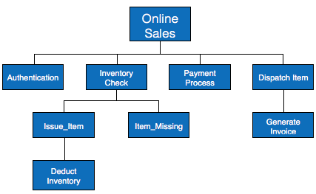

In contrast to IPO (Input Process Output) diagram, which depicts the flow of control and data in a module, HIPO does not provide any information about data flow or control flow.

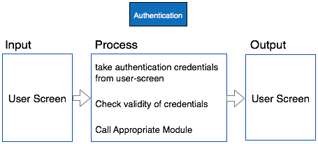

**2014-3(d)Question: A data dictonary is structured repository of data about data- discuss**

Answer:

A data dictionary is a structured repository of data elements in the system. It stores the descriptions of all DFD data elements that is, details and definitions of data flows, data stores, data stored in data stores, and the processes. A data dictionary improves the communication between the analyst and the user. It plays an important role in building a database. Most DBMSs have a data dictionary as a standard feature. For example, refer the following table:

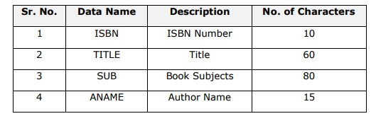

**2014- 4(a) What is decomposition and balancing ? how can you determine if DFDs are not balanced?**

Answer:

Decomposition is the iterative process by which a system description is broken down into finer and finer detail, creating a set of diagrams in which one process on a given diagram is explained in greater detail on a lower-level diagram.

Balancing is the conservation of inputs and outputs to a data flow diagram process when that process is decomposed to a lower level.

we can determine if a set of DFDs are balanced or not by observing whether or not a process which appears in a level-*n* diagram has the same inputs and outputs when decomposed for a lower-level diagram.

**2014-6(a) What is testing ? What are the type of system testing?**

**Answer:**

**Testing :**

Testing is the process or activity that checks the functionality and correctness of software according to specified user requirements in order to improve the quality and reliability of system. It is an expensive, time consuming, and critical approach in system development which requires proper planning of overall testing process.

A successful test is one that finds the errors. It executes the program with explicit intention of finding error, i.e., making the program fail. It is a process of evaluating system with an intention of creating a strong system and mainly focuses on the weak areas of the system or software.

Types of Testing:

Testing can be of various types and different types of tests are conducted depending on the kind of bugs one seeks to discover:

**Unit Testing :**

Also known as Program Testing, it is a type of testing where the analyst tests or focuses on each program or module independently. It is carried out with the intention of executing each statement of the module at least once.

• In unit testing, accuracy of program cannot be assured and it is difficult to conduct testing of various input combination in detail.

• It identifies maximum errors in a program as compared to other testing techniques.

**Integration Testing:**

In Integration Testing, the analyst tests multiple module working together. It is used to find discrepancies between the system and its original objective, current specifications, and systems documentation.

• Here the analysts are try to find areas where modules have been designed with different specifications for data length, type, and data element name.

• It verifies that file sizes are adequate and that indices have been built properly.

**Functional Testing:**

Function testing determines whether the system is functioning correctly according to its specifications and relevant standards documentation. Functional testing typically starts with the implementation of the system, which is very critical for the success of the system.

Functional testing is divided into two categories:

• Positive Functional Testing: It involves testing the system with valid inputs to verify that the outputs produced are correct

. • Negative Functional Testing: It involves testing the software with invalid inputs and undesired operating conditions.