An Auditable Agentic LLM Pipeline for Rubric-Based Grading: Evidence from a Real E-commerce Course Dataset
Nguyen Dinh Truc (corresponding) — 23521668@gm.uit.edu.vn
Nguyen Uyen Nhi — 23521115@gm.uit.edu.vn
Faculty of Information Systems, University of Information Technology (UIT), VNU-HCM, Vietnam
Supervisor: Trinh Trong Tin

Abstract
Rubric-based grading is essential for transparency and consistency but becomes a bottleneck in large classes. We present an auditable agentic grading pipeline implemented with the OpenClaw framework and apply it to four rubric-based assignments from an undergraduate e-commerce introduction course at UIT. The pipeline includes dataset normalization, text extraction with OCR when needed, incremental result writing, and automated auditing to guarantee one-to-one mapping between submissions and exported scores. Two human graders independently score a stratified subset of submissions; ground truth is defined as the mean of the two scores. We compare a single-agent grader (Phase 1) and a multi-agent grader (Phase 2) that decomposes grading into content/structure/language specialists and aggregates via a chairman agent. We report inter-rater agreement (QWK) and system-vs-human metrics (QWK/MAE/Pearson) with bootstrap confidence intervals, and analyze systematic score shifts and stability signals (veto/spread) induced by Phase 2. Results show that multi-agent grading does not automatically improve reliability and can introduce assignment-dependent calibration shifts; we provide practical recommendations for calibrating and aggregating multi-agent rubric grading in real classroom deployments.
Keywords: automated grading; rubric-based assessment; agentic AI; large language models; reliability; quadratic weighted kappa

1 Introduction

1.1 Motivation
Rubric-based assessment supports fairness and consistent grading, yet grading at scale remains time-consuming in large classes. In practice, student submissions are heterogeneous (DOCX/PDF/TXT and scanned artifacts), and instructors require not only scores and short feedback but also auditable exports (no missing/duplicate records) for course administration and research use.

1.2 Gap
Automated essay/response scoring traditionally evaluates agreement against human raters using statistics such as weighted kappa/QWK [1,2] and provides evaluation frameworks for validity and operational use [3]. Recent studies explore large language models (LLMs) for instruction- and rubric-grounded scoring [10], but real classroom deployments often require (i) end-to-end pipelines that can handle heterogeneous file formats and OCR, (ii) strict auditability guarantees, and (iii) reliability-first reporting that contextualizes system performance with human inter-rater agreement [3,4]. Meanwhile, multi-agent decompositions can help in some contexts but may also introduce calibration mismatch and aggregation instability [14,15].

1.3 Contributions
C1. An auditable grading pipeline (normalization → extraction/OCR → grading → incremental export → auditing) built on OpenClaw [18].
C2. A research-ready artifact set (derived, anonymized) for four assignments from a real UIT e-commerce course, with validated one-to-one submission-to-score mapping.
C3. Reliability-first evaluation with human inter-rater QWK and AI-vs-GT (QWK/MAE/Pearson) with bootstrap confidence intervals.
C4. Evidence-based analysis of multi-agent grading: systematic score shifts, veto/spread stability signals, and practical calibration recommendations.

2 Related Work

2.1 Automated scoring and agreement metrics
AES/SAS research commonly measures system–human agreement using Cohen’s weighted kappa variants for ordinal scales [1] and practical interpretation guidelines [2]. Evaluation frameworks emphasize reporting reliability, validity, and operational constraints [3].

2.2 Benchmarks and modeling approaches for AES
Benchmarks such as ASAP popularized QWK-based evaluation for essay scoring [7]. Neural AES methods remain a strong baseline paradigm [8], and survey work summarizes modeling choices and evaluation practices [5,9].

2.3 LLM-based rubric-grounded grading
Prompt-based LLM scoring can be adapted to new rubrics without task-specific training, yet agreement varies by prompting and calibration. Recent work documents both promise and limitations in reliability and bias [10,11,12].

2.4 Multi-agent LLM grading and aggregation
Multi-agent designs decompose grading into specialists and aggregate outputs. Such aggregation can introduce severity mismatch and instability without calibration [14]. Structured multi-agent scoring pipelines have also been proposed [15].

2.5 Reliability-first evaluation
Automated scoring should be interpreted relative to human inter-rater reliability rather than as absolute truth [3].

3 Method
Figure 1 shows the end-to-end pipeline.
Figure 1: OpenClaw grading pipeline (normalization → extraction/OCR → grading → export/audit).
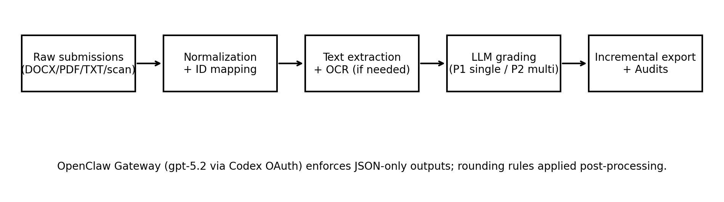

3.1 Implementation and model configuration
All LLM calls are served through a local OpenClaw Gateway exposing an OpenAI-compatible Chat Completions endpoint [18]. In our deployment configuration (openclaw.json), the agent's primary model identifier is `openai-codex/gpt-5.2`, accessed via an OAuth-based `openai-codex` profile. This identifier is produced by the gateway routing layer; the underlying model family/weights are proprietary and not publicly disclosed. Therefore, we focus reproducibility on fixed decoding settings, JSON-only scoring schemas, released derived artifacts, and evaluation scripts rather than exact replication of model weights. Phase 1 uses temperature=0.1 and max_tokens=900; Phase 2 uses temperature=0.1 and max_tokens=800 with robust retry logic for rate limits and JSON parsing. Scores are post-processed with deterministic rounding (0.25 per criterion; 0.5 total; range 0–10).

3.2 Phase 1: Single-agent rubric grading
Phase 1 grades all rubric criteria in a single call per submission and outputs per-criterion scores, total score, and short feedback.

3.3 Phase 2: Multi-agent grading (content/structure/language + chairman aggregation)
Phase 2 runs three specialist graders in parallel and aggregates per-criterion scores via a chairman agent (mean per criterion). A veto flag is triggered when specialist totals differ by more than 2.0 points, and a spread value summarizes inter-specialist disagreement.

4 Experimental Setup
We evaluate four assignments (BT1–BT4), each scored on a 0–10 scale with rubric maxima per criterion. Two human graders score a stratified subset (N=30 per assignment) selected to cover performance bands (high/medium/low) based on Phase-1 scores. Ground truth (GT) is defined as the mean of the two human scores. Human annotation budget constraints limited N; we report uncertainty via bootstrap confidence intervals.

4.1 Metrics
We report inter-rater QWK between the two humans and compare Phase 1/Phase 2 against GT using QWK, MAE, and Pearson correlation. For QWK, scores are mapped to integers by multiplying by 2 and rounding, matching the 0.5-point granularity used in totals.

5 Results

5.1 Human agreement and AI-vs-GT (with bootstrap CIs)
Table 1 reports point estimates and 95% bootstrap confidence intervals on the human-scored subset (N=30 per assignment).
BT | Human QWK [CI] | P1 QWK [CI] | P1 MAE [CI] | P1 r [CI] | P2 QWK [CI] | P2 MAE [CI] | P2 r [CI]
BT1 | 0.698 [0.464, 0.811] | 0.484 [0.273, 0.627] | 1.108 [0.892, 1.333] | 0.808 [0.681, 0.892] | 0.043 [-0.026, 0.142] | 1.842 [1.517, 2.158] | 0.225 [-0.115, 0.557]
BT2 | 0.684 [0.469, 0.802] | 0.331 [0.164, 0.443] | 1.375 [1.142, 1.600] | 0.694 [0.411, 0.860] | -0.002 [-0.237, 0.244] | 0.958 [0.708, 1.250] | -0.010 [-0.356, 0.337]
BT3 | 0.671 [0.440, 0.835] | 0.827 [0.664, 0.904] | 0.775 [0.550, 1.042] | 0.897 [0.807, 0.960] | 0.613 [0.405, 0.747] | 1.058 [0.833, 1.300] | 0.673 [0.509, 0.837]
BT4 | 0.628 [0.301, 0.791] | 0.720 [0.587, 0.799] | 0.575 [0.442, 0.725] | 0.753 [0.630, 0.861] | 0.517 [0.262, 0.698] | 0.608 [0.467, 0.750] | 0.553 [0.324, 0.725]

5.2 Phase 2 vs Phase 1 score shifts and stability signals (full dataset outputs)
Table 2 summarizes systematic score shifts of Phase 2 relative to Phase 1 on the full exported outputs, along with veto rates and mean spread.
BT | N_full | mean(P2−P1) | median(P2−P1) | veto rate | mean spread
BT1 | 137 | -0.836 | -1.000 | 0.993 | 5.150
BT2 | 129 | 1.787 | 2.000 | 0.922 | 3.387
BT3 | 123 | -0.943 | -1.000 | 0.772 | 2.653
BT4 | 131 | -0.889 | -1.000 | 0.061 | 1.133

5.3 Visualization
Figure 2 visualizes agreement with GT for Phase 1 and Phase 2 (N=30 per assignment).
Figure 2: Scatter plots of P1/P2 vs GT across assignments (dashed line indicates y=x).
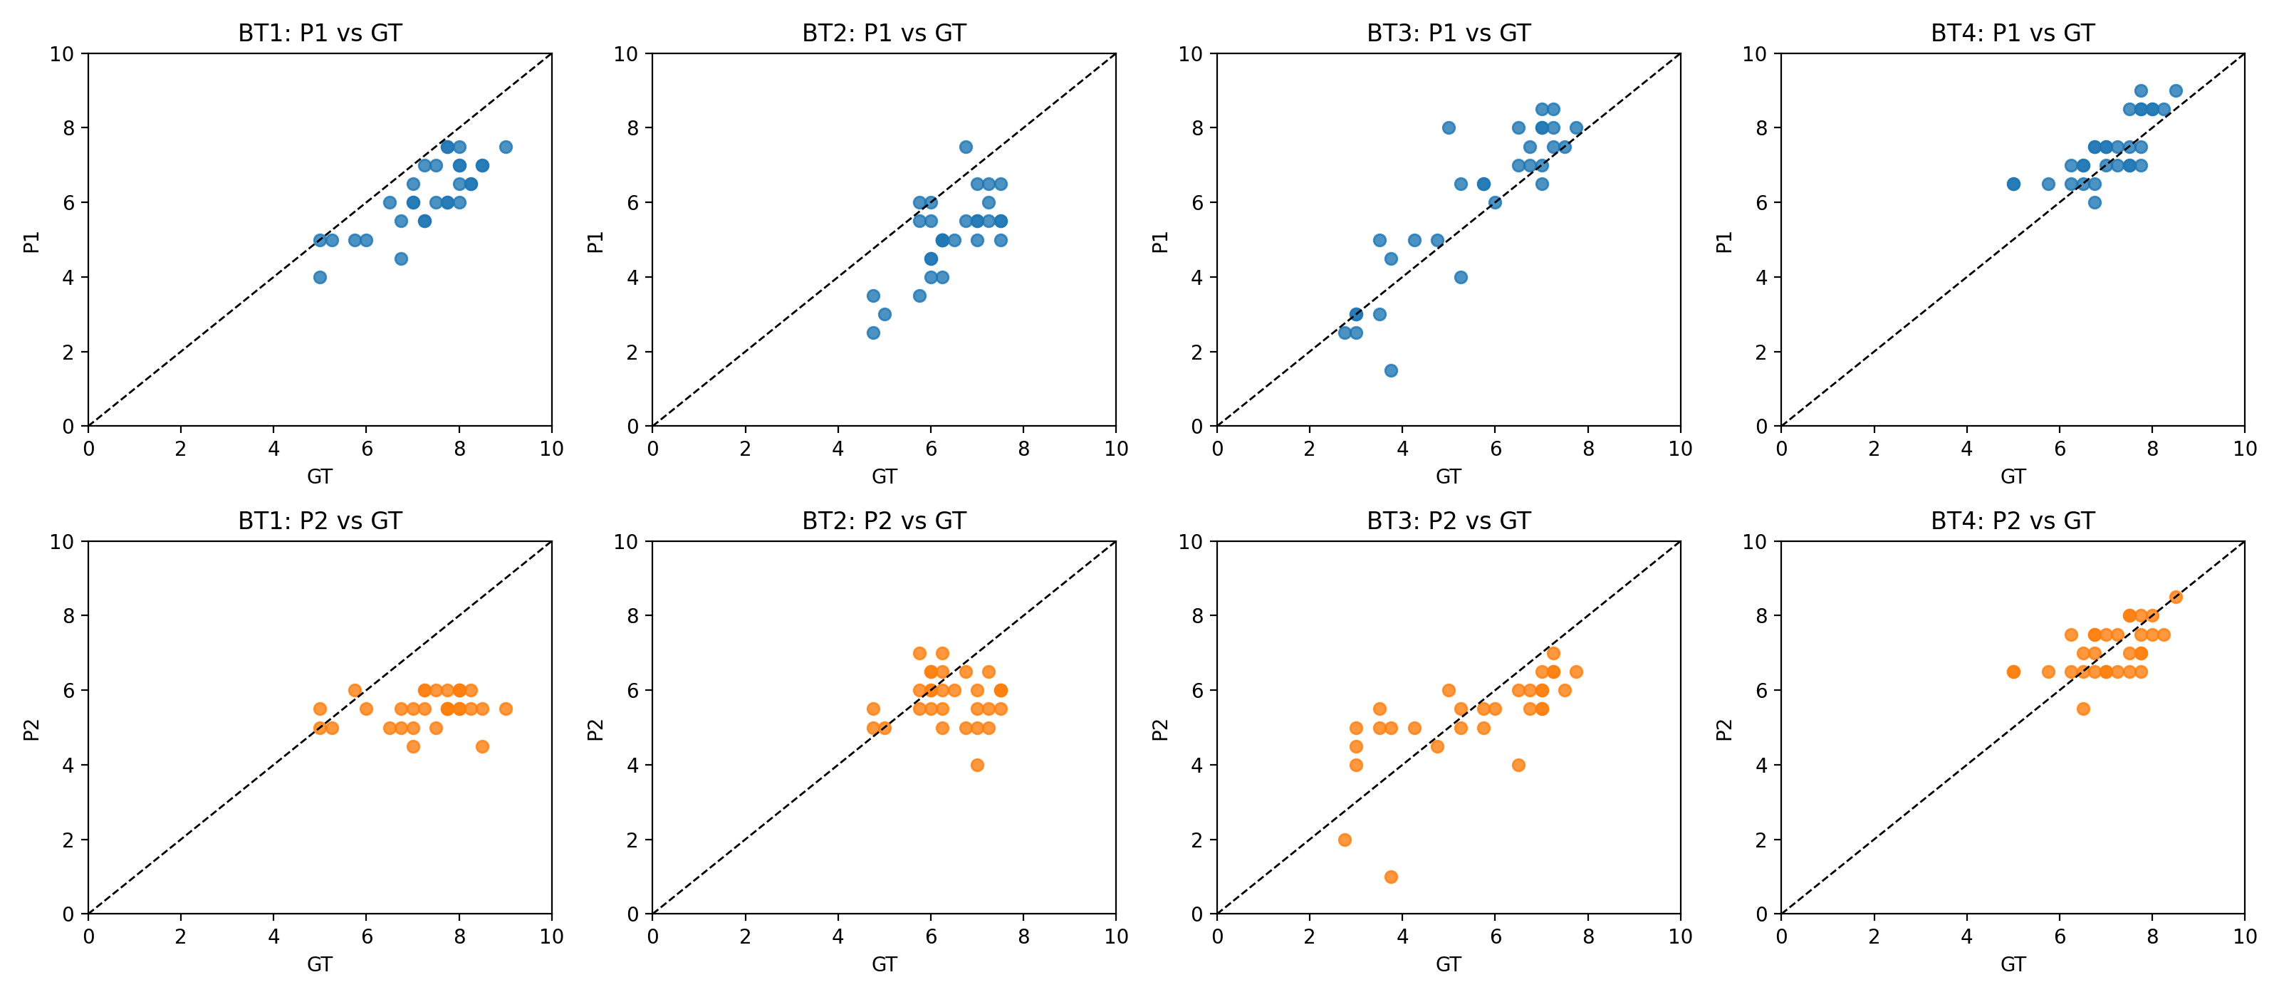

6 Discussion and recommendations
Multi-agent grading does not automatically improve ordinal agreement (QWK) with GT in our setting, and can introduce assignment-dependent score shifts. We attribute this to calibration mismatch between specialists, aggregation smoothing, and surface-feature sensitivity (language) that may be misaligned with rubric intent in factual/sourcing-heavy assignments (BT1–BT2).
Recommendations to improve multi-agent grading reliability:
R1. Calibrate specialist severity using a small anchor set and learn per-grader offsets/scales before aggregation.
R2. Use robust aggregation (median/trimmed mean) rather than simple mean to reduce outlier severity effects.
R3. Rubric-aligned weighting: downweight language/style for BT1–BT2; increase for BT3–BT4.

6.1 Limitations
Our human-scored subset is limited (N=30 per assignment) due to annotator availability; bootstrap CIs can be wide. We did not perform a full sensitivity analysis over temperature and prompting variants; results may change under different decoding settings. Ground truth is defined as the mean of two graders; when graders disagree substantially, adjudication could yield a different reference score.

7 Ethics and privacy
Student submissions are sensitive; we recommend releasing only derived anonymized artifacts (scores/metadata/audit logs) and not releasing raw submissions.

8 Conclusion
We presented an auditable OpenClaw-based grading pipeline and a reliability-first evaluation across four real assignments. Single-agent grading achieved higher agreement with human scores than multi-agent grading in our setting, and Phase 2 exhibited systematic shifts and stability issues. We provided practical calibration and aggregation recommendations for deploying multi-agent rubric grading in real courses.

References
[1] Cohen, J.: Weighted kappa: Nominal scale agreement with provision for scaled disagreement or partial credit. Psychological Bulletin 70(4), 213–220 (1968).
[2] Landis, J.R., Koch, G.G.: The measurement of observer agreement for categorical data. Biometrics 33(1), 159–174 (1977).
[3] Williamson, D.M., Xi, X., Breyer, F.J.: A framework for evaluation and use of automated scoring. Educational Measurement: Issues and Practice 31(1), 2–13 (2012).
[4] Shermis, M.D., Burstein, J. (eds.): Handbook of Automated Essay Evaluation: Current Applications and New Directions. Routledge (2013).
[5] Beigman Klebanov, B., Madnani, N.: Automated Essay Scoring. Synthesis Lectures in Human Language Technologies. Morgan & Claypool (2021).
[6] Attali, Y., Burstein, J.: Automated essay scoring with e-rater® V.2. Journal of Technology, Learning, and Assessment 4(3) (2006).
[7] Hewlett Foundation (ASAP). Automated Student Assessment Prize (ASAP) AES benchmark (Kaggle competition). https://www.kaggle.com/c/asap-aes (accessed 2026-05-01).
[8] Taghipour, K., Ng, H.T.: A neural approach to automated essay scoring. In: Proceedings of EMNLP 2016, pp. 1882–1891. ACL (2016).
[9] Ke, Z., Ng, V.: Automated essay scoring: A survey of the state of the art. In: Proceedings of IJCAI 2019, pp. 6300–6308 (2019).
[10] Mizumoto, A., Eguchi, M.: Exploring the potential of using an AI language model for automated essay scoring. Research Methods in Applied Linguistics 2(2), 100050 (2023). https://doi.org/10.1016/j.rmal.2023.100050
[11] Esterhuysen, H., et al.: Large language models in student assessment: Comparing ChatGPT and human graders. arXiv:2406.16510 (2024).
[12] Meyer, L., et al.: Reliable but not rigorous: Evaluating ChatGPT's reliability, validity, and bias in automated academic grading. Computers and Education: Artificial Intelligence (2025).
[13] Hakala, K., et al.: Automated refinement of essay scoring rubrics for language models via Reflect-and-Revise. arXiv:2510.09030 (2025).
[14] Seßler, K., et al.: Specialists or generalists? Multi-agent and single-agent LLMs for essay grading. arXiv:2601.22386 (2026).
[15] Wang, Y., Ding, Z., Wu, X., Sun, S., Liu, N., Zhai, X.: AutoSCORE: Enhancing automated scoring with multi-agent large language models via structured component recognition. arXiv:2509.21910 (2025).
[16] Fleiss, J.L., Cohen, J.: The equivalence of weighted kappa and the intraclass correlation coefficient as measures of reliability. Educational and Psychological Measurement 33(3), 613–619 (1973).
[17] OpenAI: API reference for Chat Completions (accessed via internal proxy in this work). https://platform.openai.com/docs/api-reference/chat (accessed 2026-05-01).
[18] OpenClaw Framework. Documentation: https://docs.openclaw.ai ; Source: https://github.com/openclaw/openclaw (accessed 2026-05-01).

