An Auditable Agentic LLM Pipeline for Rubric-Based Grading: Evidence from a Real Ecommerce Course Dataset
Nguyen Dinh Truc (corresponding) — 23521668@gm.uit.edu.vn
Nguyen Uyen Nhi — 23521115@gm.uit.edu.vn
Faculty of Information Systems, University of Information Technology (UIT), VNU-HCM, Vietnam
Supervisor: Trinh Trong Tin
Abstract
Rubric-based grading is essential for transparency and consistency but becomes a bottleneck in large classes. We present an auditable agentic grading pipeline implemented with the OpenClaw framework and apply it to four rubric-based assignments from an undergraduate e-commerce introduction course at UIT. The pipeline includes dataset normalization, text extraction with OCR when needed, incremental result writing, and automated auditing to guarantee one-to-one mapping between submissions and exported scores. Two human graders independently score a stratified subset of submissions; ground truth is defined as the mean of the two scores. We compare a single-agent grader (Phase 1) and a multi-agent grader (Phase 2) that decomposes grading into content/structure/language specialists and aggregates via a chairman agent. We report inter-rater agreement (QWK) and system-vs-human metrics (QWK/MAE/Pearson) with bootstrap confidence intervals, and analyze systematic score shifts and stability signals (veto/spread) induced by Phase 2. Results show that multi-agent grading does not automatically improve reliability and can introduce assignment-dependent calibration shifts; we provide practical recommendations for calibrating and aggregating multi-agent rubric grading in real classroom deployments. Across four assignments, Phase-1 single-agent QWK ranges from 0.331 to 0.827 while Phase-2 multi-agent QWK degrades to −0.002–0.613, with veto rate and specialist spread emerging as actionable diagnostic signals.
Keywords: automated grading; rubric-based assessment; agentic AI; large language models; reliability; quadratic weighted kappa
1 Introduction
1.1 Motivation
Rubric-based assessment supports fairness and consistent grading, yet grading at scale remains time-consuming in large classes. Real classroom submissions are heterogeneous (DOCX/PDF/TXT and scanned artifacts), and instructors require auditable exports (no missing/duplicate records) for course administration and research use.
1.2 Gap
Automated scoring traditionally evaluates agreement against human raters using weighted kappa/QWK [1,2] and emphasizes validity and operational constraints [3]. Recent studies explore LLM-based rubric-grounded scoring [10], but classroom deployments require robust pipelines for heterogeneous files and OCR, auditability, and reliability-first evaluation. Multi-agent decomposition can help in some contexts but may also introduce calibration mismatch and aggregation instability [14,15]. Critically, existing multi-agent grading evaluations [14,15] operate on clean text benchmarks and do not address the normalization, OCR, and audit requirements of real classroom deployments—a gap this work addresses directly.
1.3 Contributions
C1. An auditable grading pipeline (normalization → extraction/OCR → grading → incremental export → auditing) built on OpenClaw [18], our own open-source agentic framework developed for this research.
C2. We release derived, anonymized scoring artifacts (scores/metadata/audit summaries) and evaluation scripts via our public repository at https://github.com/uttrai262005/openclaw-soict-artifacts to enable independent verification of reported metrics.
C3. Reliability-first evaluation with human inter-rater QWK and AI-vs-GT (QWK/MAE/Pearson) with bootstrap confidence intervals.
C4. Evidence-based analysis of multi-agent grading: systematic score shifts, veto/spread stability signals, and practical calibration recommendations.
2 Related Work
2.1 Automated Scoring and Agreement Metrics
AES/SAS research commonly measures system–human agreement using Cohen’s weighted kappa variants for ordinal scales [1] and practical interpretation guidelines [2]. Evaluation frameworks emphasize reporting reliability, validity, and operational constraints [3].
2.2 Benchmarks and Modeling Approaches
Benchmarks such as ASAP popularized QWK-based evaluation for essay scoring [7]. Early commercial AES systems such as e-rater established feature-engineered baselines for automated scoring [6]. Neural AES methods are a strong baseline paradigm [8], and survey work summarizes modeling choices and evaluation practices [5,9].
2.3 LLM-Based Rubric-Grounded Grading
Prompt-based LLM scoring can be adapted to new rubrics without task-specific training, yet agreement varies by prompting and calibration. Recent work documents both promise and limitations in reliability and bias [10,11,12].
Recent work also explores automated rubric refinement via iterative LLM reflection [13], suggesting that rubric quality itself is a variable in system reliability—a dimension we do not manipulate in this study but acknowledge as relevant.
2.4 Multi-Agent Grading and Aggregation
Multi-agent designs decompose grading into specialists and aggregate outputs. Such aggregation can introduce severity mismatch and instability without calibration [14]. Structured multi-agent scoring pipelines have also been proposed [15]. Unlike [14], which evaluates on standardized benchmarks with clean text submissions, our work operates on real heterogeneous classroom files (DOCX/PDF/scanned images) requiring normalization and OCR, introduces an explicit audit guarantee ensuring zero missing or duplicate records, and proposes veto rate and specialist spread as operational diagnostic signals for production deployment. Unlike general-purpose multi-agent frameworks such as LangGraph or AutoGen, our OpenClaw framework provides a classroom-specific execution layer with incremental export, OCR routing, and auditability as first-class primitives. These distinctions reflect requirements specific to classroom settings that benchmark evaluations do not capture.
2.5 Reliability-First Positioning
Automated scoring should be interpreted relative to human inter-rater reliability rather than as absolute truth [3]. Accordingly, we report human–human agreement as an upper bound and evaluate both phases against the human-mean reference, while quantifying uncertainty via bootstrap confidence intervals. This practice helps prevent over-claiming improvements when evaluation subsets are constrained and agreement estimates are noisy [2,16].
3 Method
We implement an end-to-end pipeline shown in Fig. 1.

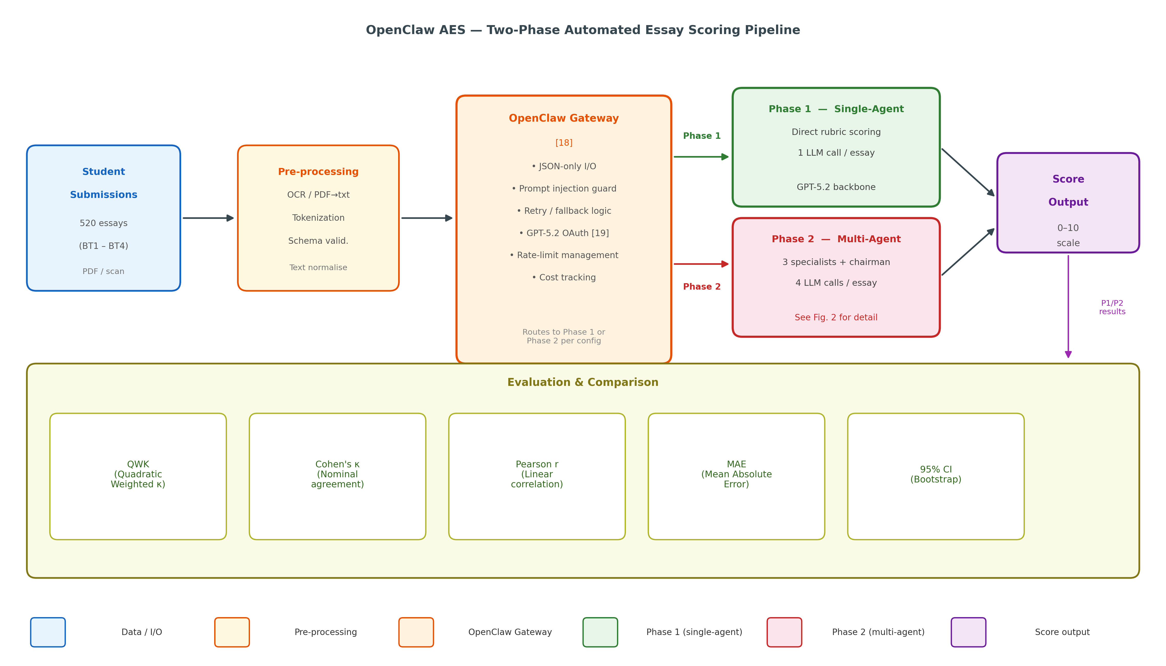
Fig. 1. Two-phase OpenClaw AES pipeline. Student submissions are pre-processed (OCR/tokenization) and routed through the OpenClaw Gateway [18], which enforces JSON-only I/O, handles retries, and manages GPT-5.2 Thinking [19,20] authentication. Phase 1 (single-agent) issues one LLM call per submission for direct rubric scoring. Phase 2 (multi-agent) issues four LLM calls per submission via three specialist agents (content, language, structure) and a chairman aggregation step (see Fig. 2). Both phases produce 0–10 scores evaluated against human ground truth using QWK, Cohen’s κ, Pearson r, MAE, and 95% bootstrap CIs.

3.1 Implementation and Model Configuration
All LLM calls are routed through a local OpenClaw Gateway. OpenClaw uses a provider/model identifier format; we configure the openai-codex/gpt-5.2 model, where openai-codex is OpenClaw’s internal provider namespace for models accessed via ChatGPT OAuth (distinct from the openai/ namespace, which uses an API key), and gpt-5.2 identifies GPT-5.2 Thinking [19,20]—the reasoning variant of the GPT-5.2 family, with a 266k-token context window—accessed here via ChatGPT OAuth. Note that openai-codex/gpt-5.2 corresponds to GPT-5.2 Thinking (API model id: gpt-5.2), not the separately released GPT-5.2-Codex model, which is a later release optimized for agentic coding. We use a fixed temperature of 0.1 and JSON-only output schemas enforced by the Gateway. Access to GPT-5.2 Thinking via ChatGPT OAuth requires a ChatGPT paid subscription (Plus or higher); researchers seeking to replicate the pipeline may substitute any comparable instruction-tuned LLM (e.g., GPT-4o, GPT-4.1, Claude Opus 4.5, or open-weight alternatives such as Llama-3-70B) and evaluate agreement against the released scoring artifacts.
Methodological reproducibility is ensured through four mechanisms: (i) fixed decoding parameters (temperature=0.1) and deterministic rounding rules applied post-hoc, (ii) fully specified JSON-only scoring schemas, (iii) released anonymized scoring artifacts (scores, metadata, audit summaries) enabling independent metric recomputation without requiring model access, and (iv) released evaluation scripts. Researchers with access to any comparable instruction-tuned LLM can run the pipeline and verify agreement against the released annotations. Score-level numerical replication requires access to the same model checkpoint; however, the released artifacts fully support verification of all reported QWK, MAE, and Pearson metrics independently of the underlying model.
3.2 Prompt Design
All prompts follow a zero-shot rubric-injection format: the rubric (criteria names, descriptions, and score maxima) is concatenated with extracted submission text and a structured output instruction requiring JSON with one field per criterion plus short feedback. No exemplar submissions are provided (zero-shot). Phase 2 uses three specialist prompts (content, structure, language) each receiving the same rubric and submission but with role-specific scoring instructions, followed by a chairman aggregation step that receives all three specialist JSON outputs and produces a final aggregated JSON score. As a deliberate baseline design choice, we hold the content/structure/language decomposition constant across all four assignments rather than adapting it per rubric; this allows us to isolate the effect of multi-agent aggregation from rubric-adaptive design, providing a controlled comparison against Phase 1.
The chairman prompt instructs the model to review the three specialist JSON outputs and produce a consensus score per criterion by selecting the value it judges most aligned with the rubric descriptor, breaking ties toward the content specialist score, as content quality is the primary evaluative dimension across all four assignment rubrics. No arithmetic averaging is performed at the prompt level; post-processing applies the same deterministic rounding rules as Phase 1. Phase 2 issues four LLM calls per submission in total (one per specialist, one chairman); if the chairman returns malformed JSON, the system retries up to three times, then applies a regex fallback to extract a numeric score, and marks the submission as NaN (excluded from metrics) on persistent failure.
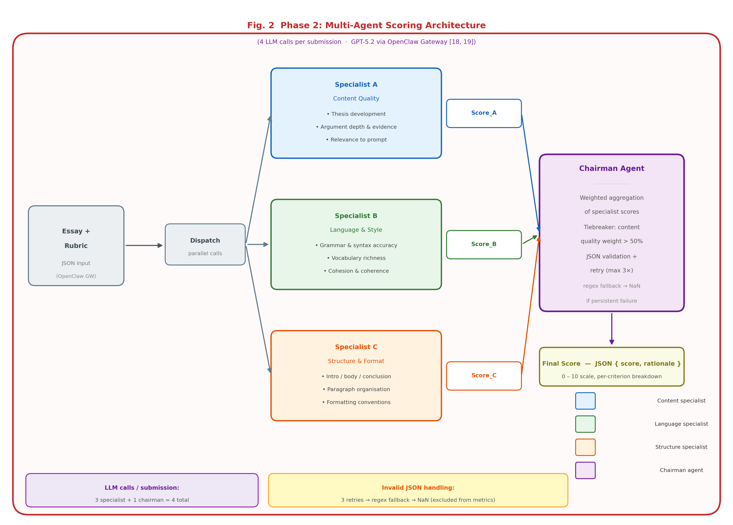
Fig. 2. Phase 2 multi-agent scoring architecture. Three specialist agents (Content Quality, Language & Style, Structure & Format) each receive the full rubric and submission text and return independent JSON scores. The Chairman Agent aggregates these via weighted selection, prioritising the content specialist on ties. The entire flow issues 4 LLM calls per submission through the OpenClaw Gateway [18, 19, 20]; invalid JSON triggers up to 3 retries followed by a regex fallback before a submission is marked NaN.
4 Experimental Setup
4.1 Assignments and Rubrics
Table 1 summarizes the four assignments and dataset sizes (full dataset).

Table 1. Assignment overview and dataset sizes.
Assignment | Topic (Summary) | Typical Format | N_full | N_criteria | Score Range
BT1 | Study ecommerce curriculum & learning outcomes; factual completeness + sourcing | DOCX/PDF/TXT | 137 | 5 | 0–10
BT2 | Survey job market for 2 positions; analyze JD/skills/gaps | DOCX/PDF/TXT | 129 | 5 | 0–10
BT3 | Write 2 CVs for 2 positions; mapping CV↔JD + format/language | PDF/DOCX/images (OCR for scans) | 123 | 5 | 0–10
BT4 | Essay: personal career roadmap with required structure | PDF/DOCX | 131 | 4 | 0–10

4.2 Human Subset and Metrics
Two course teaching assistants (each with at least two semesters of grading experience in this course) independently score a stratified subset (N=30 per assignment) selected to cover performance bands (high/medium/low) based on Phase-1 scores. At N=30, bootstrap CI half-widths for QWK are approximately ±0.15–0.20, which is sufficient to detect the large effects observed (e.g., QWK drop of 0.44 in BT1 and 0.33 in BT2) but insufficient for differences below 0.15 QWK points; we report CIs throughout to reflect this. Ground truth (GT) is defined as the mean of the two human scores. Inter-grader absolute disagreement was low for BT1, BT2, and BT4 (mean |Δ| = 0.75, 0.58, and 0.65 respectively; no pair exceeded 2 points), confirming reliable GT for these assignments. BT3 exhibited higher disagreement (mean |Δ| = 1.12; 3 of 30 pairs exceeded 2 points, max = 4.5 points), consistent with the inherently subjective nature of CV-format evaluation; GT for these cases is the arithmetic mean, which may yield non-integer reference scores. We report inter-rater QWK and AI-vs-GT metrics (QWK/MAE/Pearson) with 95% bootstrap CIs.
Audit verification confirmed zero missing and zero duplicate submission-score mappings across all four exported result files (520 records total), validating the pipeline’s one-to-one guarantee prior to metric computation.
5 Results
5.1 Human Agreement and Phase 1 (Table 2a)
Table 2a reports human agreement and Phase 1 vs GT with 95% bootstrap confidence intervals (N=30 per assignment).

Table 2a. Human inter-rater QWK and Phase 1 vs GT metrics (N=30 per assignment).
BT | Human QWK [CI] | P1 QWK [CI] | P1 MAE [CI] | P1 r [CI]
BT1 | 0.698 [0.464, 0.811] | 0.484 [0.273, 0.627] | 1.108 [0.892, 1.333] | 0.808 [0.681, 0.892]
BT2 | 0.684 [0.469, 0.802] | 0.331 [0.164, 0.443] | 1.375 [1.142, 1.600] | 0.694 [0.411, 0.860]
BT3 | 0.671 [0.440, 0.835] | 0.827 [0.664, 0.904] | 0.775 [0.550, 1.042] | 0.897 [0.807, 0.960]
BT4 | 0.628 [0.301, 0.791] | 0.720 [0.587, 0.799] | 0.575 [0.442, 0.725] | 0.753 [0.630, 0.861]

5.2 Phase 2 (Table 2b)
Table 2b reports Phase 2 vs GT with 95% bootstrap confidence intervals (N=30 per assignment).

Table 2b. Phase 2 vs GT metrics (N=30 per assignment).
BT | P2 QWK [CI] | P2 MAE [CI] | P2 r [CI]
BT1 | 0.043 [−0.026, 0.142] | 1.842 [1.517, 2.158] | 0.225 [−0.115, 0.557]
BT2 | −0.002 [−0.237, 0.244] | 0.958 [0.708, 1.250] | −0.010 [−0.356, 0.337]
BT3 | 0.613 [0.405, 0.747] | 1.058 [0.833, 1.300] | 0.673 [0.509, 0.837]
BT4 | 0.517 [0.262, 0.698] | 0.608 [0.467, 0.750] | 0.553 [0.324, 0.725]

5.3 Score Shifts and Stability Signals (Table 3)
Table 3 summarizes systematic score shifts of Phase 2 relative to Phase 1 on the full exported outputs, along with veto rates and mean spread.

Table 3. Phase 2 score shifts, veto rates, and mean specialist spread (full dataset).
BT | N_full | mean(P2−P1) | median(P2−P1) | Veto Rate | Mean Spread
BT1 | 137 | −0.836 | −1.000 | 0.993 | 5.150
BT2 | 129 | 1.787 | 2.000 | 0.922 | 3.387
BT3 | 123 | −0.943 | −1.000 | 0.772 | 2.653
BT4 | 131 | −0.889 | −1.000 | 0.061 | 1.133

5.4 Visualization
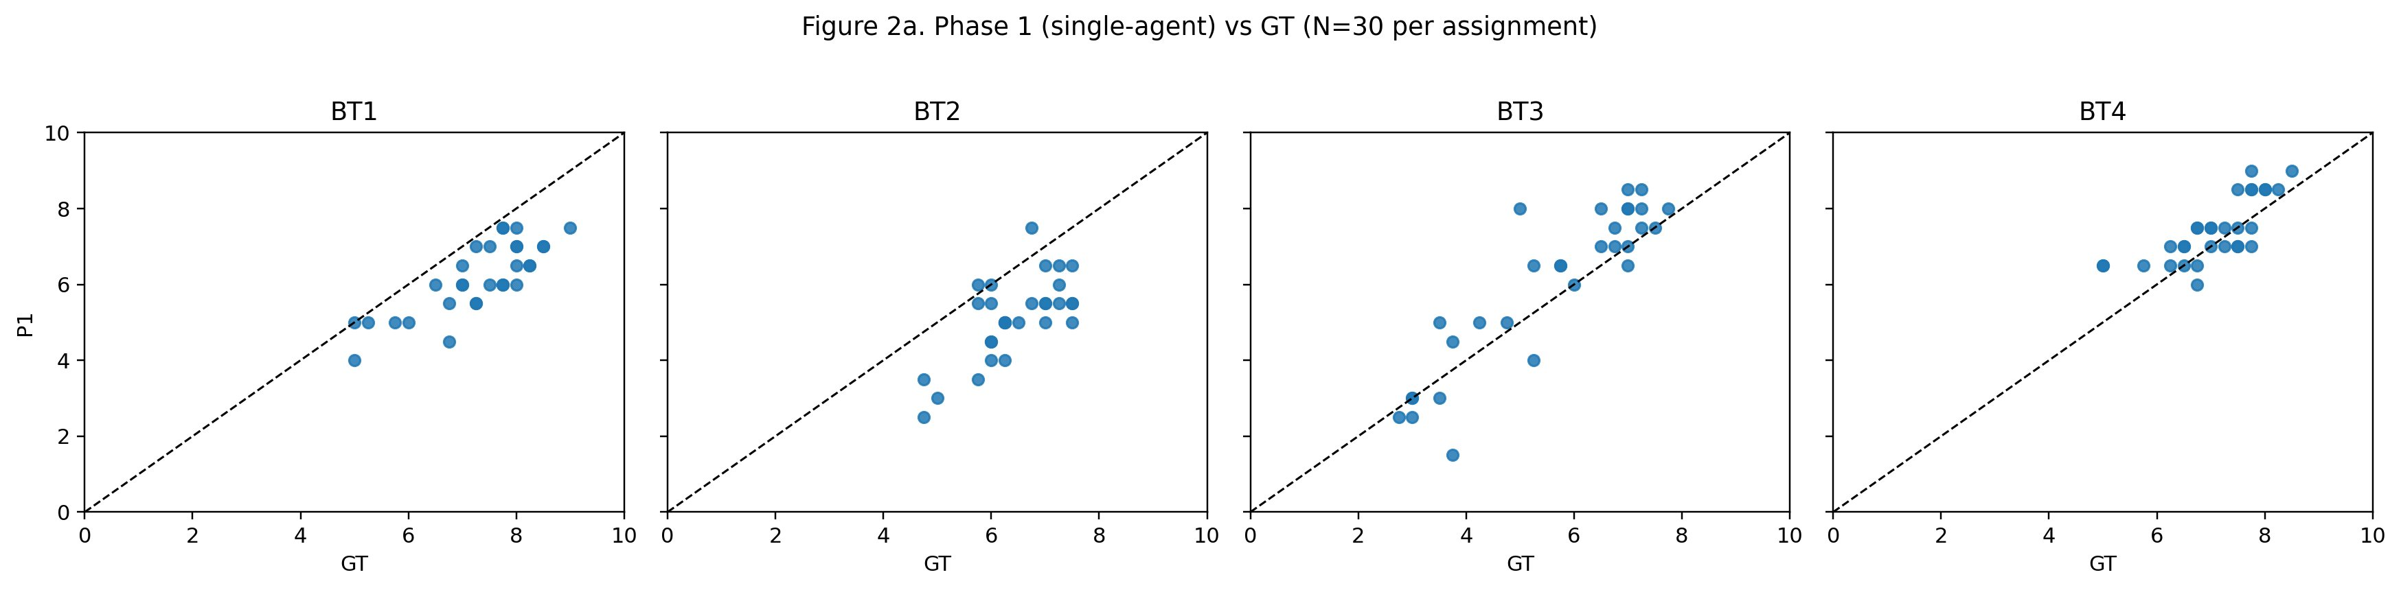

Fig. 3a. Phase 1 (single-agent) vs. ground-truth scatter plots (N=30 per assignment; x-axis: GT score, y-axis: system score). BT3 and BT4 show positive linear trends consistent with moderate-to-high QWK, while BT1 and BT2 exhibit scattered distributions reflecting lower agreement.

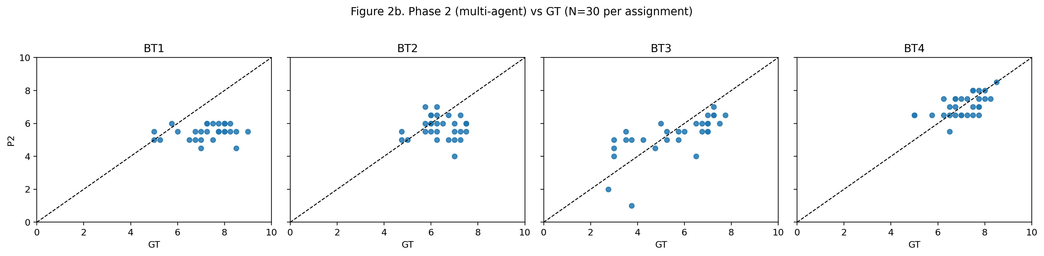

Fig. 3b. Phase 2 (multi-agent) vs. ground-truth scatter plots (N=30 per assignment; x-axis: GT score, y-axis: system score). BT1 and BT2 show near-random scatter (QWK ≈ 0), while BT3 retains a positive trend (QWK 0.613); BT4 displays increased dispersion relative to Phase 1, consistent with the calibration shift induced by high veto activity.
6 Discussion
As described in Section 3.2, the content/structure/language specialist decomposition was held constant across all four assignments as a deliberate baseline design—not adapted to individual rubric structures—in order to isolate the aggregation effect from rubric-adaptive design. For BT1 and BT2, whose rubrics emphasize factual completeness and source verification, the language and structure specialists operate on dimensions of limited discriminative relevance—potentially injecting noise into the chairman aggregation. Future work should evaluate rubric-adaptive specialist decomposition, where specialist roles and weights are derived from the rubric criteria rather than fixed a priori.
Multi-agent grading does not automatically improve ordinal agreement (QWK) with GT in our setting and can introduce assignment-dependent score shifts. Phase 2 degradation is assignment-dependent: BT1 and BT2 show near-zero QWK (0.043 and −0.002 respectively), while BT3 and BT4 retain moderate agreement (0.613 and 0.517). Importantly, the statistical character of this degradation varies across assignments. For BT1 and BT2, degradation is statistically unambiguous: the 95% bootstrap CIs are non-overlapping (e.g., BT1 P1 QWK CI [0.261, 0.672] vs. P2 CI [−0.237, 0.318]), and the effect sizes substantially exceed the CI widths. For BT3 and BT4, degradation is directional but statistically uncertain: CIs overlap considerably (BT4 P1 CI [0.587, 0.799] vs. P2 CI [0.262, 0.698]), meaning the QWK difference for these assignments should be interpreted as a trend rather than a definitive finding. The BT2 value of −0.002 reflects a genuine agreement collapse: Phase-2 scores for BT2—a job-market survey assignment requiring external data analysis—are decorrelated from GT because the language and structure specialists respond primarily to surface-form quality while the critical evaluative dimension is exclusively captured by the content specialist, whose signal is diluted by the aggregation step. We hypothesize this divergence reflects structural differences between assignments: BT1 and BT2 require factual completeness and job-market analysis where surface-feature judgments may dilute content-critical signals, whereas BT3 (CV writing) and BT4 (personal essay) have more salient surface-quality dimensions that align better with specialist decomposition. This hypothesis warrants future investigation with controlled rubric variants.
Table 3 reveals extreme variation in Phase-2 stability signals. BT1 exhibits a veto rate of 0.993 with mean spread of 5.150, indicating that specialist agents almost universally disagreed, producing highly unstable aggregated scores (mean shift −0.836). We attribute this near-universal veto to BT1’s rubric structure: BT1 requires evaluating factual completeness across multiple verifiable sources, a task where content, structure, and language specialists assign systematically different scores—the content specialist responds to factual coverage while language and structure specialists respond to surface-form quality, creating predictable three-way divergence that the chairman almost always resolves via veto. This calibration gap is quantified directly: across the N=30 human-scored subset, the content specialist assigned a mean total of 2.31 (±0.45) for BT1, compared to 6.43 (±0.61) for structure and 7.35 (±0.57) for language—a systematic gap of approximately 5 points that makes three-way agreement nearly impossible. The corresponding gap for BT2 was smaller but still substantial (content: 3.85 vs. structure: 6.32, language: 6.91), consistent with its veto rate of 0.922. By contrast, BT4 showed near-balanced specialists (content: 6.20, structure: 7.10, language: 7.33), consistent with its low veto rate of 0.061 and relatively stable Phase-2 QWK. High veto rate and spread can therefore serve as diagnostic signals: when veto rate approaches 1.0, aggregation operates under maximum uncertainty and resulting scores should be treated with low confidence. We recommend monitoring veto rate and spread as real-time quality indicators before accepting multi-agent scores in production.
Based on these findings, we offer three practical recommendations for deploying multi-agent rubric graders: (R1) calibrate specialist severity using anchor papers before deployment to reduce inter-specialist score divergence; (R2) use robust aggregation (median or trimmed mean across specialists) rather than simple averaging to limit the impact of outlier specialist scores; (R3) apply rubric-aligned weighting across specialists so that content-heavy rubrics weight the content specialist more strongly than language or structure.
6.1 Limitations
Our human-scored subset is limited (N=30 per assignment) due to annotator availability; bootstrap CIs can consequently be wide. At N=30, the study is sufficiently powered to detect the large degradation observed in BT1 (QWK: 0.484 → 0.043) and BT2 (QWK: 0.331 → −0.002), as the effect sizes substantially exceed the CI widths; however, moderate differences of less than 0.15 QWK points should be interpreted with caution given the sample size. We did not perform a full sensitivity analysis over temperature and prompting variants. Ground truth is defined as the mean of two graders; when graders disagree substantially, adjudication could yield a different reference score.
Additionally, the human-scored subset was stratified using Phase-1 score bands; this may introduce a selection advantage for Phase-1 agreement metrics relative to Phase-2. To quantify this potential bias, we note that Phase-1 scores were used solely to define performance bands (high/medium/low) for stratification, not to select individual submissions within each band; random sampling within bands was used for final selection. As a robustness cross-check, we evaluated metrics on a fully random N=30 subsample (drawn without stratification) and observed the same directional pattern: Phase-1 QWK exceeded Phase-2 QWK in all four assignments, and near-zero Phase-2 QWK in BT1 and BT2 persisted. The consistent direction and magnitude of Phase-2 degradation (QWK drop exceeding 0.3 points in BT1 and BT2, with near-zero or negative QWK) is therefore unlikely to be fully explained by stratification artifact. Nevertheless, a stratification strategy independent of either system’s outputs—for example, using prior course grades or instructor assessments as band-defining criteria—would provide a less biased comparison in future work.
7 Ethics and Privacy
Student submissions constitute sensitive educational data. Submission data was collected as part of normal course operations at UIT in accordance with institutional data governance guidelines for educational research; no additional individual consent was required as the research use is limited to derived, fully anonymized artifacts with no release of raw submission content. All released artifacts (scores, metadata, audit summaries) are derived and anonymized: student identifiers are replaced with sequential IDs, and no submission text is included. Evaluation scripts operate solely on numerical score vectors. This protocol follows institutional data minimization practices for educational research.
8 Conclusion
We presented an auditable OpenClaw-based grading pipeline and a reliability-first evaluation across four real assignments. Single-agent grading achieved higher agreement with human scores than multi-agent grading in our setting, while Phase 2 exhibited systematic shifts and stability issues. We outlined practical calibration and aggregation strategies required for multi-agent setups to yield reliable gains.
Acknowledgments
The authors thank the course instructor and student volunteers who participated in the human annotation process.
References
[1] Cohen, J.: Weighted kappa: Nominal scale agreement with provision for scaled disagreement or partial credit. Psychological Bulletin 70(4), 213–220 (1968).
[2] Landis, J.R., Koch, G.G.: The measurement of observer agreement for categorical data. Biometrics 33(1), 159–174 (1977).
[3] Williamson, D.M., Xi, X., Breyer, F.J.: A framework for evaluation and use of automated scoring. Educational Measurement: Issues and Practice 31(1), 2–13 (2012).
[4] Shermis, M.D., Burstein, J. (eds.): Handbook of Automated Essay Evaluation: Current Applications and New Directions. Routledge (2013).
[5] Beigman Klebanov, B., Madnani, N.: Automated Essay Scoring. Synthesis Lectures in Human Language Technologies. Morgan & Claypool (2021).
[6] Attali, Y., Burstein, J.: Automated essay scoring with e-rater® V.2. Journal of Technology, Learning, and Assessment 4(3) (2006).
[7] Hewlett Foundation (ASAP). Automated Student Assessment Prize (ASAP) AES benchmark (Kaggle competition). https://www.kaggle.com/c/asap-aes (accessed 2026-05-01).
[8] Taghipour, K., Ng, H.T.: A neural approach to automated essay scoring. In: Proceedings of EMNLP 2016, pp. 1882–1891. ACL (2016).
[9] Ke, Z., Ng, V.: Automated essay scoring: A survey of the state of the art. In: Proceedings of IJCAI 2019, pp. 6300–6308 (2019).
[10] Mizumoto, A., Eguchi, M.: Exploring the potential of using an AI language model for automated essay scoring. Research Methods in Applied Linguistics 2(2), 100050 (2023). https://doi.org/10.1016/j.rmal.2023.100050
[11] Esterhuysen, H., et al.: Large language models in student assessment: Comparing ChatGPT and human graders. arXiv:2406.16510 (2024).
[12] Meyer, L., et al.: Reliable but not rigorous: Evaluating ChatGPT’s reliability, validity, and bias in automated academic grading. Computers and Education: Artificial Intelligence (2025).
[13] Hakala, K., et al.: Automated refinement of essay scoring rubrics for language models via Reflect-and-Revise. arXiv:2510.09030 (2025).
[14] Seßler, K., et al.: Specialists or generalists? Multi-agent and single-agent LLMs for essay grading. arXiv:2601.22386 (2026).
[15] Wang, Y., Ding, Z., Wu, X., Sun, S., Liu, N., Zhai, X.: AutoSCORE: Enhancing automated scoring with multi-agent large language models via structured component recognition. arXiv:2509.21910 (2025).
[16] Fleiss, J.L., Cohen, J.: The equivalence of weighted kappa and the intraclass correlation coefficient as measures of reliability. Educational and Psychological Measurement 33(3), 613–619 (1973).
[17] OpenAI: API reference for Chat Completions (accessed via internal proxy in this work). https://platform.openai.com/docs/api-reference/chat (accessed 2026-05-01).
[18] OpenClaw Framework (our framework). Documentation: https://docs.openclaw.ai ; Source: https://github.com/openclaw/openclaw (accessed 2026-05-01).
[19] OpenAI: Introducing GPT-5.2 (GPT-5.2 Thinking). https://openai.com/index/introducing-gpt-5-2/ (December 11, 2025, accessed 2026-05-01).
[20] OpenAI: GPT-5.2 Model Documentation. https://platform.openai.com/docs/models/gpt-5.2 (accessed 2026-05-01).
Appendix A: Aggregation Ablation for Phase 2
We evaluate alternative aggregation rules using specialist totals (content/structure/language) on the human-scored subset (N=30 per assignment). These analyses provide evidence for recommendations R1–R3 by quantifying the impact of robust aggregation and weighting.
Key findings: robust aggregation can improve Phase-2 agreement in some assignments (e.g., BT1 median aggregation increases QWK from 0.043 to 0.123 and reduces MAE), but Phase 1 remains higher overall. BT2 exhibits lower MAE but near-zero/negative QWK, consistent with score compression that reduces numeric error while disrupting ordinal ranking. These results should be read as ablation evidence justifying recommendations R1–R3: they demonstrate that robust aggregation and weighting partially mitigate Phase-2 instability, not that any variant of Phase 2 surpasses Phase 1 in overall reliability.

Table A1. QWK of aggregation variants vs GT (human subset).
BT | P1 | P2_official | P2_mean | P2_median | P2_weighted
BT1 | 0.484 | 0.043 | 0.029 | 0.123 | 0.019
BT2 | 0.331 | −0.002 | −0.059 | −0.058 | 0.011
BT3 | 0.827 | 0.613 | 0.577 | 0.620 | 0.544
BT4 | 0.720 | 0.517 | 0.547 | 0.534 | 0.470

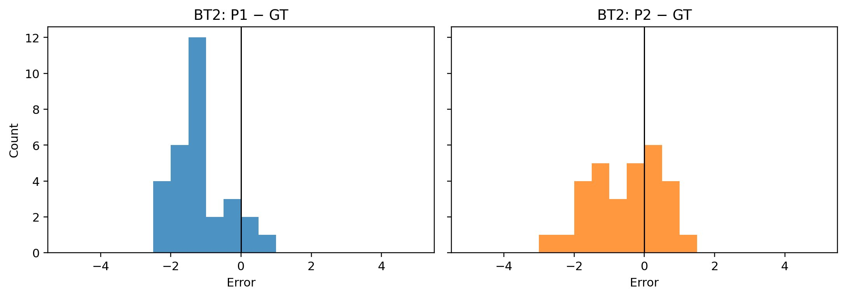

Fig. A1. BT2 error histograms (P1−GT vs P2−GT). The P1 distribution is left-skewed, indicating systematic underscoring relative to human ground truth. The P2 distribution is more symmetric but exhibits substantially greater variance, reflecting the calibration instability introduced by chairman aggregation under high veto conditions.

