An Auditable Agentic LLM Pipeline for Rubric-Based Grading: Evidence from a Real E-commerce Course Dataset
Nguyen Dinh Truc (corresponding) — 23521668@gm.uit.edu.vn
Nguyen Uyen Nhi — 23521115@gm.uit.edu.vn
Faculty of Information Systems, University of Information Technology (UIT), VNU-HCM, Vietnam
Supervisor: Trinh Trong Tin

Abstract
Rubric-based grading is essential for transparency and consistency but becomes a bottleneck in large classes. We present an auditable agentic grading pipeline implemented with the OpenClaw framework and apply it to four rubric-based assignments from an undergraduate e-commerce introduction course at UIT. The pipeline includes dataset normalization, text extraction with OCR when needed, incremental result writing, and automated auditing to guarantee one-to-one mapping between submissions and exported scores. Two human graders independently score a stratified subset of submissions; ground truth is defined as the mean of the two scores. We compare a single-agent grader (Phase 1) and a multi-agent grader (Phase 2) that decomposes grading into content/structure/language specialists and aggregates via a chairman agent. We report inter-rater agreement (QWK) and system-vs-human metrics (QWK/MAE/Pearson) with bootstrap confidence intervals, and analyze systematic score shifts and stability signals (veto/spread) induced by Phase 2. Results show that multi-agent grading does not automatically improve reliability and can introduce assignment-dependent calibration shifts; we provide practical recommendations for calibrating and aggregating multi-agent rubric grading in real classroom deployments.
Keywords: automated grading; rubric-based assessment; agentic AI; LLM; OpenClaw; reliability; quadratic weighted kappa

1 Introduction
We study rubric-grounded automated grading in a real classroom setting with heterogeneous submissions and strict auditability requirements. Beyond point estimates, we emphasize reliability-first evaluation: system performance should be interpreted relative to human inter-rater agreement.

1.1 Contributions
C1. An auditable OpenClaw grading pipeline (normalization → extraction/OCR → grading → incremental export → auditing).
C2. A clean, research-ready artifact set for four assignments from a real UIT e-commerce course.
C3. Reliability-first evaluation with human inter-rater QWK and AI-vs-GT (QWK/MAE/Pearson) with bootstrap CIs.
C4. Evidence-based analysis of multi-agent grading: systematic score shifts, veto/spread stability signals, and practical calibration recommendations.

2 Related Work
Prior work on automated essay scoring (AES) commonly uses Quadratic Weighted Kappa (QWK) to measure agreement with human raters on ordinal score scales (e.g., ASAP AES benchmark). Recent work explores large language models (LLMs) for instruction- and rubric-based scoring, showing that prompting, few-shot examples, and calibration can substantially affect agreement. In parallel, multi-agent LLM systems decompose tasks into specialists and aggregate outputs, which can improve coverage but also introduce calibration mismatch and aggregation instability. Educational measurement literature emphasizes reporting human inter-rater reliability alongside system performance and, when sample sizes are limited, reporting uncertainty (e.g., confidence intervals).

3 Method
Figure 1 shows the end-to-end pipeline.
Figure 1: OpenClaw grading pipeline (normalization → extraction/OCR → grading → export/audit).
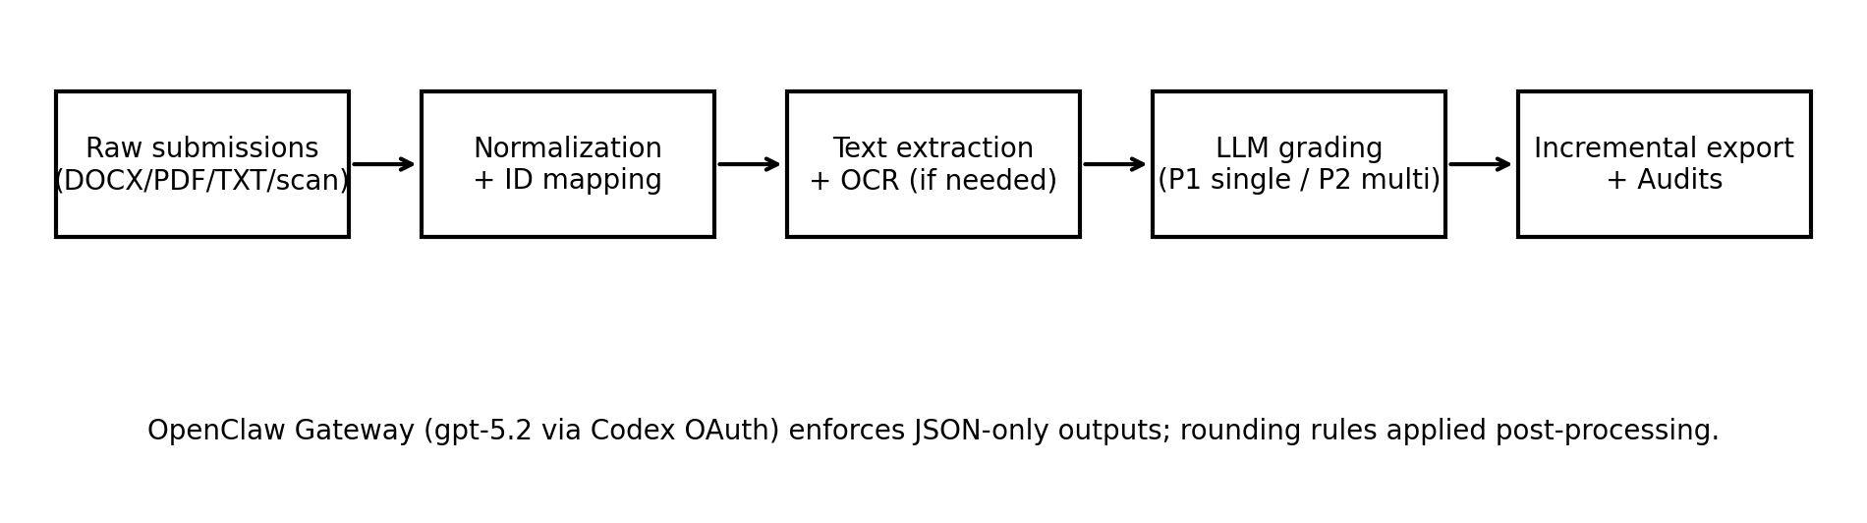

3.1 Implementation and model configuration
All LLM calls are served through an OpenAI-compatible endpoint provided by the OpenClaw Gateway. Both Phase 1 and Phase 2 use the same underlying model (gpt-5.2 via Codex OAuth in OpenClaw) to ensure a fair comparison; only the orchestration differs. Phase 1 uses temperature=0.1 and max_tokens=900; Phase 2 uses temperature=0.1 and max_tokens=800 with robust retry logic for rate limits and JSON parsing. Outputs are constrained to JSON-only schemas for reliable extraction. Scores are post-processed with deterministic rounding (0.25 per criterion; 0.5 for total score, range 0–10).

3.2 Phase 1: Single-agent rubric grading
Phase 1 grades all rubric criteria in a single call per submission and outputs per-criterion scores, total score, and short feedback.

3.3 Phase 2: Multi-agent grading (content/structure/language + chairman aggregation)
Phase 2 runs three specialist graders in parallel and aggregates per-criterion scores via a chairman agent (mean per criterion). A veto flag is triggered when specialist totals differ by more than 2.0 points, and a spread value summarizes inter-specialist disagreement.

4 Experimental Setup
We evaluate four assignments (BT1–BT4), each scored on a 0–10 scale with rubric maxima per criterion. Two human graders score a stratified subset (N=30 per assignment) selected to cover performance bands (high/medium/low) based on Phase-1 scores. Ground truth (GT) is defined as the mean of the two human scores.

4.1 Metrics
We report inter-rater QWK between the two humans and compare Phase 1/Phase 2 against GT using QWK, MAE, and Pearson correlation. For QWK, scores are mapped to integers by multiplying by 2 and rounding, matching the 0.5-point granularity used in totals.

5 Results

5.1 Human agreement and AI-vs-GT (with bootstrap CIs)
Table 1 reports point estimates and 95% bootstrap confidence intervals on the human-scored subset (N=30 per assignment).
BT | Human QWK [CI] | P1 QWK [CI] | P1 MAE [CI] | P1 r [CI] | P2 QWK [CI] | P2 MAE [CI] | P2 r [CI]
BT1 | 0.698 [0.464, 0.811] | 0.484 [0.273, 0.627] | 1.108 [0.892, 1.333] | 0.808 [0.681, 0.892] | 0.043 [-0.026, 0.142] | 1.842 [1.517, 2.158] | 0.225 [-0.115, 0.557]
BT2 | 0.684 [0.469, 0.802] | 0.331 [0.164, 0.443] | 1.375 [1.142, 1.600] | 0.694 [0.411, 0.860] | -0.002 [-0.237, 0.244] | 0.958 [0.708, 1.250] | -0.010 [-0.356, 0.337]
BT3 | 0.671 [0.440, 0.835] | 0.827 [0.664, 0.904] | 0.775 [0.550, 1.042] | 0.897 [0.807, 0.960] | 0.613 [0.405, 0.747] | 1.058 [0.833, 1.300] | 0.673 [0.509, 0.837]
BT4 | 0.628 [0.301, 0.791] | 0.720 [0.587, 0.799] | 0.575 [0.442, 0.725] | 0.753 [0.630, 0.861] | 0.517 [0.262, 0.698] | 0.608 [0.467, 0.750] | 0.553 [0.324, 0.725]

5.2 Phase 2 vs Phase 1 score shifts and stability signals (full dataset outputs)
Table 2 summarizes systematic score shifts of Phase 2 relative to Phase 1 on the full exported outputs, along with veto rates and mean spread.
BT | N_full | mean(P2−P1) | median(P2−P1) | veto rate | mean spread
BT1 | 137 | -0.836 | -1.000 | 0.993 | 5.150
BT2 | 129 | 1.787 | 2.000 | 0.922 | 3.387
BT3 | 123 | -0.943 | -1.000 | 0.772 | 2.653
BT4 | 131 | -0.889 | -1.000 | 0.061 | 1.133

5.3 Visualization
Figure 2 visualizes agreement with GT for Phase 1 and Phase 2 (N=30 per assignment).
Figure 2: Scatter plots of P1/P2 vs GT across assignments (dashed line indicates y=x).
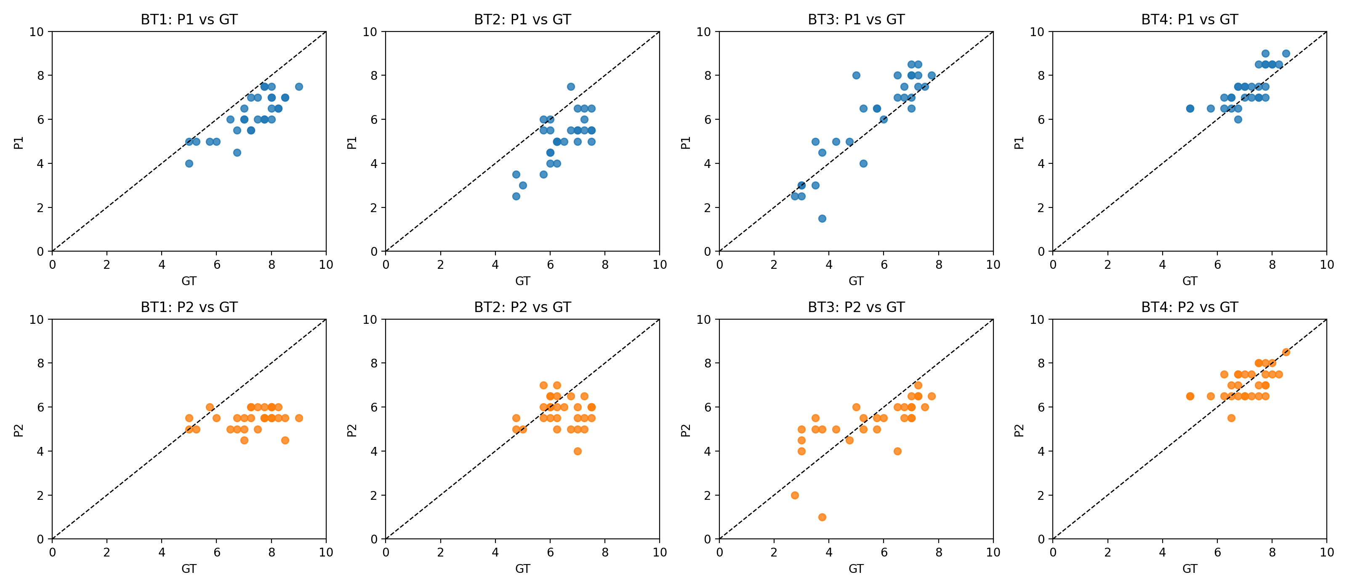

6 Discussion and recommendations
Our results show that multi-agent grading (Phase 2) does not automatically improve ordinal agreement (QWK) with human-mean ground truth, and can introduce assignment-dependent score shifts. We attribute this to (i) calibration mismatch between specialists, (ii) aggregation smoothing, and (iii) surface-feature sensitivity (language) that may be misaligned with rubric intent in factual/sourcing-heavy assignments (BT1–BT2).
Recommendations to improve multi-agent grading reliability:
R1. Calibrate specialist severity using a small anchor set and learn per-grader offsets/scales before aggregation.
R2. Use robust aggregation (median/trimmed mean) rather than simple mean to reduce outlier severity effects.
R3. Rubric-aligned weighting: downweight language/style for BT1–BT2; increase for BT3–BT4.

7 Ethics, privacy, and limitations
Student submissions are sensitive; we recommend releasing only derived anonymized artifacts (scores/metadata/audit logs) and not releasing raw submissions. Our ground truth is the mean of two graders and thus reflects human disagreement; results come from one course and institution.

8 Conclusion
We presented an auditable OpenClaw-based grading pipeline and a reliability-first evaluation across four real assignments. Single-agent grading achieved higher agreement with human scores than multi-agent grading in our setting, and Phase 2 exhibited systematic shifts and stability issues. We provided practical calibration and aggregation recommendations for deploying multi-agent rubric grading in real courses.

