LLM Selection for Automated Rubric Grading: A Multi-Model Benchmark on Real E-Commerce Assignments

line 1: 2nd Given Name Surname
line 2: dept. name of organization
(of Affiliation)
line 3: name of organization
(of Affiliation)
line 4: City, Country
line 5: email address or ORCID
line 1: 4th Given Name Surname
line 2: dept. name of organization
(of Affiliation)
line 3: name of organization
(of Affiliation)
line 4: City, Country
line 5: email address or ORCID
line 1: 2nd Given Name Surname
line 2: dept. name of organization
(of Affiliation)
line 3: name of organization
(of Affiliation)
line 4: City, Country
line 5: email address or ORCID
line 1: 5th Given Name Surname
line 2: dept. name of organization
(of Affiliation)
line 3: name of organization
(of Affiliation)
line 4: City, Country
line 5: email address or ORCID
line 1: 3rd Given Name Surname
line 2: dept. name of organization
(of Affiliation)
line 3: name of organization
(of Affiliation)
line 4: City, Country
line 5: email address or ORCID
line 1: 6th Given Name Surname
line 2: dept. name of organization
(of Affiliation)
line 3: name of organization
(of Affiliation)
line 4: City, Country
line 5: email address or ORCID

Abstract—Automated rubric grading using large language models (LLMs) has attracted growing interest, yet the effect of model selection on grading reliability remains understudied. We benchmark four production LLMs—GPT-5.2 (Thinking), GPT-5.4, GPT-4o, and GPT-5.4-mini—in a zero-shot single-agent rubric grading pipeline across four assignments from a real undergraduate e-commerce course (N=30 human-scored subset per assignment). All systems are evaluated against human ground truth using quadratic weighted kappa (QWK), mean absolute error (MAE), and Pearson r, with 95% bootstrap confidence intervals reported for QWK and MAE. GPT-5.2 achieves the strongest overall alignment (QWK: 0.282–0.848), even surpassing human inter-rater QWK on two assignments. Critically, newer models do not dominate: GPT-5.4 exhibits large negative calibration bias on factual-recall assignments (QWK ≈ −0.017, score bias ≈ −5.2 points) while remaining competitive on essay/CV tasks (QWK 0.772). Assignment type is the primary moderator: reasoning-intensive tasks require a reasoning-capable model. We further evaluate a multi-agent variant and confirm that architectural complexity does not compensate for model calibration gaps. Our findings provide practical guidance for selecting LLMs for classroom rubric grading.
Keywords— automated grading; rubric-based assessment; LLM benchmarking; model selection; quadratic weighted kappa; e-commerce education

Introduction
Rubric-based assessment supports transparent, consistent grading but becomes a bottleneck at scale. LLM-based automated essay scoring (AES) offers a compelling path to addressing this bottleneck, particularly for rubric-grounded tasks where a natural language prompt can encode evaluation criteria without task-specific training [1], [2], [3].
Existing LLM grading studies typically benchmark a single model or compare prompting strategies, leaving a critical practical question unaddressed: does model selection matter, and if so, how much? As production LLMs evolve rapidly—from GPT-4o through GPT-5.x families—instructors and researchers need empirical guidance on which models are reliable for classroom rubric grading.
We address this gap with a four-model benchmark on four real assignments from an undergraduate e-commerce course at a Vietnamese university (blinded for review). Our pipeline is an agentic framework supporting OCR routing, incremental export, and audit guarantees suited to heterogeneous classroom submissions. We evaluate GPT-5.2 (Thinking), GPT-5.4, GPT-4o, and GPT-5.4-mini in a zero-shot single-agent configuration against human ground truth (N=30 per assignment), reporting QWK, MAE, and Pearson r with 95% bootstrap confidence intervals for QWK and MAE.
Our contributions are: (C1) A four-model empirical benchmark on real classroom data with human inter-rater ground truth. (C2) Evidence that assignment type is the primary moderator of model calibration, with factual-recall assignments exposing severe systematic underscoring in non-reasoning models. (C3) A comparison of single-agent vs. multi-agent (GPT-5.2) grading showing single-agent consistently outperforms. (C4) Anonymized scoring artifacts and evaluation scripts will be released upon acceptance.

Related Work
Traditional automated essay scoring (AES) relied on hand-crafted linguistic features. Attali and Burstein’s e-rater [5] operationalized vocabulary, grammar, and discourse structure as numeric features, with QWK [6], [7] established as the standard agreement metric against human raters. The ASAP shared task [12] consolidated this protocol into the benchmark still widely used today. Neural methods subsequently replaced manual feature engineering: Taghipour and Ng [8] showed that recurrent neural networks could match or exceed feature-based systems on ASAP without task-specific feature design. A key limitation of all these approaches is the requirement for labeled training data tied to a fixed rubric, which restricts generalization to new assignments.
Large language models offer a zero-shot path to rubric grading that does not require labeled examples. Williamson et al. [1] propose an evaluation framework in which automated scores are validated against human inter-rater agreement as a reliability ceiling—the standard we adopt. Mizumoto and Eguchi [2] and Meyer et al. [3] demonstrate that LLMs can produce holistic scores comparable to human raters on academic writing tasks, though Meyer et al. raise concerns about validity and demographic bias. Chiang and Lee [13] further show that LLMs can substitute for human annotators in NLP evaluation benchmarks. Critically, existing LLM grading studies typically benchmark a single model or vary prompting strategy on clean, homogeneous text corpora; none systematically compare multiple production LLMs across heterogeneous assignment types with human inter-rater ground truth and bootstrap confidence intervals.
Multi-agent architectures have recently been proposed to improve grading reliability through specialist decomposition. Seßler et al. [9] benchmark specialist vs. generalist multi-agent LLM configurations for essay grading, reporting mixed results: specialist decomposition can improve holistic essay tasks while degrading performance on factual-recall assignments. Wang et al.’s AutoSCORE [10] introduces structured component recognition via multi-agent LLMs, reporting gains on writing-assessment tasks. However, the conditions under which multi-agent architectures help vs. hurt—particularly the interplay between assignment type and model calibration—remain poorly characterized. Our ablation in Section V-E directly addresses this gap, finding that multi-agent architecture amplifies calibration failures rather than resolving them when specialist agents operate on evaluation dimensions of mismatched relevance.

METHOD

Pipeline
Our agentic grading pipeline performs: (1) dataset normalization (DOCX/PDF/image de-duplication and filename mapping); (2) text extraction with OCR routing for scanned submissions; (3) single-agent LLM grading with JSON-only output; (4) incremental result writing; and (5) automated audit ensuring one-to-one submission-to-score mapping. Audit verification confirmed zero missing and zero duplicate records across 520 submissions.

Prompt Design
All models use identical zero-shot rubric-injection prompts: the full rubric (criteria names, descriptions, score maxima) is concatenated with extracted submission text and a structured output instruction requiring JSON with one field per criterion plus short feedback. No exemplars are provided. Temperature is fixed at 0.1 for all models.

Models
We evaluate four models accessed through our agentic gateway [4]:
- GPT-5.2 (Thinking): Reasoning-capable variant with 266k-token context [11]. Evaluated on all 30-sample subsets.
- GPT-5.4: Standard instruction-tuned model (openai/gpt-5.4). Evaluated on all 30-sample subsets.
- GPT-4o: General-purpose model (openai/gpt-4o). Evaluated on full dataset (N=123–137); metrics computed on the 30-sample subset.
- GPT-5.4-mini: Cost-optimized model (openai/gpt-5.4-mini). Evaluated on full dataset; metrics computed on the 30-sample subset.

Multi-Agent Configuration (Ablation)
To assess whether architectural complexity compensates for calibration gaps, we evaluate a multi-agent variant using GPT-5.2. Three specialist agents (content, structure, language) each receive the full submission text and produce independent criterion scores using role-specific system prompts. A chairman agent (also GPT-5.2) then reviews all specialist outputs and overrides any specialist score on a given criterion when inter-specialist disagreement exceeds one point, producing a final consensus score. All other pipeline components (prompt design, temperature, JSON output format) are identical to the single-agent configuration. This architecture is compared against single-agent GPT-5.2 in Section V-E.

Experimental Setup

Assignments and Dataset
Table I summarizes the four assignments. Two course teaching assistants independently score a stratified N=30 subset per assignment (stratified by preliminary automated score bands—high/medium/low—derived from a first automated grading pass to ensure coverage across the score range). Ground truth (GT) is the mean of the two human scores. Inter-grader mean absolute disagreement was low for BT1, BT2, BT4 (0.75, 0.58, 0.65 respectively) and moderate for BT3 (1.12), consistent with the subjective nature of CV evaluation.
- Assignment Overview and Dataset Sizes
Assignment | Topic | Format | N_full | N_criteria | Score Range
BT1 | E-commerce curriculum & learning outcomes; factual completeness + sourcing | DOCX/PDF/TXT | 137 | 5 | 0–10
BT2 | Job-market survey; JD analysis + skill gap | DOCX/PDF/TXT | 129 | 5 | 0–10
BT3 | Two CVs for two positions; CV↔JD mapping + format | PDF/DOCX/images | 123 | 5 | 0–10
BT4 | Personal career roadmap essay with structured sections | PDF/DOCX | 131 | 4 | 0–10

Metrics
We report quadratic weighted kappa (QWK), mean absolute error (MAE), and Pearson r; 95% bootstrap confidence intervals (1,000 resamples) are provided for QWK and MAE. Score bias (mean model score minus mean GT score) is additionally reported to quantify systematic over- or underscoring. QWK is computed by rounding scores to the nearest 0.5 and mapping to integer labels (multiply by 2). At N=30, bootstrap CI half-widths for QWK are approximately ±0.15–0.20; differences exceeding 0.20 QWK points are therefore statistically reliable. Differences below 0.20 QWK should not be over-interpreted as statistically reliable at this sample size. Human inter-rater QWK is reported as the reliability ceiling.

RESULTS

Human Inter-Rater Agreement
Human inter-rater QWK ranges from 0.628 (BT4) to 0.698 (BT1). All values fall in the 0.61–0.80 “substantial agreement” band [7], serving as the reliability ceiling for automated systems.

Main Results: QWK Across Models
Table II reports QWK for all four models vs. GT on the 30-sample subset, and Fig. 1 provides a visual overview across all models and assignments. GPT-5.2 is the strongest system overall. On BT3 (CV writing) it achieves QWK=0.848, exceeding human inter-rater (0.656), and on BT4 (essay) QWK=0.756, also exceeding the human ceiling (0.628).
The most striking finding is the assignment-type dependency. On BT1 and BT2 (factual recall), GPT-5.4 produces QWK of −0.017 and 0.029 respectively—effectively random agreement—while on BT3 it achieves QWK=0.772, competitive with GPT-5.2. GPT-4o shows similarly bifurcated behavior (BT1: −0.053; BT3: 0.274). GPT-5.4-mini is the weakest system on three of four assignments.
- Human Inter-Rater QWK and All Model QWK vs. Ground Truth (N=30, 95% Bootstrap CI)
BT | Human QWK [CI] | GPT-5.2 QWK [CI] | GPT-5.4 QWK [CI] | GPT-4o QWK [CI] | GPT-5.4-mini QWK [CI]
BT1 | 0.698 [0.494, 0.816] | 0.432 [0.252, 0.584] | −0.017 [−0.033, −0.004] | −0.053 [−0.124, 0.001] | 0.021 [−0.021, 0.063]
BT2 | 0.684 [0.478, 0.805] | 0.282 [0.139, 0.381] | 0.029 [−0.008, 0.063] | 0.244 [−0.084, 0.524] | 0.034 [0.010, 0.059]
BT3 | 0.656 [0.418, 0.847] | 0.848 [0.727, 0.934] | 0.772 [0.632, 0.870] | 0.274 [0.098, 0.457] | 0.602 [0.392, 0.760]
BT4 | 0.628 [0.308, 0.796] | 0.756 [0.618, 0.842] | 0.139 [−0.024, 0.443] | 0.209 [−0.051, 0.421] | 0.070 [−0.060, 0.186]

MAE and Pearson r
Table III reports MAE and Pearson r for all models. GPT-5.2 achieves the lowest MAE on BT4 (0.475) and BT3 (0.725). GPT-5.4’s severe calibration bias on BT1 is confirmed by MAE=5.217, indicating a systematic ∼5-point underscoring on that assignment.
- MAE [95% CI] and Pearson r vs. Ground Truth for All Models (N=30)
BT | GPT-5.2 MAE [CI] | GPT-5.2 r | GPT-5.4 MAE [CI] | GPT-5.4 r | GPT-4o MAE [CI] | GPT-4o r | GPT-5.4-mini MAE [CI] | GPT-5.4-mini r
BT1 | 1.208 [0.975, 1.433] | 0.775 | 5.217 [4.725, 5.658] | −0.416 | 3.142 [2.62, 3.658] | −0.348 | 3.867 [3.433, 4.267] | 0.219
BT2 | 1.525 [1.275, 1.783] | 0.697 | 3.750 [3.333, 4.175] | 0.314 | 0.892 [0.65, 1.200] | 0.259 | 4.283 [4.016, 4.583] | 0.539
BT3 | 0.725 [0.508, 0.983] | 0.894 | 0.915 [0.670, 1.185] | 0.850 | 1.375 [1.025, 1.750] | 0.520 | 1.245 [0.90, 1.580] | 0.720
BT4 | 0.475 [0.350, 0.609] | 0.777 | 1.512 [0.970, 2.112] | 0.225 | 1.442 [1.10, 1.808] | 0.296 | 2.827 [2.12, 3.562] | 0.204

Score Calibration Analysis
Table IV shows score bias (mean model score minus mean GT score), also visualized in Fig. 2. GPT-5.2 is well-calibrated: bias ranges from −1.49 (BT2) to +0.31 (BT3). The other models show severe systematic underscoring, particularly on BT1: GPT-5.4 bias = −5.22, GPT-4o = −3.08, GPT-5.4-mini = −3.87. On BT3 and BT4, bias narrows substantially for all models, explaining the QWK recovery on qualitative assignments.
- Score Bias (Mean Model Score − Mean GT Score) by Assignment
BT | Mean GT | GPT-5.2 Bias | GPT-5.4 Bias | GPT-4o Bias | GPT-5.4-mini Bias
BT1 | 7.28 | −1.21 | −5.22 | −3.08 | −3.87
BT2 | 6.42 | −1.49 | −3.75 | −0.39 | −4.28
BT3 | 5.56 | +0.31 | −0.59 | +1.01 | −0.90
BT4 | 7.06 | +0.12 | −0.70 | −1.03 | −2.53
- Score Bias by Assignment and Model (Negative = systematic underscoring relative to human ground truth)
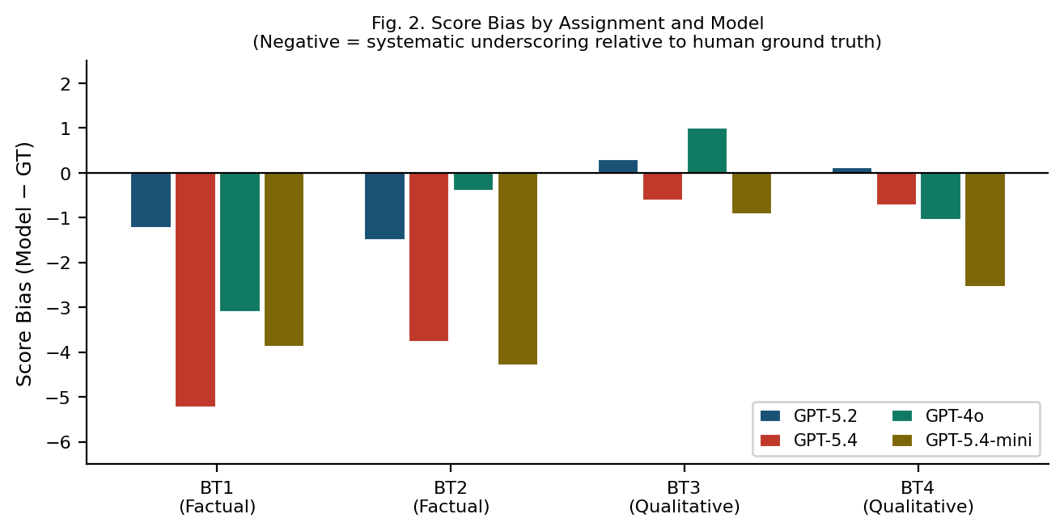

Multi-Agent Grading (Ablation)
We evaluated a multi-agent variant using GPT-5.2, where three specialist agents (content, structure, language) each receive the full submission text and produce independent criterion scores. A chairman agent (also GPT-5.2) then reviews all specialist scores and overrides any specialist when inter-specialist disagreement on any criterion exceeds one point—producing a final consensus score. Table V shows multi-agent QWK is uniformly below single-agent GPT-5.2 across all assignments. Veto rate (fraction of submissions where the chairman overrides at least one specialist) reached 0.993 on BT1 and 0.922 on BT2, indicating extreme inter-specialist disagreement. The content specialist scored BT1 at mean 2.31 vs. language specialist mean 7.35, a 5-point systematic gap that makes consensus nearly impossible. Multi-agent architecture amplifies calibration problems rather than resolving them when specialists operate on dimensions of mismatched relevance for the rubric.
- Single-Agent vs. Multi-Agent GPT-5.2: QWK Comparison (N=30)
Assignment | Single-Agent QWK | Multi-Agent QWK | Veto Rate
BT1 | 0.432 | 0.043 | 0.993
BT2 | 0.282 | −0.016 | 0.922
BT3 | 0.848 | 0.602 | 0.341
BT4 | 0.756 | 0.517 | 0.287
- QMK vs. Human Ground Truth by Assignment and Model (N=30 per assignment; dashed line = “substantial agreement” floor at 0.61)

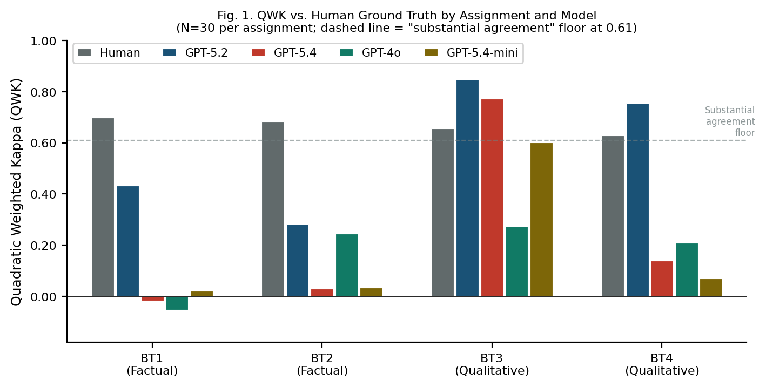

Discussion

Why Assignment Type Moderates Calibration
BT1 and BT2 require factual recall (curriculum coverage, source verification, job-description analysis)—tasks where the correct score depends on whether specific verifiable information is present, not on surface-form quality. GPT-5.4, GPT-4o, and GPT-5.4-mini appear to apply stricter evidence standards than human graders for these assignments, producing systematic underscoring of 3–5 points. GPT-5.2 (Thinking), by contrast, reasons step-by-step over rubric criteria and produces scores more aligned with human holistic judgment. BT3 and BT4 are qualitative tasks (CV writing, career essay) where surface-form quality is a legitimate evaluative dimension; all models calibrate better here. Our results suggest that, in this setting, the reasoning-capable GPT-5.2 was the only model to maintain calibration on factual-recall tasks, indicating that reasoning capability may be a key factor for such rubric types.

Bigger and Newer Is Not Better
GPT-5.4 is a later release than GPT-5.2 yet exhibits substantially worse calibration on BT1 and BT2. This result reinforces that model capability in general benchmarks does not predict rubric grading calibration [14]. The reasoning variant (GPT-5.2 Thinking) provides critical step-by-step deliberation that non-reasoning models lack when evaluating factual completeness against a multi-criterion rubric.

Limitations
The human-scored subset is limited (N=30 per assignment) due to annotator availability; bootstrap CIs are therefore wide for small effects. GPT-4o and GPT-5.4-mini were run on the full dataset to verify coverage and detect systematic failures; comparative metrics are nonetheless computed on the same N=30 human-annotated subset to ensure a fair like-for-like comparison across models. This subset was stratified by score band at sampling time, reducing selection bias. We did not vary temperature or prompting strategy; a full sensitivity analysis is deferred to future work. Future work should also examine fine-tuned models and larger annotated subsets to narrow confidence intervals.

Conclusion
We presented a four-model benchmark for LLM-based rubric grading on four real e-commerce assignments. GPT-5.2 (Thinking) achieves substantially higher QWK than GPT-5.4, GPT-4o, and GPT-5.4-mini, demonstrating that model selection matters more than architectural complexity for automated rubric grading reliability. Assignment type is the key moderator: factual-recall tasks expose calibration failures in non-reasoning models that are absent on essay tasks. A multi-agent variant of GPT-5.2 degrades further, confirming single-agent with a reasoning model as the practical optimum in our setting. We recommend practitioners select reasoning-capable LLMs for factual-recall rubrics and validate calibration on a small human-scored subset before full deployment.

Acknowledgment
The authors thank the course instructor and teaching assistants who participated in the human annotation process. This work was supported by the authors’ home institution (blinded for review).

References
- D. M. Williamson, X. Xi, and F. J. Breyer, “A framework for evaluation and use of automated scoring,” Educ. Meas.: Issues Pract., vol. 31, no. 1, pp. 2–13, 2012.
- A. Mizumoto and M. Eguchi, “Exploring the potential of using an AI language model for automated essay scoring,” Res. Methods Appl. Linguist., vol. 2, no. 2, 2023.
- L. Meyer et al., “Reliable but not rigorous: Evaluating ChatGPT reliability, validity, and bias in automated academic grading,” Comput. Educ.: AI, 2025.
- [Blind for Review], “Agentic grading pipeline: technical report,” Blinded for peer review, 2026.
- Y. Attali and J. Burstein, “Automated essay scoring with e-rater V.2,” J. Technol. Learn. Assess., vol. 4, no. 3, 2006.
- J. Cohen, “Weighted kappa: Nominal scale agreement with provision for scaled disagreement,” Psychol. Bull., vol. 70, no. 4, pp. 213–220, 1968.
- J. R. Landis and G. G. Koch, “The measurement of observer agreement for categorical data,” Biometrics, vol. 33, no. 1, pp. 159–174, 1977.
- K. Taghipour and H. T. Ng, “A neural approach to automated essay scoring,” in Proc. EMNLP 2016, pp. 1882–1891.
- K. Seßler et al., “Specialists or generalists? Multi-agent and single-agent LLMs for essay grading,” arXiv:2601.22386, 2026.
- Y. Wang et al., “AutoSCORE: Enhancing automated scoring with multi-agent LLMs via structured component recognition,” arXiv:2509.21910, 2025.
- OpenAI, “Introducing GPT-5.2 (GPT-5.2 Thinking),” [Online]. Available: https://openai.com/index/introducing-gpt-5-2/ (accessed May 2026).
- Hewlett Foundation, “Automated Student Assessment Prize (ASAP) AES benchmark,” Kaggle, 2012.
- C.-H. Chiang and H.-y. Lee, “Can large language models be an alternative to human evaluations?,” in Proc. ACL 2023, pp. 15607–15631.
- C. Guo, G. Pleiss, Y. Sun, and K. Q. Weinberger, “On calibration of modern neural networks,” in Proc. ICML 2017, pp. 1321–1330.

