An Auditable Agentic LLM Pipeline for Rubric-Based Grading: Evidence from a Real E-commerce Course Dataset
Nguyen Dinh Truc (corresponding) — 23521668@gm.uit.edu.vn
Nguyen Uyen Nhi — 23521115@gm.uit.edu.vn
Faculty of Information Systems, University of Information Technology (UIT), VNU-HCM, Vietnam
Supervisor: Trinh Trong Tin

Abstract
Rubric-based grading is essential for transparency and consistency but becomes a bottleneck in large classes. We present an auditable agentic grading pipeline implemented with the OpenClaw framework and apply it to four rubric-based assignments from an undergraduate e-commerce introduction course at UIT. The pipeline includes dataset normalization, text extraction with OCR when needed, incremental result writing, and automated auditing to guarantee one-to-one mapping between submissions and exported scores. Two human graders independently score a stratified subset of submissions; ground truth is defined as the mean of the two scores. We compare a single-agent grader (Phase 1) and a multi-agent grader (Phase 2) that decomposes grading into content/structure/language specialists and aggregates via a chairman agent. We report inter-rater agreement (QWK) and system-vs-human metrics (QWK/MAE/Pearson) with bootstrap confidence intervals, and analyze systematic score shifts and stability signals (veto/spread) induced by Phase 2. Results show that multi-agent grading does not automatically improve reliability and can introduce assignment-dependent calibration shifts; we provide practical recommendations for calibrating and aggregating multi-agent rubric grading in real classroom deployments.
Keywords: automated grading; rubric-based assessment; agentic AI; large language models; reliability; quadratic weighted kappa

1 Introduction

1.1 Motivation
Rubric-based assessment supports fairness and consistent grading, yet grading at scale remains time-consuming in large classes. Real classroom submissions are heterogeneous (DOCX/PDF/TXT and scanned artifacts), and instructors require auditable exports (no missing/duplicate records) for course administration and research use.

1.2 Gap
Automated scoring traditionally evaluates agreement against human raters using weighted kappa/QWK [1,2] and emphasizes validity and operational constraints [3]. Recent studies explore LLM-based rubric-grounded scoring [10], but classroom deployments require robust pipelines for heterogeneous files and OCR, auditability, and reliability-first evaluation. Multi-agent decomposition can help in some contexts but may also introduce calibration mismatch and aggregation instability [14,15].

1.3 Contributions
C1. An auditable grading pipeline (normalization → extraction/OCR → grading → incremental export → auditing) built on OpenClaw [18].
C2. We release derived, anonymized scoring artifacts (scores/metadata/audit summaries) and evaluation scripts via our public repository to enable independent verification of reported metrics.
C3. Reliability-first evaluation with human inter-rater QWK and AI-vs-GT (QWK/MAE/Pearson) with bootstrap confidence intervals.
C4. Evidence-based analysis of multi-agent grading: systematic score shifts, veto/spread stability signals, and practical calibration recommendations.

2 Related Work

2.1 Automated scoring and agreement metrics
AES/SAS research commonly measures system–human agreement using Cohen’s weighted kappa variants for ordinal scales [1] and practical interpretation guidelines [2]. Evaluation frameworks emphasize reporting reliability, validity, and operational constraints [3].

2.2 Benchmarks and modeling approaches
Benchmarks such as ASAP popularized QWK-based evaluation for essay scoring [7]. Neural AES methods are a strong baseline paradigm [8], and survey work summarizes modeling choices and evaluation practices [5,9].

2.3 LLM-based rubric-grounded grading
Prompt-based LLM scoring can be adapted to new rubrics without task-specific training, yet agreement varies by prompting and calibration. Recent work documents both promise and limitations in reliability and bias [10,11,12].

2.4 Multi-agent grading and aggregation
Multi-agent designs decompose grading into specialists and aggregate outputs. Such aggregation can introduce severity mismatch and instability without calibration [14]. Structured multi-agent scoring pipelines have also been proposed [15].

2.5 Reliability-first positioning
Automated scoring should be interpreted relative to human inter-rater reliability rather than as absolute truth [3]. Accordingly, we report human–human agreement as an upper bound and evaluate both phases against the human-mean reference, while quantifying uncertainty via bootstrap confidence intervals. This practice helps prevent over-claiming improvements when evaluation subsets are constrained and agreement estimates are noisy [2,16].

3 Method
Figure 1 shows the end-to-end pipeline.
Figure 1: OpenClaw grading pipeline (normalization → extraction/OCR → grading → export/audit).
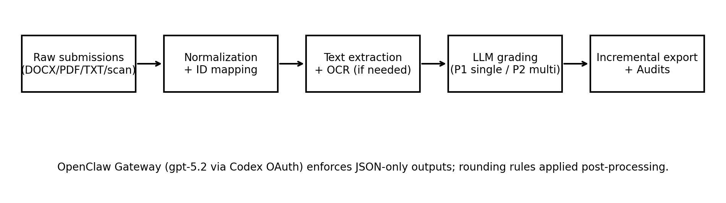

3.1 Implementation and model configuration
All LLM calls are served through a local OpenClaw Gateway exposing an OpenAI-compatible Chat Completions endpoint [18]. The gateway-reported model identifier in our deployment is `openai-codex/gpt-5.2` (a routing identifier); the underlying model weights are proprietary and not publicly disclosed. Therefore, we focus reproducibility on fixed decoding settings, JSON-only scoring schemas, released derived artifacts, and evaluation scripts rather than exact replication of model weights. Phase 1 uses temperature=0.1 and max_tokens=900; Phase 2 uses temperature=0.1 and max_tokens=800 with retry logic for rate limits and JSON parsing. Scores are post-processed with deterministic rounding (0.25 per criterion; 0.5 total; range 0–10).

4 Experimental Setup

4.1 Assignments and rubrics
Table 0 summarizes the four assignments and dataset sizes (full dataset).
Assignment | Topic (summary) | Typical format | N_full
BT1 | Study e-commerce curriculum & learning outcomes; factual completeness + sourcing | DOCX/PDF/TXT | 137
BT2 | Survey job market for 2 positions; analyze JD/skills/gaps | DOCX/PDF/TXT | 129
BT3 | Write 2 CVs for 2 positions; mapping CV↔JD + format/language | PDF/DOCX/images (OCR for scans) | 123
BT4 | Essay: personal career roadmap with required structure | PDF/DOCX | 131

4.2 Human subset and metrics
Two human graders score a stratified subset (N=30 per assignment) selected to cover performance bands (high/medium/low) based on Phase-1 scores. Ground truth (GT) is defined as the mean of the two human scores. We report inter-rater QWK and AI-vs-GT metrics (QWK/MAE/Pearson) with 95% bootstrap CIs.

5 Results

5.1 Human agreement + Phase 1 (Table 1a)
Table 1a reports human agreement and Phase 1 vs GT with 95% bootstrap confidence intervals (N=30 per assignment).
BT | Human QWK [CI] | P1 QWK [CI] | P1 MAE [CI] | P1 r [CI]
BT1 | 0.698 [0.464, 0.811] | 0.484 [0.273, 0.627] | 1.108 [0.892, 1.333] | 0.808 [0.681, 0.892]
BT2 | 0.684 [0.469, 0.802] | 0.331 [0.164, 0.443] | 1.375 [1.142, 1.600] | 0.694 [0.411, 0.860]
BT3 | 0.671 [0.440, 0.835] | 0.827 [0.664, 0.904] | 0.775 [0.550, 1.042] | 0.897 [0.807, 0.960]
BT4 | 0.628 [0.301, 0.791] | 0.720 [0.587, 0.799] | 0.575 [0.442, 0.725] | 0.753 [0.630, 0.861]

5.2 Phase 2 (Table 1b)
Table 1b reports Phase 2 vs GT with 95% bootstrap confidence intervals (N=30 per assignment).
BT | P2 QWK [CI] | P2 MAE [CI] | P2 r [CI]
BT1 | 0.043 [-0.026, 0.142] | 1.842 [1.517, 2.158] | 0.225 [-0.115, 0.557]
BT2 | -0.002 [-0.237, 0.244] | 0.958 [0.708, 1.250] | -0.010 [-0.356, 0.337]
BT3 | 0.613 [0.405, 0.747] | 1.058 [0.833, 1.300] | 0.673 [0.509, 0.837]
BT4 | 0.517 [0.262, 0.698] | 0.608 [0.467, 0.750] | 0.553 [0.324, 0.725]

5.3 Score shifts and stability signals (Table 2)
BT | N_full | mean(P2−P1) | median(P2−P1) | veto rate | mean spread
BT1 | 137 | -0.836 | -1.000 | 0.993 | 5.150
BT2 | 129 | 1.787 | 2.000 | 0.922 | 3.387
BT3 | 123 | -0.943 | -1.000 | 0.772 | 2.653
BT4 | 131 | -0.889 | -1.000 | 0.061 | 1.133

5.4 Visualization (Figures 2a/2b)
Figure 2a: Phase 1 vs GT scatter plots (N=30 per assignment).
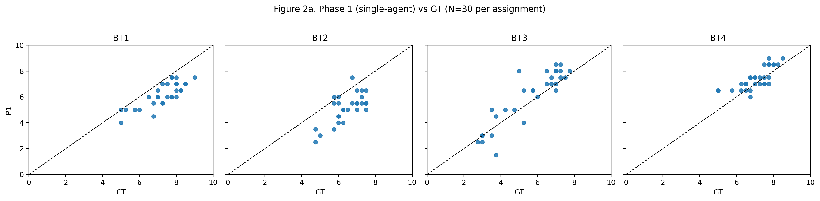
Figure 2b: Phase 2 vs GT scatter plots (N=30 per assignment).
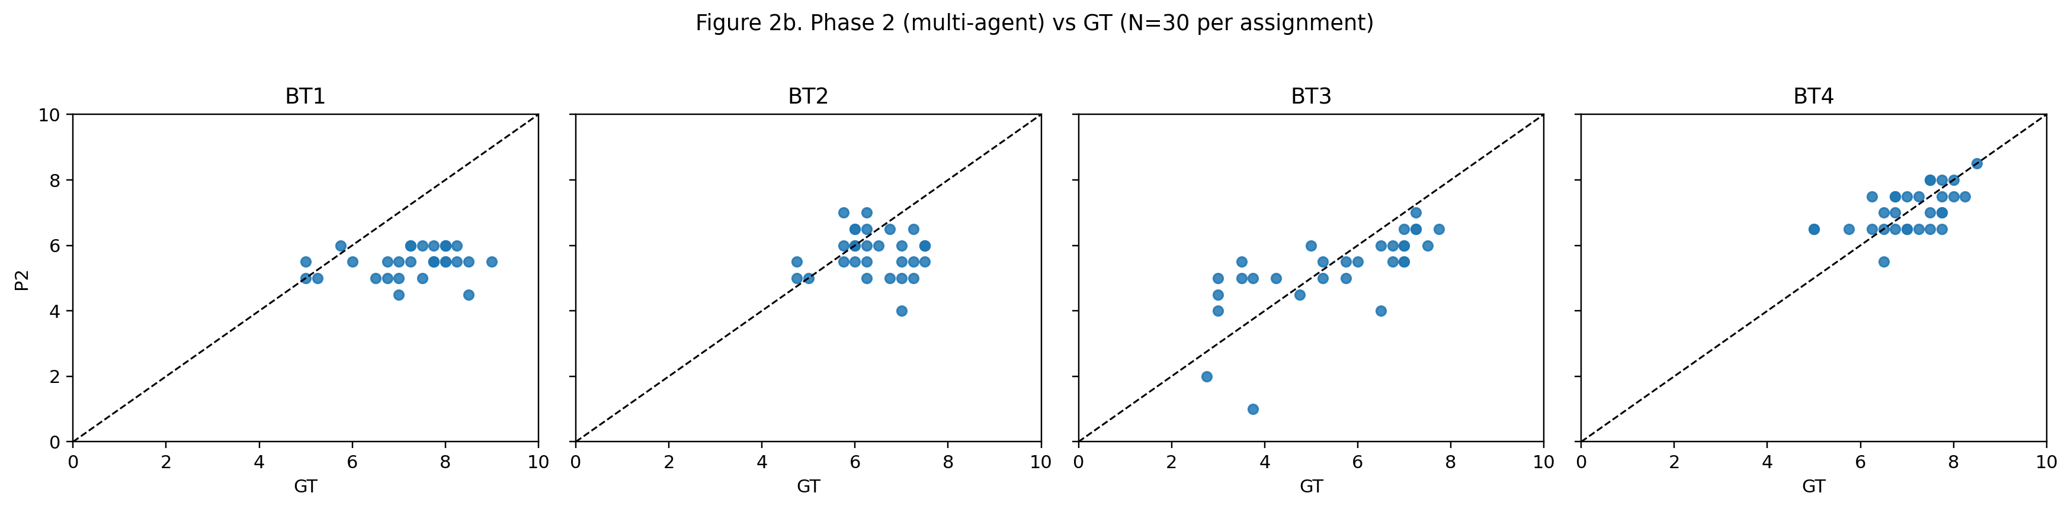

References
[1] Cohen, J.: Weighted kappa: Nominal scale agreement with provision for scaled disagreement or partial credit. Psychological Bulletin 70(4), 213–220 (1968).
[2] Landis, J.R., Koch, G.G.: The measurement of observer agreement for categorical data. Biometrics 33(1), 159–174 (1977).
[3] Williamson, D.M., Xi, X., Breyer, F.J.: A framework for evaluation and use of automated scoring. Educational Measurement: Issues and Practice 31(1), 2–13 (2012).
[4] Shermis, M.D., Burstein, J. (eds.): Handbook of Automated Essay Evaluation: Current Applications and New Directions. Routledge (2013).
[5] Beigman Klebanov, B., Madnani, N.: Automated Essay Scoring. Synthesis Lectures in Human Language Technologies. Morgan & Claypool (2021).
[6] Attali, Y., Burstein, J.: Automated essay scoring with e-rater® V.2. Journal of Technology, Learning, and Assessment 4(3) (2006).
[7] Hewlett Foundation (ASAP). Automated Student Assessment Prize (ASAP) AES benchmark (Kaggle competition). https://www.kaggle.com/c/asap-aes (accessed 2026-05-01).
[8] Taghipour, K., Ng, H.T.: A neural approach to automated essay scoring. In: Proceedings of EMNLP 2016, pp. 1882–1891. ACL (2016).
[9] Ke, Z., Ng, V.: Automated essay scoring: A survey of the state of the art. In: Proceedings of IJCAI 2019, pp. 6300–6308 (2019).
[10] Mizumoto, A., Eguchi, M.: Exploring the potential of using an AI language model for automated essay scoring. Research Methods in Applied Linguistics 2(2), 100050 (2023). https://doi.org/10.1016/j.rmal.2023.100050
[11] Esterhuysen, H., et al.: Large language models in student assessment: Comparing ChatGPT and human graders. arXiv:2406.16510 (2024).
[12] Meyer, L., et al.: Reliable but not rigorous: Evaluating ChatGPT's reliability, validity, and bias in automated academic grading. Computers and Education: Artificial Intelligence (2025).
[13] Hakala, K., et al.: Automated refinement of essay scoring rubrics for language models via Reflect-and-Revise. arXiv:2510.09030 (2025).
[14] Seßler, K., et al.: Specialists or generalists? Multi-agent and single-agent LLMs for essay grading. arXiv:2601.22386 (2026).
[15] Wang, Y., et al.: AutoSCORE: Enhancing automated scoring with multi-agent large language models via structured component recognition. arXiv:2509.21910 (2025).
[16] Fleiss, J.L., Cohen, J.: The equivalence of weighted kappa and the intraclass correlation coefficient as measures of reliability. Educational and Psychological Measurement 33(3), 613–619 (1973).
[17] OpenAI: API reference for Chat Completions (accessed via internal proxy in this work). https://platform.openai.com/docs/api-reference/chat (accessed 2026-05-01).
[18] OpenClaw Framework. Documentation: https://docs.openclaw.ai ; Source: https://github.com/openclaw/openclaw (accessed 2026-05-01).

