An Auditable Agentic LLM Pipeline for Rubric-Based Grading: Evidence from a Real E-commerce Course Dataset
Nguyen Dinh Truc (corresponding) — 23521668@gm.uit.edu.vn
Nguyen Uyen Nhi — 23521115@gm.uit.edu.vn
Faculty of Information Systems, University of Information Technology (UIT), VNU-HCM, Vietnam
Supervisor: Trinh Trong Tin

Abstract
Rubric-based grading is essential for transparency and consistency but becomes a bottleneck in large classes. We present an auditable agentic grading pipeline implemented with the OpenClaw framework and apply it to four rubric-based assignments from an undergraduate e-commerce introduction course at UIT. The pipeline includes dataset normalization, text extraction with OCR when needed, incremental result writing, and automated auditing to guarantee one-to-one mapping between submissions and exported scores. Two human graders independently score a stratified subset of submissions; ground truth is defined as the mean of the two scores. We compare a single-agent grader (Phase 1) and a multi-agent grader (Phase 2) that decomposes grading into content/structure/language specialists and aggregates via a chairman agent. We report inter-rater agreement (QWK) and system-vs-human metrics (QWK/MAE/Pearson) with bootstrap confidence intervals, and analyze systematic score shifts and stability signals (veto/spread) induced by Phase 2. Results show that multi-agent grading does not automatically improve reliability and can introduce assignment-dependent calibration shifts; we provide practical recommendations for calibrating and aggregating multi-agent rubric grading in real classroom deployments.
Keywords: automated grading; rubric-based assessment; agentic AI; large language models; reliability; quadratic weighted kappa

1 Introduction

1.1 Motivation
Rubric-based assessment supports fairness and consistent grading, yet grading at scale remains time-consuming in large classes. Real classroom submissions are heterogeneous (DOCX/PDF/TXT and scanned artifacts), and instructors require auditable exports (no missing/duplicate records) for course administration and research use.

1.2 Gap
Automated scoring traditionally evaluates agreement against human raters using weighted kappa/QWK [1,2] and emphasizes validity and operational constraints [3]. Recent studies explore LLM-based rubric-grounded scoring [10], but classroom deployments require robust pipelines for heterogeneous files and OCR, auditability, and reliability-first evaluation. Multi-agent decomposition can help in some contexts but may also introduce calibration mismatch and aggregation instability [14,15].

1.3 Contributions
C1. An auditable grading pipeline (normalization → extraction/OCR → grading → incremental export → auditing) built on OpenClaw [18].
C2. We release derived, anonymized scoring artifacts (scores/metadata/audit summaries) and evaluation scripts via our public repository at https://github.com/uttrai262005/openclaw-soict-artifacts to enable independent verification of reported metrics.
C3. Reliability-first evaluation with human inter-rater QWK and AI-vs-GT (QWK/MAE/Pearson) with bootstrap confidence intervals.
C4. Evidence-based analysis of multi-agent grading: systematic score shifts, veto/spread stability signals, and practical calibration recommendations.

2 Related Work

2.1 Automated scoring and agreement metrics
AES/SAS research commonly measures system–human agreement using Cohen’s weighted kappa variants for ordinal scales [1] and practical interpretation guidelines [2]. Evaluation frameworks emphasize reporting reliability, validity, and operational constraints [3].

2.2 Benchmarks and modeling approaches
Benchmarks such as ASAP popularized QWK-based evaluation for essay scoring [7]. Neural AES methods are a strong baseline paradigm [8], and survey work summarizes modeling choices and evaluation practices [5,9].

2.3 LLM-based rubric-grounded grading
Prompt-based LLM scoring can be adapted to new rubrics without task-specific training, yet agreement varies by prompting and calibration. Recent work documents both promise and limitations in reliability and bias [10,11,12].

2.4 Multi-agent grading and aggregation
Multi-agent designs decompose grading into specialists and aggregate outputs. Such aggregation can introduce severity mismatch and instability without calibration [14]. Structured multi-agent scoring pipelines have also been proposed [15].

2.5 Reliability-first positioning
Automated scoring should be interpreted relative to human inter-rater reliability rather than as absolute truth [3]. Accordingly, we report human–human agreement as an upper bound and evaluate both phases against the human-mean reference, while quantifying uncertainty via bootstrap confidence intervals. This practice helps prevent over-claiming improvements when evaluation subsets are constrained and agreement estimates are noisy [2,16].

3 Method
We implement an end-to-end pipeline shown in Fig. 1.
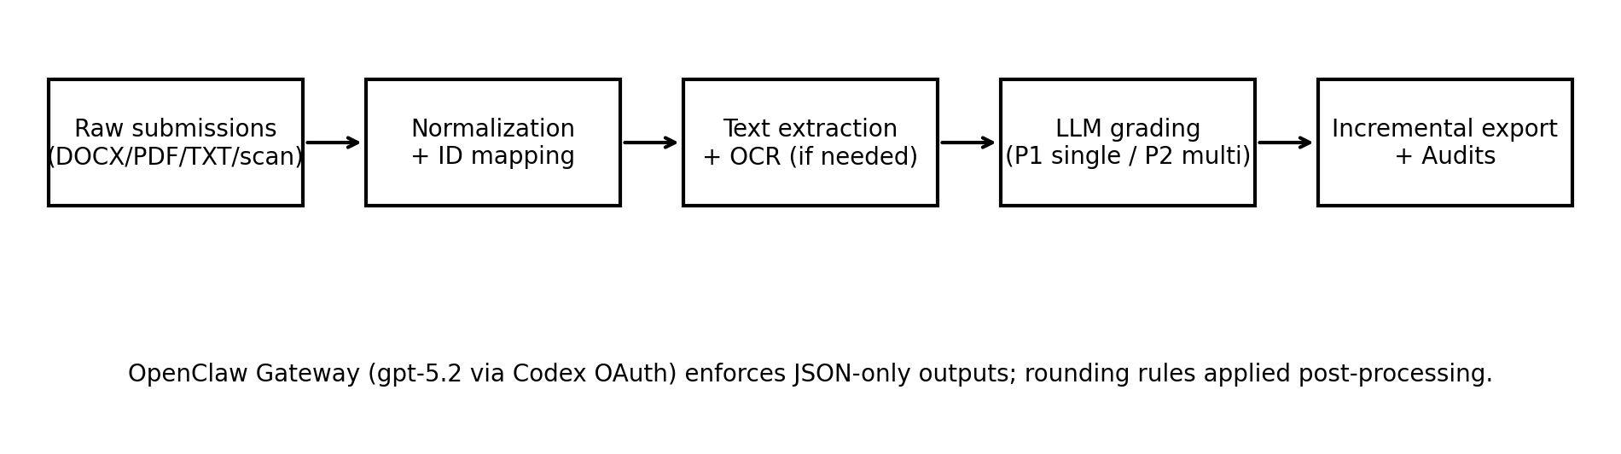
Fig. 1. OpenClaw grading pipeline (normalization → extraction/OCR → grading → export/audit). The OpenClaw Gateway enforces JSON-only outputs; rounding rules are applied post-processing.

3.1 Implementation and model configuration
All LLM calls are served through a local OpenClaw Gateway exposing an OpenAI-compatible Chat Completions endpoint [18]. The gateway-reported model identifier in our deployment is `openai-codex/gpt-5.2` (a routing alias assigned by the local proxy; the underlying model weights are proprietary and not publicly disclosed). We acknowledge that exact numerical replication of scores is not possible without access to the same model weights. However, methodological reproducibility is ensured through: (i) fixed decoding parameters (temperature=0.1) and deterministic rounding, (ii) fully specified JSON-only scoring schemas, (iii) released anonymized scoring artifacts enabling metric recomputation, and (iv) released evaluation scripts. Researchers with access to a comparable instruction-tuned LLM can replicate the pipeline and evaluate agreement against the released annotations.

3.2 Prompt design
All prompts follow a zero-shot rubric-injection format: the rubric (criteria names, descriptions, and score maxima) is concatenated with extracted submission text and a structured output instruction requiring JSON with one field per criterion plus short feedback. No exemplar submissions are provided (zero-shot). Phase 2 uses three specialist prompts (content, structure, language) each receiving the same rubric and submission but with role-specific scoring instructions, followed by a chairman aggregation step that receives all three specialist JSON outputs and produces a final aggregated JSON score.

4 Experimental Setup

4.1 Assignments and rubrics
Table 1 summarizes the four assignments and dataset sizes (full dataset).
Assignment | Topic (summary) | Typical format | N_full | N_criteria | Score range
BT1 | Study e-commerce curriculum & learning outcomes; factual completeness + sourcing | DOCX/PDF/TXT | 137 | 5 | 0–10
BT2 | Survey job market for 2 positions; analyze JD/skills/gaps | DOCX/PDF/TXT | 129 | 5 | 0–10
BT3 | Write 2 CVs for 2 positions; mapping CV↔JD + format/language | PDF/DOCX/images (OCR for scans) | 123 | 5 | 0–10
BT4 | Essay: personal career roadmap with required structure | PDF/DOCX | 131 | 4 | 0–10

4.2 Human subset and metrics
Two human graders score a stratified subset (N=30 per assignment) selected to cover performance bands (high/medium/low) based on Phase-1 scores. Ground truth (GT) is defined as the mean of the two human scores. We report inter-rater QWK and AI-vs-GT metrics (QWK/MAE/Pearson) with 95% bootstrap CIs.

5 Results

5.1 Human agreement and Phase 1 (Table 2a)
Table 2a reports human agreement and Phase 1 vs GT with 95% bootstrap confidence intervals (N=30 per assignment).
BT | Human QWK [CI] | P1 QWK [CI] | P1 MAE [CI] | P1 r [CI]
BT1 | 0.698 [0.464, 0.811] | 0.484 [0.273, 0.627] | 1.108 [0.892, 1.333] | 0.808 [0.681, 0.892]
BT2 | 0.684 [0.469, 0.802] | 0.331 [0.164, 0.443] | 1.375 [1.142, 1.600] | 0.694 [0.411, 0.860]
BT3 | 0.671 [0.440, 0.835] | 0.827 [0.664, 0.904] | 0.775 [0.550, 1.042] | 0.897 [0.807, 0.960]
BT4 | 0.628 [0.301, 0.791] | 0.720 [0.587, 0.799] | 0.575 [0.442, 0.725] | 0.753 [0.630, 0.861]

5.2 Phase 2 (Table 2b)
Table 2b reports Phase 2 vs GT with 95% bootstrap confidence intervals (N=30 per assignment).
BT | P2 QWK [CI] | P2 MAE [CI] | P2 r [CI]
BT1 | 0.043 [-0.026, 0.142] | 1.842 [1.517, 2.158] | 0.225 [-0.115, 0.557]
BT2 | -0.002 [-0.237, 0.244] | 0.958 [0.708, 1.250] | -0.010 [-0.356, 0.337]
BT3 | 0.613 [0.405, 0.747] | 1.058 [0.833, 1.300] | 0.673 [0.509, 0.837]
BT4 | 0.517 [0.262, 0.698] | 0.608 [0.467, 0.750] | 0.553 [0.324, 0.725]

5.3 Score shifts and stability signals (Table 3)
Table 3 summarizes systematic score shifts of Phase 2 relative to Phase 1 on the full exported outputs, along with veto rates and mean spread.
BT | N_full | mean(P2−P1) | median(P2−P1) | veto rate | mean spread
BT1 | 137 | -0.836 | -1.000 | 0.993 | 5.150
BT2 | 129 | 1.787 | 2.000 | 0.922 | 3.387
BT3 | 123 | -0.943 | -1.000 | 0.772 | 2.653
BT4 | 131 | -0.889 | -1.000 | 0.061 | 1.133

5.4 Visualization
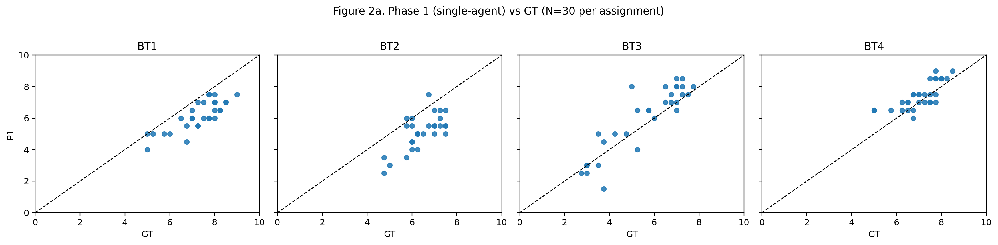
Fig. 2a. Phase 1 vs GT scatter plots (N=30 per assignment).
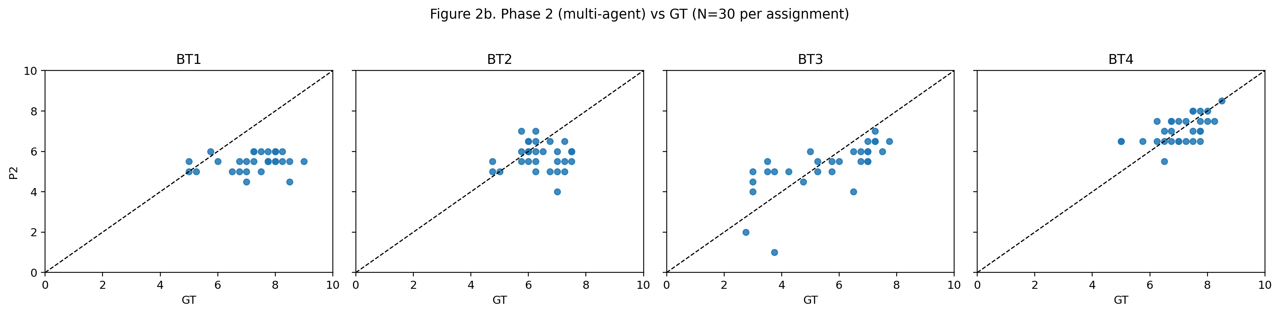
Fig. 2b. Phase 2 vs GT scatter plots (N=30 per assignment).

6 Discussion
Multi-agent grading does not automatically improve ordinal agreement (QWK) with GT in our setting and can introduce assignment-dependent score shifts. Notably, Phase 2 degradation is assignment-dependent: BT1 and BT2 show near-zero QWK (0.043 and −0.002 respectively), while BT3 and BT4 retain moderate agreement (0.613 and 0.517). We hypothesize this divergence reflects structural differences between assignments: BT1 and BT2 require factual completeness and job-market analysis where surface-feature judgments may dilute content-critical signals, whereas BT3 (CV writing) and BT4 (personal essay) have more salient surface-quality dimensions that align better with specialist decomposition. This hypothesis warrants future investigation with controlled rubric variants.
Table 3 reveals extreme variation in Phase-2 stability signals. BT1 exhibits a veto rate of 0.993 with mean spread of 5.150, indicating that specialist agents almost universally disagreed, producing highly unstable aggregated scores (mean shift −0.836). By contrast, BT4 shows a veto rate of 0.061 and mean spread of 1.133, suggesting specialists converged consistently—consistent with its comparatively better Phase-2 QWK. High veto rate and spread can therefore serve as diagnostic signals: when veto rate approaches 1.0, aggregation operates under maximum uncertainty and resulting scores should be treated with low confidence. We recommend monitoring veto rate and spread as real-time quality indicators before accepting multi-agent scores in production.
Based on these findings, we offer three practical recommendations for deploying multi-agent rubric graders: (R1) calibrate specialist severity using anchor papers before deployment to reduce inter-specialist score divergence; (R2) use robust aggregation (median or trimmed mean across specialists) rather than simple averaging to limit the impact of outlier specialist scores; (R3) apply rubric-aligned weighting across specialists so that content-heavy rubrics weight the content specialist more strongly than language or structure.

6.1 Limitations
Our human-scored subset is limited (N=30 per assignment) due to annotator availability; bootstrap CIs can be wide. We did not perform a full sensitivity analysis over temperature and prompting variants. Ground truth is defined as the mean of two graders; when graders disagree substantially, adjudication could yield a different reference score. Additionally, the human-scored subset was stratified using Phase-1 score bands; this may introduce a selection advantage for Phase-1 agreement metrics relative to Phase-2. A stratification strategy independent of either system's outputs would provide a less biased comparison.

7 Ethics and Privacy
Student submissions are sensitive. We do not release raw submissions; instead we release derived, anonymized scoring artifacts and evaluation scripts to support verification of reported results.

8 Conclusion
We presented an auditable OpenClaw-based grading pipeline and a reliability-first evaluation across four real assignments. Single-agent grading achieved higher agreement with human scores than multi-agent grading in our setting, while Phase 2 exhibited systematic shifts and stability issues. We outlined practical calibration and aggregation strategies required for multi-agent setups to yield reliable gains.

Acknowledgments
The authors thank the course instructor and student volunteers who participated in the human annotation process.

References
[1] Cohen, J.: Weighted kappa: Nominal scale agreement with provision for scaled disagreement or partial credit. Psychological Bulletin 70(4), 213–220 (1968).
[2] Landis, J.R., Koch, G.G.: The measurement of observer agreement for categorical data. Biometrics 33(1), 159–174 (1977).
[3] Williamson, D.M., Xi, X., Breyer, F.J.: A framework for evaluation and use of automated scoring. Educational Measurement: Issues and Practice 31(1), 2–13 (2012).
[4] Shermis, M.D., Burstein, J. (eds.): Handbook of Automated Essay Evaluation: Current Applications and New Directions. Routledge (2013).
[5] Beigman Klebanov, B., Madnani, N.: Automated Essay Scoring. Synthesis Lectures in Human Language Technologies. Morgan & Claypool (2021).
[6] Attali, Y., Burstein, J.: Automated essay scoring with e-rater® V.2. Journal of Technology, Learning, and Assessment 4(3) (2006).
[7] Hewlett Foundation (ASAP). Automated Student Assessment Prize (ASAP) AES benchmark (Kaggle competition). https://www.kaggle.com/c/asap-aes (accessed 2026-05-01).
[8] Taghipour, K., Ng, H.T.: A neural approach to automated essay scoring. In: Proceedings of EMNLP 2016, pp. 1882–1891. ACL (2016).
[9] Ke, Z., Ng, V.: Automated essay scoring: A survey of the state of the art. In: Proceedings of IJCAI 2019, pp. 6300–6308 (2019).
[10] Mizumoto, A., Eguchi, M.: Exploring the potential of using an AI language model for automated essay scoring. Research Methods in Applied Linguistics 2(2), 100050 (2023). https://doi.org/10.1016/j.rmal.2023.100050
[11] Esterhuysen, H., et al.: Large language models in student assessment: Comparing ChatGPT and human graders. arXiv:2406.16510 (2024).
[12] Meyer, L., et al.: Reliable but not rigorous: Evaluating ChatGPT's reliability, validity, and bias in automated academic grading. Computers and Education: Artificial Intelligence (2025).
[13] Hakala, K., et al.: Automated refinement of essay scoring rubrics for language models via Reflect-and-Revise. arXiv:2510.09030 (2025).
[14] Seßler, K., et al.: Specialists or generalists? Multi-agent and single-agent LLMs for essay grading. arXiv:2601.22386 (2026).
[15] Wang, Y., Ding, Z., Wu, X., Sun, S., Liu, N., Zhai, X.: AutoSCORE: Enhancing automated scoring with multi-agent large language models via structured component recognition. arXiv:2509.21910 (2025).
[16] Fleiss, J.L., Cohen, J.: The equivalence of weighted kappa and the intraclass correlation coefficient as measures of reliability. Educational and Psychological Measurement 33(3), 613–619 (1973).
[17] OpenAI: API reference for Chat Completions (accessed via internal proxy in this work). https://platform.openai.com/docs/api-reference/chat (accessed 2026-05-01).
[18] OpenClaw Framework. Documentation: https://docs.openclaw.ai ; Source: https://github.com/openclaw/openclaw (accessed 2026-05-01).

Appendix A: Aggregation ablation for Phase 2
We evaluate alternative aggregation rules using specialist totals (content/structure/language) on the human-scored subset (N=30 per assignment). These analyses provide evidence for recommendations R1–R3 by quantifying the impact of robust aggregation and weighting.
Key findings: robust aggregation can improve Phase-2 agreement in some assignments (e.g., BT1 median aggregation increases QWK from 0.043 to 0.123 and reduces MAE), but Phase 1 remains higher overall. BT2 exhibits lower MAE but near-zero/negative QWK, consistent with score compression that reduces numeric error while disrupting ordinal ranking.
Table A1: QWK of aggregation variants vs GT (human subset).
BT | P1 | P2_official | P2_mean | P2_median | P2_weighted
BT1 | 0.484 | 0.043 | 0.029 | 0.123 | 0.019
BT2 | 0.331 | -0.002 | -0.059 | -0.058 | 0.011
BT3 | 0.827 | 0.613 | 0.577 | 0.620 | 0.544
BT4 | 0.720 | 0.517 | 0.547 | 0.534 | 0.470
Figure A1: BT2 error histograms (P1−GT vs P2−GT), illustrating score compression effects.
