TradeWise AI: An Event-Oriented Artificial Intelligence Framework for Predicting Irish Potato Price Changes in Rwanda
UWASE UTUJE Sandrine
Rwanda Coding Academy, Rwanda
Independent Student Research

ABSTRACT
Purpose: This study develops and evaluates TradeWise AI, an event-oriented artificial-intelligence framework for predicting whether meaningful Irish potato price changes are likely to occur across Rwandan markets under irregular observation. The study focuses on event occurrence within a seven-day operational window and separately evaluates direction, timing, and magnitude.

Materials and Methods: The study uses a quantitative predictive design with chronological out-of-sample evaluation. After product filtering, market-eligibility checks, event labeling, and strict outcome-observability filtering, 1,395 Kinigi Grade 2 observations from 11 markets were retained. Chronological training, validation, and test sets contained 1,112, 181, and 102 observations. Logistic Regression, Random Forest, and XGBoost were compared using validation ROC-AUC. The selected Random Forest was evaluated on an untouched test set, with controlled ablations for cross-market, weather, exchange-rate, and CPI information, together with bootstrap and permutation procedures.

Findings: The historical data only Random Forest reached 53.92% accuracy, F1 of 0.561, ROC-AUC of 0.643, and PR-AUC of 0.630 on the test set. Direction prediction showed stronger ranking performance (ROC-AUC 0.697), while timing and magnitude were weaker. Cross-market and external variables did not provide consistent incremental gains. Unseen-market evaluation produced ROC-AUC 0.486, and walk-forward results varied over time.

Implications: The findings support event-oriented, human-in-the-loop decision support rather than guaranteed or autonomous trading predictions. The results show the importance of strict temporal availability, market-specific evaluation, explicit uncertainty, probability calibration, and monitoring for distribution shift. For agricultural decision support, the evidence favors locally adapted systems and cautious interpretation of model scores before operational use.

Keywords: Artificial Intelligence; Agricultural Price Forecasting; Irish Potatoes; Event Prediction

1.0 INTRODUCTION
Agricultural price volatility creates uncertainty for farmers and traders because short-term price movements can affect purchasing, selling, transport, and inventory decisions. Many forecasting approaches focus on continuous price levels or volatility, yet an operational user may need a different answer: whether a meaningful movement is likely to occur soon. TradeWise AI was motivated by this practical problem after a market observation in which an Irish potato seller reacted to another price increase. The study therefore investigates whether machine-learning methods can identify meaningful Irish potato price movements before they occur, using information that would actually have been available at the prediction point.
TradeWise AI defines a meaningful event as an absolute price movement of at least 5% associated with the first qualifying future observation within seven calendar days. The primary task predicts event occurrence, while direction, timing, and magnitude are assessed separately. The framework deliberately distinguishes predictive ranking from guaranteed forecasting: artificial intelligence is used as an umbrella term for the machine-learning methods evaluated rather than as a claim of a deep-learning or autonomous trading system.
The study makes four linked methodological contributions. First, it predicts a discrete threshold-based event instead of treating price-level or volatility accuracy as equivalent to event-detection accuracy. Second, it retains irregular market observations rather than forcing the data into an artificially regular daily series. Third, it applies strict temporal availability so that future information is excluded from predictors. Fourth, it tests whether cross-market, weather, exchange-rate, and consumer-price-index information provides genuine out-of-sample value through controlled ablations. The work also examines direction, timing, magnitude, temporal stability, threshold and horizon sensitivity, and transfer to unseen markets.
1.1 Problem Statement
Irish potato farmers and traders in Rwanda operate in markets where prices can change materially over short periods, yet the available forecasting evidence does not directly establish whether a meaningful price movement can be detected prospectively within a short operational horizon under irregular observations. Prior Rwanda-focused studies have examined volatility, inter-commodity relationships, reference-price setting, and longer-run time-series behavior, but these objectives are not equivalent to short-horizon event detection. A model may describe volatility or price levels accurately without identifying whether a threshold-crossing movement occurred within the next several days. The problem affects farmers and traders because poorly timed decisions can increase exposure to unfavorable price changes, while overconfident forecasts can create additional risk. This study addresses the knowledge gap by evaluating an explicitly specified event-oriented prediction framework under strict chronological testing and by explicitly examining the limits of generalization and external information.
1.2 Study Objectives
The study objectives are to construct a systematically defined event-oriented labeling scheme for meaningful short-horizon Irish potato price movements; develop and evaluate a history-only event model under a strict chronological train-validation-test protocol; test whether cross-market, weather, and economic variables add predictive value; evaluate direction, timing, and magnitude conditional on qualifying events; and assess robustness and generalizability across markets, thresholds, horizons, products, and time.

1.3 Research Questions
RQ1. Can machine learning identify whether a meaningful Irish potato price change will occur within seven days?
RQ2. Does strictly available cross-market information improve event prediction?
RQ3. Do weather, exchange-rate, and CPI variables provide additional predictive information?
RQ4. How well can the framework predict the direction, timing, and magnitude of qualifying price changes?
RQ5. How stable is the predictive signal across thresholds, horizons, markets, and time?
RQ6. Does the predictive signal persist for a different Irish potato product series?
2.0 LITERATURE REVIEW
2.1 Theoretical Review
The original TradeWise AI study is empirical and does not claim a named classical theory as its formal foundation. To avoid attributing an unsupported theory, this research paper retains the conceptual foundations actually used in the study: event-oriented predictive decision support, strict temporal information availability, and human-in-the-loop interpretation. Under this perspective, the value of a predictive system is determined not only by model complexity but by whether its target matches the operational decision, whether all predictors were available at prediction time, and whether uncertainty and generalization boundaries are made explicit. The study therefore treats machine learning as a decision-support instrument rather than as an autonomous trading mechanism. This conceptual position is consistent with the study design in which a model score is evaluated as a ranking signal and not automatically interpreted as a calibrated probability. It also motivates the use of chronological splitting, controlled ablations, untouched test evaluation, sensitivity checks, and unseen-market tests. These design principles link the literature review directly to the research problem by asking what the available historical information can legitimately support.
2.2 Empirical Review
Agricultural price forecasting research spans econometric models, machine learning, deep learning, ensemble methods, and multi-source systems. Wu et al. (2026) synthesize 773 studies and show that forecasting performance depends on input-output design, temporal resolution, objective definition, model selection, and uncertainty treatment. Manogna et al. (2025) compare statistical, machine-learning, and deep-learning approaches across 23 commodities, while Jain et al. (2026) evaluate scalable ensemble decision support across 22 commodities. These studies demonstrate that nonlinear methods can capture useful structure, but they do not directly answer whether a prospectively defined threshold event can be detected under irregular observations. Rwanda-specific evidence shows that Irish potato prices exhibit economically relevant dynamics. Habyarimana et al. (2014) used monthly vector autoregression models to study volatility and predictive relationships among food commodities. Nsabimana et al. (2015) examined daily Irish potato prices using GARCH- and VECM-related methods with fertilizer, pesticide, and exchange-rate variables. Del Prete and Mukaneza (2024) considered Irish potato reference-price setting and seasonal volatility from a policy perspective. These studies establish the importance of price dynamics but use objectives that differ from the event-oriented target in TradeWise AI. Research on heterogeneous information motivates testing variables beyond target-market history. Wang et al. (2025) incorporate textual information into agricultural commodity forecasting; Ghonge and Kulkarni (2026) combine market and external agricultural information; Vairo et al. (2026) evaluate weather variables and show that value depends on granularity and market structure; and Wu et al. (2025) develop an interpretable combination-forecasting framework. Together, these studies motivate multimodal testing while also suggesting that an added modality is useful only when its timing, spatial scale, and measurement process are compatible with the prediction target.
2.3 Conceptual Framework
The conceptual framework links four information groups historical target-market prices, cross-market prices, weather, and economic variables to temporal preprocessing, feature engineering, predictive modeling, and human decision support. The primary modeling path intentionally uses historical target-market information only, while multimodal inputs are evaluated as robustness and ablation paths. Outputs include event occurrence, direction, timing, and magnitude. The framework therefore separates the main predictive claim from secondary tests of incremental information value.
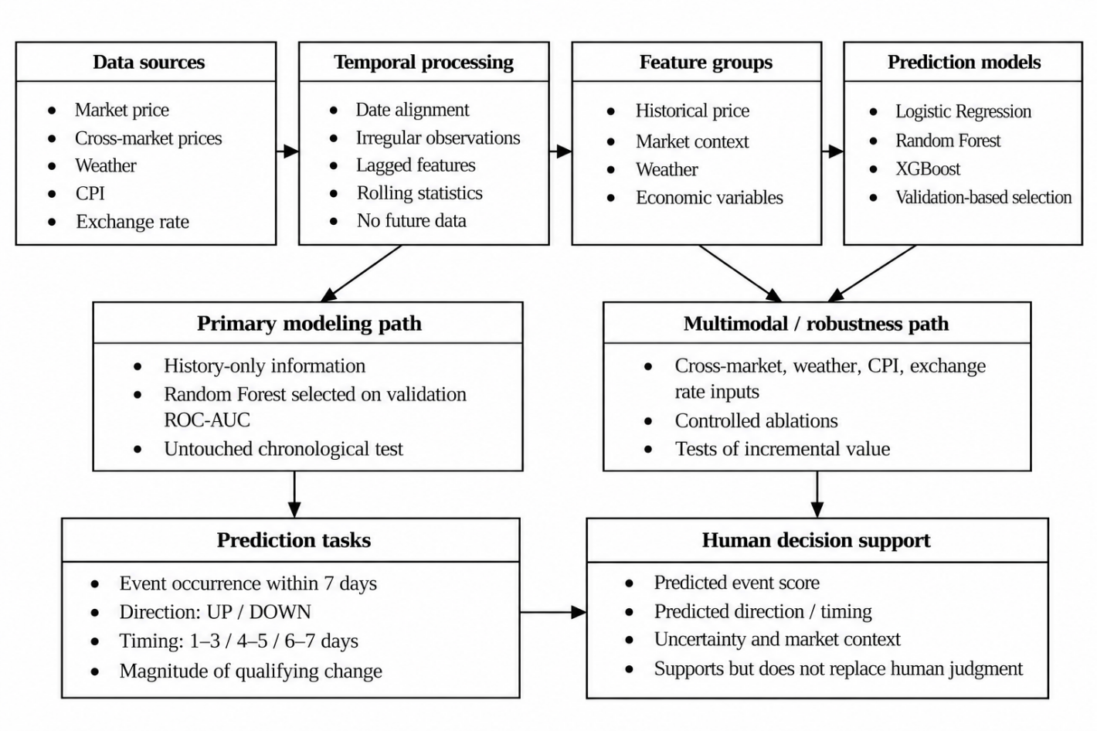
Figure 1: TradeWise AI Conceptual Framework
2.4 Research Gaps
The reviewed studies leave a combined methodological gap in four areas: direct event-oriented prediction rather than price-level or volatility forecasting; retention of irregular market observations rather than artificial daily regularization; strict restriction of predictors to information available at prediction time; and controlled out-of-sample testing of whether cross-market, weather, and economic modalities add incremental value. TradeWise AI seeks to fill this gap by combining these four features within one Rwanda-specific evaluation framework and by reporting both predictive signal and generalization boundaries.
3.0 MATERIAL AND METHODS
Study Design: This study used a quantitative predictive and observational machine-learning design with chronological out-of-sample evaluation.
Study Location: The analysis covered Irish potato market observations from Rwanda, with the final Kinigi Grade 2 dataset spanning 11 eligible markets.
Population: The source market dataset contained 163,271 records, including 10,062 Irish potato records; after product filtering and aggregation of records that shared the same date, product, and market into unique keys, 8,783 unique date-product-market keys remained.
Sample and Sampling Techniques: Market eligibility required at least 50 observations and at least 20 consecutive-day observation pairs. Eleven markets met the criteria, and strict seven-day outcome-observability filtering produced 1,395 supervised observations. The chronological split contained 1,112 training observations, 181 validation observations, and 102 untouched test observations.
Data Collection: Market prices were obtained from the TangaBid/eSoko data-access export, while secondary analyses used publicly available CPI, exchange-rate, and weather information from Rwanda and NASA sources; each external variable was aligned only when it was available at or before the prediction date. All predictor variables were constructed using information available no later than the prediction observation. Future observations used to determine the event label were excluded from feature construction.
Statistical Analysis: A meaningful event was defined as the first same-market future observation within seven calendar days showing an absolute price movement of at least 5%. Candidate event classifiers were Logistic Regression, Random Forest, and XGBoost, with model selection based on validation ROC-AUC. The selected Random Forest used 500 trees, maximum depth 8, minimum leaf size 1, and seed 42. Event evaluation used accuracy, precision, recall, F1, ROC-AUC, and PR-AUC; direction used classification metrics and ROC-AUC; timing used accuracy and macro F1; magnitude used MAE, RMSE, and R². The primary model evaluation and controlled ablation analyses were conducted as separate experimental pipelines. The primary pipeline used validation-based model selection followed by evaluation of the selected model on the untouched test set, whereas the controlled ablations used a common secondary protocol to compare the incremental value of different information sources. Therefore, closely related specifications may produce slightly different ROC-AUC estimates across these analyses, and the results are reported separately rather than treated as interchangeable. Statistical uncertainty checks included 5,000 bootstrap resamples and a 10,000-permutation test against ROC-AUC = 0.50. Controlled ablations, threshold and horizon sensitivity, leave-one-market-out evaluation, product robustness, and walk-forward testing were used to examine robustness and generalization.

For each observation at time t, future observations from the same market and product were searched from t+1 through t+7 calendar days. The first future observation satisfying |(P_t' − P_t)/P_t| ≥ 0.05 defined the event. If future observations existed within the seven-day window but none satisfied the threshold, the observation was labeled a non-event. If no future observation was available within the window, the outcome was treated as unobservable and excluded from the strict supervised dataset.

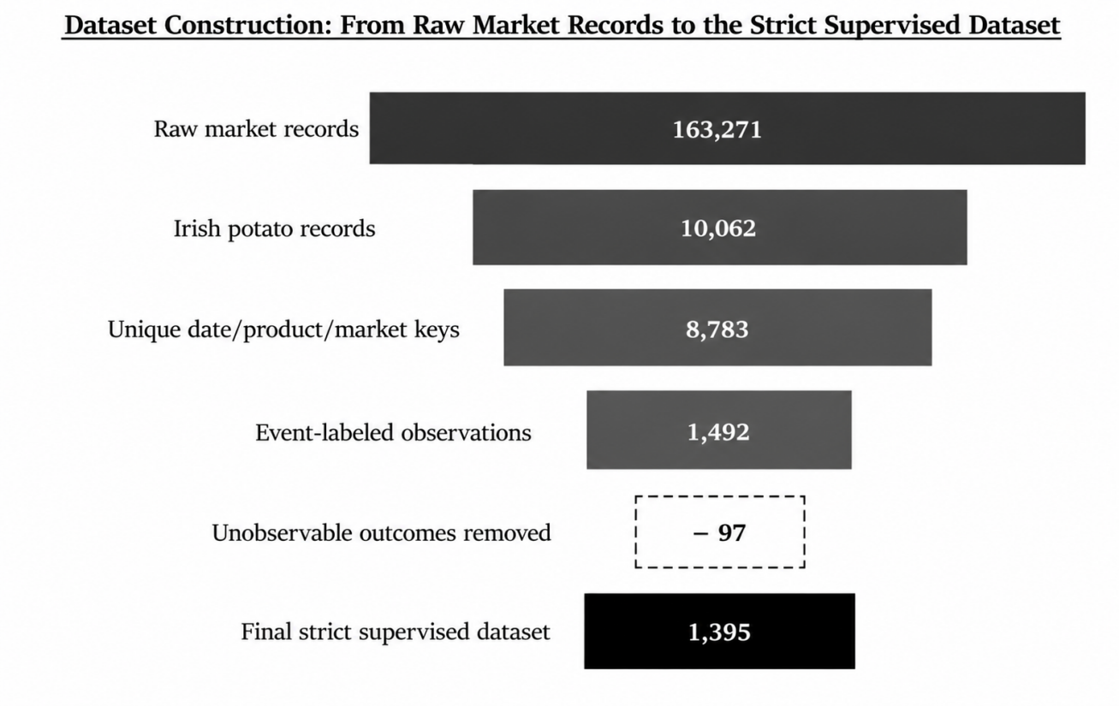
Figure 2: Dataset Construction from Raw Market Records to the Strict Supervised Dataset

Table 1: Market Composition of the Strict Supervised Dataset
Market | Observations | Events | Event Rate
Nyabugogo | 273 | 215 | 78.8%
Kibuye | 261 | 130 | 49.8%
Mulindi | 189 | 60 | 31.7%
Nyagatare | 143 | 55 | 38.5%
Kimironko | 97 | 61 | 62.9%
Musanze | 90 | 35 | 38.9%
Kicukiro-Center | 89 | 29 | 32.6%
Gahoromani | 77 | 41 | 53.2%
Kibungo | 76 | 38 | 50.0%
Butare | 57 | 27 | 47.4%
Ziniya | 43 | 32 | 74.4%

Table 2: Chronological Train-Validation-Test Split
Split | Calendar Period | n | Role
Train | 2025-01-01 to 2026-01-16 | 1,112 | Model fitting
Validation | 2026-01-17 to 2026-03-27 | 181 | Model selection
Test | 2026-03-28 to 2026-08-14 | 102 | Final untouched evaluation
4.0 FINDINGS
4.1 RQ1: Primary Event Prediction
Validation ROC-AUC selected the Random Forest from the three candidate classifiers. On the untouched test set, the history-only Random Forest achieved 53.92% accuracy, 55.56% precision, 56.60% recall, F1 of 0.561, ROC-AUC of 0.643, and PR-AUC of 0.630. The test set contained 53 events and 49 non-events, giving a majority-class accuracy baseline of 51.96%. The 95% bootstrap interval for ROC-AUC was 0.533 to 0.748. A 10,000-permutation test against AUC = 0.50 produced p = 0.0064 under the stated procedure. These results support a modest ranking signal in the held-out sample, while the sample size and confidence interval limit how strongly deployment performance can be inferred. An ROC-AUC of 0.643 indicates that the model provides some ranking information for distinguishing future event and non-event cases, but it is far from perfect discrimination.

Table 3: Candidate-Model Validation Ranking and Held-Out Test Performance
Model | Validation ROC-AUC | Test ROC-AUC | Test F1 | Test PR-AUC
Logistic Regression | 0.508 | 0.626 | 0.608 | 0.652
Random Forest | 0.592 | 0.643 | 0.561 | 0.630
XGBoost | 0.584 | 0.626 | 0.593 | 0.625

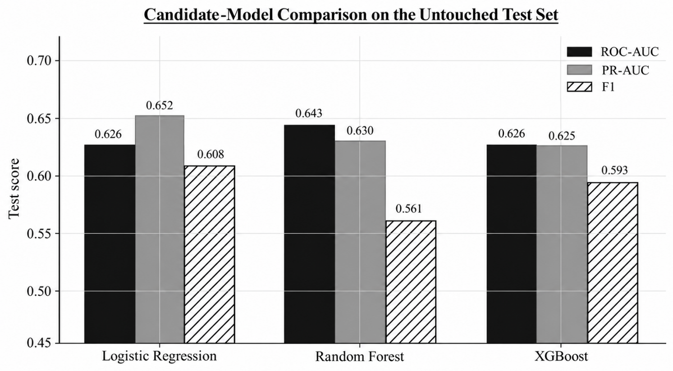
Figure 3: Candidate-Model Comparison on the Untouched Test Set
4.2 Probability Calibration
The primary model achieved a Brier score of 0.235. Calibration was reasonable in the central range of predicted scores but weaker in the highest predicted-score group, which contained only five test cases. Model outputs should therefore be interpreted as predictive scores until explicit calibration is added.
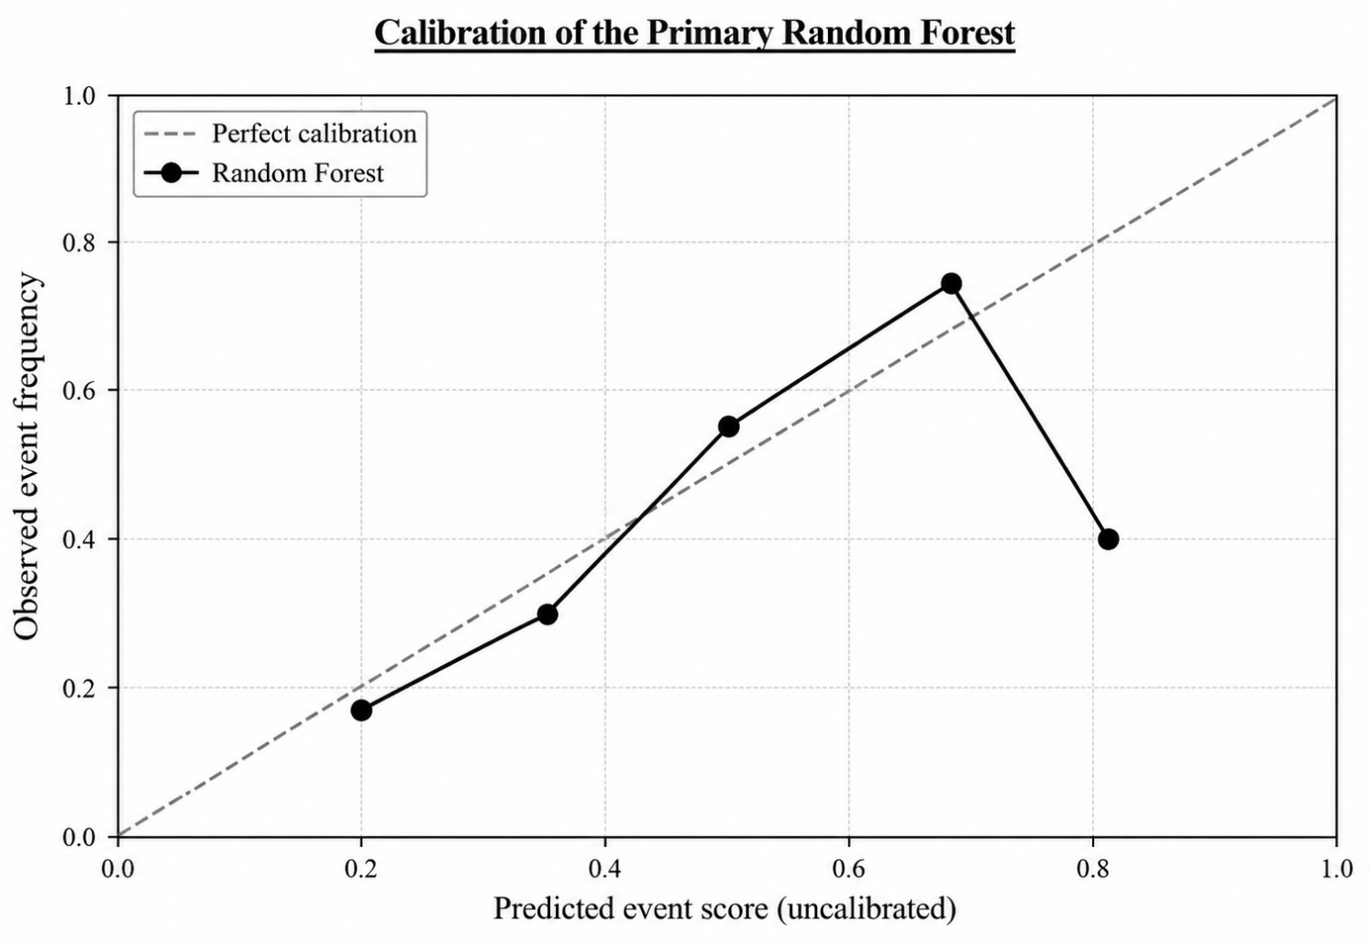
Figure 4: Calibration of the Primary Random Forest on the Untouched Test Set
4.3 RQ2-RQ3: Cross-Market and External Information
The dedicated strictly lagged cross-market evaluation achieved 56.86% accuracy, 56.86% F1, ROC-AUC of 0.612, and PR-AUC of 0.609. Although accuracy and F1 were slightly higher than those of the primary history-only model, the cross-market specification had lower ROC-AUC and PR-AUC. A separate controlled ablation analysis used a common secondary pipeline to compare information sources; in that analysis, the history + strict lagged cross-market configuration achieved ROC-AUC of 0.593 (Figure 5).
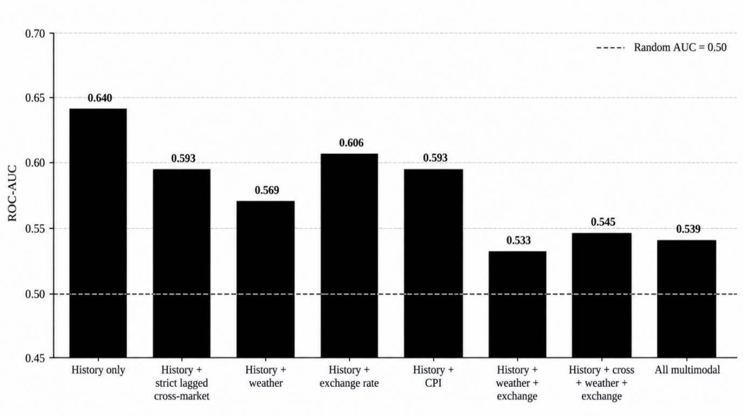
Figure 5: Controlled Multimodal Ablation under the Common Secondary Evaluation Pipeline

4.4 RQ4: Direction, Magnitude and Timing
Among the 53 test event cases, conditional direction prediction achieved 64.15% accuracy, 80.00% precision, 32.00% recall, F1 of 0.4571, ROC-AUC of 0.697, and PR-AUC of 0.651. Direction therefore showed stronger ranking signal than the broader event-occurrence task. Magnitude prediction was weak, with MAE of 0.1043, RMSE of 0.1429, and R² of -7.903. Exclusion of extreme observations, winsorization, and log transformation reduced error but left R² negative. Three-class timing prediction achieved 47.17% accuracy and macro F1 of 0.344 on 53 event cases, indicating that identifying an upcoming event was easier than locating it precisely within the seven-day window.
4.5 RQ5-RQ6: Product Robustness, Generalization and Temporal Stability
For the secondary Kirundo product series, the held-out test set contained 128 observations with a 22.66% event rate. The Random Forest achieved 39.84% accuracy, F1 of 0.403, ROC-AUC of 0.639, and PR-AUC of 0.335. This suggests that a modest ranking signal persisted for another product series, although performance changed with prevalence and product distribution. Leave-one-market-out evaluation produced 48.24% accuracy, 53.12% F1, ROC-AUC of 0.486, and PR-AUC of 0.534 across 1,395 observations. The 95% bootstrap interval for ROC-AUC was 0.456 to 0.516 and the permutation test gave p = 0.370. This was the clearest generalization boundary: the learned signal did not transfer reliably to completely unseen markets. Expanding-window walk-forward evaluation with a seven-day purge yielded ROC-AUC values of 0.565, 0.569, and 0.641 across three chronological windows, showing that predictive strength varied over time and that monitoring for distribution shift is necessary.

Overall, the findings show that the forecasting problem has several levels of difficulty rather than a single model-performance answer. A modest event-occurrence signal is detectable in the primary held-out sample, direction contains stronger ranking information, timing is difficult, and magnitude is unreliable. Additional data modalities do not automatically improve predictive performance when temporal resolution, spatial scale, and observation timing are mismatched with the target. The poor unseen-market result further indicates that the current signal is substantially market-specific rather than a demonstrated Rwanda-wide effect. For practical use, TradeWise AI is best interpreted as human-in-the-loop decision support. A future interface could present an event-risk score, directional evidence, uncertainty, and recent market context to help users decide when closer monitoring or additional information is warranted. It should not present model outputs as guaranteed prices or automatic buy/sell instructions. Explicit calibration, larger prospective samples, cluster-aware evaluation, richer supply-and-demand information, and market-adaptation strategies are necessary before stronger operational claims can be made.
5.0 CONCLUSION AND RECOMMENDATIONS
5.1 Conclusion
TradeWise AI showed that historical Irish potato market data contains a modest but measurable signal for predicting meaningful price changes within seven days. On the untouched test set, the history-only Random Forest achieved a ROC-AUC of 0.643 and PR-AUC of 0.630, providing limited evidence of predictive ability beyond the 51.96% majority-class baseline. Direction prediction was stronger, with a ROC-AUC of 0.697, while timing and magnitude prediction remained weak. Cross-market, weather, exchange-rate, and CPI information did not provide consistent additional predictive value, and performance on unseen markets fell to a ROC-AUC of 0.486, showing limited generalization.
5.2 Recommendations
Future work should first apply explicit probability calibration before model scores are interpreted as calibrated event probabilities. The framework should also be evaluated prospectively using larger out-of-sample and walk-forward test windows. Incorporating richer supply-and-demand variables may help explain market-specific effects, while market-adaptation strategies could improve transfer to unseen markets. Future evaluation should also consider cluster-aware bootstrap or permutation procedures when independent event identifiers are available. In any future deployment, distribution shift should be monitored and the model periodically recalibrated or retrained. Finally, outputs should be presented as human decision support with uncertainty and market context rather than as guaranteed prices or autonomous trading instructions.

6.0 REFERENCES
Wu, B., Wang, J., Li, Q., Fu, D., & Wang, L. (2026). A comprehensive review for agricultural product prices forecasting: Architectural diversity and open challenges. Expert Systems, 43(5), e70254. https://doi.org/10.1111/exsy.70254
Manogna, R. L., Dharmaji, V., & Sarang, S. (2025). Enhancing agricultural commodity price forecasting with deep learning. Scientific Reports, 15, 20903. https://doi.org/10.1038/s41598-025-05103-z
Jain, R., Lwin, N. O., Dal, R., & Oo, A. M. (2026). Explainable and scalable ensemble decision-support framework for multi-commodity price forecasting in agricultural markets. Journal of Decisions and Operations Research, 11(1), 53–79. https://doi.org/10.22105/dmor.2026.559398.2038
Habyarimana, J. B., Munyemana, E., & Impeta, F. B. (2014). Food prices volatility in Rwanda: A VAR model. World Journal of Agricultural Research, 2(6), 296–302. https://doi.org/10.12691/wjar-2-6-9
Nsabimana, I., Mung’atu, J. K., & Kigabo, T. (2015). Forecasting price of Irish potatoes volatility using GARCH and VECM models in Rwanda. International Journal of Thesis Projects and Dissertations, 3(3), 44–53. https://www.researchpublish.com/papers/forecasting-price-of-irish-potatoes-volatility-using-garch-andvecm-models-in-rwanda
Del Prete, D., & Mukaneza, M. (2024). Fair prices for Irish potatoes in Rwanda: A new price-setting mechanism. Food and Agriculture Organization of the United Nations. https://doi.org/10.4060/cd0585en
Wang, L., Yu, L., & An, W. (2025). Two-stream reinforcement ensemble framework for agricultural commodity prices forecasting using textual data. Journal of Forecasting, 44(8), 2386–2404. https://doi.org/10.1002/for.70015
Ghonge, V. D., & Kulkarni, Y. (2026). Multi-source data fusion and machine learning for soybean crop price forecasting in India. Journal of Computational and Cognitive Engineering. https://doi.org/10.47852/bonviewJCCE62027619
Vairo, A., Romano, F., & Grilli, L. (2026). Assessing the role of weather in commodity price forecasting: Evidence from fine durum wheat. Computational Management Science, 23, 26. https://doi.org/10.1007/s10287-026-00576-3
Wu, B., Gao, R., Wang, X., & Zeng, H. (2025). Agricultural futures prices combination forecasting with whole-process interpretable method. Applied Soft Computing, 185, 114049. https://doi.org/10.1016/j.asoc.2025.114049
TangaBid. (2026). Data access: Market prices and data exports. https://www.tangabid.com/data-access/
National Institute of Statistics of Rwanda. (2026). Consumer Price Index (CPI). https://www.statistics.gov.rw/data-sources/surveys/Consumer-Price-Index/consumer-price-index-cpi-2026
National Bank of Rwanda. (2026). Historical exchange rates. https://www.bnr.rw/exchangeRatehis
Rwanda Meteorology Agency. (2026). Meteo Rwanda monitoring and evaluation system. https://mis.meteorwanda.gov.rw/
NASA POWER. (2026). Data access and meteorological data services. NASA Langley Research Center. https://power.larc.nasa.gov/

