IHESHABUBASHA
Ngewe, UWASE UTUJE Sandrine,
Itariki y'amavuko: 30 Nyakanga 2009
Telefoni: 0785805869
Aho ntuye: Mpenge, Muhoza, Musanze
Mpaye ububasha umubyeyi wanjye w'umugabo:
Amazina: HAVUGIMANA Appollinaire
Numero y’ irangamuntu: 1197480021405123

Uburenganzira bwo ku mpagararira imbere y'inzego zibishinzwe mw’izina ryanjye, mu bikorwa bijyanye no gusaba no kwakira Indangamuntu yanjye.
Kubera ko ndi ku ishuri ntabwo nashobora kwitabira inzira zikenewe kugira ngo mbone Indangamuntu, natanze ubu bubasha ku mubyeyi wanjye kugira ngo ansimbure muri izo gahunda. Muhaye ububasha bwo gutanga no gushyikiriza inzego zibishinzwe ibyangombwa bisabwa, gukurikirana dosiye yanjye, kwakira amakuru ajyanye n'ubusabe bwanjye, no kwakira Indangamuntu yanjye igihe izaba imaze gutangwa.
Indangamuntu ndayikeneye mu rwego rwo kwemeza umwirondoro wanjye mu gihe nzaba nkora ikizamini cya Duolingo English Test.
Ubu bubasha mbutanze ku bushake kandi buzakoreshwa ku mpamvu zavuzwe haruguru.
Bikorewe i: Mukamira, Nyabihu
Itariki: 20 Nzeri 2026

UTANZE UBU BUBASHA (Usaba Indangamuntu)
Amazina: UWASE UTUJE Sandrine
Umukono: 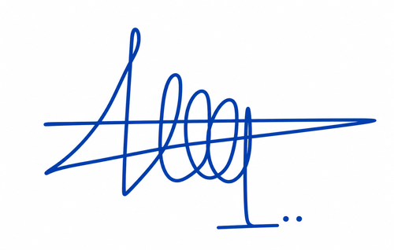

UHAWE UBU BUBASHA (Umubyeyi)
Amazina: HAVUGIMANA Appollinaire
Umukono:

