EAASP v2.0
Platform Product Forms
Application Model for Power Grid Dispatching & Control Centers

Enterprise Autonomous Agent Support Platform
April 2026 | CONFIDENTIAL

1 Executive Summary
This document defines the application product forms for EAASP v2.0, the Enterprise Autonomous Agent Support Platform. EAASP v2.0 is a five-layer architecture with three vertical pipelines that enables enterprises to deploy, govern, and scale heterogeneous AI agent runtimes as a unified platform service. The platform is designed around event-driven orchestration, deterministic hook enforcement, persistent organizational memory, multi-agent review, and a self-service capability factory.
The application model is structured as a four-layer framework: meta-paradigms define the platform’s architectural operating logic; product forms define the reusable delivery patterns through which the platform creates value; portfolio clusters organize products by domain priority; and domain scenarios specify concrete application products for power grid dispatching and control centers.
Because EAASP v2.0’s target users are power grid dispatching and control centers, approximately 70% of the product portfolio directly serves core grid dispatching and control scenarios. The remaining portfolio addresses dispatching support, governance, and platform evolution. This weighting reflects the architectural fit: EAASP’s event rooms, four-card paradigm, five-stage approval chain, evidence chains, and multi-agent review map naturally to dispatch work, which is continuous, risk-sensitive, evidence-intensive, approval-bound, and retrospective-rich.
Positioning: EAASP v2.0 is not a general-purpose enterprise agent platform with some dispatch use cases. It is a dispatch-centered event-and-execution platform, with research, compliance, knowledge, and innovation products built around that core.

2 Application Model: Four-Layer Framework
The EAASP v2.0 application model is organized in four layers, progressing from architectural abstraction to domain-specific implementation. Each layer constrains and informs the layers below it.
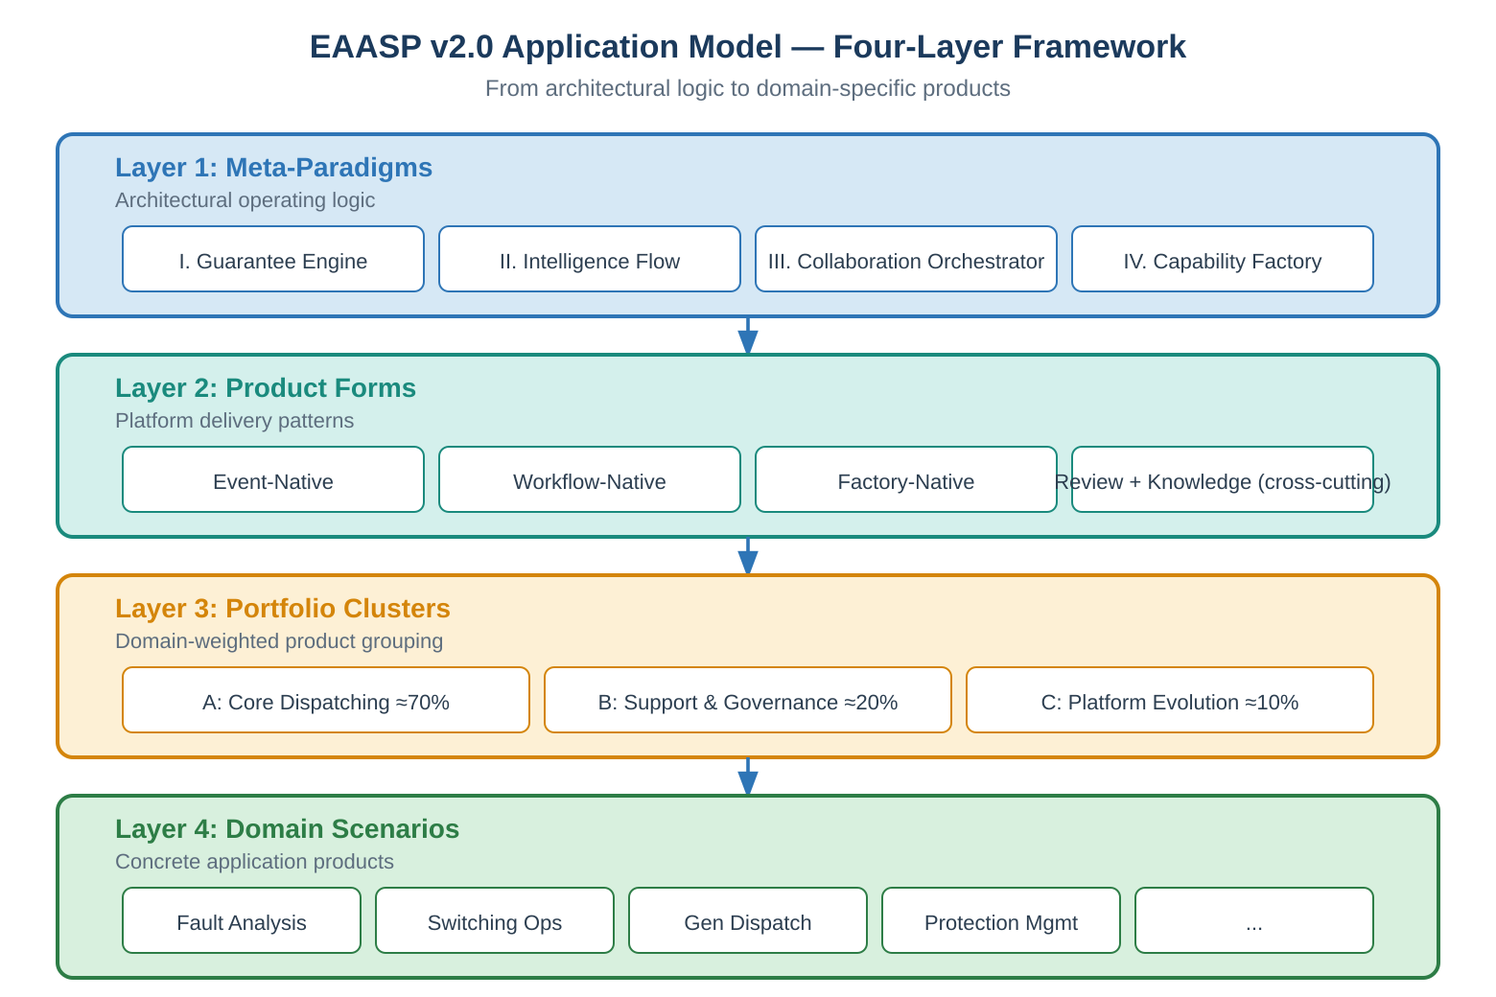
Layer 1 — Meta-Paradigms: Four architectural operating logics derived from EAASP’s three vertical pipelines plus the Agent Factory operational model. These describe how the platform operates and evolves.
Layer 2 — Product Forms: Three primary delivery patterns plus two cross-cutting capabilities. These describe how the platform delivers value to users, independent of any specific business domain.
Layer 3 — Portfolio Clusters: Domain-weighted product groupings. For power grid dispatching, three clusters with priority weighting ensure resource allocation matches operational importance.
Layer 4 — Domain Scenarios: Concrete application products mapped to specific grid dispatching business scenarios, each realized through a specific product form and powered by one or more meta-paradigms.

3 Four Meta-Paradigms
EAASP v2.0’s application capabilities emerge from four meta-paradigms. Each is derived from a distinct architectural element: the first three from the platform’s three vertical pipelines, and the fourth from the Agent Factory operational model introduced in v2.0. Together they form a reinforcing cycle: the outputs of each paradigm serve as inputs to the others.
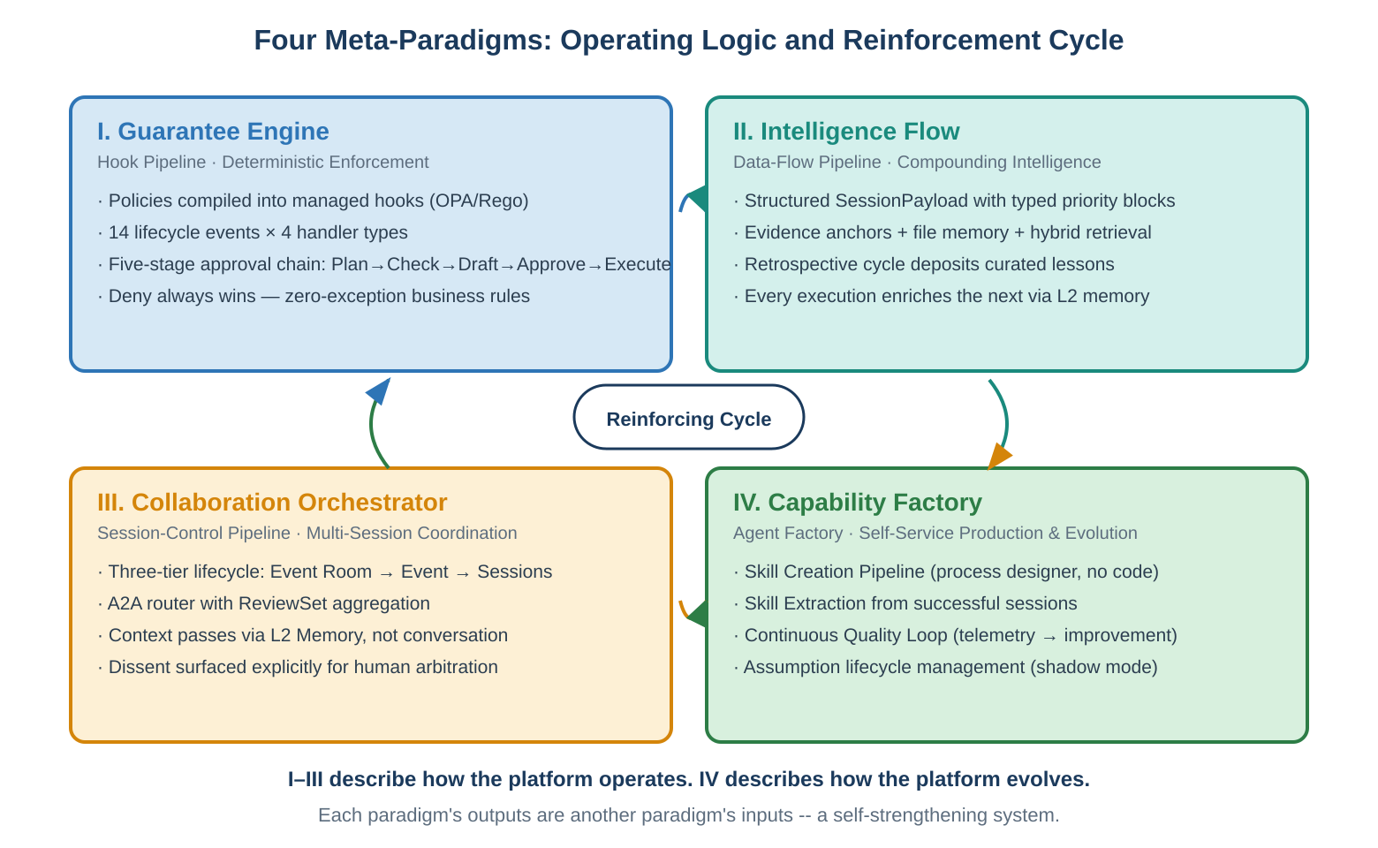

3.1 Meta-Paradigm I: The Guarantee Engine
Derived from the Hook Pipeline. The Guarantee Engine provides deterministic enforcement of zero-exception business rules. Administrators declare policies in L5’s admin console; L3’s policy compiler translates them into executable hook configurations, with OPA/Rego as a first-class compilation target for command hooks; and L1’s hook bridge ensures consistent enforcement across all agent runtimes regardless of their native capabilities.
The platform defines 14 lifecycle events across three layers (9 in L1, 2 in L3, 3 in L4), with four handler types forming an escalation ladder: command hooks at millisecond latency, HTTP hooks at approximately 300ms, prompt hooks at approximately 2 seconds, and agent hooks at approximately 15 seconds. The foundational guarantee: deny always wins. If any hook at any scope level denies an action, the action is blocked regardless of what any other hook or agent reasoning decides.
The five-stage approval chain (Plan → Check → Draft → Approve → Execute) provides governed execution with risk-tiered response levels. Low-risk operations proceed autonomously with audit logging. Medium-risk operations produce drafts with notifications. High-risk operations require the full chain with mandatory human authorization.
Grid significance: Power grid dispatching requires absolute operational determinism. Switching operations, protection settings, and generation dispatch commands must comply with physical grid constraints and regulatory rules without exception. The Guarantee Engine ensures that agent intelligence never overrides grid safety constraints—policies are enforced by code, not by suggestion.

3.2 Meta-Paradigm II: The Intelligence Flow
Derived from the Data-Flow Pipeline. The Intelligence Flow creates compounding organizational intelligence through two-directional data enrichment. Downstream: user messages and external events are enriched with memory, ontology context, skill instructions, and policy constraints as they descend from L5 through L4/L3/L2 into L1. The SessionPayload is structured as typed priority blocks (policy context P1, event context P2, memory references P3, skill instructions P4, user preferences P5). When context windows are constrained, lower-priority content is trimmed first—policy and evidence always survive.
Upstream: agent execution produces four output types—response chunks for streaming, telemetry events for audit, memory writes for persistent knowledge, and event stream entries for complete session capture. The retrospective cycle at the end of every event deposits curated lessons back into L2 memory, enriching the context assembly for all future events. Every execution makes the platform smarter.
Grid significance: Grid dispatching accumulates decades of operational experience—historically locked in individual dispatchers’ tacit knowledge and at risk of loss through retirement attrition. The Intelligence Flow systematically captures, curates, and reuses this experience. Threshold calibrations, fault response patterns, seasonal load behaviors, and equipment-specific handling preferences all compound in L2’s Memory Engine. Evidence anchors ensure that every analytical conclusion is traceable to original SCADA data snapshots, transforming AI outputs from ungrounded suggestions into professionally defensible analyses.

3.3 Meta-Paradigm III: The Collaboration Orchestrator
Derived from the Session-Control Pipeline. The Collaboration Orchestrator manages the platform’s most complex relationship: the three-tier lifecycle hierarchy. Event Rooms in L5 are long-lived, persisting across all sessions and archiving only after the retrospective phase. Events in L4 own the authoritative state machine (received → triaging → active → pending_approval → executing → monitoring → closed → retrospective). Sessions in L3→L1 are ephemeral—one event can spawn multiple sessions for initial analysis, follow-up investigation, A2A parallel reviews, and post-approval execution. The critical design decision: sessions pass context through L2 Memory, not conversation history.
The A2A protocol (capability registration, collaboration dispatch, ReviewSet aggregation) enables multi-agent parallel review. When L3 policy triggers escalation—because of required cross-review, parallel evidence-gathering, trust-domain isolation, or the need for visible dissent—multiple specialist agents analyze the same event independently. The aggregation engine performs conflict detection, confidence weighting, and produces one of three outcomes: unanimous merge, conflict flagging with human arbitration, or partial completion with pending items noted. Disagreement is surfaced explicitly rather than hidden.
Grid significance: Complex grid disturbances exceed the analytical capacity of any single agent or human operator. A major system disturbance requires simultaneous stability analysis, protection system assessment, load management evaluation, and restoration planning. The Collaboration Orchestrator enables these perspectives to work in parallel with their conclusions mathematically aggregated, contradictions surfaced, and the composite recommendation presented to the chief dispatcher for informed arbitration—transforming hours of sequential analysis into minutes of parallel review.

3.4 Meta-Paradigm IV: The Capability Factory
Derived from the Agent Factory operational model. The Capability Factory is what transforms EAASP from a project-deployment platform into a self-improving organizational capability system. Three operational flows compose it.
Skill Creation Pipeline: Business analysts and domain experts open the process designer in L5 and describe workflows using structured fields. The process designer compiles input into SKILL.md format and submits to L2’s skill repository via the governance-gated skill lifecycle API. The skill enters the four-stage promotion pipeline: automated testing in a sandboxed L1 session, human review, and final approval. No code is written by the business expert at any point.
Skill Extraction: When a user and an agent complete a complex task through creative problem-solving, the PostSessionEnd hook triggers the skill-creator meta-skill, which analyzes the session’s event stream—the complete sequence of reasoning, tool calls, recoveries, and intermediate results—and extracts the reusable pattern into a draft SKILL.md. Once promoted through review, organizational capability scales from individual success into a repeatable, governed workflow.
Continuous Quality Loop: Execution telemetry produces per-skill quality metrics: success/failure rates, execution time, token consumption, user satisfaction, and failure patterns. The observability hub surfaces quality issues. The assumption health dashboard tracks hook effectiveness metrics (true-positive rate, false-positive rate, fire frequency trends), identifying hooks that have become dead weight as model capabilities improved. Shadow-mode testing validates whether a hook can be safely retired. Graduated policy relaxation shifts controls from approval-required to auto-approve-with-audit. Governance configurations become more precisely targeted over time, not more burdensome.
Grid significance: In grid dispatching, the Capability Factory is how experiential knowledge (经验库) becomes executable capability (技能库). A senior dispatcher’s successful handling of a rare grid event is captured through skill extraction, reviewed by engineering leadership, and deployed as a governed workflow-skill available to all dispatchers. As grid operating conditions evolve—increasing renewable penetration, changing load patterns, updated regulations—the assumption lifecycle management ensures governance configurations evolve in step, preventing both under-governance (safety risk) and over-governance (operational latency).

4 Product Forms
Product forms are the reusable delivery patterns through which EAASP creates value. They are intermediate between meta-paradigms (architectural logic) and domain scenarios (specific products): a product form describes how the platform delivers, independent of what it delivers. Every concrete application product is an instance of one primary product form, potentially enriched by cross-cutting capabilities.
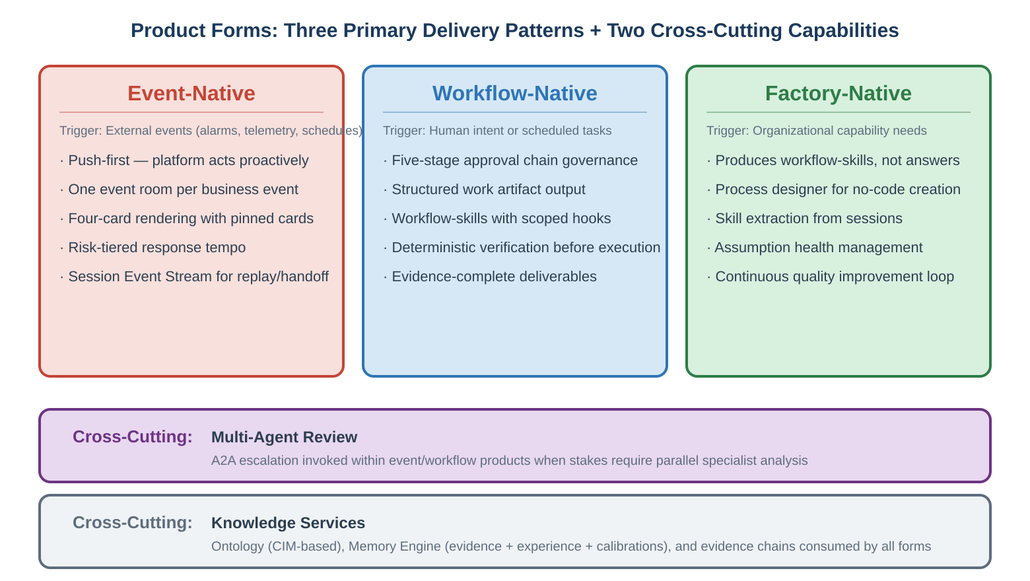

4.1 Event-Native Products
Definition: Products triggered by external events—alarms, telemetry changes, log entries, scheduling triggers, or business events—that create one event room per business event, render four pinned cards, and push the right action to humans proactively rather than waiting for a prompt.
Architectural foundation: L4 event engine (ingest → dedup → cluster → correlate → event object), L5 push channels (SSE/WebSocket + IM bots), four-card paradigm (event card, evidence pack, action card, approval card), event state machine (received through retrospective), Session Event Stream for complete event recovery.
Defining characteristics:
- Push-first interaction. The platform acts proactively. When a business event occurs, L5 pushes a notification with a pre-assembled event card. The user’s first interaction is decision, not question.
- Aggregation, not relay. The event engine clusters related raw signals into a single structured business event. One hundred alerts constitute a single event, not one hundred event rooms.
- Risk-tiered response tempo. Simple events complete autonomously with a result card. Judgment events produce an action card requesting human input. Sensitive events activate the full approval chain. The tempo is determined by L3 policy, not by the agent.
- Shift-spanning persistence. Event rooms are long-lived—they persist across sessions and shift changes. The Session Event Stream preserves complete context, enabling handoff without information loss.
- Retrospective closure. Every event terminates with a retrospective stage that deposits curated lessons into L2 memory, creating compounding organizational intelligence.
Grid mapping: Event-native products are the most architecturally native form for grid dispatch centers. Grid operations are fundamentally event-driven: faults occur, protection operates, load shifts, equipment degrades. The event engine’s pluggable clustering strategies enable spatial-topology-aware clustering that understands which alerts come from equipment on the same distribution line, bus section, or protection zone.

4.2 Workflow-Native Products
Definition: Products triggered by human intent or scheduled tasks that produce structured work artifacts through the five-stage governed execution chain. Their purpose is not to answer questions but to generate plans, validate them, produce drafts, pass approval, and execute through controlled connectors.
Architectural foundation: L3 approval control chain (Plan → Check → Draft → Approve → Execute), workflow-skills with scoped hooks in YAML frontmatter, L3 deterministic verifier (rule-engine, simulation, compliance, and numeric cross-validation), OPA/Rego policy backend for declarative safety constraints.
Defining characteristics:
- Governed artifact production. The output is a structured work artifact—a switching ticket, a dispatch order, a compliance report, a maintenance plan—not a conversational answer. Quality is enforced by hooks, not hoped for through prompting.
- Deterministic verification. High-stakes judgments pass through the deterministic verifier using rule engines and simulation tools rather than LLM probabilistic reasoning. Same input, same output, every time.
- Scoped hooks in skills. Each workflow-skill’s YAML frontmatter carries hooks that activate only during that skill’s execution. Intelligence and guarantee coexist in a single asset: prose instructions tell the agent what good looks like; hooks guarantee that certain checks happen.
- Evidence-complete deliverables. Every conclusion in the output references evidence anchors. The Stop hook verifies evidence coverage before the deliverable enters the approval card.
Grid mapping: Workflow-native products map to the most procedure-intensive activities in grid dispatching: switching operations, dispatch orders, generation scheduling, protection setting verification, and regulatory compliance reporting. These activities are structured, repetitive, approval-bound, and subject to strict regulatory rules—exactly the pattern that EAASP’s workflow-skill model and approval chain were designed to serve.

4.3 Factory-Native Products
Definition: Products that manufacture other products. These are not business copilots—they are the industrialization engine that produces workflow-skills, captures organizational experience, and continuously improves platform governance.
Architectural foundation: L5 process designer, L2 skill repository with four-stage promotion pipeline, skill extraction mechanism (event-stream-to-skill via PostSessionEnd hook), assumption health dashboard, hook shadow mode, graduated policy relaxation.
Defining characteristics:
- Capability production. The output is a governed, reusable workflow-skill—not a one-time answer. The Skill Creation Pipeline enables domain experts to build workflow-skills without writing code. The process designer compiles structured input into SKILL.md format.
- Experience capture. Skill Extraction analyzes successful sessions’ event streams and identifies reusable patterns, converting tacit expertise into governed organizational assets.
- Governance evolution. The Continuous Quality Loop and assumption health management ensure the platform’s governance configurations evolve as model capabilities improve and operational conditions change.
Grid mapping: Factory-native products are how grid dispatch centers transition from project-based AI deployment to self-sustaining capability growth. Senior dispatchers’ expertise is captured as skills, tested in simulation mode, promoted through review, and deployed across the organization. As grid codes update, new regulations are compiled into OPA/Rego policies and tested via shadow mode before enforcement.

4.4 Cross-Cutting: Multi-Agent Review
Multi-agent review is not a standalone product form—it is a capability invoked within event-native or workflow-native products when the decision stakes exceed single-agent capacity. The A2A router escalates when L3 policy identifies one of four conditions: specialized cross-review is needed, parallel evidence-gathering reduces latency, trust-domain isolation is required, or humans need to see dissent rather than a single conclusion. The ReviewSet aggregation engine surfaces disagreement explicitly, ensuring that conflicting recommendations are flagged and presented for human arbitration rather than merged into an opaque consensus.
Grid mapping: Major system disturbances, generation scheduling with competing objectives (economic vs. stability vs. environmental), restoration strategy selection, and cross-regional coordination decisions all trigger multi-agent review within their parent event-native or workflow-native product.

4.5 Cross-Cutting: Knowledge Services
Knowledge services are the data substrate consumed by all product forms. Three components compose them.
- Ontology Service: Structured knowledge of equipment, personnel, processes, organizations, rules, and their relationships. For grid dispatching, the ontology should be built on the IEC 61970/61968 Common Information Model (CIM) standard, ensuring interoperability with existing EMS/SCADA systems. Provides ontology_query (type/attribute/relation queries), ontology_traverse (relationship-path traversal), and ontology_context (context packs around specified objects).
- Memory Engine: Three-layer persistent storage: evidence anchors (every conclusion references a data-snapshot ID), file-based memory (human-reviewable structured files with lifecycle governance), and a hybrid retrieval index (keyword + semantic + time-decay). Memory starts as agent_suggested and requires human confirmation before promotion to confirmed status.
- Evidence Chain Manager: Validates that agent outputs attach required evidence anchors, confirms data snapshot integrity, enables traceback from any conclusion to its complete evidence chain, and generates evidence-chain-organized audit reports.

5 Power Grid Dispatching Portfolio
The application product portfolio for power grid dispatching and control centers is organized into three clusters weighted by operational priority. This structure ensures that development resources concentrate on the highest-impact products first, with supporting and evolutionary products built around the operational core.
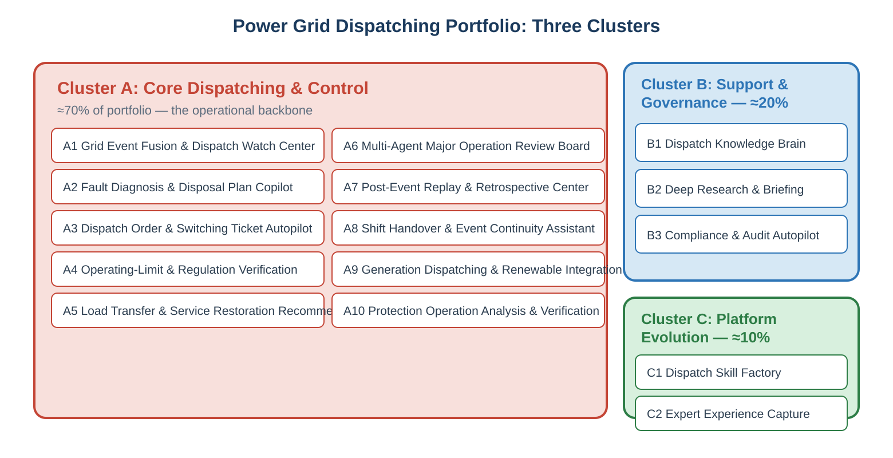

6 Cluster A: Core Dispatching & Control Products
Cluster A is the operational backbone of the EAASP v2.0 deployment. These products directly support the minute-by-minute work of grid dispatchers and control center operators. Approximately 70% of the portfolio’s development investment, delivery attention, and early success metrics should focus here.

6.1 A1: Grid Event Fusion & Dispatch Watch Center
Product form: Event-native
Meta-paradigms: II (Intelligence Flow) + I (Guarantee Engine)
The flagship product and operational entry point for the entire platform. This product fuses multiple raw alarms from SCADA, EMS, relay protection systems, PMU feeds, and weather services into structured dispatch events, presenting them through L5’s event room and four-card paradigm.

Core capabilities
- Spatial-topology-aware clustering: The event engine’s clustering strategies are configured with power grid topology awareness. The L2 Ontology Service (CIM-based) provides the graph model of electrical buses, transmission lines, and equipment connectivity. When 100+ alarms trigger across multiple substations within milliseconds, the algorithm recognizes them as a single propagation wave along a topological path, not as isolated incidents. One event, one room, one action set.
- Cross-system correlation: Merges SCADA state changes, EMS power flow alerts, relay event records, PMU oscillation data, and weather service notifications into a comprehensive event object with multi-source context. A protection trip signal (t=0), breaker failure relay activation (t=200ms), and remote backup protection operation (t=500ms) are correlated into a single protection sequence event.
- Push-first presentation: The Event Card displays severity, impacted topological zone, and estimated impact. The Evidence Pack (collapsed by default to reduce cognitive load) contains root alarm identifiers and evidence anchor IDs. The Action Card presents the agent’s recommended response as a verifiable step-tree. The Approval Card provides scope, rationale, rollback path, and one-click authorize/reject.
- Predictive pattern detection: The event engine’s correlation logic identifies developing patterns—progressive temperature rise across multiple transformers on the same feeder, trending voltage decline at the edge of a reactive power zone—and generates pre-emptive warning events before fault thresholds are breached.

Architectural boundary
EAASP operates at the supervisory layer. Primary protection and real-time hardware control remain in dedicated SCADA/EMS/protection systems. EAASP connects to these systems via MCP connectors with hardware-isolated sandboxes (Firecracker/Kata for critical infrastructure connections) and hook-bridge-injected credentials. The platform enhances dispatchers’ situational awareness and decision quality; it does not replace the deterministic hardware protection systems that provide millisecond-level grid safety.

6.2 A2: Fault Diagnosis & Disposal Plan Copilot
Product form: Event-native (activated by A1’s event creation)
Meta-paradigms: II (Intelligence Flow) + I (Guarantee Engine)
When A1 produces a grid fault event, A2 transforms the structured event into a disposal plan routed through the Check → Draft → Approve execution stages. This product embodies the collaboration loop’s core principle: agents form plans; the system verifies, authorizes, executes, and keeps records.
- Evidence-anchored fault analysis: Each analytical conclusion references specific SCADA data snapshots (voltage waveforms, current magnitudes, relay action sequences, breaker status changes) as L2 evidence anchors. The analysis is traceable, not anecdotal.
- Protection action verification: The L3 deterministic verifier runs a rule-engine check comparing actual relay operations against expected protection logic for the specific topology configuration. Discrepancies are flagged with relay IDs and expected-vs-actual comparison details.
- Impact scope mapping: Using ontology_traverse, the agent maps the fault’s impact through the grid topology: de-energized loads, disconnected generation, remaining transfer capacity on parallel paths, and affected customer count.
- Disposal plan generation: The agent produces a step-tree disposal plan with preconditions and expected results for each step. Low-risk disposals (relay operated correctly, load transferred automatically) proceed to the action card for dispatcher acknowledgment. High-risk disposals (protection failure suspected, cascading risk identified) activate the full five-stage approval chain.

6.3 A3: Dispatch Order & Switching Ticket Autopilot
Product form: Workflow-native
Meta-paradigms: I (Guarantee Engine) + II (Intelligence Flow)
The most procedure-intensive product in the portfolio. Generates switching tickets, dispatch orders, safety measures, rollback paths, and approval packages, then validates completeness before submission to the approval chain.
- Ontology-driven sequence generation: The agent queries the CIM-based ontology for current grid topology (equipment states, interlocking conditions, grounding requirements) and generates a step-by-step switching sequence transforming the grid from current state to target state.
- Five-rule deterministic verification: The deterministic verifier runs five mandatory checks against each switching step: electrical isolation verification, interlocking condition satisfaction, grounding rule compliance, sequence ordering correctness, and safety distance requirements. These are rule-engine checks compiled from OPA/Rego policies, not LLM judgments.
- Scoped hooks in the switching skill: PreToolUse command hooks block any topology-modifying tool call unless prerequisite steps are marked complete. PostToolUse prompt hooks evaluate whether each step includes all required safety annotations. The Stop hook verifies all required fields are populated before the document enters the approval card.
- Execution supervision: During switching execution, each step passes through the approval chain. After each step, the agent verifies actual equipment state (via SCADA MCP) against expected state. Discrepancies trigger an immediate halt event.
- Evidence chain: Every step’s execution produces an evidence anchor linking switching command, SCADA confirmation, verification result, and timestamp. The complete operation produces a fully traceable evidence chain for regulatory audit.
Security model: Hardware-level sandbox isolation (Firecracker/Kata) for sessions interacting with grid control systems. Hook-bridge-injected credentials ensure the agent receives only minimum-privilege credentials for the specific equipment involved. Egress control policies restrict network access to authorized SCADA endpoints only.

6.4 A4: Operating-Limit & Regulation Verification Copilot
Product form: Workflow-native
Meta-paradigms: I (Guarantee Engine) + II (Intelligence Flow)
Specializes in regulation retrieval, limit extraction, evidence-backed rule interpretation, and deterministic verification against thresholds, formulas, or simulation tools. This product addresses a critical grid need: LLM reasoning alone is insufficient for operational limits—rules must be linked to evidence anchors and validated deterministically before recommendations are used.
- Regulation-grounded responses: Every operational limit response references the specific regulation, standard, or grid code clause. Evidence anchors link to the source regulation document stored in L2.
- Deterministic limit checking: The verifier interfaces with power system analysis tools (power flow solvers, short-circuit calculators, stability analysis engines) via MCP connectors. When an operator asks whether a proposed operating point violates thermal limits, the verifier runs the calculation—it does not ask the LLM to estimate.
- Policy-as-code: Grid operating limits are compiled into OPA/Rego policies, enabling version-controlled, machine-enforceable safety constraints that evolve as grid codes are updated.

6.5 A5: Load Transfer & Service Restoration Recommender
Product form: Event-native (triggered by outage/fault events)
Meta-paradigms: I (Guarantee Engine) + II (Intelligence Flow) + III (Collaboration Orchestrator)
Recommends candidate restoration paths, load-transfer sequences, expected impacts, and rollback options. Positioned between planning and execution: the agent proposes, the verifier checks, and the human authorizes. Maps directly to the Action Card + Approval Card pattern.
- Topology-aware path search: The agent uses ontology_traverse to identify all feasible restoration paths through the grid topology, considering equipment ratings, switching constraints, and protection coordination requirements.
- Simulation-verified recommendations: Each candidate path is verified through power flow simulation via MCP. Only paths that converge without thermal or voltage violations populate the action card.
- Priority-aware load management: The ontology provides load classification (critical infrastructure, industrial, commercial, residential). Restoration sequencing prioritizes critical loads while respecting grid constraints.

6.6 A6: Multi-Agent Major Operation Review Board
Product form: Event-native or Workflow-native + Multi-Agent Review (cross-cutting)
Meta-paradigms: III (Collaboration Orchestrator) + I (Guarantee Engine)
For major mode changes, inter-regional coordination, black-start exercises, large maintenance windows, and cross-domain risk review, a single-agent answer is insufficiently transparent. This product dispatches multiple specialist agents in parallel, exposes disagreement, and presents a merged recommendation with conflict visibility.
- A2A ReviewSet dispatch: L3 policy triggers A2A escalation. The A2A router creates parallel sessions with specialist agents: stability analysis, protection coordination, economic dispatch, environmental compliance—each with access only to its authorized MCP connectors (trust-domain isolation).
- Conflict surfacing: If the economic dispatch agent recommends maximizing a low-cost thermal unit while the stability agent identifies a voltage constraint at that operating point, both positions appear in the action card with evidence anchors and confidence scores. The dispatch director arbitrates with full visibility into the disagreement.
- Confidence weighting: Each agent’s conclusion is weighted by historical quality scores from blind-box evaluations and usage analytics. Agents with proven track records on specific analysis types carry more weight.

6.7 A7: Post-Event Replay & Retrospective Center
Product form: Event-native (terminal stage)
Meta-paradigms: II (Intelligence Flow) + IV (Capability Factory)
This product leverages the Session Event Stream—EAASP v2.0’s append-only, positionally queryable event log—to provide complete post-event replay and analysis. In grid dispatching, the ability to review the full event-handling chain is as important as the initial response.
- Full session replay: The event stream captures the complete ordered sequence: initial alarms, agent reasoning, tool calls, hook decisions (including what shadow-mode hooks would have decided), context management operations, and memory writes. Reviewers can step through the entire event-handling sequence.
- Decision forensics: Why did the agent recommend Path A over Path B? The event stream records the tool call inputs, simulation results, memory queries, and hook evaluations that led to each decision, enabling precise forensic analysis.
- Skill extraction trigger: When the retrospective identifies a particularly effective handling pattern, the skill extraction mechanism can convert it into a draft workflow-skill for promotion through the governance pipeline. Individual success becomes organizational capability.

6.8 A8: Shift Handover & Event Continuity Assistant
Product form: Event-native (lifecycle management)
Meta-paradigms: III (Collaboration Orchestrator) + II (Intelligence Flow)
Grid dispatch work is long-lived and shift-based. Events may span multiple shifts, and zero-information-loss handoff is operationally critical. This product supports session continuity, handoff, and event-room persistence across sessions and shifts.
- Automated shift briefing: Before each shift change, the agent assembles a comprehensive handoff package: active events with current status, completed events pending retrospective, ongoing switching operations with current step, pending approvals, overnight anomaly summary, and carry-forward action items.
- Event room persistence: Event rooms do not close when sessions end. The incoming dispatcher inherits the complete event room with full history. New sessions are created within the same event room, with context pulled from L2 memory.
- Context recovery: The Session Event Stream enables the incoming session to recover the complete context of the outgoing session, including compacted messages that remain accessible through the event stream’s reversible compaction mechanism.

6.9 A9: Generation Dispatching & Renewable Integration
Product form: Workflow-native + Multi-Agent Review (cross-cutting)
Meta-paradigms: III (Collaboration Orchestrator) + I (Guarantee Engine) + II (Intelligence Flow)
Generation dispatching involves multi-objective optimization balancing economic efficiency, grid stability, renewable integration, environmental compliance, and contractual obligations.
- Day-ahead scheduling with multi-agent review: A2A escalation dispatches parallel specialist agents: economic optimization (with cost curves and market data via MCP), grid stability (with N-1 contingency analysis), and renewable integration (with weather forecasts and generation prediction). ReviewSet aggregation surfaces conflicts between objectives.
- Real-time generation adjustment: Event-driven re-dispatch triggered by load forecast deviations, unexpected generation trips, tie-line flow changes, frequency excursions, or renewable output variability. The 30-second decision cycle design ensures timely recommendations. Memory-enhanced decisions leverage historical patterns for similar conditions.
- Hierarchical control boundary: EAASP manages secondary and tertiary control (AGC optimization, economic dispatch, VoltVAR optimization). Primary control (droop response, fast frequency response) remains in hardware controllers at the grid edge. PreToolUse command hooks enforce hard equipment limits before any setpoint command reaches the SCADA system.

6.10 A10: Protection Operation Analysis & Verification
Product form: Event-native + Workflow-native
Meta-paradigms: I (Guarantee Engine) + II (Intelligence Flow)
Provides post-fault analysis of protection system operation and continuous verification of protection settings against grid topology changes.
- Protection operation analysis: When a protection event occurs, the agent retrieves fault records from relay event recorders (via MCP), reconstructs the fault timeline, and compares actual protection behavior against expected behavior. The deterministic verifier applies protection coordination rules to identify misoperations (overreach or underreach).
- Setting verification against topology: When grid topology changes (new line commissioned, bus configuration changed, generation pattern shifted), the event engine generates a protection-review event. The agent identifies affected protection devices and verifies setting adequacy using short-circuit calculations and coordination analysis.
- Statistical tracking and prediction: The Memory Engine accumulates protection operation statistics per relay, per manufacturer, and per protection scheme type. Trend dashboards in the observability hub enable proactive identification of protection performance degradation.

7 Cluster B: Dispatching Support & Governance Products
Cluster B products support compliance, research, knowledge management, and audit functions. They do not replace the core operational center of gravity (Cluster A) but provide the institutional intelligence and regulatory assurance that sustain it. Approximately 20% of portfolio investment.

7.1 B1: Dispatch Knowledge Brain
Product form: Knowledge Services (cross-cutting) surfaced as an interactive product
Combines the L2 Ontology Service (CIM-based grid topology, equipment, organizations, rules) with the Memory Engine (historical cases, confirmed lessons, threshold calibrations, operational experience) into a queryable organizational knowledge system. Serves regulation Q&A, case comparison, on-the-job assistance, scenario recall, and equipment history queries.
The key value is not better answers—it is a better institutional memory. Every query result is evidence-anchored. Agent-suggested knowledge requires human confirmation before promotion. The retrospective cycle continuously enriches the knowledge base with curated lessons learned from resolved events.

7.2 B2: Deep Research & Briefing Center
Product form: Workflow-native
Generates daily operational briefings, major-event preparation packages, weekly operations analyses, archive-based compilations, training courseware, and specialized studies for dispatch leadership. Evidence anchors and accumulated retrospective memory produce higher-trust operational research than ungrounded AI assistance.
The Session Event Stream enables long research sessions with crash recovery—critical for archive-based compilation that may run for hours. Each briefing iteration deposits conclusions into L2 memory, and the agent accumulates understanding of what the reader prioritizes over time.

7.3 B3: Compliance & Audit Autopilot
Product form: Event-native (continuous monitoring) + Workflow-native (report generation)
Continuously tracks whether conclusions are evidence-backed, whether MCP security tiers are respected, whether approvals were valid, and whether execution complied with organizational policy. For grid dispatch centers: safety constraint compliance, operating procedure adherence, switching operation verification, and regulatory audit package generation.
Every operational action generates telemetry flowing through L3’s audit service. The evidence chain manager enables traceback from any conclusion to its complete evidence chain—including source system, tool version, model version, rule version, and timestamps. When regulatory auditors request evidence, they receive cryptographically verifiable chains of what actually happened, not summaries of what the AI said it did.

8 Cluster C: Platform Evolution Products
Cluster C products make the platform scalable and self-improving. They are the industrialization engine that transitions EAASP from a project deployment into a self-sustaining capability system. Approximately 10% of portfolio investment, deployed after the operational backbone is established.

8.1 C1: Dispatch Skill Factory
Product form: Factory-native
Enables dispatch domain experts, protection engineers, and grid planners to build workflow-skills through the L5 process designer without writing code. Skills enter the four-stage promotion pipeline (automated testing in sandboxed simulation → human review by senior engineers → approval by skill approvers → production deployment). The simulation mode uses read-only MCP connectors pointing to grid simulation engines instead of live SCADA, allowing full testing with hooks firing identically to production.
This product is how experiential knowledge becomes executable capability. When a new grid code is published, the regulation compliance team can codify it as a workflow-skill and OPA/Rego policy set, test via shadow mode, and deploy—without waiting for engineering sprint capacity.

8.2 C2: Skill Extraction & Expert Experience Capture
Product form: Factory-native
Analyzes successful session event streams to identify reusable handling patterns and converts them into draft workflow-skills. This is strategically critical because dispatch expertise is often tacit, fragmented, and embodied in a small number of senior operators approaching retirement. The platform systematically converts that expertise into governed, reusable organizational assets.
The extraction process: PostSessionEnd hook triggers the skill-creator meta-skill → event stream analysis isolates the specific reasoning and action sequence that succeeded → the meta-skill generates a draft SKILL.md with prose instructions and YAML frontmatter hooks → senior engineering reviewers validate reusability and promote to production.

9 Deployment Roadmap
The deployment roadmap aligns application product delivery with EAASP v2.0’s seven-phase evolution strategy. Each phase delivers an independently valuable increment of grid dispatching capability without reworking prior phases.
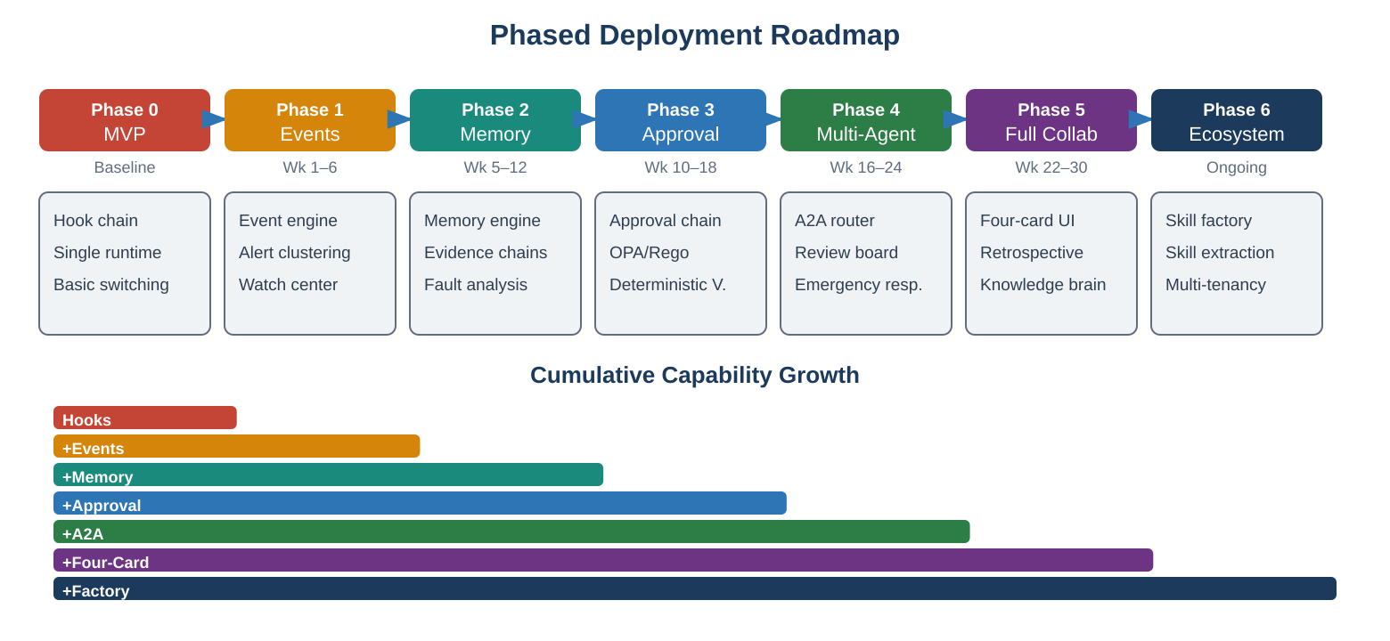
Phase | Infrastructure Delivered | Grid Products Unlocked | Validation Criteria
Phase 0  MVP  Baseline | Full L4→L3→L2→L1 chain, policy compiler, five API contracts, hook enforcement, Session Event Stream provisioning | A3 Switching Ticket (basic)  A4 Limit Verification (basic) | A complete switching workflow-skill executes under managed-hooks governance with event stream capture
Phase 1  Events  Weeks 1–6 | L4 event engine (ingest → dedup → cluster → event objects → state machine), L5 event room, L4 hooks | A1 Grid Event Fusion  A8 Shift Handover (basic) | 50+ SCADA alarms from a simulated bus fault correctly aggregate into a single event object
Phase 2  Memory  Weeks 5–12 | L2 Memory Engine (evidence anchors + file memory + hybrid index), L1→L2 memory write channel, context assembly, skill extraction | A2 Fault Diagnosis  A10 Protection Analysis  B1 Knowledge Brain (initial)  B2 Briefing Center | Fault analysis reports achieve 95%+ evidence coverage rate; protection analyses reference historical patterns
Phase 3  Approval  Weeks 10–18 | L3 approval chain, deterministic verifier, L5 approval card, OPA/Rego, egress control, sandbox isolation tiers | A3 Switching (full)  A4 Limit Verification (full)  A5 Load Transfer  B3 Compliance Autopilot | OPA/Rego policies enforce switching rules; hardware-isolated sandbox for SCADA interactions
Phase 4  Multi-Agent  Weeks 16–24 | L4 A2A router, parallel execution, ReviewSet aggregation, T0 Managed Harness | A6 Major Operation Review  A9 Generation Dispatching | Multi-agent review surfaces stability-vs-economics conflicts; emergency assessment within 60 seconds
Phase 5  Full Collab  Weeks 22–30 | L5 four-card rendering, IM bot plugins, retrospective cycle, assumption health dashboard, hook shadow mode | A7 Post-Event Replay  A8 Shift Handover (full)  B1 Knowledge Brain (full) | Complete four-card rendering with push to IM; retrospective deposits improve future responses
Phase 6  Ecosystem  Ongoing | Runtime certification, skill marketplace, multi-tenancy, API SDK, graduated policy relaxation | C1 Skill Factory  C2 Experience Capture  Cross-center knowledge sharing | Domain experts create and deploy workflow-skills without engineering support
Critical investment note: Phase 2 (Memory and Evidence) is the highest-leverage phase for grid applications—it simultaneously unlocks four products and lays the foundation for evidence-complete compliance. It warrants disproportionate engineering investment.

10 Product-Form Mapping Summary
Each product’s primary form, supporting meta-paradigms, and cross-cutting capabilities at a glance.
Product | Primary Form | Meta-Paradigms | Cross-Cutting
A1 Grid Event Fusion | Event-native | II + I | Knowledge
A2 Fault Diagnosis | Event-native | II + I | Knowledge
A3 Switching Ticket | Workflow-native | I + II | Knowledge
A4 Limit Verification | Workflow-native | I + II | Knowledge
A5 Load Transfer | Event-native | I + II + III | Multi-Agent Review, Knowledge
A6 Major Operation Review | Event / Workflow | III + I | Multi-Agent Review, Knowledge
A7 Post-Event Replay | Event-native | II + IV | Knowledge
A8 Shift Handover | Event-native | III + II | Knowledge
A9 Generation Dispatch | Workflow-native | III + I + II | Multi-Agent Review, Knowledge
A10 Protection Analysis | Event + Workflow | I + II | Knowledge
B1 Knowledge Brain | Knowledge (surface) | II | —
B2 Research & Briefing | Workflow-native | II | Knowledge
B3 Compliance Autopilot | Event + Workflow | I + II | Knowledge
C1 Skill Factory | Factory-native | IV | —
C2 Experience Capture | Factory-native | IV + II | Knowledge

