EAASP v2.0
Executive Overview

Enterprise Autonomous Agent Support Platform

Origins · Goals · Architecture · Design · Capabilities · Operations · Roadmap

CONFIDENTIAL

April 2026

Table of Contents

1. Origins and Motivation

1.1 The Enterprise AI Gap
Enterprise AI has reached an inflection point. Large language models can reason, plan, and execute complex tasks across domains. Yet the gap between model intelligence and enterprise deployment readiness remains vast. Industry surveys consistently show that while the overwhelming majority of organizations experiment with AI, fewer than ten percent have successfully deployed multi-step agentic systems into production business functions.
The barriers are not intelligence — they are governance, security, operational control, and integration. Enterprises need to enforce organizational policy across all agents uniformly, ensure every agent conclusion is traceable to evidence, let business analysts create intelligent workflows without writing code, and manage credentials, data sovereignty, and audit trails at scale. No single agent framework addresses all of these requirements.
EAASP was created to fill this gap. It is not an agent — it is the platform that hosts, governs, and orchestrates agents. It treats agent runtimes the way an operating system treats applications: providing the execution environment, enforcing security boundaries, managing shared resources, and presenting a unified interface to users, regardless of which agent engine runs underneath.

1.2 The Managed Agents Convergence
In April 2026, Anthropic released Managed Agents — a hosted service in the Claude Platform for running long-horizon autonomous agents. The accompanying engineering blog post articulated a profound architectural insight: decouple the brain from the hands from the session. Agent components (the reasoning harness, the execution sandbox, the durable session log) should be independent interfaces, not a monolithic container.
The analogy was drawn explicitly from operating system design: decades ago, operating systems virtualized hardware into abstractions — process, file — general enough for programs that did not exist yet. The abstractions outlasted the hardware. Managed Agents virtualizes agent components (session, harness, sandbox) into interfaces general enough for future harnesses and models.
EAASP v2.0 absorbs the most valuable ideas from Managed Agents — the append-only session event stream, structural credential isolation, and the meta-harness philosophy — while preserving what Managed Agents does not provide: enterprise governance, multi-runtime heterogeneity, organizational access control, evidence chains, and the complete collaboration lifecycle from event detection through memory deposit.
The core relationship: Managed Agents is an infrastructure-level abstraction — it answers how to run one agent reliably. EAASP is a platform-level architecture — it answers how to deploy, govern, and orchestrate many agents across an enterprise. They are complementary strata. You stack them, you do not choose between them.

1.3 The Enterprise Private Deployment Imperative
For industries under GDPR, HIPAA, NIS2, or national security regulation, data must stay within the enterprise’s network boundary. The enterprise research on Managed Agent privatization provides a comprehensive analysis of the architectural patterns required: zero-trust security with AI agent gateways, hardware-isolation sandboxes, egress control and data loss prevention, and full private deployment where no data exits the enterprise perimeter.
EAASP addresses this directly. The platform is model-agnostic by configuration — all LLM access is redirected through environment variables. The same platform stack, the same runtime tiers, the same governance hooks run identically whether backed by Claude, Llama, Mistral, or any capable model. Fully private deployment is a configuration choice, not an architectural variant.

2. Strategic Goals
EAASP addresses eight core challenges that prevent enterprises from scaling AI agents:
- Runtime-agnostic execution. Any agent engine implementing the standard runtime contract can join the execution pool. The platform selects the best runtime per task. Enterprises are never locked to a single vendor or framework.
- Unified agent governance. A single set of managed hooks applies to every agent identically. Administrators deploy a policy once; the platform compiles it into deterministic enforcement. Deny always wins — no agent can override organizational policy.
- Event-driven proactive service. Agents do not wait for user commands. The event engine aggregates raw alerts, logs, and change events into structured business-event objects. One hundred alerts may constitute a single event. Agents shift from passive order-takers to proactive scene-watchers.
- Persistent memory and evidence chains. Every agent conclusion must reference evidence anchors — immutable snapshots of the original data. Memory is a persistent asset managed across sessions, not ephemeral state. Auditing moves from recording what happened to proving why a judgment was made.
- Multi-agent parallel review. Complex scenarios split across multiple specialist agents for parallel cross-checking. The default is single-agent; multi-agent escalation occurs only when specialization, parallelism, trust-domain isolation, or visibility of dissent is required.
- Governed execution chain. A five-stage approval control chain — Plan, Check, Draft, Approve, Execute — provides graduated control for high-risk operations. A deterministic verifier handles critical judgments using rule engines rather than probabilistic reasoning.
- Intelligent workflows as managed assets. Business processes are encoded as workflow-skills with scoped hooks, preserving agent intelligence while providing deterministic safeguards. Intelligence and guarantees coexist in a single asset.
- Organizational capability factory. Business analysts create, test, deploy, and continuously improve intelligent workflows through a visual process designer. Successful interactions are extracted into reusable skills. The platform is a self-improving production system.

3. Architecture Overview

3.1 Five-Layer Model
The architecture comprises five layers numbered bottom-up, each with a clear mandate, plus three vertical pipelines that traverse all layers. Five layers are logical architecture, not five mandatory physical deployments — logical separation ensures responsibility boundaries and change isolation.
Layer | Responsibility | Key Components | Enforcement
L5 Cowork | Human-agent collaboration: event rooms, four-card rendering, multi-endpoint adaptation | Event room engine, card renderer, push channels, IM bots, admin console, process designer, observability hub | Four-card forced pinning
L4 Orchestration | Event-driven orchestration: event intake/aggregation, 1:N session orchestration, A2A routing | Event engine, session orchestrator, A2A router, Session Event Stream, API gateway, cost governance | Event state-machine constraints
L3 Governance | Policy enforcement, approval control chain, deterministic verification, audit, asset lifecycle | Policy engine (OPA/Rego), approval gates, audit service, hook deployment, MCP registry, evidence chain manager, egress control | Managed hooks, deny always wins
L2 Assets | Skill management, MCP orchestration, persistent memory/evidence, business ontology integration | Skill repository (MCP server), promotion engine, Memory Engine, Ontology Service, usage analytics | Skill-frontmatter scoped hooks
L1 Execution | LLM reasoning, tool invocation, hook evaluation across heterogeneous runtimes | Runtime selector, adapter registry, hook bridge, telemetry collector, T0/T1/T2/T3 runtime tiers | Native or bridged hooks

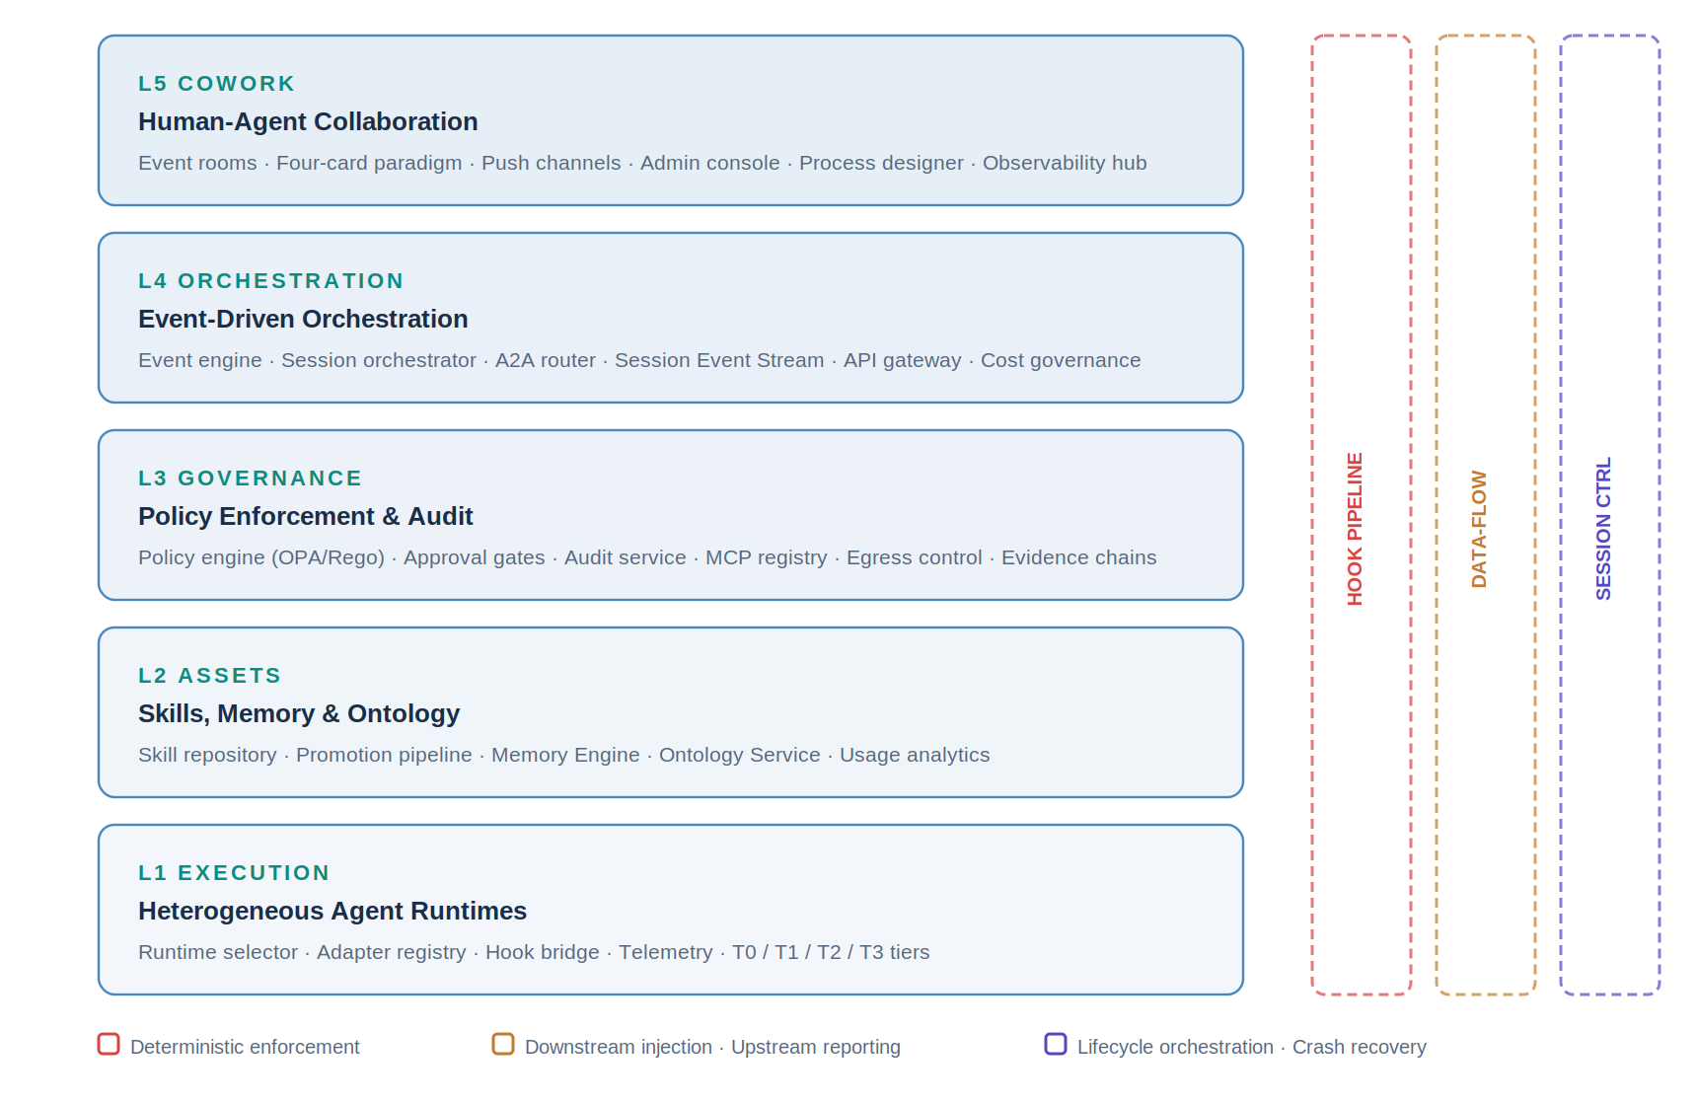
Figure 1 — EAASP five-layer architecture with three vertical pipelines

3.2 Three Vertical Pipelines
Pipeline A — Hook Pipeline (deterministic enforcement). Hooks provide deterministic, guaranteed enforcement at every critical lifecycle event, traversing all five layers. Administrators declare policies in L5’s admin console; L3’s policy compiler compiles them into hook configurations (optionally using OPA/Rego for microsecond evaluation); L1’s hook bridge ensures consistent enforcement across all agents. The platform defines 14 lifecycle events: 9 in L1, 2 in L3, and 3 in L4. Four handler types form an escalation ladder: command (milliseconds), http (~300ms), prompt (~2s), agent (~15s). Deny always wins.
Pipeline B — Data-Flow Pipeline (downstream injection + upstream reporting). Downstream: events enter from L5 → L4’s event engine aggregates them into event objects and assembles structured SessionPayload with typed priority blocks (policy context P1, event context P2, memory refs P3, skill instructions P4, user preferences P5) → L3 performs authentication, policy compilation, and hook binding → L1 begins execution. Upstream: L1 produces ResponseChunks (streaming), TelemetryEvents (async audit), MemoryWrites (evidence anchors), and EventStreamEntries (append-only session log).
Pipeline C — Session-Control Pipeline (lifecycle orchestration). Three-tier lifecycle objects: Event Room (L5, long-lived), Event (L4, complete state machine), Session (L3→L1, single agent task execution). One Event can contain multiple Sessions. Sessions pass context via L2 Memory, not conversation history. The Session Event Stream provides crash recovery via event replay and reversible compaction.

3.3 The Collaboration Loop
The three pipelines support a complete collaboration loop — the core operating model:
Event → Context → Plan → Check → Draft → Approve → Execute → Observe → Retrospect → Memory → (feeds back to next event)
Stage | Layer | Output
Event | L4 event engine | Structured business-event object (clustered from raw alerts/logs)
Context | L4 orchestrator + L2 Memory/Ontology | Complete SessionPayload with typed priority blocks
Plan | L1 agent | Operation plan as a step tree with preconditions
Check | L3 deterministic verifier | Verification result (pass/fail/warning) plus evidence anchor
Draft | L1 agent | Executable draft — does not execute directly
Approve | L3 approval gate + L5 approval card | Human authorization (approve/reject/request info)
Execute | L1 agent | Actual execution result via MCP calls
Observe | L4 + L3 audit | Execution telemetry, evidence chain, event state update
Retrospect | L4 orchestrator | Post-incident review report
Memory | L2 Memory Engine | Preferences, experience, knowledge deposited into persistent memory

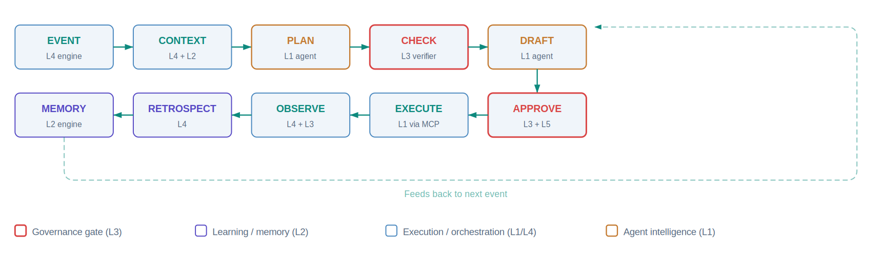
Figure 2 — The ten-stage collaboration loop
Core principle: agents form plans; the system verifies, authorizes, executes, and keeps records.

4. Design Philosophy
Every architectural decision in EAASP is tested against these principles. They emerged from four iterations of design evolution and were sharpened during the v2.0 analysis against Managed Agents’ meta-harness philosophy.
1. The platform provides governance, knowledge, and policy; the runtime provides execution intelligence. This is the master boundary principle. The platform defines what must happen (hooks, policies, approval chains, credential scoping). The runtime decides how to accomplish the work (planning, tool selection, error recovery). Neither crosses into the other’s domain.
2. Deny always wins. If any hook at any scope level denies an action, the action is blocked regardless of what other hooks or the agent’s reasoning concludes. This is deterministic, not probabilistic.
3. Hooks provide guarantees; agents provide judgment. Things that must happen every time (policy, audit, quality checks) are hooks. Things requiring adaptation and reasoning (plan decomposition, creative problem-solving) are agent intelligence. Do not substitute one for the other.
4. Governance is permanent; governance configurations are not. The hook protocol and approval chain mechanism are stable. Specific thresholds, policies, and rules are living configurations that must evolve as models improve. Assumption debt — stale configurations calibrated to older models — is actively managed through observability, shadow testing, and graduated relaxation.
5. Drafts first — never overreach. Agents produce drafts, never directly executing high-risk operations. All write operations pass through the five-stage approval control chain.
6. Model-agnostic by configuration. No architectural component depends on a specific inference provider. Model backend selection is an environment variable. The same platform runs on Claude, Llama, Mistral, or any capable model.
7. Extend, never rebuild. Each evolution phase adds components incrementally without modifying existing capabilities. The v2.0 upgrade added six enhancements with zero v1.8 components removed.
8. Evidence chains are complete. Every agent conclusion must reference evidence anchors (original data snapshot IDs), providing full-chain traceability from conclusion to source.
9. Memory is an asset. Memory is a peer of Skills — a persistent asset managed by L2, not session-ephemeral state. It accumulates organizational knowledge over time.

5. Platform Capabilities

5.1 Heterogeneous Runtime Pool
L1 hosts any agent engine that implements the standard runtime contract: 12 MUST methods (the compliance core, unchanged from v1.7) plus 4 optional operational extensions (Health, DisconnectMcp, PauseSession, ResumeSession). Proto and trait implement all 16; certifiers test against the 12 MUST core.
Runtimes are organized in four tiers by adapter thickness and governance integration depth:
Tier | Adapter | Examples | Hook Integration
T0 Managed Harness | External (SSE interception) | Anthropic Managed Agents | Adapter intercepts SSE stream, evaluates hooks locally within enterprise trust boundary
T1 Harness Agents | Thin (native compatibility) | Claude Code, grid-engine, hermes-agent, Claude Agent SDK | Native hooks — zero overhead, in-process execution
T2 Aligned Agents | Medium (partial compat.) | Aider, Goose, Roo Code CLI, Cline CLI, OpenCode | Hook bridge sidecar wraps every tool call externally
T3 Framework Agents | Thick (full translation) | LangGraph, CrewAI, Pydantic AI | Hook bridge + skill-to-framework translation

Five selection strategies route each session to the best available runtime: task-matched (analyze request, match to runtime capability manifests), random blind-box (two runtimes simultaneously, user votes without knowing which produced which), user preference, A/B testing, and cost-optimized.

5.2 L5 Cowork Layer — Four-Card Interaction
L5 replaces traditional chat-based AI interaction with structured decision support. When a business event occurs, users see four pinned cards covering the complete decision cycle:
- Event Card: One-line conclusion, severity, impact scope/level/trend, quick-action buttons. Data source: L4 event engine state machine.
- Evidence Pack: Alert clustering summary, measurement windows, topology snapshots, historical similar events; each item has an anchor ID. Data source: L2 Memory Engine evidence anchors.
- Action Card: Step tree with preconditions and expected results per step; quick actions to spawn sub-rooms or mention specialist agents. Data source: L4 orchestrator Plan object + L3 verifier Check result.
- Approval Card: Action scope, rationale summary, rollback path, verification result; approve/reject/request-info buttons. Data source: L3 approval gate Approval object.
The design philosophy is push, not pull. Traditional enterprise AI requires users to open an application and type a request. L5 inverts this: when a business event occurs, L5 pushes a notification with a pre-assembled event card. The user’s first interaction is not asking AI a question but deciding whether an event needs their attention.

5.3 Event Engine and Proactive Service
The event engine transforms agents from passive order-takers into event-driven proactive partners. It accepts events from six source types: webhooks (monitoring platforms, CRM, HRIS), message queues (Kafka/NATS), CDC streams (database change-data-capture), scheduled tasks (cron), user messages (via L5), and A2A calls (agent-to-agent dispatch).
Events flow through a processing pipeline: ingest → dedup (same-source events merge within a configurable window) → cluster (spatial, temporal, and causal correlation) → correlate (cross-source: monitoring alert + ticket + user complaint = same event) → generate event object. One hundred related alerts aggregate into a single actionable event, not one hundred separate event rooms.

5.4 Approval Control Chain
L3 provides a five-stage governed execution chain that refines the basic deny/allow binary into graduated control:
Plan (agent forms read-only operation plan) → Check (deterministic verification; same input always produces same output) → Draft (agent produces executable draft but does not execute) → Approve (human authorization via 30-second approval card) → Execute (actual execution via MCP calls to external systems).
Risk tiers determine which stages are required. Low-risk operations (read-only queries, summaries) skip all stages. Medium-risk operations (report generation, suggested modifications) proceed to Draft with notification. High-risk operations (config changes, work-order dispatch, equipment operations) traverse the full five-stage chain.

5.5 Memory Engine
The Memory Engine provides three-layer persistent storage enabling experience accumulation, evidence tracing, and cross-session reference:
- Evidence anchor store: Append-only, immutable records. Each anchor contains a globally unique ID, event ID, session ID, type, data reference, snapshot hash, and versioning metadata. Every agent conclusion must reference at least one anchor. Anchors are never modified after creation.
- File-based memory: Structured files depositing preferences, thresholds, and retrospective experience. Human-reviewable and editable. Agent-written memory is initially marked agent_suggested; human confirmation promotes it to confirmed.
- Hybrid retrieval index: Combines keyword retrieval (exact match on device IDs, event types, proper nouns), semantic retrieval (vector similarity for fuzzy matching), and time-decay weighting (recent memory ranked higher). The index is rebuilt from the file store; it is never the source of truth.
Core design constraint: the file is the governance object; the index is the retrieval object. Both derive from the same source and must never diverge.

5.6 Session Event Stream (v2.0)
Every session writes to an append-only event stream capturing the complete, ordered sequence of events. Six categories of event types are recorded: session lifecycle (start, pause, resume, end, crash), message flow (user message, agent response chunks), tool execution (call start, result, failure), hook decisions (fired, decision, shadow decision), context management (compaction start/complete, context recovery), and memory operations (anchor written, file written, search executed).
The stream enables crash recovery (a new runtime instance replays from the last completed event), reversible compaction (compacted messages remain accessible via positional read), and complete audit replay. The event stream is the substrate; audit records in L3, memory in L2, and checkpoints in Redis are all derived views.

5.7 Tiered Credential Isolation (v2.0)
MCP credentials are structurally isolated using a mechanism matched to each runtime tier:
- T0 (Managed Harness): Full credential proxy. The sandbox never sees credentials. Auth is injected by the adapter’s credential proxy per-call.
- T1 (Harness Agents): Pre-bundled ephemeral credentials. At session creation, the platform provisions short-lived, narrowly-scoped tokens (per-session, minimum necessary permissions, auto-expiring on session end).
- T2/T3 (Bridged Agents): Hook-bridge-injected credentials. The bridge strips credential placeholders from outbound MCP calls, injects real credentials from the vault, forwards the call, and strips credentials from responses. The runtime never sees real credentials.
The platform guarantees that credentials are always scoped, short-lived, and least-privilege. The enforcement mechanism adapts to the runtime’s operational model; the security outcome is equivalent across all tiers.

5.8 Assumption Lifecycle Management (v2.0)
Hooks, skills, and policies encode assumptions about model capabilities that go stale as models improve. Left unmanaged, this creates assumption debt — accumulated governance configurations that add latency and friction without improving outcomes. Symptoms include latency creep (dead-weight hooks firing on every tool call), over-governance (approval chains blocking operations the model handles correctly), skill bloat (over-decomposed instructions consuming context budget), and false-positive governance (quality hooks rejecting correct output).
The platform provides three capabilities to manage assumption debt:
- Assumption observability: Track each hook’s activity (fire frequency, block rate, override rate, trend) and impact (correlation between intervention and session outcome quality).
- Proactive staleness detection: The observability hub surfaces assumption health reports identifying low-impact hooks, over-decomposed skills, over-restrictive policies (approval rate exceeding 95%), and under-restrictive configurations.
- Controlled assumption testing: Shadow mode for hooks (evaluate but do not enforce, recording what would have happened). A/B testing for skills. Graduated policy relaxation (shift from approval-required to auto-approve-with-audit).
The design principle: governance is permanent; governance configurations are not. Hooks stay; thresholds evolve. Approval chains stay; auto-approve boundaries adjust. Skills stay; instructions simplify. Governance hardens by becoming more precisely targeted, not by accumulating layers.

6. Managed Agents Integration
EAASP v2.0 absorbs six key ideas from Anthropic’s Managed Agents, each integrated into the existing five-layer architecture:
Managed Agents Concept | EAASP Implementation | Layer
Append-only session log | Session Event Stream — complements Redis checkpoints, L3 audit, and L2 Memory. Enables crash recovery, reversible compaction, complete event replay. | L4
Brain-hands decoupling | T0 Managed Harness runtime tier. Option, not mandate. T1/T2/T3 continue single-container for lower latency. | L1
Structural credential isolation | Tiered credential isolation matched to runtime tiers: T0 proxy, T1 ephemeral, T2/T3 bridge-injected. | L3
Meta-harness philosophy | Assumption lifecycle management — observability, staleness detection, shadow testing, graduated relaxation. | L3/L5
Sandbox as cattle | L1 containers already ephemeral (per-session). v2.0 adds sandbox isolation tiers (standard/kernel/hardware) as governed policy. | L1
Context as external object | Explicit context assembly boundary: platform sources and prioritizes; runtime formats and manages window. Structured SessionPayload with typed priority blocks. | L4

What EAASP adds beyond Managed Agents: enterprise governance (unified hooks, deny-always-wins, approval chains), multi-runtime heterogeneity (T0/T1/T2/T3 execution pool with five selection strategies), organizational access control (RBAC-scoped skills and memory), evidence chains (every conclusion traceable to source data), the collaboration lifecycle (event rooms, four-card paradigm, retrospective and memory deposit), and the Agent Factory (skill creation, extraction, and continuous quality improvement).

7. The Agent Factory
EAASP is not just a technical platform — it is an organizational capability factory for intelligent workflows. The Agent Factory is not a new component; it is a named operational pattern describing how existing layers compose into a self-service production system.
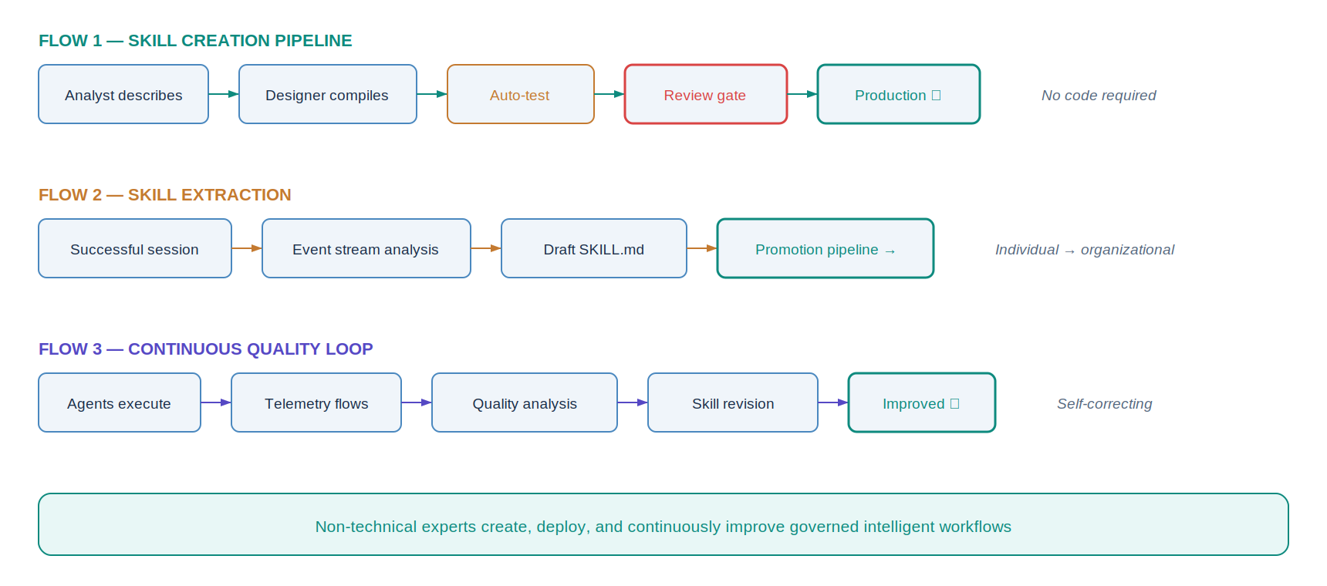
Figure 3 — The Agent Factory: three operational flows

7.1 Flow 1: Skill Creation Pipeline
Business analyst opens the process designer (L5) → describes the workflow using structured fields and natural language → the designer compiles to SKILL.md with frontmatter hooks → the draft is submitted to L2’s skill repository → the promotion engine runs automated testing (sandbox execution against sample inputs) → a reviewer examines content, test results, and hook declarations → an approver promotes to production → the skill is available to all authorized users → agents execute it under L3 governance. No code is written by the business analyst.

7.2 Flow 2: Skill Extraction
A user and agent complete a complex task successfully → PostSessionEnd hook triggers → the event stream captures the full interaction → the skill-creator meta-skill analyzes the event stream, identifies the reusable workflow pattern, and generates a draft SKILL.md with appropriate hooks → the draft enters the promotion pipeline from the testing stage → after review and promotion, the organization can repeat this workflow at scale. Individual expertise becomes organizational capability.

7.3 Flow 3: Continuous Quality Loop
L1 agents execute workflow-skills → telemetry flows through L3’s audit service → L2’s usage analytics engine aggregates per-skill quality metrics (success rates, failure patterns, execution time, user satisfaction from blind-box votes) → L5’s observability hub surfaces skills needing attention (high failure rate, declining quality, unused skills for deprecation) → the skill author opens the process designer to revise → the revised skill enters the promotion pipeline → the improved version replaces the old one → quality metrics improve → the loop continues. The factory is self-correcting.

8. Enterprise Security Architecture

8.1 Hook-Based Policy Enforcement
The hook system is the single most important architectural mechanism. Fourteen lifecycle hook events span three layers. Four handler types form an escalation ladder: command hooks (shell scripts, milliseconds, deterministic rules), http hooks (POST to endpoint, ~100–500ms, centralized policy), prompt hooks (lightweight model evaluation, ~1–3s, semantic quality), and agent hooks (subagent with tool access, ~5–30s, complex validation). L3’s policy compiler can target OPA/Rego for command hooks, achieving microsecond deterministic evaluation with declarative, version-controlled, industry-standard policy rules.
Hooks deploy at four scope levels: managed hooks (enterprise tier, cannot be overridden), skill-scoped hooks (active only during skill execution), project hooks (team-level conventions), and user hooks (personal preferences). Deny from any level blocks the action regardless of all other levels.

8.2 Sandbox Isolation Tiers
L1’s execution zone provides configurable isolation levels per organizational unit:
- Standard (Docker/containerd): Sufficient for trusted internal agents running vetted skills. The current default.
- Kernel (gVisor): Syscall interception in user-space. Prevents kernel escape without full virtualization overhead. Appropriate for agents executing semi-trusted generated code.
- Hardware (Firecracker/Kata Containers): Full VM boundary with microsecond-class startup. For multi-tenant environments or fully untrusted code execution.
All tiers enforce ephemeral execution — containers are created per-session and destroyed on completion. No persistent state survives in the sandbox.

8.3 Egress Control and Data Loss Prevention
Egress policies are a governed policy type in L3, defined in the admin console alongside hook policies. They specify allowed domains (network-level allowlists), DLP data patterns (sensitive content detection), and external/internal connector classification. These compile to two enforcement mechanisms:
- Network-level: Domain allowlists deployed as Kubernetes NetworkPolicy resources. Fast, coarse-grained. Prevents connection to unauthorized destinations.
- Hook-level: PreToolUse hooks inspecting outbound tool call content for PII, classified markers, and credential fragments. Fine-grained content inspection on authorized channels.
The combination blocks unauthorized destinations and unauthorized data on authorized destinations — preventing the lateral data exfiltration risk unique to MCP-orchestrated agent workflows.

9. Deployment and Operations

9.1 Deployment Topology
The platform deploys across six infrastructure zones on Kubernetes, each independently scalable. The architecture supports fully private deployment with no external dependencies.
Zone | Key Services | Scaling Model
Edge / CDN | Static portal assets, API rate limiting, DDoS protection | CDN auto-scale
L5 Cowork Cluster | Event room service, card renderer, push gateway, IM bots (WeChat Work, DingTalk, Feishu, Slack, Teams), admin console, observability hub | 2+ replicas per service
L4 Orchestration Cluster | API gateway (3+ pods), session orchestrator (3+ pods), event engine, A2A router, notification service, cost governance | Horizontal auto-scale on request rate / active sessions
L3 Governance Cluster | Policy engine, compiler (OPA/Rego), approval gates, audit service (3+ pods, highest-write), hook deployment, MCP registry | Stateless, 2–3+ replicas
L2 Assets Cluster | Skill repository MCP server, promotion engine, Memory Engine, Ontology Service, usage analytics | 2+ replicas per service
L1 Execution Zone | Ephemeral agent pods (one per session), hook bridge sidecars (for T2/T3), OPA sidecars (where configured) | Auto-scale on active session count

9.2 Data Tier
Six managed data services provide persistent state: PostgreSQL (user profiles, policy config, skill metadata), TimescaleDB or ClickHouse (audit event store, execution logs), Redis cluster (session state checkpoints, AOF persistence), Session Event Stream (Kafka/NATS JetStream or append-only S3), object storage (skill content, output files, backups), and secrets vault (HashiCorp Vault / AWS Secrets Manager for all credentials, auto-rotated, never in config files).

9.3 Network Security
Three network zones with controlled ingress/egress. The public zone contains CDN and API gateway external endpoints. The internal zone hosts L4, L3, and L2 services communicating via service mesh with mTLS. The runtime zone hosts L1 containers with restricted egress: L1 can reach MCP server endpoints, L2 skill repository, L3 audit service, and Session Event Stream only. L1 containers cannot reach L4 directly. This prevents a compromised agent from accessing persistent state, user databases, or admin interfaces.

9.4 High Availability
All L4, L3, and L2 services run with 2+ replicas across availability zones. Database failover is automated. RPO: zero for active sessions (real-time replication), 15 minutes for execution logs. RTO: under 5 minutes for service failover, under 30 seconds for L1 agent replacement. The Session Event Stream provides structural crash recovery: a failed agent is replaced by a new instance that replays from the event stream.

10. Development Roadmap
The platform evolves through seven phases. Each delivers independent value with no rework of prior phases. v2.0 capabilities integrate into existing phases.
Phase | Scope | v2.0 Additions
Phase 0: MVP | Full L4→L3→L2→L1 chain, contracts, handshake | Session Event Stream provisioning
Phase 1: Event-driven (Wk 1–6) | Event engine, event rooms, L4 hooks | —
Phase 2: Memory (Wk 5–12) | Memory Engine, evidence anchors, context assembly | Skill extraction, reversible compaction
Phase 3: Approval (Wk 10–18) | Approval chain, deterministic verifier | OPA/Rego backend, egress control, sandbox tiers
Phase 4: Multi-agent (Wk 16–24) | A2A router, parallel execution | T0 Managed Harness as A2A participant
Phase 5: Collaboration (Wk 22–30) | Four-card rendering, IM bots, retrospective | Assumption health dashboard, hook shadow mode
Phase 6: Ecosystem (Ongoing) | Runtime certification, skill marketplace | Assumption lifecycle management, credential tiers

11. Conclusion
EAASP v2.0 represents the maturation of enterprise AI agent infrastructure from experimental tooling to governed production capability. The platform’s lasting value lies in the layers that no single agent framework provides: human collaboration (L5), event-driven orchestration (L4), unified governance (L3), and enterprise knowledge assets (L2). These layers are independent of how L1 executes. Whether L1 is a single-container runtime, a decoupled brain-hands pair, or a Managed Agents session, the platform wraps it identically with hooks, skills, memory, approval chains, and event rooms.
The integration of Managed Agents’ architectural insights — the session event stream, tiered credential isolation, and assumption lifecycle management — strengthens the platform without disturbing its structural integrity. Six enhancements were added; zero components were removed. This is the extend, never rebuild principle in practice.
The Agent Factory operational model — skill creation pipeline, skill extraction, continuous quality loop — transforms EAASP from a technical platform into an organizational capability. Business analysts create intelligent workflows. Successful interactions become reusable skills. Quality improves with every execution. The platform accumulates institutional knowledge over time.
The execution substrate evolves; the enterprise control plane persists.

For enterprises navigating the transition from experimental AI to production-scale agentic systems, EAASP provides the architecture that makes this transition safe, governed, auditable, and continuously improving.

End of Document

