Enterprise Autonomous Agent
Support Platform
Design Specification
Version 1.8 — April 2026
Architecture Layers: L5 Cowork · L4 Orchestration · L3 Governance · L2 Assets · L1 Execution
Vertical Pipelines: Hook Enforcement · Data Flow · Session Control
Core Mechanisms: Event Engine · Memory Engine · A2A Protocol · Approval Chain · Four-Card Paradigm
Agent Ecosystem: Harness Agents · Aligned Agents · Framework Agents
CONFIDENTIAL

1. Executive Summary

This document is the authoritative design specification for the Enterprise Autonomous Agent Support Platform (EAASP). It defines a five-layer architecture with three vertical pipelines that enables enterprises to deploy, govern, and scale heterogeneous AI agent runtimes as a unified platform service, transforming AI into a collaboration partner that boosts employee productivity.

The five layers are numbered bottom-up, each with distinct responsibilities: L5 Cowork Layer faces human users, providing event rooms and four-card interaction; L4 Orchestration Layer drives event aggregation, session orchestration, and multi-agent coordination; L3 Governance Layer constrains and controls agent behavior through policy enforcement and approval chains; L2 Asset Layer manages skills, memory, ontology, and MCP connections; L1 Execution Layer hosts the heterogeneous agent runtimes that perform work. Three vertical pipelines traverse all layers: the Hook pipeline (deterministic enforcement), the Data-flow pipeline (downward injection and upward reporting), and the Session-control pipeline (lifecycle orchestration).

The platform addresses eight core challenges:

Runtime-agnostic execution. L1 contains an internal abstraction mechanism (runtime selector, adapter registry, hook bridge, telemetry collector). Any agent implementing the 12-method runtime interface contract can join the runtime pool — from harness agents (EAASP Runtime, Claude Code), to aligned CLI agents (Aider, Goose), to framework agents (LangGraph, CrewAI). Agents are selected per-session via five configurable strategies.

Unified agent governance. L3 compiles enterprise policies into managed hooks and deploys them via managed-settings.json. The L1 hook bridge ensures consistent enforcement across all agents, including those that do not natively support hooks. Four handler types form an escalation ladder. "Deny always wins."

Event-driven proactive service. L4's event engine aggregates raw alerts, logs, and change events into structured business-event objects. One hundred alerts may constitute a single "distribution-line overload event." Agents move from passive order-takers to proactive scene-watchers.

Persistent memory and evidence chains. L2's Memory Engine provides three-layer persistent storage: an evidence-anchor store (every agent conclusion must reference a data-snapshot ID), file-based memory (human-reviewable structured files), and a hybrid retrieval index (keyword + semantic + time-decay). Auditing moves from "recording what happened" to "proving why this judgment was made."

Multi-agent parallel review. L4's A2A router supports splitting complex scenarios across multiple specialist agents for parallel cross-checking. The default mode remains single-agent; A2A escalation occurs only when specialization, parallelism, trust-domain isolation, or human visibility of dissent is required.

Governed execution chain. L3's approval control chain provides five-stage governed execution: Plan → Check → Draft → Approve → Execute. A deterministic verifier handles high-stakes judgments using rule engines and simulation tools rather than LLM probabilistic reasoning.

Intelligent workflows. Business processes are encoded in L2 as workflow-skills with scoped hooks in YAML frontmatter, preserving agent intelligence while providing deterministic safeguards. Intelligence and guarantees coexist in a single asset.

Skill and memory asset management. L2 is a full operational layer with runtime services for skill management (repository, promotion, access control, dependency resolution, versioning, analytics) and memory management (evidence anchors, file-based memory, hybrid retrieval, cross-agent sharing).

Core assertions: The platform is runtime-agnostic. Governance is unified. Intelligence flows through Skills. Memory is an asset. Hooks provide deterministic guarantees. Events drive proactive service. Evidence chains are fully traceable. Drafts first — never overreach. Deny always wins. L5 serves humans. L4 orchestrates collaboration. L3 governs agents. L2 manages knowledge and memory. L1 executes work.

2. Architecture Overview
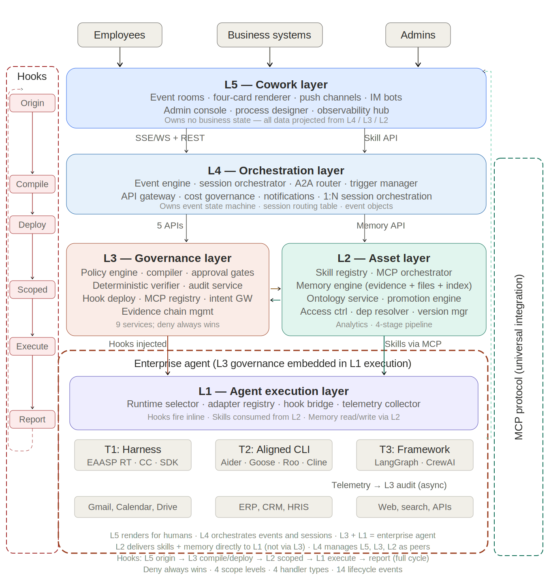
Figure 2-1: EAASP v1.8 Overall Architecture

The architecture comprises five layers numbered bottom-up, each with a clear mandate, plus three vertical pipelines that traverse all layers. This chapter provides the complete structural overview before subsequent chapters expand each component.

2.1 Five-layer model

Layer | Responsibility | Key Components | State Ownership | Enforcement
L5 Cowork | Human-agent collaboration: event rooms, four-card rendering, multi-endpoint adaptation | Event room engine, card renderer, push channels, IM bots, admin console, process designer, observability hub | Connection state only; no business truth | Four-card forced pinning
L4 Orchestration | Event-driven orchestration: event intake/aggregation, 1:N session orchestration, A2A routing | Event engine, session orchestrator, A2A router, trigger manager, API gateway, cost governance | Event state machine, session routing table | Event state-machine constraints
L3 Governance | Policy enforcement, approval control chain, deterministic verification, audit, asset lifecycle | Policy engine, compiler, approval gates, verifier, audit service, hook deployment, MCP registry, intent gateway, evidence chain manager | Policy config, RBAC, hooks, managed-settings | Managed hooks, deny always wins
L2 Assets | Skill management, MCP orchestration, persistent memory/evidence, business ontology integration | Skill Registry, MCP Orchestrator, Memory Engine, Ontology Service | Versioned: skills, metadata, memory files, evidence anchors | Skill-frontmatter scoped hooks
L1 Execution | LLM reasoning → tool invocation → hook evaluation loop across heterogeneous runtimes | Runtime selector, adapter registry, hook bridge, telemetry collector + T1/T2/T3 runtime tiers | Ephemeral: conversation, kernel state, filesystem | Native or bridged hooks

Layer interactions follow well-defined boundaries. L5 communicates with L4 via SSE/WebSocket (downstream push) and REST (upstream actions). L4 communicates with L3 via five REST API contracts (policy deployment, intent gateway, skill lifecycle, telemetry ingest, session control). L4 accesses L2's Memory Engine directly via the Memory API for context assembly. L3 communicates with L1 through hooks embedded at session creation, not per-message API calls. L2 is accessed through MCP server interfaces by all layers.

Important: five layers are logical architecture, not five mandatory physical deployments. In early phases, L5 and L4 may co-deploy, and L2 subsystems may share processes. Logical separation ensures responsibility boundaries and change isolation.

2.2 Three vertical pipelines

Pipeline A: Hook pipeline (deterministic enforcement). Hooks provide deterministic, guaranteed enforcement at every critical lifecycle event, traversing all five layers. Administrators declare policies in L5's admin console; L3's policy compiler compiles them into hook configurations and deploys via managed-settings.json; L1's hook bridge ensures consistent enforcement across all agents; results report back to L3's audit service. The platform defines 14 lifecycle events: 9 in L1, 2 in L3, and 3 in L4. Four handler types form an escalation ladder: command (ms), http (~300ms), prompt (~2s), agent (~15s). Deny always wins.

Pipeline B: Data-flow pipeline (downstream injection + upstream reporting). Downstream: user messages or external events enter from L5 → L4's event engine aggregates them into event objects, the orchestrator pulls relevant memory from L2 for context assembly → L3 performs the three-way handshake (authentication, policy compilation, hook binding) → L2 provides skill content and memory context → L1's AgentLoop begins execution. Upstream: L1 produces three data types — ResponseChunks (streaming), TelemetryEvents (async to L3 audit), MemoryWrites (evidence anchors and memory files to L2) → L3 persists telemetry and validates evidence chains → L4 updates event state machine and builds four-card data → L5 renders and pushes to user endpoints.

Pipeline C: Session-control pipeline (lifecycle orchestration). Three-tier lifecycle objects: Event Room (L5, long-lived, does not close when sessions end), Event (L4, complete state machine: received → triaging → active → pending_approval → executing → monitoring → closed → retrospective), Session (L3→L1, single agent task execution bound to skill + runtime). One Event can contain multiple Sessions. Sessions pass context via L2 Memory, not conversation history.

2.3 Collaboration loop
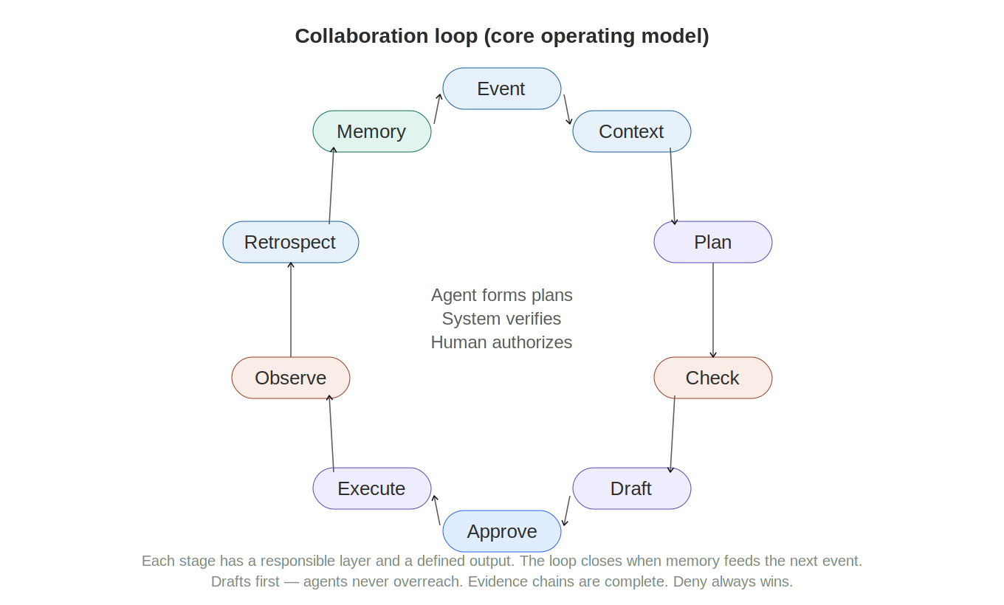
Figure 2-2: Collaboration Loop

The three pipelines support a complete collaboration loop — the core operating model:

Event → Context → Plan → Check → Draft → Approve → Execute → Observe → Retrospect → Memory → (feeds back to next event)

Stage | Layer | Output
Event | L4 event engine | Structured business-event object (clustered from raw alerts/logs)
Context | L4 orchestrator + L2 Memory/Ontology | Complete SessionPayload with event context, relevant memory, skill instructions
Plan | L1 agent | Operation plan as a step tree with preconditions and expected results
Check | L3 deterministic verifier | Verification result (pass/fail/warning) plus evidence anchor
Draft | L1 agent | Executable draft (config change, work order, document) — does not execute directly
Approve | L3 approval gate + L5 approval card | Human authorization (approve/reject/request info)
Execute | L1 agent | Actual execution result via MCP calls to external systems
Observe | L4 + L3 audit | Execution telemetry, evidence chain, event state update
Retrospect | L4 orchestrator | Post-incident review report
Memory | L2 Memory Engine | Preferences, experience, knowledge deposited into persistent memory

Core principle: agents form plans; the system verifies, authorizes, executes, and keeps records.

2.4 Design principles

Governance is unified. A single set of L3 managed hooks applies to every agent in L1. Administrators deploy a policy once in L5; L3 compiles it into hooks; L1's hook bridge enforces it identically on EAASP Runtime, Claude Code, Aider, Goose, and any LangGraph agent.

Intelligence flows through Skills. L2 Skills are runtime-agnostic knowledge assets. The same workflow-skill runs on EAASP Runtime (via kernel boot skill), Claude Code (via native skill system), or a LangGraph agent (via adapter skill→graph translation).

Hooks provide guarantees; agents provide judgment. Things that must happen every time (policy enforcement, audit logging, quality checks) are handled by hooks. Things requiring adaptation and reasoning (plan decomposition, error recovery, creative problem-solving) are handled by agent intelligence. Do not substitute one for the other.

Extend, never rebuild. Each evolution phase adds components incrementally without modifying or breaking existing capabilities.

Deny always wins. If any hook at any scope level denies an action, the action is blocked regardless of what other hooks or agent reasoning decides.

Event-driven. Agents do not wait for user commands; events trigger proactive service. The platform supports both event-driven and request-driven modes.

Evidence chains are complete. Every agent conclusion must reference evidence anchors (original data snapshot IDs), providing full-chain traceability.

Drafts first. Agents produce drafts, never directly executing high-risk operations. All write operations pass through L3's approval control chain.

Memory is an asset. Memory is a peer of Skills — a persistent asset managed by L2, not session-ephemeral state.

3. L5 — Cowork layer
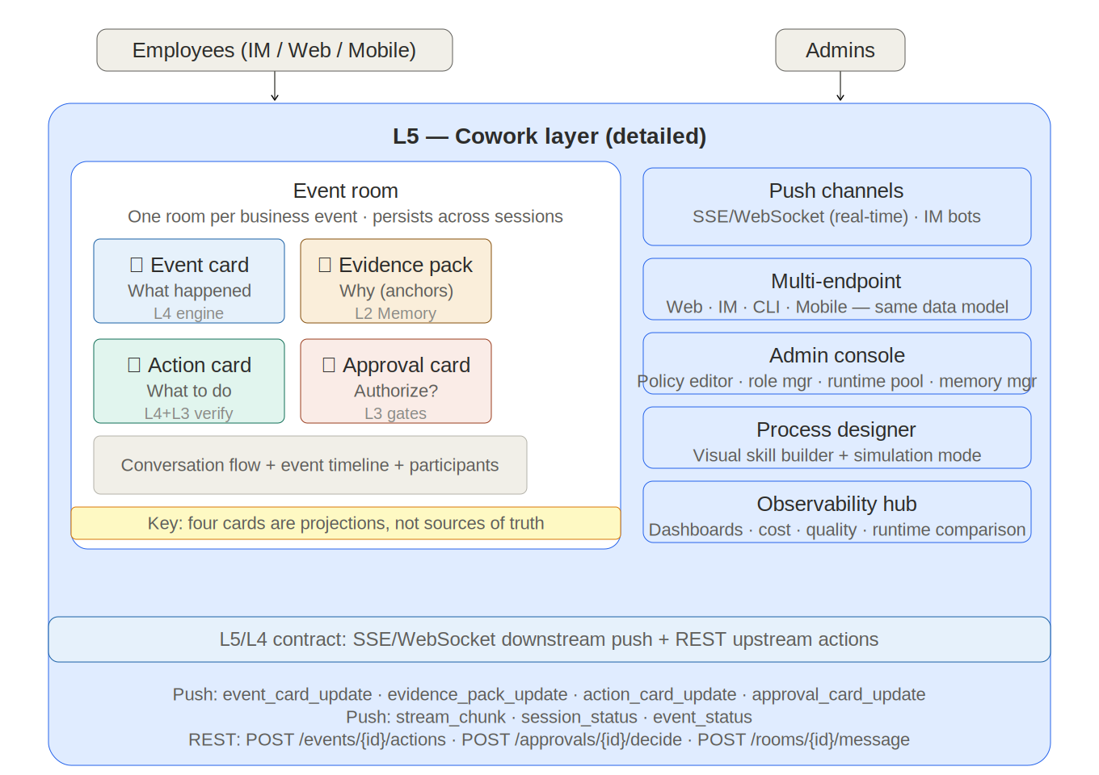
Figure 3-1: L5 Cowork Layer Detail

L5 is the layer users directly interact with. It is the platform's face — the event room where employees watch events unfold, review agent conclusions, and authorize actions. L5 can materialize as an enterprise IM plugin (WeChat Work, DingTalk, Feishu, Slack, Teams), a web portal, a CLI, or a mobile app. Regardless of form factor, every endpoint renders the same data model: an event room with four pinned cards.

The design philosophy is "push, not pull." Traditional enterprise AI requires users to open an application and type a request. L5 inverts this: when a business event occurs, L5 pushes a notification to the user with a pre-assembled event card summarizing what happened, how severe it is, and what the minimum viable next action is. The user's first interaction is not "ask AI a question" but "decide whether this event needs my attention."

L5 owns no business truth. All business data comes from downstream layers: event state from L4, policy and audit data from L3, skills and memory from L2. L5 owns only connection state (WebSocket sessions, push queues, card render caches) and rendering state. This constraint ensures that all endpoints — web, IM, CLI, mobile — render consistently because they read from the same sources.

3.1 Event room

The event room is the core interaction primitive. One room per business event. When L4's event engine creates an event object, L5 automatically generates a corresponding event room. The room contains:

Four pinned cards at the top, covering the four cognitive stages of decision-making: awareness (event card), verification (evidence pack), planning (action card), and authorization (approval card). The four-card paradigm replaces traditional message-list interaction. Each card must enable a decision within 30 seconds.

Conversation flow below the cards, where the user and agent exchange messages within the context of the event. Unlike standalone chat, every message is contextualized by the event and its evidence.

Event timeline showing the complete chronology from event intake to current state, including all agent actions, hook decisions, and human interventions.

Participant list showing which users and agents are involved, their roles, and their current status.

The event room's lifecycle follows the event state machine: it is created when the event is created, persists across all sessions spawned by the event (sessions may come and go, but the room persists), and archives after the retrospective phase (queryable but immutable).

3.2 Four-card paradigm

The four cards are derived views (projections) — not sources of truth. Each card's data comes from a specific downstream layer:

Card | Content | Data Source
Event card | One-line conclusion, severity, impact scope/level/trend, quick-action buttons | L4 event engine state machine
Evidence pack (collapsed by default) | Alert clustering summary, measurement windows, topology snapshots, historical similar events; each item has an anchor ID | L2 Memory Engine evidence anchors
Action card | Step tree with preconditions and expected results per step; quick actions to spawn sub-rooms or mention specialist agents | L4 orchestrator Plan object + L3 verifier Check result
Approval card | Action scope, rationale summary, rollback path, verification result; approve/reject/request-info buttons | L3 approval gate Approval object

Why four cards and not more? Four covers the complete decision cycle. More increases cognitive load; fewer omits critical stages. Different business scenarios reuse the same four-card structure with different content.

3.3 Push channels

Real-time push: SSE or WebSocket for web portal and mobile endpoints. Card updates stream as events occur — users see the event card update in real time as the agent works.

Async push: IM bots deliver card-formatted messages with interactive buttons to WeChat Work, DingTalk, Feishu, Slack, and Teams. Email notifications handle approval requests and daily event digests.

Push priority: Critical events push to all channels immediately. High-priority events push to IM plus in-app. Medium-priority events push in-app with IM digest. Low-priority events show in-app only. Users configure quiet hours and channel preferences per-event-type.

3.4 Multi-endpoint adaptation

L5 provides adapter interfaces for each form factor. Every adapter implements the same data model with different rendering:

Web portal provides the full experience: complete four-card display, event room with conversation flow, event timeline, admin console, process designer, and observability dashboards. This is the richest endpoint.

IM plugins render card-formatted messages with button interactions. The four cards appear as structured message cards in the IM platform's native card format. Users can approve, reject, or request info directly from the IM without switching to the web portal.

CLI provides structured text output with command-line interaction, suitable for DevOps and power users who prefer terminal workflows.

Mobile app provides simplified cards optimized for small screens, push notifications, and quick-approval flows.

3.5 Admin console

Admin console. The single most critical L4 application. Provides: a policy editor (translating business-language rules into managed hook configurations), a role manager (defining RBAC roles and mapping them to skill access and MCP permissions), an MCP connector manager (registering, configuring, and monitoring connectors), a skill promotion dashboard (reviewing and approving skills through draft → tested → reviewed → production), a runtime execution manager (enabling/disabling runtimes per organizational unit, configuring selection strategies, viewing comparison analytics), and a user management interface (assigning roles, viewing per-user activity, managing quotas).

3.6 Process designer

Process designer. Visual, form-based tool for business analysts to create and edit workflow-skills without writing SKILL.md by hand. The designer provides structured fields for workflow name, trigger conditions, step descriptions, quality criteria, required MCP connectors, and hook configurations. It compiles user input into SKILL.md format and submits to the skill repository via the skill lifecycle API. Includes simulation mode: a sandboxed L1 session with read-only MCP connectors where analysts can test workflows before submitting.

3.7 Observability hub

Observability hub. Consumes telemetry from L3's audit service and provides dashboards for: workflow execution performance (latency, success/failure rates, step-level traces), skill quality analytics (which skills have the highest failure rates, which need improvement), runtime comparison (per-runtime quality scores from blind-box votes, cost efficiency, latency distributions, task-type affinity heat maps), MCP connector health over time, cost tracking (per-user, per-team, per-workflow token usage and compute time), budget alerts (threshold-based notifications when spending patterns indicate budget overrun), evidence coverage rate (proportion of conclusions with attached evidence anchors), approval response latency (time from card push to human decision), and rollback rate. The hub feeds insights back to the admin console and process designer, creating a feedback loop: execution data (L1) → audit telemetry (L3) → analytics (L5) → skill improvement (back to L2).

4. L4 — Orchestration layer
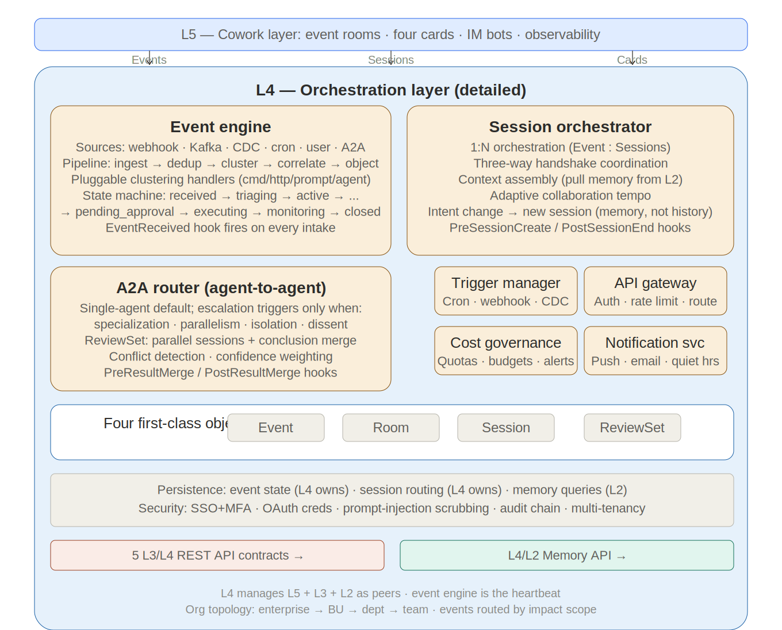
Figure 4-1: L4 Orchestration Layer Detail

L4 is the platform's brain — the event-driven orchestration engine that decides what happens when events arrive, which agents to dispatch, and how to coordinate their work. It replaces the simpler session-management model with full event-driven orchestration.

L4 manages four first-class objects: Event (business-event object produced by the event engine), Room (collaboration-space object in L5, linked to an event), Session (a single agent-execution object bound to a specific skill and runtime), and ReviewSet (a multi-agent review object managing parallel sessions and conclusion aggregation for A2A scenarios).

4.1 Event engine

The event engine is the heartbeat of the platform. It transforms agents from passive order-takers into event-driven proactive partners.

Event sources. The engine accepts events from six source types: webhooks (from monitoring platforms, CRM, HRIS, ticketing systems), message queues (Kafka/NATS for high-throughput scenarios), CDC streams (database change-data-capture triggers), scheduled tasks (cron expressions for periodic checks), user messages (via L5 when users initiate requests), and A2A calls (when one agent dispatches work to another). Each source requires signature verification, deduplication (event ID or content hashing), and normalization into the platform's structured-intent format.

Processing pipeline. Events flow through: ingest → dedup (same-source same-type events merge within a configurable time window, default 3 minutes) → cluster (spatial correlation for same-device/area events, temporal correlation for time-proximate events, causal correlation for known cause-effect chains) → correlate (cross-source correlation: monitoring alert + ticket + user complaint = same event; severity escalation when multiple low-priority events aggregate into a high-priority situation) → generate event object.

Clustering and correlation are designed as pluggable event-processing strategies supporting the same four handler types as hooks (command/http/prompt/agent). This allows different industries to customize clustering logic: a power-grid operator uses spatial-topology-aware clustering; a financial institution uses transaction-pattern clustering.

Event state machine. Each event follows a defined state machine: received (raw events ingested) → triaging (clustering and correlation complete) → active (event card pushed, processing begins) → pending_approval (agent has produced an action plan and entered the approval gate) → executing (human approved, agent is executing) → monitoring (execution complete, in observation period) → closed (observation normal, user confirmed closure) → retrospective (post-incident review and memory deposit triggered). The reject transition (pending_approval → active) handles cases where the approver requires revision.
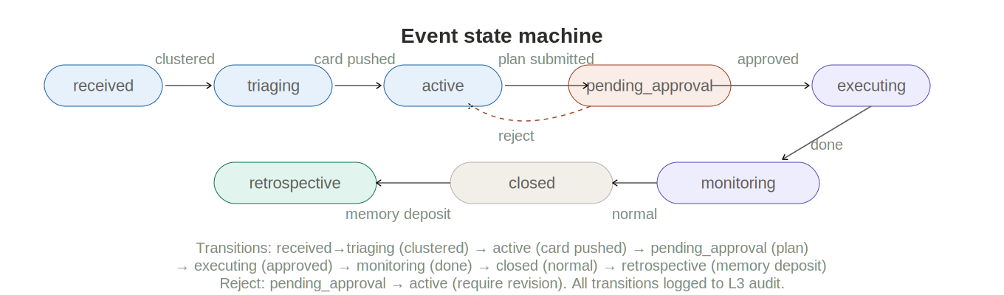
Figure 4-2: Event State Machine

EventReceived hook fires on every event intake, enabling policy-based filtering, priority adjustment, routing modification, and cost-budget checks before the event enters the pipeline.

4.2 Session orchestrator

The session orchestrator manages L1 runtime lifecycle. Its core advancement over simple session management is 1:N orchestration: one event can spawn multiple sessions.

Orchestration rules. One Event Room associates with one Event, which can contain multiple Sessions. Intent change creates a new Session (the old session's conclusions are written to L2 Memory; the new session starts by pulling relevant memory into its SessionPayload). Agent sub-task requests are dispatched as new Sessions via A2A. Approval-gate triggers pause the current Session pending L5 human confirmation. When all Sessions complete, the Event transitions to monitoring or closed.

Context passing. Sessions do not share conversation history. Instead, Session 1's output writes to L2's Memory Engine; Session 2's startup pulls relevant memory from L2 into its SessionPayload. This structured-memory approach is more robust than raw conversation forwarding because memory is curated, versioned, and access-controlled.

Adaptive collaboration tempo. Simple operations (queries, summaries) — agent completes autonomously, pushes result card. Judgment required (option selection, predictions) — agent produces action card, requests human input. Sensitive operations (config changes, dispatches, equipment operations) — full approval control chain. The tempo is determined by L3's policy engine based on operation type, impact scope, and organizational policy.

4.3 A2A router

The A2A (agent-to-agent) router coordinates multi-agent parallel review.

Key constraint: single-agent default, A2A escalation by trigger. The platform does not run multiple agents by default. A2A escalation occurs only when: (1) specialized cross-review is needed (e.g., protection review + topology analysis + safety check each require different domain expertise), (2) parallel evidence-gathering reduces latency (multiple data sources queried simultaneously), (3) different trust domains or tool permissions require isolation (some tools only accessible to specific agents), or (4) humans need to see dissent rather than a single conclusion (risk-critical scenarios). A2A escalation conditions are defined by L3 policy.

ReviewSet is the core A2A orchestration unit. Created by L4, it contains: the set of parallel Sessions, each Session's conclusion with evidence anchors and confidence score, and the aggregated unified recommendation. The aggregation strategy handles three cases: unanimous (merge into unified action card), conflicting (flag dissent and request human arbitration), partial completion (mark completed and pending portions).

A2A protocol endpoints: POST /api/v1/a2a/register (register agent capabilities), GET /api/v1/a2a/discover (discover available agents by capability), POST /api/v1/a2a/dispatch (dispatch parallel review with event_id, required_capabilities, parallel flag, timeout, shared context), POST /api/v1/a2a/tasks/{id}/result (submit individual results), GET /api/v1/a2a/tasks/{id}/aggregate (retrieve merged conclusions).

4.4 Integration plane

API gateway. Single entry point for all programmatic access. Handles OAuth 2.0/SSO authentication, rate limiting, request validation, and routing. Every L3/L4 interface contract passes through the gateway. Supports both internal (employee portal) and external (business systems) access, differentiated by authentication method and authorization scope.

Event bus. Receives business triggers from external systems and translates them into structured intents for dispatch through L3. Three trigger types: schedules (cron expressions for periodic workflows), webhooks (HTTP callbacks from CRM, HRIS, ticketing platforms), and data-change events (database triggers, stream processing). Each event is validated (webhook signature verification), deduplicated (event ID or content hashing), and translated into a structured intent containing source identity, event type, target skill ID, parameters, and callback URL.

Connector fabric. ETL/ELT pipelines between enterprise systems (ERP, CRM, HRIS, Active Directory, data lake) and L4's persistence plane. Distinct from L1's MCP connectors used during agent execution. The connector fabric syncs organizational structure, employee data, and business metrics into L4's databases.

4.5 Persistence plane

L4 owns four data stores providing all persistent state:

User database: Employee profiles, organizational role assignments, preferences, and quota usage. Synced with enterprise identity providers (Active Directory, Okta, Azure AD) through the connector fabric.

Execution log: Structured workflow execution history aggregated from L3's audit service telemetry. Provides queryable records: workflow X ran for user Y at time Z, completed in N seconds, produced output W, escalated at step S.

Session store: Conversation history and session state surviving across L1 session boundaries. When an L1 session ends, the session manager serializes kernel state and conversation summary here. When the employee returns, a new L1 session initializes with restored context.

Cost ledger: Resource consumption per user, team, and workflow: API tokens, compute time, MCP calls, storage. Feeds cost dashboards and enables chargeback models.

4.6 Multi-tenancy and organizational topology

L4 models the enterprise's organizational hierarchy: enterprise → business unit → department → team. Policies can be defined at any level; lower-level policies can tighten but cannot loosen higher-level policies. When the session orchestrator creates an L1 instance, it resolves the employee's organizational unit and loads the correct layered set of managed hooks. Skills in the repository are also organizationally scoped. The event engine routes events to corresponding organizational units based on impact scope.

4.7 Security architecture

L4 handles: authentication via enterprise SSO with MFA for human users and OAuth client credentials for system triggers; secrets management through a vault (HashiCorp Vault, AWS Secrets Manager, or Azure Key Vault) for MCP connector credentials, API tokens, and deployment credentials; prompt injection defense by sanitizing all external inputs from the event bus before they enter L3/L1; and audit trail completeness by logging every admin action (policy deployments, skill promotions, role changes) in L4's own audit trail, distinct from L3's execution audit.

4.8 Additional capabilities

Proactive notifications. Generated by the event bus (business events employees should know about) or by L1 execution results requiring action. The notification system handles channel preferences (push, email, Slack), priority levels (urgent vs. informational), and quiet hours.

Delegation and handoff. Employees can transfer in-progress workflows to colleagues. The session store serializes current state into a shareable format; the session manager creates a new L1 session for the delegate pre-loaded with that state.

Approval inbox. When a hook or approval gate pauses execution, L5 presents the pending request in the employee portal or as a notification, with context and one-click approve/reject. The approve action calls the intent gateway API to release the paused workflow.

Cost governance. Quota management (per-user/team/department limits enforced by SessionStart hooks checking quota status), cost attribution (telemetry aggregated by org unit), budget alerts (threshold-based notifications), event-triggered cost control (EventReceived hook checks event-processing budget before pipeline entry), and A2A cost estimation (pre-dispatch estimate of total parallel-agent cost).

5. L3 --- Agent governance layer
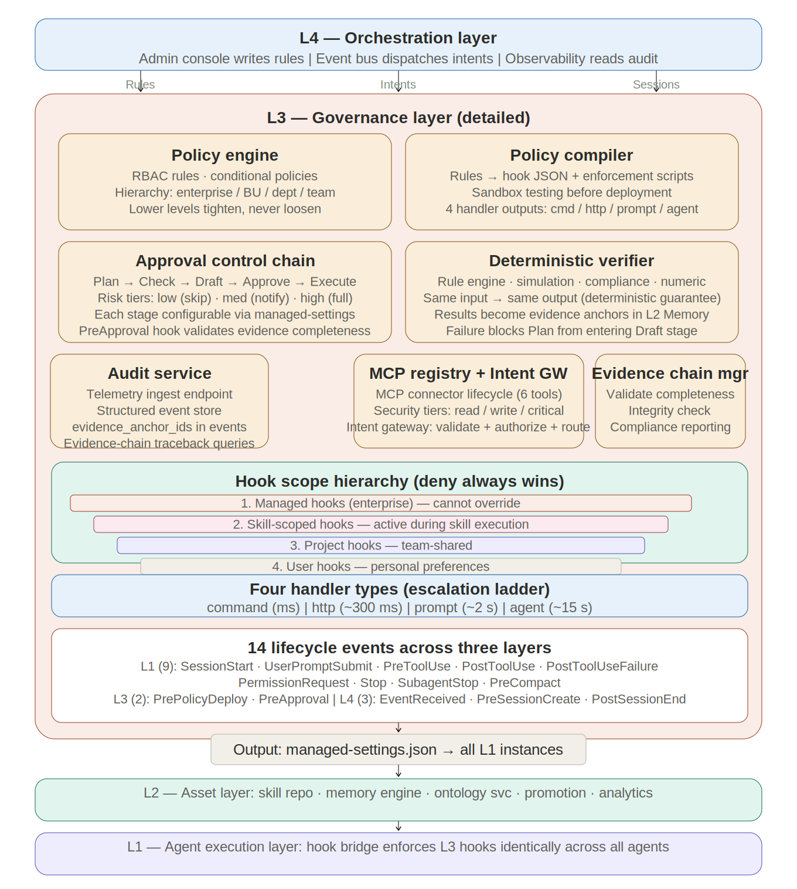
Figure 5-2: L3 Governance Layer Detail

L3 is a thin governance layer. It does not orchestrate workflows or make execution decisions. Its sole purpose is to enforce organizational policy, govern asset lifecycles, and capture audit telemetry. Its primary enforcement mechanism is managed hooks.

5.1 Policy engine

Translates organizational policies into managed hooks. Policies declared by administrators in L4's admin console are compiled by L3's policy compiler and deployed through the policy deploy API. The policy engine maintains the master configuration store for all organizational units. Supports hierarchical policy scoping: enterprise-level policies apply to everyone; BU/department/team policies add restrictions. Lower-level policies can tighten but never loosen higher-level policies.

5.2 Approval gates

Implemented as hook handlers that check approval status. Three gate types: pre-execution gates (PreToolUse hooks that block tool calls requiring approval before execution), mid-execution gates (PostToolUse hooks that block progress when anomalies or compliance issues are detected), and post-execution gates (Stop hooks that block completion until review is confirmed). The PermissionRequest hook event specifically supports approval workflows: managed hooks can auto-approve safe operations and escalate sensitive ones.

5.3 Audit service

Receives telemetry from every L1 runtime instance via async PostToolUse HTTP hooks. Stores structured execution records: who initiated the action, what was requested, which tools were called, what decisions hooks made, the outcome, and the resource consumption. Feeds L3's observability hub through the telemetry ingest API. The audit service is the single source of truth for execution history across all runtimes.

5.4 MCP registry

Implemented as an MCP server. Manages the lifecycle of all MCP connectors available to the platform. Exposes tools: connector_list, connector_register, connector_health, connector_config, connector_grant, connector_revoke. The execution kernel's pre-flight phase queries the registry to verify connector availability. The SessionStart hook injects current MCP health status into the session context.

5.5 Hook scope hierarchy

Hooks deploy at four scope levels. Deny from any level blocks the action regardless of all other levels:

- 1. Managed hooks (enterprise tier): Deployed via managed-settings.json by L3's policy compiler. Cannot be overridden by users or projects. When allowManagedHooksOnly is enabled, only managed hooks are permitted. This is where L3 governance policies live.

- 2. Skill-scoped hooks (frontmatter): Defined in a skill's YAML frontmatter. Active only while the skill is executing; automatically cleaned up when the skill finishes. This is how workflow-skills enforce domain-specific rules.

- 3. Project hooks: Defined in project settings. Shared across the team. Enforce project-level conventions (formatting, testing, review requirements).

- 4. User hooks: Defined in user settings. Personal preferences and convenience automations.

5.6 Four hook handler types

Type | Mechanism | Best for | Cost / Latency
command | Shell script: receives JSON on stdin, returns exit code + stdout | File path checks, deny-list matching, format validation, deterministic rules | Near zero: milliseconds, no API calls
http | POST to HTTP endpoint, receive JSON response | Centralized policy checks against L3 services, remote validation | Low: network round-trip, ~100–500 ms
prompt | Send prompt to lightweight Claude model for single-turn evaluation | Semantic quality evaluation, compliance checks, anomaly detection | Medium: LLM inference, ~1–3 s
agent | Spawn subagent with tool access (Read, Grep, Glob) for deep verification | Complex validation: numerical reconciliation, comprehensive code testing | High: multi-step reasoning, ~5–30 s

5.7 Hook lifecycle events

Event | Fires when | Architectural role
SessionStart | Session begins (startup, resume, clear, compact) | Context injection: user role, MCP health, quota status. Quota enforcement.
UserPromptSubmit | User submits a prompt, before processing | Mode router: SIMPLE vs KERNEL classification. Policy context injection.
PreToolUse | Before any tool executes | Primary enforcement: policy gates, access control, safety. Allow/deny/ask + input modification.
PostToolUse | After tool succeeds | Quality evaluation (prompt hooks), async audit logging (HTTP hooks), output validation.
PostToolUseFailure | After tool fails | Error telemetry, diagnostic injection for adaptive recovery, retry logic.
PermissionRequest | Agent requests permission for a tool | Auto-approve safe ops (managed hooks), escalate sensitive ops to user or L4 approval inbox.
Stop | Agent finishes responding | Final quality gate (exit 2 forces agent to continue). Telemetry push to L3 audit service.
SubagentStop | Subagent finishes | Validate subagent output before incorporating into main execution flow.
PreCompact | Before context compaction | Save execution state summary to L4 session store before conversation history is compressed.

5.8 MCP security tiers

MCP connectors are classified by security tier for risk-appropriate governance: read-only connectors (no side effects — query tools can be auto-authorized), write connectors (side effects — modification tools require policy authorization or approval), and critical connectors (high-risk side effects such as equipment, funds, or permission operations — must pass through the approval gate). Tools must declare side-effect classifications. Connector credentials should be short-lived (per-session issuance, expired on session end). The minimum-privilege principle applies: agents receive only the connector permissions required by the current skill. High-risk scenarios retain triple constraints: egress network allowlist + tool allowlist + operation-level approval.

5.9 Approval control chain
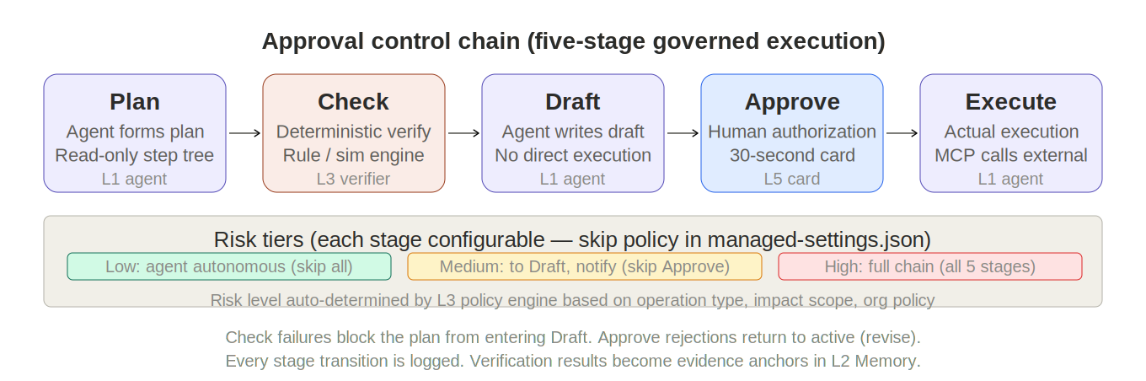
Figure 5-1: Approval Control Chain

L3 provides a five-stage governed execution chain that refines the basic deny/allow binary into graduated control:

Plan (agent forms a read-only operation plan as a step tree) → Check (deterministic verification via rule engine or simulation tool; same input always produces same output) → Draft (agent produces an executable draft — a config change, work order, or document — but does not execute it) → Approve (human authorization via a 30-second approval card in L5 showing action scope, rationale, rollback path, and verification result) → Execute (actual execution via MCP calls to external systems).

Each stage is configurable and skippable. The approval_chain_policy in managed-settings.json defines per-operation-type behavior. Risk tiers: low-risk operations (read-only queries, summaries) skip all stages and let the agent complete autonomously; medium-risk operations (report generation, suggested modifications) proceed to Draft and push a notification without forcing approval; high-risk operations (config changes, work-order dispatch, equipment operations) traverse the full five-stage chain. Risk level is auto-determined by L3's policy engine based on operation type, impact scope, and organizational policy.

5.10 Deterministic verifier

The verifier interface accepts a check_type (e.g., "five_prevention", "limit_check"), a plan object, and context data. It returns a result (pass/fail/warning), details, an evidence_anchor_id (the verification result itself becomes an evidence anchor in L2), and a list of rules_applied. Verifier types are extensible: rule-engine verification (business rule matching), simulation verification (feasibility validation via simulation tools), compliance verification (regulatory and standards checks), and numeric cross-validation (computation result verification). The key design decision: the verifier is deterministic — the same input always produces the same output. This is what distinguishes it from LLM-based evaluation. Verification failure blocks the plan from entering the Draft stage.

5.11 Evidence chain management

Every agent conclusion must reference evidence anchors. The evidence chain traces from conclusion → evidence pack (multiple anchors) → original data snapshots. L3's evidence chain manager handles: validation (checking that agent outputs attach required evidence anchors), integrity verification (confirming that referenced data snapshots exist and are intact), audit query support (enabling traceback from any conclusion to its complete evidence chain), and compliance reporting (generating evidence-chain-organized audit reports). Evidence anchor storage and retrieval is handled by L2's Memory Engine; validation, integrity checks, and audit queries are handled by L3. L3 defines the rules ("which outputs must attach evidence"); L2 provides the storage.

6. L2 --- Skill assets layer
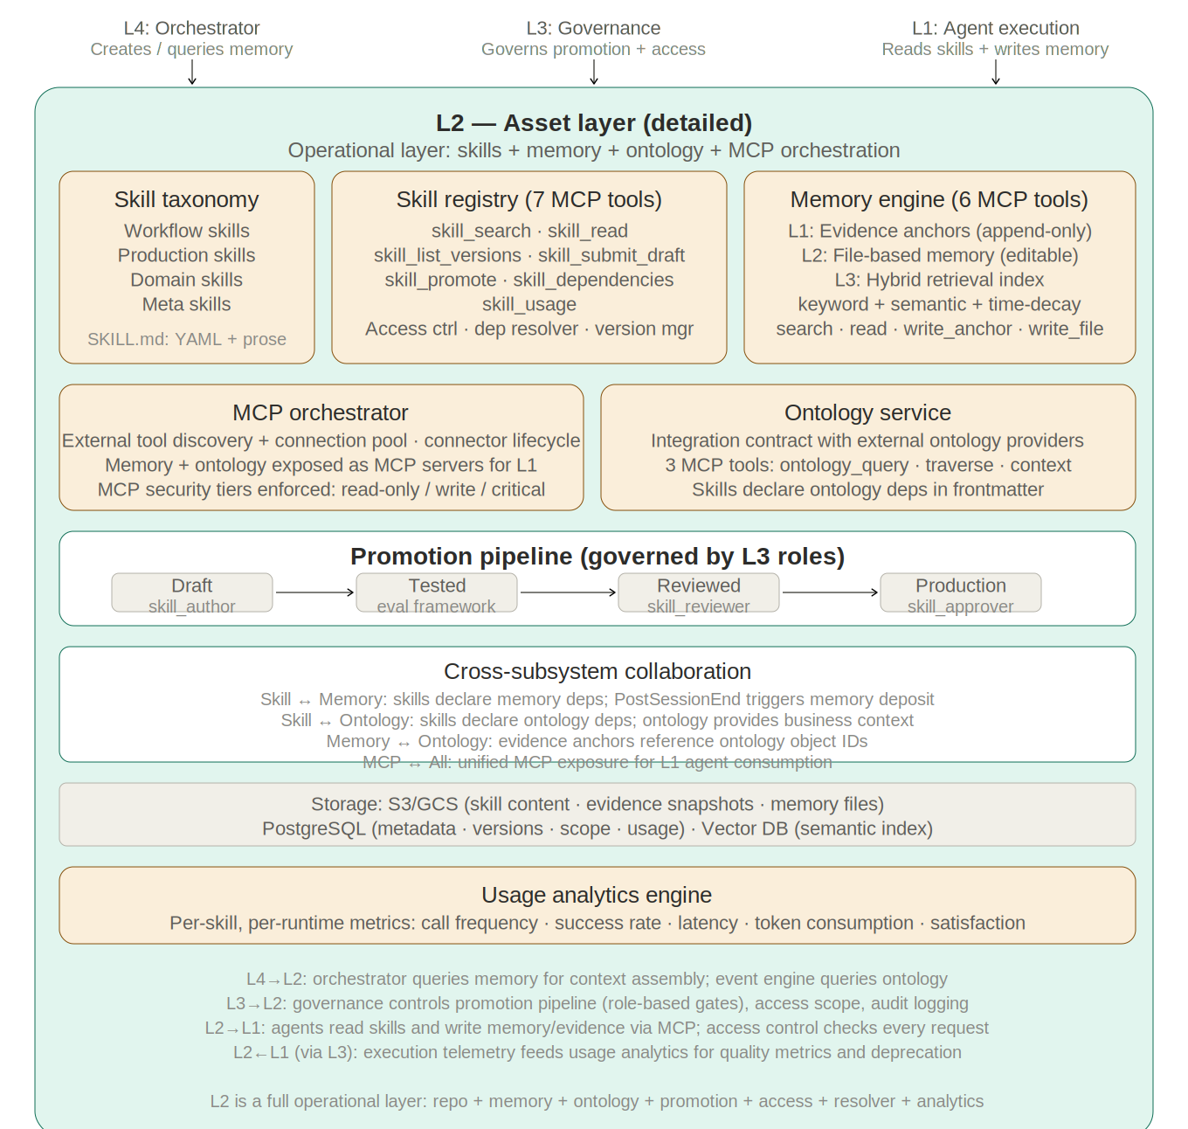
Figure 6-1: L2 Asset Layer Detail

L2 is a full operational layer --- not a passive repository. It owns the complete lifecycle of skill assets: storage, discovery, validation, promotion, access control, dependency resolution, version management, and usage analytics. All interactions with skill content pass through L2's runtime services, accessed via MCP protocol by L4 (process designer creates skills), L3 (governance controls promotion and access), and L1 (agents read skills during execution).

6.1 Layer architecture

L2 contains six operational services, each independently deployable and scalable:

- Skill repository (MCP server): The core storage and retrieval engine. Exposes seven MCP tools: skill_search (discover by name, tags, description, affinity), skill_read (load content including frontmatter hooks), skill_list_versions (version history with diffs and authors), skill_submit_draft (create new version; validates author role), skill_promote (transition lifecycle status; requires appropriate role), skill_dependencies (track inter-skill dependencies), skill_usage (invocation frequency, success rates, failure patterns per runtime). All skill content is stored in object storage (S3/GCS) with metadata in PostgreSQL.

- Promotion engine: Manages the governed lifecycle pipeline: draft → tested → reviewed → production. Each transition requires role-based authorization from L3 (skill_author submits, eval framework tests, skill_reviewer approves, skill_approver promotes). The engine enforces transition rules: no skip from draft to production, no demotion without explicit rollback, no promotion without passing all automated tests. Every transition is logged to L3's audit service with the approver's identity, timestamp, and diff from the previous version.

- Access control service: Enforces organizational scoping for all skill operations. Skills can be scoped to enterprise (visible to all), business unit, department, or team. Access control interacts with L3's RBAC to determine which users can read, edit, submit, review, or approve skills. When L1 requests a skill during execution, the access control service validates the user's organizational unit against the skill's scope before returning content.

- Dependency resolver: Tracks inter-skill dependencies and validates compatibility. When a skill references other skills (e.g., a workflow-skill that invokes a domain-skill for legal review), the resolver ensures all dependencies are at compatible versions, are accessible to the requesting user, and are in production status. During promotion, the resolver checks that promoting or deprecating a skill won't break downstream dependents.

- Version manager: Handles semantic versioning, branching, and rollback. Each skill edit creates a new version with full diff. The version manager supports rollback to any previous version, version pinning (a workflow-skill can pin its dependency to a specific version), and deprecation warnings. It maintains the complete edit history including who changed what and when.

- Usage analytics engine: Collects invocation data from L1 telemetry (via L3's audit service) and produces per-skill, per-runtime metrics: invocation frequency, success/failure rates, average execution time, token consumption, user satisfaction scores (from blind-box votes), and failure pattern analysis. These metrics feed into L4's observability hub and inform skill improvement decisions. The analytics engine also detects unused skills for deprecation candidates and identifies high-failure skills for quality review.

6.2 Skill taxonomy

Four skill types, all stored and governed identically but serving different purposes:

Skill type | Purpose | Hook integration
Workflow skills | Business processes as intelligent playbooks. Steps, quality criteria, error handling, adaptation strategies — replacing rigid YAML pipelines. | Carry scoped hooks in frontmatter. PostToolUse prompt hooks for quality eval. Stop hooks for completeness checks. PreToolUse for domain safety.
Production skills | Output quality best practices for specific deliverables (docx, pptx, xlsx, PDF). The enterprise equivalent of style guides, but executable. | PostToolUse command hooks for format validation. PreToolUse hooks for template and input checks.
Domain skills | Specialized professional knowledge: legal (contract review, compliance), financial (reporting standards, regulatory requirements), medical (coding standards). | PreToolUse prompt hooks for compliance checks. PostToolUse hooks for terminology and expression consistency.
Meta skills | Tools for the skill ecosystem: skill-creator (generates new skills), skill-evaluator (benchmarks quality), description optimizer (improves trigger accuracy), dependency analyzer. | Agent hooks for deep evaluation. PostToolUse hooks to track evaluation results.

6.3 Skill content structure

Each skill is a SKILL.md file with three sections:

- YAML frontmatter: Declares scoped hooks (PreToolUse, PostToolUse, Stop handlers that activate only during this skill's execution), runtime affinity (preferred_runtime, compatible_runtimes, or no affinity), access scope (organizational unit), dependencies (other skills required), and metadata (author, version, tags, description).

- Prose instructions: Natural language instructions that the agent reads and follows. Written for an intelligent reader --- they describe intent, quality criteria, edge cases, and adaptation strategies. The prose is the 'intelligence' part; it tells the agent what good looks like and how to handle the unexpected.

- Runtime affinity declaration: Skills can specify preferred_runtime (e.g., Octo for kernel-dependent workflows), compatible_runtimes (list of runtimes supporting the skill's requirements), or no affinity (works on any runtime with required tools). L1's runtime selector considers skill affinity when choosing a runtime. Skills with no affinity are the most portable and should be preferred.

6.4 Scoped hooks in skills

Workflow-skills solve the tension between intelligence and reliability. The skill's prose instructions tell the agent what to do and how to adapt. The skill's frontmatter hooks guarantee that certain checks happen every time. Intelligence and guarantee coexist in the same asset, each handling what it does best.

Three hook events are commonly used in skill frontmatter: PreToolUse (domain safety --- e.g., 'block writes to production databases during business hours'), PostToolUse (quality evaluation --- e.g., 'review output for anomalies exceeding 25% variance; if found, block'), and Stop (completion validation --- e.g., 'verify all required sections are present in the final document'). Skill-scoped hooks activate when the skill is loaded and deactivate when it completes. They compose with L3's managed hooks: both fire in parallel, and deny from either blocks the action.

6.5 Promotion pipeline

Skills pass through a governed lifecycle with four stages and three gates:

- Draft: Submitted by a user with the skill_author role. The skill is syntactically validated (YAML frontmatter parsed, hook declarations checked, runtime affinity verified against known runtimes). Available only to the author for testing in sandbox sessions.

- Tested: The promotion engine runs the skill through the evaluation framework: automated test cases (if provided), skill-evaluator meta-skill analysis, and sandbox execution against sample inputs. Test results are attached to the version. Skills failing automated tests cannot be promoted.

- Reviewed: A user with the skill_reviewer role examines the skill content, test results, hook declarations, and dependency graph. The reviewer can approve, reject with feedback, or request changes. Review decisions are logged with rationale.

- Production: A user with the skill_approver role gives final approval. The skill becomes available to all users whose organizational roles match the skill's access scope. Production skills are immutable --- changes require a new version through the full pipeline.

6.6 L2 interfaces with adjacent layers

L2 communicates with adjacent layers through defined mechanisms:

- L4 → L2: The process designer in L4 creates and edits skills through the skill lifecycle API (L3/L4 Contract 3), which L3 routes to L2's promotion engine and repository.

- L3 → L2: L3's governance controls L2's promotion pipeline (role-based gates), access scoping (organizational hierarchy), and audit logging (every skill operation is recorded). L3's managed-settings.json can reference L2 skills by ID.

- L2 → L1: Agents in L1 access L2 through the skill repository MCP server. During execution, an agent calls skill_search to find relevant skills, skill_read to load content, and skill_dependencies to resolve required sub-skills. L2's access control validates every read request against the user's organizational scope.

- L2 ← L1 (via L3): Execution telemetry from L1 flows through L3's audit service to L2's usage analytics engine, closing the feedback loop: skill execution data informs quality metrics, which inform improvement priorities.

6.7 Memory Engine

The Memory Engine is a core subsystem managing agent persistent memory — enabling experience accumulation, evidence tracing, and cross-session reference. It sits in L2 because memory is an asset, peer to Skills: L1 reads and writes at execution time, L4 queries during context assembly.

Core design constraint: the file is the governance object; the index is the retrieval object. Both derive from the same source and must never diverge. Every memory item simultaneously has a file view (human-reviewable, editable, promotable, archivable, access-controlled) and an index view (keyword + semantic + time-decay hybrid retrieval). The two views share one source record; "exists in index but not in file store" is a system integrity violation.

Three-layer storage architecture:

Layer 1: Evidence anchor store. Append-only, immutable records. Each anchor contains: anchor_id (globally unique), event_id, session_id, type (measurement_window, topology_snapshot, rule_reference, document_excerpt, computation_result), data_ref (URI to original data), snapshot_hash (integrity hash), source_system, tool_version, model_version, rule_version (for deterministic verification), timestamps, and extensible metadata. Every agent conclusion must reference at least one anchor. Anchors are never modified after creation.

Layer 2: File-based memory. Structured files depositing preferences, thresholds, and retrospective experience — analogous to CLAUDE.md. Each file contains: memory_id, scope (user, team, org_unit, event_type), category (preference, experience, knowledge, calibration), content (structured text that humans can read and edit), evidence_refs (linked anchor IDs), status (agent_suggested → confirmed → archived), version (incremented on every edit), and audit metadata. Agent-written memory is initially marked "agent_suggested"; human confirmation promotes it to "confirmed."

Layer 3: Hybrid retrieval index. Combines three search modes: keyword retrieval (exact match on device IDs, event types, proper nouns), semantic retrieval (vector similarity for fuzzy "similar events" matching), and time-decay weighting (recent memory ranked higher). The index is rebuilt from the file store; it is never the source of truth.

6 MCP tools: memory_search (hybrid retrieval with scope, category, time_range filters), memory_read (read file or anchor details), memory_write_anchor (create evidence anchor, append-only), memory_write_file (create or update memory file), memory_list (enumerate by scope/category), memory_archive (soft-delete with audit trail).

Cross-agent sharing rules: All sessions under the same event_id share memory. User-scope memory is visible to all agents serving that user. Team-scope memory is visible to all team members. Write conflicts use last-write-wins with optimistic version locking.

6.8 Ontology Service

The Ontology Service integrates enterprise business ontologies — structured knowledge graphs modeling core business objects (equipment, personnel, processes, organizations, rules) and their relationships. EAASP does not build ontologies; it defines a standardized integration contract for consuming them.

Platform-provided capabilities: An ontology query interface exposed as an MCP server with three tools (ontology_query for type/attribute/relation queries, ontology_traverse for relationship-path traversal, ontology_context for returning context packs around specified objects). Context-assembly integration (L4's event engine queries ontology during context assembly to enrich SessionPayload with business context). Evidence-anchor linkage (anchors can reference ontology object IDs as data_ref). Skill ontology dependency declarations (skills declare required ontology types in frontmatter).

Ontology provider contract: Standard query API (REST or MCP), schema publication (type definitions, attributes, relation types), version management (versioned queries for evidence-anchor consistency), and access-control interop (coordinated with L3's RBAC for role-based query scoping).

6.9 L2 interfaces with adjacent layers

L5 → L2: Process designer creates and edits Skills via the Skill lifecycle API (routed through L3). Admin console reviews and edits memory files.

L4 → L2: Orchestrator queries Memory Engine for context assembly. Event engine queries Ontology Service for event correlation.

L3 → L2: Governance controls the promotion pipeline (role-based gates), access scope (organizational hierarchy), and audit logging (every skill and memory operation recorded). L3's managed-settings.json can reference L2 Skills by ID.

L2 → L1: Agents access L2 through MCP server interfaces — Skill repository for skill_search/skill_read, Memory Engine for memory_search/memory_write_anchor/memory_write_file, Ontology Service for ontology_query/ontology_traverse. L2's access control validates every request against the user's organizational scope.

L2 ← L1 (via L3): Execution telemetry from L1 flows through L3's audit service into L2's usage analytics engine, closing the feedback loop.

7. L1 internal abstraction mechanism
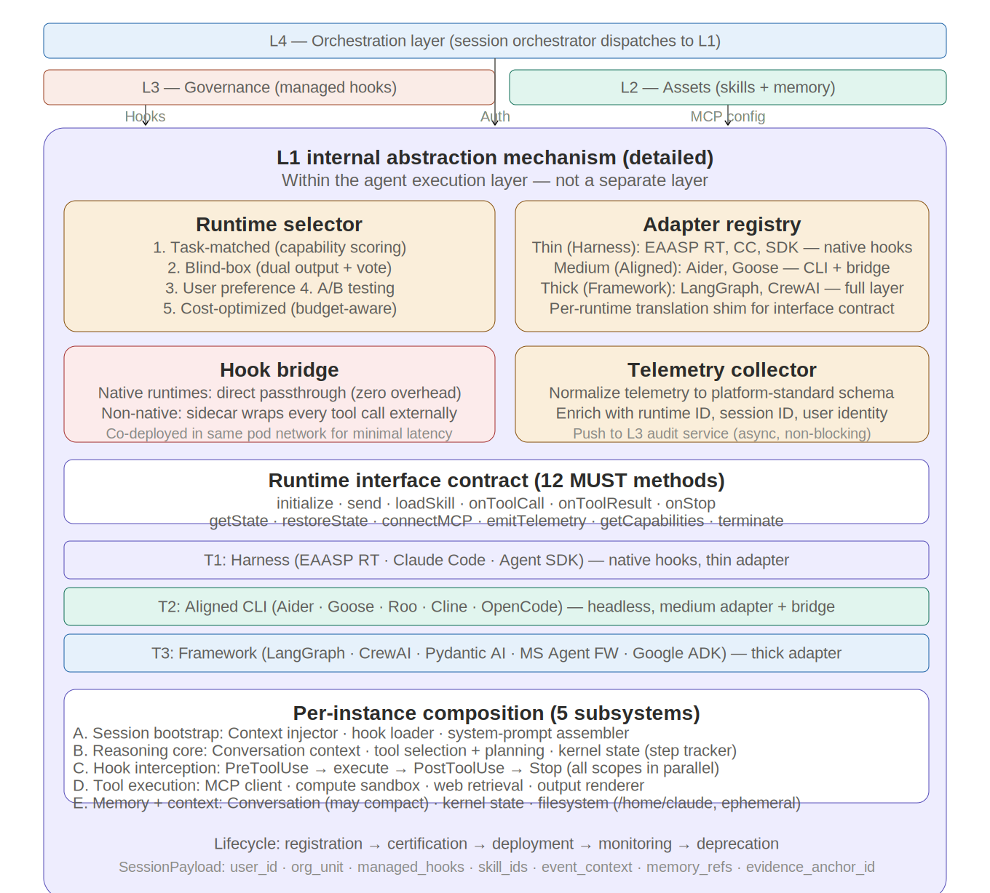
Figure 7-1: L1 Internal Abstraction Mechanism

L1\'s internal abstraction mechanism enables runtime-agnostic operation. L4, L3, and L2 interact with L1 through this mechanism, not with specific agents. It contains four components.

7.1 Runtime selector

When L3's session manager requests a new session, the selector chooses a runtime from the execution pool. Five selection strategies:

- Task-matched: Analyze the request (or anticipated workload from user role/history), match to runtime capability manifests. A coding task routes to Claude Code; a document workflow routes to Octo; a research task routes to a LangGraph agent.

- Random blind-box: Assign two runtimes simultaneously, present both outputs, user votes up/down without knowing which runtime produced which. Generates pairwise comparison data for empirically grounded quality scoring. Cost: doubles execution for sampled sessions.

- User preference: Employee explicitly chooses their preferred runtime. Can be constrained by policy (admin may restrict certain runtimes for certain roles).

- A/B testing: Controlled random assignment: a percentage of sessions go to an experimental runtime while the rest go to the default. Enables safe rollout of new runtimes.

- Cost-optimized: Among runtimes matching the task profile, choose the cheapest. Token cost and compute cost from capability manifests. Combinable with task-matching.

7.2 Adapter registry

Each runtime has an adapter --- a shim translating between the platform's runtime interface contract and the runtime's native API. Adapter thickness varies by runtime tier:

- Harness agents (thin): Octo, Claude Code, Claude Agent SDK. Native hooks, MCP, and skills. Adapter handles session lifecycle and payload translation only.

- Aligned agents (medium): Aider, Goose, Roo Code CLI, Cline CLI. Some native MCP, no native hooks. Adapter bridges hooks through the hook bridge, translates skill format, normalizes output.

- Framework agents (thick): LangGraph, CrewAI, Pydantic AI. Own execution models. Adapter translates skills to framework format (LangGraph nodes, CrewAI crew definitions), bridges MCP, bridges hooks, normalizes output.

7.3 Hook bridge

Ensures L3 governance applies identically to all runtimes. For hook-native runtimes: managed hooks load directly into the runtime's hook system --- zero overhead, in-process execution. For non-hook-native runtimes: the bridge wraps every tool call externally. Sequence: framework decides to call a tool → bridge intercepts → runs PreToolUse hooks → if allowed, forwards to tool → tool executes → bridge intercepts result → runs PostToolUse hooks → if not blocked, returns result to framework. The bridge should be colocated with the runtime (same container network) to minimize the latency overhead of external interception.

7.4 Telemetry collector

Normalizes telemetry from all runtimes into the platform's standard schema before pushing to L3's audit service. For hook-native runtimes: telemetry flows through async PostToolUse hooks. For bridged runtimes: the hook bridge captures telemetry as it intercepts tool calls. The collector enriches events with runtime ID, session ID, and user identity before forwarding.

7.5 Runtime interface contract

Any runtime must implement (via its adapter) these methods to join the execution pool:

Method | Level | Description
initialize(payload) | MUST | Accept session init payload (user context, role, managed hooks, quota, event_context, memory_refs). Return session handle. Adapter translates payload to runtime-native config.
send(message) | MUST | Accept user message or structured intent. Return streamed response. Adapter maps platform message format to runtime input format.
loadSkill(content) | MUST | Load workflow-skill SKILL.md content, activate scoped hooks. For framework agents: adapter converts to graph/crew config.
onToolCall / onToolResult | MUST | Emit PreToolUse/PostToolUse events. Native: passthrough. Bridged: hook bridge wraps tool calls.
onStop() | MUST | Emit Stop event when runtime finishes. Support exit-2 blocking (force agent to continue working).
getState / restoreState | MUST/SHOULD | Serialize/restore session state for persistence to L4 session store. Enables cross-session continuity.
connectMCP(servers) | MUST | Connect to MCP servers (skill repo, MCP registry, Memory Engine, external services). For non-MCP runtimes: adapter translates protocol.
emitTelemetry() | MUST | Emit standardized telemetry events in platform schema. Collector normalizes and forwards to L3.
getCapabilities() | MUST | Return capability manifest: model, context window, tools, native hooks/MCP/skills support, cost, strengths, limitations.
terminate() | MUST | Clean up resources, emit SessionEnd, flush all async telemetry before exit.

7.6 SessionPayload extension

The SessionPayload carries three additional fields for event-driven and memory-aware operation:

event_context (provided by L4's event engine): event_id, event_type, severity, scope, and raw_summary. For non-event-driven user-initiated requests, this field is empty and the payload functions identically to a basic request-response flow.

memory_refs (assembled by L4 from L2 Memory Engine queries): an array of {memory_id, type, relevance_score} tuples representing the most relevant prior memory for this task context.

evidence_anchor_id (assigned by L4): the anchor ID to which this session's conclusions should attach evidence.

L1 runtimes do not need to understand these fields' business semantics — they are injected into the SystemPrompt where the LLM uses them during reasoning.

7.7 Memory write channel

L1 agents write three data types to L2's Memory Engine during execution: evidence anchors (critical data snapshots from tool calls — append-only, immutable), conclusion memory (agent conclusions with evidence references), and preferences/experience (long-term memory for future sessions). Writes use MCP protocol calls to L2, triggered by PostToolUse or Stop hooks.

8. L1 --- Agent execution layer
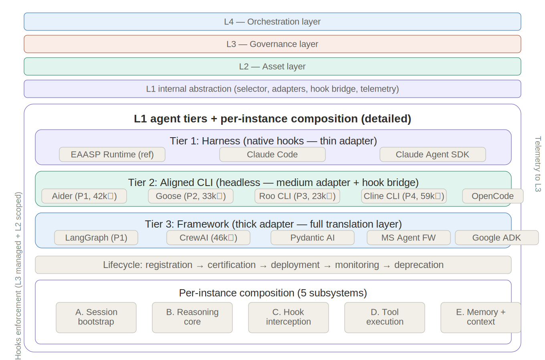
Figure 8-1: L1 Runtime Tiers

The agent execution layer contains multiple agent implementations organized into three tiers by platform compatibility. Each agent instance, regardless of tier, shares the same five internal subsystems.

8.1 Runtime tiers

Tier 1: Harness agents (native compatibility)

Built on Anthropic's infrastructure. Native hooks (21 events, 4 handler types), native MCP, native skills, managed-settings hierarchy. Thin adapters. Zero governance overhead.

- Claude Code: Reference harness. Terminal-based coding agent. Full managed-settings with allowManagedHooksOnly. Subagents, skills with frontmatter hooks. Strongest coding capability. Powered by Claude Opus 4.6.

- Octo: Extended Claude Code with kernel boot skill. Enterprise personal assistant focus. Mode router, structured execution protocol (intent parser, resource coordinator, execution loop). The primary general-purpose runtime.

- Claude Agent SDK: Anthropic's SDK for building custom harness agents. Enterprises build domain-specific agents (finance agent, legal agent) that inherit native hooks/MCP. In-process MCP server model and lifecycle hooks.

Tier 2: Aligned agents (headless, light--medium adapter)

Natively headless CLI agents that can run as independent server-side processes. Partial platform compatibility. Important: some agents in this tier (Cline, Roo Code) are primarily VS Code extensions; only their CLI variants qualify for the server-side execution pool. The VS Code extensions can coexist as client-side runtimes governed by managed hooks in local settings files.

- Aider (42k stars): Natively headless CLI. Git-native (auto-commits every change). 100+ model support. Fastest and most token-efficient in benchmarks. Simple execution loop makes hook bridge straightforward. Priority 1 for Tier 2 execution pool expansion.

- Goose (33k stars): Natively headless. Block/Square, Linux Foundation governance. MCP-native, local-first, extensible. Transparent execution model suits hook bridge. Priority 2.

- Roo Code CLI (23k stars): CLI variant of VS Code extension. Multi-mode (architect/code/debug/orchestrator) maps to kernel execution protocol. Skills + checkpoints. MCP-native. Priority 3.

- Cline CLI (59k stars): CLI variant of VS Code extension. Plan/Act modes, approval-first philosophy aligns with hook model. MCP-native. Cline Teams adds RBAC. Priority 4.

- OpenCode: Natively headless. Multi-platform, model-agnostic. Simple architecture. Priority 5.

Tier 3: Framework agents (significant adapter)

AI frameworks (libraries for building agents) rather than ready-made agents. Adapting them requires building an agent using the framework, then wrapping it with the platform adapter.

- LangGraph (GA v1.0): Best production maturity. Graph-based orchestration. Durable execution with checkpointing (crash recovery). Pre/post model hooks exist (close to our tool hooks). LangSmith for observability. Strongest candidate for long-running, crash-recoverable workflows. Priority 1 for Tier 3.

- CrewAI (46k stars): Role-based multi-agent. Native MCP + A2A. Largest community. 12M+ daily executions. Best for team-structured tasks. Role model diverges from kernel pattern; heavy skill translation needed.

- Pydantic AI (15k stars): Type-safe, clean Python. Native MCP. Simple agent model. Needs full hook bridge + skill translation.

- Microsoft Agent Framework: AutoGen + Semantic Kernel merged. RC Feb 2026. Graph workflows, A2A, MCP. Azure-native enterprise features. Heavy Azure coupling.

- Google ADK: Multimodal, A2A, MCP. Vertex AI integration. GCP-coupled. Full hook bridge needed.

Tier 4: Community agents (deferred)

OpenClaw (257k stars) is a life assistant with its own skill system, no hooks, no MCP, and critical security vulnerabilities (CVE-2026-25253). AutoGen is in maintenance mode with near-zero security mechanisms. Both are deferred from the execution pool.

8.2 Runtime lifecycle in the execution pool

Registration (submit adapter + capability manifest) → certification (automated testing against interface contract + blind-box quality testing vs. established runtimes) → deployment (enabled for specific organizational units with configurable blind-box sampling rate) → monitoring (continuous quality scoring via telemetry, blind-box votes, error rates) → deprecation (removed from selection when superseded or quality degrades below threshold).

8.3 Per-instance internal composition

Each runtime instance, regardless of implementation, has five internal subsystems:

- Session bootstrap plane: Context injector (formats session init payload), hook loader (activates managed hooks or registers with bridge), system prompt assembler (constructs full prompt with kernel boot skill, organizational context, preferences, resumption state). Assembly must be deterministic for debugging.

- Reasoning core: The LLM or framework engine that decides actions. Maintains conversation context (message history + tool results) and kernel state (structured step tracker). Context window management: PreCompact hook saves state before compaction. For harness agents: Claude with kernel boot skill. For frameworks: native execution loop.

- Hook interception layer: Between reasoning and tool execution. PreToolUse → execute → PostToolUse on every tool call. Managed hooks, skill-scoped hooks, project hooks, user hooks all fire. Deny from any blocks. For non-native runtimes: the hook bridge operates externally.

- Tool execution plane: Four tool families: MCP client (unified interface for all MCP servers), compute sandbox (containerized Linux, ephemeral filesystem), web retrieval (search, fetch, image search), output renderer (artifacts, files, API-in-API). MCP client maintains connection pooling and per-server health tracking.

- Memory and context plane: Three state forms: conversation memory (full history, subject to compaction), kernel state (structured step tracker, preserved through compaction), working filesystem (/home/claude, ephemeral). Feedback loop: reason → act → observe → reason. L1 data survives sessions only by writing to L2 (hooks) or L3 (MCP).

9. L3/L4 interface: five API contracts
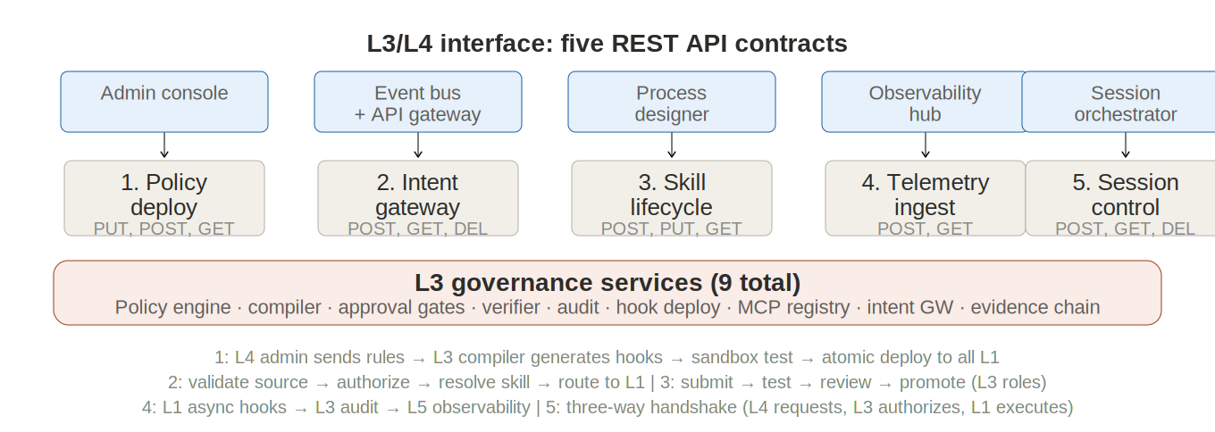
Figure 9-1: L3/L4 Five API Contracts

Five REST API contracts define all communication between L4 and L3. No other cross-boundary communication is permitted. Each contract passes through L4's API gateway for authentication, rate limiting, and versioning.

9.1 Contract 1: Policy deployment

Caller: L4 admin console. L3 policy compiler executes. Endpoints: PUT /v1/policies/managed-hooks (deploy compiled hooks atomically across all L1 instances), POST /v1/policies/test (run hooks against sample events in sandbox), GET /v1/policies/versions (list all policy versions with diffs and authors), POST /v1/policies/rollback (revert to a previous managed-settings version). Implementation: the policy compiler generates hook JSON + enforcement scripts, tests them in a sandboxed L1 session, and deploys via managed-settings distribution. Deployment must be atomic: either all instances receive the update, or it rolls back.

9.2 Contract 2: Intent gateway

Caller: event bus + API gateway. Endpoints: POST /v1/intents/dispatch (translate business event into intent, validate source identity, authorize against policy, resolve target skill, route to session manager for L1 allocation), GET /v1/intents/{id}/status (async polling for intent execution progress), POST /v1/intents/{id}/approve (release paused workflow after human approval), DELETE /v1/intents/{id}/cancel (abort pending or running intent). The gateway performs three checks on every dispatch: source authentication, policy authorization, and skill resolution.

9.3 Contract 3: Skill lifecycle

Caller: process designer + admin console. Endpoints: POST /v1/skills/submit (create draft in repository; L3 validates submitter has skill_author role), PUT /v1/skills/{id}/promote (move through lifecycle: draft → tested → reviewed → production; requires appropriate role for each transition), GET /v1/skills/{id}/versions (version history with diffs, authors, and change reasons), GET /v1/skills/search (discover skills by name, tags, description, runtime affinity). The skill promotion pipeline is governed by L3: who can submit, who can review, who can approve for production.

9.4 Contract 4: Telemetry ingest

Caller: L3 audit service (receiving from L1 hooks). Endpoints: POST /v1/telemetry/events (receive async hook telemetry in standardized schema), GET /v1/telemetry/query (power observability dashboards with structured queries: by user, skill, time range, outcome, runtime), GET /v1/telemetry/aggregate (rollups for cost tracking, skill usage analytics, runtime comparison). The telemetry schema captures: session ID, runtime ID, user identity, every tool call (tool, input, output, duration), every hook event (which hooks fired, decisions), final outcome, resource consumption, and blind-box votes.

9.5 Contract 5: Session control

Caller: employee portal + session manager. Endpoints: POST /v1/sessions/create (three-way handshake: L4 requests session → L3 validates user role and attaches managed hooks → L1 selects runtime and allocates instance), GET /v1/sessions/{id} (check session status and metadata), POST /v1/sessions/{id}/message (send user input to L1, stream response back), DELETE /v1/sessions/{id} (tear down session, flush state to session store). This contract is where all three layers meet: L4 initiates, L3 governs, L1 executes. After session creation, messages stream directly between L4 and L1, with L3's hooks intercepting every tool call inline within the runtime.

9.6 Session creation: the three-way handshake

The session creation sequence is the most critical integration point. (1) The employee opens the portal or an event arrives at the event bus. (2) L4 authenticates the user/source and resolves their organizational role and unit. (3) L4 calls POST /v1/sessions/create with the user context, task profile, and requested runtime preference. (4) L3 validates the user's role against policy, resolves the layered managed hooks for their organizational unit, and attaches them to the session. (5) L1's runtime selector chooses a runtime based on the task profile, skill affinity, and selection strategy. (6) L1 allocates the agent instance, the session bootstrap plane runs (context injector, hook loader, system prompt assembler), and the SessionStart hook fires to inject context. (7) L3 returns the session handle to L4. (8) L4 connects the portal to the session and begins streaming messages. After creation, messages flow directly L4 ↔ L1, with hooks enforcing L3 governance inline.

10. L5/L4 interface: real-time communication contract
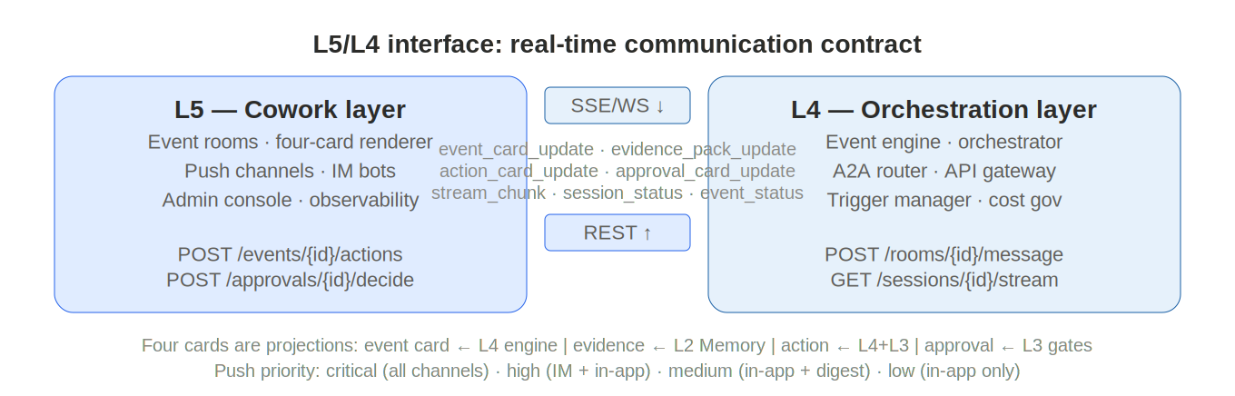
Figure 10-1: L5/L4 Real-Time Communication

L5 and L4 communicate through a bidirectional real-time protocol. Downstream (L4 → L5) uses Server-Sent Events (SSE) or WebSocket for streaming card updates and agent output. Upstream (L5 → L4) uses HTTP REST for user actions.

10.1 Downstream push events

L4 pushes seven event types to L5:

Event Type | Payload | Trigger
event_card_update | EventCard data (title, summary, severity, impact, quick actions) | Event state change or new aggregation
evidence_pack_update | Array of evidence anchor summaries with preview data | New anchor written by L1 agent
action_card_update | Step tree with per-step status and quick actions | Agent produces or revises plan
approval_card_update | Approval object (scope, rationale, rollback path, verification result) | Agent enters approval gate
stream_chunk | text_delta, tool_start, tool_result, or done token | Agent streaming response
session_status | Session state (created, active, paused, completed, failed) | Session lifecycle transition
event_status | Event state machine transition | Event state change

L5 subscribes per-event-room. Multiple L5 endpoints (web, IM, mobile) can subscribe to the same room simultaneously; all receive identical data and render it in their respective formats.

10.2 Upstream REST actions

L5 sends three types of actions to L4:

POST /v1/events/{id}/actions — User-initiated event actions: start review, delegate to colleague, acknowledge, escalate. The action type and any parameters are included in the request body. L4 routes the action to the appropriate handler (session orchestrator, A2A router, or notification service).

POST /v1/approvals/{id}/decide — Approval decisions: approve, reject, or request_info. The decision is forwarded to L3's approval gate, which either clears the gate (resume execution) or returns the event to active state (require revision).

POST /v1/rooms/{id}/message — User messages within an event room. The message is forwarded to the active L1 session via L4's session orchestrator.

11. L4/L2 interface: Memory API
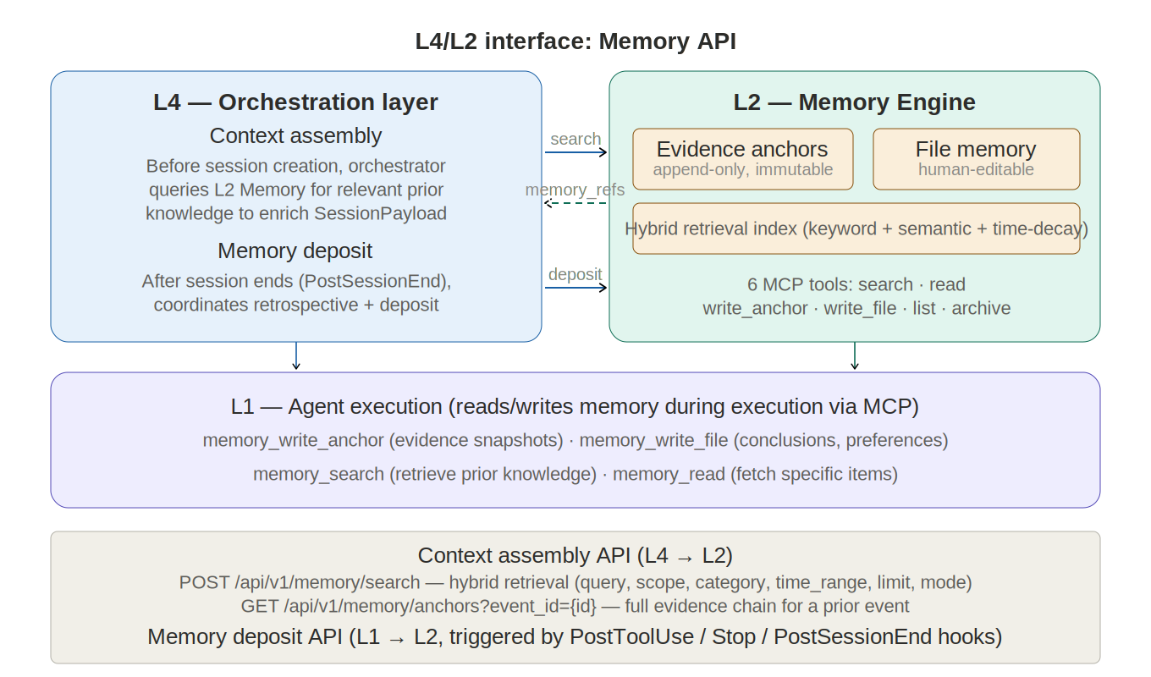
Figure 11-1: L4/L2 Memory API Interface

L4 accesses L2's Memory Engine at two points in the collaboration loop: during context assembly (before session creation) and during memory deposit (after session completion).

11.1 Context assembly queries

Before creating a session, L4's orchestrator queries L2 to enrich the SessionPayload with relevant prior knowledge:

POST /api/v1/memory/search — Hybrid retrieval combining keyword, semantic, and time-decay modes. Parameters include query text (derived from the event summary), scope filters (user, team, org_unit, event_type), category filters (preference, experience, knowledge, calibration), time range, and result limit. Returns ranked memory items with relevance scores.

GET /api/v1/memory/anchors?event_id={id} — Retrieves the complete evidence chain for a prior event, enabling the agent to reference historical conclusions and their supporting evidence.

The orchestrator selects the top-K most relevant memory items and includes them as memory_refs in the SessionPayload.

11.2 Memory deposit

After a session completes (triggered by the PostSessionEnd hook), L4 coordinates memory deposit:

L1's session output (conclusions, evidence anchors, identified preferences) is written to L2 via the memory write channel. L4 then triggers a retrospective cycle if the event enters the retrospective state, during which a dedicated session reviews the complete event history and produces curated memory files summarizing lessons learned, threshold calibrations, and operational experience.

12. L1/L3 interface: hooks as the connection mechanism
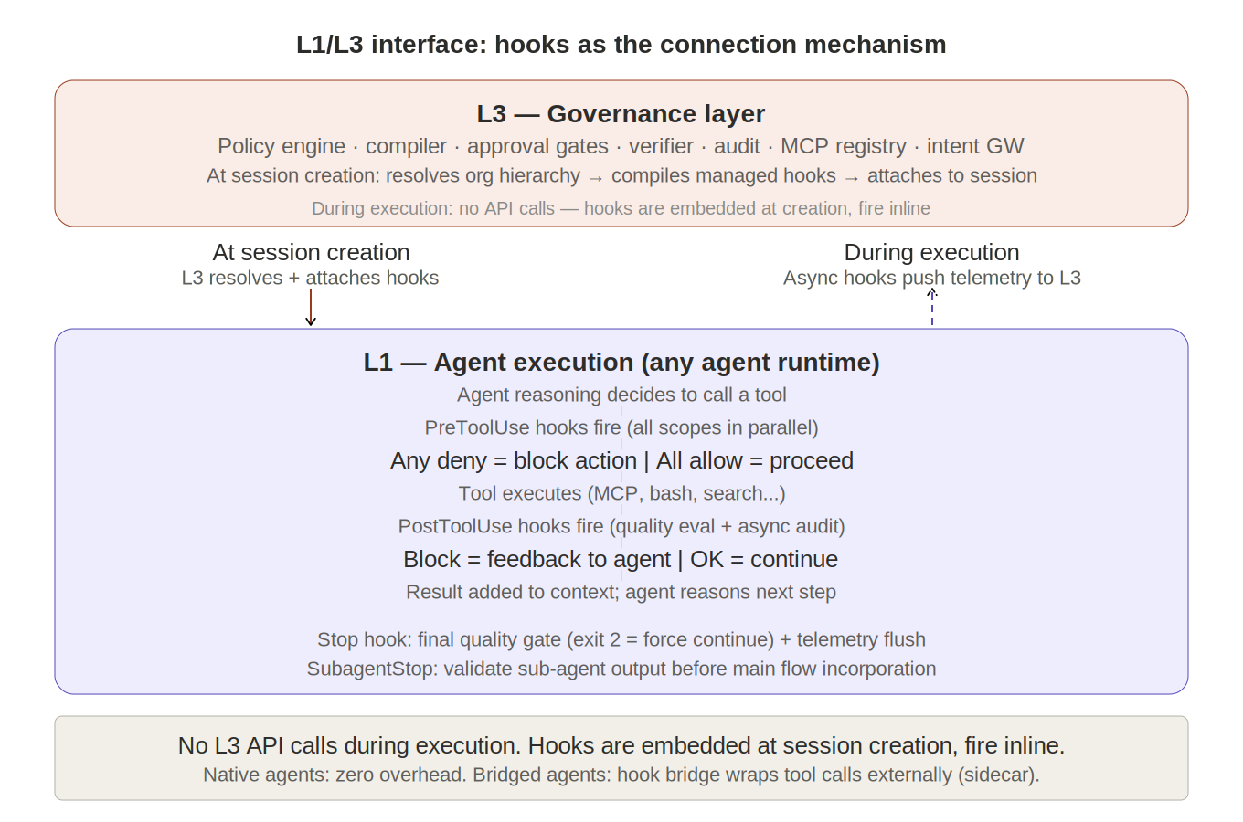
Figure 12-1: L1/L3 Interface — Hooks as Connection

The L1/L3 interface is fundamentally different from the L3/L4 interface. L3/L4 communicates through explicit REST API contracts. L1/L3 communicates through hooks --- embedded enforcement that is injected into L1 at session creation time and runs inline during execution.

12.1 How L3 governance reaches L1

At session creation (the three-way handshake in Contract 5), L3 resolves the layered managed hooks for the user's organizational unit and attaches them to the session. For harness agents, these hooks load into the runtime's native hook system. For other runtimes, they register with L1's hook bridge. From this point forward, L3 governance is embedded in L1 --- no additional L3 API calls are needed per message or per tool call. Hooks fire inline within the runtime's execution loop, making enforcement near-zero-latency for native runtimes.

12.2 How L1 reports back to L2

L1 pushes telemetry back to L2 through async PostToolUse HTTP hooks. These hooks fire after every tool call, POST the execution context to L3's audit service endpoint, and return immediately without blocking execution. The Stop hook fires a final telemetry push with the complete execution summary. For hook-bridged runtimes, the bridge handles telemetry collection and pushes it through the same L3 audit endpoint.

12.3 How skills bridge L1 and L2

When a workflow-skill is loaded during execution, its scoped hooks activate in L1 alongside managed hooks. These skill-scoped hooks are governed by L2 (the skill's promotion status, access scoping, and hook configurations are all managed through L3's governance). But they execute in L1, inline with the runtime's tool calls. The skill repository is the bridge: L2 governs what's in it; L1 reads from it.

12.4 How approval gates cross the L1/L3 boundary

When a hook detects a condition requiring human approval (e.g., a PostToolUse prompt hook finds a financial anomaly exceeding the threshold), it blocks execution and returns a structured reason. L1's runtime receives the block and reports it upward: the telemetry push includes the block event with its reason. L3's audit service notifies L4 (through the telemetry ingest API), which presents the approval request in the employee's approval inbox. When the approver clicks approve, L4 calls the intent gateway API (Contract 2, POST /v1/intents/{id}/approve), which signals L3 to release the block. L3 clears the gate, and L1's runtime resumes execution.

13. A2A protocol
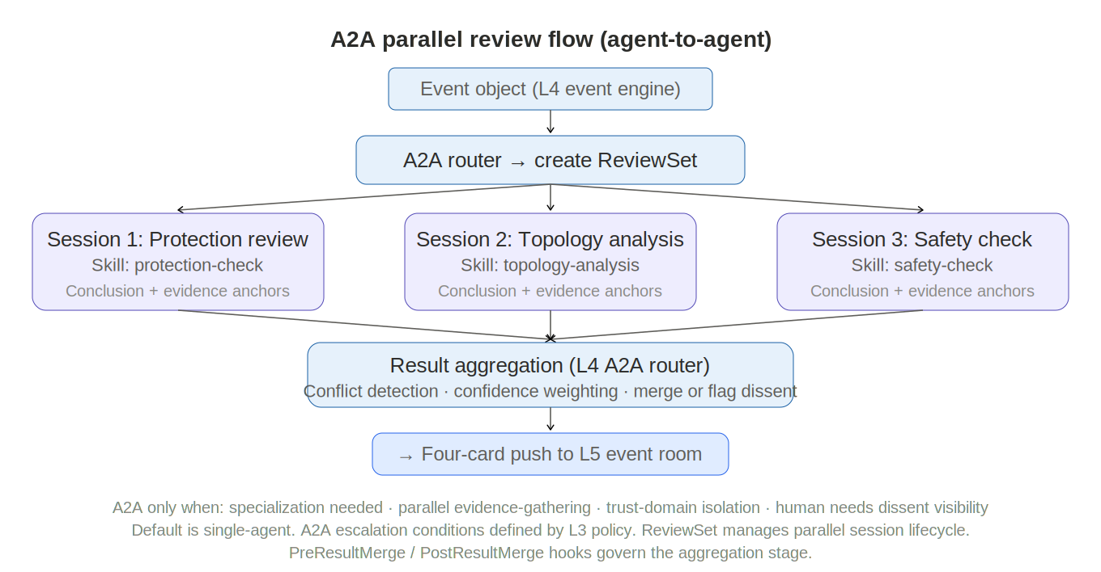
Figure 13-1: A2A Parallel Review Flow

The A2A (agent-to-agent) protocol governs how L4's A2A router coordinates multi-agent parallel review. It defines capability advertisement, collaboration dispatch, and result aggregation.

13.1 Agent capability registration

Every deployable agent (a Skill + Runtime combination) publishes a capability descriptor: agent_id, capabilities (array of capability tags such as "protection_analysis", "topology_review"), skill_id, runtime_tier (T1/T2/T3), average latency, and quality score (from blind-box voting). The registry is maintained by L4's A2A router and updated as new skills are promoted to production or new runtimes are certified.

POST /api/v1/a2a/register — Register or update an agent's capability descriptor.
GET /api/v1/a2a/discover?capabilities=X,Y — Discover agents matching required capabilities.

13.2 Collaboration dispatch

When L4 decides to escalate to A2A (per L3 policy conditions), it creates a ReviewSet and dispatches parallel sessions:

POST /api/v1/a2a/dispatch — Parameters: event_id, required_capabilities (array of review dimensions needed), parallel (boolean, typically true for cross-review), timeout (maximum wait time), and context (shared event context for all participants). The router matches each required capability to the best available agent, creates a Session for each, and starts them in parallel.

GET /api/v1/a2a/tasks/{id}/status — Poll task status. Returns per-session progress (pending, running, completed, failed) and overall ReviewSet status.

POST /api/v1/a2a/tasks/{id}/result — Each completing agent submits its result: conclusion text, confidence score, evidence anchor IDs, and any dissent flags.

13.3 Result aggregation

GET /api/v1/a2a/tasks/{id}/aggregate — Returns the merged result. The aggregation engine applies three checks:

Conflict detection: Compares conclusions across sessions. If conclusions contradict (e.g., one agent recommends action A while another recommends the opposite), the conflict is flagged with specific contradiction details.

Confidence weighting: Each conclusion's confidence score is weighted by the agent's historical quality score. The weighted aggregate determines the overall confidence of the unified recommendation.

Final recommendation: If unanimous, conclusions merge into a unified action card. If conflicting, dissent is explicitly surfaced in the action card with both positions presented, and the approval card requires human arbitration. If partially complete (some sessions timed out), completed portions are presented with pending items noted.

PreResultMerge and PostResultMerge hooks fire during aggregation, enabling L3 governance to validate completeness and consistency of the merged result.

14. Hooks: cross-cutting enforcement architecture
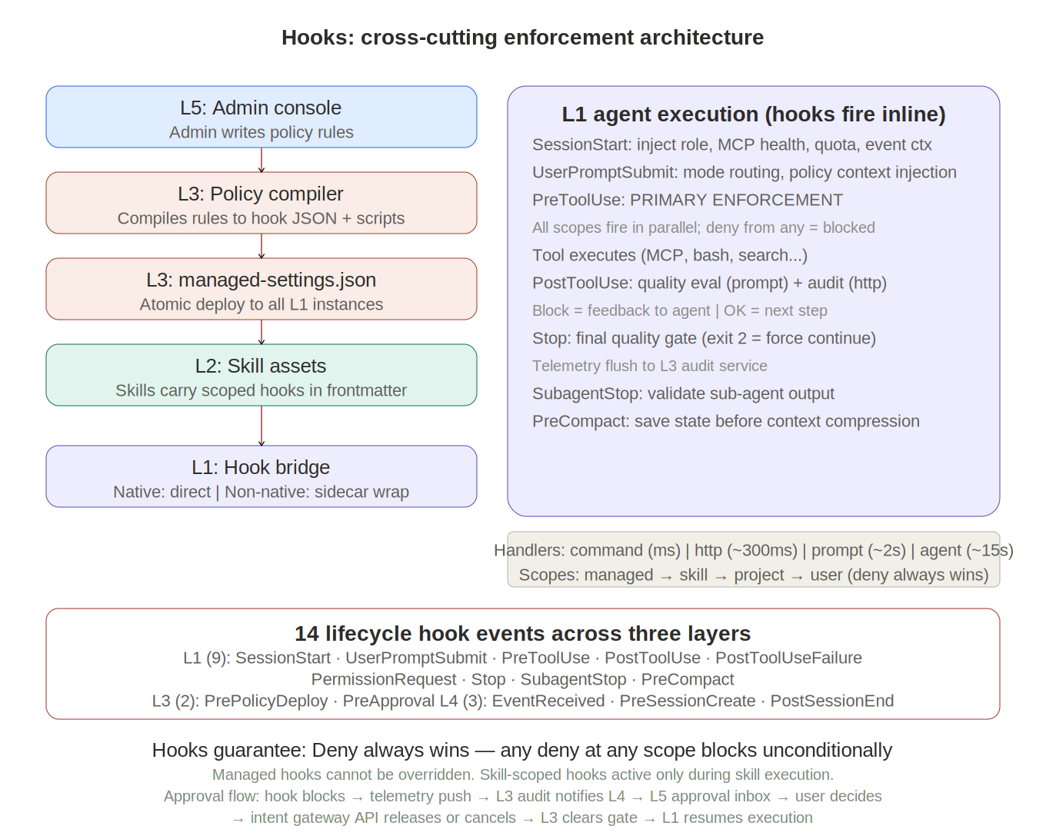
Figure 14-1: Hook Pipeline

Hooks are the single most important architectural mechanism in the platform. They provide deterministic, guaranteed enforcement at every lifecycle point, threading through all four layers. This chapter details how hooks originate, deploy, execute, and thread across the entire architecture.

14.1 Hooks origin: L3 admin console

Hooks begin as business-language policies defined by enterprise administrators in L4\'s admin console. A policy like \'the legal department cannot share documents externally without compliance review\' is captured in the policy editor as a structured rule with scope (role:legal), trigger (PostToolUse on Write/Edit tools), action (prompt hook checking for external sharing indicators), and escalation (block completion if compliance approval is not obtained). The admin console passes this structured rule to L3's policy compiler via the policy deploy API.

14.2 Hooks compilation: L3 policy compiler

The policy compiler translates structured rules into executable hook configurations. For each rule, it generates: the hook JSON configuration (specifying the event, matcher, handler type, and parameters) and the enforcement artifact (a shell script for command handlers, an HTTP endpoint URL for HTTP handlers, a prompt template for prompt handlers, or a subagent configuration for agent handlers). The compiler tests the compiled hooks against sample events in a sandboxed L1 session. If tests pass, the compiled hooks are packaged as a managed-settings.json update.

14.3 Hooks deployment: L3 managed-settings

The policy deploy API (L3/L4 Contract 1) receives the compiled managed-settings.json update. L3\'s configuration store records the new version with author, timestamp, and diff from the previous version. L3 distributes the update atomically to all active and future L1 instances. Active sessions receive new hooks at their next lifecycle event. New sessions receive hooks at SessionStart. Deployment is atomic: either all instances receive the update, or it rolls back. L3 also stores the hook scope hierarchy: managed hooks at the enterprise/BU/dept/team level, ensuring lower-level policies tighten but never loosen higher-level policies.

14.4 Hooks bridging: L1 hook bridge

When L1\'s runtime selector creates a session, the adapter loads managed hooks into the runtime. For harness agents (Octo, Claude Code), hooks load directly into the runtime\'s native hook system with zero overhead. For non-hook-native runtimes (Aider, Goose, LangGraph agents), L1\'s hook bridge intercepts externally. The bridge wraps every tool call: the framework decides to call a tool, the bridge intercepts, runs PreToolUse hooks, forwards to the tool if allowed, intercepts the result, runs PostToolUse hooks, and returns the result if not blocked. The bridge runs as a sidecar container colocated with the runtime for minimal latency. The bridge also handles skill-scoped hooks: when a workflow-skill is loaded and its frontmatter hooks activate, the bridge adds them to the interception pipeline alongside managed hooks.

14.5 Hooks execution: L1 inline firing

During execution within any L1 agent instance, hooks fire inline at every lifecycle event:

- SessionStart: Fires when the session begins. Managed hooks inject organizational context (user role, MCP connector health, quota status) into the agent\'s initial context. Quota enforcement hooks check remaining allocation and block session creation if exceeded.

- UserPromptSubmit: Fires when the user submits a message, before processing. The kernel boot skill\'s mode router is implemented as a command handler on this event, classifying requests as SIMPLE (bypass kernel) or KERNEL (activate structured execution). Additional managed hooks can inject policy context or block prohibited request patterns.

- PreToolUse: The primary enforcement point. Fires before every tool execution. All matching hooks fire in parallel (managed, skill-scoped, project, user). If any hook returns deny (exit code 2), the tool call is blocked and the denial reason is fed back to the agent as context. The agent can then adapt, choose a different tool, or inform the user. This is where access control, safety checks, and domain-specific guards execute.

- PostToolUse: Fires after tool execution succeeds. Two roles: quality evaluation (prompt hooks assess output for anomalies, compliance issues, or quality criteria defined in the workflow-skill) and audit logging (async HTTP hooks push the execution context to L3\'s audit service without blocking). If a PostToolUse hook blocks, the block reason is fed back to the agent, which must address the issue before proceeding.

- PostToolUseFailure: Fires when a tool call fails. Injects diagnostic information into the agent\'s context (\'the Google Drive MCP connector is returning 503; it may be temporarily unavailable\'). Enables the kernel\'s adaptive recovery: the agent reads the diagnostic and decides whether to retry, skip the step, or escalate.

- PermissionRequest: Fires when the agent requests permission for a tool. Managed hooks can auto-approve safe operations and escalate sensitive ones. The escalation creates an approval request in L4\'s approval inbox.

- Stop: Fires when the agent finishes responding. The final quality gate: exit code 2 forces the agent to continue working (fix issues identified by the hook). Exit code 0 allows completion. The Stop hook also pushes a final telemetry summary to L3\'s audit service.

- PreCompact: Fires before context window compaction. Allows a hook to save the current kernel execution state summary to L4\'s session store (via async HTTP hook) before detailed conversation history is compressed. Critical for maintaining execution coherence across long-running workflows.

14.6 Hooks telemetry flow: L1 to L2 to L3

After every tool call, async PostToolUse HTTP hooks push telemetry from L1 to L3\'s audit service. This is the primary feedback mechanism. The telemetry includes: session ID, runtime ID, user identity, tool name, tool input (sanitized), tool output (truncated), execution duration, hook decisions (which hooks fired, what they decided), and resource consumption (tokens, compute time). L3\'s audit service stores these events and makes them available to L4\'s observability hub through the telemetry ingest API (Contract 4). L3 aggregates and visualizes the data in dashboards. This creates the complete observability pipeline: L1 generates data, L3 captures and stores it, L4 presents and analyzes it.

14.7 Hooks approval flow: L1 to L2 to L3 to L1

When a hook blocks execution pending human approval, a cross-layer flow activates. The hook blocks in L1 and returns a structured reason. The async telemetry push includes a \'blocked_pending_approval\' event. L3\'s audit service notifies L3 through the telemetry ingest API. L4\'s notification system presents the approval request in the employee\'s approval inbox (or via Slack/email notification). The approver reviews the context and clicks approve or reject. L3 calls the intent gateway API (Contract 2, POST /v1/intents/{id}/approve) to release or cancel the blocked workflow. L3 clears the gate, and L1\'s runtime resumes execution. This is the only hook flow that requires a cross-layer round-trip during execution; all other hooks complete inline.

14.8 Hooks guarantee: deny always wins

The fundamental guarantee: if any hook at any scope level denies an action, the action is blocked regardless of what other hooks decide or what the agent\'s reasoning concludes. This is not a probability or a suggestion; it is a deterministic rule enforced by the hook execution engine. Managed hooks cannot be overridden by skill-scoped, project, or user hooks. Skill-scoped hooks cannot be overridden by project or user hooks. This hierarchical deny-always-wins model is what makes hooks suitable for enterprise governance: an administrator can guarantee that a policy is enforced even if a skill author, a project configuration, or the agent itself would prefer otherwise.

14.9 Additional lifecycle events (L3 and L4)

Beyond the nine L1 events described above, the platform defines five additional hook events at L3 and L4:

PrePolicyDeploy (L3). Fires before a new managed-settings.json version is deployed. Enables format validation, conflict detection between new and existing policies, and mandatory sandbox testing. If the hook denies, the deployment is aborted.

PreApproval (L3). Fires before an approval decision is processed. Auto-triggers deterministic verification if not already performed, validates evidence completeness (all required anchors present and intact), and can inject additional context into the approval card.

EventReceived (L4). Fires when a raw event enters the event engine. Enables policy-based event filtering (drop irrelevant events before they consume pipeline resources), priority adjustment (escalate or de-escalate based on organizational rules), routing modification (redirect events to different organizational units), and cost-budget checks (block event processing if the budget is exhausted).

PreSessionCreate (L4). Fires before the three-way handshake creates a session. Enables quota checks (block if the user or team has exceeded their allocation), permission verification (ensure the user has access to the requested skill), and runtime selection strategy override (force a specific runtime for compliance reasons).

PostSessionEnd (L4). Fires after a session completes. Triggers memory deposit (write conclusions and evidence to L2's Memory Engine), telemetry summarization (aggregate session-level metrics), event state update (transition the parent event's state machine if all sessions are complete), and retrospective scheduling (queue a retrospective session if the event enters the closed state).

These five events bring the total to 14 lifecycle hook points across three layers, providing governance coverage of the complete request lifecycle from event intake to memory deposit.

15. Data-flow pipeline
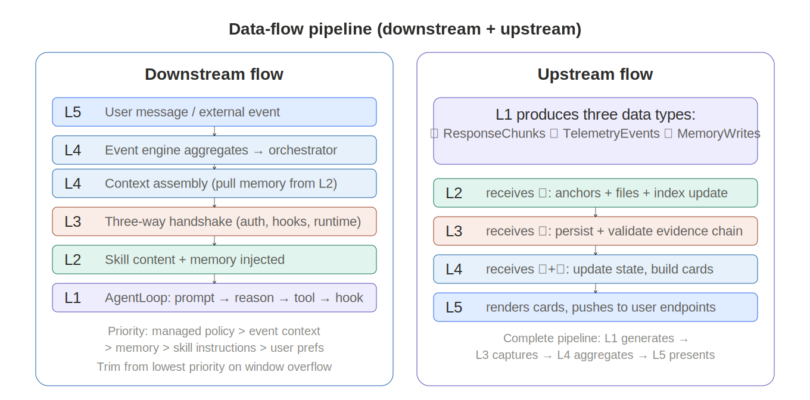
Figure 15-1: Data-flow Pipeline

The data-flow pipeline defines how information moves through the five layers in both directions.

15.1 Downstream flow

The downstream path transforms a raw event or user request into an executing agent with full context:

L5 receives user message or external event → L4's event engine aggregates (dedup, cluster, correlate) into a structured event object → L4's orchestrator queries L2's Memory Engine for relevant prior memory and L2's Ontology Service for business context → L4 assembles the complete SessionPayload → L3 performs the three-way handshake: authenticates the user, resolves organizational role, compiles hierarchical managed hooks, selects the runtime → L2 provides the skill content (SKILL.md with frontmatter hooks) → L1 receives the SessionPayload, boots the session (context injection, hook loading, system-prompt assembly), and enters the AgentLoop.

Context assembly priority. When assembling the SystemPrompt, content is prioritized: managed policy context (highest) → event context → relevant memory → skill instructions → user preferences (lowest). When the context window is constrained, lower-priority content is trimmed first.

15.2 Upstream flow

L1 produces three upstream data types during and after execution:

ResponseChunks (streaming): text_delta, tool_start, tool_result, and done tokens flow from L1 through L4 to L5 for real-time rendering in the event room.

TelemetryEvents (async): After every tool call, async PostToolUse HTTP hooks push structured telemetry (session ID, runtime ID, user identity, tool name, inputs/outputs, hook decisions, resource consumption) from L1 to L3's audit service. L3 stores these events and makes them available to L5's observability dashboards.

MemoryWrites (on-demand): Evidence anchors (append-only data snapshots) and memory files (conclusions, preferences, experience) flow from L1 to L2's Memory Engine during execution, triggered by PostToolUse or Stop hooks. After session completion, PostSessionEnd triggers a memory deposit summarizing the session's contributions.

The complete telemetry pipeline: L1 generates → L3 captures and validates → L4 aggregates and routes → L5 presents and analyzes.

16. Session-control pipeline
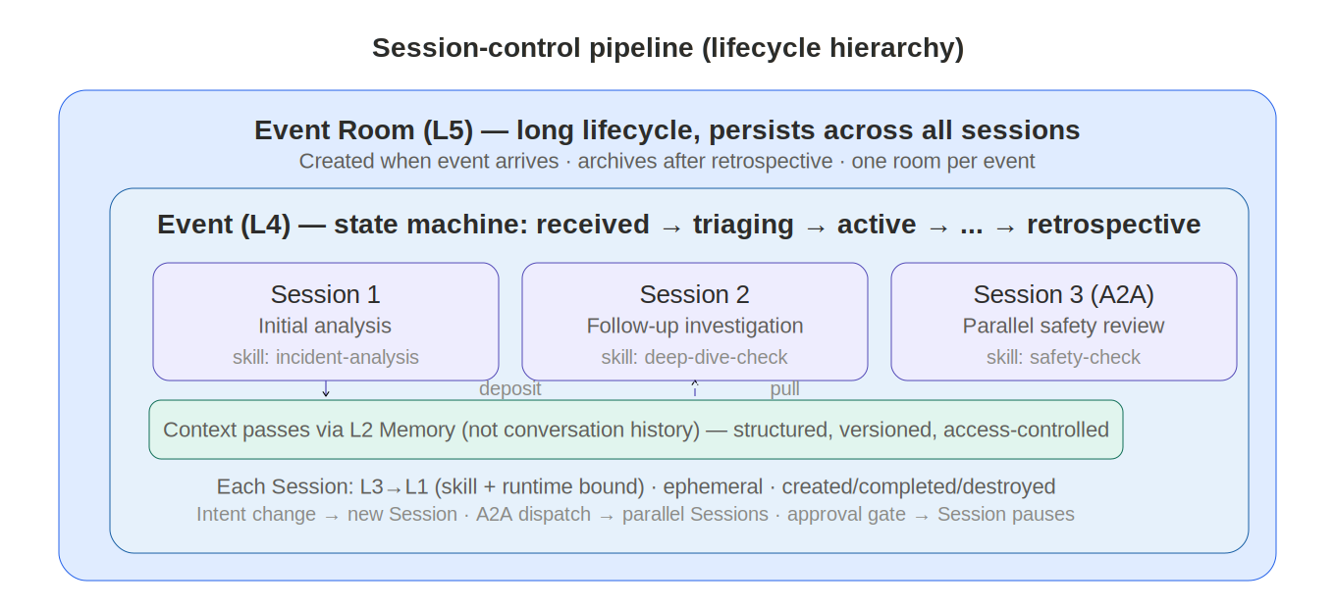
Figure 16-1: Session-control Pipeline

The session-control pipeline manages the lifecycle relationship between event rooms, events, and sessions.

16.1 Session model

The three-tier hierarchy:

Event Room (L5): The user-facing collaboration space. Long-lived — created when the event is created, persists across all sessions, archives after retrospective. Not closed when individual sessions end.

Event (L4): A business-event object with a complete state machine (received through retrospective). One Event Room associates with exactly one Event. The Event owns the authoritative state.

Session (L3→L1): A single agent task execution bound to a specific Skill and Runtime. One Event can spawn multiple Sessions: initial analysis, follow-up investigation, A2A parallel reviews, post-approval execution. Sessions are ephemeral — created, executed, completed.

Sessions pass context through L2 Memory, not conversation history. When Session 1 ends, its conclusions are deposited into L2. When Session 2 starts, the orchestrator pulls relevant memory from L2 into the new SessionPayload.

16.2 Three-way handshake
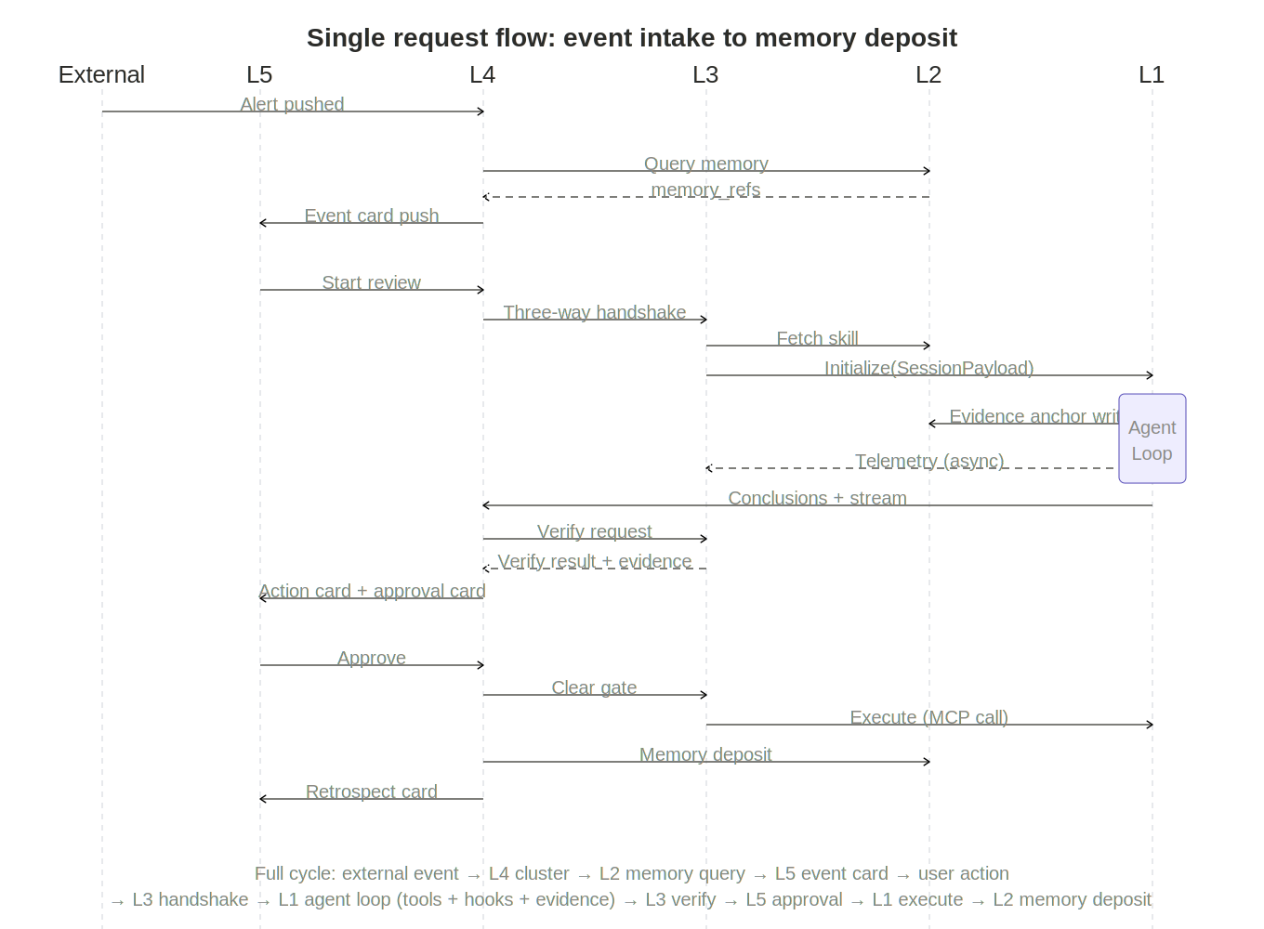
Figure 16-1: Full Sequence

Session creation is the most critical integration point, involving three layers in a coordinated sequence:

(1) The employee opens an event room in L5, or the event bus receives an external trigger. (2) L4's orchestrator queries L2's Memory Engine for relevant prior memory (memory_refs). (3) L4 calls POST /v1/sessions/create on L3, providing user context, task profile, runtime preference, event_context, and memory_refs. (4) L3 authenticates the user or source, resolves organizational role and unit. (5) L3 compiles the hierarchical managed hooks for the user's organizational unit (enterprise → BU → department → team). (6) L3 calls L1's runtime selector, which chooses a runtime based on task profile, skill affinity, and selection strategy. (7) L1 allocates a runtime instance. The session bootstrap subsystem activates: context injector formats the SessionPayload, hook loader activates managed hooks (native or via bridge), system-prompt assembler builds the complete prompt from skill instructions + event context + memory + organizational context. SessionStart hook fires. (8) L3 returns the session handle to L4. (9) L4 connects the L5 event room to the session and begins streaming messages.

After creation, message flow is L4 ↔ L1 with L3's hooks executing inline on every tool call. No L3 API calls occur during execution — governance is embedded at creation time.

17. Deployment topology
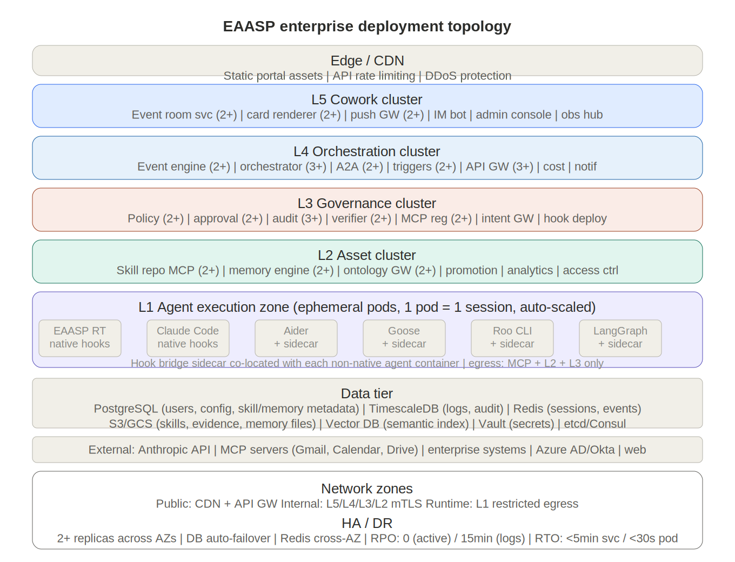
Figure 17-1: Deployment Topology

The platform deploys across six infrastructure zones, each independently scalable. The architecture is designed for Kubernetes-based container orchestration but can adapt to serverless or VM-based deployments. Each of the four layers maps to its own deployment zone, plus shared edge and data tiers.

17.1 Edge / CDN zone

Static portal assets (web application, mobile PWA), API rate limiting, and DDoS protection. Serves employee portal HTML/JS/CSS and routes dynamic API calls to the L4 services cluster. CloudFront, Cloudflare, or equivalent CDN.

17.2 L4 human engagement cluster

Kubernetes namespace hosting all L4 services as independently scalable deployments. API gateway (3+ replicas, horizontal auto-scaling on request rate), session manager (3+ replicas, auto-scaling on active session count), event bus (2+ replicas with message queue backing: SQS, Kafka, or NATS), observability hub (2+ replicas, read-heavy workload), admin console and process designer (web applications, 2+ replicas each), cost governance service (1+ replicas), and notification service (2+ replicas with push notification and email provider integrations). All L4 services communicate internally via service mesh (Istio or Linkerd) with mTLS.

17.3 L3 agent governance cluster

Kubernetes namespace hosting L3 governance services. Policy engine (2+ replicas, evaluates RBAC and conditional policies), policy compiler (2+ replicas, compiles rules to hook JSON with sandbox testing), approval gates service (2+ replicas, manages block/release state and L4 inbox notifications), hook deployment service (2+ replicas, atomic managed-settings.json distribution with versioning and rollback), audit service (3+ replicas, high-write telemetry ingest from all L1 instances), intent gateway (2+ replicas, handles event-driven workflow dispatch), and MCP registry (2+ replicas, serves connector health checks from all runtimes). L3 services are stateless; all persistent state lives in the data tier. L3 communicates upward to L4 via the five L3/L4 API contracts and downward to L1 by embedding hooks at session creation.

17.4 L2 skill assets cluster

Kubernetes namespace hosting L2 operational services. Skill repository MCP server (2+ replicas, serves skill reads from all L1 agents and skill writes from L4 process designer), promotion engine (2+ replicas, manages lifecycle transitions with role-based gates from L3), dependency resolver (1+ replicas, validates skill compatibility on promotion and read), access control service (colocated with repository, enforces organizational scoping on every request), version manager (colocated with repository, handles versioning and rollback), and usage analytics engine (2+ replicas, processes telemetry from L3 audit service to produce per-skill quality metrics). L2 services store skill content in object storage (S3/GCS) and metadata in PostgreSQL.

17.5 L1 agent execution zone

Container execution zone hosting agent runtime instances. Each runtime type has its own container image: Octo (Claude runtime + kernel boot skill + managed hooks), Claude Code (Claude runtime + coding tools + managed hooks), Aider (Python runtime + Aider CLI + hook bridge sidecar), Goose (Rust runtime + Goose binary + hook bridge sidecar), LangGraph agent (Python runtime + LangGraph + adapter + hook bridge sidecar). L1 containers are ephemeral: created on session start, destroyed on session end. Auto-scaling based on active session count with configurable min/max per runtime type. The hook bridge runs as a sidecar container colocated with each non-native runtime, sharing the pod network for minimal interception latency.

Resource isolation: each L1 container gets dedicated CPU/memory limits, an isolated filesystem (tmpfs or ephemeral volume for /home/claude), and network egress restricted to allowed MCP server endpoints, L2 skill repository, and L3 audit service. No L1 container can access another L1 container or any L4 service directly.

17.6 Data tier

Managed database services providing persistent state across layers:

- PostgreSQL: L4 user database (profiles, roles, quotas), L3 configuration store (policies, RBAC rules), and L2 skill metadata (versions, access scope, promotion status, dependencies). Primary + read replicas. Point-in-time recovery.

- TimescaleDB or ClickHouse: L4 execution log and L3 audit event store. Optimized for time-series append and analytical queries. Retention policies per data category.

- Redis: L4 session store (conversation state, kernel state snapshots for cross-session resumption). Cluster mode with persistence (AOF) for durability. TTL-based expiry for abandoned sessions.

- Object storage (S3/GCS/Azure Blob): L2 skill repository content (SKILL.md files, templates, assets), L1 output file storage (generated documents, artifacts), and backup storage.

- Secrets vault (HashiCorp Vault / AWS Secrets Manager): MCP connector credentials (OAuth tokens, API keys), database connection strings, deployment signing keys. Rotated automatically. Never stored in configuration files or environment variables.

17.7 External integrations

Anthropic API (Claude model inference for all harness agents), MCP servers (Gmail, Calendar, Drive, and custom enterprise MCP servers), enterprise systems (ERP, CRM, HRIS accessed by both L4 connector fabric and L1 MCP connectors), web (search, fetch for L1 agent web retrieval), and identity providers (Azure AD, Okta for SSO/SAML authentication).

17.8 Network architecture

Three network zones with controlled ingress/egress. The public zone contains the CDN and API gateway external endpoint. The internal zone hosts L4, L3, and L2 services communicating via service mesh with mTLS. The runtime zone hosts L1 containers with restricted egress: L1 can reach MCP server endpoints, L2 skill repository, and L3 audit service only. L1 containers cannot reach L4 directly; telemetry flows L1 → L3 (async hooks) → L4 (telemetry ingest API). This prevents a compromised agent from accessing persistent state, user databases, or admin interfaces.

17.9 High availability and disaster recovery

All L4, L3, and L2 services run with 2+ replicas across availability zones. Database primary/replica failover is automated. The session store (Redis cluster) replicates across zones for session continuity during zone failures. L1 containers are stateless and recoverable: a failed agent is replaced by a new instance initialized from L4's session store. RPO (recovery point objective): zero for active sessions (real-time replication), 15 minutes for execution logs (async batch write). RTO (recovery time objective): under 5 minutes for L4/L3/L2 service failover, under 30 seconds for L1 agent replacement.

- L4 Human Engagement Cluster --- a K8s namespace with 7+ microservices. This is what users actually touch. The API gateway (FastAPI, 3+ pods) is the single entry point for all access --- employee portal, Slack/Teams, webhooks, CLI, admin console. The session manager (WebSocket-capable, 3+ pods) is the brain that orchestrates the three-way handshake. The event bus (Kafka/NATS, 2+ pods) turns business triggers (CRM webhook, cron job, DB change event) into structured intents. All four data stores (PostgreSQL, TimescaleDB, Redis, S3) are owned by L4.

- L3 Governance Cluster --- a separate K8s namespace with 7 stateless services. The key operational relationship: when the session manager in L4 creates a session, it calls L3 which resolves the user\'s org hierarchy (enterprise → BU → department → team), compiles the layered managed hooks, and attaches them to the session payload. The hook deployment service distributes managed-settings.json atomically via etcd/Consul. The audit service is the highest-write service (receives async telemetry from every tool call in every L1 pod).

- L2 Skill Assets Cluster --- another K8s namespace. The skill repository MCP server is the single access point --- L1 agents connect to it directly via MCP protocol (not routed through L3). When an agent calls skill_read, L2\'s access control validates the user\'s org scope against L3\'s RBAC, then returns the SKILL.md content including frontmatter hooks. L3 governs what gets promoted (role-based gates), but L2 serves content directly to L1.

- L1 Agent Execution Zone --- ephemeral container pods, one per session. Each pod contains the agent runtime + (for non-native agents) a hook bridge sidecar sharing the pod network. Tier 1 pods (Octo, Claude Code) load hooks natively with zero overhead. Tier 2/3 pods (Aider, Goose, LangGraph) have the sidecar intercepting every tool call. Pods are created on session start, destroyed on session end, auto-scaled on active session count. Network egress is restricted to three endpoints only: MCP servers, L2 skill repo, L3 audit service.

The operational flow for a single request: User opens Slack → Edge routes to L4 API gateway → SSO auth → session manager starts three-way handshake → L3 attaches managed hooks → L1 selector picks runtime → pod created with hooks embedded → user message streams L4↔L1 → every tool call: PreToolUse hooks fire (including skill-scoped from L2) → tool executes → PostToolUse hooks fire (quality check + async audit to L3) → response streams back → session ends → pod destroyed, state flushed to L4 session store.

17.10 L5 Cowork cluster

Event room service (2+ replicas, event room lifecycle management), card renderer service (2+ replicas, four-card data assembly and SSE/WebSocket push), push gateway (2+ replicas, connection management for real-time streaming), IM bot services (per-platform: WeChat Work, DingTalk, Feishu, Slack adapters), admin console and process designer (web applications, 2+ replicas each), observability hub (2+ replicas, read-intensive dashboards). L5 services communicate via service mesh within the cluster.

17.11 L2 Memory Engine cluster

Memory Engine (2+ replicas, evidence anchor store + file memory + hybrid retrieval index), Ontology Service gateway (2+ replicas, ontology query proxy + MCP exposure). These services share the L2 asset cluster's PostgreSQL metadata and S3/GCS object storage, with an additional vector database (pgvector or standalone) for the semantic retrieval index.

18. Evolution strategy

The platform evolves through seven phases aligned with the five-layer architecture. Each phase delivers independent value with no rework of prior phases.

Phase 0: MVP Validation (baseline). Full L4→L3→L2→L1 chain. Policy compiler, five API contracts, three-way handshake, skill injection, hook enforcement. Validation: a complete workflow-skill executes end-to-end under managed-hooks governance.

Phase 1: Event-driven foundation (weeks 1–6). L4 event engine (ingest → dedup → cluster → event objects → state machine). L5 event room data model and event-card API. L4 hooks (EventReceived, PreSessionCreate, PostSessionEnd). Independent value: automatic alert aggregation and notification, reducing alert fatigue.

Phase 2: Memory and evidence (weeks 5–12, parallel with Phase 1). L2 Memory Engine (evidence anchors + file memory + hybrid index). L1→L2 memory write channel. L4→L2 context assembly channel. Independent value: agents accumulate experience; repeated-task quality improves; audit becomes traceable.

Phase 3: Approval and verification (weeks 10–18). L3 approval control chain (Plan → Check → Draft → Approve → Execute). Deterministic verifier interface. L5 approval card interaction. Independent value: systematic control for high-risk operations.

Phase 4: Multi-agent collaboration (weeks 16–24). L4 A2A router (capability publish, dispatch, aggregation). Parallel execution. L5 review-conclusion display. Independent value: multi-dimensional cross-checking for complex decisions.

Phase 5: Complete collaboration space (weeks 22–30). L5 four-card rendering engine. IM bot plugins. Retrospective and memory-deposit closed loop. Validation: complete lifecycle from external event to memory deposit operates via IM card interaction.

Phase 6: Ecosystem expansion (ongoing). Runtime certification pipeline. L2 skill marketplace. Multi-tenancy. Platform API SDK. L2 Ontology Service integration.

19. Design anti-patterns

- Using prompts where hooks are needed: If something must happen every time (policy, validation, audit), it must be a hook. Prompts are suggestions; hooks are guarantees.

- Overusing expensive hooks: Not every check needs a prompt or agent hook. Start with command hooks (ms), escalate to prompt hooks (seconds) only when semantic evaluation is needed.

- Skipping the mode router: Routing all requests through the kernel adds latency to simple tasks. 80% of requests should be classified as SIMPLE with zero kernel overhead.

- Governance without managed hooks: Reasoning-based policy enforcement can be ignored by the agent. Only managed hooks provide the deny-always-wins guarantee.

- Monolithic hook scripts: Keep hooks small, fast, single-purpose. They run in parallel; a slow hook blocks everything. Split into separate hooks.

- Skills without scoped hooks: A skill relying entirely on natural-language instructions for quality enforcement will eventually miss criteria. Add hooks for non-negotiable checks.

- Bypassing the skill repository: Loading skills from filesystem loses versioning, access scoping, and usage analytics. All skills through the repository MCP server.

- Treating the filesystem as persistent: L1's filesystem resets between sessions. Use L2 hooks (telemetry) or L3 MCP (session store) for anything that must survive.

- Ignoring runtime headless capability: VS Code extensions (full Cline, full Roo Code) cannot run as server-side execution pool runtimes. Only CLI variants qualify. The extensions can be client-side runtimes governed by local managed hooks.

- Double abstraction: If the skill system already handles a pattern, don't wrap it in an L2 abstraction. L2 invokes skills; it doesn't re-implement their logic.

11. Treating every alert as a separate event. One hundred related alerts should aggregate into a single event object, not spawn one hundred event rooms. The event engine's clustering capability is the core differentiator. An event engine without clustering is just a message forwarder.

12. Conclusions without evidence. Agent conclusions without evidence anchors are as untraceable as operations without audit logs. Every critical conclusion must reference at least one evidence anchor.

13. Using LLMs for deterministic verification. "Did the five-prevention check pass?" should not be answered by an LLM. Rule engines, simulation tools, and other deterministic systems handle verification; LLMs handle reasoning. Deterministic tasks go to deterministic tools.

14. Agent overreach. Agents should produce drafts, not directly execute high-risk operations. The cost of a draft is seconds of waiting; the cost of overreach may be irreversible consequences.

15. Treating memory as a vector database. Memory files should be human-readable structured text, not a vector-only black box. If humans cannot review memory content, they cannot correct agent drift. Hybrid retrieval (keyword + semantic + time-decay) outperforms pure vector search.

20. Complete design decision trail

This table traces every key architectural question across all five iterations of the design.

Question | v1–v2 | v3 (hooks) | v4 (pool) | v7 final
What is L1? | Single runtime only | Runtime + kernel + hooks | Abstraction + pool | L1 Agent Execution Layer. Internal abstraction (selector, adapters, hook bridge, telemetry). 3 tiers. 12-method contract.
What is L2? | Skill files on disk | Skill repo (MCP) | Shared MCP server | L2 Skill Assets Layer. Full operational layer with 6 services, 4-stage promotion pipeline, org-scoped access control.
What is L3? | Undefined | Managed hooks | Governance layer | L3 Agent Governance Layer. 7 services. Deny always wins. 4 hook scope levels. 4 handler types.
What is L4? | Not addressed | Not addressed | Enterprise app | L4 Human Engagement Layer. 4 planes (experience, integration, control, persistence). 5 API contracts. Multi-tenant.
Workflows? | YAML pipelines | Skills + hooks | + affinity | Workflow-skills with scoped hooks + runtime affinity. Intelligence and deterministic safeguards in one asset.
Governance? | Undefined | Managed hooks | + hook bridge | Managed hooks + hook bridge for all runtimes. Policy compiled from admin console. Deny always wins.
Agents? | Single runtime | Single runtime | 4 tiers mapped | T1 Harness (EAASP RT, Claude Code, SDK). T2 Aligned (Aider, Goose, Roo, Cline). T3 Framework (LangGraph, CrewAI). T4 deferred.
State? | Undefined | Ephemeral | Layer split | L4 persistent (DB). L3 config (managed-settings). L1 ephemeral (in-session). Cross-session via hooks or MCP.
Layers? | Two (L2+L1) | Three + hooks | Four + hooks | Four layers + 3 cross-cutting mechanisms (hooks, skills, MCP).
Evolution? | Not addressed | Not addressed | Extend, 5 phases | Extend existing runtime: 5 phases (kernel → repo → L3+T2 → full L4+T3 → ecosystem). Each phase delivers independent value.

Additional v1.8 design decisions:

Question | Resolution
What is the top layer? | L5 Cowork layer (event rooms + four-card paradigm); L4 becomes Orchestration layer
Driving model? | Event-driven + request-driven hybrid (event engine in L4)
Multi-agent? | A2A parallel review via ReviewSet orchestration; single-agent default with policy-triggered escalation
Memory? | L2 Memory Engine with three-layer storage (evidence anchors + file memory + hybrid index)
Business ontology? | L2 Ontology Service with integration contract for external providers
Interaction paradigm? | Event rooms + four pinned cards; cards are projections, not truth sources
Approval model? | Five-stage control chain: Plan → Check → Draft → Approve → Execute; risk-tiered
Evidence? | Every conclusion references evidence anchors; L3 validates chain completeness
Hook event count? | 14 events across three layers (L1: 9, L3: 2, L4: 3)

21. Implementation team assignment
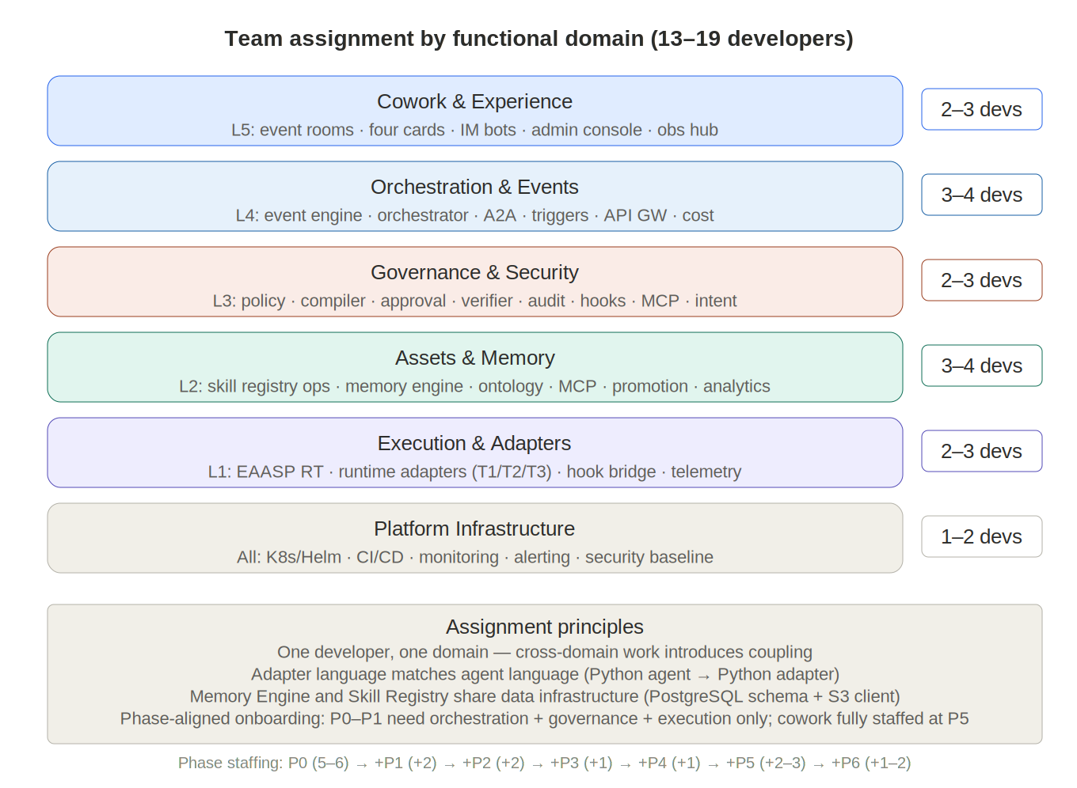
Figure 21-1: Team Assignment

This chapter maps every platform component to individual developers based on a Python-heavy team of 10--16 people. The team has four language competencies: Python (majority), TypeScript with React (frontend), Java (enterprise infrastructure), and Rust (small, performance-critical). Each developer owns 2--4 related modules that share the same domain logic, data model, or deployment unit. There are no single-module assignments. The minimum viable team is 10 developers (Py1--5, TS1--2, Java1, Rust1, DevOps1); optional roles (Py6, Java2) scale the team to 16 as agent breadth and data-pipeline volume grow.

21.1 Python team (5--8 developers)

The largest group, owning the majority of backend services across L4, L3, L2, and L1. The core team requires five Python developers (Py1--5); up to three additional developers (Py6--8) are added as agent diversity and operational volume grow. Python's ecosystem covers all requirements: FastAPI for high-performance async services, Python MCP SDK for MCP server implementations, SQLAlchemy for metadata management, pandas/numpy for analytics, and native fluency with the AI agent ecosystem.

Py Dev 1 --- L4 backend + L1 harness

Owns the L4 async I/O layer: API gateway (FastAPI with middleware for auth, rate limiting, routing), session manager (WebSocket streaming, session lifecycle, three-way handshake coordination), notification service (push notifications, email integration, approval inbox routing), and connector fabric (MCP connector lifecycle, credential delegation to secrets vault). Also owns the thin harness agent adapters for Octo, Claude Code, and Agent SDK in L1, since these are lightweight Python shims over the runtime interface contract that share the session manager's connection model.

Py Dev 2 --- L3 governance core

Owns all five TypeScript-free L3 governance services: policy engine (RBAC rule management, conditional policy evaluation, organizational hierarchy scoping), policy compiler (rules-to-hook-JSON compilation, enforcement script generation, sandbox testing in isolated L1 sessions), approval gates (block/release state machine, L4 inbox notification), MCP registry (MCP server exposing connector health and registration), and intent gateway (event-driven workflow dispatch and routing). These five services share the same domain model --- policies, hooks, organizational units --- making them a natural single-developer scope. Implemented with FastAPI + Python MCP SDK.

Py Dev 3 --- L2 repository and access

Owns the L2 core data services: skill repository MCP server (7 MCP tools for search, read, submit, promote, list versions, dependencies, usage), access control service (validates every read/write against organizational scope via L3's RBAC), dependency resolver (graph traversal for inter-skill compatibility, break detection on promotion/deprecation), version manager (semantic versioning, rollback, diff tracking, deprecation warnings), and storage layer (S3/GCS integration for SKILL.md content, PostgreSQL for metadata, read-through caching for production skills). These services share the same database schema and object storage client, making them a cohesive ownership scope.

Py Dev 4 --- L2 lifecycle and quality

Owns the L2 intelligence services: promotion engine (four-stage lifecycle pipeline with role-based gates, eval framework integration), usage analytics engine (telemetry processing from L3 audit service, per-skill quality metrics, failure pattern analysis, deprecation candidate detection), skill validator (YAML frontmatter syntax validation, hook declaration checking against known handler types, runtime affinity verification against registered runtimes), and skill authoring tools (skill-creator and skill-evaluator meta skills using LLM API calls). These services form the skill quality feedback loop: execution data feeds analytics, analytics informs quality scores, quality scores guide promotion decisions and skill improvement.

Py Dev 5 --- L1 adapters (core)

Owns the primary Python-based agent adapters in L1: Aider (git-native, simple execution loop makes hook bridge integration straightforward), Goose (MCP-native, transparent execution model), and LangGraph (thick adapter translating skills to graph nodes, durable execution with checkpointing). Each adapter must implement the 12-method runtime interface contract via the agent's native Python API. This developer also writes Python hook handler scripts (command hooks, HTTP endpoint handlers) used across the platform. If the team operates at minimum size (no Py Dev 6), this developer additionally absorbs CrewAI and Pydantic AI adapters with a narrower initial scope (fewer agents onboarded in Phase 2).

Py Dev 6 --- L1 adapters (extended, optional)

Owns the remaining agent adapters: CrewAI (role-based multi-agent, skill-to-crew translation) and Pydantic AI (type-safe, clean agent model). Also responsible for onboarding future agents into the execution pool --- writing new adapters, validating them against the runtime certification pipeline, and extending hook bridge compatibility. This role is optional at launch: Py Dev 5 can cover all five adapters in a smaller team, but separating the role avoids bottlenecking adapter velocity as agent diversity grows beyond Phase 2.

21.2 TypeScript / React team (2 developers)

Focused exclusively on L4 frontend applications. Both developers work in React + TypeScript building the user-facing surfaces that the Python backend serves.

TS/React Dev 1 --- Portal

Owns the employee portal: web application, mobile PWA, Slack/Teams embed integration. Handles multi-channel routing, conversation continuity across devices, and session UX. The portal is the primary surface through which employees interact with the platform.

TS/React Dev 2 --- Admin and operations

Owns the admin console (policy rule editor, role management, agent execution management), process designer (visual skill builder with drag-and-drop, simulation mode), and observability hub dashboards (runtime comparison, cost tracking, workflow execution traces). These three applications share a common admin design system and API client library.

21.3 Java team (1--2 developers)

Handles enterprise infrastructure components where Java's maturity in reliability, transaction management, and high-throughput data processing provides irreplaceable value.

Java Dev 1 --- L4 infrastructure

Owns the L4 enterprise backbone: event bus (Kafka/NATS integration, schedule/webhook/CDC triggers, exactly-once delivery guarantees), persistence plane (PostgreSQL connection pools, TimescaleDB time-series writes, Redis session store with AOF persistence), and cost governance service (quota enforcement, budget tracking, chargeback reporting). These three services share JDBC connection pools and the same data tier.

Java Dev 2 --- L3 data pipeline (optional)

Owns the L3 high-write services: audit service (telemetry ingest endpoint receiving async PostToolUse events from all L1 instances, structured event store with TimescaleDB) and hook deployment service (atomic managed-settings.json distribution via etcd/Consul, version tracking, rollback, diff management). If the team has only one Java developer, these services can be absorbed by Java Dev 1, since the audit service and persistence plane share the same TimescaleDB infrastructure. Alternatively, the audit service can be implemented in Python (Py Dev 2) using async frameworks, with Java Dev 1 extending to cover hook deployment.

21.4 Rust developer (1)

Owns the L1 sidecar binary: hook bridge (intercepts every tool call for non-native agents, enforces deny-always-wins), runtime selector (matches task profiles against capability manifests on every session creation), and telemetry collector (normalizes high-throughput event streams before pushing to L3 audit). All three components compile into a single Rust binary deployed as a sidecar container colocated with each non-native agent. This is the most performance-critical code in the platform --- the hook bridge's latency directly impacts every tool call for every bridged agent. A single senior Rust developer can own this scope because the three components are tightly coupled, share the same async runtime (tokio), and deploy as one unit.

21.5 DevOps (1 developer)

Owns all infrastructure automation: container images (Dockerfiles for each agent type with hook bridge sidecar), Kubernetes deployment (Helm charts for L4/L3/L2 service clusters and L1 container execution zone), CI/CD pipelines (automated testing, security scanning, deployment automation), monitoring infrastructure (Prometheus, Grafana, alerting), and the runtime certification pipeline (automated interface contract testing for new agents joining the execution pool). DevOps works across all layers but does not own application logic.

21.6 Assignment principles

- Domain-clustered ownership: Each developer owns modules that share the same domain model, database schema, or deployment unit. Py Dev 2 owns all L3 governance services because they share the policy/hook domain model. Py Dev 3 owns all L2 data services because they share the same PostgreSQL schema and S3 client. The Rust developer owns the entire sidecar binary. No developer works on unrelated modules.

- Python absorbs backend breadth: With a Python-heavy team, Python replaces TypeScript for all backend services including MCP servers (via Python MCP SDK), API services (via FastAPI), and governance logic. TypeScript is reserved for React frontend only. This maximizes code sharing and reduces the number of language boundaries in the system.

- Java for data reliability only: Java is restricted to components where its transaction management, connection pooling, and exactly-once delivery guarantees are genuinely irreplaceable: event bus (Kafka), persistence plane (JDBC), and high-write audit ingestion. Do not expand Java scope to application logic.

- Rust for the hot path only: The Rust sidecar binary is the only Rust component. Do not expand Rust usage beyond L1 internals. The single Rust developer is sufficient because the three components are a single deployment unit.

- Phase-aligned onboarding: Phase 1 (weeks 1--4): Py Dev 1 + Py Dev 4 (kernel boot skill, initial hooks, workflow-skills). Phase 2 (weeks 5--12): add Py Dev 3 + Py Dev 5 + Rust Dev 1 (L2 repo, first adapters, hook bridge). Phase 3 (weeks 13--20): add Py Dev 2 + TS Dev 1--2 + Java Dev 1 (L3 governance, portal, infrastructure). Phase 4+: add optional roles (Py Dev 6 for adapter breadth, Java Dev 2 for data pipeline isolation) as workload demands.

21.7 Staffing summary

Team | Size | Developer roles | Key modules
Python | 5–8 | Py1: L4 backend + L1 harness. Py2: L3 governance (5 svc). Py3: L2 repo + access (5 svc). Py4: L2 lifecycle + quality (4 svc). Py5: L1 adapters (core). Py6: L1 adapters (extended, optional). | API gateway, session mgr, policy engine, compiler, approval gates, MCP registry, intent GW, skill repo MCP, access ctrl, dep resolver, version mgr, promotion, analytics, validator, adapters (Aider/Goose/LangGraph)
TypeScript / React | 2 | Dev1: Portal. Dev2: Admin + designer + observability. | Employee portal (web, mobile, Slack/Teams), admin console, process designer, observability dashboards
Java | 1–2 | Dev1: L4 infra (event bus, persistence, cost). Dev2: L3 audit + hook deploy (if available). | Event bus, persistence plane, cost governance, audit service, hook deployment service
Rust | 1 | Dev1: L1 sidecar binary. | Hook bridge + runtime selector + telemetry collector (single binary)
DevOps | 1 | Containers, K8s, CI/CD, monitoring. | Dockerfiles, Helm charts, pipelines, Prometheus/Grafana, certification pipeline

Total 10--16

> *The Enterprise Autonomous Agent Support Platform is runtime-agnostic, governance-uniform, skill-intelligent, and incrementally evolvable. L4 serves humans. L3 governs agents. L2 manages knowledge. L1 executes work. Hooks thread through everything.*

21.8 Additional roles for v1.8 capabilities

The five-layer architecture introduces new functional domains requiring additional or reassigned personnel:

Cowork and Experience domain (L5, 2–3 developers). Event room frontend, four-card rendering engine, multi-endpoint adaptation (web, IM, CLI, mobile), IM bot plugins, push gateway. Primarily TypeScript/React. Fully staffed at Phase 5.

Event and orchestration additions (L4, +1–2 developers). Event engine (ingest, dedup, clustering, state machine), A2A router (capability registry, parallel dispatch, result aggregation). Python (FastAPI) or TypeScript.

Memory Engine (L2, +1–2 developers). Evidence anchor store, file-based memory, hybrid retrieval index (keyword + semantic + time-decay), Memory Engine MCP server. Python (FastAPI + vector DB integration). Joins at Phase 2.

Approval and verification (L3, +1 developer). Approval control chain state machine, deterministic verifier integration, evidence chain management. TypeScript or Python. Joins at Phase 3.

With these additions, the core team grows from 10–16 (v1.7 scope) to 13–19 developers for the full v1.8 platform.

