Enterprise Autonomous Agent
Support Platform
Design Specification
Version 1.8 — Milestone 1 “Operator Edition”
April 2026
Architecture Layers: L5 Cowork · L4 Orchestration · L3 Governance · L2 Assets · L1 Execution
M1 Scope: Event-driven Advisory · Four-Card Interaction · Evidence Chains · Persistent Memory
Runtime: Claude Code (T1 Harness) · Advisory Mode (read-only)
CONFIDENTIAL

1. Executive Summary

This document specifies Milestone 1 ("Operator Edition") of the Enterprise Autonomous Agent Support Platform (EAASP v1.8). Milestone 1 delivers a complete, launchable system for trial operation — an event-aware AI assistant that watches enterprise systems, presents structured analysis with traceable evidence, and accumulates institutional memory across sessions.

Milestone 1 implements the full five-layer architecture defined in the EAASP v1.8 master specification, scoped to the capabilities required for trial deployment in a single organizational unit. Every component is built to its final v1.8 interfaces even when the internal implementation is simpler, ensuring that subsequent milestones extend without replacing any Milestone 1 work.

What the user experiences in Milestone 1:

An external alert arrives via webhook. The platform aggregates it into an event and pushes a notification to the user's web portal with an event card summarizing what happened, how serious it is, and what the minimum viable next action is. The user clicks into an event room and sees four pinned cards: event summary, evidence pack, suggested actions, and an approval placeholder. The agent has already analyzed the situation, attached evidence anchors to its conclusions, and recalled relevant precedents from past events. After the event is resolved, key conclusions are deposited into persistent memory for next time.

Milestone 1 operates in advisory mode. The agent analyzes and recommends but does not have write access to external systems. There are no approval gates because there are no write operations to approve. This eliminates governance complexity and allows the trial to focus on analysis quality, evidence traceability, and memory accumulation. Write access and the full approval control chain are introduced in Milestone 2.

What Milestone 1 includes:

- Five-layer architecture (L5 through L1) with all layer interfaces operational
- Event engine with webhook intake, time-window deduplication, and manual event grouping
- Web portal with event rooms and four-card interaction paradigm
- Evidence anchor store — every agent conclusion references traceable data snapshots
- File-based persistent memory — agent experience accumulates across sessions with keyword retrieval
- Managed hooks governance with deny-always-wins enforcement
- Claude Code as the sole T1 harness runtime
- Twelve lifecycle hook events (9 in L1, 3 in L4)

What Milestone 1 defers to later milestones:

- Multi-agent parallel review (A2A) — Milestone 2
- Deterministic verifier and five-stage approval chain — Milestone 2
- IM bot integration (WeChat Work, DingTalk, Slack) — Milestone 2
- T2/T3 runtimes (Aider, Goose, LangGraph) — Milestone 2/3
- Semantic/vector search in Memory Engine — Milestone 2
- Ontology Service — Milestone 3
- Multi-tenancy — Milestone 2
- Skill marketplace and platform API SDK — Milestone 3

Core assertions: The platform is event-driven. Four cards structure every decision. Evidence chains are traceable. Memory accumulates. Hooks enforce governance. Advisory mode — the agent recommends, never acts. Deny always wins.

2. Architecture Overview
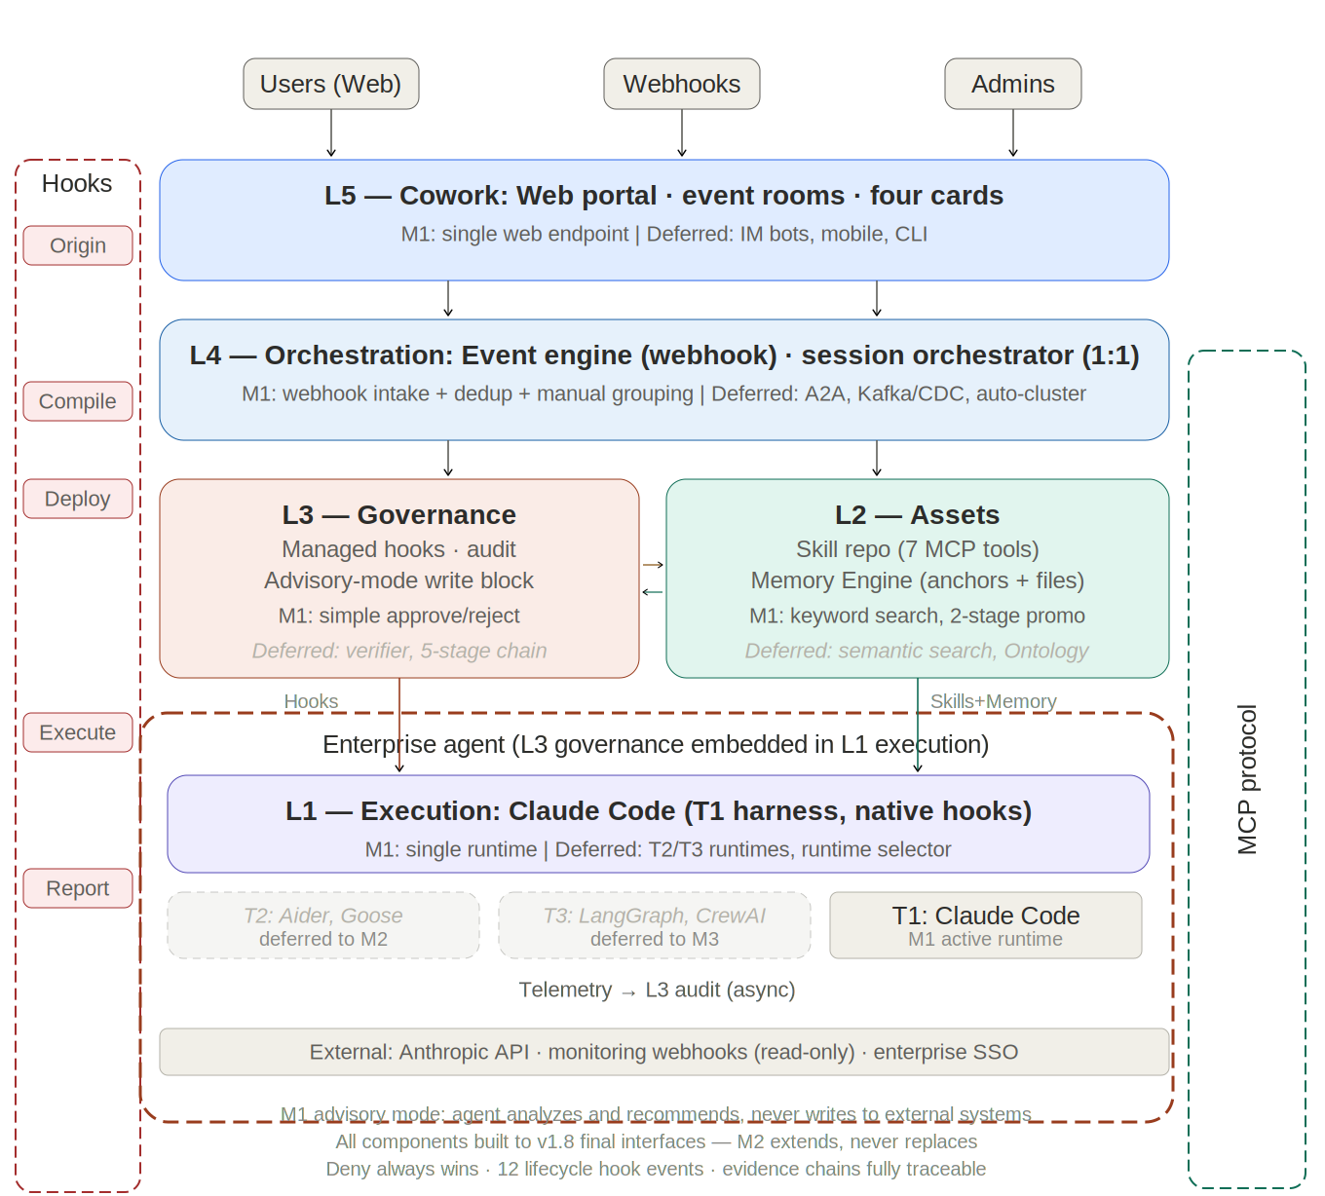
Figure 2-1: M1 Architecture Overview

2.1 Five-layer model

The architecture comprises five layers numbered bottom-up. Milestone 1 implements all five layers with scoped capability at each level. The five-layer structure is preserved exactly as specified in the master v1.8 architecture to ensure forward compatibility.

Layer | M1 Responsibility | Key M1 Components | Deferred to M2/M3
L5 Cowork | Web portal with event rooms and four-card interaction | Event room engine, card renderer, push via SSE/WebSocket | IM bots, mobile app, CLI endpoint
L4 Orchestration | Event-driven session management, webhook intake | Event engine (webhook + dedup), session orchestrator (1:1), API gateway | A2A router, CDC/Kafka intake, auto-clustering, 1:N orchestration
L3 Governance | Managed hooks, audit with evidence tracking | Policy engine, compiler, audit service, hook deployment, MCP registry | Deterministic verifier, 5-stage approval chain, MCP security tiers
L2 Assets | Skill repository and basic memory engine | Skill repo MCP (7 tools), Memory Engine (anchors + files + keyword search) | Semantic search, Ontology Service, full 4-stage promotion
L1 Execution | Single-runtime agent execution with memory write | Claude Code (T1), hook bridge, telemetry collector, memory write channel | T2/T3 runtimes, runtime selector strategies, blind-box

Important: all M1 components are built to v1.8 final interfaces. The Memory Engine exposes all 6 MCP tools even though search is keyword-only. The event engine uses the same pluggable handler interface even though only rule-based dedup is implemented. The session orchestrator handles 1:1 sessions but accepts the same SessionPayload schema that will later carry A2A dispatch parameters. Nothing is thrown away when Milestone 2 arrives.

2.2 Three vertical pipelines

The three vertical pipelines from the master v1.8 specification are fully operational in Milestone 1:

Pipeline A: Hook pipeline. Administrators declare policies in L5's admin console → L3's policy compiler compiles them into hook configurations → managed-settings.json deploys atomically to L1 → Claude Code executes hooks natively inline → telemetry reports to L3 audit. Milestone 1 supports 12 lifecycle hook events: 9 in L1 (SessionStart, UserPromptSubmit, PreToolUse, PostToolUse, PostToolUseFailure, PermissionRequest, Stop, SubagentStop, PreCompact) and 3 in L4 (EventReceived, PreSessionCreate, PostSessionEnd). Deny always wins.

Pipeline B: Data-flow pipeline. Downstream: webhook event → L4 event engine aggregates → L4 orchestrator queries L2 Memory for relevant prior knowledge → L3 three-way handshake (auth, hooks, runtime) → L2 provides skill content → L1 AgentLoop executes. Upstream: L1 produces ResponseChunks (streaming to L5), TelemetryEvents (async to L3 audit), and MemoryWrites (evidence anchors and memory files to L2).

Pipeline C: Session-control pipeline. Event Room (L5, long-lived) → Event (L4, state machine) → Session (L3→L1, bound to skill + Claude Code). Milestone 1 operates 1:1 (one session per event). Sessions pass context through L2 Memory when a follow-up session is created for the same event.

2.3 Collaboration loop

The collaboration loop operates in advisory mode for Milestone 1:

Event → Context → Plan → (Check deferred) → Draft → (Approve deferred) → (Execute deferred) → Observe → Retrospect → Memory

Stage | M1 Behavior
Event | L4 event engine receives webhook, deduplicates, creates event object
Context | L4 orchestrator queries L2 Memory for relevant prior memory, assembles SessionPayload
Plan | L1 agent analyzes the event, forms a recommended action plan with evidence
Draft | L1 agent produces advisory output — recommendations, not executable commands
Observe | L3 audit captures telemetry with evidence anchor references
Retrospect | PostSessionEnd hook triggers review of session output quality
Memory | L2 Memory Engine receives evidence anchors and experience files for future reference

Check, Approve, and Execute stages are bypassed in advisory mode. The agent never has write access to external systems in Milestone 1. The full Plan→Check→Draft→Approve→Execute chain activates in Milestone 2 when write access is introduced.

2.4 Design principles

All nine v1.8 design principles apply to Milestone 1. Advisory mode does not relax governance — it narrows the action space while maintaining the same enforcement architecture:

Governance is unified. Managed hooks apply to Claude Code identically to how they will apply to every future runtime. Intelligence flows through Skills. The same workflow-skills work in M1 and M2 without modification. Hooks provide guarantees; agents provide judgment. Extend, never rebuild. Every M1 component extends into M2 without replacement. Deny always wins. Event-driven. Events trigger analysis proactively. Evidence chains are complete. Every conclusion references anchors. Drafts first. In advisory mode, everything is a draft — the agent never executes. Memory is an asset. Even in trial operation, memory accumulates and persists.

3. L5 — Cowork Layer
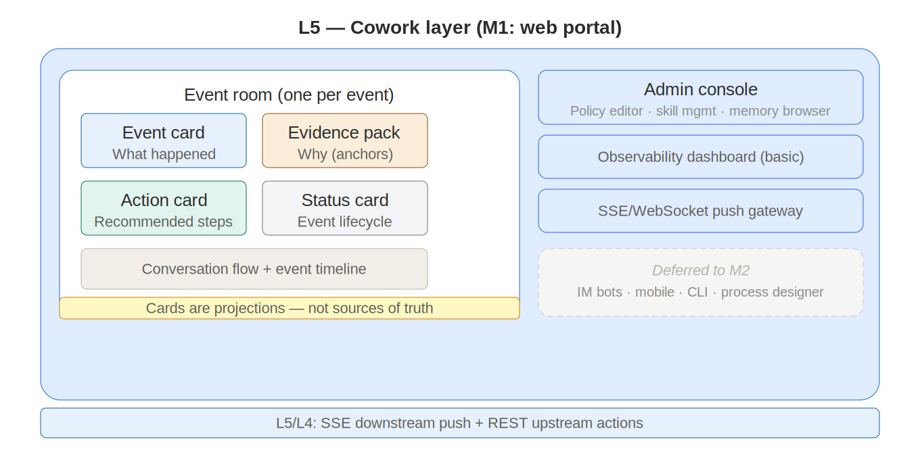
Figure 3-1: L5 Cowork Layer (M1)

L5 is the layer users directly interact with. In Milestone 1, L5 materializes as a web portal — a single-page application that provides event rooms with four-card interaction.

The design philosophy is "push, not pull." When a business event occurs, L5 pushes a notification with a pre-assembled event card. The user's first interaction is not "ask AI a question" but "decide whether this event needs my attention."

L5 owns no business truth. All business data comes from downstream layers: event state from L4, audit data from L3, skills and memory from L2. L5 owns only connection state (WebSocket sessions, push queues) and rendering state.

3.1 Event room

One room per business event. When L4's event engine creates an event object, L5 automatically generates a corresponding event room containing:

Four pinned cards at the top, covering the four cognitive stages of decision-making: awareness (event card), verification (evidence pack), planning (action card), and acknowledgment (status card — replacing the approval card in advisory mode since there is nothing to approve). Each card enables a decision within 30 seconds.

Conversation flow below the cards, where the user and agent exchange messages within the event context. Every message is contextualized by the event and its evidence.

Event timeline showing complete chronology from event intake to current state, including all agent actions and hook decisions.

The event room's lifecycle follows the event state machine. It is created when the event arrives, persists across sessions, and archives after closure.

3.2 Four-card paradigm (M1 advisory variant)

In advisory mode, the four cards adapt to the read-only context:

Card | M1 Content | Data Source
Event card | One-line conclusion, severity, impact scope, trend indicator | L4 event engine
Evidence pack (collapsed by default) | Alert summary, measurement data references, historical similar events; each item has an anchor ID | L2 Memory Engine
Action card | Recommended steps as a step tree with preconditions; marked "advisory — no auto-execution" | L1 agent output via L4
Status card | Event state, session status, memory deposit confirmation | L4 state machine + L2 Memory

The approval card from the full v1.8 spec is replaced by a status card in M1 because there are no write operations requiring human authorization. The status card shows event lifecycle state and provides manual close/archive actions. When Milestone 2 introduces write access, the status card reverts to the approval card.

Cards are derived views (projections), not sources of truth. Multiple browser tabs rendering the same event room see identical data because all read from the same downstream sources.

3.3 Admin console (M1 scope)

The admin console in Milestone 1 provides: a policy editor for defining managed hook configurations, a skill management interface for submitting and promoting skills (2-stage: draft → production), a memory browser for reviewing and editing agent-written memory files, and a basic observability dashboard showing session execution metrics and evidence coverage rates.

Deferred to M2: role manager with full RBAC, MCP connector manager, runtime pool manager, skill promotion dashboard (4-stage), cost governance dashboards.

3.4 Push channels (M1 scope)

Real-time push via SSE or WebSocket to the web portal. Event card updates stream as events occur. No IM bot integration in M1 — the web portal is the sole endpoint. External notification webhooks can be configured to push event summaries to existing enterprise notification systems (email, Slack incoming webhooks) as a bridge until native IM integration arrives in M2.

4. L4 — Orchestration Layer
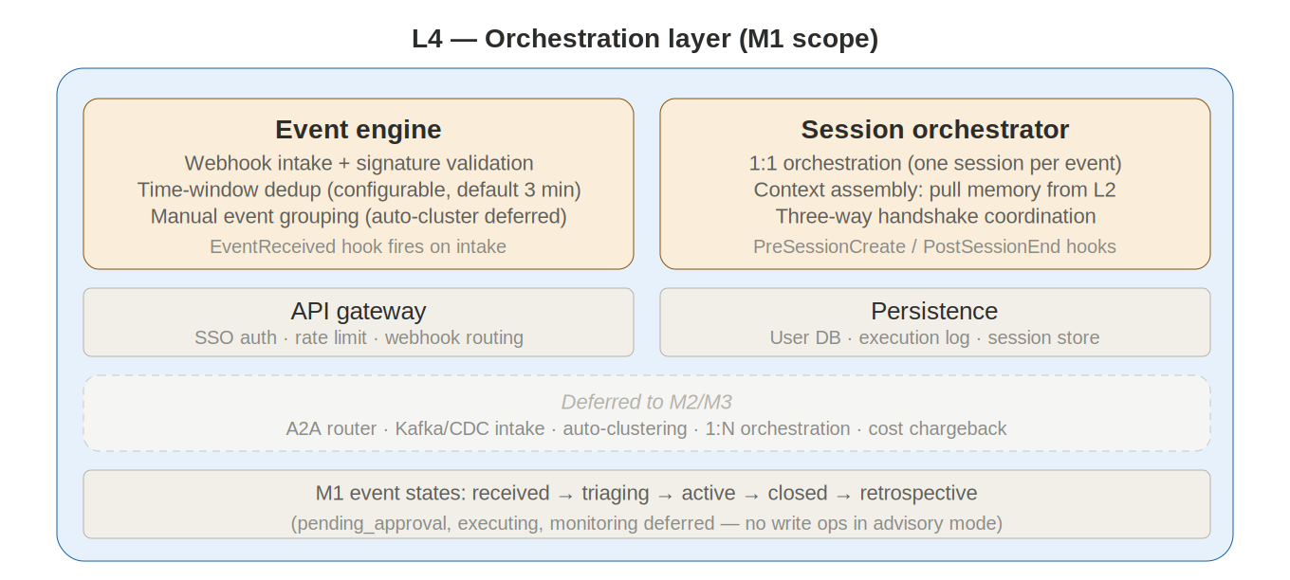
Figure 4-1: L4 Orchestration Layer (M1)

L4 is the platform's event-driven orchestration engine. In Milestone 1, L4 handles webhook event intake, basic deduplication, session management, and event lifecycle state.

4.1 Event engine (M1 scope)

Webhook intake. The event engine accepts events via HTTP webhooks from monitoring platforms, ticketing systems, and other enterprise sources. Each webhook is validated (signature verification), deduplicated (event ID or content hash within a configurable time window, default 3 minutes), and normalized into the platform's structured event format.

Manual event grouping. Milestone 1 does not implement automatic event clustering or correlation. Related events that arrive as separate webhooks create separate event objects. Users can manually merge events through the web portal's event room interface — selecting two or more event rooms and merging them into one. This manual approach allows the team to observe real usage patterns before investing in auto-clustering logic for Milestone 2.

Event object model. Each event contains: event_id (globally unique), type (string), severity (low/medium/high/critical), scope (impact description), source_events (array of raw webhook payloads with source, raw_id, timestamp), status (state machine position), event_room_id, sessions (associated session IDs), evidence_anchors (associated anchor IDs), and timestamps.

Event state machine. Milestone 1 uses a simplified state machine appropriate for advisory mode:
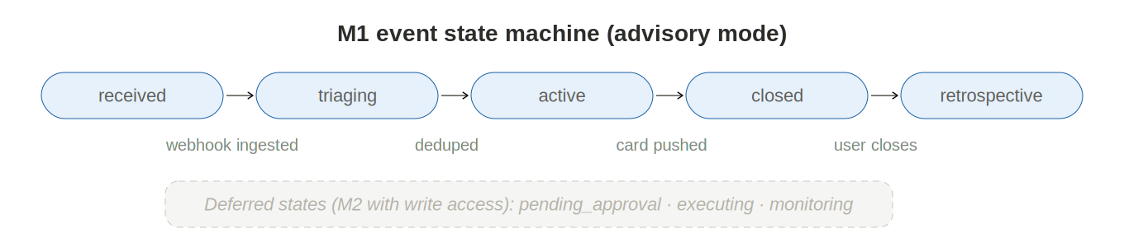
Figure 4-2: M1 Event State Machine

received → triaging → active → closed → retrospective

The "received" state means the raw webhook was ingested. "Triaging" means deduplication is complete and the event object is formed. "Active" means the event card has been pushed and analysis is underway. "Closed" means the user has acknowledged and closed the event. "Retrospective" means the PostSessionEnd hook has triggered memory deposit. The pending_approval, executing, and monitoring states from the full v1.8 spec are absent because advisory mode has no write operations.

EventReceived hook fires on every webhook intake, enabling policy-based filtering and priority adjustment before the event enters the pipeline.

4.2 Session orchestrator (M1 scope)

The session orchestrator manages L1 runtime lifecycle in a 1:1 model: one event spawns one session. When the user opens an event room or the event engine determines analysis is needed, the orchestrator:

(1) Queries L2's Memory Engine for relevant prior memory (memory_refs). (2) Calls L3 to initiate the three-way handshake with user context, event_context, and memory_refs. (3) L3 authenticates, compiles managed hooks, and returns the session configuration. (4) L1 allocates a Claude Code instance, boots the session (context injection, hook loading, prompt assembly), and fires SessionStart. (5) L4 connects the L5 event room to the session for streaming.

Context passing. If the user triggers a follow-up session for the same event (e.g., asking for deeper analysis after reading the initial report), the orchestrator creates a new session. The previous session's conclusions are available through L2 Memory (not conversation history forwarding). The new session's SessionPayload includes memory_refs pointing to the prior session's deposited evidence and conclusions.

PreSessionCreate hook fires before session creation, enabling quota checks and permission verification. PostSessionEnd hook fires after session completion, triggering memory deposit and event state updates.

4.3 Integration plane (M1 scope)

API gateway. Single entry point for all programmatic access. Handles authentication (enterprise SSO for users, API keys for webhook sources), rate limiting, and request routing. All L3/L4 interface contracts pass through the gateway.

Webhook receiver. Accepts POST requests from external monitoring systems. Validates webhook signatures, parses payloads, and forwards to the event engine. Provides a configuration interface for registering webhook sources with their expected payload formats and authentication methods.

4.4 Persistence plane (M1 scope)

L4 owns three data stores in Milestone 1:

User database: Employee profiles and preferences. Synced with enterprise identity provider via standard SSO integration. Single organizational unit — no hierarchy.

Execution log: Structured session execution history from L3 audit telemetry. Queryable records for the observability dashboard.

Session store: Conversation history and session state for session resumption. When a session ends, the session manager serializes kernel state here.

The cost ledger from the full v1.8 spec is deferred to Milestone 2 (simple quota tracking via SessionStart hooks is sufficient for trial).

4.5 Security architecture (M1 scope)

Authentication via enterprise SSO for human users and API keys for webhook sources. Secrets management through environment variables (vault integration deferred to M2). Prompt injection defense by sanitizing all webhook payloads before they enter L3/L1. Audit trail logging every admin action in L4's own audit trail.

5. L3 — Governance Layer
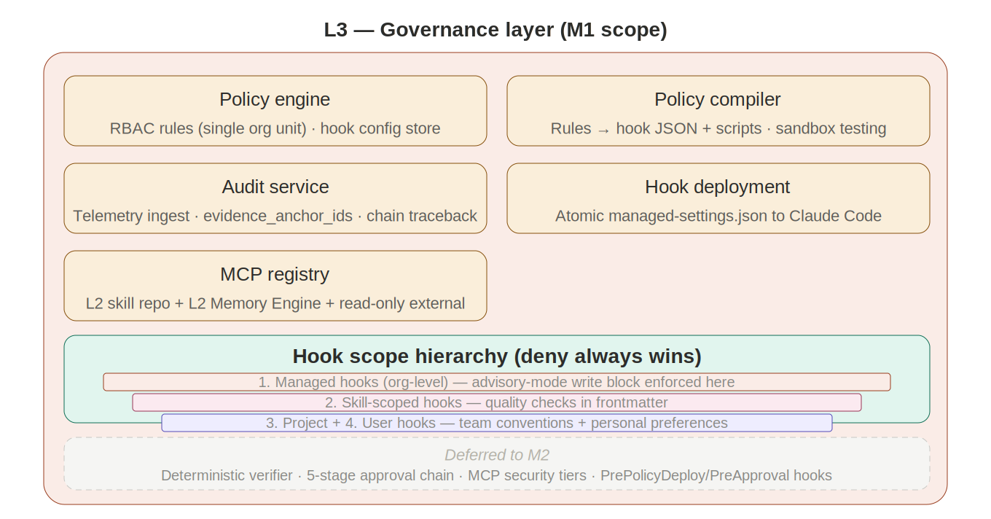
Figure 5-1: L3 Governance Layer (M1)

L3 enforces organizational policies, governs asset lifecycles, and captures audit telemetry. In Milestone 1, L3 operates with the full hook architecture but without the deterministic verifier or five-stage approval chain (unnecessary in advisory mode).

5.1 Policy engine

Translates organizational policies into managed hooks. In Milestone 1, policies are defined for a single organizational unit (no hierarchy). The policy engine maintains the master configuration store and validates hook configurations before deployment.

5.2 Policy compiler

Translates structured rules into executable hook configurations. For each rule, generates the hook JSON configuration (event, matcher, handler type, parameters) and the enforcement artifact (shell script for command handlers, endpoint URL for HTTP handlers, prompt template for prompt handlers). Tests compiled hooks against sample events in a sandboxed L1 session before deployment.

5.3 Hook deployment service

Atomically distributes managed-settings.json to the L1 Claude Code instance. Deployment is atomic: the instance receives the update or it rolls back. Supports version tracking and diff management. Since Milestone 1 runs a single runtime instance, atomic distribution is straightforward; the multi-instance distribution protocol from the full spec is implemented but exercised with a pool of one.

5.4 Audit service

Receives telemetry from L1 via async PostToolUse HTTP hooks. Stores structured execution records: who initiated, what was requested, which tools were called, what hooks decided, final outcome, resource consumption, and evidence_anchor_ids. The audit service is the single source of truth for execution history. Supports evidence-chain traceback: from any conclusion, trace to all associated evidence anchors.

5.5 MCP registry and intent gateway

The MCP registry manages connector lifecycle for the MCP servers used in Milestone 1: L2's Skill repository MCP server, L2's Memory Engine MCP server, and any external read-only MCP connectors configured for the trial (e.g., a monitoring system's data query API). The intent gateway validates webhook sources and routes events to the session orchestrator.

5.6 Hook scope hierarchy

Four scope levels apply in Milestone 1, with deny-always-wins semantics:

1. Managed hooks (organizational) — deployed via managed-settings.json, cannot be overridden. In M1 these encode the trial organization's policies.
2. Skill-scoped hooks — defined in skill YAML frontmatter, active only during skill execution. Encode domain-specific quality checks.
3. Project hooks — defined in project settings, shared by the trial team.
4. User hooks — personal preferences and convenience automation.

Any deny at any scope level blocks the action unconditionally.

5.7 Hook handler types

Type | Mechanism | M1 Use Cases | Latency
command | Shell script: receives JSON on stdin, returns exit code + stdout | File path checks, format validation, deny-list matching | Milliseconds
http | POST to HTTP endpoint, receives JSON response | Centralized policy checks, audit telemetry push | ~100–500 ms
prompt | Send prompt to lightweight Claude model for single-turn evaluation | Quality assessment, compliance checks, anomaly detection in agent output | ~1–3 s
agent | Spawn subagent for deep verification | Deferred to M2 (not needed in advisory mode) | ~5–30 s

The agent handler type is implemented in M1 but not actively used. Advisory mode's read-only scope means complex multi-step verification is unnecessary; prompt hooks provide sufficient quality control for analysis output.

5.8 Hook lifecycle events (M1 scope)

Milestone 1 supports 12 lifecycle events across two layers:

Event | Layer | Fires When | M1 Role
SessionStart | L1 | Session begins | Context injection: user role, MCP health, quota check
UserPromptSubmit | L1 | User submits prompt | Mode routing, policy context injection
PreToolUse | L1 | Before any tool executes | Primary enforcement: access control, safety checks, advisory-mode write block
PostToolUse | L1 | After tool succeeds | Quality evaluation, async audit logging, evidence validation
PostToolUseFailure | L1 | After tool fails | Error telemetry, diagnostic injection
PermissionRequest | L1 | Agent requests tool permission | Auto-approve read-only tools, block write tools (advisory mode)
Stop | L1 | Agent finishes responding | Final quality gate, telemetry flush
SubagentStop | L1 | Subagent finishes | Validate subagent output
PreCompact | L1 | Before context compaction | Save execution state to L4 session store
EventReceived | L4 | Webhook intake | Event filtering, priority adjustment
PreSessionCreate | L4 | Before session creation | Quota check, permission verification
PostSessionEnd | L4 | After session ends | Memory deposit trigger, event state update

The two L3 events from the full v1.8 spec (PrePolicyDeploy, PreApproval) are deferred to Milestone 2 where the deterministic verifier and approval chain require them.

Advisory mode enforcement. The PreToolUse managed hook includes an advisory-mode rule that blocks any tool call classified as a write operation. This is the mechanism that prevents agents from modifying external systems in M1 — it is a hook-enforced policy, not a runtime limitation, which means it can be relaxed to specific approved write operations simply by updating the managed-settings when M2 is ready.

6. L2 — Asset Layer
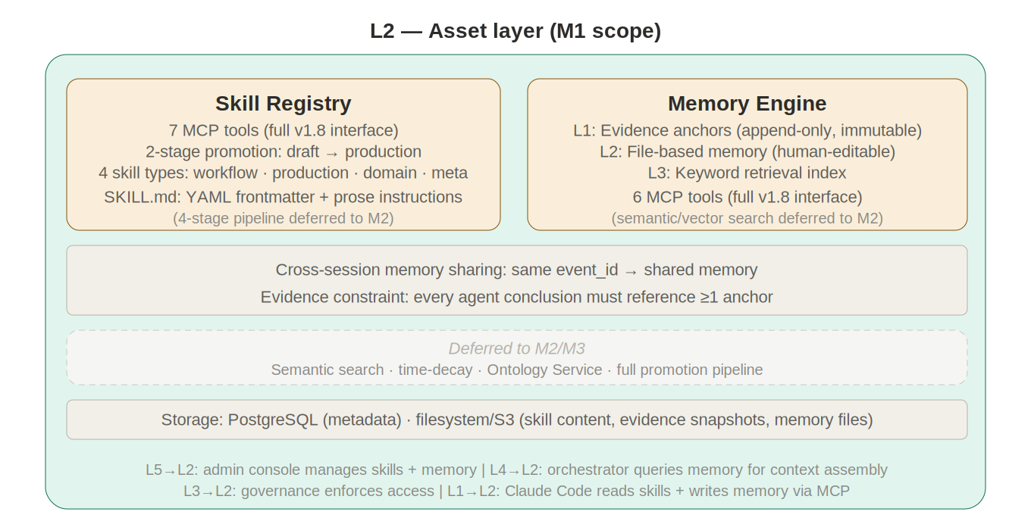
Figure 6-1: L2 Asset Layer (M1)

L2 manages skills and memory. In Milestone 1, L2 operates two subsystems: Skill Registry and Memory Engine. The MCP Orchestrator's functionality is simplified to managing connections to these two internal MCP servers plus any configured external read-only connectors. The Ontology Service is deferred to Milestone 3.

6.1 Skill Registry (M1 scope)

Skill repository MCP server. Exposes the full 7-tool MCP interface defined in v1.8: skill_search, skill_read, skill_list_versions, skill_submit_draft, skill_promote, skill_dependencies, skill_usage. All tools are operational. Content stored in the filesystem (S3/GCS in production); metadata in PostgreSQL.

Simplified promotion pipeline. Milestone 1 uses a 2-stage pipeline: draft → production. An admin submits a skill draft, reviews it, and promotes directly to production. The tested and reviewed intermediate stages from the full spec are deferred to Milestone 2, but the promotion engine's internal state machine already supports all four stages — M1 simply auto-advances through the middle two.

Skill types. All four skill types are supported: workflow skills (the primary type for M1 trial scenarios), production skills (output quality guidelines), domain skills (specialized knowledge), and meta skills. In practice, M1 trials typically use 3–5 workflow-skills tailored to the trial organization's specific operational scenarios.

Skill content structure. Each skill is a SKILL.md file with YAML frontmatter (scoped hooks, metadata) and prose instructions. Runtime affinity declarations are ignored in M1 (only one runtime exists). The frontmatter schema is the full v1.8 schema — fields not relevant to M1 are simply unused.

6.2 Memory Engine (M1 scope)

The Memory Engine provides persistent memory with keyword retrieval. It is the mechanism by which agents accumulate experience across sessions.

Core design constraint (preserved from full v1.8): the file is the governance object; the index is the retrieval object. Both derive from the same source and must never diverge.

Layer 1: Evidence anchor store. Append-only, immutable records. Each anchor contains: anchor_id (globally unique), event_id, session_id, type (measurement_window, topology_snapshot, rule_reference, document_excerpt, computation_result), data_ref (URI to original data), snapshot_hash (integrity hash), source_system, tool_version, model_version, timestamps, and extensible metadata. Every agent conclusion must reference at least one anchor.

Layer 2: File-based memory. Structured files depositing preferences, experience, and knowledge. Each file contains: memory_id, scope (user or team — org_unit and event_type scopes deferred to M2), category (preference, experience, knowledge, calibration), content (structured text, human-readable and editable), evidence_refs (linked anchor IDs), status (agent_suggested or confirmed), version, and audit metadata.

Layer 3: Keyword retrieval index. Milestone 1 implements keyword search over memory files and evidence anchors. The index supports exact-match queries on device IDs, event types, proper nouns, and any structured field. Semantic (vector) search and time-decay weighting are deferred to Milestone 2. The search API accepts the full v1.8 query schema (including search_mode parameter); in M1, the "semantic" and "hybrid" modes fall back to keyword search with a warning.

6 MCP tools: memory_search (keyword retrieval with scope and category filters), memory_read (read file or anchor details), memory_write_anchor (create evidence anchor, append-only), memory_write_file (create or update memory file), memory_list (enumerate by scope/category), memory_archive (soft-delete with audit trail).

Cross-agent sharing (M1 scope). All sessions under the same event_id share memory. User-scope memory is visible to all sessions for that user. Since M1 operates in a single organizational unit with one runtime, sharing conflicts are minimal.

6.3 L2 interfaces

L5 → L2: Admin console submits and promotes skills; memory browser reviews and edits memory files.

L4 → L2: Session orchestrator queries Memory Engine for context assembly before session creation.

L3 → L2: Audit service reads evidence anchors for chain-traceback queries. Governance enforces access control on skill operations.

L2 → L1: Claude Code accesses L2 through MCP — skill_search/skill_read for skills, memory_search/memory_write_anchor/memory_write_file for memory.

7. L1 — Execution Layer
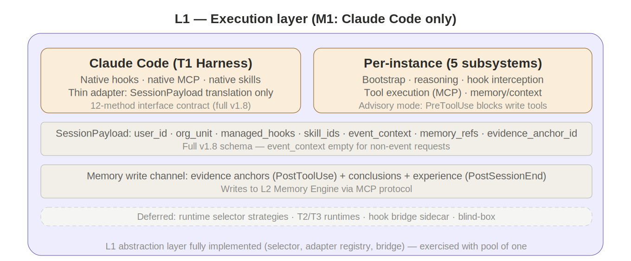
Figure 7-1: L1 Execution Layer (M1)

L1 hosts the agent runtime. In Milestone 1, L1 runs a single T1 harness runtime: Claude Code.

7.1 Why Claude Code

Claude Code is the pragmatic choice for Milestone 1: it is production-ready today with native hook support (all lifecycle events, all handler types), native MCP, native skills, and full managed-settings compatibility. Building a custom EAASP Runtime would add weeks to the schedule without changing trial outcomes. Claude Code serves as the reference runtime; the runtime abstraction layer (selector, adapter registry) is implemented but exercises a pool of one.

7.2 Internal abstraction

The L1 internal abstraction mechanism is fully implemented even though only one runtime exists:

Runtime selector. Returns Claude Code for every request. The task-matching, blind-box, and cost-optimization strategies are implemented but produce trivial results with a single runtime in the pool. This ensures the selector is tested and ready when T2 runtimes arrive in Milestone 2.

Adapter registry. Contains one thin adapter for Claude Code. The adapter translates between the platform's 12-method runtime interface contract and Claude Code's native API. Since Claude Code natively supports hooks, MCP, and skills, the adapter is minimal — primarily handling SessionPayload translation and telemetry normalization.

Hook bridge. Passes through to Claude Code's native hook system. No sidecar needed. The bridge implementation for non-native runtimes exists in the codebase but is not deployed in M1.

Telemetry collector. Normalizes Claude Code's telemetry to the platform schema and pushes to L3 audit service.

7.3 Runtime interface contract

Claude Code implements all 12 methods through its thin adapter: initialize(payload), send(message), loadSkill(content), onToolCall/onToolResult, onStop(), getState/restoreState, connectMCP(servers), emitTelemetry(), getCapabilities(), terminate(). The contract is identical to the full v1.8 specification.

7.4 SessionPayload

The SessionPayload carries the full v1.8 schema:

Field | M1 Usage
user_id, org_unit | Single org unit, authenticated via SSO
managed_hooks_json | Full managed hook configuration
skill_ids, skill_registry_url | Bound workflow-skill for this event type
event_context (event_id, event_type, severity, scope, raw_summary) | Populated from L4 event engine
memory_refs (array of memory_id, type, relevance_score) | Populated by L4 from L2 Memory keyword search
evidence_anchor_id | Assigned by L4; this session's conclusions attach evidence here

For non-event-driven user-initiated requests (user opens portal and types a question), event_context is empty and the SessionPayload functions as a standard request-response session.

7.5 Memory write channel

During execution, the Claude Code agent writes to L2's Memory Engine via MCP:

Evidence anchors. After each significant tool call (querying a monitoring API, retrieving historical data), the agent creates an evidence anchor recording the data snapshot reference, integrity hash, and source metadata. These are append-only and immutable.

Conclusion memory. When the agent forms a conclusion, it creates a memory file linking the conclusion text to its supporting evidence anchors. The file is initially marked "agent_suggested."

Experience deposit. At session end (triggered by PostSessionEnd hook), the agent summarizes key findings, threshold observations, and operational patterns as experience-category memory files for future reference.

7.6 Per-instance composition

Each Claude Code session instance contains five subsystems (identical to the full v1.8 spec): session bootstrap (context injector, hook loader, system-prompt assembler), reasoning core (Claude model with conversation context and kernel state), hook interception (PreToolUse → execute → PostToolUse → Stop, all scopes in parallel), tool execution (MCP client connecting to L2 skill repo, L2 Memory Engine, and external read-only connectors), and memory/context plane (conversation memory, kernel state, ephemeral working filesystem).

8. Cross-Layer Interfaces

8.1 L3/L4 interface: five API contracts
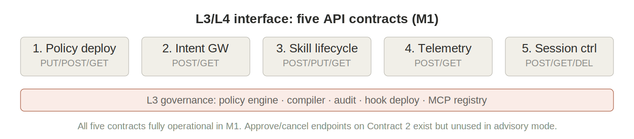
Figure 8-1: L3/L4 Five API Contracts

The five REST API contracts from the full v1.8 specification are fully operational in Milestone 1:

Contract 1: Policy deployment. PUT /v1/policies/managed-hooks (atomic deploy), POST /v1/policies/test (sandbox test), GET /v1/policies/versions (version history), POST /v1/policies/rollback (rollback). Used by the admin console to manage hook configurations.

Contract 2: Intent gateway. POST /v1/intents/dispatch (validate webhook source, authorize, resolve skill, route to session orchestrator), GET /v1/intents/{id}/status (poll status). The approve and cancel endpoints exist but are unused in advisory mode.

Contract 3: Skill lifecycle. POST /v1/skills/submit (create draft), PUT /v1/skills/{id}/promote (promote draft → production in M1's 2-stage pipeline), GET /v1/skills/{id}/versions (version history), GET /v1/skills/search (discovery).

Contract 4: Telemetry ingest. POST /v1/telemetry/events (receive async hook telemetry from L1), GET /v1/telemetry/query (structured query for observability dashboard), GET /v1/telemetry/aggregate (aggregation for metrics).

Contract 5: Session control. POST /v1/sessions/create (three-way handshake), GET /v1/sessions/{id} (session state), POST /v1/sessions/{id}/message (route user message to L1), DELETE /v1/sessions/{id} (destroy session, flush state).

8.2 L5/L4 interface: real-time communication
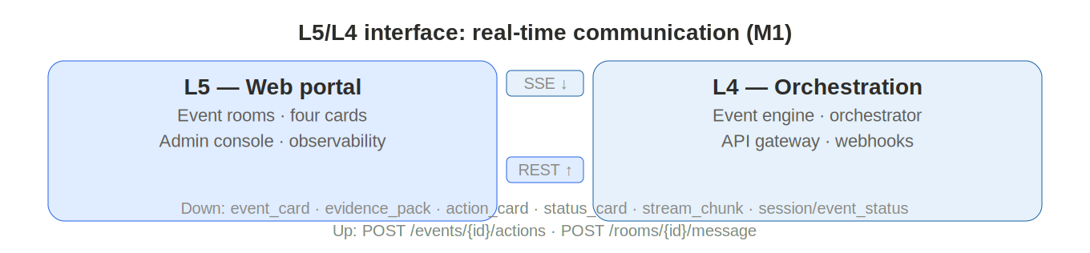
Figure 8-2: L5/L4 Real-Time Communication

Downstream push (L4 → L5): SSE/WebSocket. Seven event types: event_card_update, evidence_pack_update, action_card_update, status_card_update (replaces approval_card_update in M1), stream_chunk, session_status, event_status.

Upstream actions (L5 → L4): HTTP REST. POST /v1/events/{id}/actions (user actions: acknowledge, merge events, close, reopen), POST /v1/rooms/{id}/message (user messages within event room).

8.3 L4/L2 Memory API
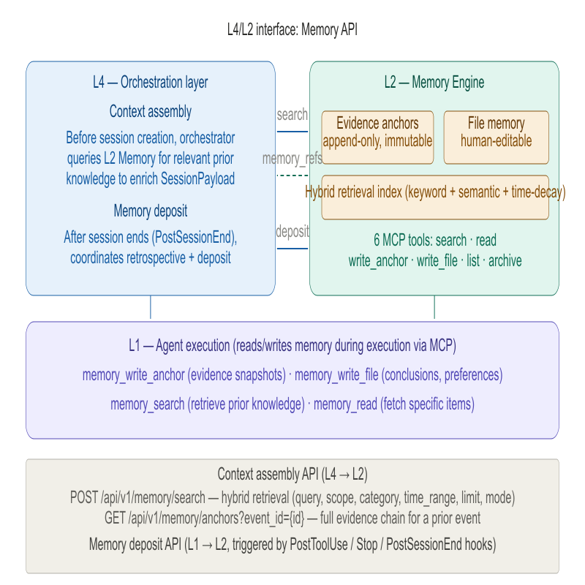
Context assembly (L4 → L2). POST /api/v1/memory/search (keyword retrieval for context assembly), GET /api/v1/memory/anchors?event_id={id} (evidence chain for prior events).

Memory write (L1 → L2 via MCP). memory_write_anchor (evidence snapshots), memory_write_file (conclusions and experience), memory_search (retrieve prior knowledge during execution).

8.4 L1/L3 interface: hooks as the connection mechanism
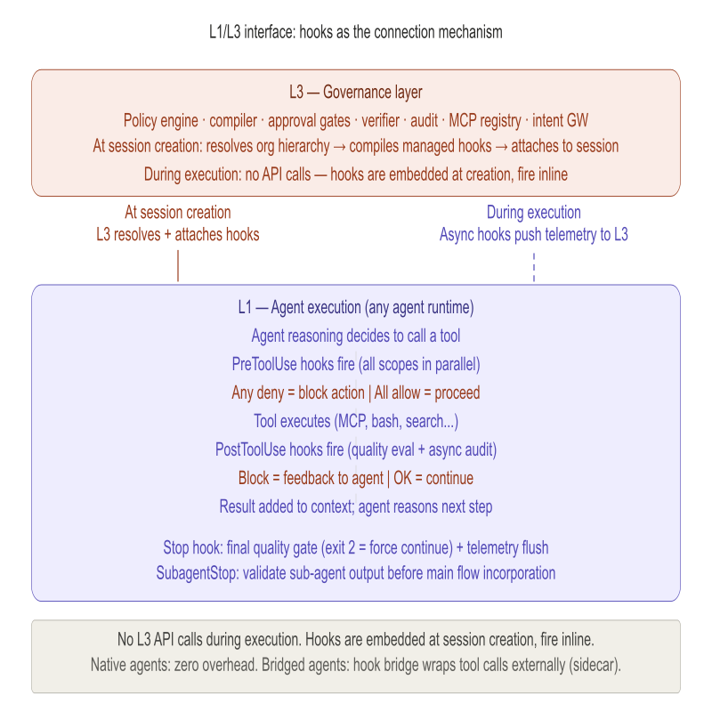
L1 and L3 communicate through hooks, not REST APIs. At session creation, L3 attaches managed hooks to the session. During execution, hooks fire inline with zero L3 API calls. Claude Code's native hook system handles this with zero overhead. Telemetry flows back via async PostToolUse HTTP hooks to L3 audit. This interface is identical to the full v1.8 specification.

8.5 Three-way handshake
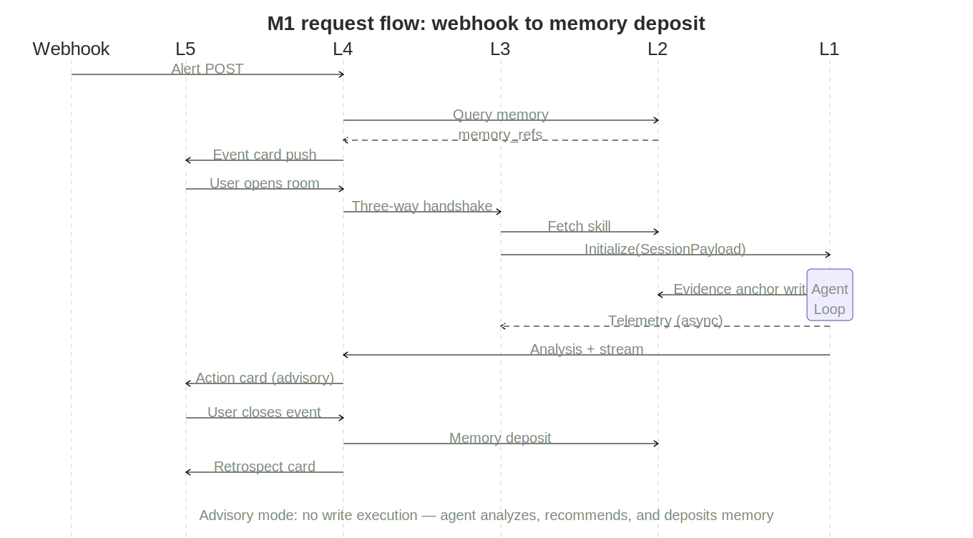
Figure 8-5: M1 Request Flow

(1) L4 event engine receives webhook or user initiates request. (2) L4 orchestrator queries L2 Memory for relevant prior memory. (3) L4 calls POST /v1/sessions/create on L3 with user context, event_context, memory_refs. (4) L3 authenticates user, compiles managed hooks for the organizational unit. (5) L1 allocates Claude Code instance, boots session (context injection, hook loading, prompt assembly), fires SessionStart hook. (6) L3 returns session handle to L4. (7) L4 connects L5 event room to session, begins streaming.

After creation, message flow is L4 ↔ L1 with L3's hooks executing inline on every tool call.

9. Hook Architecture
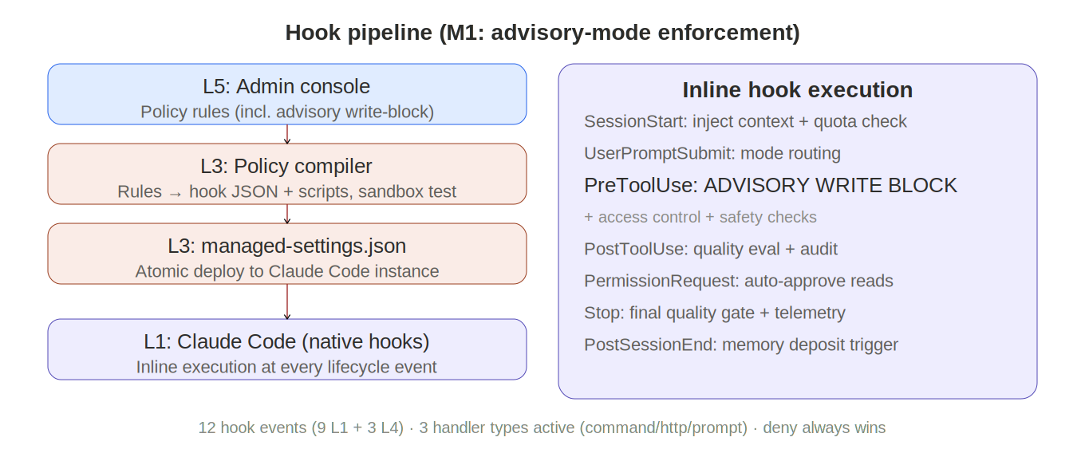
Figure 9-1: Hook Pipeline (M1 Advisory)

Hooks are the single most important architectural mechanism. They provide deterministic, guaranteed enforcement at every lifecycle point. This chapter preserves the full hook architecture from the v1.8 master specification — advisory mode does not simplify hooks; it uses them as the enforcement mechanism for the read-only constraint.

9.1 Hook origin

Hooks begin as business-language policies defined by administrators in L5's admin console. A policy like "agents must not call any tool classified as a write operation" is captured as a structured rule with scope, trigger (PreToolUse on all tools), action (command hook checking tool classification), and response (deny if write-classified). The admin console passes the rule to L3's policy compiler.

9.2 Hook compilation

The policy compiler translates structured rules into executable hook configurations: hook JSON config plus enforcement artifacts. The compiler tests against sample events in a sandboxed L1 session. If tests pass, the result packages as a managed-settings.json update.

9.3 Hook deployment

The policy deploy API receives the compiled update. L3 distributes atomically to the Claude Code instance. Active sessions receive new hooks at their next lifecycle event; new sessions at SessionStart. Deployment is atomic: update succeeds or rolls back entirely.

9.4 Hook execution: inline firing

During execution, hooks fire inline at every lifecycle event:

SessionStart: Managed hooks inject organizational context (user identity, MCP connector health, quota status, event context from SessionPayload) into the agent's initial context.

UserPromptSubmit: Fires when the user submits a message. Can inject policy context or classify request patterns.

PreToolUse: The primary enforcement point. All matching hooks fire in parallel across all scope levels. If any hook returns deny (exit code 2), the tool call is blocked and the denial reason is fed back to the agent. In Milestone 1, the advisory-mode hook operates here — it checks every tool call against a write-operation classification list and denies write tools.

PostToolUse: Quality evaluation (prompt hooks assess output quality against workflow-skill criteria) and audit logging (async HTTP hooks push telemetry to L3 without blocking).

PostToolUseFailure: Injects diagnostic information into agent context when a tool call fails, enabling adaptive recovery.

PermissionRequest: Auto-approves read-only tool access. Denies write-classified tools in advisory mode.

Stop: Final quality gate. Exit code 2 forces the agent to continue working. The Stop hook also triggers final telemetry push to L3 audit, including evidence coverage check (did the agent attach evidence anchors to all key conclusions?).

SubagentStop and PreCompact: Operate identically to the full v1.8 specification.

9.5 Hook guarantee: deny always wins

The fundamental guarantee is preserved in full: if any hook at any scope level denies an action, the action is blocked regardless of what other hooks or agent reasoning decides. This is the mechanism that enforces advisory mode — not a configuration flag, but a deterministic hook rule.

10. Deployment Topology
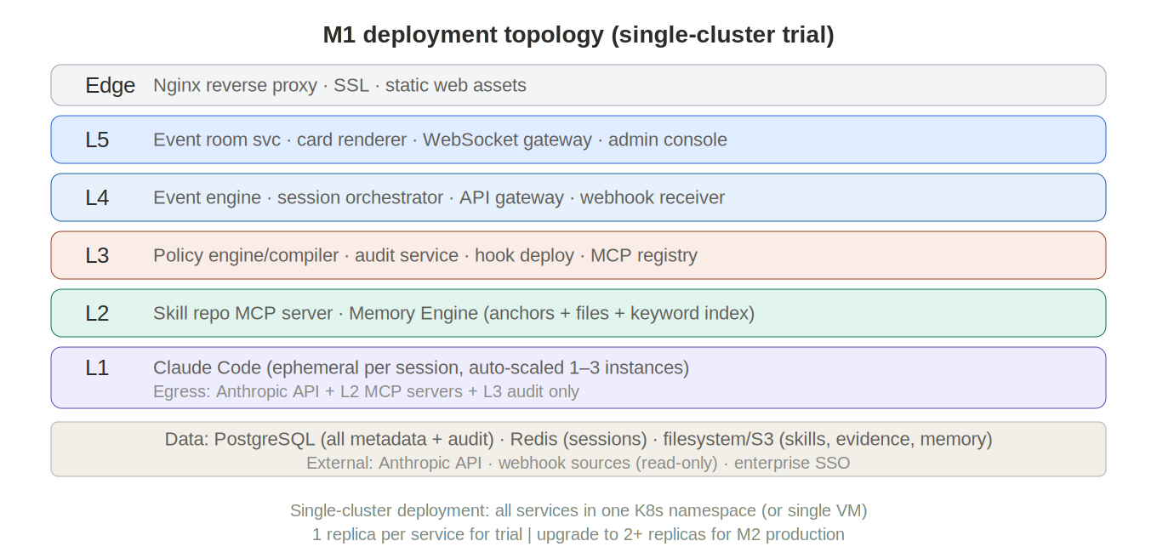
Figure 10-1: M1 Deployment Topology

Milestone 1 deploys as a simplified topology suitable for trial operation in a single organizational unit.

10.1 Single-cluster deployment

All services deploy within a single Kubernetes namespace (or a single VM for minimal infrastructure). The five-layer separation is maintained as logical service boundaries, not physical cluster boundaries.

Zone | Services | Replicas
Edge | Nginx reverse proxy, static web portal assets, SSL termination | 1
L5 | Event room service, card renderer, WebSocket gateway | 1
L4 | Event engine, session orchestrator, API gateway, webhook receiver | 1
L3 | Policy engine/compiler, audit service, hook deployment, MCP registry | 1
L2 | Skill repo MCP server, Memory Engine (anchors + files + keyword index) | 1
L1 | Claude Code instance (ephemeral per session, auto-scaled 1–3) | 1–3
Data | PostgreSQL (users, config, skill/memory metadata, audit), Redis (sessions), filesystem (skill content, evidence snapshots, memory files) | 1 each

Production note: For trial operation, a single replica per service is acceptable with manual restart procedures. Before moving to Milestone 2 production deployment, all services should run 2+ replicas with the full multi-zone topology from the v1.8 master specification.

10.2 External integrations

Anthropic API (Claude model inference), webhook sources (enterprise monitoring systems configured during trial setup), and enterprise SSO (identity provider for user authentication).

10.3 Network

Single network zone with services communicating via localhost or cluster-internal DNS. L1 Claude Code instances have restricted egress: Anthropic API, L2 MCP servers, and L3 audit endpoint only. No direct access to L5 or L4.

11. Evolution Roadmap

11.1 Milestone 1 → Milestone 2 transition

Milestone 2 ("Enterprise Edition") adds write access, multi-agent review, and IM integration. The transition preserves all M1 components and extends them:

M1 Component | M2 Extension
Advisory-mode PreToolUse hook | Replaced by per-tool-type write classification with approval routing
Status card (4th card) | Becomes approval card with approve/reject/request-info buttons
Event engine (webhook + manual grouping) | Add Kafka/CDC intake, rule-based auto-clustering
Session orchestrator (1:1) | Add 1:N orchestration, A2A ReviewSet dispatch
Single runtime (Claude Code) | Add Aider and Goose as T2 runtimes with hook bridge sidecar
Memory Engine (keyword search) | Add semantic (vector) search and time-decay weighting
Skill promotion (2-stage) | Full 4-stage pipeline (draft → tested → reviewed → production)
Single org unit | Multi-tenancy (enterprise → BU → department → team)
Web portal only | Add IM bot integration (WeChat Work, DingTalk, Slack)
No verifier | Deterministic verifier with rule engine integration
Simple approve/reject hook | Five-stage approval chain (Plan → Check → Draft → Approve → Execute)

11.2 Milestone 2 → Milestone 3 transition

Milestone 3 ("Platform Edition") opens the ecosystem:

T3 framework agents (LangGraph, CrewAI), Ontology Service integration, skill marketplace (cross-org sharing), runtime certification pipeline, platform API SDK, cost governance with chargeback, and blind-box runtime comparison.

11.3 Key architectural guarantee

Every M1 component is built to v1.8 final interfaces. The Memory Engine's MCP tools accept the full query schema. The event engine's internal pipeline has extension points for pluggable clustering handlers. The SessionPayload schema includes all v1.8 fields. The hook scope hierarchy supports all four levels. Nothing is thrown away — each milestone extends the previous one.

12. Implementation Team

Milestone 1 requires a lean team of 6–8 developers.

Role | Count | Responsibility
Fullstack (TypeScript/React) | 2 | L5 web portal (event rooms, four cards, admin console), L4 API gateway and webhook receiver
Backend (Python) | 2 | L4 event engine and session orchestrator, L3 policy engine/compiler/audit, L2 skill repo MCP server
Backend (Python) | 1 | L2 Memory Engine (anchor store, file memory, keyword index, MCP server)
Agent/Adapters (TypeScript) | 1 | L1 Claude Code adapter, hook integration, telemetry normalization, SessionPayload assembly
DevOps | 1 | Kubernetes deployment, CI/CD, monitoring, trial environment setup
Skill author (domain expert) | 1 (part-time) | Create 3–5 workflow-skills for trial scenarios, tune quality hooks

Phase-aligned onboarding: Weeks 1–2: fullstack + backend (core API + event engine + skill repo). Weeks 3–4: add Memory Engine developer + Claude Code adapter developer. Weeks 5–6: integration testing, hook tuning, trial deployment. The DevOps role can be shared with an existing infrastructure team. The skill author joins at week 4 to prepare trial content.

Principles: One developer, one layer. Backend developers do not touch L5 frontend code. The Claude Code adapter developer understands both the platform interface contract and Claude Code's native API. The Memory Engine developer owns the complete evidence-and-memory subsystem including the MCP server.

Appendix A: Design Anti-Patterns

1. Using prompts where hooks are needed. If something must happen every time, use a hook. Advisory mode's write-block is a hook, not a prompt instruction.
2. Overusing expensive hooks. Start with command hooks (ms). Escalate to prompt hooks only for semantic evaluation.
3. Skipping mode routing. Classify 80% of requests as SIMPLE to avoid kernel overhead on trivial queries.
4. Governance without managed hooks. Managed hooks are the only mechanism providing deny-always-wins.
5. Skills without scoped hooks. Add hooks for non-negotiable quality checks; do not rely solely on prose instructions.
6. Conclusions without evidence. Every critical conclusion must reference at least one evidence anchor.
7. Treating memory as session state. Memory is a persistent L2 asset, not L1 ephemeral state.
8. Building auto-clustering before observing patterns. M1 deliberately uses manual event grouping to learn real-world clustering patterns before automating in M2.
9. Adding write access before the approval chain is ready. Advisory mode exists precisely so that the trial can validate analysis quality without the complexity of governed write operations.
10. Premature multi-runtime. One well-understood runtime (Claude Code) is better than three poorly integrated ones. Add T2/T3 only after the hook architecture is proven in production.

Appendix B: Glossary

Term | Definition
Advisory mode | M1 operating mode: agent analyzes and recommends but has no write access to external systems
Evidence anchor | Immutable reference to an original data snapshot, attached to agent conclusions for traceability
Event room | L5 collaboration space; one room per business event, persists across sessions
Four cards | Event card + evidence pack + action card + status/approval card; pinned at top of every event room
Managed hooks | Organizational-level hooks deployed via managed-settings.json; cannot be overridden; deny always wins
Memory Engine | L2 subsystem managing persistent agent memory: evidence anchors, file-based memory, retrieval index
Operator Edition | Milestone 1 — the first launchable version of EAASP v1.8 for trial operation
SessionPayload | Session initialization payload containing user context, hooks, skill, event context, and memory refs
Three-way handshake | Session creation protocol involving L4 (request), L3 (authorize + hooks), L1 (allocate + boot)

Appendix C: Deferred Capabilities Reference

Capability | Deferred To | Reason
A2A multi-agent parallel review | M2 | Complex orchestration; needs proven single-agent baseline first
Deterministic verifier | M2 | Requires rule engine integration; unnecessary in advisory mode
Five-stage approval chain | M2 | Requires write access which M1 does not provide
IM bot integration | M2 | Web portal sufficient for trial; IM adds deployment complexity
T2/T3 runtimes | M2/M3 | One runtime proves the architecture; multiple runtimes prove the abstraction
Semantic/vector memory search | M2 | Keyword search sufficient for early memory corpus; vector index needs tuning
Ontology Service | M3 | Requires external ontology provider; independent of core platform
Multi-tenancy | M2 | Trial runs in single organizational unit
Skill marketplace | M3 | Requires cross-org trust framework
Cost governance with chargeback | M2 | Simple quotas sufficient for trial
Blind-box runtime comparison | M3 | Meaningless with single runtime

The Enterprise Autonomous Agent Support Platform — Milestone 1 "Operator Edition" — is event-driven, evidence-traceable, memory-persistent, and governance-enforced. Advisory mode ensures safety while proving the paradigm. Every component extends into Milestone 2 without replacement. Deny always wins.

