Ubaid ur Rehman

BSCS-5B

Reg. number: 00000123495

[Email address]

Advanced Programming

Lab 2 Document (Matrix Computer)

# Introduction

In this lab we build a Matrix Calculator that will allow the user to input named matrices (Allow the user to give names to his matrices like A, B, C, d, matrixAName, matrixBName, etc.) followed by an equation with the matrix names and operations(Sum, Difference, Scalar Multiplication, Transpose, Matrix Multiplication, and Matrix Inverse). Our program then replace the Matrix names with the Matrix, and apply the user desired operations, finally producing the result.

# Approach

We made matrix through dynamic array and fill out with random numbers and set matrix names same that user desired. Than we allow user to input equation for different matrix functions like ( A+B , A*B etc..).

In test cases, inputs and expected outputs are passed and if the expected output matched the calculated output, the test case passes, else it fails.

# Screenshots

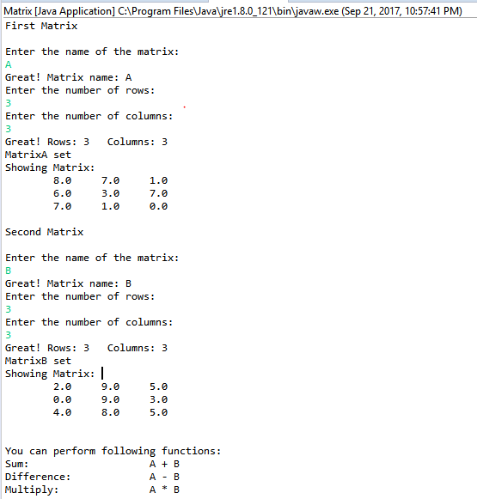

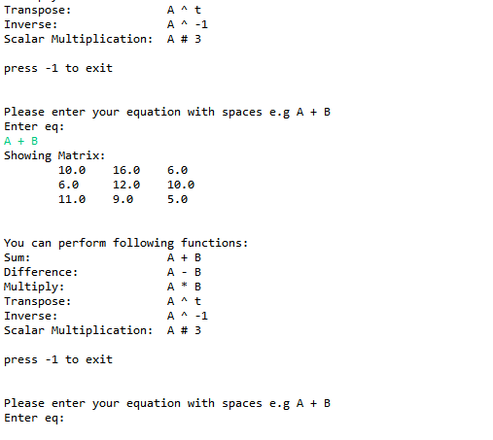

Github link: https://github.com/uurehman/Matrix-Computer